Tourism as a Tool for Local Economic Development: Inclusive Growth, Enterprise Linkages and Leakage Control
Option 1: Tourism as a Tool for Local Economic Development
M20 - Tourism and Local Development Cooperation

Table of Contents
1. Abstract
2. Introduction
3. Literature Review
4. Methodology
5. Findings
6. Discussion
7. Conclusion
8. References
9. Appendices

Abstract
This report examines tourism as a tool for local economic development and evaluates the conditions under which tourism produces inclusive local gains rather than narrow commercial growth. Tourism can generate employment, income, entrepreneurship, fiscal revenue, infrastructure improvement and regional competitiveness, but those benefits depend on how tourism value chains are organised. The analysis uses secondary research and a comparative case based approach to connect development cooperation concepts with practical destination management. It argues that the central issue is not whether tourism grows, but whether tourism spending is retained locally, distributed fairly, linked to small businesses, governed with community participation and reinvested in public goods. Evidence from global tourism policy and development agencies shows that tourism can support 357 million jobs worldwide and contribute substantially to GDP and visitor exports, yet many localities experience leakage, seasonal work, housing pressure, environmental costs and unequal control of assets (World Bank, n.d.; OECD, 2024). The report therefore proposes a local tourism development model based on local sourcing, skills development, cooperative governance, visitor management, small enterprise finance and transparent monitoring of distributional outcomes. The findings show that tourism has the strongest development effect when destinations move beyond promotional growth and build linkages with agriculture, crafts, transport, cultural services, construction, digital platforms and local government planning. The conclusion is that tourism can be a credible local development instrument only when cooperation mechanisms convert visitor demand into stable livelihoods, local ownership and sustainable infrastructure rather than dependency on externally controlled demand.

Introduction
Tourism is frequently promoted as a practical route to local economic development because it brings external spending into places that may have limited industrial capacity, weak formal employment and underused cultural or natural assets. Unlike many export sectors, tourism is consumed in the destination itself, which means that visitors travel to local landscapes, heritage sites, food systems, transport networks, accommodation enterprises and service workers. This gives tourism a special development potential because even small towns, rural areas and peripheral regions can compete through place identity rather than through large scale manufacturing. However, the same local embeddedness also makes tourism politically sensitive. The benefits and costs are experienced by residents in everyday life through jobs, prices, congestion, public services, housing availability, cultural change and environmental pressure.
The assignment topic is therefore best understood through the relationship between tourism growth and local development cooperation. Local development cooperation refers to the coordinated action of community actors, public authorities, private firms, civil society organisations and external development partners to improve local economic and social outcomes. In tourism, this cooperation is essential because no single actor controls the whole destination product. A hotel may provide accommodation, but the destination also relies on transport, safety, waste management, water supply, cultural interpretation, local food production, informal vendors, protected areas and public spaces. When these actors cooperate, tourism can support employment, income generation, entrepreneurship and infrastructure. When they do not cooperate, tourism can create leakage, dependence, inequality and resident resistance.
This report focuses on Option 1 and asks how tourism contributes to local economic development. The discussion covers employment creation, income generation, small business growth, infrastructure, entrepreneurship and regional competitiveness. It also critically evaluates dependency, leakage and unequal distribution. The report uses a secondary research methodology because the task requires a broad conceptual and applied analysis rather than primary fieldwork. Current policy literature from international organisations is combined with academic concepts such as the tourism multiplier, value chain linkages, pro poor tourism, destination competitiveness and sustainable local economic development. The approach is intentionally critical. It does not assume that all tourism growth is good for residents, and it does not treat visitor numbers as an automatic measure of development success.
The report argues that tourism contributes to local development through 3 main channels. First, tourism directly creates employment and household income in accommodation, food service, guiding, transport, retail, events and cultural interpretation. Second, tourism indirectly supports local suppliers, construction firms, farmers, artisans, maintenance providers and digital service businesses. Third, tourism can justify improvements in infrastructure such as roads, public space, broadband, waste systems, water supply, signage and public safety. The weakness of this model is that benefits can leak out through foreign ownership, imported goods, external booking platforms and low wage labour systems. For that reason, the report evaluates not only the scale of tourism activity but also the ownership, procurement and governance arrangements that determine how much value remains in the destination.
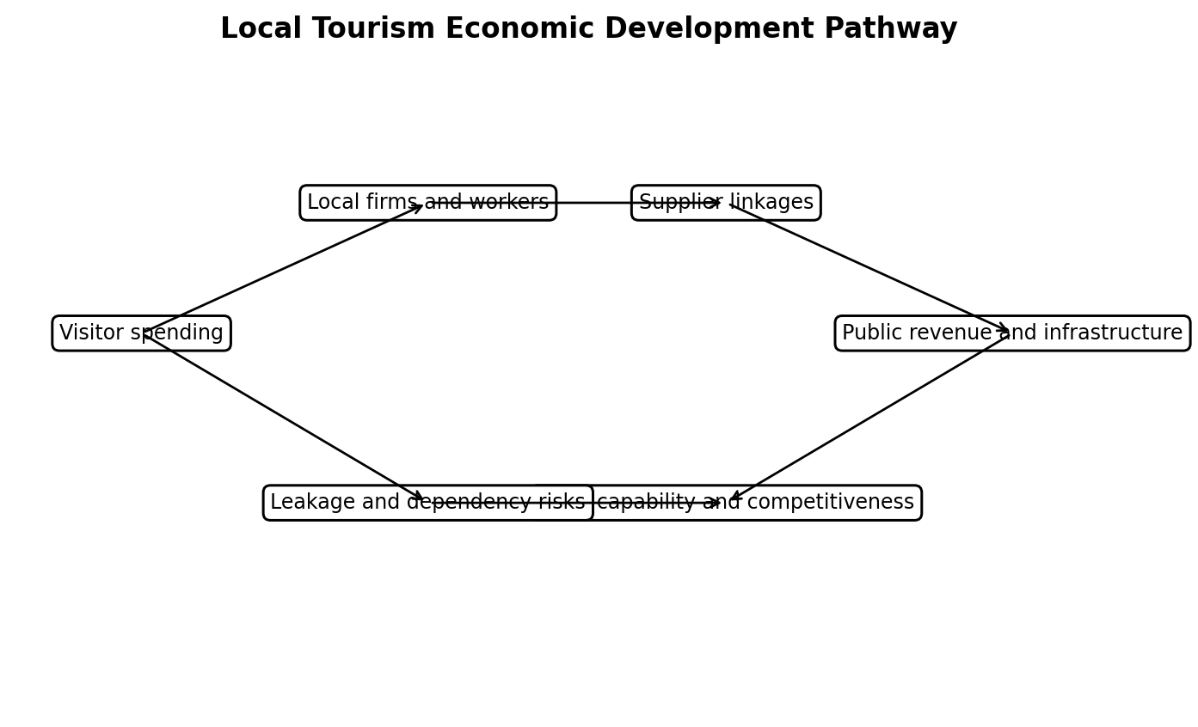
Figure 1. Local tourism economic development pathway.

Literature Review
The local economic development literature treats development as more than growth in output. It includes employment quality, local enterprise formation, income distribution, resilience, participation and improvement in collective assets. Tourism fits this agenda because it has a relatively broad employment base and can create opportunities for groups that are often excluded from capital intensive sectors. The World Bank describes tourism as an inclusive and scalable engine of job creation, while the OECD stresses that post pandemic tourism recovery needs coordinated and forward looking policies to build a more resilient, sustainable and inclusive sector (OECD, 2024; World Bank, n.d.). These statements are important because they move tourism policy away from simple arrival growth and towards quality of development.
The tourism multiplier is one of the central concepts used to explain the economic role of tourism. Tourist expenditure becomes direct income for hotels, restaurants, transport companies, attractions and guides. Those businesses then purchase goods and services from other local suppliers, which creates indirect effects. Employees then spend wages in the local economy, creating induced effects. In principle, this means that a visitor payment for a homestay can support the host household, the local farmer who provides food, the craft producer who sells souvenirs, the driver who provides transport and the local authority that collects fees. The multiplier is stronger when local supply chains are deep and locally owned. It is weaker when businesses import food, use external labour, rely on foreign management contracts or send profits outside the locality.
Employment generation is one of tourism's strongest arguments. Tourism uses a mix of skilled, semi skilled and entry level labour, so it can absorb workers with different educational backgrounds. It also creates work for women, young people and informal entrepreneurs in many destinations. However, employment quality is a key concern. Tourism jobs may be seasonal, low paid, informal and vulnerable to external shocks such as pandemics, recessions, climate hazards, political instability or transport disruptions. The local development value of tourism employment therefore depends on wage standards, training pathways, career progression, worker protection and diversification across markets. A destination that celebrates job numbers while ignoring labour conditions risks producing visible tourism growth with weak social development.
Small business growth is another major theme in the literature. Tourism creates market access for micro and small enterprises because visitors demand accommodation, food, transport, entertainment, crafts, experiences and local knowledge. Local entrepreneurs can turn cultural capital and place based knowledge into commercial services. This is especially relevant in rural and heritage contexts where residents may have few alternative income sources. Yet entrepreneurship is not automatic. Small businesses often face barriers such as weak finance, low digital skills, limited marketing power, poor infrastructure, quality certification costs and dependence on tour operators. Local development cooperation is therefore needed to connect small firms to training, credit, licensing support, digital platforms and public procurement opportunities.
Infrastructure improvement is often presented as an economic benefit of tourism. Visitor demand can justify investment in roads, airports, public transport, signage, lighting, water supply, sanitation, public spaces, broadband and emergency services. When planned well, this infrastructure benefits residents as much as visitors. For example, a public waterfront improvement may support tourism while also improving local quality of life. However, infrastructure can also be captured by tourist enclaves. If public funds are used mainly to serve resorts, airports or cruise terminals while resident neighbourhoods remain underserved, tourism infrastructure becomes unequal development. The development question is therefore whether infrastructure serves a shared local development strategy or only the convenience of visitors and investors.
Destination competitiveness literature explains how tourism can strengthen a region's economic position. Tourism can diversify a local economy, build a positive place brand, attract investment and stimulate complementary sectors such as food production, creative industries, festivals, transport and education. Regional competitiveness is not limited to cheaper prices or higher visitor numbers. It also involves quality, authenticity, sustainability, safety, accessibility, innovation and institutional capacity. This is consistent with the OECD's argument that tourism policy needs structural change and coordinated governance to address resilience and sustainability (OECD, 2024). A destination can be competitive in the short term by exploiting cheap labour and fragile resources, but such competitiveness is weak if it damages the social and environmental base of tourism.
The main critical concept is leakage. Leakage occurs when tourism revenue exits the local economy through imported goods, external ownership, international booking platforms, profit repatriation, franchise fees, airline payments or non local labour. Leakage weakens the multiplier and can leave host communities with low wage service roles while external companies capture the most profitable segments. This is especially problematic in small island, rural and developing destinations where supply chains may be shallow and capital is externally controlled. Lacher and Nepal (2010) argue that the challenge is to move from leakages to linkages by strengthening local procurement and community enterprise connections. This concept is central to the report's later recommendations.
Tourism dependency is another risk. A locality that becomes highly dependent on tourism may experience economic vulnerability when visitor flows decline. The COVID 19 pandemic exposed this fragility across destinations that relied heavily on travel and hospitality. Dependency can also distort local labour markets by pulling workers away from agriculture, education or manufacturing, and it can inflate land and housing prices in tourism zones. Overtourism protests in the Canary Islands have illustrated resident concerns about housing affordability, environmental pressure and an economic model that residents perceive as unequal (Burgen, 2024). These concerns show that tourism led development must include social limits and resident voice, not only marketing targets.
The literature on pro poor and inclusive tourism argues that tourism contributes to development when low income residents receive direct and indirect benefits. This requires local employment, enterprise ownership, access to tourist markets, community funds, revenue sharing, skills development and rights over cultural and natural resources. Sustainable tourism policy extends this by asking whether tourism protects the environmental and cultural assets on which the economy depends. UN Tourism defines sustainable development in tourism through a balance between biodiversity conservation, social welfare and economic security (UN Tourism, n.d.). Therefore, local economic development through tourism must be assessed across economic, social and environmental outcomes, not simply through visitor arrivals or hotel occupancy.
Table 1. Tourism mechanisms and local development outcomes
Mechanism | Positive local development effect | Main risk | Cooperation response
Employment creation | Creates jobs in accommodation, food, transport, guiding, events and retail. | Low wage, seasonal or informal work. | Skills pathways, labour standards and local hiring agreements.
Income generation | Turns visitor spending into household income and public revenue. | Income captured by external firms or local elites. | Local ownership, transparent benefit sharing and community funds.
Small business growth | Expands markets for crafts, food, homestays, tours and services. | Weak finance, quality gaps and dependence on intermediaries. | Supplier development, micro finance and cooperative marketing.
Infrastructure improvement | Justifies roads, sanitation, broadband, signage and public space investment. | Tourist enclaves receive priority over resident areas. | Resident benefit tests and integrated local planning.
Regional competitiveness | Builds destination identity and attracts investment. | Overgrowth can damage affordability and authenticity. | Carrying capacity, diversification and resident satisfaction monitoring.

Methodology
This report uses a qualitative secondary research methodology. The purpose is to analyse how tourism contributes to local economic development and to evaluate the risks that reduce local development impact. Primary data collection was not used because the assignment is a desk based project report and the selected topic requires broad international evidence rather than a single destination survey. The methodology combines academic literature, international development policy sources and real world destination examples. This approach is appropriate because tourism and local development cooperation are multi actor processes that can be understood through theory and comparative practice.
The analysis follows 4 stages. First, the report identifies the main economic development mechanisms associated with tourism, including direct employment, indirect supply chain effects, induced spending, entrepreneurship, infrastructure and regional competitiveness. Second, it examines development cooperation concepts by asking which actors are needed to convert tourism demand into local benefits. These actors include local authorities, community groups, tourism firms, NGOs, financial institutions, training providers and infrastructure agencies. Third, it assesses negative outcomes such as leakage, dependence, seasonality, income inequality, displacement and resource pressure. Fourth, it develops recommendations based on local value retention, cooperative governance and sustainability monitoring.
The sources were selected because they provide a mix of policy relevance and conceptual depth. International sources from the World Bank, OECD, UN Tourism and UN agencies were used for current sector framing and development policy. Academic and practitioner sources were used for concepts such as multiplier effects, tourism leakage, local sourcing and community based tourism. Examples were selected to show variation across urban, rural, heritage, island and nature based destinations. This comparative method has limitations. It does not measure direct local impacts in 1 destination, and it relies on published sources that may present tourism projects positively. To reduce this limitation, the discussion includes both positive cases and negative cases such as overtourism pressure and resident protest.

Findings
The first finding is that tourism supports local economic development most directly through employment. Accommodation, restaurants, transport, guiding, visitor attractions, events, retail and destination management all require labour. These jobs are significant for local development because they are geographically rooted and cannot be fully relocated away from the destination. For young people, women and workers without advanced formal qualifications, tourism may provide an entry point into the paid economy. However, the employment benefit is strongest when jobs are formal, locally accessible and linked to training. Without these conditions, tourism can create many low wage jobs but still fail to reduce poverty or build long term human capital.
The second finding is that tourism can generate household income through micro enterprise and self employment. Homestays, food stalls, craft markets, walking tours, boat trips, bicycle rentals, cultural performances, rural experiences and local transport services allow residents to sell directly to visitors. These activities can be especially important in villages or secondary towns where formal employment is limited. Community based tourism initiatives in Thailand and India show how local knowledge, culture and nature can be turned into tourism products when communities are supported through co creation, accessibility planning and institutional partnerships (UNDP India, 2021; UNDP Thailand, 2023). The key point is that the tourism product is not only a hotel room or attraction. It is a bundle of local experiences that can include many small suppliers.
The third finding is that tourism stimulates small business growth when destinations strengthen local procurement. Hotels and restaurants purchase food, laundry, maintenance, transport, entertainment, furniture, construction services and digital marketing. If these inputs are sourced locally, the economic impact spreads beyond the immediate tourism business. If they are imported or supplied through national chains, much of the value leaves the locality. This means that procurement policy is a central development instrument. Local authorities and destination organisations can create supplier directories, quality standards, buyer meetings, food hubs and craft certification schemes to help small businesses enter tourism value chains.
The fourth finding is that tourism supports infrastructure, but the distribution of infrastructure benefits is uneven. Tourism can provide the economic case for road upgrades, pedestrian improvements, sanitation, waste systems, lighting, internet connectivity, health services and visitor information. These investments increase destination attractiveness while also improving residents' daily lives. Yet there is a risk that infrastructure follows tourist enclaves and neglects residential areas. Development cooperation should therefore require infrastructure planning to include resident use. A road to a resort can be development enhancing if it also connects villages to markets, schools and clinics. It is less development enhancing if it simply facilitates extraction of visitor spending by an external operator.
The fifth finding is that tourism can improve regional competitiveness by creating a recognisable place identity. Destinations that develop food routes, cultural districts, nature trails, heritage festivals or creative clusters can differentiate themselves from competitors. This differentiation attracts visitors, investors and sometimes new residents. However, competitiveness should not be confused with aggressive growth. If a region becomes popular but loses affordability, authenticity or environmental quality, the source of competitiveness is damaged. The Canary Islands case demonstrates this tension. Strong visitor demand can coexist with resident dissatisfaction if housing, ecological pressure and distribution of benefits are not addressed (Burgen, 2024).
The sixth finding is that leakage remains a major barrier to local economic development. Leakage is high where accommodation, booking systems, food imports, transport and tour operations are controlled externally. Even when visitor arrivals increase, local residents may receive only low paid jobs while profits, management fees and platform commissions leave the region. Small islands and remote regions are particularly exposed because they often import food, construction materials, skilled labour and energy. Leakage should therefore be treated as a measurable development problem. Destinations should estimate local retention by tracking ownership, procurement, wages, taxes and community funds rather than relying only on visitor expenditure totals.
The seventh finding is that tourism dependency can reduce resilience. A locality that depends on 1 market, 1 season, 1 attraction or 1 type of visitor becomes vulnerable to sudden shocks. Pandemics, climate events, exchange rate changes, political conflict, airline route changes and changing consumer preferences can all reduce arrivals. Dependency also creates political pressure to keep growing tourism even when residents experience congestion or environmental stress. Local economic development should therefore use tourism as part of a diversified economy rather than as a replacement for agriculture, education, healthcare, manufacturing or public services. The strongest destinations connect tourism to wider development sectors rather than isolating it as a separate visitor economy.
The eighth finding is that unequal distribution is not a side issue but a central development concern. Tourism may increase local GDP while widening inequality between landowners and renters, skilled managers and casual workers, formal businesses and informal vendors, or central tourism zones and peripheral neighbourhoods. Inequality also appears in gendered work patterns when women are concentrated in low paid housekeeping, informal food service or unpaid family labour. A local development approach must therefore measure who benefits, who pays the costs and who has decision making power. Community benefit agreements, local hiring targets, supplier inclusion, training funds and participatory budgeting can help correct unequal distribution.
The ninth finding is that development cooperation improves tourism's local impact. Tourism outcomes depend on relationships among public authorities, private firms, communities, NGOs, educators, investors and infrastructure providers. Cooperation is needed to coordinate training, market access, environmental management, product development, heritage protection and small business support. UNDP's community based tourism work in Türkiye and Thailand demonstrates that tourism development is more effective when government, communities and development partners work together on capacity building, product design and inclusion (UNDP Thailand, 2023; UNDP Turkiye, n.d.). Cooperation does not remove conflict, but it creates institutions through which conflict can be managed.
The final finding is that tourism's local economic contribution is strongest when economic objectives are integrated with sustainability. The destination assets that attract visitors are often shared resources: beaches, forests, streets, historic buildings, culture, festivals, cuisine and community hospitality. If tourism degrades these resources, the economic model becomes self defeating. Sustainable tourism therefore supports local development by protecting the resource base, reducing social conflict and maintaining the quality of visitor experience. This requires carrying capacity tools, environmental regulation, cultural respect, resident participation and reinvestment of tourism revenue into local public goods.
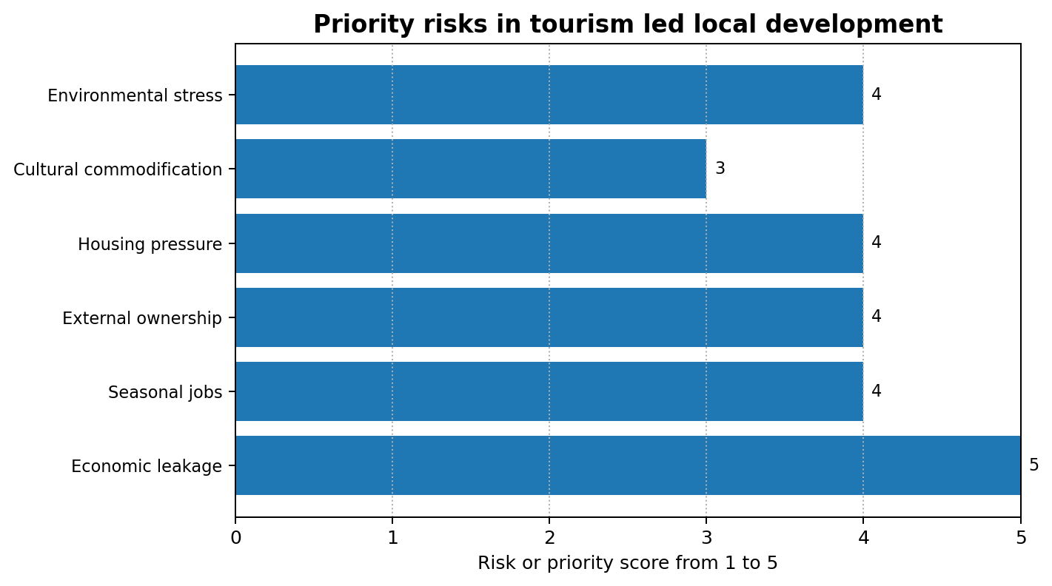
Figure 2. Priority risks in tourism led local development.

Table 2. Selected destination lessons for local economic development
Example | Development opportunity | Critical lesson
Community based tourism in Thailand | Co creation can connect local communities to markets and inclusive visitor experiences. | External facilitation is useful when it builds local capability rather than long term dependency.
Community tourism in Ladakh, India | Nature and tradition can support livelihoods while reinforcing conservation values. | Local control over culture and environment is essential for legitimacy.
Canary Islands overtourism pressures | High visitor numbers can generate revenue and jobs. | Growth can become politically unstable when affordability and environmental concerns are ignored.
Rural tourism and local sourcing | Tourism demand can support farmers, craft producers and transport providers. | Leakage falls only when deliberate local procurement links are created.

Discussion
The findings show that tourism can be a powerful local economic development tool, but only when destinations deliberately design value retention mechanisms. The basic economic argument is persuasive. Visitors bring spending from outside the locality, and that spending can support jobs, businesses, infrastructure and public revenue. However, the development impact depends on how money moves after the first transaction. A luxury hotel with imported food, non local managers and external owners may produce high visitor expenditure but limited local development. A smaller locally owned tourism network with local food sourcing, community guides, craft sellers and resident decision making may produce lower gross revenue but a stronger local multiplier.
This distinction is important because many tourism strategies still use growth indicators that hide distributional problems. Visitor arrivals, hotel occupancy and total expenditure are useful, but they do not show whether residents gain stable livelihoods or whether local businesses capture value. A destination can appear successful in tourism statistics while local workers face insecure employment and residents struggle with higher rents. Therefore, local development cooperation should introduce indicators such as local procurement share, percentage of tourism firms locally owned, average wage levels, seasonal employment variation, number of community enterprises, resident satisfaction and investment in public infrastructure. These indicators align tourism performance with development rather than marketing alone.
The role of the public sector is especially important. Local government cannot control all tourism behaviour, but it can shape the conditions under which tourism operates. Planning rules, licensing, public space management, infrastructure investment, visitor taxes, training partnerships and small business support all influence local outcomes. Government also has a responsibility to protect residents from excessive externalities. If tourism growth raises land values and creates pressure on water, waste systems and housing, local authorities need policy tools such as zoning, short term rental regulation, environmental standards and reinvestment of tourism revenue. This does not mean rejecting tourism. It means making tourism accountable to resident welfare.
Private tourism businesses also have a development role beyond profit generation. Hotels, tour operators, restaurants and platforms can strengthen local development through local hiring, fair wages, supplier development, mentoring, environmental management and cultural respect. Large firms often claim that their presence creates jobs, but a stronger development test is whether they build local capability and supplier networks. Procurement from farmers and artisans, apprenticeships for young people, transparent career pathways and partnership with local schools can turn private investment into a broader local asset. Without such commitments, businesses may capture destination value while externalising social and environmental costs.
Local communities should not be treated only as beneficiaries. They are co producers of the tourism experience because they maintain culture, provide hospitality, protect landscapes and live with the consequences of tourism development. Community participation helps identify acceptable forms of tourism, protect sensitive cultural practices and direct benefits to local priorities. It also reduces the risk of conflict by giving residents a voice before resentment becomes protest. However, participation must be meaningful. Consultation after decisions have been made is not enough. Communities need access to information, representation in destination governance, benefit sharing mechanisms and the right to challenge development that threatens local identity or resources.
The critical challenge is balancing economic growth with resilience. Tourism can create quick income, but quick growth can produce dependency and fragility. A destination that becomes famous through social media may experience sudden visitor growth without enough infrastructure, regulation or community preparation. This can damage the visitor experience and resident life at the same time. Resilience requires diversification across markets, seasons and products. It also requires linking tourism to sectors such as agriculture, conservation, education, digital services and creative industries. In this model, tourism becomes a market for local capabilities rather than a single fragile dependency.
A further issue is cultural commercialisation. Tourism often uses culture as an attraction, but local culture is not simply an economic resource. If cultural expression is controlled by external operators or simplified for tourist expectations, residents may experience loss of dignity and identity. On the other hand, tourism can support cultural preservation when communities control interpretation and revenue helps sustain festivals, crafts, language, food traditions and heritage sites. The economic development question is therefore linked to cultural power. Local development cooperation should ensure that cultural tourism is based on consent, fair payment and community controlled storytelling.
The report's overall argument is that tourism should be managed as a local value chain rather than as a visitor count. A value chain approach asks who owns assets, who supplies goods, who receives wages, who pays environmental costs, who controls narratives and who makes decisions. This approach makes leakage and inequality visible. It also shows where interventions can improve development impact, such as local supplier programmes, community funds, worker training, small business finance, heritage protection and infrastructure planning. Tourism can then become a tool for inclusive development rather than an extractive use of place.
A further implication is that local development through tourism should include financial inclusion. Many residents have ideas for tourism services but lack the capital, insurance and compliance knowledge required to begin. Small grants, revolving loan funds and cooperative savings schemes can reduce entry barriers, especially for women and young entrepreneurs. Financial inclusion also protects residents from predatory intermediaries who may offer short term access to tourists while capturing most profit.

Conclusion
Tourism contributes to local economic development through employment creation, household income, small business growth, infrastructure improvement, entrepreneurship and regional competitiveness. Its development potential is strong because tourism takes place within local communities and uses place based assets that cannot be fully relocated. However, tourism is not automatically inclusive. The same sector can create jobs and businesses while also producing leakage, dependency, inequality, housing pressure, cultural commodification and environmental strain. The decisive factor is governance. Tourism produces stronger local development when destinations build cooperation among communities, government agencies, private businesses, NGOs, training providers and infrastructure actors.
The report therefore concludes that tourism should be treated as a managed local development system rather than a simple growth sector. Policy should focus on local value retention, local sourcing, fair employment, resident participation, infrastructure that serves both visitors and residents, and transparent measurement of distributional outcomes. Real world examples show that community based and sustainable tourism can create livelihoods and preserve local identity, but overtourism cases also show the danger of ignoring resident welfare. The best local tourism strategy is not the one that maximises arrivals. It is the one that converts visitor demand into durable local capability, shared prosperity and protection of the cultural and natural resources that make the destination worth visiting.

References
Ashley, C., Roe, D., & Goodwin, H. (2001). Pro-poor tourism strategies: Making tourism work for the poor. Overseas Development Institute.
Bramwell, B., & Lane, B. (2011). Critical research on the governance of tourism and sustainability. Journal of Sustainable Tourism, 19(4-5), 411-421.
Burgen, S. (2024, April 20). Tens of thousands protest against Canary Islands' unsustainable tourism model. The Guardian. https://www.theguardian.com/world/2024/apr/20/thousands-protest-canary-islands-unsustainable-tourism
Goodwin, H. (2011). Taking responsibility for tourism. Goodfellow Publishers.
Jackson, L. A. (2025). Community-based tourism: A catalyst for achieving the Sustainable Development Goals. Tourism and Hospitality, 6(1), 29. https://www.mdpi.com/2673-5768/6/1/29
Lacher, R. G., & Nepal, S. K. (2010). From leakages to linkages: Local-level strategies for capturing tourism revenue in Northern Thailand. Tourism Geographies, 12(1), 77-99. https://doi.org/10.1080/14616680903493654
Mitchell, J., & Ashley, C. (2010). Tourism and poverty reduction: Pathways to prosperity. Earthscan.
Organisation for Economic Co-operation and Development. (2024). OECD tourism trends and policies 2024. OECD Publishing. https://www.oecd.org/en/publications/2024/07/oecd-tourism-trends-and-policies-2024_17ff33a3.html
Quang, T. D., et al. (2023). Toward sustainable community-based tourism development. Humanities and Social Sciences Communications, 10, 676. https://pmc.ncbi.nlm.nih.gov/articles/PMC10617687/
Scheyvens, R. (1999). Ecotourism and the empowerment of local communities. Tourism Management, 20(2), 245-249.
Tosun, C. (2000). Limits to community participation in the tourism development process in developing countries. Tourism Management, 21(6), 613-633.
United Nations Department of Economic and Social Affairs. (n.d.). Sustainable tourism. https://sdgs.un.org/topics/sustainable-tourism
United Nations Development Programme India. (2021, October 23). Community-based tourism: Protecting nature, conserving traditions. https://www.undp.org/india/blog/community-based-tourism-protecting-nature-conserving-traditions
United Nations Development Programme Thailand. (2023). Community-Based Tourism for All: Co-creation Journey. https://www.undp.org/thailand/publications/community-based-tourism-all-co-creation-journey
United Nations Development Programme Turkiye. (n.d.). Capacity development for sustainable community based tourism. https://www.undp.org/turkiye/projects/capacity-development-sustainable-community-based-tourism
UN Tourism. (n.d.). Sustainable development. https://www.untourism.int/sustainable-development
World Bank. (n.d.). Tourism. https://www.worldbank.org/ext/en/topic/tourism
World Economic Forum. (2024, February 15). Turning tourism into development. https://www.weforum.org/stories/2024/02/turning-tourism-into-development/

Appendices
Appendix A provides a practical checklist for assessing whether tourism supports local economic development. The checklist includes local employment quality, local business ownership, procurement from local suppliers, community benefit funds, infrastructure benefits for residents, leakage control, seasonality management and resident satisfaction.
A destination authority can use the checklist during annual tourism planning. Each indicator should be scored from 1 to 5, where 1 means weak evidence and 5 means strong evidence. Low scores should trigger specific policy actions rather than general promotional campaigns.

