Macroeconomic Recovery, Exchange-Rate Risk and Tourism Demand in Sri Lanka
Fundamentals of Economics – Detailed Project Report
Option 3: Macroeconomic Indicators, Exchange Rates, and Tourism Demand

Student: Student 5 – Name: ____________________
Student ID: ____________________
Module: Fundamentals of Economics
Submission: Academic Year 2026
Main-text word count: 4043

Table of Contents
Executive Summary 3
Introduction 4
Microeconomic Analysis & Market Structure 6
Macroeconomic Environment & Policy Impact 9
Empirical Data & Case Study Analysis 16
Strategic Implications for Tourism 20
Conclusion & Recommendations 24
References 25
Appendices 26

Executive Summary
Sri Lanka’s tourism recovery provides a distinctive macroeconomic case because visitor growth has occurred alongside a broader stabilisation process following the country’s severe economic and external-financing crisis. Official tourism data show 2,362,521 arrivals in 2025, an increase of 15.1% from the previous year (Sri Lanka Tourism Development Authority [SLTDA], 2026). International institutions also reported improved macroeconomic conditions: the World Bank (2025) noted strong growth in 2024 with tourism-related services contributing to the recovery, while the International Monetary Fund (IMF, 2025) reported a current-account surplus supported by tourism and remittances and recovering international reserves. These developments demonstrate the importance of tourism as both a source of demand and a source of foreign exchange.
The report analyses how exchange rates, inflation, interest rates and national income affect Sri Lankan tourism flows and tourism-business performance. A currency depreciation can make Sri Lanka cheaper for foreign visitors, but sharp volatility can deter advance planning and raise the local-currency cost of imported fuel, food, equipment and debt service. The evidence indicates that exchange-rate effects should be analysed together with origin-market income and macro stability rather than as a simple competitiveness mechanism (Adeleye et al., 2023; Rathnayake, 2018). The recommended strategy is a “resilience portfolio”: destination management organisations (DMOs) should diversify source markets, track real effective prices and visitor yield, while hospitality operators should match foreign-currency revenue against FX-sensitive costs, preserve liquidity, reduce import dependence where quality permits, and stress-test demand under alternative growth and exchange-rate scenarios.

Introduction
Tourism links the domestic economy to global income, prices and financial conditions. Foreign visitors bring external purchasing power into hotels, transport, food services, attractions and retail, and tourism receipts supply foreign exchange that can help finance imports. This linkage is especially important for an economy that has experienced external-financing constraints. Yet the same openness exposes tourism businesses to currency and business-cycle volatility. A hotel may benefit from more international guests after depreciation while simultaneously paying more for imported equipment, food products, energy or foreign-currency obligations.
Macroeconomic analysis must therefore separate demand-side and cost-side effects. On the demand side, the exchange rate changes the destination’s price relative to competing countries, while source-market income determines whether households have the ability to travel. Inflation changes the real value of the tourism bundle. Interest rates affect domestic investment and working capital. On the supply side, access to imported inputs, aviation connectivity, credit and infrastructure shapes the ability of firms to respond to growing arrivals.
Sri Lanka is particularly useful because recent tourism performance cannot be understood independently of macro stabilisation. The World Bank (2025) described a strong rebound in economic activity in 2024, including tourism-related services, while the Asian Development Bank (ADB, 2025) characterised the recovery as stronger than expected but still fragile. The IMF’s 2025 programme review reported improved reserves and external balances but continued the emphasis on macroeconomic and debt sustainability (IMF, 2025). Tourism is both a beneficiary of recovery and a contributor to it through receipts and employment.
The report first explains the microeconomic mechanisms by which international travellers respond to price and income. It then evaluates monetary and fiscal transmission during recovery, examines 2025 visitor evidence and academic work on exchange-rate effects, and develops practical risk controls for DMOs and hospitality operators. The objective is to protect tourism value through macro volatility rather than to make a speculative forecast of the Sri Lankan rupee.

Microeconomic Analysis & Market Structure

Relative Prices, Tourism Demand and Substitution
A foreign tourist compares Sri Lanka with alternative destinations based on the total expected cost and experience. The exchange rate affects accommodation, food, domestic transport and attractions in the traveller’s home currency. If the rupee depreciates while local prices are sticky, Sri Lanka’s relative price falls and quantity demanded can increase. The size of the response depends on price elasticity and on the availability of substitutes such as Thailand, Vietnam, Indonesia, India or other Indian Ocean destinations.
Exchange-rate competitiveness is not uniform across market segments. High-end resort guests may be less sensitive to a modest change in room price if they value a specific property, wildlife itinerary or wellness product. Backpackers and long-stay travellers may be more sensitive to the daily cost of the destination. Visiting friends and relatives can have a lower destination-substitution elasticity because the purpose of the trip is location-specific. A DMO therefore needs segment-level demand elasticities rather than one national number.
Rathnayake (2018) analyses the effect of exchange-rate volatility on Sri Lanka’s inbound tourist flow, highlighting that uncertainty itself can matter. A stable but moderately weaker currency may be easier for travellers and tour operators to plan around than a currency that moves dramatically between booking and arrival. Volatility also affects tourism firms that quote packages months in advance. The economic exposure is therefore to both the expected exchange rate and the uncertainty around that expectation.

Income Elasticity and the Business Cycle
International leisure travel generally has positive income elasticity. When household income and confidence rise in origin markets, consumers are more willing to purchase long-haul flights, premium rooms and discretionary experiences. During recession they may travel closer to home, shorten trips or trade down. Adeleye et al. (2023) examine tourism, exchange rates and growth in Sri Lanka and reinforce the interconnected nature of the variables. Destination pricing cannot fully offset a severe source-market income shock if consumers are reducing discretionary travel altogether.
Income effects also alter visitor mix. A global slowdown may reduce long-haul premium demand more than regional visits, increasing the share of price-sensitive travellers. Average spend per arrival can therefore fall even if visitor numbers remain resilient. Hotels that plan only from occupancy may miss this change in willingness to pay. Revenue management should combine booking pace with origin-market macro indicators and length-of-stay patterns.
Domestic national income matters on the supply and complementary-demand side. Stronger local activity supports restaurants, transport and domestic tourism, while a weak domestic economy can reduce local hotel demand even as international tourism rises. Operators serving both markets should treat international and domestic demand as separate segments with different income and currency drivers.
Table 1. Macroeconomic risk transmission and mitigation for Sri Lankan tourism
Risk | Transmission to tourism | Early warning indicator | Mitigation action
Rupee depreciation / FX volatility | Changes destination affordability and imported costs | Real exchange rate; forward FX volatility | Currency matching; flexible contracts; diversified markets
Inflation / cost shock | Raises wages, food, utilities and transport costs | CPI; food/energy prices; supplier quotes | Menu engineering; local sourcing; cash buffer
External financing stress | Can constrain imports, aviation fuel and investment | Reserves; current account; sovereign spreads | Maintain working capital; secure critical supply chains
Source-market recession | Reduces discretionary long-haul travel | Origin GDP, confidence, air-search data | Diversify origin markets and segments
Domestic policy tightening | Higher borrowing costs and weaker local demand | Policy rates; credit growth | Phase capex; reduce refinancing concentration

Market Structure and Capacity Response
The short-run tourism supply curve is constrained by existing rooms, transport and skilled labour. If arrivals recover rapidly, high-demand areas can experience rising occupancy and rates before new supply enters. Over the longer run, investment can expand hotels and tourism services, but that response depends on financing conditions, construction costs and investor confidence. High interest rates or external financing constraints can make supply less elastic even when demand is strong.
This has a strategic implication for recovery. A destination can regain visitor volume faster than it restores service capacity. If staffing, maintenance, transport or imported supplies remain constrained, the tourist experience may deteriorate and weaken repeat demand. Macro risk management therefore includes operational capacity, not only hedging currencies.

Macroeconomic Environment & Policy Impact

Exchange Rates and the Balance of Payments
Tourism receipts enter the external accounts as exports of services. Rising international arrivals can improve the current account and provide foreign exchange to finance imports. The IMF (2025) reported that Sri Lanka’s current-account position was supported by tourism and remittance inflows during the recovery. This creates a positive macro feedback: successful tourism strengthens foreign-exchange availability, while greater external stability can make the destination easier for firms and travellers to plan around.
However, reliance on tourism also creates vulnerability. A geopolitical shock, pandemic, airline-capacity reduction or recession in major source markets can quickly reduce receipts. If external obligations and essential imports remain large, a tourism shortfall can reopen balance-of-payments pressure. The correct national strategy is to view tourism as one export sector in a diversified foreign-exchange portfolio, not as a substitute for broader export resilience.
At firm level, exchange-rate movements have asymmetric effects. A hotel earning dollars, euros or pounds may have a natural hedge against some imported costs. A domestically oriented restaurant with largely rupee revenue but imported ingredients has a different exposure. Each operator should map the currency of revenue, direct costs, debt and planned capital expenditure rather than rely on the national exchange-rate story.

Inflation, Monetary Conditions and Recovery
Inflation can weaken tourism competitiveness even after a depreciation. If domestic prices rise rapidly, the foreign-currency price advantage narrows. Inflation also compresses real household income and raises wage and supplier costs. The World Bank (2025) reported a period of very low or negative inflation during the stabilisation phase, illustrating how sharply inflation conditions changed from the crisis period. For tourism firms, this reduced the speed of nominal cost escalation but did not eliminate balance-sheet damage accumulated earlier.
Interest rates affect the speed of tourism investment. Tight policy may be necessary to stabilise prices and the currency, yet it raises the hurdle rate for hotel renovation, new rooms, vehicles and working capital. Firms with large short-term debt are particularly exposed. A property can report strong occupancy while remaining financially fragile if cash flow is absorbed by debt service and overdue maintenance.
Recovery policy should therefore protect macro stability while improving the investment environment through predictability, not through permanently cheap credit. Investors need credible inflation, tax and exchange-rate expectations to evaluate long-lived assets. Temporary targeted programmes can address specific market failures, such as energy-efficiency finance or SME working-capital gaps, without encouraging excessive leverage across the entire sector.

Fiscal Policy and Tourism-Sector Resilience
Fiscal policy influences tourism through taxes, infrastructure and destination services. Airports, roads, sanitation, heritage conservation, national parks and public safety are complementary inputs to private hotels and tour operators. When fiscal space is constrained, project selection becomes especially important. Investment should prioritise bottlenecks that raise visitor value, local productivity and resilience rather than prestige projects with weak utilisation.
Tax policy also affects the final tourism price. A rise in VAT or sector-specific charges can partly offset a favourable exchange rate, while abrupt rule changes increase planning uncertainty. The sector benefits from stable and transparent tax administration even when rates themselves are not low. Predictability reduces the risk premium required by investors and allows tour operators to quote future packages with greater confidence.
The ADB (2025) emphasised that Sri Lanka’s recovery remained fragile despite stronger growth. This is a useful warning against pro-cyclical tourism spending. Strong arrival growth should not automatically trigger aggressive public borrowing or private expansion. Investment should be tested against conservative demand scenarios so that the sector remains viable if the recovery slows.

External Vulnerability, Tourism Multipliers and Recovery Quality
Tourism’s contribution to macroeconomic recovery depends on how much visitor expenditure remains in the domestic economy. Gross receipts can overstate the local value added if hotels import a high share of food, beverages, equipment, software or management services. The tourism multiplier is larger when businesses source competitively from domestic farmers, manufacturers, transport providers and creative industries. Local sourcing is therefore not only a social policy; where quality and reliability are adequate, it can reduce foreign-exchange leakage and strengthen the balance-of-payments benefit of each tourist dollar.
Leakage analysis should nevertheless avoid a simplistic preference for local inputs at any cost. Imported equipment may improve energy efficiency, food safety or service quality enough to raise future demand. The relevant comparison is lifecycle value. A foreign-currency investment that reduces electricity use for ten years can lower external vulnerability even though it initially requires imports. Hospitality operators should classify imports into essential productivity-enhancing capital, quality-critical operating inputs and substitutable items, then focus localisation efforts where economic trade-offs are favourable.
The same logic applies to employment. Visitor growth creates income when hotels, guides, restaurants and transport businesses hire and retain local workers. If the recovery is highly seasonal, firms may rely on temporary labour and lose skills between peaks. Workforce retention can therefore be treated as a resilience investment. Training and predictable scheduling reduce the probability that service quality collapses when arrivals rebound rapidly, protecting repeat demand and the destination’s non-price competitiveness.
External debt conditions also influence tourism through confidence and access to capital. Even a hotel with strong occupancy can face high financing costs if country risk remains elevated. The IMF (2025) programme context and the ADB’s description of a fragile recovery (ADB, 2025) imply that operators should use a higher hurdle rate for discretionary projects than they might in a mature low-volatility market. Projects should be ranked by their ability to generate foreign-currency earnings, reduce recurrent costs or preserve essential service quality.
From the national perspective, tourism receipts can help rebuild reserves, but the sector should not become a justification for renewed external imbalance. If strong tourism encourages a rapid increase in imported consumption and debt-financed construction, some of the foreign-exchange benefit can leak out. Macro policy should allow investment where expected productivity and export earnings are strong while maintaining safeguards against another unsustainable credit cycle. The quality of recovery is therefore as important as its speed.
Tourism multipliers also vary geographically. A resort enclave that imports supplies and sells pre-arranged packages may retain less local value than a visitor itinerary that uses community guides, independent restaurants and regional transport. DMOs can increase the multiplier through destination dispersal, supplier-development programmes and digital visibility for local businesses. These policies do not require forcing visitors away from major resorts; they create more opportunities for expenditure to spread through the economy.
A macro shock should be evaluated by its effect on the entire visitor-value chain. For example, currency depreciation may improve hotel demand while raising fuel costs for excursion providers. If transport prices rise sharply, visitors may spend less outside the hotel, reducing local multiplier effects. Destination dashboards should therefore combine hotel occupancy with transport activity, attraction visits and regional expenditure rather than treating accommodation statistics as the whole tourism economy.
The recovery should finally be assessed against resilience indicators. Useful measures include reserve coverage, tourism-receipt concentration by source market, share of FX-linked debt in the hospitality sector, seasonality of arrivals, import intensity of key tourism inputs and average retained spend per visitor. These metrics identify whether growth is making the system safer or simply larger. A 15% increase in arrivals is strategically stronger when it comes with diversified markets, healthier balance sheets and lower leakage.
Resilience also requires attention to aviation access. An island destination depends heavily on international air capacity, so tourism demand can be constrained even when hotels are attractively priced. Airline schedule reductions, fuel-price shocks or weak route economics can raise the delivered cost of visiting Sri Lanka. DMOs should therefore monitor seat capacity, load factors and route diversity together with exchange rates. Air-service partnerships can reduce a bottleneck that room-price discounts alone cannot solve.
Digital payment and settlement arrangements form another part of external resilience. International guests increasingly expect reliable card and online payment systems, while operators need predictable access to foreign-currency settlement and imported digital services. A macro crisis that disrupts payment confidence can damage conversion even before physical capacity is affected. Hotels should maintain redundant payment options and reconcile foreign-currency receivables frequently so that liquidity problems are detected early.
Insurance and contingency contracts can complement financial hedges. Business-interruption cover, flexible supplier clauses and cancellation policies can reduce the cash-flow impact of shocks that are not directly hedgeable in currency markets. The cost of protection should be compared with the expected loss and the firm’s ability to self-insure. Smaller operators may benefit from pooled purchasing or industry schemes where individual access is limited.
Finally, scenario exercises should include recovery from the shock, not only the initial response. Deep discounting may be sensible when demand collapses, but leaving those discounts in place after recovery can anchor low reference prices and reduce future yield. Similarly, emergency cost cuts that weaken maintenance or staff capability can harm the rebound. Pre-agreed exit triggers help firms reverse temporary measures as conditions normalise.
Performance reporting should separate growth in visitor numbers from growth in foreign-exchange earnings per visitor. If arrivals rise while real spend per visitor falls, capacity can become busier without generating proportionate resources for wages, maintenance or public infrastructure. A balanced scorecard should therefore include average stay, real daily spend, regional dispersal and local procurement share alongside the headline arrival target.
These measures also improve crisis readiness. When managers know which markets generate the highest retained value, which costs are FX-sensitive and which months create cash deficits, they can respond to a shock with targeted changes rather than indiscriminate discounting or cuts. Better information is therefore itself a form of macroeconomic resilience.
For governance, the DMO can publish a quarterly resilience brief that combines tourism demand with macro indicators. A consistent public dashboard helps hotels, lenders and local suppliers form expectations from the same evidence and can reduce overreaction to individual exchange-rate movements. Clear data do not remove uncertainty, but they improve coordination and make investment decisions less dependent on rumours or short-term headlines.

Empirical Data & Case Study Analysis

Tourist Arrivals in 2025
SLTDA data show that Sri Lanka received 2,362,521 tourist arrivals in 2025, 15.1% above 2024 (SLTDA, 2026). Monthly arrivals were strongly seasonal, with January and December above 250,000 visitors and lower volumes in several middle months. The pattern matters for employment, pricing and working capital: a business that is profitable in peak months can still face cash stress during the shoulder season.
Strong annual growth signals recovery, but the level of arrivals is not a complete welfare measure. Tourism value depends on spend, length of stay, import leakage, local wage income, regional distribution and pressure on environmental assets. A higher-spending visitor who uses local services can generate more value than a high-volume low-margin segment. DMOs should therefore pair arrival targets with expenditure and sustainability metrics.
Seasonality also interacts with exchange rates. A depreciation just before a major booking period may affect the next season more strongly than an equivalent movement after most visitors have prepaid. Exchange-rate elasticities estimated from annual data can hide this timing effect. Hotel managers should monitor booking-window exposure by origin market so that price and currency movements are linked to when customers actually decide.
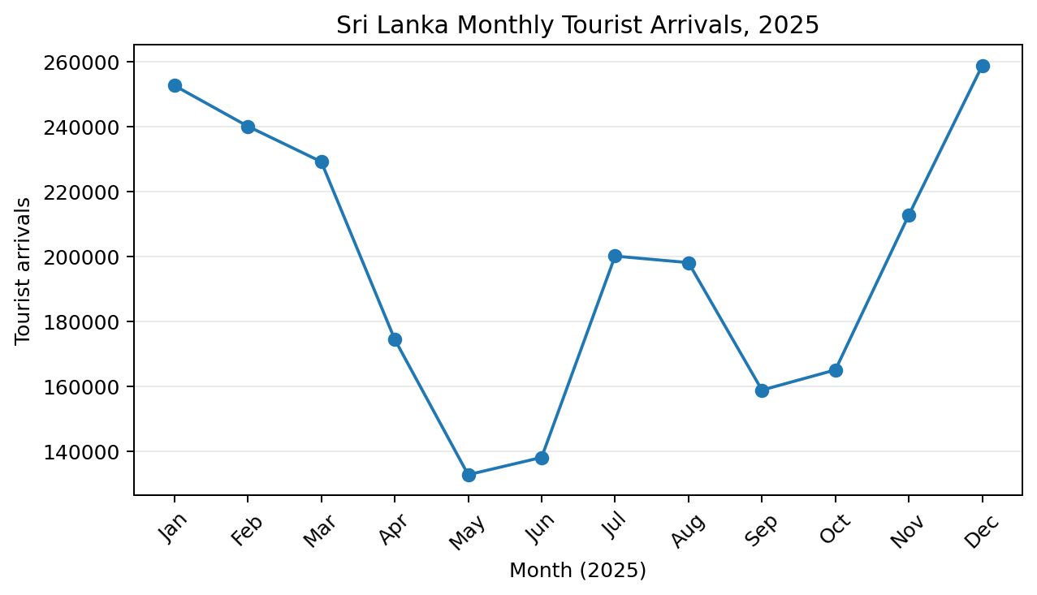
Figure 1. Monthly tourist arrivals reported by the Sri Lanka Tourism Development Authority for 2025.

Macroeconomic Recovery and Tourism’s Foreign-Exchange Role
The IMF’s fourth review under the Extended Fund Facility noted improved external conditions, including gross official reserves of about US$6.2 billion at end-April 2025 and a current-account surplus in the first quarter supported by tourism and remittances (IMF, 2025). The Central Bank of Sri Lanka (2026) likewise places tourism within the country’s wider 2025 economic and external-sector recovery. These figures show why tourism policy has macroeconomic significance beyond hotel profitability: visitor receipts improve foreign-exchange liquidity and can support confidence in the broader economy.
The World Bank (2025) reported that Sri Lanka’s economy grew by 5% in 2024, with services including tourism contributing to recovery. ADB (2025) projected continued but moderating growth and described the recovery as fragile. The combination suggests a positive cycle—macroeconomic stability supports tourism, tourism supports foreign exchange and employment, and these support further stabilisation—but also a reason to avoid complacency.
Tourism-dependent firms should not assume that macro recovery removes all crisis-era risk. Debt restructuring, tax adjustment and changes in public spending can affect domestic demand and financing. International visitors can remain strong while local businesses face high borrowing costs or weak balance sheets. A robust strategy needs both market demand and financial resilience.
Table 2. Selected Sri Lanka recovery and tourism indicators
Indicator | Recent evidence | Economic significance
2025 tourist arrivals | 2,362,521; +15.1% | Strong tourism-demand recovery
2024 real GDP growth | About 5% (World Bank) | Broader activity recovered alongside services
Gross official reserves | About US$6.2bn at end-April 2025 (IMF) | Improved external buffer
Q1 2025 current account | Surplus supported by tourism/remittances (IMF) | Tourism contributes foreign exchange
Growth outlook | Recovery expected to continue but remain fragile (ADB) | Businesses should plan conservative downside scenarios

Empirical Research on Exchange Rates and Tourism
Sri Lanka-specific research confirms that exchange rates interact with tourism demand and growth. Rathnayake (2018) focuses on exchange-rate volatility and inbound tourist flow. Adeleye et al. (2023) analyse growth-led tourism and the role of exchange rates, while Adeleye et al. (2025) examine tourism, exchange-rate dynamics and economic growth. The combined message is that tourism and macro performance are jointly determined rather than connected by a single one-way channel.
Evidence from other island tourism economies also helps identify mechanisms. Rookayyah et al. (2024) use disaggregated tourism data to study exchange-rate level and volatility effects. The usefulness of disaggregation is particularly relevant for Sri Lanka because visitors from India, Europe, Russia, China and other markets face different airfares, incomes and currency movements. Aggregation can cancel out opposing responses and produce an elasticity that is not useful for any actual segment.
For forecasting, operators should therefore model origin markets separately or in clusters. A short-haul regional market may respond quickly to promotions and air capacity; long-haul European demand may depend more on advance booking, winter seasonality and household income. Exchange rates should be translated into the visitor’s currency and combined with airfare and package cost. The total trip price is the relevant economic variable.

Strategic Implications for Tourism

A Resilience Portfolio for Destination Management Organisations
The first DMO priority is source-market diversification. Dependence on a narrow set of countries makes arrivals sensitive to recessions, visa rules, airline capacity and bilateral shocks. Diversification should target markets with different seasonal peaks and macro cycles so that demand fluctuations are imperfectly correlated. Air-service development, digital marketing and trade partnerships should be evaluated by the incremental resilience they add, not only by immediate visitor volume.
Second, DMOs should monitor real competitiveness. A nominally weaker rupee is not enough if domestic prices, taxes or airfares rise faster. A dashboard should combine real exchange rates, average package prices, competitor-destination prices, air capacity and search/booking indicators. This gives early warning when Sri Lanka is losing value positioning even if the nominal currency appears favourable.
Third, destination strategy should focus on yield and local value addition. Encouraging longer stays, regional dispersal, local food, guiding, cultural products and nature experiences can raise retained expenditure without requiring unlimited volume. This reduces pressure on infrastructure and protects the destination when global travel demand softens.

Financial and Operating Controls for Hospitality Firms
Hotels and operators should create a currency exposure statement that is updated at least monthly in volatile periods. Revenue should be classified by settlement currency and source market; costs should be split between domestic and FX-linked components; debt and planned capital expenditure should be included. The resulting net exposure determines whether forward cover, foreign-currency deposits, natural hedges or revised contract terms are appropriate. Hedging should reduce cash-flow volatility, not become a profit centre.
Liquidity is the second control. Tourism cash flow is seasonal and shocks can arrive quickly. Businesses should maintain a minimum cash buffer, stagger debt maturities and negotiate committed lines before demand weakens. Capital projects should be sequenced so that critical maintenance and energy efficiency are protected while discretionary expansion can be delayed. This is particularly important in a recovery where borrowing costs and investor risk premiums may remain elevated.
Supply-chain resilience is the third control. Where quality permits, local sourcing can reduce foreign-currency exposure and increase local economic multipliers. For essential imported items, hotels can diversify suppliers and hold prudent inventory. The objective is not autarky: some imported inputs are necessary for quality. The objective is to understand which cost categories can disrupt operations when foreign exchange becomes scarce or expensive.
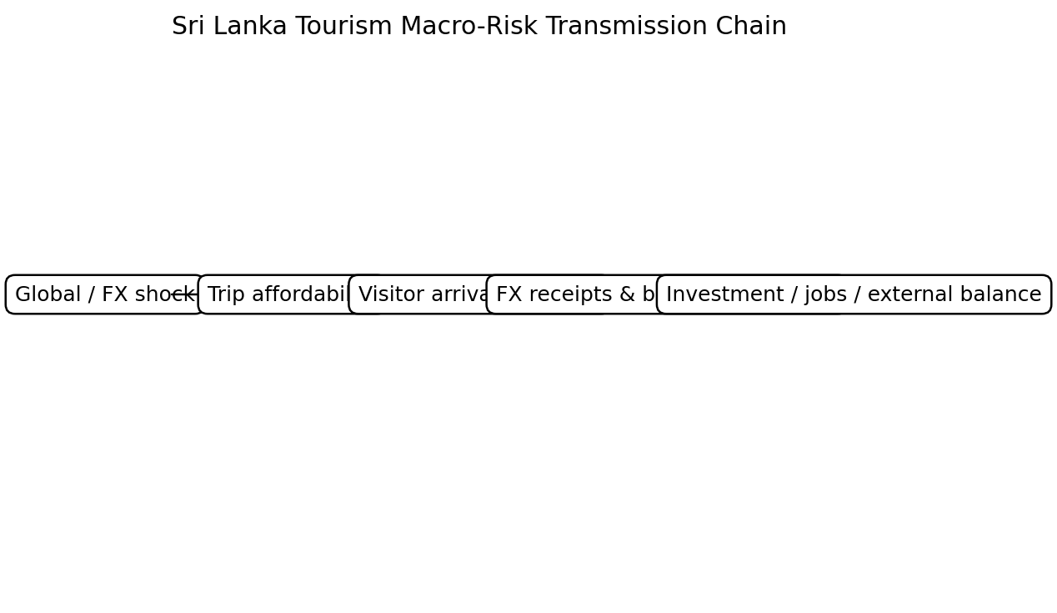
Figure 2. Simplified feedback loop linking international tourism demand to firm performance and the external economy.

Scenario Planning and Decision Triggers
A practical resilience plan uses a small number of scenarios rather than one point forecast. In a “stable recovery” case, arrivals grow, inflation stays contained and the currency is relatively stable; firms can focus on productivity and selective expansion. In a “currency shock” case, depreciation improves visitor affordability but raises imported costs; pricing and procurement controls become the priority. In a “global slowdown” case, origin-market income falls; marketing shifts toward closer or more resilient markets and capital spending is delayed.
Each scenario should have quantitative triggers. Examples include a specified fall in forward bookings, a rise in food or energy cost, a change in the real exchange rate, or a minimum liquidity ratio. Trigger-based plans reduce slow decision-making during a shock because actions are agreed in advance. They also prevent managers from overreacting to ordinary weekly volatility.
Finally, risk management should be integrated with sustainability. Energy efficiency, water management, local sourcing and workforce retention can reduce exposure to imported costs while improving destination value. Investments that serve both environmental and financial resilience are particularly attractive because their benefits persist across macro scenarios.

Conclusion & Recommendations
Sri Lanka’s tourism rebound is closely linked to macroeconomic stabilisation. Rising arrivals and tourism receipts contribute foreign exchange, employment and service-sector demand, while improved reserves, lower inflation and greater policy stability make the country easier to operate in and visit. Yet tourism remains exposed to exchange-rate volatility, origin-market income, financing costs and external shocks. A weaker currency can support competitiveness, but the benefit is reduced when volatility, inflation or imported costs rise.
The 2025 arrival total of more than 2.36 million demonstrates strong recovery momentum, but strategy should focus on resilience rather than extrapolating one year of growth. DMOs should diversify origin markets, track real rather than nominal price competitiveness, monitor visitor yield and support regional value creation. Hotels and operators should map currency exposure, protect liquidity, stagger refinancing, strengthen supply chains and use scenario triggers. By treating tourism as both an export sector and a local business ecosystem, Sri Lanka can convert recovery into a more stable source of foreign exchange and income while reducing vulnerability to the next currency or business-cycle shock.

References
Adeleye, B. N., Adam, L. S., Ahmad, P., & Ola-David, O. (2025). Investigating tourism and exchange rate dynamics on economic growth in Sri Lanka. Journal of Policy Research in Tourism, Leisure and Events, 17(1), 155–171. https://doi.org/10.1080/19407963.2022.2130343
Adeleye, B. N., Musbahu, H. O., Abdulkareem, H. K. K., & Kanwal, A. (2023). Growth-led tourism and the role of exchange rate: Empirical evidence from Sri Lanka. Tourism, 71(3), 600–617. https://doi.org/10.37741/t.71.3.11
Asian Development Bank. (2025). Sri Lanka’s growth recovery exceeded expectations but remains fragile. Asian Development Bank.
Central Bank of Sri Lanka. (2026). Annual economic review 2025. https://www.cbsl.gov.lk/
International Monetary Fund. (2025). Sri Lanka: Fourth review under the Extended Fund Facility arrangement (IMF Country Report No. 25/162). International Monetary Fund.
Rathnayake, G. I. (2018). Effect of exchange rate volatility on Sri Lanka’s inbound tourist flow. Staff Studies, 48(2), 41–81. https://doi.org/10.4038/ss.v48i2.4712
Rookayyah, I., Seetanah, B., Nunkoo, R., & Jaffur, Z. K. (2024). The impact of exchange rate and exchange rate volatility on tourism demand using disaggregated data. International Journal of Tourism Research, 26(2), e2640. https://doi.org/10.1002/jtr.2640
Sri Lanka Tourism Development Authority. (2026). Monthly tourist arrivals reports 2025 and annual summary. https://www.sltda.gov.lk/
World Bank. (2025). Sri Lanka development update 2025. World Bank.

Appendices
Appendix A. 2025 monthly tourist arrivals used in Figure 1 (Jan–Dec): 252,761; 240,217; 229,298; 174,608; 132,919; 138,241; 200,244; 198,235; 158,971; 165,193; 212,906; 258,928. Annual total: 2,362,521 (SLTDA, 2026).
Appendix B. The risk framework uses scenario analysis rather than an exchange-rate forecast. Its purpose is to identify management actions that remain useful across multiple macroeconomic outcomes.

