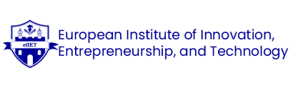

Talent Pipeline for Sustainable Eco-Lodge Ventures

Student Name :Vivek
Student ID: DE240014
Date: 28th of may
2nd semester : Prof. Mr Vaibhav Sai Sri

Table of Contents

Introduction 3
Context: Eco-Tourism and Talent in Germany 3
Talent Pipeline Framework 5
Sample Talent Development Materials 6
Onboarding Content 6
Employee Engagement Survey (Sample Questions) 7
Mentorship Plan 7
DEI and Green Tourism Integration 8
Incentive and Retention Programs 8
Conclusion 9
References 10

Introduction
Eco-lodges in Germany are contributing to a bigger effort in sustainable tourism that matches what travellers want nowadays. Climate change and more informed tourism have inspired Germany to grow nature-based tourism across its national parks and protected areas. By focusing on green systems, culture, education, and the environment, eco-lodges support the mission of sustainable tourism around the world (Badr, 2022).
If local talent is involved, the venture is sure to stay authentic, be successful, and last for many years. The use of residents in these fields improves community life, supports local businesses, and ensures that the services respect the community’s culture, traditions, and environmental measures. The use of the local workforce, especially where industry has declined, aids in preserving nature, which naturally supports the eco-tourism movement. Cooperation among people in local areas supports the lasting protection of Germany’s nature and culture (Lapotulo & Amalia, 2024).
This report’s goal is to establish a talent pipeline that meets cultural preferences and supports sustainability for eco-lodge businesses in Germany. The objective is to put in place a complete plan that supports local employees in playing a useful role in green hospitality. This process includes making training that stresses environmental responsibility, connecting with vocational schools and groups dedicated to sustainability, building onboarding that highlights positive values, and starting team engagement initiatives such as asking for input from workers and starting mentorship programs. One important piece of the pipeline is to add diversity, equity, and inclusion (DEI) so that rural youth, migrants, and women get equitable opportunities. In turn, the strategy encourages ecologically friendly travel and helps everyone take part in Germany’s eco-tourism activities.

Context: Eco-Tourism and Talent in Germany
There has been a rapid increase in eco-tourism in Germany because of a wider effort to focus on climate and sustainability across Europe and Germany. Owing to many nature parks, UNESCO biosphere reserves, and effective environmental laws, Germany is now a favourite destination for those seeking green hospitality. People traveling now try to choose hotels that make use of renewable sources, reflect local customs, and practice low-impact methods. Here, eco-lodges are important for rest and also act as ways to educate, protect the environment, and get communities involved (Daneshwar & Revaty, 2024).

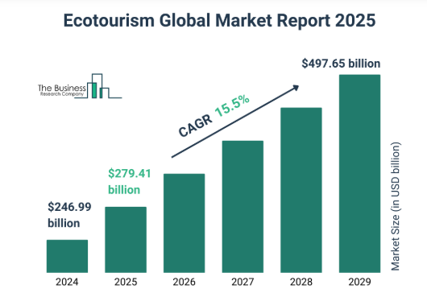
Figure 1: Ecotourism Global Market Report
Source: (The Business Research Company, n.d.)
Strong demand is matched by significant difficulties for the sector. Across Germany’s hospitality sector, there is growing worry about finding enough staff, especially in rural places where eco-lodges are often found. Finding the people needed for sustainable operations is hard unless there are designed local efforts, relevant training courses, and clear paths for career advancement. Managing environmental practices that match what a business promises has been difficult for many because it requires considerable investment or changing corporate habits (Abul, 2024).
Another issue is fitting into the company’s sustainability goals. Although many in hospitality agree with sustainability in theory, having detailed knowledge or clear guidelines isn’t always easy for them. Small eco-lodge companies don’t usually have adequate money or staff to train everyone in sustainability, which leads to irregular guest stays and unloved workplaces (Yoo, 2024).
Even so, there are many significant prospects. Germany has the potential to profit from such EU green incentives as tax reductions for green building and staff subsidies for eco-training. Youth today in Germany, particularly from Generation Z, are paying more attention to careers that are environmentally friendly. To many, sustainability is both important and something they focus on at work. Newer employees in employment may like holding higher positions, however, they want decisions that protect the environment and for their employers to stand for the same (Nižić & Butković, 2023).
Overall, facing some logistical and staffing issues, the combination of what locals need, government support, and young interest offers a stable base for constructing a local talent pipeline.

Talent Pipeline Framework
The first step in a sustainable eco-lodge talent pipeline in Germany is a careful plan to hire from local areas and educational institutions. Since eco-lodges are found in both rural and environmentally connected locations, efforts to expand should be targeted at local high schools, universities with sustainability or hospitality courses, and environmental NGOs. When the community is involved, more employment becomes available to rural people, and the company’s attention to the environment begins from the recruitment stage. GHRM methods have succeeded in attracting candidates who share an interest in the environment and matching human resource practices with the goals of sustainability (Sitohang et al., 2024).
As soon as talented personnel are recruited, solid and customized training programs are important. You should ensure that these practices start with being environmentally responsible, including sustainability certifications, saving energy in housekeeping, offering greener food, and involving guests in sustainability matters. Knowledge about waste and green energy systems is vital too, because eco-lodges must be very eco-friendly. All employees should learn to control waste, run solar-powered systems, and keep track of water usage.
What stands out in this framework is the emphasis on cultural competence. Being culturally aware and knowledgeable about the environment helps staff make guest experiences that respect the place and the community. Workers ought to be able to discuss the local area’s past, wildlife, and efforts to protect nature in a way that benefits and encourages people who care about the environment. Testing this training model suggests that it helps employees enhance the quality of their services and become more environmentally focused within the organization (Yoo, 2024).
For people to remain engaged in the company, the pipeline needs to provide planned progress from starting roles up to leadership. As an example, individuals starting at Jetwing Natural may work as eco-hosts or green stewards and move on to become Sustainability Coordinators, Environmental Education Officers, or Eco-Lodge Managers. Every part of the process needs mentorship, small credentials (carbon auditors or ecotourism specialists), and motivating rewards for eco-friendly work. Hospitality employees tend to remain and feel more satisfied at work when green HR programs provide incentives for environmentally conscious actions (Palupiningtyas et al., 2024).
Besides, making environmental goals a part of HR activities can be done daily, from hiring to awards. As such, every job should list what is required on the environmental side, and when reviewing performance, looking at how much energy is being used is important. Integrating sustainability in key HR roles helps develop a common idea and treats caring for the environment as something important to everyone in the organization (Suleman et al., 2025).
In short, the proposed framework includes local events, training focused on sustainability, integration with local culture, and career advancement to create a reliable, motivated, and eco-aware staff for the country’s eco-lodges. Thanks to this approach, not only do operations improve, but the hotel also meets national and European sustainability criteria, offering guests real green experiences.

Sample Talent Development Materials

Onboarding Content
Good onboarding is key in the green hospitality industry. Having a good onboarding program helps establish the expectations for environmentally friendly actions and supports the community. From the start of a project, companies should talk about sustainability since it leads to early acceptance and increases environmentally friendly habits (Sitohang et al., 2024).
Sample Welcome Email:
Subject: Welcome to EcoLodge in Bavaria – Let’s Work Together for a Greener World!
“Dear [Employee’s Name],
We’re pleased to have you on the team! It isn’t just a hotel; EcoLodge Bavaria is all about people who care about sustainability. What you do here helps us ensure that Germany’s nature is protected and that our guests have amazing trips. We’re thrilled that you’ll be part of making hospitality greener and positively affecting your community.”
Orientation Document Excerpt:
“Running the EcoLodge based on sustainability is our main aim. You’ll learn about renewable systems, saving water, and the history of your region. We motivate you to talk about your development, keep learning new things, and participate in your community.”
The approach fosters teamwork by having staff members work toward environmental goals that matter to them (Palupiningtyas et al., 2024).

Employee Engagement Survey (Sample Questions)
People are reminded about green culture, while gaps in learning or support are also noted. Asking the right questions allows individual actions to line up with the organization's sustainability targets (Vovk & Vovk, 2024).
Sample Questions:
- How comfortable are you in answering guest questions about our sustainability practices?
- Are you able to take action to reduce wasting resources every day?
- How well do you think your company helps you stay mentally and physically healthy while working?
- What feedback do you have about how we implement green operations on-site?
The results of these surveys can be used to judge the success of training and make improvements to future approaches (Vovk & Vovk, 2024).

Mentorship Plan
To be sustainable, a workforce needs to be meaningful to all people from various cultures. Mentorship spanning cultures can close the knowledge gap, reduce the stress of training, and bring employees together towards a common purpose. Green HR puts a strong focus on relationship-building to pass on the values of sustainability (Yoo, 2024).
Mentorship Plan Overview:
Refugees and EU migrants who join the company are matched with veteran German employees for a six-month mentoring period. Each month, group members come together and talk about how to be more sustainable, the challenges in guest service, and what people from other countries value.
Mentors will help with tasks as well as assist with being part of the community and explaining the environmental responsibilities of the lodge. Using this model helps to keep employees longer and supports an environmentally friendly and all-inclusive culture.

DEI and Green Tourism Integration
Putting diversity, equity, and inclusion (DEI) practices into eco-tourism initiatives ensures that both ethics and reliability are built into how the hospitality industry operates. German companies work to ensure that people from many backgrounds, genders, and abilities are included in their recruiting and on-the-job learning. Based on research, hospitality organizations can make inclusion truly meaningful by including DEI when designing jobs, hiring staff, and developing performance (Adegbite, 2024).
In addition to being inclusive, tourism should concentrate on regenerative tourism, which tries to repair the environment and empower people living nearby. When workforce development follows sustainable values, hotels are inspired to invest in cultural training and become leaders in sustainability (Russen & Dawson, 2023).
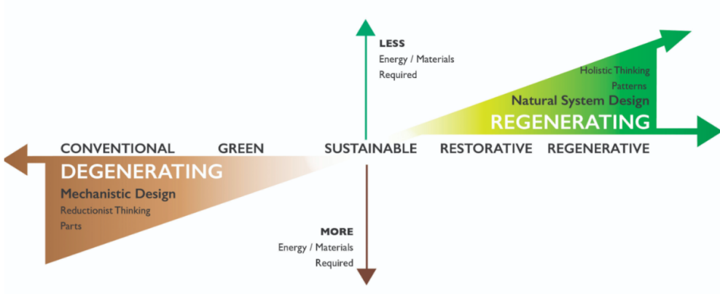
Figure 2: Features of Regenerative Tourism Compared to Normal and Sustainable Tourism
Source: (CBI Ministry of Foreign Affairs, 2022)
If eco-lodges want to support more people, they could give rural, older, or migrant residents flexible hours, help them learn the language through community guidance, and hire them temporarily. They promote staff loyalty and ensure the company’s social health over time. Having diverse and supportive staff members represents regenerative tourism’s values and helps build cultural ties with people from both the local community and the guest list.

Incentive and Retention Programs
To retain skilled people in green hospitality, incentive programs are very important. Green bonuses can be used to encourage employees in eco-lodges to do better at preserving the environment by cutting down on waste, energy, and other resources. According to studies, when companies recognize employees for their green actions, their workers become more motivated to support the environment (Abedelrahim et al., 2024).
Transportation assistance can play a big role, mainly for workers who have to travel from rural locations to their job. It helps employees attend work more often, reduces our carbon impact, and increases access.
Beyond all this, giving out accomplishments like certificates for gaining the Green Key or EU Ecolabel prompts workers to keep learning and growing professionally. It helps increase team pride, keeps employees with the brand, and results in better customer service and ongoing brand growth. According to Dias et al. (2024), adding certification schemes to incentives can encourage more employee participation at work.

Conclusion
Safeguarding a long-term supply of skilled workers is very important for matching tourism progress with eco-friendly and community objectives in Germany. By using local employment, offering environmentally friendly education, encouraging equality when hiring, and setting work progression clearly, eco-lodges form a reliable group of employees. Promoting diversity, giving staff reasons to stay, and encouraging regenerative values are all ways to boost the long-term effects of such organizations. Such coordination helps eco-lodges do well and also supports Germany’s positive role in sustainable community tourism.

References
Abedelrahim, S., Amal Abdulmajeed Qassim, & Fatmah Mohmmed H. Alatawi. (2024). Green Practices in Action: Examining HRM’s Role in Fostering Environmental Performance in Egypt’s Hospitality Sector. Sustainability, 16(8), 3314–3314. https://doi.org/10.3390/su16083314
Abul, M. (2024). Navigating Sustainability In the Tourism and Hospitality Industry: Transformation Under the Influence of Climatic Challenges. SocioEconomic Challenges, 8(4), 112–120. https://doi.org/10.61093/sec.8(4).112-120.2024
Adegbite, A. O. (2024). Diversity, Equity, And Inclusion In Workforce Training: From Concept To Implementation. IOSR Journal of Humanities and Social Science, 29(12), 30–37. https://doi.org/10.9790/0837-2912093037
Badr, M. E. (2022). Challenges and Future of the development of sustainable ecotourism. International Journal of Modern Agriculture and Environment, 2(2), 54–72. https://doi.org/10.21608/ijmae.2023.214937.1006
CBI Ministry of Foreign Affairs. (2022). Regenerative tourism: Moving beyond Sustainable and Responsible Tourism | CBI. Www.cbi.eu. https://www.cbi.eu/market-information/tourism/regenerative-tourism
Daneshwar & Revaty. (2024). A Paradigm Shift towards Environmental Responsibility in Sustainable Green Tourism and Hospitality. International Journal of Social Science and Human Research, 7(05). https://doi.org/10.47191/ijsshr/v7-i05-33
Dias, F., Lavaredas, A. M., & Esteves, P. (2024). What Is the Value of an Environmental Certification Label in Tourism Industry? Is It Worth the Effort? Sustainability, 16(19), 8587–8587. https://doi.org/10.3390/su16198587
Lapotulo, N., & Amalia, F. R. (2024). Sustainable Tourism Post-Pandemic: Strategies for Reviving Local Economies Through Eco-Friendly Practices. International Journal of Social and Human, 1(2). https://doi.org/10.59613/pfyc3y34
Nižić, M. K., & Butković, I. (2023). CAN GENERATION Z IMPLEMENT SUSTAINABLE DEVELOPMENT IN TOURISM? Tourism in South East Europe .../Tourism in Southern and Eastern Europe. https://doi.org/10.20867/tosee.07.16
Palupiningtyas, D., Retno Mulatsih, Sulistyowati, & Andar Sri Sumantri. (2024). The Role Of Green HRM In Talent Management Development To Improve Employee Performance In Hospitality Companies. International Journal of Economics and Management Research, 3(1), 246–252. https://doi.org/10.55606/ijemr.v3i1.185
Russen, M., & Dawson, M. (2023). Which should come first? Examining diversity, equity and inclusion. International Journal of Contemporary Hospitality Management, 36(1), 25–40. https://doi.org/10.1108/ijchm-09-2022-1184
Sitohang, A. M. D., Absah, Y., Harahap, H., & Sibarani, R. (2024). The role of green human resource management in promoting sustainable tourism practices. E3S Web of Conferences, 577, 02013. https://doi.org/10.1051/e3sconf/202457702013
Suleman, A.-R., Nejati, M., Shafaei, A., & Redmond, J. (2025). Green human resource management practices in the hospitality and tourism industry: An integrative multilevel systematic review. Journal of Hospitality and Tourism Management, 62, 46–56. https://doi.org/10.1016/j.jhtm.2024.12.009
The Business Research Company. (n.d.). Ecotourism Market Analysis, Size And Trends Global Forecast To 2022-2030. Www.thebusinessresearchcompany.com. https://www.thebusinessresearchcompany.com/report/ecotourism-global-market-report
Vovk, I., & Vovk, Y. (2024). Sustainable personnel management in the hospitality industry: Enhancing organizational performance through employee engagement and commitment. Economics, Management and Sustainability, 9(2), 44–58. https://doi.org/10.14254/jems.2024.9-2.4
Yoo, D. Y. (2024). Eco-Leadership in Action: Integrating Green HRM and the New Ecological Paradigm to Foster Organizational Commitment and Environmental Citizenship in the Hospitality Industry. Sustainability, 16(20), 9044–9044. https://doi.org/10.3390/su16209044

