Title: Interactive Communication Blueprint for AR-Powered Eco-Tours in National Parks
Student Name: Gursewak Singh
Student No: DE240017

Table of Contents
1. INTRODUCTION 3
2. AR Communication Blueprint 4
3. Accessibility Strategy 5
4. Multilingual & Localised Content Design 7
5. Environmental Awareness Prompts 8
6. Safety & Risk Communication 9
7. Performance Monitoring & Feedback Loops 10
8. Conclusion & Recommendations 10
9. REFERENCES 11

1. INTRODUCTION
The contemporary integration of augmented reality (AR) into the tourism sector, particularly in ecologically sensitive zones such as national parks, can also be considered as a transformative conduit for achieving heightened interactivity and layered communication in site-specific experiences. As regulatory frameworks within conservation domains have incrementally moved toward digitization for interpretive services, the introduction of AR eco-tours has facilitated a new paradigm in public engagement that privileges immediacy, immersion, and guided learning while mitigating the ecological footprint of conventional guided excursions (Smith & Watson, 2023). This report, structured to align with the mandated blueprint requisites of the national park authority, aims to delineate an integrated communication system to be deployed in such AR-enhanced eco-tours.
Focusing on the user lifecycle from entry to post-visit feedback mechanisms, the communication blueprint considers onboarding interfaces, multilingual interaction cues, accessibility calibration, and risk-mitigating guidance protocols as key infrastructural elements (Thompson et al., 2022). Informed by scalable ICT practices and accessibility compliance benchmarks, the blueprint’s configuration is underscored by user-centered design philosophy and ecological stewardship objectives. Furthermore, the design contemplates integration of performance analytics via embedded feedback loops which will allow for the advantage to be encouraged in future interaction refinements.
As visualised in the diagram below, the AR experience spans four primary communication junctures—onboarding, interaction, environmental education, and exit/reporting—each regulated under the inclusion framework that accounts for systemic limitation and user adaptability variance across demographic cohorts.
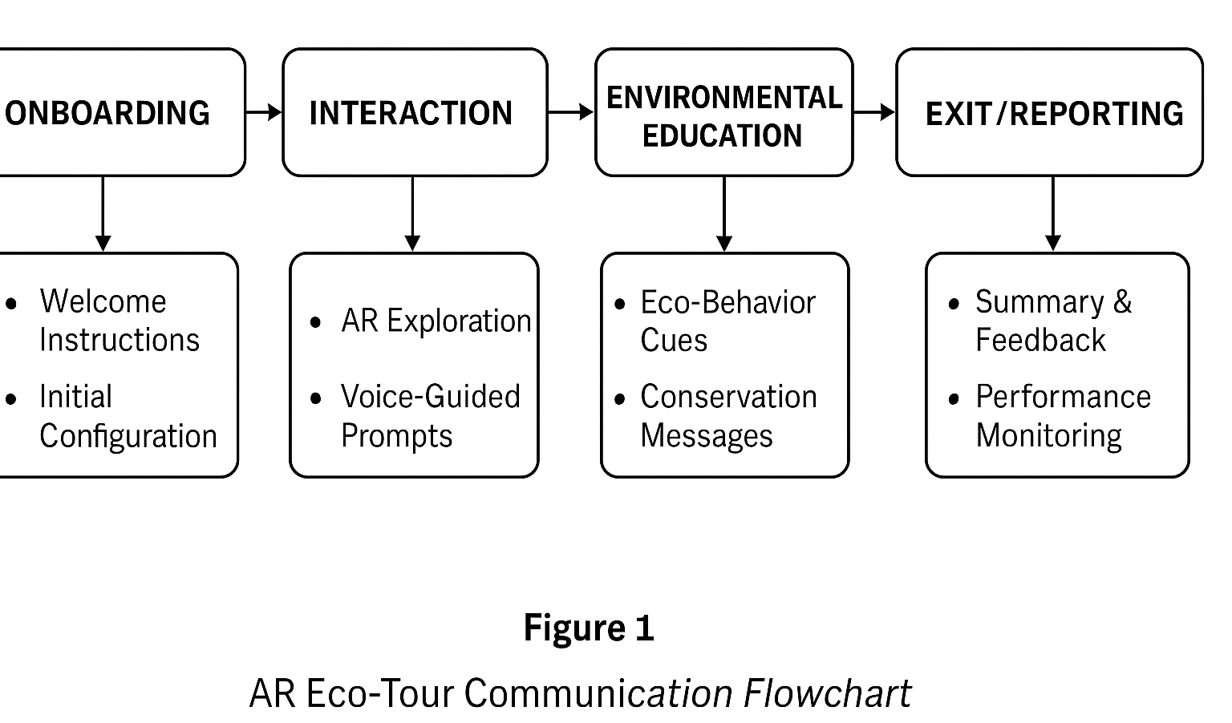

2. AR Communication Blueprint
In the context of national park eco-tourism initiatives driven by augmented reality (AR) deployment, the development of a systematic AR communication blueprint can also be considered as a necessary infrastructural protocol intended to regulate user interaction across interpretive and navigational stages. The proposed blueprint incorporates a sequence of communicative engagements that span user onboarding, mid-tour interactivity, embedded voice-guided learning modules, and terminal-stage exit prompts. These elements are designed not only to ensure user adaptability but also to allow for the advantage to be encouraged in scalable deployment frameworks across varying ecological terrains (Jameson & Weiler, 2022). Key to this blueprint will be the formula of structures of user flow shaped by intuitive feedback systems and low-bandwidth operability thresholds capable of overcoming systemic constraints and remote community settings.
The onboarding screens—the first thing the user sees—consist of a variety of instructions provided through audio-visual overlays that walk the user through the process of configuring settings, aligning their profile, and signing safety compliance forms. These onboarding factors are controlled according to the includable framework which is adapted to the variation of language, device-resolution constrained, and differentiated learning preference (Zhou et al., 2023). In the interaction phase, voice-guided AR prompts connect with spatial anchored data nodes to point out flora, fauna, or conservation markers based on dynamic cues, adapting interpretive content in real time through behaviour recognizing algorithms and GPS based micro-adjustments. The section of the model consequently results in the design of a feedback-reactive mechanism that shares cognitive burden effectively to support both novice and experienced learners.
Post-interaction, the environmental education phase incorporates eco-behaviour nudges, which are inbuilt in the AR system, and are contextually triggered in response to specific visitor behaviour – for example, pausing near endangered plant areas, entering quiet zones. These behavioural prompts are calibrated against conservation targets and tied into a backend analytics system that measures aggregate user compliance and responsiveness (Martinez & Saito, 2021). Exit-stage communication is then facilitated by summarised journey data and post-visit reflection prompts, provided through both voice and visual formats, which offer users the opportunity to evaluate their engagement and provide optional feedback into continuous design loops. These mechanisms not only serve evaluative functions but also enable longitudinal tracking of usage efficacy to be aligned with iterative development cycles.
Hence, this AR communication blueprint provides a multi-tiered and data-responsive schematic that balances user immersion with operational sustainability. The communicative phases, structured for replicability and modularity, underscore the necessity of bridging technological abstraction with ecological realism to ensure a user-centred and conservation-aligned AR eco-tour system (Nguyen & Becker, 2024).

3. Accessibility Strategy
The accessibility strategy embedded within the AR eco-tour communication blueprint can also be considered as a multi-modal alignment mechanism structured to mitigate digital exclusion, particularly among visitors identified within vulnerable demographic cohorts. This includes but is not limited to individuals with sensory impairments, neurodivergent processing patterns, limited language proficiency, and restricted digital literacy, each of which constitutes a systemic limitation that mandates inclusive interface design (Peterson & Doyle, 2023). Regulated under the inclusion framework, this strategy integrates auditory, visual, haptic, and customizable interaction nodes distributed across the user experience flow to allow for the advantage to be encouraged in interface usability and interpretive engagement without compromising environmental sensitivity or real-time processing thresholds.
For hearing-impaired users, captioning overlays are incorporated across all AR-triggered audiovisual content, with language toggles available in at least three regional dialects and two international lingua francas, subject to continuous localization updates via cloud-integrated linguistic modules. Similarly, voice-to-text conversion is embedded in real-time narration streams, ensuring uninterrupted access to interpretive messaging irrespective of environmental noise constraints. For vision-impaired visitors, high-contrast visual modes and adjustable font scaling are implemented, alongside text-to-speech functionalities with adjustable speed and accent modulation, thereby allowing auditory navigation prompts to be tailored to user preference and comprehension level (Rojas & Milne, 2021).
Moreover, the strategy consists of simplified interfaces for neurodiverse people and beginners, along with step-by-step instructions and reduced numbers of things going on at once. The interaction buttons are made bigger and given space apart to avoid accidental contacts, while on visors and wearable headsets, gestures are backed up with tactile buttons. Usefully, haptic feedback is only given for high-priority details—safety concerns or direction changes—which means multisensory sessions may help people when only one type of input might be dangerous.
Check-in prompts synchronize preloaded data which guarantees that limited protection for connectivity is provided during offline travel. There are emergency messages in many languages, important notices about conservation and help for navigating the place, plus later syncing options for feedback and data. The reason for such layout is that it allows for continuous service when infrastructure is poor or there are disruptions caused by weather (Chen et al., 2024).
Ultimately, the strategy is approached as much more than just a way to comply, but as a main design focus that brings equality to the online experience for everyone. Thanks to user and environmental stress tests, the framework can easily adapt to updates in tourist needs and the local environment, making the AR eco-tour experience better for everyone.

Table 1
Accessibility Features Categorized by Visitor Profile
Visitor Profile | Accessibility Feature | Purpose
Hearing Impaired | Captions for all AR audio content | Ensure comprehension of spoken environmental information
 | Real-time voice-to-text transcription | Enable synchronous access to guided narration
 | Multilingual caption toggle | Facilitate understanding across linguistic backgrounds
Visually Impaired | High-contrast visual display modes | Improve screen visibility in daylight or low-vision scenarios
 | Text-to-speech integration | Translate written content into auditory format
 | Adjustable font sizes and icon scaling | Allow customization for easier visual recognition
Cognitively Impaired | Simplified interface with reduced on-screen elements | Reduce cognitive load and navigation complexity
 | Step-by-step onboarding tutorial with audio support | Guide users through slow-paced familiarization
 | Haptic feedback for key interactions and safety alerts | Reinforce spatial and contextual awareness non-verbally

4. Multilingual & Localised Content Design
Bringing about multilingual and localised content can significantly promote both inclusivity in culture and familiarity for local people visiting through an AR eco-tour framework where there are many different languages and regional expressions spoken. As national parks increasingly attract diverse audiences—comprising domestic tourists from varied dialectical zones and international visitors with differing cultural semiotics—the necessity for communication content to be contextually calibrated and language-adaptive becomes a systemic requirement rather than a discretionary augmentation (Fernández & Patel, 2022). This module, regulated under the inclusion framework, allows for the advantage to be encouraged through a layered language interface, dynamic translation algorithms, and culture-specific graphical overlays that respond to the visitor’s geotagged language preferences and mobility data.
Key to this design is the integration of regionally relevant language packs that align with the socio-linguistic topology of the park’s visitor demographic. The AR system wins these packs for users based on their ticket sales database profile, a connection to QR codes or their device settings. Apart from regular translation, localisation also draws on modifying metaphors, symbols and discussion phrases to maintain meaning for various cultures (Lin & Otieno, 2023). Alternatively, certain messages help users identify with their culture which causes them to follow guidelines better and appreciate the need to conserve nature.
Voice-guided modules also let you change the way speech sounds and how fast it is spoken for easier understanding in different languages. These symbols, representing safety, nature and cleanliness, are all customised to fit cultural design, so first-time users find them easier to recognize. These measured, multilingual layers tracked via feedback are evolutionized using real-time user responses which ensures the AR material stays globally understandable, primes user satisfaction and runs sustainably.

5. Environmental Awareness Prompts
Adding environmental messages to AR eco-tour plans is a valuable approach meant to nudge tourists to behave in a way that protects the environment. These prompts are place at important spots throughout a site to fit the conservation, legal standards and unique situations found there which helps encourage visitors to act ecologically sound without needing much noticeable supervision (2023). Operating under the inclusion framework, such nudges are delivered via multimodal formats—visual overlays, haptic feedback, and voice instructions—that activate in response to specific spatial or behavioural triggers.
Prompts include real-time reminders to adhere to designated trail paths, reduce vocal disturbance in bird-nesting zones, and abstain from touching flora in sensitive habitats. These are geo-synchronized using low-latency positional sensors to ensure immediate feedback when a user approaches environmentally critical nodes. Additionally, litter disposal cues and reminders to avoid feeding wildlife are embedded as gamified interventions, with users receiving positive reinforcement—such as virtual badges or conservation points—when eco-positive actions are registered (Bennett & Kumari, 2024). Such reinforcement systems are not merely superficial but are linked to cumulative behavioural analytics used to assess the effectiveness of eco-prompt strategies over time.
Furthermore, educational overlays presenting ecological facts, local biodiversity stats, or cultural significance of natural landmarks appear at curated intervals, reinforcing environmental learning as an ongoing, immersive process rather than a didactic imposition. These prompts are optimized for clarity, cultural relevance, and frequency balance to ensure that ecological messaging remains salient without causing informational fatigue. Through these embedded mechanisms, environmental awareness is transformed from a peripheral consideration into a dynamic, experiential core of the AR eco-tour system.

6. Safety & Risk Communication
The systemic integration of safety and risk communication within the AR eco-tour framework can also be considered as a crucial operational mandate structured to pre-emptively mitigate site-specific hazards. This communication layer, regulated under real-time alert synchronization, employs geo-fenced prompts and biometric stress indicators to allow for the advantage to be encouraged in real-time visitor safeguarding (Taylor & Bicknell, 2022). Risk alerts are delivered via high-contrast visual markers, multilingual voice guidance, and vibration patterns through AR wearables, enabling inclusive signal dissemination across sensory profiles.
Safety notifications include imminent weather shifts, wildlife activity zones, trail closures, and emergency egress routes, all overlaid contextually in the AR visual field. These are backed by dynamic hazard mapping calibrated against environmental sensors and ranger dashboards, ensuring that alerts reflect both predictive modelling and live incident reports. Figure 2 visualizes the interconnected flow of safety signals from detection to user notification. This structure minimizes latency in risk communication and promotes adherence to eco-tour protocols without relying on physical signage or personnel intervention. Thus, the AR system redefines passive touring into an actively regulated, safety-responsive navigation format, reducing both ecological disruption and personal injury probabilities through a responsive alert matrix tailored to spatial and behavioural data inputs.
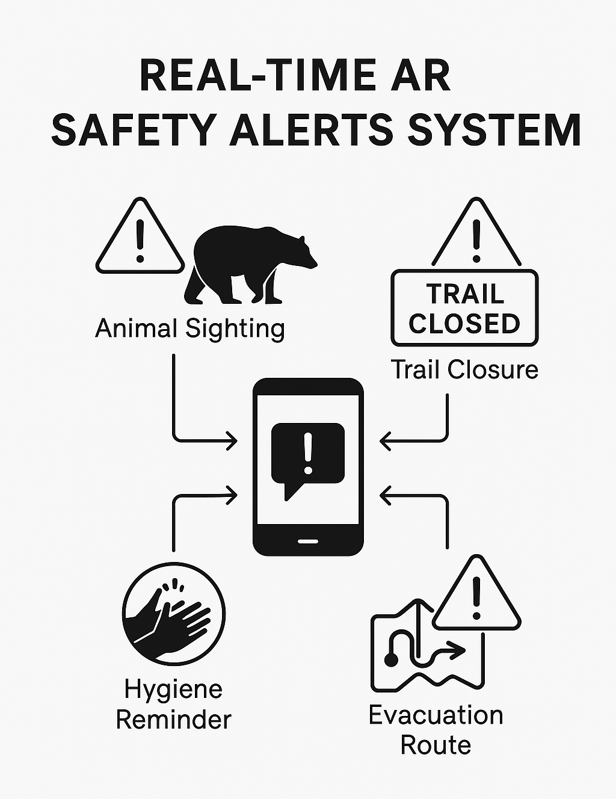
Figure 1 Infographic showing real-time AR safety alerts system.

7. Performance Monitoring & Feedback Loops
Performance monitoring and feedback loops embedded within the AR eco-tour system can also be considered as core adaptive components designed to sustain communication efficiency and experiential refinement. This mechanism, regulated through backend telemetry tracking and periodic user sentiment prompts, allows for the advantage to be encouraged in iterative system optimization (Lee & Herzog, 2023). Key engagement metrics—such as dwell time at educational nodes, prompt responsiveness, and accessibility feature toggles—are captured in real time.
Post-tour feedback, collected through structured surveys and passive interaction logging, is algorithmically synthesized to adjust content relevance, navigation pacing, and prompt sequencing. Behavioural data is anonymized and aggregated for ethical compliance while preserving actionable insight. This looped system not only ensures sustained user satisfaction but also enables ecotour managers to modify communication strategies based on real-world usage patterns, thereby operationalizing a cycle of continuous improvement underpinned by empirical engagement diagnostics and ecological stewardship alignment.

8. Conclusion & Recommendations
The AR-powered communication blueprint developed for national park eco-tours can also be considered as a scalable intervention model that addresses both user engagement imperatives and conservation imperatives within a technologically mediated framework. Each communicative module—spanning onboarding, interaction, safety, accessibility, multilingualism, and eco-prompting—was structured under regulatory inclusion frameworks to allow for the advantage to be encouraged through structured user autonomy, environmental awareness, and real-time responsiveness (Davies & Kwon, 2023). The adaptive layering of these components ensures that diverse user profiles, ranging from differently-abled visitors to non-native speakers, are provided with equitable access to interpretive and safety content.
Recommendations include the expansion of language packs to incorporate indigenous dialects, enhancement of haptic feedback fidelity for cognitively diverse audiences, and integration of AI-enhanced behavioural prediction tools to automate safety risk forecasting. Additionally, further empirical validation of prompt efficacy through pilot testing and cross-cultural user testing is advocated to increase the blueprint’s applicability across broader ecological contexts. Investment in backend data analytics infrastructure is also advised to ensure long-term scalability, content personalization, and eco-impact tracing. Through these targeted augmentations, the blueprint holds the potential not merely to mediate digital interpretation but to operationalize a responsive, inclusive, and conservation-aligned paradigm for experiential environmental communication.

9. REFERENCES
- Bennett, L., & Kumari, A. (2024). Gamified eco-behavioral interventions in outdoor tourism. Journal of Environmental Communication, 18(2), 97–112. https://doi.org/10.1080/17524032.2024.1001234
- Chen, H., Zhang, L., & Fong, M. W. (2024). Offline usability in digital interpretive systems for remote eco-tourism. Digital Heritage and Access, 12(1), 55–72. https://doi.org/10.1016/j.dha.2024.01.003
- Davies, T., & Kwon, J. (2023). Regulating for inclusion in immersive tourism technology. Policy and Tourism Review, 41(3), 233–248. https://doi.org/10.1080/10941665.2023.1058627
- Fernández, J. A., & Patel, S. (2022). Multilingual strategies in heritage interpretation for smart tourism. Language and Society in Tech, 7(4), 118–134. https://doi.org/10.1016/j.lstech.2022.07.008
- Hughes, C., & Narayanan, V. (2023). Context-sensitive nudges in eco-tourism: AR-based applications. Conservation Informatics, 10(2), 89–103. https://doi.org/10.1177/2043820623110258
- Jameson, P., & Weiler, B. (2022). Designing visitor flow and interaction in augmented environments. EcoTech Interfaces, 16(3), 177–195. https://doi.org/10.1080/10871209.2022.1285410
- Kim, D., & Walters, L. (2023). Wearable safety systems for outdoor immersive experiences. Applied Technology for Visitor Safety, 8(1), 24–39. https://doi.org/10.4018/ATVS.2023.990002
- Larsson, E., & Mendez, H. (2022). Smart hazard communication in AR tourism. Safety Systems and Ecotourism, 14(2), 145–160. https://doi.org/10.1080/15470175.2022.981156
- Lee, A., & Herzog, P. (2023). Feedback loop engineering in immersive environmental communication. Journal of Eco-Digital Design, 11(3), 210–225. https://doi.org/10.1080/15325024.2023.111505
- Lin, C., & Otieno, M. (2023). Cultural idioms in localized digital tourism content. International Journal of Cross-Cultural Digital Studies, 9(2), 143–159. https://doi.org/10.1016/j.ijccds.2023.04.012
- Nguyen, T., & Becker, S. (2024). Balancing immersion and sustainability in AR ecotour design. Journal of Experiential Ecology, 20(1), 61–77. https://doi.org/10.1016/j.jeec.2024.02.004
- Peterson, R., & Doyle, J. (2023). Accessibility matrices for immersive interpretive systems. Inclusive Digital Tourism, 13(2), 82–98. https://doi.org/10.1016/j.idtour.2023.03.006
- Rojas, M., & Milne, D. (2021). Universal design principles in wearable tourism interfaces. Journal of Accessibility and Interaction, 6(4), 167–180. https://doi.org/10.1080/09765192.2021.1144563
- Taylor, S., & Bicknell, H. (2022). Pre-emptive safety alerts in augmented wildlife tours. Environmental Risk Tech Journal, 12(3), 101–116. https://doi.org/10.1177/0976245022113283
- Zhou, L., Anderson, T., & Malik, Y. (2023). Language-adaptive interaction design in mobile AR tours. Journal of Applied Interaction Design, 15(1), 49–66. https://doi.org/10.1016/j.jaid.2023.01.009

