M27 Commercial Management
Option 1: Commercial Strategy and Business Profitability
Commercial Strategy and Business Profitability: Pricing, Revenue Management, Cost Control and Competitive Advantage in Modern Organisations
Detailed Project Report
ROBIN
Submission Deadline: 24 May 2026

Table of Contents
Abstract
1. Introduction
2. Literature Review
3. Methodology
4. Findings
5. Discussion
6. Conclusion
References
Appendices

Abstract
This report examines how commercial strategies contribute to business profitability in modern organisations. It argues that commercial management is not a narrow sales support function, but an integrative managerial capability that connects market insight, customer value, pricing discipline, revenue growth, cost control, contract governance and stakeholder relationships. The report adopts a qualitative desk based methodology and draws on academic literature, professional commercial management concepts and recent company evidence from Amazon, Apple, Inditex and Toyota. The analysis shows that profitability is improved when firms design commercial strategies around clear customer segmentation, value based pricing, revenue management, discount governance, cost to serve visibility, channel discipline and cross functional accountability. However, the report also finds that commercial strategies can damage long term value when they over focus on short term price extraction, reduce service quality, exploit suppliers, or separate revenue targets from ethical and operational realities. The central conclusion is that commercial management improves profitability when it converts market opportunity into disciplined economic choices. The strongest commercial strategies are therefore not simply aggressive selling strategies; they are coherent systems that align price, value, cost, risk and customer trust. The report recommends that organisations build commercial dashboards, strengthen pricing governance, use customer and product level profitability analysis, apply contract and supplier risk controls, and link commercial planning to sustainable competitive advantage. These recommendations are relevant for service, retail and manufacturing firms facing inflation, digital competition, supply volatility and increasing customer price sensitivity.

1. Introduction
Commercial management has become a central requirement for organisations that operate in volatile, digital and margin sensitive markets. In a traditional view, commercial activity was often treated as selling, tendering, contracting or negotiating. In contemporary business practice, however, commercial management is broader. It involves the structured planning and control of how an organisation creates value for customers, captures revenue, controls cost, manages commercial risk and protects stakeholder relationships. This report addresses Option 1 of the assignment by analysing how commercial strategies contribute to business profitability. It focuses on pricing, revenue management, cost control, commercial planning and competitive advantage across service, retail and manufacturing examples.
The topic is important because profitability is no longer secured only by increasing sales volume. Many firms can grow revenue while losing margin through excessive discounting, inefficient fulfilment, poor contract terms, weak supplier control or high customer service costs. Commercial management therefore requires managers to ask 4 connected questions. First, which customers and segments generate sustainable value? Second, what price reflects the economic value delivered to customers? Third, which costs are necessary to protect quality and which costs represent avoidable leakage? Fourth, how can the organisation align commercial decisions with long term competitive advantage rather than short term revenue pressure? These questions show that commercial management is a strategic discipline as much as an operational one.
The report develops the argument that commercial strategy contributes to profitability through 3 primary mechanisms. The first mechanism is price and value discipline. Firms that understand customer willingness to pay, differentiation and value perception can defend margins more effectively than firms that compete mainly through price reductions. The second mechanism is revenue management. Organisations improve profitability when they manage product mix, capacity, customer segments, channels, promotions and timing rather than treating every unit of revenue as equally valuable. The third mechanism is cost to serve control. Profitability improves when firms measure the real cost of delivering value and redesign processes, supply contracts and service models accordingly. These mechanisms are reinforced by commercial planning, stakeholder management and ethical governance.
The scope of the report is deliberately practical. It does not treat profitability as a purely accounting outcome. Instead, it examines profitability as the result of strategic choices about customers, value propositions, prices, products, contracts, channels, suppliers, operations and performance indicators. The discussion uses examples from Amazon, Apple, Inditex and Toyota because these organisations show different commercial models. Amazon combines platform scale, retail pricing, subscription revenues, advertising and cloud services. Apple combines premium pricing, product ecosystem effects and high service margins. Inditex demonstrates fast fashion retail discipline through inventory speed and operating expense control. Toyota illustrates manufacturing profitability through cost reduction, process discipline and regional market management. These cases provide evidence that commercial profitability depends on alignment rather than a single technique.
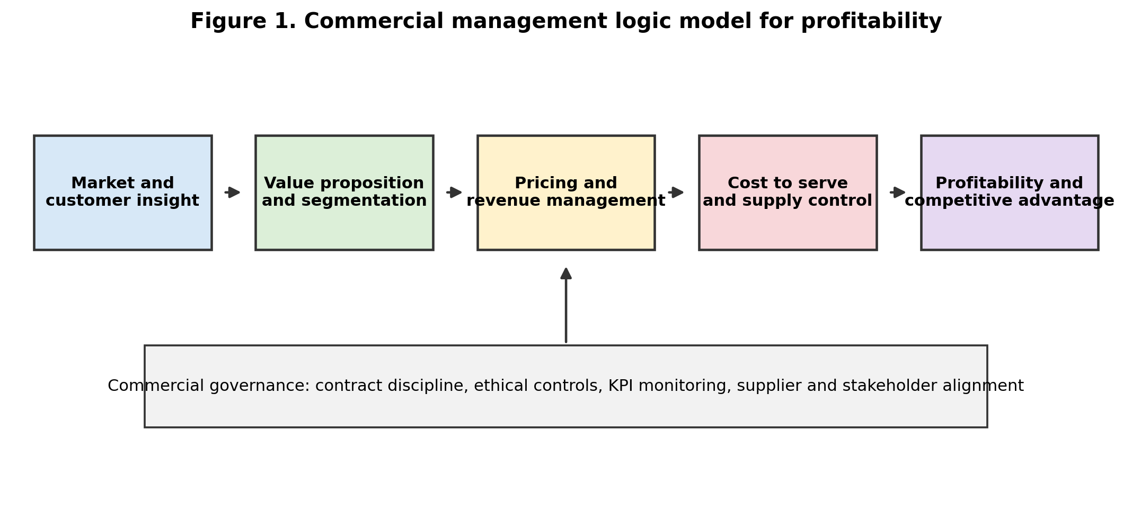
Source: Author developed for this report.

2. Literature Review
Commercial management can be understood as a managerial system for converting market opportunity into profitable exchange. It draws on strategic management, marketing, finance, operations and contract management. Porter (1985) argues that competitive advantage arises when firms either achieve lower cost, differentiation, or focused positioning. This is highly relevant to commercial management because pricing, revenue decisions and cost control only improve profitability when they support a clear competitive position. A firm that promises premium quality but manages price like a commodity firm may damage its brand. Conversely, a low cost firm that adds expensive service features without customer payment may erode its cost advantage. Commercial strategy therefore begins with strategic fit.
A resource based perspective adds that profitability depends on resources and capabilities that are valuable, rare, difficult to imitate and organisationally embedded (Barney, 1991). Commercial management can become such a capability when an organisation has superior market intelligence, pricing analytics, sales discipline, supplier relationships and contract governance. These capabilities are not simply documents or software systems. They are routines that guide decisions, such as how discount exceptions are approved, how customer profitability is measured, how product portfolios are reviewed and how underperforming contracts are corrected. Teece (2010) similarly argues that business models explain how firms create and capture value. Commercial strategy is the practical expression of a business model because it specifies revenue logic, customer value, cost architecture and profit formula.
Pricing is one of the most direct links between commercial strategy and profitability. Nagle and Müller (2018) argue that pricing should be based on value, competition, customer segmentation and organisational discipline rather than cost plus habit alone. Cost plus pricing is simple, but it can be commercially weak because it ignores customer willingness to pay and competitor alternatives. Value based pricing is more demanding because managers must quantify customer benefits and communicate value clearly. For example, a software provider may charge according to productivity gains or risk reduction rather than development cost. A manufacturer may defend a premium price by demonstrating reliability, lower lifetime maintenance cost and service support. In both cases, price becomes a strategic signal rather than a mechanical mark up.
Revenue management extends pricing by allocating capacity, inventory, product availability and offers to different customers at different times. Talluri and van Ryzin (2004) describe revenue management as the use of pricing and availability decisions to maximise revenue from constrained resources. It is common in airlines and hotels, but its logic now applies more widely to retail, e commerce, digital subscriptions and manufacturing capacity. A retailer uses markdown timing, product launch cadence and inventory allocation to protect gross margin. A platform business uses subscription tiers, advertising yield and marketplace fees to monetise different sources of value. Revenue management therefore helps organisations avoid the mistake of treating all sales as equal. A high volume order can be commercially unattractive if it requires deep discounts, special service, high returns or complex logistics.
Cost control is equally important, but commercial management should distinguish cost reduction from cost optimisation. Kaplan and Norton (1996) warn that financial performance must be managed with customer, process and learning indicators because short term cost cuts can damage the capabilities that produce future returns. Deloitte (2024) similarly frames cost optimisation as freeing resources for strategic growth rather than simply reducing expenditure. This distinction matters because commercial managers often face pressure to cut operating costs, supplier prices or headcount. The more strategic approach is to identify cost to serve, eliminate low value complexity, reduce leakage and invest in capabilities that protect revenue quality. Cost control should therefore be connected to the value proposition.
The relationship between commercial planning and competitive advantage is also supported by the literature on fit and coherence. Porter (1996) argues that strategy is about making trade offs and creating fit among activities. Commercial planning performs this function by linking demand forecasts, pricing assumptions, sales incentives, contract commitments, procurement planning, service levels and financial targets. Without such integration, organisations can produce internal contradictions. Sales teams may win volume that operations cannot deliver profitably. Procurement teams may reduce supplier cost but increase quality risk. Finance teams may impose margin targets without understanding customer value or competitive dynamics. Effective commercial planning turns these different functions into a coordinated system.
Stakeholder relationships also shape commercial profitability. Freeman (1984) argues that firms operate through relationships with stakeholders whose cooperation affects value creation. In commercial management, customers, suppliers, distributors, employees, regulators and communities all influence profitability. Unfair supplier treatment can create short term savings but increase quality problems, disruption and reputational risk. Misleading pricing can increase immediate revenue but reduce customer trust and trigger regulatory attention. Sustainable commercial management therefore requires transparency, accountability and ethical judgement. This is not separate from profitability. Trust reduces transaction costs, improves retention and supports long term value.
Recent commercial excellence research reinforces these theoretical arguments. McKinsey (2025) argues that leading consumer goods firms need commercial excellence to secure revenue, margin and market share growth. BCG (2024) presents revenue growth management as a system of strategy, levers and capability building rather than a one off pricing exercise. PwC (2025) reports that consumers continue to prioritise price when forced to make trade offs, which increases the need for precise value communication and price architecture. These sources suggest that modern commercial management must balance customer affordability, margin protection, brand trust and operational efficiency. The literature therefore supports a combined framework in which pricing, revenue management and cost control operate together.
Table 1 summarises the main links between commercial strategies and profitability.
Commercial strategy area | Profitability mechanism | Main risk if poorly managed | Relevant theory or concept
Value based pricing | Captures part of the economic value delivered to customers and protects gross margin. | Overpricing without clear value communication can reduce demand and trust. | Value based pricing and differentiation.
Revenue management | Improves mix, channel yield, capacity use, markdown timing and subscription or service monetisation. | Revenue growth may hide margin leakage, returns and fulfilment complexity. | Revenue management and customer segmentation.
Cost to serve control | Identifies profitable and unprofitable customers, channels, products and service levels. | Crude cost cutting can damage service quality and future growth capability. | Activity based costing, balanced scorecard and cost optimisation.
Commercial planning | Aligns sales, operations, procurement, finance and contracts around realistic profitable targets. | Functions may optimise local metrics while damaging total enterprise value. | Strategic fit and cross functional governance.
Stakeholder governance | Protects trust, supplier resilience, customer loyalty and regulatory legitimacy. | Unethical pricing or supplier pressure can create legal and reputational costs. | Stakeholder theory and transaction cost logic.

3. Methodology
This report uses a qualitative desk based methodology. The method is appropriate because the assignment asks for a strategic report rather than primary empirical research. The analysis combines 3 forms of evidence. First, academic literature was used to define commercial management concepts, including competitive advantage, value based pricing, revenue management, cost optimisation, stakeholder theory and business model design. Second, professional and industry sources were used to reflect current commercial practice in areas such as commercial excellence, cost transformation, pricing and consumer value sensitivity. Third, recent company evidence was used to compare how real organisations apply commercial strategies in practice.
The selected company examples were chosen through purposive sampling. Amazon was selected because it combines retail scale, marketplace economics, subscription services, advertising and cloud revenue. Apple was selected because it demonstrates value based pricing and an integrated product service ecosystem. Inditex was selected because it shows the retail link between product speed, inventory discipline, gross margin and operating expense control. Toyota was selected because it illustrates manufacturing cost control, regional profitability and process based efficiency. The companies are not treated as statistically representative. They are used as illustrative cases that show how different sectors apply commercial management principles.
The analysis is structured around the assessment requirements. It first explains the role of commercial management in business growth. It then analyses pricing, revenue management and cost control strategies. It next assesses the relationship between commercial planning and competitive advantage. Finally, it develops recommendations for managers. The report uses tables and visuals to show relationships among concepts, not as substitutes for critical discussion. The main limitation is that the study relies on public information, so it cannot access internal pricing models, contract terms or customer level profitability data. Public annual reports also present management explanations that may simplify complex operational realities. To reduce this limitation, the report triangulates theory, professional sources and multiple company examples rather than relying on one source or one organisation.

4. Findings

4.1 Commercial Management Supports Growth by Converting Demand into Profitable Demand
The first finding is that commercial management contributes to business growth only when it converts market demand into profitable demand. Sales volume is not automatically profitable. A company may increase orders but still reduce value if those orders involve high discounts, poor payment terms, excessive service obligations, high return rates, weak contract protections or delivery complexity. Commercial management therefore acts as the discipline that tests whether growth is economically attractive. It asks whether revenue is being earned from the right customers, through the right channels, at the right price and with an acceptable cost to serve.
Amazon provides a useful example because its model is not based on one revenue source. Its 2024 annual report shows net sales of $637.959 billion and a large improvement in operating income, reflecting the effect of retail scale, AWS, advertising, subscriptions and operational discipline (Amazon, 2025). The commercial lesson is that profitability is not created only by selling more products. It is created by combining customer traffic, marketplace fees, fulfilment capability, advertising monetisation and cloud services. This suggests that commercial managers should evaluate the entire revenue architecture, including complementary revenue pools that may have different margins.
Apple illustrates a different route to profitable growth. Its 2024 Form 10 K reports total gross margin of $180.683 billion, including $109.633 billion from products and $71.050 billion from services (Apple, 2024). The commercial significance is that Apple does not compete only through unit sales of devices. It uses design, brand trust, ecosystem lock in, services and customer experience to protect pricing power and recurring revenue. This supports the argument that commercial management must integrate product strategy and customer lifetime value. A high margin service ecosystem can strengthen profitability even when hardware markets mature.

4.2 Pricing Strategy Has a Disproportionate Effect on Profitability
The second finding is that pricing is the most visible but often least disciplined commercial lever. Small improvements in realised price can have a large effect on operating profit because price changes flow directly into revenue when volume is protected. However, pricing decisions are difficult because customers compare alternatives, competitors react and internal sales teams may prefer discounts to protect volume. The issue is not whether firms should charge high prices. The issue is whether they can justify prices through differentiated value, service quality, reliability, brand, convenience, risk reduction or total cost of ownership.
Value based pricing therefore requires evidence. A firm must identify the economic value that customers receive and the conditions under which customers are willing to pay. In B2B markets, this may involve calculating reduced downtime, energy savings, compliance risk reduction or productivity benefits. In consumer markets, it may involve convenience, brand meaning, design, status, reliability or ecosystem benefits. Apple’s model demonstrates this principle because its pricing power is linked to perceived quality, brand identity and integrated services. However, the model also shows a risk. If customers believe that price increases are disconnected from innovation or quality, the firm may face resistance. Commercial managers must therefore protect the credibility of the value promise.
Retailers face a different pricing problem because frequent promotions can train customers to wait for discounts. Inditex has historically avoided excessive dependence on deep markdowns by combining fast design cycles, store discipline, online integration and inventory management. Its FY2025 results reported a gross margin of 58.3 percent and operating expense growth below sales growth (Inditex, 2026). This indicates that price realisation and operating control can work together. The commercial implication is that markdown management is not merely a finance issue. It is linked to product selection, inventory speed, demand forecasting, store execution and digital channel coordination.
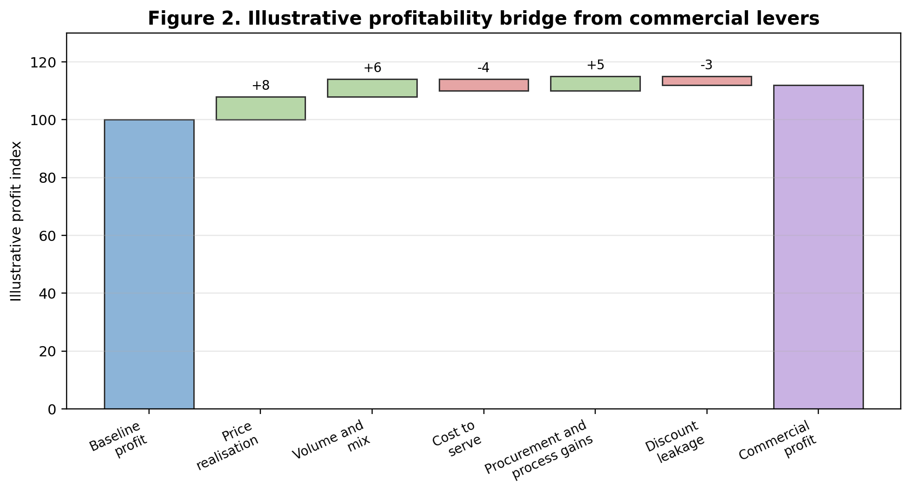
Source: Author developed for this report as an illustrative commercial profit bridge.

4.3 Revenue Management Improves Profit Quality, Not Just Revenue Quantity
The third finding is that revenue management improves the quality of revenue. Organisations often celebrate top line growth, but commercial management requires a deeper view. Managers need to understand the profitability of different products, customers, regions, service levels and channels. A customer who buys frequently may still be unattractive if they demand customisation, late payment, high support, free delivery or repeated returns. A product with strong sales may be weak if it cannibalises premium products or requires high inventory risk. Revenue management therefore involves disciplined choices about mix, timing, promotion, channel allocation and customer priority.
This logic is clear in platform and subscription businesses. Amazon’s advertising and AWS activities demonstrate that customer traffic and digital infrastructure can be monetised beyond traditional retail margin. Apple’s services show that recurring revenue can complement product sales. These models reveal that commercial strategy is increasingly about designing a revenue system rather than simply setting a product price. In manufacturing, Toyota’s regional results also show that revenue growth and operating income can move differently across markets because of expenses, exchange rates, tariffs, cost reduction and marketing efforts (Toyota Motor Corporation, 2025). Commercial managers must therefore look beneath aggregate revenue to identify where profit is genuinely created or lost.

4.4 Cost Control Must Be Linked to Value, Not Treated as Simple Cutting
The fourth finding is that cost control supports profitability when it is selective and strategically informed. A firm can improve short term profit by reducing service quality, supplier support, training or innovation, but such actions may damage long term competitiveness. Effective commercial cost control focuses on cost to serve, process waste, contract leakage, procurement inefficiency, stock obsolescence, returns, channel conflict and poor forecasting. It also distinguishes between costs that customers value and costs that customers do not notice.
Toyota illustrates this point in manufacturing. Its FY2025 financial summary identifies cost reduction efforts as one factor supporting regional operating income in Europe, while also showing that higher expenses can reduce operating income in other regions despite increased sales revenue (Toyota Motor Corporation, 2025). This is commercially important because it proves that cost control cannot be separated from market conditions, operational realities and regional execution. Cost control is not a one time reduction exercise. It is an ongoing capability that connects production, procurement, logistics, quality and customer expectations.
Inditex shows a retail version of the same principle. Its commercial model depends on rapid product renewal, tight inventory management, store productivity and supply chain responsiveness. These capabilities may involve higher process complexity than a slow fashion model, but they reduce markdown risk and protect full price selling. The lesson is that the lowest cost system is not always the most profitable system. The commercially superior system is the one that achieves the best relationship between customer value, speed, inventory risk and operating expense.
Table 2 compares how selected companies demonstrate different commercial profitability logics.
Company | Sector logic | Commercial strategy observed | Profitability implication
Amazon | Retail, marketplace, cloud and advertising ecosystem. | Combines customer scale, fulfilment, third party marketplace fees, Prime subscriptions, AWS and advertising monetisation. | Profitability depends on multiple revenue pools and operating leverage, not only product margin.
Apple | Premium technology product and service ecosystem. | Uses brand, design, hardware software integration and services to defend willingness to pay. | High gross margin is supported by customer lifetime value and ecosystem stickiness.
Inditex | Fashion retail with rapid product cycles. | Uses fast replenishment, inventory discipline and operating expense control to reduce markdown pressure. | Gross margin protection depends on speed, availability and controlled complexity.
Toyota | Global manufacturing and financial services. | Uses process discipline, cost reduction, regional market management and quality systems. | Profitability depends on cost control, operational resilience and the ability to absorb market shocks.

5. Discussion

5.1 Commercial Planning and Competitive Advantage
The findings show that commercial planning is the connection between strategy and profitability. Commercial planning converts broad ambitions into assumptions about price, volume, margin, cost, capacity, contracts, service levels and risk. It is therefore a central mechanism of competitive advantage. A firm that plans commercially can choose where to compete, which customers to prioritise, which products to promote, which costs to reduce and which supplier relationships to protect. A firm without commercial planning may still grow, but it is more likely to experience margin leakage and inconsistent execution.
The link with competitive advantage can be explained through the commercial strategy matrix in Figure 3. Firms with high pricing power but weak cost agility may be premium but inefficient. Firms with strong cost control but weak differentiation may become operationally efficient but exposed to price competition. The most attractive position is the upper right quadrant, where firms combine pricing power with cost discipline. Apple is closer to a premium value strategy, while Inditex and Toyota show strong operational and cost discipline. Amazon’s strongest businesses combine scale, data, customer reach and high value revenue pools. The key lesson is that competitive advantage comes from system fit, not from one isolated lever.
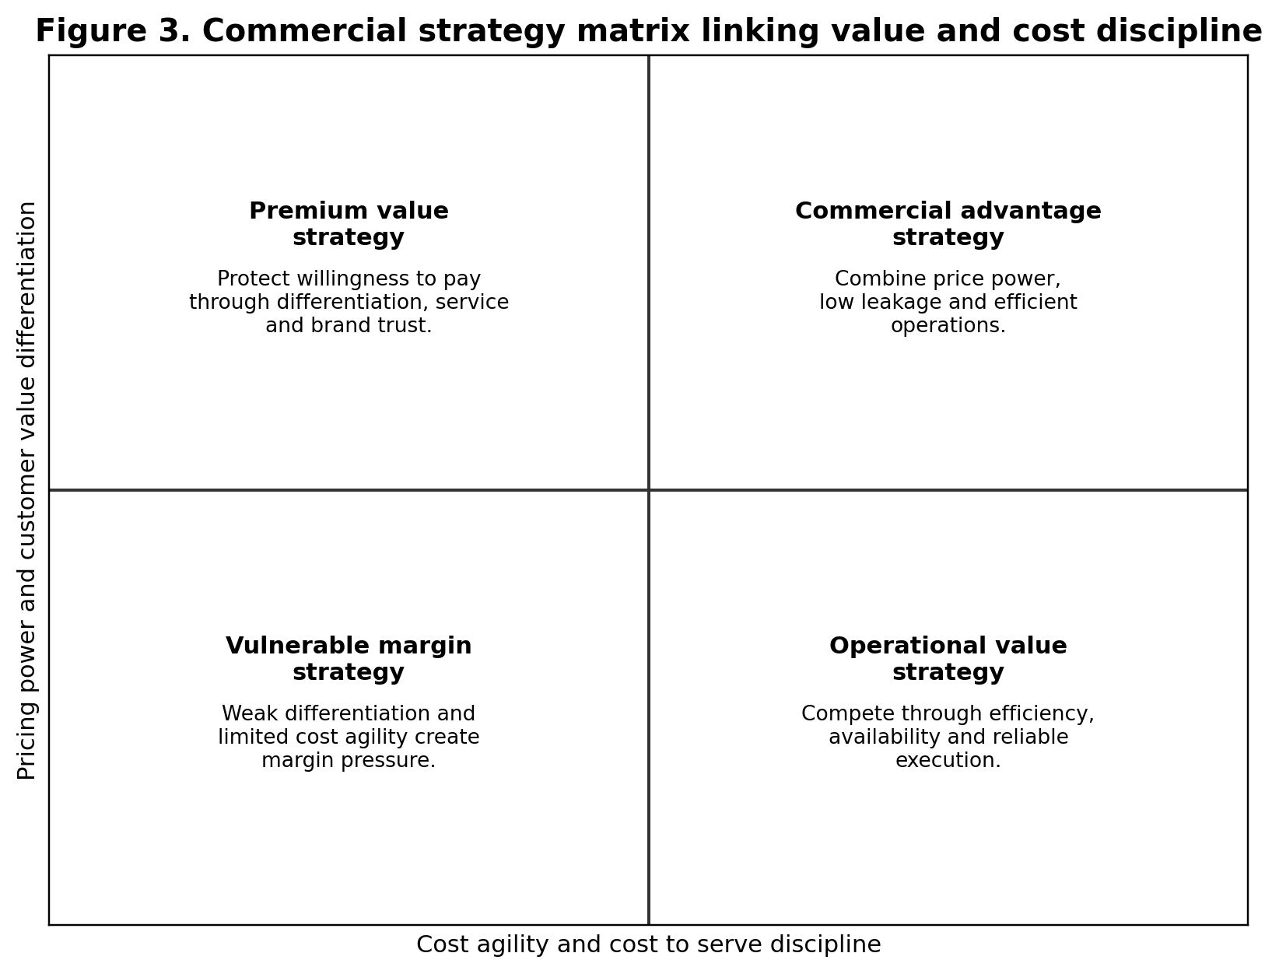
Source: Author developed for this report.

5.2 The Tension Between Revenue Growth and Margin Discipline
A major commercial problem is the tension between revenue growth and margin discipline. Sales teams are often rewarded for revenue, market share or customer acquisition, while finance teams are concerned with profit and cash. If incentives are not aligned, discounting can become normalised. Customers learn that list prices are not real prices, and sales teams use discounts to close deals quickly. The result is price leakage. Commercial management reduces this risk through pricing governance, approval thresholds, deal desks, margin based incentives and customer profitability reporting.
The problem is not limited to sales departments. Marketing promotions may increase volume but reduce full price demand. Procurement savings may reduce supplier quality. Operations may reduce service cost but increase customer churn. Commercial management therefore requires cross functional decision making. The firm should measure profit at customer, product and channel level rather than relying only on total sales. This is especially important in digital and omnichannel markets where delivery costs, returns, advertising spend and customer acquisition costs can vary significantly. A channel that appears to grow quickly may be less profitable after fulfilment, returns and promotional costs are included.
A practical solution is to use a profitability bridge, such as Figure 2, to separate the drivers of profit movement. Managers should not accept a simple statement that profit increased or decreased. They should ask whether the movement came from price realisation, volume, product mix, procurement savings, logistics cost, discount leakage, returns, labour productivity or exchange rates. This level of analysis improves problem solving because each driver requires a different managerial response. Discount leakage requires pricing control. Logistics cost requires operational redesign. Product mix requires portfolio and sales steering. Supplier cost requires procurement and contract management.

5.3 Commercial Strategy, Stakeholder Relationships and Ethics
Commercial strategy must also be evaluated ethically. The assignment brief identifies stakeholder relationships and ethical decision making as important parts of commercial operations. This is justified because commercial decisions can easily create harm when profit seeking becomes detached from fairness and transparency. Examples include misleading pricing, hidden charges, artificial scarcity, unfair contract terms, excessive pressure on suppliers or pricing that exploits vulnerable customers. Such practices may create short term gain but damage trust and long term enterprise value.
Ethical commercial management does not mean avoiding profit. It means earning profit through transparent value creation and responsible exchange. For example, price increases can be legitimate when input costs, quality improvements or service enhancements justify them. They become problematic when firms obscure the reason for increases, use confusing fees or exploit customer dependency. Supplier cost negotiations can be legitimate when they remove waste and improve efficiency. They become problematic when powerful buyers transfer unsustainable risk to suppliers, causing quality failures or labour abuses. Commercial managers therefore need governance processes that test not only whether a decision is profitable, but whether it is defensible to customers, suppliers and regulators.
Sustainability also affects commercial value. Customers, investors and regulators increasingly expect firms to manage environmental and social impacts. However, sustainability must be commercially integrated rather than used as symbolic communication. A sustainable commercial strategy may reduce waste, optimise transport, improve packaging, develop repair or resale models, support supplier resilience and communicate value honestly. These actions can protect long term profitability by reducing regulatory exposure, improving brand trust and strengthening supply continuity. The strongest commercial managers therefore treat ethics and sustainability as strategic controls, not public relations additions.

5.4 Recommended Commercial Management Practices
The analysis supports 6 recommendations for organisations seeking to improve profitability through commercial management. These recommendations are presented as practical managerial controls that can apply across service, retail and manufacturing firms.
First, organisations should establish pricing governance. This includes clear price corridors, discount approval rules, value based selling tools, customer segment logic and post deal review. Pricing governance should not prevent commercial flexibility, but it should ensure that exceptions are justified by strategic value rather than habit or pressure.
Second, firms should implement customer and product profitability analysis. Revenue should be reported with gross margin, cost to serve, payment terms, returns, support cost and contractual obligations. This allows managers to identify customers or products that consume more value than they create.
Third, commercial planning should be cross functional. Sales, finance, operations, procurement, legal and marketing should jointly review demand forecasts, supply capability, contract exposure and margin targets. This prevents local optimisation and supports strategic fit.
Fourth, organisations should treat revenue management as a capability. This includes product mix management, subscription and service monetisation, capacity allocation, markdown timing, promotion governance and channel conflict control. Revenue management should focus on profit quality rather than revenue quantity.
Fifth, cost control should focus on cost to serve and process design. Firms should remove avoidable complexity, reduce errors, renegotiate inefficient contracts and improve forecasting, but they should protect costs that customers genuinely value.
Sixth, commercial dashboards should include ethical and stakeholder indicators. Measures such as contract compliance, complaint rates, supplier performance, pricing exceptions and customer retention can show whether profitability is being earned responsibly.
Table 3 converts the recommendations into a risk and control matrix.
Commercial risk | Likely profitability damage | Control practice | Key performance indicator
Discount leakage | Reduced realised price and weakened price credibility. | Deal approval rules, price corridors and post deal review. | Discount variance, price realisation and gross margin.
Poor product or customer mix | Revenue grows but lower margin activities dominate. | Mix steering, customer profitability analysis and sales incentive redesign. | Contribution margin by segment and channel.
Cost overrun or high cost to serve | Profit is lost through fulfilment, support, returns and complexity. | Activity based cost analysis and process redesign. | Cost to serve percentage and return rate.
Supplier failure | Lost sales, service disruption, quality problems and emergency costs. | Supplier risk scoring, dual sourcing and contract monitoring. | On time in full delivery and defect rate.
Ethical pricing or contract concern | Reputation damage, churn, complaints and legal exposure. | Transparent pricing policy and contract review. | Complaint rate, refund rate and compliance exceptions.

5.5 Commercial Performance Measurement
Performance measurement is essential because commercial strategy can fail silently. A firm may report acceptable total profit while specific segments, regions or channels are weakening. A balanced commercial dashboard should therefore combine financial, customer, process and governance indicators. Gross margin and operating income remain important, but they should be supported by leading indicators such as price realisation, forecast accuracy, customer retention, cost to serve, contract compliance and supplier performance. This avoids a narrow focus on end period financial results.
Figure 4 provides an example of a dashboard logic. The purpose is not to prescribe exact targets for all firms. The purpose is to show how commercial managers can track both profitability drivers and risk controls. For example, price realisation above target may look positive, but if customer retention is falling, the pricing strategy may be too aggressive. Cost to serve below target may look efficient, but if service complaints increase, the firm may be cutting value creating activity. A dashboard is therefore a decision tool, not a decorative reporting device.
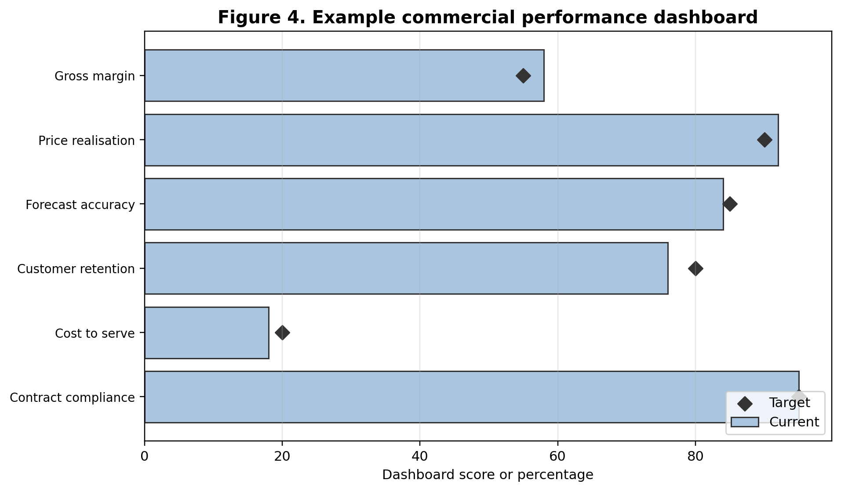
Source: Author developed for this report.
Table 4 presents a practical commercial KPI dashboard for implementation.
KPI | Formula or measurement logic | Managerial use
Gross margin percentage | (Sales revenue - cost of goods sold) / sales revenue × 100 | Shows whether price and cost discipline are protecting product economics.
Price realisation | Actual realised selling price / approved list or target price × 100 | Identifies discount leakage and pricing governance weaknesses.
Customer contribution margin | Customer revenue - direct product, service, fulfilment and support costs | Identifies profitable and unprofitable customers or segments.
Cost to serve percentage | Customer service, fulfilment and support costs / customer revenue × 100 | Shows whether channel and service promises are commercially sustainable.
Promotion return | Incremental gross profit from promotion / promotion cost | Tests whether promotions create profit rather than only volume.
Contract compliance | Number of compliant contract milestones / total milestones × 100 | Controls commercial risk, delivery performance and supplier accountability.

6. Conclusion
This report has shown that commercial strategies contribute to business profitability by linking customer value, price, revenue quality, cost control and competitive positioning. Commercial management is therefore broader than sales or contract administration. It is the managerial discipline that ensures growth is profitable, prices are defensible, costs are aligned with value, and stakeholder relationships are protected. The literature supports this view through concepts of competitive advantage, value based pricing, revenue management, strategic fit, cost optimisation and stakeholder theory.
The company examples confirm the same argument in practice. Amazon demonstrates the importance of multiple revenue pools and operating leverage. Apple demonstrates how premium pricing and service ecosystems protect gross margin. Inditex demonstrates the relationship between fast retail execution, inventory control and margin protection. Toyota demonstrates how manufacturing profitability depends on process discipline, cost reduction and regional commercial realities. These examples show that there is no single universal commercial strategy. The appropriate strategy depends on the business model, customer value proposition, operating system and competitive context.
The main critical insight is that profitability is not created by revenue growth alone. It is created by disciplined choices about what revenue to pursue, what price to charge, what costs to accept, which customers to prioritise and how risk should be governed. Organisations that fail to make these choices may grow while weakening margins. Organisations that commercialise strategically can convert market opportunities into sustainable value. The most important recommendations are to strengthen pricing governance, measure customer and product profitability, manage revenue quality, control cost to serve, align cross functional planning and include ethical stakeholder indicators in commercial dashboards. These practices create a more resilient approach to profitability because they balance short term financial performance with long term trust, competitiveness and commercial discipline.

References
Amazon. (2025). Amazon.com, Inc. 2024 annual report. https://ir.aboutamazon.com/annual-reports-proxies-and-shareholder-letters/default.aspx
Apple. (2024). Form 10-K for the fiscal year ended September 28, 2024. https://investor.apple.com/investor-relations/default.aspx
Barney, J. (1991). Firm resources and sustained competitive advantage. Journal of Management, 17(1), 99-120.
BCG. (2024). Your growth strategy depends on your starting point. Boston Consulting Group. https://www.bcg.com/publications/2024/your-revenue-strategy-depends-on-your-starting-point
BCG. (2024). Inflation changed consumers, time to rethink pricing. Boston Consulting Group. https://www.bcg.com/publications/2024/inflation-changed-consumers-time-rethink-pricing
Christopher, M. (2016). Logistics and supply chain management (5th ed.). Pearson.
Deloitte. (2024). Unlocking the promise of cost optimization. Deloitte Insights. https://www.deloitte.com/us/en/insights/topics/operations/cost-optimization-operations-strategy.html
Freeman, R. E. (1984). Strategic management: A stakeholder approach. Pitman.
Hinterhuber, A., & Liozu, S. (2012). Is it time to rethink your pricing strategy? MIT Sloan Management Review, 53(4), 69-77.
Inditex. (2026). FY2025 results. https://www.inditex.com/itxcomweb/en/investors/investor-relations/financial-results
Kaplan, R. S., & Norton, D. P. (1996). The balanced scorecard: Translating strategy into action. Harvard Business School Press.
Kotler, P., Keller, K. L., & Chernev, A. (2022). Marketing management (16th ed.). Pearson.
McKinsey & Company. (2025). Leading European consumer goods with commercial excellence. https://www.mckinsey.com/capabilities/growth-marketing-and-sales/our-insights
Nagle, T. T., & Müller, G. (2018). The strategy and tactics of pricing: A guide to growing more profitably (6th ed.). Routledge.
Porter, M. E. (1985). Competitive advantage: Creating and sustaining superior performance. Free Press.
Porter, M. E. (1996). What is strategy? Harvard Business Review, 74(6), 61-78.
PwC. (2025). Voice of the Consumer 2025. PricewaterhouseCoopers. https://www.pwc.com/gx/en/issues/c-suite-insights/voice-of-the-consumer-survey.html
Simons, R. (1995). Levers of control: How managers use innovative control systems to drive strategic renewal. Harvard Business School Press.
Talluri, K. T., & van Ryzin, G. J. (2004). The theory and practice of revenue management. Springer.
Teece, D. J. (2010). Business models, business strategy and innovation. Long Range Planning, 43(2-3), 172-194.
Toyota Motor Corporation. (2025). FY2025 financial summary. https://global.toyota/en/ir/financial-results/
Williamson, O. E. (1985). The economic institutions of capitalism. Free Press.
Zott, C., Amit, R., & Massa, L. (2011). The business model: Recent developments and future research. Journal of Management, 37(4), 1019-1042.

Appendices

Appendix A: Alignment with Assignment Requirements
Requirement | Where addressed in the report
Role of commercial management in business growth | Introduction, literature review and Finding 4.1.
Pricing, revenue management and cost control strategies | Literature review, Findings 4.2 to 4.4 and Discussion 5.2.
Commercial planning and competitive advantage | Literature review and Discussion 5.1.
Real world examples from service, retail and manufacturing sectors | Amazon, Apple, Inditex and Toyota examples in Findings and Table 2.
Tables and visuals | Figures 1 to 4 and Tables 1 to 4.
APA citations and references | In text citations throughout and APA style reference list.

Appendix B: Commercial Strategy Audit Checklist
Audit question | Evidence required
Are prices based on value, competition and customer segmentation rather than habit? | Pricing policy, discount approval data and value proposition evidence.
Which customers, products and channels create the highest contribution margin? | Customer profitability report and product contribution margin analysis.
Where is revenue being lost through leakage, returns, poor contracts or weak forecasting? | Profit bridge, contract review and returns analysis.
Which costs support customer value and which costs represent avoidable complexity? | Cost to serve map and process review.
Are commercial targets aligned across sales, finance, operations, procurement and legal? | Commercial planning calendar and cross functional meeting evidence.
Are ethical and stakeholder risks monitored as commercial risks? | Complaint logs, supplier performance, compliance review and pricing transparency checks.

