M07 Financial Management
Financial Planning and Strategic Decision Making in Organizations

Assignment Option 1
Detailed Project Report
Student Name: [Enter Name]
Student ID: [Enter Student ID]
Module: M07 Financial Management
Date: May 2026

Table of Contents
Abstract
1. Introduction
2. Literature Review
2.1 Role and Objectives of Financial Management
2.2 Financial Planning, Budgeting and Forecasting
2.3 Performance Evaluation and Value Based Control
2.4 Investment, Financing and Dividend Decisions
2.5 Risk, Ethics and Governance
3. Methodology
4. Findings
4.1 Strategic Role of Financial Management
4.2 Planning, Budgeting and Forecasting Tools
4.3 Investment, Financing and Dividend Decisions
4.4 Real World Examples
5. Discussion
6. Conclusion
References
Appendices
List of Figures
Figure 1. Integrated financial management decision cycle
Figure 2. Planning, budgeting and forecasting as a control cycle
Figure 3. Capital budgeting tools and strategic decision value
Figure 4. Financial risk and ethical control framework
Figure 5. Working capital view of cash flow timing

Abstract
Financial management is no longer a narrow accounting function concerned only with record keeping, cost control and statutory reporting. In modern organizations, it operates as a strategic decision system that links resource allocation, risk appetite, financing choices and performance evaluation with the overall direction of the business. This report critically examines how financial management supports strategic business decisions through financial planning, budgeting, forecasting, capital investment appraisal, financing policy, dividend policy and performance control. It adopts a topic based qualitative methodology and uses academic finance literature, corporate governance frameworks and real company examples to assess how financial managers contribute to growth, stability and restructuring. The analysis finds that financial planning supports strategy most effectively when it translates strategic objectives into cash flow forecasts, capital budgets, working capital targets and measurable key performance indicators. However, the report also finds that traditional budgets and single point forecasts can create rigidity if they are not supported by scenario analysis, rolling forecasts and risk adjusted performance measures. Real world examples from Apple, Microsoft, Unilever and Tesla show that financial management creates value when capital allocation is disciplined, liquidity is protected, and financing decisions remain aligned with long term strategic priorities. The report concludes that effective financial management is a strategic governance capability rather than a purely technical finance activity.

1. Introduction
Financial management is central to organizational success because every strategic choice eventually requires a financial judgement about affordability, expected return, risk, timing and accountability. A strategy that cannot be funded, measured or controlled remains only a statement of intention. For this reason, modern financial management is concerned with the acquisition, allocation and control of financial resources in a way that supports the long term objectives of the organization (Brigham & Ehrhardt, 2022). It links corporate strategy with cash flow, capital investment, financing structure, working capital discipline and performance evaluation. This role is especially important in volatile business environments where organizations face inflation, interest rate uncertainty, supply chain disruption, technological investment pressure and increasing stakeholder scrutiny.
The purpose of this report is to examine how financial management supports strategic business decisions in modern organizations. The selected assignment option is Financial Planning and Strategic Decision Making in Organizations. The report explains the role and objectives of financial management, analyses financial planning, budgeting, forecasting and performance evaluation, discusses how financial managers support investment, financing and dividend decisions, and uses real world examples to show how financial planning supports growth, stability and restructuring.
The report argues that financial management contributes to strategy in 3 connected ways. First, it disciplines strategy by converting broad ambitions into financial targets, budgets and capital allocation priorities. Second, it improves decision quality by applying tools such as net present value, sensitivity analysis, weighted average cost of capital, cash conversion analysis and variance analysis. Third, it protects organizational sustainability by assessing liquidity risk, solvency risk, ethical risk and the consequences of excessive leverage. These functions are not mechanical. They require judgement because finance tools depend on assumptions about future demand, cost behaviour, interest rates, competitive pressure and managerial incentives (Brealey et al., 2023). A technically correct model can still support a poor strategic decision if the assumptions are unrealistic or if the organization ignores wider stakeholder and governance issues.
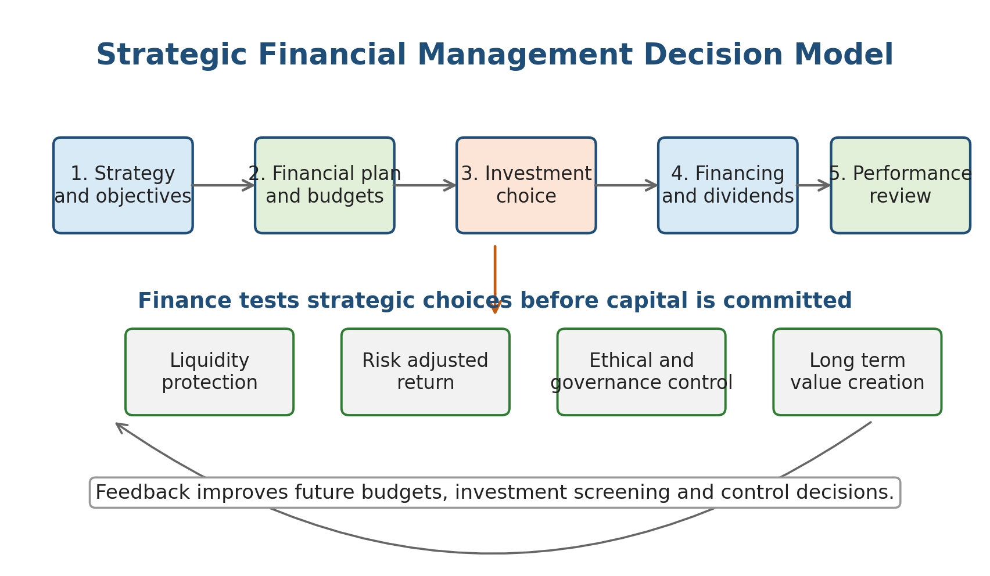
Figure 1. Integrated financial management decision cycle.
Source: Author developed from the financial management literature reviewed in this report.
The report is organized into 6 main sections. After this introduction, the literature review examines key financial management theories and tools. The methodology explains the qualitative topic based approach used to analyse the issue. The findings section applies the literature to planning, investment, financing, dividends and company examples. The discussion section critically evaluates limitations and implications. The conclusion summarizes the argument and identifies the conditions under which financial management is most likely to support organizational success.

2. Literature Review

2.1 Role and Objectives of Financial Management
The traditional objective of financial management is often described as maximising shareholder wealth rather than simply maximising accounting profit. Shareholder wealth is usually linked to the present value of expected future cash flows, adjusted for risk and timing (Ross et al., 2022). This distinction is important because accounting profit can be increased through short term actions that damage cash flow, reputation or investment capacity. For example, reducing maintenance, research and development or employee training may improve current profit but weaken future competitiveness. Financial management therefore requires a balance between short term financial discipline and long term value creation.
Modern finance theory provides several foundations for this role. Modigliani and Miller (1958) showed that, under restrictive perfect market assumptions, financing structure would not affect firm value. In practice, those assumptions rarely hold because taxes, bankruptcy costs, information asymmetry and agency conflicts make financing choices strategically significant. Myers (1984) argued that firms often follow a pecking order in which internal finance is preferred to debt and debt is preferred to new equity because external financing can signal information to markets. Jensen (1986) added that excess free cash flow can create agency problems when managers invest in low value projects rather than returning surplus funds to shareholders. These theories show that financial management is not only about raising money. It is also about controlling managerial behaviour and aligning capital allocation with value creating opportunities.
A wider view of financial management recognizes that organizations also have obligations to lenders, employees, customers, regulators and communities. The G20 and OECD Principles of Corporate Governance emphasize transparency, accountability and the equitable treatment of shareholders, while also recognizing the importance of stakeholders and sustainability in corporate governance (OECD, 2023). This means strategic finance must consider value creation, risk management and ethical conduct together. Financial managers are expected to support profitable decisions, but they must also prevent distorted reporting, excessive leverage, insider dealing, and short term decision making that transfers hidden risk to others.

2.2 Financial Planning, Budgeting and Forecasting
Financial planning converts strategy into numbers. It estimates future revenue, costs, capital expenditure, working capital needs, financing requirements and cash flows. A strategic plan may state that the organization will expand into a new market, digitise operations or launch a new product. Financial planning tests whether that ambition is affordable, what resources are required, how risk will be financed and what milestones should be monitored. Brigham and Ehrhardt (2022) describe planning as a forward looking process that links sales forecasts, asset requirements, financing needs and performance targets.
Budgeting remains one of the most common tools of financial control. A budget allocates resources, sets responsibility targets and provides a basis for variance analysis. However, budgeting is also criticized for encouraging rigidity, negotiation behaviour and short term target gaming. Hope and Fraser (2003) argue that traditional fixed budgets can become outdated quickly and may restrict adaptive decision making when market conditions change. This criticism does not mean that budgets are useless. It means that budgets should be supported by rolling forecasts, scenario analysis and flexible performance measures. A fixed annual budget may be suitable for cost discipline, while a rolling forecast may be better for strategic adaptation.
Forecasting is especially important in uncertain markets because the value of a decision depends on future cash flows rather than past accounting results. Financial managers use sales forecasts, cost forecasts, cash flow forecasts and funding forecasts to anticipate liquidity pressures and investment capacity. Forecasting also supports scenario planning. For example, a company considering international expansion may test the effect of exchange rate changes, higher borrowing costs, delayed customer payments and lower than expected sales. This improves strategic decision making because managers can identify trigger points before risks become crises.
Performance evaluation closes the planning cycle. Tools such as return on invested capital, economic value added, free cash flow, cash conversion cycle and balanced scorecard measures help managers assess whether strategic plans are producing value. Kaplan and Norton (1992) argued that performance should not rely only on financial measures because customer, internal process, and learning indicators are also drivers of future financial results. This is highly relevant to financial management because finance teams need both lagging indicators such as profit and leading indicators such as order backlog, productivity, quality and customer retention.
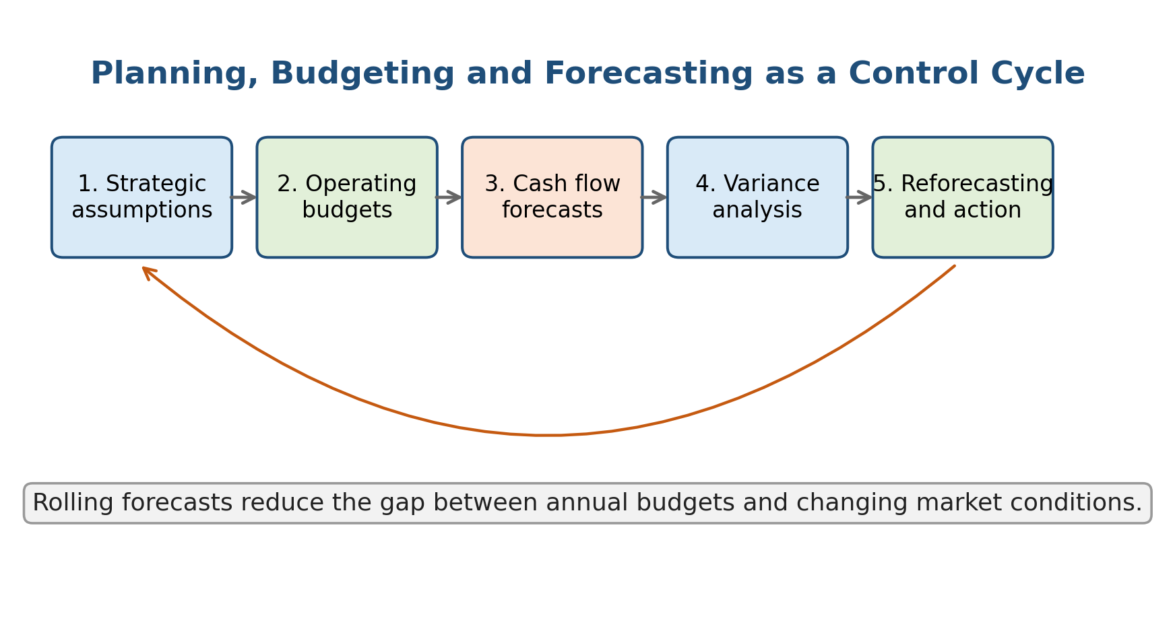
Figure 2. Planning, budgeting and forecasting as a control cycle.
Source: Author developed for this report.

2.3 Performance Evaluation and Value Based Control
Strategic financial control depends on measuring performance in a way that supports value creation. Accounting measures such as gross profit, operating profit and net income are useful, but they can be incomplete because they do not always reveal cash generation, capital intensity or risk. For example, a business unit may report high profit while absorbing excessive working capital through slow receivables collection and high inventory. Cash flow based measures therefore provide a stronger picture of financial sustainability (Atrill, 2020).
Value based management attempts to connect performance evaluation with the cost of capital. Return on invested capital should be compared with the weighted average cost of capital because value is created only when returns exceed the opportunity cost of funds. Economic value added applies the same principle by deducting a capital charge from operating profit. The advantage of such measures is that they discourage growth for its own sake. A division that expands revenue but earns returns below the cost of capital destroys value even if its accounting profit appears positive (Brealey et al., 2023).
However, value based control also has limitations. It can encourage underinvestment if managers are rewarded too heavily on short term returns. New projects, digital transformation and sustainability investments may reduce near term accounting returns while building future capabilities. For this reason, performance evaluation should combine financial and non financial indicators. The balanced scorecard is useful because it links financial outcomes to operational drivers, although it can become overloaded if too many indicators are selected (Kaplan & Norton, 1996). Effective financial management therefore requires a small set of strategically relevant measures rather than a long list of disconnected metrics.

2.4 Investment, Financing and Dividend Decisions
Investment decisions determine where the organization places scarce capital. Capital budgeting tools such as net present value, internal rate of return, payback period and profitability index are used to evaluate whether a project should be accepted. Net present value is generally preferred because it measures the expected increase in value after discounting future cash flows at a risk appropriate rate (Ross et al., 2022). Graham and Harvey (2001) found that chief financial officers widely use net present value and internal rate of return, which confirms the practical importance of investment appraisal in corporate finance.
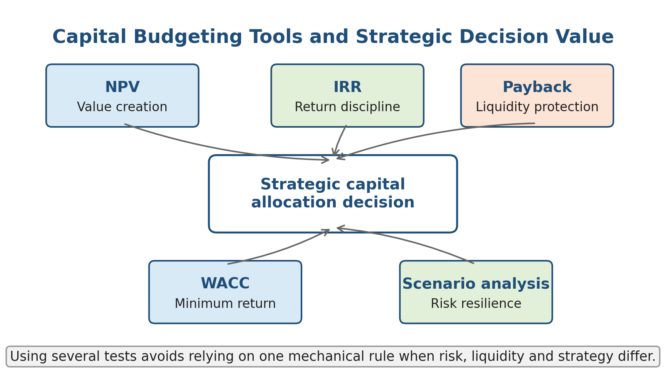
Figure 3. Capital budgeting tools and strategic decision value.
Source: Author developed from capital budgeting theory discussed in the literature review.
Financing decisions determine how investments are funded. Debt can reduce the weighted average cost of capital because interest is tax deductible in many jurisdictions, but excessive debt increases financial distress risk and reduces flexibility. Equity is more flexible but can be expensive and may dilute existing shareholders. The optimal financing decision therefore depends on cash flow stability, asset risk, growth opportunities, tax position, credit market conditions and strategic control (Myers, 1984). Financial managers must also consider maturity matching. Long term assets should generally be funded with long term capital, while seasonal working capital needs may be funded with short term facilities.
Dividend decisions are closely connected with investment and financing choices. A company with many profitable projects may retain earnings to fund growth. A mature company with strong cash flow and fewer reinvestment opportunities may return cash through dividends or share repurchases. Jensen's (1986) free cash flow theory suggests that distributions can reduce agency problems by limiting the cash available for low return projects. However, aggressive distributions can also weaken resilience if they are funded through debt or if they leave the company with insufficient liquidity during downturns. Dividend policy should therefore be interpreted as a capital allocation signal rather than a simple reward to shareholders.

2.5 Risk, Ethics and Governance
Risk management is part of financial management because risk affects both expected cash flows and the discount rate applied to those cash flows. Liquidity risk threatens the ability to meet short term obligations. Credit risk arises when customers or counterparties fail to pay. Market risk includes interest rate, exchange rate, commodity price and equity price exposure. Operational risk arises from process failure, fraud, technology breakdown or weak internal control. COSO (2017) argues that enterprise risk management should be integrated with strategy and performance rather than treated as a separate compliance activity. This is relevant because strategic decisions often fail when financial models ignore execution risk and governance risk.
Ethical financial decision making is equally important. Financial misreporting, hidden liabilities, aggressive revenue recognition and misleading forecasts can distort strategic choices. Managers may accept projects to meet personal bonus targets even when risk adjusted value is poor. Excessive leverage may increase shareholder returns in favourable conditions but transfer distress costs to employees, suppliers and creditors during downturns. Responsible financial management requires transparent assumptions, independent review of major investments, clear audit trails and a willingness to reject projects that are financially attractive only because they rely on unrealistic assumptions or unethical practices. The literature therefore supports a broad view of financial management as a strategic, analytical and ethical function.
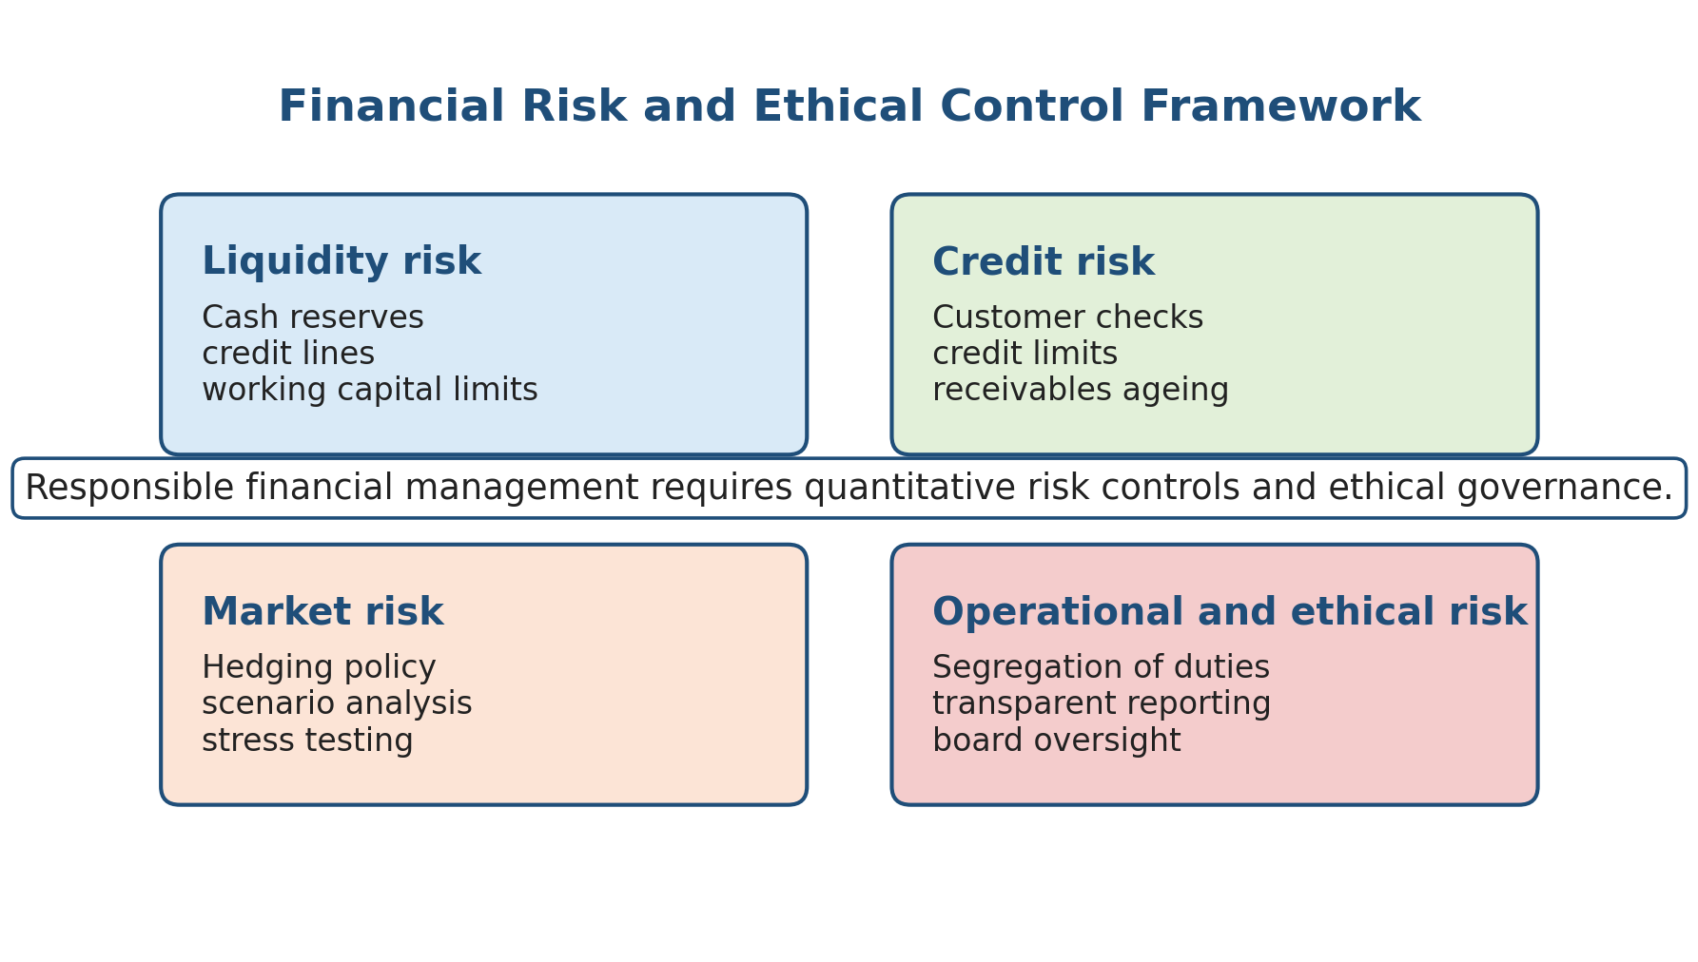
Figure 4. Financial risk and ethical control framework.
Source: Author developed from the risk and governance discussion in this report.

3. Methodology
This report uses a qualitative, topic based methodology. The purpose is not to test a statistical hypothesis with primary data. Instead, the report critically analyses how financial management supports strategic business decisions by combining academic theory, professional frameworks and real company examples. This approach is appropriate because the assignment requires conceptual explanation, application of financial tools and critical evaluation of real world relevance.
The research design has 3 stages. First, academic literature on corporate finance, budgeting, performance management, agency theory and governance was reviewed to identify the main principles of financial management. This included finance textbooks and journal articles on capital structure, free cash flow, investment appraisal and performance evaluation. Second, financial management tools were mapped against strategic decisions. For example, net present value was linked with investment decisions, weighted average cost of capital with financing decisions, variance analysis with budgetary control, and cash conversion cycle with working capital strategy. Third, real company examples were selected to illustrate how financial planning operates in practice.
The examples were selected purposively rather than randomly. Apple was selected because it provides a clear example of mature cash generation, dividend policy and share repurchases. Microsoft was selected because its 2025 annual report shows how large scale capital expenditure can support artificial intelligence and cloud growth. Unilever was selected because it illustrates the use of performance measures, cash conversion and portfolio discipline in a global consumer goods business. Tesla was selected because it demonstrates high growth capital expenditure, operational restructuring and risk management issues in a volatile technology and manufacturing context. These examples allow comparison across different strategic situations: maturity, growth, portfolio management and restructuring.
The analysis is limited by its reliance on secondary sources. Annual reports are useful because they are official corporate disclosures, but they present management's interpretation and may emphasize favourable information. Academic finance models are useful for structure, but they simplify reality by assuming measurable cash flows and rational decision makers. The report therefore uses the evidence critically. It does not assume that every financial technique automatically improves strategy. Instead, it assesses whether the technique improves strategic judgement when used with realistic assumptions, governance controls and awareness of ethical consequences.
The main criteria for evaluation are strategic alignment, value creation, liquidity protection, risk control and ethical accountability. These criteria reflect the assignment focus on financial planning, investment decisions, financing decisions, working capital management, risk assessment, capital structure, valuation and ethical financial decision making. The methodology therefore supports an integrated analysis of financial management as both a technical discipline and a strategic management function.

4. Findings

4.1 Strategic Role of Financial Management
The first finding is that financial management supports strategy by converting ambition into resource discipline. Strategy often begins with qualitative objectives such as growth, innovation, market expansion, cost leadership or restructuring. Financial management makes these objectives operational by estimating cash requirements, expected returns, funding capacity and performance milestones. Without this financial translation, strategic decisions can become over optimistic. A company may announce expansion, but if the cash flow forecast shows insufficient internal funding and limited borrowing capacity, management must adjust the pace of growth, seek equity finance or reduce other expenditure.
Financial managers also support strategy by acting as internal challengers. They test whether projected revenue growth is consistent with market size, whether cost savings are realistic, whether capital expenditure will be completed on time and whether the organization can tolerate downside scenarios. This challenge role is important because strategic proposals often contain optimism bias. Net present value and sensitivity analysis do not remove uncertainty, but they force managers to identify the assumptions that drive value. For example, if a project's positive net present value depends entirely on a small increase in market share, the strategic risk is higher than if value remains positive under conservative demand assumptions.
The strategic role of finance is also visible in capital allocation. Organizations rarely have unlimited capital. Finance teams therefore help prioritize projects by comparing expected value, risk, strategic fit and timing. A disciplined capital allocation process prevents resources from being spread thinly across too many initiatives. It also ensures that projects are reviewed after approval. Post investment review is important because it compares actual outcomes with the original business case and creates learning for future decisions. In this way, financial management supports not only the decision to invest but also the governance of investment after funds have been committed.

4.2 Planning, Budgeting and Forecasting Tools
The second finding is that planning, budgeting and forecasting are most valuable when they are connected rather than treated as separate administrative exercises. Strategic planning identifies direction. Budgeting allocates resources. Forecasting updates expectations as conditions change. Performance evaluation checks whether the plan is being achieved. When these processes are disconnected, a company may have a strategy that is not reflected in the budget, a budget that ignores new forecasts, or performance measures that reward behaviour inconsistent with strategy.
Budgeting supports strategic decisions by setting financial boundaries and responsibility targets. For example, an organization pursuing cost leadership needs budgets that track operating efficiency, procurement savings, labour productivity and overhead control. An organization pursuing differentiation may need budgets that protect brand investment, product development and customer service. This shows that budgeting is not neutral. The design of the budget should reflect the business model and strategic priorities.
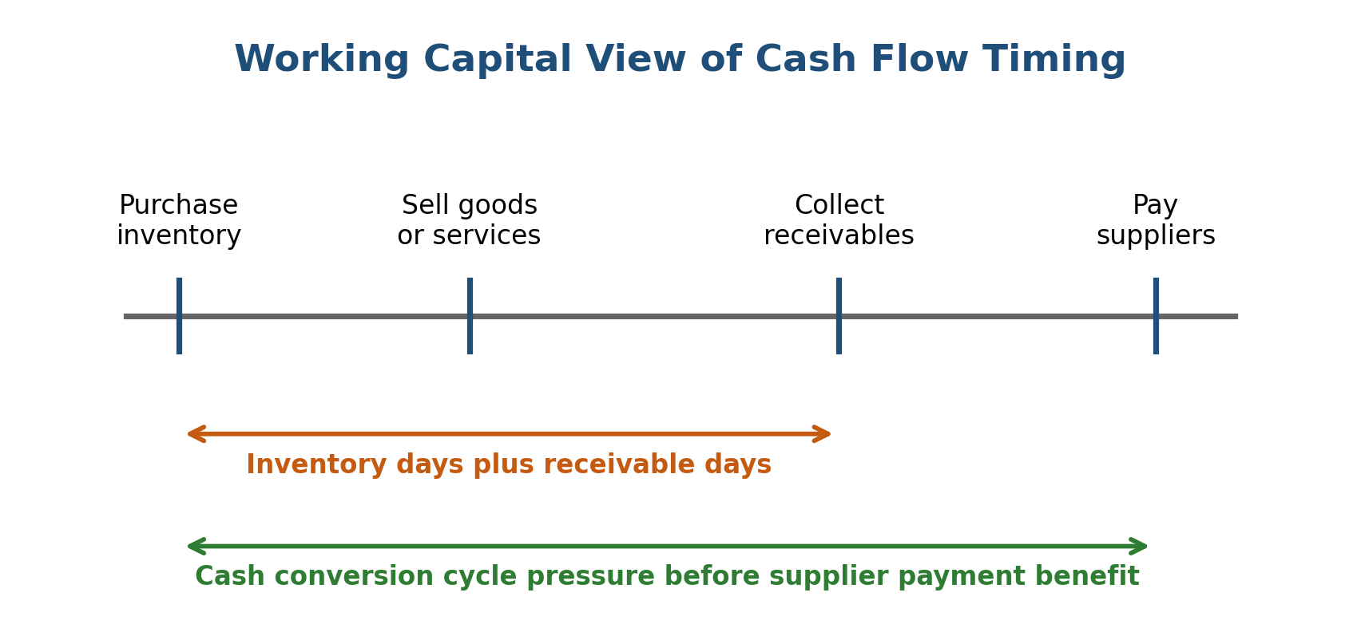
Figure 5. Working capital view of cash flow timing.
Source: Author developed to illustrate cash flow timing in strategic financial planning.
Forecasting improves budgeting by adding adaptability. A fixed budget created once per year may become unrealistic if demand changes, exchange rates shift or interest costs rise. Rolling forecasts allow management to update revenue, cost and cash flow expectations throughout the year. Scenario analysis provides an additional layer by showing outcomes under base, optimistic and pessimistic assumptions. This supports better decision making because managers can prepare financing options, cost controls and contingency plans before the organization experiences pressure.
Performance evaluation is the feedback mechanism. Variance analysis compares actual performance with budgeted performance. However, variance analysis must be interpreted carefully. A favourable cost variance may indicate efficiency, but it may also indicate underinvestment in quality or maintenance. An unfavourable marketing variance may be justified if it supports long term customer acquisition. Financial managers therefore need to combine numerical control with strategic interpretation. The finding is that financial tools work best when they support judgement rather than replace judgement.

4.3 Investment, Financing and Dividend Decisions
The third finding is that investment, financing and dividend decisions are interdependent. A company cannot evaluate investment opportunities without considering the cost and availability of finance. It cannot set dividend policy without considering future investment needs and liquidity requirements. It cannot choose capital structure without considering risk, cash flow stability and strategic flexibility.
Investment appraisal supports strategic choice by comparing expected cash inflows with initial and ongoing cash outflows. The key strength of net present value is that it incorporates the time value of money and risk through the discount rate. It also focuses on absolute value creation rather than percentage return only. Internal rate of return is useful because managers often understand percentage returns, but it can mislead when projects differ in scale or when cash flow patterns are unconventional. Payback period is simple and useful for liquidity screening, but it ignores cash flows after the payback point and does not fully measure value. Profitability index is useful when capital is rationed because it compares value created per unit of investment. Therefore, no single appraisal tool is sufficient for every decision.
Financing decisions influence the feasibility and risk of strategic plans. Debt can support growth without ownership dilution, but it creates fixed obligations. Equity can provide flexibility, but it may be more expensive and may signal that management believes the share price is high. Internal funding avoids transaction costs and information problems, but reliance on retained earnings can slow growth. A resilient financing strategy usually combines internal cash generation, appropriate debt maturity, access to committed facilities and disciplined equity use. The best financing decision is not simply the cheapest source of funds. It is the source that supports strategy while preserving financial flexibility.
Dividend decisions complete the capital allocation cycle. Stable dividends can signal confidence and attract income oriented investors. Share repurchases can provide flexibility and may be efficient when shares are undervalued. Retentions can support growth if the company has positive net present value projects. The weakness of high distributions is that they may reduce financial resilience if cash flows deteriorate. Financial managers therefore need to recommend distributions only after testing investment requirements, liquidity needs, debt covenants and downside scenarios.

4.4 Real World Examples
Real world evidence shows that financial planning supports different strategic priorities in different organizational contexts. Apple provides an example of mature financial management in a cash generative technology business. Its 2025 Form 10 K describes an authorized share repurchase program and a quarterly cash dividend of $0.26 per share as of September 27, 2025 (Apple Inc., 2025). This reflects a capital allocation pattern in which a mature company continues to invest in products and services while returning surplus cash to shareholders. The strategic point is not simply that Apple pays dividends or repurchases shares. The point is that strong operating cash flow gives management flexibility to fund innovation, manage supply chain commitments and distribute cash without relying excessively on external finance.
Microsoft provides a contrasting example of growth focused investment planning. Its 2025 annual report reported revenue of $281.7 billion, operating income of $128.5 billion and Azure revenue exceeding $75 billion for the first time (Microsoft Corporation, 2025). The company also connected its financial performance with demand for artificial intelligence and cloud infrastructure. This illustrates how financial management supports strategic investment decisions. Large capital expenditure can reduce near term free cash flow, but it may be justified if it expands capacity in a market where demand is expected to grow. The critical issue is whether the expected long term cash flows from cloud and artificial intelligence services exceed the cost of capital and whether management can control execution risk.
Unilever illustrates planning and performance management in a diversified consumer goods organization. Its Annual Report and Accounts 2025 explains non GAAP measures such as underlying sales growth, underlying operating margin, free cash flow, cash conversion, net debt and return on invested capital (Unilever, 2026). These measures show how financial management supports portfolio discipline. A global consumer goods company must decide which brands, regions and categories deserve investment. It must also manage working capital across suppliers, inventories, retailers and currencies. Financial planning helps such a company link brand strategy with cash generation and balance sheet strength.
Tesla illustrates the importance of financial planning in high growth and volatile sectors. Its 2024 Form 10 K described restructuring actions that generated $583 million of employee termination expenses and noted foreign exchange effects and digital asset fair value remeasurement within other income and expense (Tesla, Inc., 2025). This example shows that financial management must address both growth investment and restructuring discipline. Companies in technology and manufacturing may require high capital expenditure for factories, tooling, batteries and automation, but they also face demand volatility, price pressure and execution risk. Strategic finance therefore needs to test whether growth assumptions remain valid and whether restructuring costs are likely to produce sustainable efficiency gains.

4.5 Synthesis of Key Tools
The findings can be summarized through the relationship between strategic decisions and financial tools. Financial planning supports strategy by giving managers a structured basis for choosing between alternatives. Budgeting supports implementation by allocating resources to approved priorities. Forecasting supports adaptation by updating the financial view as conditions change. Investment appraisal supports capital discipline by estimating whether projects create value. Financing analysis supports resilience by matching funding sources to risk and maturity. Dividend policy supports capital allocation by deciding whether cash should be reinvested or returned. Risk assessment and ethical controls protect the credibility of all these processes.
The most important finding is that financial management is valuable only when tools are used critically. A budget can become a target game. A forecast can become a false comfort if it uses unrealistic assumptions. Net present value can become misleading if the discount rate is wrong or if strategic options are ignored. A low debt cost can encourage excessive leverage. Dividends can signal confidence, but they can also hide underinvestment. Financial managers therefore add strategic value by combining technical analysis with professional scepticism, governance discipline and ethical judgement.

Table 1. Strategic Use of Selected Financial Management Tools
Tool | Strategic purpose | Main strength | Main limitation
Budgeting | Allocates resources to strategic priorities | Creates responsibility and control | Can become rigid if fixed targets dominate
Rolling forecast | Updates expectations as conditions change | Improves adaptability and early warning | Depends on data quality and managerial honesty
Net present value | Evaluates whether investment creates value | Uses cash flow, timing and risk | Sensitive to assumptions and discount rate
Variance analysis | Compares actual results with planned results | Identifies performance gaps | Needs interpretation to avoid false conclusions
Cash conversion cycle | Tracks working capital efficiency | Links profit with liquidity | Can encourage excessive supplier pressure if misused

5. Discussion
The analysis shows that financial management supports strategic decision making, but it also shows that finance tools have limits. The strength of financial management is that it imposes discipline on strategy. It requires managers to specify expected cash flows, funding requirements, risks, milestones and accountability. This is especially important because strategic narratives can be persuasive even when the financial case is weak. A strong finance function reduces this danger by asking whether the proposal creates value, whether the organization can fund it, and whether the risks are acceptable.
However, financial management can also weaken strategy if it becomes too mechanical. Over reliance on short term budgets may discourage innovation. Excessive focus on payback may reject projects that create long term value. Strict return on investment targets may penalize early stage digital or sustainability projects whose benefits are uncertain but strategically necessary. The solution is not to abandon financial discipline. The solution is to use different tools for different types of decisions. Stable replacement investments can be evaluated mainly through cost savings and discounted cash flow. Transformational projects may require scenario analysis, real option thinking and staged funding because uncertainty is higher.
The real world examples support this balanced view. Apple shows that mature companies can use financial management to combine innovation investment with shareholder returns. Microsoft shows that financial planning can justify very large capital expenditure when management believes that long term demand and strategic positioning support it. Unilever shows that performance measures can guide portfolio and working capital discipline. Tesla shows that growth finance must be accompanied by restructuring awareness and risk control. These examples also reveal that financial management is context specific. The same dividend policy, debt level or investment hurdle rate would not suit every company.
Ethics and governance are central to the discussion. Financial decisions affect multiple stakeholders, not only shareholders. A decision to increase leverage may improve equity returns but also raise the probability of distress. A decision to reduce costs may improve margins but damage service quality or employee capability. A decision to report aggressive forecasts may help secure funding but mislead investors. Therefore, strategic financial management must include transparency, realistic assumptions and accountability. The finance function should not be treated as a department that simply approves or rejects spending. It should be treated as a governance partner that helps the organization choose strategies that are financially sound, strategically coherent and ethically defensible.
Overall, the discussion supports the argument that financial management is most effective when it operates at board and senior management level. It should contribute to strategy formation, not merely report historical outcomes after decisions are made. When finance is involved early, organizations can design strategies that are fundable, measurable and resilient. When finance is involved late, it often becomes a control function that identifies problems after commitments have already been made. The strategic value of financial management therefore depends on timing, integration and the quality of managerial judgement.

6. Conclusion
This report has critically examined how financial management supports strategic business decisions in modern organizations. The main conclusion is that financial management is a strategic capability because it links organizational objectives with financial planning, capital allocation, risk assessment, performance evaluation and ethical governance. It supports success by converting strategic goals into budgets, forecasts, investment cases, financing plans and measurable performance indicators.
The report found that financial planning improves decision making by testing affordability and resource requirements. Budgeting supports implementation, but it must be flexible enough to avoid rigidity. Forecasting and scenario analysis improve adaptability in uncertain markets. Investment appraisal tools such as net present value, internal rate of return, payback period and profitability index support capital discipline, although they must be interpreted with awareness of their limitations. Financing decisions shape risk and flexibility, while dividend decisions signal how management balances reinvestment and shareholder returns.
Real world examples from Apple, Microsoft, Unilever and Tesla show that financial management works differently across business contexts. Mature companies may emphasize cash returns and balance sheet discipline. Growth companies may emphasize capital expenditure and strategic capacity building. Portfolio businesses may emphasize return on invested capital, cash conversion and working capital control. Volatile manufacturing and technology businesses may need stronger risk assessment and restructuring discipline.
The final conclusion is that financial management should not be viewed as a narrow technical activity. It is a decision framework that improves strategy when it is integrated early, based on realistic assumptions, supported by governance and guided by ethical accountability. Organizations that use finance only for reporting may measure performance after the fact. Organizations that use finance strategically are more likely to make decisions that create sustainable value.

References
Apple Inc. (2025). Form 10-K for the fiscal year ended September 27, 2025. U.S. Securities and Exchange Commission. https://www.sec.gov/Archives/edgar/data/320193/000032019325000079/aapl-20250927.htm
Atrill, P. (2020). Financial management for decision makers (9th ed.). Pearson.
Brealey, R. A., Myers, S. C., & Allen, F. (2023). Principles of corporate finance (14th ed.). McGraw Hill.
Brigham, E. F., & Ehrhardt, M. C. (2022). Financial management: Theory and practice (16th ed.). Cengage Learning.
Committee of Sponsoring Organizations of the Treadway Commission. (2017). Enterprise risk management: Integrating with strategy and performance. COSO. https://www.coso.org
Graham, J. R., & Harvey, C. R. (2001). The theory and practice of corporate finance: Evidence from the field. Journal of Financial Economics, 60(2-3), 187-243. https://doi.org/10.1016/S0304-405X(01)00044-7
Hope, J., & Fraser, R. (2003). Who needs budgets? Harvard Business Review, 81(2), 108-115.
Jensen, M. C. (1986). Agency costs of free cash flow, corporate finance, and takeovers. American Economic Review, 76(2), 323-329.
Kaplan, R. S., & Norton, D. P. (1992). The balanced scorecard: Measures that drive performance. Harvard Business Review, 70(1), 71-79.
Kaplan, R. S., & Norton, D. P. (1996). Using the balanced scorecard as a strategic management system. Harvard Business Review, 74(1), 75-85.
Microsoft Corporation. (2025). Microsoft annual report 2025. https://www.microsoft.com/investor/reports/ar25/index.html
Modigliani, F., & Miller, M. H. (1958). The cost of capital, corporation finance and the theory of investment. American Economic Review, 48(3), 261-297.
Myers, S. C. (1984). The capital structure puzzle. Journal of Finance, 39(3), 575-592.
Organisation for Economic Co-operation and Development. (2023). G20/OECD principles of corporate governance 2023. OECD Publishing. https://doi.org/10.1787/ed750b30-en
Ross, S. A., Westerfield, R. W., Jaffe, J., & Jordan, B. D. (2022). Corporate finance (13th ed.). McGraw Hill.
Tesla, Inc. (2025). Form 10-K for the fiscal year ended December 31, 2024. U.S. Securities and Exchange Commission. https://www.sec.gov/Archives/edgar/data/1318605/000162828025003063/tsla-20241231.htm
Unilever. (2026). Annual report and accounts 2025. https://www.unilever.com/files/unilever-annual-report-and-accounts-2025.pdf

Appendices

Appendix A. Core Financial Management Formulas
Net present value: NPV = Σ CFt / (1 + r)^t - I0
Weighted average cost of capital: WACC = (E / V × Re) + (D / V × Rd × (1 - T))
Free cash flow: FCF = EBIT × (1 - T) + Depreciation - Capital expenditure - Δ Working capital
Cash conversion cycle: CCC = Days inventory outstanding + Days sales outstanding - Days payable outstanding
Variance: Variance = Actual result - Budgeted result

