

The Marketing Mix: Price in Tourism Services

Ajay Kumar
Student ID NO: DE240022

1st semester: Prof. Mahmoud Abdou
Due Date: 28th February

Contents
Introduction 2
The essence of price in the marketing mix 2
Factors Affecting Pricing Decisions 2
Costs of production 3
Market demand 3
Competition 4
Consumer perception and value 4
Economic environment 4
Government Regulations and Taxes 5
Pricing Strategies in Marketing 5
Cost-Based Pricing 5
Value-Based Pricing 5
Penetration Pricing 5
Skimming Pricing 6
Competitive Pricing 6
Psychological Pricing 6
Bundle Pricing 6
The Relationship between Price and Consumer Behaviour 6
Price Sensitivity 6
Price-Quality Perception 7
Discounts and Promotions 7
Reference Pricing 7
Pricing Strategy Problems 8
Balancing Profitability and Market Share 8
Managing Competitive Pressure 8
Customer Expectations and Price Fairness 8
Variations in Global Pricing 8
Discussion 8
Conclusion 9
References 10

Introduction

Price is one of the most important components of the marketing mix that directly affects the demand for products, a brand's positioning, and the profitability of the entire enterprise. Price is the only element along with Product, Place, and Promotion that generates revenue. Insofar as price actively yields a competitive position and influences customer perceptions, pricing strategies may well be the last glaring difference by which firms can turn the focus of target consumers and maintain maximum profitability.
Knowing price within the marketing mix entails the review of diverse pricing strategies, factors that determine price, and the influence of these in the decision-making processes of consumers. Businesses should strike a balance between competitive pricing and profitability against their competitors, their customer expectations, and market demand. Based on this discussion, a price holds importance in marketing, and its indirect impact on consumer behavior shall be outlined. Also, varied pricing strategies and their implications shall be discussed (Abidin et al., 2023).

The essence of price in the marketing mix

Price is a critical element in the marketing mix that affects the revenue generated by the company and the purchasing decisions of customers. Price, unlike product, promotion, and place, has a direct impact on the business’s bottom line. Proper pricing assures profits earned by the business in line with market expectations and positioning.
Pricing is not simply just a case of setting a cost for a product or service. It involves knowing customer perceptions, competitor actions, and overall market dynamics. An effective pricing strategy can cultivate a strong brand image, engender customer loyalty, and enhance competitiveness. Price-setting should reflect market situations, production costs, and perceived value (Trebicka & Tartaraj, 2023).

Factors Affecting Pricing Decisions

Many other factors determine pricing decisions. These can be internal or external to an enterprise. They determine how a business comes about to reach the final price for its product or service (Huang et al., 2023).
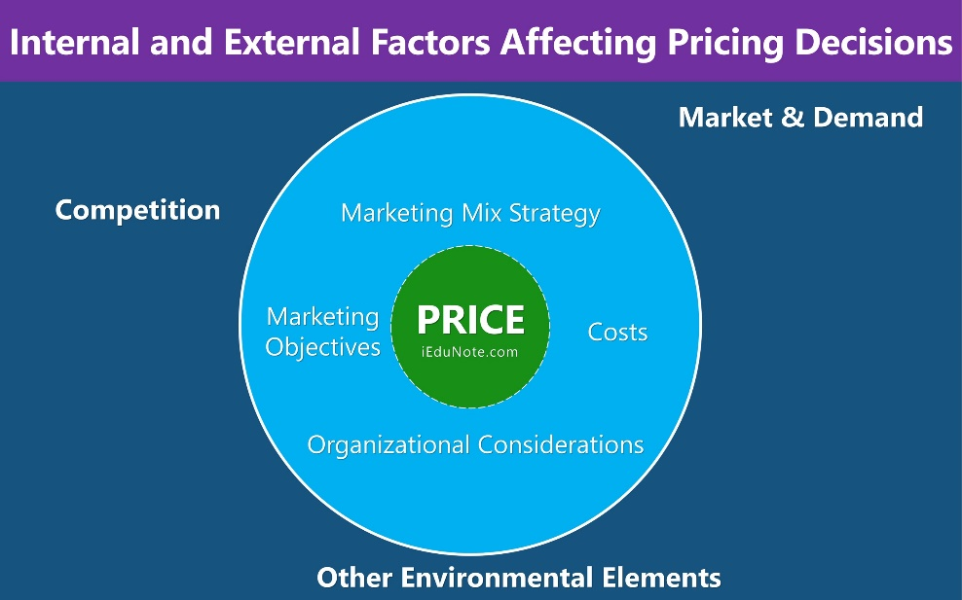
Source: https://www.iedunote.com/factors-affecting-price-decisions

Costs of production

The total cost of making a product, including raw materials, labor, and overhead costs, significantly affects the price. The company will need to ensure that the selling price will provide for all costs incurred, allowing for a profit at the end of the day.
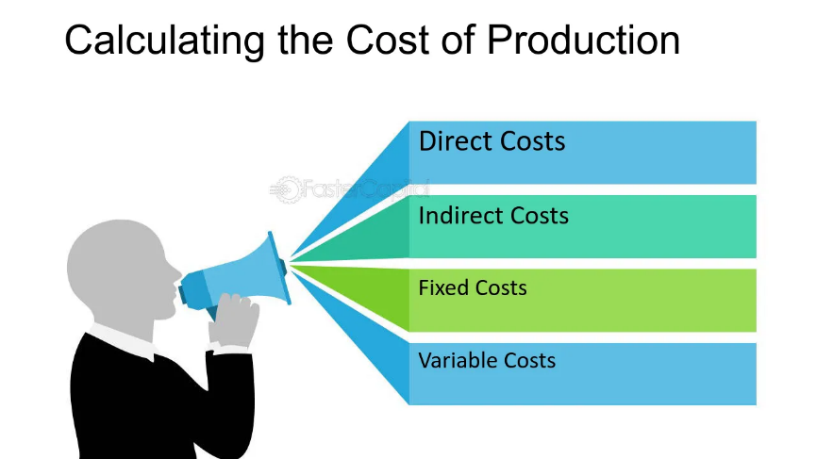

Market demand

High market demand always translates to higher prices, while low demand will lower prices to increase sales. Businesses forecast demand to modify pricing strategies.
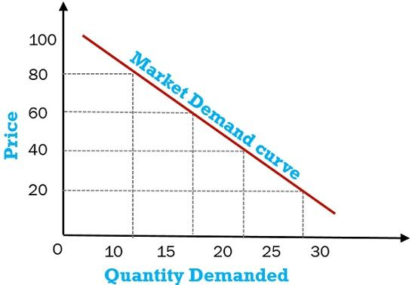

Competition

Competitor's prices have a great influence on how companies price their products. There are competitive pricing strategies, penetration pricing, and premium pricing.

Consumer perception and value
Perceived value dictates how much a customer will pay for a product. An expensive product must justify its price with quality, branding, or uniquely differentiated features.
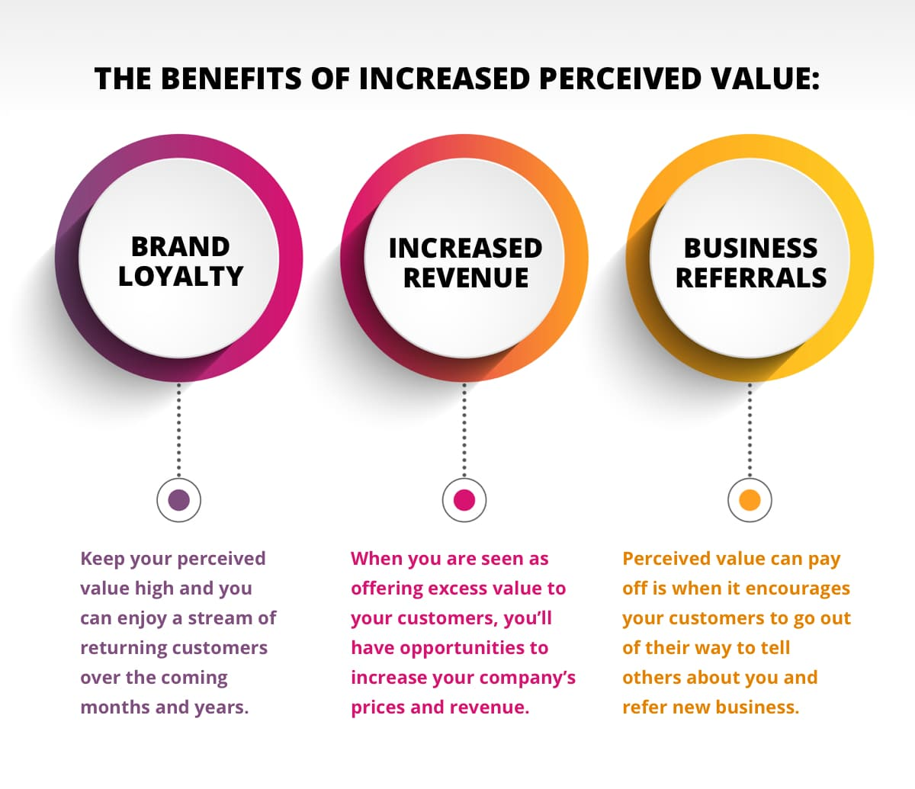
Source: https://www.sanctuarymg.com/academy/strategy/customer-perceived-value/

Economic environment

The effects of pricing decisions depend on inflation, recession, and consumer purchasing power. During economic downturns, a company may lower its price to entice buyers with minimal purchasing power.

Government Regulations and Taxes

Price controls, tariffs, and tax policies can affect the pricing. When deciding what price to charge for products, companies must follow various regulations.

Pricing Strategies in Marketing

Other pricing strategies used by businesses include those that differ according to market status, business aspirations, and consumer disposition.
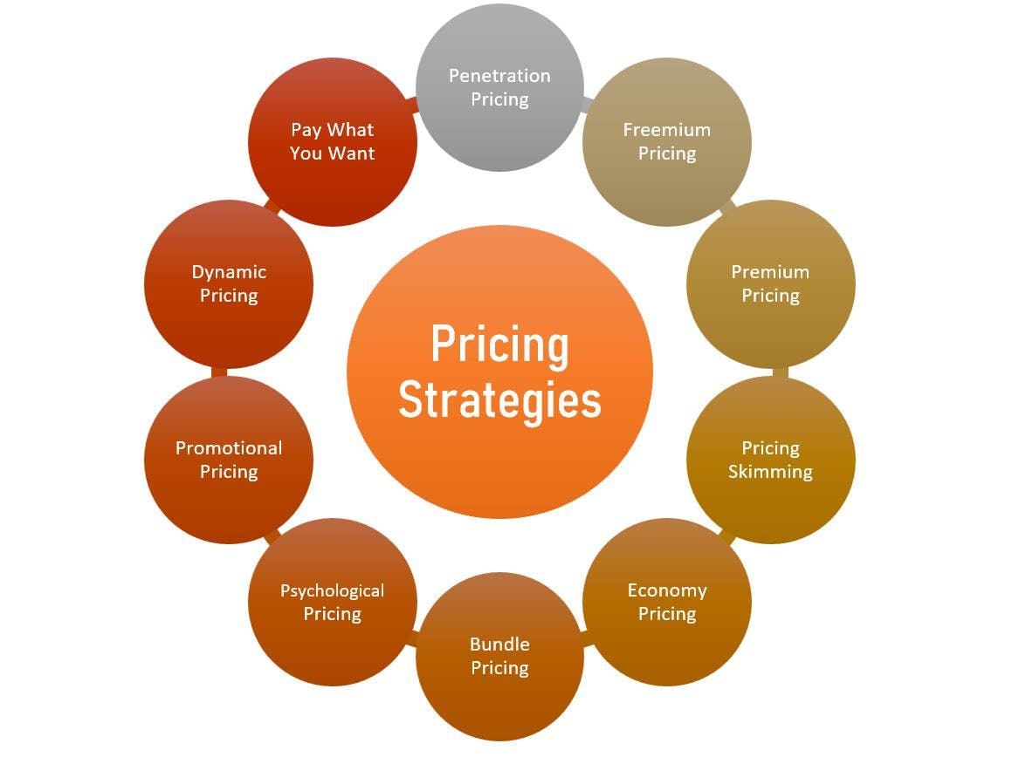
Source: https://awware.co/blog/pricing-strategy/

Cost-Based Pricing

The price is simply made by adding a specified margin of profit to the cost of production, which assures cost recovery and a fair profit; demand and competition are rarely taken into consideration.

Value-Based Pricing

Setting the price based on the perceived value of the brand to the consumer is a technique implemented by many businesses. Those who use this method prioritize what customers are willing to pay, as opposed to what it costs to produce.

Penetration Pricing

Prices are set extremely low during the product's introduction with an emphasis on capturing a larger market share. The price may rise as soon as a sizeable customer base is secured. This affordable strategy is usually associated with the introduction of new products (Aspara & Tikkanen, 2013).

Skimming Pricing

A high price at launch targets early adopters of the new product are willing to pay for it at that price this price is gradually decreased to attract mass market acceptance. Usually, a strategy that is common within the technology industry.

Competitive Pricing

Competitive pricing implies that prices are set after consultation with competitors. Businesses will either sell their products at lower, higher, or similar prices to the competition, just depending on the strategy they adopt.

Psychological Pricing

This pricing strategy uses psychological tactics to influence consumers. For example, instead of being priced at $10, the product appears as though it is on sale when it is priced at $9.99.

Bundle Pricing

More than one product is offered together at a discounted price, thus encouraging a consumer to buy more items. This pricing strategy is normally used in retailing and the software industry (Paranikas et al., 2015).

The Relationship between Price and Consumer Behaviour

There is often a strong correlation between price and consumer behavior. Price can influence buying decisions based on brand perception and customer loyalty.

Price Sensitivity

Depending on the particular purchase at hand, consumer behavior changes from one to another concerning price. Price-sensitive buyers always keep looking for the lowest price; whereas, others may resort to quality and brand reputation over the cost factor.
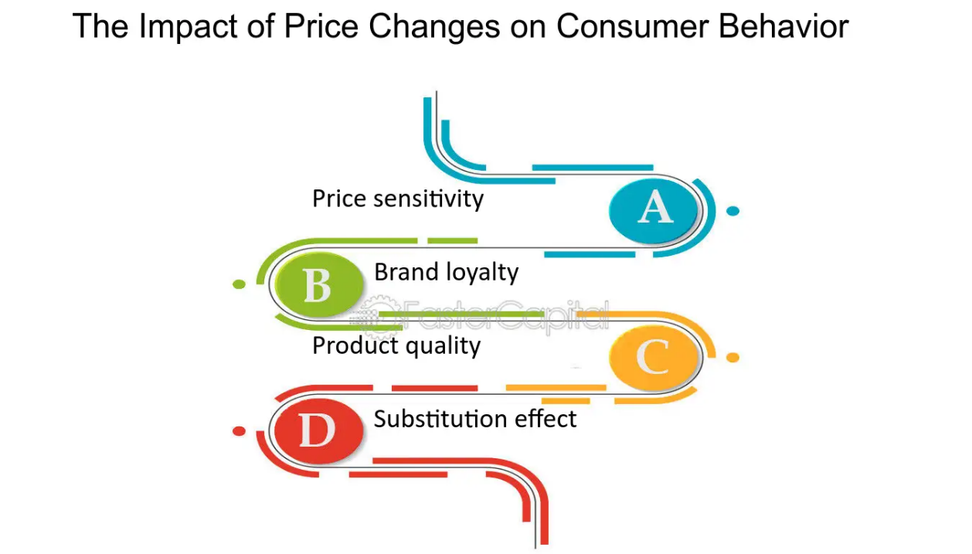
Source: https://fastercapital.com/topics/the-impact-of-price-changes-on-consumer-behavior.html

Price-Quality Perception

Consumers often associate higher prices with quality. Lower-priced articles are typically construed as inferior. Luxury brands take advantage of that perception by pricing intentionally higher than their competition.

Discounts and Promotions

Price reductions, discounts, and special offers spur urgency and assure immediacy with merchants. Seasonal discounts and limited-time offers are common salary strategies.

Reference Pricing

Consumers compare the price of one product with those of other similar products within the market. A product that is priced must exceed or below its competitors will have an impact on buying behavior (Gharpure & Ranade, 2019).

Pricing Strategy Problems

While pricing is a very important element of the marketing mix, companies face other challenges in making a pricing strategy.

Balancing Profitability and Market Share

Setting the highest price for a product may lead to maximum profit but lower sales volume. Lower prices appeal to customers but lower the profit margin. Thus, it is crucial to find a perfect balance (Trebicka & Tartaraj, 2023).

Managing Competitive Pressure

In competitive markets, firms must constantly keep track of rival pricing decisions, altering their strategies whenever necessary. Price wars erode profitability.

Customer Expectations and Price Fairness

Consumers expect a price that is fair according to the value of the product. Overpricing is likely to drive customers away while under-pricing will damage the brand image.

Variations in Global Pricing

Multinational companies must adapt their pricing according to local market conditions, currency fluctuations, and purchasing power differentials (Huang, 2024).

Discussion

Price is a very dynamic and complex component of a marketing mix that requires businesses to adopt flexible pricing strategies aligned with their objectives. Cost-based pricing guarantees profitability for businesses, whereas value-based pricing is solely linked to the customer's perception. The contingency of the effectiveness of the pricing strategy will depend on market conditions, competition, and consumer behavior (Abidin et al., 2023).
A good understanding of elasticities and the cyclical nature of demand will help maximize revenue through the appropriate pricing. The omnipresence of digital has introduced other pricing models such as dynamic pricing, where prices are continuously updated based on demand and consumer behavior (Gao, 2023).
Moreover, ethical considerations in pricing-such as fair pricing and transparency-are getting more priority. A false pricing claim puts one's reputation at stake and destroys customer trust.

Conclusion

Price is a key factor influencing business profits, consumer behavior, and market position. Companies must analyze very carefully market conditions, competition, and customers' expectations before setting prices. The method of pricing, whether cost-based pricing, penetration pricing, skimming pricing, or value-based pricing, plays an important role in achieving the goals and objectives of that organization's business ventures.
A proper pricing strategy will be grounded on brand perception, fidelity of customers, and longer-term profitability. However, competitive pressure, consumer expectations, and differences in pricing schemes worldwide are other areas of conundrum. New avenues for establishing dynamic and bespoke pricing strategies have opened up with the advent of digital marketing combined with e-commerce.
Finally, Price is more than a number; it's a strategic tool that makes or breaks consumer choices and market success. By employing a research-driven pricing approach, businesses gain a sustainable competitive advantage and build sustainable growth in the market.

References
Abidin, F. Z., Jamaluddin, A., Tanggamani, V. A., Nadia, S. A., & Sapari, A. (2023). Pricing strategies: Determining the best strategy to create a competitive advantage. International Journal of Academic Research in Business and Social Sciences, 13(6). https://doi.org/10.6007/ijarbss/v13-i6/17593
Gao, R. (2023). On the importance of pricing strategy in marketing strategy: A case study of lululemon. Frontiers in Business, Economics and Management, 10(1), 158–161. https://doi.org/10.54097/fbem.v10i1.10234
Huang, X., Lou, Z., Dai, X., & Luo, L. (2023). Pricing strategies for new product and remanufactured product considering emission sensitive demand. PloS One, 18(9), e0288225. https://doi.org/10.1371/journal.pone.0288225
Huang, Y. (2024). A review of research on pricing strategies and pricing factors of enterprise products. Frontiers in Business, Economics and Management, 15(1), 388–392. https://doi.org/10.54097/a2stnk37
Lee, H., Lee, D. I., Kim, T., & Lee, J. (2013). The moderating role of socio-semantic networks on online buzz diffusion. Journal of Business Research, 66(9), 1367–1374. https://doi.org/10.1016/j.jbusres.2012.02.038
Panagopoulos, N. G., & Avlonitis, G. J. (2010). Performance implications of sales strategy: The moderating effects of leadership and environment. International Journal of Research in Marketing, 27(1), 46–57. https://doi.org/10.1016/j.ijresmar.2009.11.001
Paranikas, P., Whiteford, G. P., Tevelson, B., & Belz, D. (2015). How to negotiate with powerful suppliers: A framework for assessing your strategic options. Harvard Business Review, 93(7/8), 90–98.
Rustemi, V. (2023). Referee report. For: Analyzing the relationship between pricing strategy and customer retention in hotels: A study in Albania [version 1; peer review: 2 approved, 1 not approved]. F1000 Research Limited. https://doi.org/10.5256/F1000RESEARCH.145667.R189945

