Employee Training, Development and Performance Management
Option 2 Report
M09 Human Resource Management
Detailed Project Report
Submission deadline: 24 May 2026

Contents
Abstract 2
Introduction 3
Literature Review 4
Methodology 8
Findings 9
Discussion 13
Recommendations 17
Conclusion 19
References 19
Appendices 21
Appendix A. Evidence based HR implementation checklist 21
Appendix B. Suggested structure for implementation review meetings 22

Abstract
This report examines employee training, development and performance management as a strategic system for workforce improvement. It argues that modern learning and performance systems must move beyond generic training calendars and annual appraisals toward an evidence based capability architecture. The analysis is grounded in the 2025 and 2026 context of artificial intelligence adoption, skill volatility, employee career anxiety and managerial overload. Recent workforce evidence shows that organizations need rapid reskilling, stronger career mobility and more frequent feedback if they want to maintain productivity and retention. The report uses a secondary qualitative methodology drawing on recent academic research, professional reports and corporate examples from Microsoft, LinkedIn, DBS Bank and Accenture style consulting environments. The findings show that training improves performance when it is linked to skill diagnostics, role based pathways, coaching, practice, transfer conditions and measurable work outcomes. Development improves long term capability when it includes career architecture, mentoring, internal mobility and leadership pipelines. Performance management improves motivation when goals are clear, feedback is continuous, rewards are credible and managers are trained to coach rather than merely rate. The report is critical of weak training metrics, inflated appraisal systems and reward schemes that prioritise short term output while damaging learning and trust. Recommendations include a 4 level capability evaluation model, AI skills academies, manager coaching standards, continuous performance conversations, transparent reward calibration and a performance dashboard that integrates skills, behaviour and business outcomes.

Introduction
Employee training, development and performance management are central to workforce improvement because they determine whether employees can adapt, perform and grow in line with organizational strategy. The issue has become more urgent in 2026 because work is being redesigned by artificial intelligence, hybrid collaboration, data intensive decision making and flatter career expectations. The World Economic Forum (2025) expects employers to make major investments in reskilling and workforce transformation across 2025 to 2030. LinkedIn Learning (2025) similarly presents AI skills and career development as connected priorities. This means that learning and performance management can no longer be treated as separate HR activities. They must operate as one capability system.
The assignment requires analysis of employee learning, skills development, career growth, coaching, mentoring, online learning, workshops, leadership development, appraisal, feedback, goal setting and rewards. This report addresses those requirements through a technical and critical lens. It argues that organizations often invest heavily in training but fail to generate measurable performance improvement because the training is not linked to work design, manager behaviour or reward systems. Similarly, organizations often have formal performance management processes but fail to improve motivation because goals are vague, ratings are politicised, feedback is delayed and rewards are not trusted.
A strategic approach starts with 3 questions. First, what capabilities are required by the organization’s future operating model? Second, how will employees acquire, practise and demonstrate those capabilities? Third, how will performance management reinforce behaviour change and long term growth? These questions matter because modern skills decay quickly. A technical skill that is valuable in 2024 can become insufficient by 2026 if work processes change. Equally, behavioural skills such as adaptability, collaboration, ethical judgment and conflict mitigation become more valuable when employees work with AI systems and cross functional teams.
The report is organised into a literature review, methodology, findings, discussion, conclusion, references and appendices. It uses recent research and corporate evidence to develop a practical model of workforce improvement. The focus is not to celebrate training as automatically beneficial. The focus is to identify when training, development and performance management create actual capability, and when they become costly rituals that satisfy HR process requirements but do not improve performance.

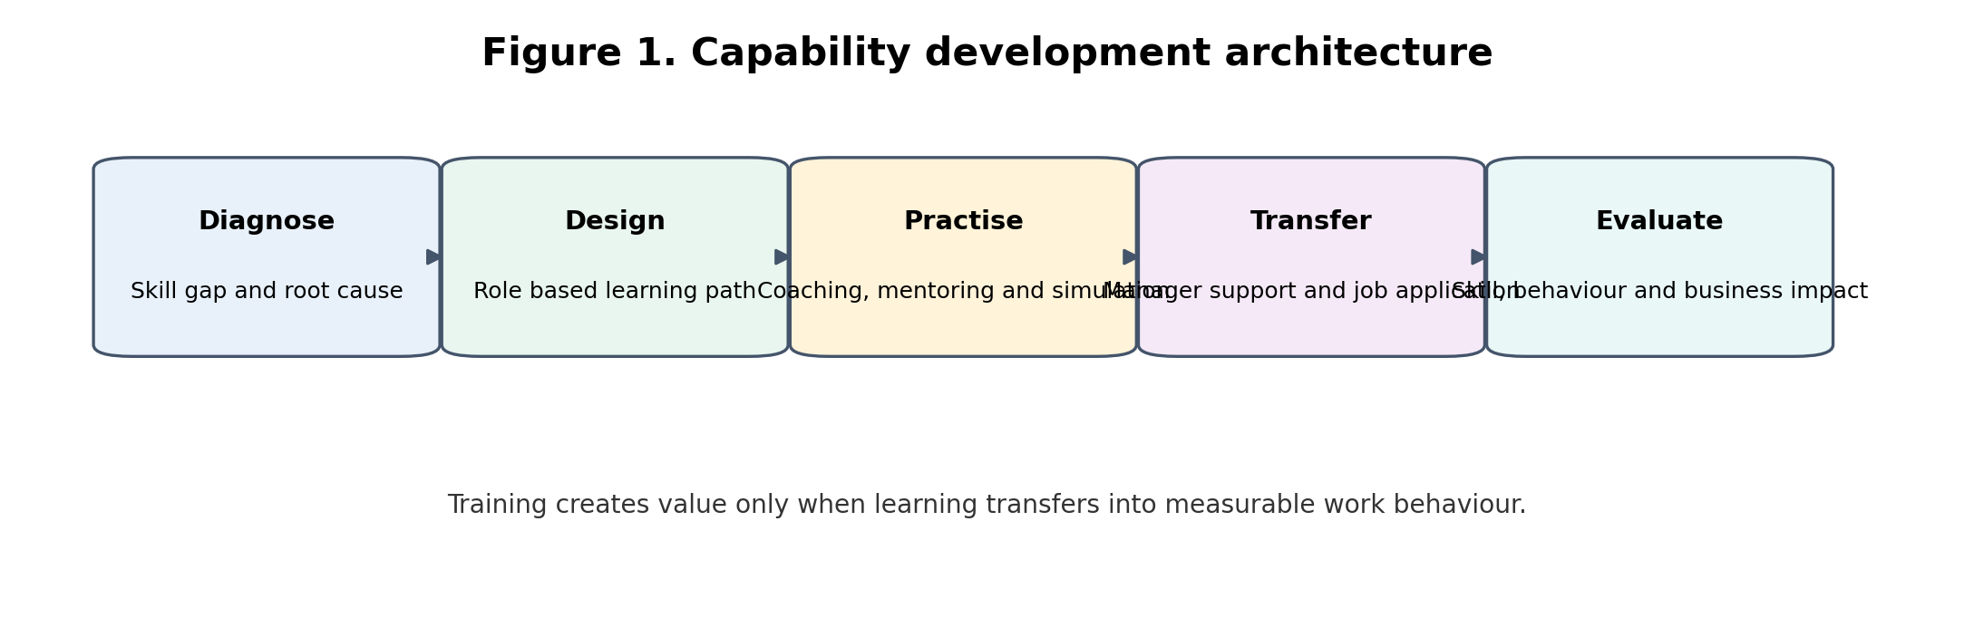
Figure 1. Capability development architecture

Literature Review
Training is the planned acquisition of knowledge, skills and behaviours required for current role performance. Development is broader and future oriented because it prepares employees for career progression, leadership, mobility and changing work demands. Performance management is the process of setting expectations, monitoring progress, providing feedback, evaluating contribution and connecting outcomes to rewards or development. In strategic HRM, these 3 functions are interdependent. Training without performance application creates unused knowledge. Development without career pathways creates frustration. Performance management without learning support creates pressure without capability.
Recent research supports the performance relevance of training and development. Hosen et al. (2023) find that training, career development and organizational commitment are associated with work performance. Li (2022) highlights reskilling and upskilling as essential to industry 4.0 readiness. These findings are important because they move the training discussion away from classroom delivery and toward capability renewal. Employees need structured opportunities to learn, practise and apply new skills. Organizations need evidence that learning investments change behaviour and support business outcomes.
The 2025 learning environment is shaped strongly by AI. Microsoft (2025a) identifies AI literacy as a critical skill for the future of work, while LinkedIn Learning (2025) emphasises the strategic connection between AI skills and career growth. However, AI training is not a single curriculum. Employees need differentiated learning based on role exposure and risk. A customer service employee may need AI assisted response quality and privacy awareness. A software engineer may need model integration, evaluation and secure deployment skills. A manager may need to understand how to redesign workflows, govern AI use and evaluate AI supported output. Strategic learning design must therefore be role based, not generic.
Coaching and mentoring are important because they bridge formal learning and work application. Coaching is usually performance focused and helps employees improve specific behaviours or outcomes. Mentoring is broader and supports career navigation, identity development and organizational socialisation. Both methods are valuable in environments where employees need contextual judgement rather than only technical knowledge. For example, employees can complete an online course on data analytics, but they often need coaching to interpret messy business data and mentoring to understand how analytics decisions affect stakeholders.
Online learning provides scale and flexibility, but it has weaknesses when used alone. Completion rates can be high while skill transfer remains low. Employees may click through modules without practising. Digital learning can also transfer responsibility for development onto employees while managers continue to overload them with work. Strategic online learning must therefore include diagnostic entry assessment, practice exercises, manager follow up and evidence of application. Workshops remain valuable where employees need interaction, feedback, scenario practice and group problem solving. Leadership development requires even deeper design because leadership behaviour is learned through feedback, reflection, role modelling and accountability.
Performance appraisal has been criticised because annual ratings often become retrospective and defensive. Yet organizations still need performance evaluation for accountability, development, reward decisions and succession planning. The issue is not whether performance should be managed. The issue is how. Goal setting theory suggests that clear, challenging and accepted goals improve performance, but only when employees have capability, resources and feedback. In practice, goals often become numeric targets that ignore work quality, collaboration and ethical behaviour. A strategic system should balance output goals, behavioural expectations and learning objectives.
Feedback is the central mechanism connecting performance management to improvement. Feedback works when it is timely, specific, behaviour focused and trusted. It fails when it is delayed until the annual review, when it is vague, or when employees believe the manager has already decided the rating. Continuous performance conversations reduce surprise and allow early correction. However, they require manager time and skill. Without manager training, continuous feedback can become continuous criticism or superficial check ins. Therefore, manager capability is the hidden infrastructure of performance management.
Rewards influence motivation but only under conditions of perceived fairness and controllability. Employees need to believe that rewards reflect real contribution and that they can influence the outcomes being assessed. If rewards are tied to targets affected by market conditions, poor system design or managerial favouritism, they can reduce motivation. Strategic reward systems should combine financial incentives, recognition, career opportunities and development access. The strongest systems do not reward only individual output because many modern tasks require collaboration. They also do not reward only team output because individual contribution can become invisible.
Career development has become a retention and capability issue. Employees increasingly expect visible growth pathways. LinkedIn Learning (2025) links career development to employee energy and organizational adaptability. A technical career architecture includes skill taxonomies, job families, proficiency levels, lateral moves, internal talent marketplaces and transparent promotion criteria. Without this architecture, organizations may lose employees who cannot see a future inside the firm even when they are satisfied with their current role.
The literature also highlights a persistent evaluation problem. Training is frequently evaluated through satisfaction surveys, while performance management is evaluated through completion rates. These metrics are weak. A more technical approach evaluates reaction, learning, behaviour transfer and business results. It also uses control groups or baseline comparisons where possible. For example, an AI productivity training programme should not only report attendance. It should measure pre and post proficiency, adoption quality, error reduction, cycle time improvement and employee confidence. This evidence is necessary to defend learning investment during budget pressure.
Table 1. Training and development methods by strategic use
Method | Best use | Technical risk | Control measure
Online learning | Scale basic knowledge and AI literacy | Completion without competence | Pre and post assessment plus manager follow up
Workshops | Practice communication, conflict and leadership scenarios | Event energy without transfer | Action plan and 30 day review
Coaching | Improve specific behaviour and performance barriers | Dependent on coach quality | Coach standards and outcome notes
Mentoring | Career navigation and social capital access | Informal access can be inequitable | Structured matching and participation audit
Leadership development | Build manager capability and culture delivery | Prestige programme without behaviour change | Team climate and attrition indicators

Methodology
This report uses a secondary qualitative methodology. Sources were selected from recent academic studies, professional workforce reports, and corporate public materials published mainly from 2022 to 2026. The method is appropriate because the task asks for a strategic paper and recommendations rather than primary empirical testing. The evidence is analysed thematically across 5 categories: employee learning, skills development, career growth, performance management and motivation.
The methodology follows 4 steps. First, the report identifies capability pressures from recent workforce reports, especially AI skills, career mobility and manager capability. Second, it evaluates training and development methods such as coaching, mentoring, online learning, workshops and leadership programmes. Third, it analyses how appraisal, feedback, goals and rewards influence motivation. Fourth, it develops strategic recommendations for improving performance and long term organizational capability. The approach is comparative rather than descriptive because it evaluates both strengths and limitations of each HR practice.
The main limitation is that public reports and corporate examples may not reveal internal failure rates or local implementation problems. The report therefore avoids assuming that all named organizations are best practice in every respect. The examples are used to illustrate mechanisms, not to claim perfect performance. The conclusion is based on convergence across sources and theoretical logic rather than direct causal measurement.

Findings
The first finding is that training improves performance only when it begins with a precise capability diagnosis. Organizations frequently start with a training calendar because it is visible and administratively easy. This can create activity without capability. A better approach starts by identifying performance gaps, skill gaps, work process gaps and behavioural gaps. For example, if customer complaints are increasing, the cause may be product complexity, weak systems, low staffing, poor communication or insufficient problem solving skill. Training is only appropriate if the root cause involves knowledge, skill or behaviour that can realistically be developed.
The second finding is that skill development now requires modular and role based design. Artificial intelligence has increased the difference between general awareness and applied proficiency. Employees may understand basic AI vocabulary but still lack the ability to evaluate AI output, protect confidential data, challenge biased recommendations or redesign a workflow. Microsoft (2025a) and LinkedIn Learning (2025) both show the strategic importance of AI literacy, but strategic learning requires segmentation by role. A senior manager needs AI governance and operating model insight. A frontline employee needs task support and escalation judgment. A data specialist needs technical validation capability.
The third finding is that career growth is a performance issue, not only a retention benefit. Employees invest more effort in learning when they can see how new skills connect to future opportunity. Career development increases the perceived return on learning. A skills taxonomy can make this visible by showing employees what proficiency level is required for progression. Internal mobility platforms can then match employees to projects, stretch assignments or vacancies. Without internal mobility, training can increase external employability and unintentionally accelerate turnover.
The fourth finding is that coaching and mentoring improve transfer because they add social context to learning. Formal courses provide knowledge, but employees often need feedback when applying knowledge to ambiguous situations. Coaching helps employees translate learning into role behaviour. Mentoring helps employees understand career options, political context and identity transitions. In leadership development, coaching is especially important because leaders may not notice the impact of their own behaviours. A workshop can introduce inclusive leadership, but coaching can help the manager recognise how interruption patterns or decision habits reduce psychological safety.
The fifth finding is that performance appraisal affects motivation through fairness, clarity and credibility. Employees are more motivated when they understand goals, receive feedback early, and believe the evaluation process is fair. They are less motivated when ratings appear inconsistent across managers or when outcomes depend on factors outside their control. Calibration panels can reduce inconsistency, but they can also become political if evidence is weak. Therefore, performance systems need observable criteria, documented examples and manager training in bias reduction.
The sixth finding is that rewards can reinforce learning or undermine it. If employees are rewarded only for short term output, they may avoid experimentation, mentoring or process improvement. If rewards include development contribution, knowledge sharing and team outcomes, employees are more likely to support organizational learning. However, reward systems must be simple enough to be understood. Overly complex incentive schemes create confusion and suspicion. The strategic design issue is to align rewards with the behaviours the organization actually needs.
The seventh finding is that manager capability is the bottleneck in both learning and performance management. HR can create learning platforms, appraisal forms and reward policies, but managers create the everyday learning climate. They allocate time for training, give feedback, approve internal mobility, support career conversations and interpret performance standards. If managers are overloaded or untrained, the system fails at delivery. Gallup (2026) and CIPD (2025a) indicate that manager quality is central to engagement and work experience. Therefore, management development should be treated as infrastructure, not as an optional leadership benefit.
The eighth finding is that training metrics are often misleading. Completion rate does not equal competence. Employee satisfaction does not equal behaviour change. A strategic evaluation model needs 4 levels: participation and reaction, knowledge or skill acquisition, workplace behaviour transfer, and business impact. For AI skills, business impact could include reduced cycle time, fewer errors, better quality assurance or improved customer response accuracy. For leadership development, impact could include engagement improvement, lower team attrition, faster onboarding and fewer employee relations escalations.
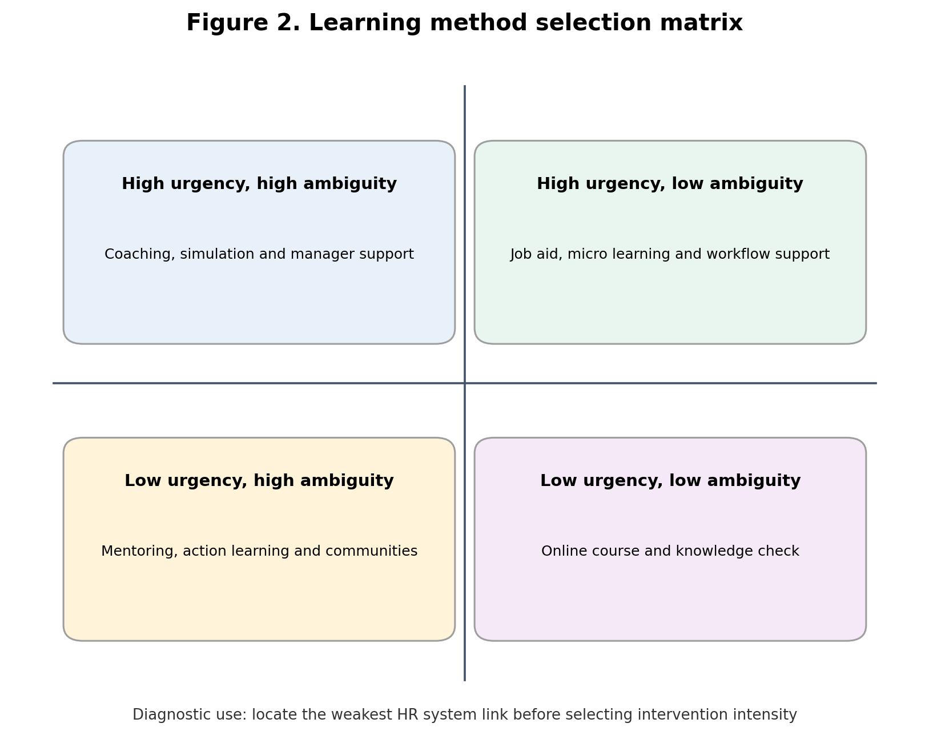
Figure 2. Learning method selection matrix
Table 2. Performance management dashboard
Dimension | Indicator | Interpretation | Action trigger
Goal quality | Percent of goals with measurable outcome and behaviour criteria | Shows clarity of direction | Below 85 percent requires manager coaching
Feedback cadence | Average documented check ins per quarter | Shows whether correction is timely | Low cadence in high risk teams triggers HR review
Rating integrity | Distribution by manager and demographic group | Shows possible bias or inflation | Outlier managers require calibration
Learning transfer | Post training application evidence | Shows whether learning changes work | Weak transfer requires job redesign or coaching
Reward credibility | Pay and bonus exceptions with documented reasons | Shows fairness and transparency | Unexplained variation triggers pay governance

Discussion
Training and development should be understood as a capability supply chain. The organization identifies strategic capability demand, diagnoses current supply, builds learning pathways, enables practice, measures transfer and updates workforce plans. When any link is missing, the system leaks value. For example, an organization may buy a high quality online learning platform but fail to protect learning time. Employees then complete modules outside working hours, perceive development as an additional burden, and apply little of the material. The technology is not the failure. The system design is the failure.
Microsoft’s AI skilling emphasis shows how training can support a strategic technology shift. The organization’s public materials link generative AI, digital learning and LinkedIn pathways to workforce transformation (Microsoft, 2025b). The positive lesson is that a firm cannot sell, build and implement AI enabled products if its own workforce lacks AI fluency. The critical limitation is that AI skill acquisition needs governance. Employees must not only learn how to use AI tools. They must also learn when not to use them, when to verify outputs, how to protect data and how to document human accountability.
LinkedIn Learning (2025) provides a useful evidence base because it connects learning with career growth and adaptability. The strategic implication is that learning departments should not only ask what courses employees need. They should ask what career moves, work redesigns and business capabilities the organization needs to enable. A high quality learning system should therefore be integrated with talent marketplaces, succession planning and workforce analytics. Otherwise, learning remains disconnected from mobility and business planning.
DBS Bank is often cited in management discussions as an example of digital transformation using skill building, agile practices and internal learning. The broader lesson for this report is that organizational transformation requires learning at multiple levels. Frontline employees need digital service capability. Managers need agile coaching and prioritisation skills. Senior leaders need portfolio governance and risk judgement. This multi level design is superior to one size fits all digital training. However, the risk is transformation fatigue. Employees can experience continuous learning as continuous inadequacy if the organization does not provide clarity, time and psychological safety.
Consulting and professional service organizations provide another useful lens because they rely heavily on human capital, knowledge transfer and performance differentiation. In these environments, coaching, mentoring and project based learning are critical because much expertise is tacit. Employees learn through exposure to clients, feedback from seniors and reflection on assignments. The risk is that high performance cultures can become burnout cultures if utilisation targets, travel demands and promotion pressure exceed human capacity. Therefore, performance management must include workload sustainability and wellbeing indicators, not only revenue and billable hours.
Online learning, workshops, coaching and mentoring should not be treated as competing methods. They are different mechanisms for different learning needs. Online learning is efficient for knowledge transmission and scalable skill awareness. Workshops are better for interaction, practice and shared problem solving. Coaching is best for behaviour adjustment and goal focused performance improvement. Mentoring is best for career growth and organizational navigation. Leadership development needs a blended architecture because leaders must acquire knowledge, practise behaviour, receive feedback and be held accountable over time.
A major criticism of training strategy is that many organizations confuse learning access with learning equity. Giving all employees access to a digital learning library appears democratic, but employees with more time, better managers and clearer career plans will benefit more. Employees in understaffed teams may be unable to use the resource. Strategic HR must therefore track learning participation and progression by role, manager, location and demographic group. If access is unequal in practice, learning investment can widen internal opportunity gaps.
Performance management should shift from annual judgement to continuous enablement. This does not mean removing accountability. It means making accountability timely, specific and developmental. A strong system should include quarterly goal reviews, monthly check ins for priority roles, evidence based feedback and mid cycle adjustment where strategy changes. It should also include clear distinction between development conversations and pay decisions. Employees need safe spaces to discuss skill gaps without assuming that honesty will automatically reduce their rating.
Rewards should reinforce both performance and learning. A purely individual incentive may be appropriate for sales roles where outputs are measurable and controllable. It is weaker for collaborative innovation or care work where results depend on team behaviour and quality. A balanced reward design can include individual objectives, team outcomes, skill certification, customer impact and values based behaviour. However, reward design must avoid excessive complexity. Employees should be able to explain in 2 minutes how contribution is evaluated and rewarded.
The biggest technical improvement is to implement a performance and capability dashboard. The dashboard should combine skills data, learning transfer, goal quality, feedback cadence, internal mobility, engagement, attrition and business outcomes. For example, if a department has high training completion but low skill assessment scores, the learning method may be weak. If a department has strong performance ratings but high turnover, managers may be over demanding or ratings may be inflated. If a department has low feedback cadence and low engagement, manager capability may be the priority intervention.
Organizations should also introduce learning governance. This includes prioritising learning investment according to strategic value, validating training vendors, defining proficiency levels, evaluating transfer and retiring obsolete programmes. Many training portfolios accumulate legacy courses that no longer match strategy. A learning governance board involving HR, business leaders, finance and risk can ensure that learning resources are allocated to the most important capability gaps. This also improves credibility when executives challenge the return on learning investment.
The final point is ethical. Training, development and performance management affect employee opportunity. If leadership programmes are allocated informally, if mentoring is available only to favoured employees, or if appraisal ratings reflect bias, the organization reproduces inequality. Strategic HRM must therefore audit access to development, promotion outcomes, rating distributions and reward decisions. Fairness is not only a legal concern. It is a performance concern because employees are less likely to commit to learning and improvement when they perceive the system as closed or biased.

Recommendations
Organizations should replace general training calendars with capability academies. Each academy should focus on a strategic capability such as AI literacy, customer analytics, leadership, project delivery or ethical decision making. Every academy should define entry level, working level and advanced proficiency. Employees should not simply attend courses. They should demonstrate skills through work samples, simulations, manager observation and applied projects. This creates a stronger link between learning investment and performance capability.
The learning function should introduce a transfer contract for important programmes. Before training, the manager and employee should agree why the learning matters, when practice will occur and what evidence will show transfer. After training, the manager should review application at 30, 60 and 90 days. This simple mechanism addresses one of the most common failures in workplace learning: employees complete training but return to work conditions that prevent behaviour change.
Performance management should be redesigned around continuous performance enablement. The recommended model includes quarterly goal setting, monthly feedback for priority roles, documented coaching notes, mid cycle calibration and annual reward decisions. Goals should combine output, behaviour and development criteria. This prevents employees from chasing numeric targets while ignoring collaboration, customer quality, ethical judgment or learning. Manager training is essential because weak feedback skill can turn frequent check ins into stress rather than support.
Rewards should be calibrated to reinforce both current contribution and future capability. Organizations should not reward only short term output because that can discourage mentoring, learning and process improvement. A balanced reward model should include individual delivery, team contribution, skill development, knowledge sharing and values based conduct. Reward exceptions should be documented and reviewed because unexplained exceptions damage trust. Transparent calibration improves motivation by showing employees that performance decisions are evidence based rather than political.
A learning and performance analytics dashboard should be implemented. The dashboard should connect skill gaps, learning participation, proficiency results, feedback frequency, performance ratings, internal mobility, engagement and turnover. HR should use the dashboard to diagnose system failure. For example, high learning participation with low performance improvement suggests weak transfer. High ratings with high turnover suggests rating inflation or unsustainable work pressure. Low mobility after training suggests blocked career pathways. This diagnostic approach is more useful than reporting training hours.

Conclusion
Training, development and performance management contribute to workforce improvement when they operate as an integrated capability system. The report shows that learning must begin with capability diagnosis, development must be connected to career growth, and performance management must provide clear goals, frequent feedback and credible rewards. The most effective systems combine online learning, workshops, coaching, mentoring and leadership development according to the capability being developed. They also measure transfer and business impact rather than relying on completion rates.
The main recommendation is that organizations should replace generic training calendars and annual appraisal rituals with a technical capability architecture. This architecture should include role based skill pathways, AI literacy standards, coaching protocols, mentoring access, career mobility, manager training, transparent calibration and a performance dashboard. In 2026, organizational capability depends not only on hiring talent but on continuously developing, directing and retaining it. Training and performance management are therefore not support activities. They are strategic controls for adaptability, motivation and long term competitiveness.

References
ADP Research. (2026). People at work: A global workforce view. https://in.adp.com/resources/insights/people-at-work.aspx
Arokiasamy, L. (2024). Role of HRM practices in organization performance. Journal of the International Council for Small Business, 5(2), 150 to 166. https://doi.org/10.1080/26437015.2024.2328342
Chen, Z. (2023). Ethics and discrimination in artificial intelligence enabled recruitment practices. Humanities and Social Sciences Communications, 10, 567. https://www.nature.com/articles/s41599-023-02079-x
CIPD. (2025a). Good Work Index 2025. https://www.cipd.org/uk/knowledge/reports/goodwork/
CIPD. (2025b). Resetting EDI and reaffirming inclusion. https://www.cipd.org/uk/knowledge/reports/Resetting-EDI-reaffirming-inclusion/
Deloitte. (2026). 2026 Global Human Capital Trends. https://www.deloitte.com/us/en/insights/topics/talent/human-capital-trends.html
Gallup. (2026). State of the Global Workplace 2026. https://www.gallup.com/workplace/349484/state-of-the-global-workplace.aspx
Hosen, S., Hamzah, S. R., Ismail, I. A., Noorman, N. H., Yusof, F. M., & Rahman, M. M. (2023). Training and development, career development, and organizational commitment as the predictors of work performance. Heliyon, 9(1), e12918. https://pmc.ncbi.nlm.nih.gov/articles/PMC10796978/
Li, L. (2022). Reskilling and upskilling the future ready workforce for industry 4.0 and beyond. Information Systems Frontiers, 24, 1451 to 1469. https://pmc.ncbi.nlm.nih.gov/articles/PMC9278314/
LinkedIn Learning. (2025). Workplace Learning Report 2025. https://business.linkedin.com/learn/resources/workplace-learning-report
Microsoft. (2025a). 2025 Work Trend Index Annual Report. https://www.microsoft.com/en-us/worklab/work-trend-index/2025-the-year-the-frontier-firm-is-born
Microsoft. (2025b). Annual Report 2025. https://www.microsoft.com/investor/reports/ar25/index.html
Nastase, C. (2025). Strategic human resource management in the digital era. Businesses, 5(4), 23. https://www.mdpi.com/2673-8104/5/4/23
OECD. (2025). AI and work. https://www.oecd.org/en/topics/sub-issues/ai-and-work.html
Sony, M. M. A. A. M. (2025). Bias in AI driven HRM systems: Investigating discrimination and legal accountability in employment decision making. Journal of Responsible Technology, 22, 100124. https://www.sciencedirect.com/science/article/pii/S2590291125008113
World Economic Forum. (2025). The Future of Jobs Report 2025. https://www.weforum.org/publications/the-future-of-jobs-report-2025/
Zhao, Z. (2025). Impact of ambidextrous human resource practices on employee innovation performance: The roles of inclusive leadership and psychological safety. Frontiers in Psychology, 16, 1491930. https://pmc.ncbi.nlm.nih.gov/articles/PMC12696671/

Appendices

Appendix A. Evidence based HR implementation checklist
Control area | Evidence to collect | Review frequency
Workforce planning | Critical role list, vacancy risk, skills gap and workload data | Quarterly
Recruitment fairness | Structured interview evidence, shortlist diversity and adverse impact check | Every campaign
Learning transfer | Pre and post skill assessment, manager observation and application evidence | 30, 60 and 90 days
Performance quality | Goal audit, feedback cadence and rating calibration by manager | Quarterly and annual
Retention risk | Regretted turnover, critical role turnover and stay interview themes | Monthly
Ethical governance | Privacy review, AI tool audit and grievance trend analysis | Quarterly

Appendix B. Suggested structure for implementation review meetings
The HR review meeting should begin with the strategic workforce risk dashboard. The agenda should prioritise decisions rather than updates. Each metric should be linked to a named owner, a target, an exception threshold and a corrective action.
The review should include one case example from a business unit where the HR system is working and one case example where the system is failing. This prevents the meeting from becoming a generic dashboard presentation and forces discussion of root causes.
The review should end with an action log showing the decision, responsible person, deadline and evidence required at the next review. This protects accountability and prevents HR recommendations from remaining aspirational.

