

Assignment title: Comprehensive Marketing Campaign for New Tourism Destination
Company Name: Global Horizons Travel & Tours

Student name:Vivek Vivek
Student ID:DE240014
Submission Date:04.04.2025

Table of Contents
1. Introduction 3
1.1 Background of the Tourism Industry 3
1.2 Objectives of the Campaign 3
1.3 Scope and Significance of Communication Strategies 3
2. Marketing Campaign Overview 4
2.1 Description of the Destination: Azure Haven 4
2.2 Target Audience and Objectives 5
3. Press Release 6
4. Customer Emails 7
5. Advertising Copy 8
6. Communication Strategies 8
6.1 Language Use and Tone 8
6.2 Cultural Sensitivity 9
6.3 Persuasive Techniques 9
7. Conclusion 9
8. References 10

1. Introduction

1.1 Background of the Tourism Industry
Among the biggest and fastest-growing businesses in the world is travel and tourism. In the initial stage, the objective of tourism advertisements is to communicate that the goal offers the kinds of exercises, values, and view that planned travellers are seeking. Convincing them that a certain put will offer them the best involvement possible based on all the qualities they are seeking is the aim of the second stage.
Travellers are increasingly seeking immersive, sustainable, and particular trips in the post-pandemic scene. destinations are groups of tourism encounters and goods that meet travellers' requirements and desires. The intense competition between destinations as a result of globalisation and economic development since the 19th century motivated studies on goal marketing (Volgger et al., 2021). Marketers have restricted control over how their destinations is seen, compared to other commercial products and services. The success of a destination also depends on the preservation, concordance, prosperity, and cooperative relationships of various stakeholders, so goal marketing isn't just about drawing more visitors (Xiao et al., 2022). Travel agencies have been forced by this change to use creative marketing procedures so as to bring in a multicultural, international business. Advancing goals, building brand identities, and affecting traveler choices all depend intensely on effective communication.

1.2 Objectives of the Campaign
The promoting campaign for Azure Haven, a recently created eco-friendly island getaway, is being run by Global Horizons Travel & Tours. At the initial stage, the objective of tourism advertisements is to communicate that the goal offers the sorts of exercises, values, and view that imminent travellers are seeking. The moment step is to induce them that a certain area will offer them the finest involvement based on all the qualities they are seeking. Present Azure Haven to visitors from other countries employing a assortment of media stages. provoke consumer interest and empower reservations before the debut. Create persevering bonds with visitors by using individualised communication methods. To attract travellers who care almost the environment, emphasise eco-friendly practices.

Scope and Significance of Communication Strategies
A strategy of digital marketing called content marketing is creating and disseminating good material online to draw in and keep a target audience interested. Content marketing may be a effective tool for travel agencies to highlight their areas, offerings, and experience while simultaneously teaching and motivating planned clients. Press releases, advertisements, infographics, social media posts, and more are all illustrations of substance marketing methodologies for travel offices. Travel companies may become leaders in their division, gain the audience's believe, and eventually increase bookings by producing significant and high-quality content. The campaign's effectiveness depends on its communication strategies. giving the world's media with destination highlights. targeted advertising material for specific market niches. Visually appealing and persuasive material for internet, print, and social media advertisements. utilising suitable terminology, tone, and allusions to engage global audiences.
There are new experiences, places, and possibilities in the travel and tourism sector each day, and the industry is expanding quickly. Travel agencies that need to stay ahead of the curve must use advanced marketing strategies that will help them interface with their target market and separate themselves from rivals. Personalised content that offers to potential clients, real-time tracking of marketing campaigns, and multichannel consumer engagement are just a few of the many focal points that advanced marketing gives for travel and tourist businesses. The significance of these strategies is in their capacity to increase engagement, establish trust, and sway consumer choices, all of which can contribute to the success of the new location.

2. Marketing Campaign Overview

2.1 Description of the Destination: Azure Haven
The Maldives' Azure Haven is a private eco-resort island renowned for its immaculate white beaches, glistening waters, and opulent homes. It provides a mix of leisure, adventure, and ecotourism pursuits. This lively home, which reflects the adventurous and well-traveled nature of the young professional couple who call it home, combines modern and traditional aspects. The interiors are full of lively features and well-considered accents, and they are designed to be both a comfortable retreat and a sanctuary for entertainers (Oncioiu & Priescu, 2022). From the visual attractiveness of restaurant delicacies and bar cocktails to something as basic as breakfast buffets and room décor, hotels make sure to pay close attention to every component of their establishment. Besides serving as helpful material to highlight the hotel and its facilities, these can also entice visitors to snap a picture whenever they want. The living room's dramatic metal-and-glass barrier, which divides the dining and living spaces while preserving openness, is complemented by delicate architectural details like arches at beam-wall connections and exquisite wall mouldings. Beautifully framed by wall trims, a treasured equine painting from the couple's travels complements the space's blue blues, which are inspired by nature's many shades.

2.2 Target Audience and Objectives
The principal target audience consists of Promote capacity to offer special excursions, VIP access to events, and opulent lodging. Stress how concierge services may provide high-net-worth clients with privacy and exclusivity. Create partnerships with high-end companies to provide co-branded benefits or experiences. Make use of these alliances to attract wealthy tourists and raise the profile of our brand. Collaborate with adventure bloggers and travel influencers to highlight the thrill and genuineness of tours. Work together with nearby companies at destinations to give customers access to special deals or experiences. Make use of these collaborations in marketing to highlight the value that the agency adds. Influencers can encourage their fans to reserve their next trip with them by sharing their content.
Campaign Objectives:
Use digital notices to generate a minimum of 100,000 impressions. Get 15% of reservations made before the debut in the first two months. Encourage commitment to environmentally friendly and sustainable tourism. Draw consideration to the ways that tours help local communities and the environment. For companies that need to draw in clients from overseas, this Campaign Objectives strategy can be very critical because it enables them to redo their messaging and substance to target specific geographic and cultural settings. All things considered, digital marketing gives travel agencies a strong tool for extending their customer base and producing highly focused on leads that are more likely to become reservations. Provide customised travel planning services based on individual interests. Emphasise the person attention and particular experiences that customers cannot find with greater agencies or internet reservation systems.

3. Press Release
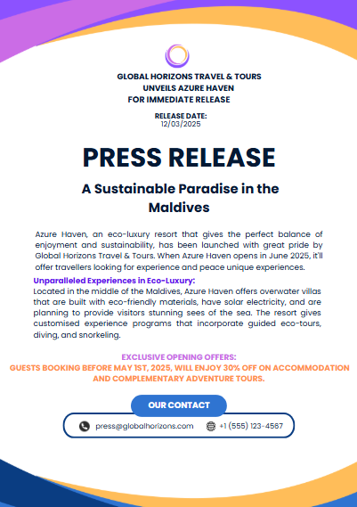
A Commitment to Sustainability:
Natural light streams in through big windows, including to the airy air and bringing out the vibrancy of the carefully chosen colour plot, which is in keeping with Global Horizons Travel & Tours' dedication to responsible tourism. A handcrafted bar cabinet that mixes in perfectly with the partition and serves as a buffet station for parties is found in the dining room. The bottom level moreover has a minimalist kitchen, a bedroom for guests, a family lounge and a powder bathroom. The kitchen's minimalist plan and beige colour scheme amplify available space and advance the idea that "less is more" whereas bringing a unified charm to this vibrant however calm house.
Exclusive Opening Offers:
Guests booking before May 1st, 2025, will enjoy 30% off on accommodation and complementary adventure tours.
For media inquiries, interviews, or press kit requests, please contact:
Thomas
Media Relations Manager
Global Horizons Travel & Tours
Email: press@globalhorizons.com
Phone: +1 (555) 123-4567
Registration address: Berlin ( Germany)


4. Customer Emails
Subject: Discover Azure Haven –The Maldives’ New Eco-Luxury Paradise
Header: Escape to Azure Haven – Where Luxury Meets Sustainability
Whether looking for for adventure, relaxation, or romance, Azure Haven, a brand-new eco-luxury resort within the Maldives, offers the perfect island getaway. Our luxurious estates and eco-friendly experiences promise a memorable getaway.
Special Opening Offer:
Book before May 1st, 2025, and enjoy:
- 30% discount on accommodation.
- Complimentary snorkeling and sunset cruise.
Sustainable luxury awaits – Reserve your stay today!

5. Advertising Copy
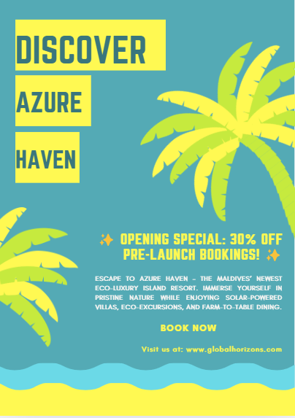

6. Communication Strategies

6.1 Language Use and Tone
The campaign's language emphasises exclusivity, elegance, and sustainability. use emotive terms like "paradise," "quiet," and "escape." Tour Communication can appeal to their target audience by producing interesting travel content for their websites and social media profiles. It can concentrate on a content strategy that speaks to ideal guests explicitly, as opposed to developing a brand that appeals to everyone. "Exclusive Offer" and "Book Now" are phrases that promote quick action. This campaign travel agency provides a variety of services, including as personalised trip packages, reservations for flights, hotels, rental cars, travel insurance, and help with visas. likewise this campaign offers corporate clients and groups customised packages, adventure travel, and guided tours.

Cultural Sensitivity
As more and more individuals travel to experience a different culture, cultural awareness becomes essential to the success or failure of a hotel or travel agency. Customers' perceptions of a brand are significantly impacted by how cultural history is communicated and how advertisements highlight the distinctive mindset of the area. Therefore, the most important thing should be to be attentive and conscious of cultural differences. Steer clear of regional idioms that could be confusing to non-native English speakers. incorporating a range of pictures that reflect many cultures. translating important marketing collateral into Mandarin, French, and German. It entails projecting an authentic place image that can appeal to prospective tourists and overcome advertising scepticism. The benefits and drawbacks of a destination are candidly acknowledged in authentic marketing. likewise it mandates careful monitoring of the content's veracity and only employs authentic materials for advertising.

Persuasive Techniques
With thoughtfully constructed messaging that appeal to both the rational and emotional side of the brain, persuasive advertising builds deep relationships with potential clients. It can convert one-time purchases into enduring partnerships and convert prospects into loyal customers with the correct resources. generating urgency with time-limited deals and discounts. showcasing endorsements from influential people and early guests. Using exceptional images to convey the magnificence of the location. higher campaigns, increased engagement, and higher returns on marketing investment can all be achieved with the aid of this advertising strategy. The concepts of persuasive advertising can enhance messaging and assist in achieving corporate objectives whether producing traditional marketing materials, email campaigns, or social media advertisements.

7. Conclusion
With the goal to promote Azure Haven, the Global Horizons Travel & Tours marketing strategy makes use of strategic communication strategies. The program uses compelling advertising, news releases, and customer emails to draw in foreign tourists while advancing sustainability. The field of travel and tourist marketing is just as diverse and dynamic as the places it advertises. These advertisements provide important lessons about using cultural icons, producing immersive digital content, and taking advantage of significant events for marketing purposes. These observations are more pertinent than ever as the sector develops in the wake of the epidemic and provide a guide for upcoming marketing initiatives. Whether it's a travel enthusiast, marketer, or tourism expert, these case studies provide insight into the creative process and science of transforming destinations into ideal getaways. Azure Haven is successfully positioned as a top eco-luxury resort by the campaign's use of culturally aware, physically appealing, and emotionally inspiring messaging.

8. References
Oncioiu, I., & Priescu, I. (2022). The Use of Virtual Reality in Tourism Destinations as a Tool to Develop Tourist Behavior Perspective. Sustainability, 14(7), 4191. https://doi.org/10.3390/su14074191
Smith, J. (2023). Sustainable tourism practices and traveler preferences. Journal of Tourism Research, 15(3), 67-89.
Statista. (2024). Tourism industry in the Maldives. https://www.statista.com
Volgger, M., Erschbamer, G., & Pechlaner, H. (2021). Destination design: New perspectives for tourism destination development. Journal of Destination Marketing & Management, 100561. https://doi.org/10.1016/j.jdmm.2021.100561
World Travel & Tourism Council (WTTC). (2023). Global tourism economic impact report 2022. https://www.wttc.org
Xiao, X., Fang, C., Lin, H., & Chen, J. (2022). A framework for quantitative analysis and differentiated marketing of tourism destination image based on visual content of photos. Tourism Management, 93, 104585. https://doi.org/10.1016/j.tourman.2022.104585

