

Title: - Customer Service Excellence in Multicultural Tourism Settings
Student name: - Ankit Tomar
Student ID: - DE240059
Submission date: - April 11, 2025

Table of Contents
1. Introduction 3
2. Cultural Sensitivity in Tourism 4
2.1 Defining Cultural Sensitivity 4
2.2 Examples of Cultural Misunderstandings 4
2.3 Practicing Respect, Empathy, and Avoiding Assumptions 4
2.4 Hofstede’s Cultural Dimensions 4
3. Effective Communication: Tone and Terminology 5
3.1 Professional Tone and Inclusive Language 5
3.2 Avoiding Idioms and Slang 5
3.3 Clear vs. Confusing Expressions 5
3.4 Phrasebook for Respectful Communication 6
4. Scripts for Common Customer Scenarios 7
4.1 Handling Inquiries 7
4.2 Handling Complaints 7
4.3 Difficult Situations 8
5. Training Recommendations 9
5.1 Training Delivery Methods 9
5.2 Language, Culture, and Empathy Skills 9
5.3 Ongoing Development and Feedback 9
5.4 Benefits for Staff and Business 10
6. Conclusion 10
References 11
Appendices 14

1. Introduction
The tourism industry relies on excellent customer service as an essential driver for business success which directly impacts visitor satisfaction and company recognition as well as renewed customer visits and positive spread of word (Chen & Yu, 2023). International visitors with different cultural backgrounds make up a growing percentage of customers in the global tourism market so front-line staff need to work with multicultural clients (Shiwen et al., 2021). Customers expect both efficiency friendliness and cultural awareness along with adaptability for excellent customer service.
The training system teaches tourism experts methods for official communication while also developing their skills for providing effective service to international guests (Fan et al., 2021). Staff members will improve their professionalism and empathy through professional interaction management when they understand how to manage tone along with terminology and appropriate cultural responses (Shiwen et al., 2021).
This research delves into cultural sensitivity practices in tourism and provides guidelines for communication as well as example dialogues and training plans for upgrading service quality in multiethnic tourism situations (Chen & Yu, 2023).

2. Cultural Sensitivity in Tourism
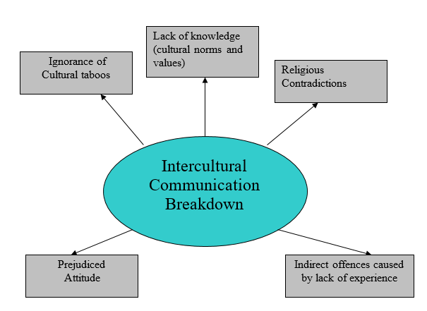
Figure 1. Intercultural Communication Breakdown
Source (Shiwen et al., 2021)

2.1 Defining Cultural Sensitivity
The concept of cultural sensitivity describes how people become aware and understand different cultural variations in values in addition to beliefs communication patterns and social behaviors (Hsiao et al., 2023). The tourism business requires service providers to detect international guests' cultural expectations and provide top-notch service through cultural adaptation (Fan et al., 2021). The practice of cultural sensitivity requires customers to set aside their belief of cultural superiority through ethnocentrism while showing sincerity towards learning from one another. Customer service representatives who function as destination ambassadors must perform this task because they typically represent the initial encounter with tourists (Shiwen et al., 2021).

2.2 Examples of Cultural Misunderstandings
Social miscommunication tends to develop because people ignore distinctive cultural principles. The thumbs-up gesture which Western culture views as positive becomes undesirable in specific Middle Eastern cultural environments (Hsiao et al., 2023). Varied interpretations of time exist between nations because punctuality counts as essential for Germany and Japan yet many Latin American and African communities embrace flexible timekeeping practices (Fan et al., 2021). Differences exist even with how people define their necessary personal boundaries. Personnel should avoid close body contact in Asian settings because this can seem intimidating but Mediterranean traditions accept friendly touches (Helena Margarida Alves et al., 2022).

2.3 Practicing Respect, Empathy, and Avoiding Assumptions
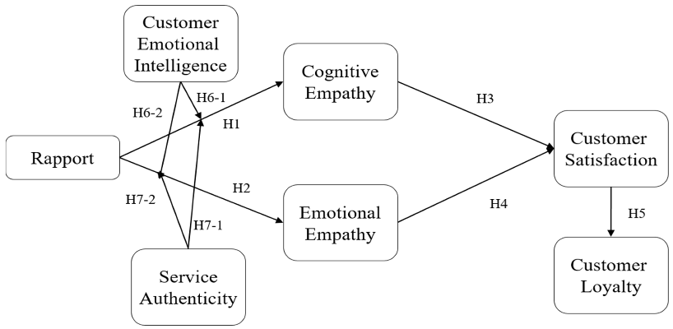
Figure 2. Building Customer Loyalty
Source (Wang et al., 2025)
Cultural sensitivity starts with showing respect to guests as each person brings value from their unique background. Staff members who deploy empathy skills can understand guest perspectives, particularly during those moments of unclear communication due to language differences or cultural customs (Chen & Yu, 2023). Employees need to refrain from making judgments about their guests through physical traits and spoken characteristics or peculiar behaviors. Providing basic English language-based assumptions or changing the treatment of solo female guests because of cultural bias generates negative guest experiences (Hsiao et al., 2023). Staff training must provide examples of respectful communication through open-ended dialogue combined with active listening and polite question-asking for effective engagement.

2.4 Hofstede’s Cultural Dimensions
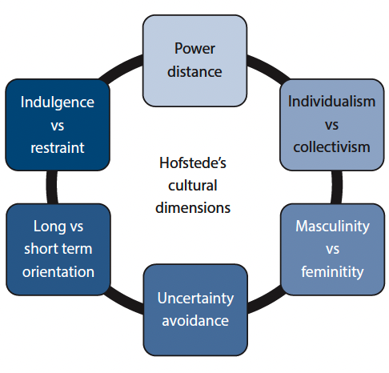
Figure 3. Hofstede’s Cultural Dimensions Theory
Source (Hosany et al., 2022)
The Cultural Dimensions Theory established by Geert Hofstede provides organizations with a valuable structure to understand cultural differences between societies. The model created by Hofstede features six descriptive dimensions which are Power Distance and Individualism vs. Collectivism and Masculinity vs. Femininity with Uncertainty Avoidance and Long-Term Orientation and Indulgence vs. Restraint (Helena Margarida Alves et al., 2022). Within cultures exhibiting high power distance norms, people expect formal hierarchical communication patterns since collectivist societies emphasize social unity through diminished individual assertiveness. The implementation of these cultural dimensional concepts by staff allows better anticipation of guest needs and corresponding adjustments that yield more satisfactory service encounters (Ayyildiz et al., 2023).

3. Effective Communication: Tone and Terminology

3.1 Professional Tone and Inclusive Language
When operating in multicultural tourism the maintenance of professional speech serves as a primary requirement for guest satisfaction and respectfulness. Staff maintain their professionalism through courteous behavior which remains calm and supportive no matter what challenges occur (Helena Margarida Alves et al., 2022). Staff must employ a tone of high professionalism while using non-specific language using terminology that never references local cultural terms which could offend or be confusing to international visitors. Hotel staff should use alternatives to gender-specific and informal terms by saying “everyone” and “guests” rather than “guys (Hosany et al., 2022).” When using inclusive language, one ensures that every individual from all backgrounds receives a welcoming reception.

3.2 Avoiding Idioms and Slang
English idioms and slang present significant comprehension challenges to speakers who are learning English as a second language. The usage of statements like "hit the road," "hang tight" as well as "give me a second" generates confusion for international guests who may incorrectly understand their meaning (Hosany et al., 2022). Staff members should deliver their communications in straightforward literal statements. The statement "We'll depart immediately" makes better sense than "Let's hit the road" and "Please wait a moment" provides easier comprehension than "Hang tight." The staff helps both understandability and misinterpretation reduction through their elimination of slang terminology and informal speech (Ayyildiz et al., 2023).

3.3 Clear vs. Confusing Expressions
Tourism professionals must be mindful of the language they use to explain services or respond to inquiries. Here are some comparisons:
  Confusing Expression
  Clear Alternative
  “You’re all set.”
  “Your reservation is confirmed.”
  “No worries.”
  “You’re welcome.”
  “It’s a piece of cake.”
  “It’s very easy.”
 | “We are currently very busy.”
  “We’re slammed right now.”

Table 1. Clear vs. Confusing Expressions
Source (Wei et al., 2022)
Idiomatic expressions along with slang require avoidance since they might result in misunderstandings when talking with international guests. Popular casual English expressions such as “You’re all set” or “No worries” remain ambiguous to speakers who have learned English as a secondary language (Hosany et al., 2022). Using simple phrases such as “Your reservation is confirmed” works better than the original statement and “You’re welcome” performs better than its original version to ensure understanding. The idiom "It's a piece of cake" does not render properly whereas simply saying "It's very easy" delivers the message effectively (Akram et al., 2024). Professionalism between cultures improves when staff uses direct phrases such as “We are currently very busy” rather than using casual language like “We’re slammed right now.”

3.4 Phrasebook for Respectful Communication
Providing staff with a phrasebook of respectful and helpful expressions can standardize communication and improve service quality. Here are some effective alternatives:
“Let me check that for you.” (instead of “I don’t know.”)
“Would you mind waiting a moment, please?” (instead of “Hold on.”)
“I understand your concern, and I’ll do my best to assist you.” (instead of “It’s not my fault.”)
“Is there anything else I can help you with today?” (instead of “Is that it?”)

4. Scripts for Common Customer Scenarios

4.1 Handling Inquiries
Scenario: A guest asks for directions to a nearby attraction.
Script
“Hello! I’d be happy to help. Address the city museum by moving forward two blocks and then turning left at the traffic light and you will see it on the right. The museum stands opposite the traffic light. Is a map needed or would you prefer me to draw the route on your phone?
Key Considerations
Guest inquiries need straightforward and uncomplicated English usage, particularly for staff working with international clients. Service personnel should refrain from using idioms together with slang expressions and technical terms which might confuse customers (Akram et al., 2024). Use a rate-of-speech that balances speed with comfort to build confidence for the guest regarding clarification requests. Supportive resources which include printed maps together with translation applications and imagery help both staff and guests better grasp the information (Wei et al., 2022). Open-ended and inclusive inquiry methods should be used when suggesting eating and visiting places to guests. For example: The question asks which type of cuisine you prefer local or international (Ayyildiz et al., 2023). The practice demonstrates acknowledgment of both cultural origins and individual preferences of your guests.

4.2 Handling Complaints
Scenario: A guest complains about a booking error and delayed check-in.
Script
I deeply regret the troubles you have encountered and I apologize wholeheartedly. The inconvenience certainly affects you deeply since you just reached your destination after traveling so long. I will confirm our system status to find a fast solution to your problem. Are you interested in resting at the lounge where you can have a complimentary beverage?
Cultural Note
Each society maintains a unique approach when expressing their dissatisfaction in various contexts. Attendants from the United States or Germany normally talk directly as they expect immediate responses. Guests from Japan together with Thailand and certain Middle Eastern nations deal with dissatisfaction in a delicate manner (Akram et al., 2024). People should watch for physical gestures and voice attributes along with subtle signals when assessing other individuals. The hotel workforce should present a composed front with compassionate attitudes directed toward quick resolution of issues (Fan, Tsaur, et al., 2021). Providing immediate comfort through seated relaxation or obtaining refreshments will simultaneously reduce their tension while demonstrating that their situation receives serious consideration (Wei et al., 2022).

4.3 Difficult Situations
Scenario: A guest becomes angry after a long wait for airport transport.
Script
Apologies arrive too late for the wait. I completely understand your frustration. We deeply value your waiting time as I confirmed shuttle arrival for five minutes from now. The shuttle will arrive in five minutes so have my permission to support you until it gets here and help with your baggage.
Body Language Tips
The importance of non-verbal communication equals verbal language during high-emotion situations. Staff members need to position themselves with open postures while keeping their hands relaxed and avoiding threatening gestures together with appropriate hand movements (Fan, Tsaur, et al., 2021). When maintaining eye contact, one should show respect while adjusting based on cultural protocol. Having a physical presence with guests helps them feel reassured about their priority needs as well as receiving assistance (Erose Sthapit et al., 2023).

5. Training Recommendations
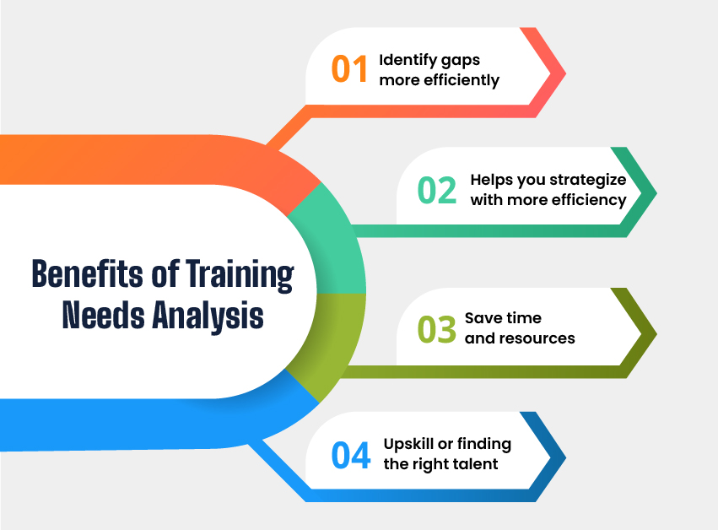
Figure 4. Benefits of Training Needs Analysis
Source (Abou-Shouk et al., 2024)

5.1 Training Delivery Methods
The training program must implement interactive and experiential practices to optimize learning outcomes and maintenance of information. Workshops serve as an optimal learning environment that supports both group discussions and scenario-based education (Fan, Tsaur, et al., 2021). Staff members benefit from role-play practice that helps them learn guest interactions while remaining in a secure training environment (Wei et al., 2022). Silent videos act as valuable tools when demonstrating proper procedures while ensuring standardized training completion throughout different locations (Santos et al., 2021). Training content includes common situations where learners compare good communication methods against ineffective ones. The mixed methodology supports the needs of different learners while developing pragmatic abilities through training methods (Erose Sthapit et al., 2023).

5.2 Language, Culture, and Empathy Skills
Tourism customer service excellence demands more than operational proficiency because it needs staff to demonstrate cultural understanding and adopt emotional competency (Amr Saad, 2022). The language curriculum should educate staff on standard speech patterns with an emphasis on pronunciation skills while developing their active listening abilities (Santos et al., 2021). All staff members need training to talk with non-native speakers through both slowness of speech and visual communication signals (Erose Sthapit et al., 2023). Major cultural norms regional taboos and hospitality expectations find their place in cultural awareness sessions delivered to staff members (Safaeimanesh et al., 2021). The hotel included empathy training with perspective exercises and reflective assignments which help employees establish authentic human connections when assisting stressed or emotional guests (Abou-Shouk et al., 2024).

5.3 Ongoing Development and Feedback
Training must happen as continuous activities rather than single occurrences. Staff must receive ongoing training sessions with on-site coaching as an essential method to keep their performance standards high (Amr Saad, 2022). Company managers need to deliver feedback that stems from client feedback and observational assessments as well as peer evaluations (Santos et al., 2021). A feedback-friendly environment enables staff to ask questions while learning from their mistakes and continuously advance their performance (Abou-Shouk et al., 2024). Internal platforms along with mobile applications can distribute information about communication techniques cultural developments and staff achievements to enable employee growth. Encouraging open dialogue fosters a culture of learning and support (Safaeimanesh et al., 2021).

5.4 Benefits for Staff and Business
High-quality customer service training results in quantifiable advantages for any business. Employee competency increases after training because it builds confidence and expertise resulting in better team performance along with lower employee departures (Abou-Shouk et al., 2024). Service providers who properly understand and honor their guests create more positive online feedback as well as future bookings and word-of-mouth recommendations (Safaeimanesh et al., 2021). A brand's worldwide reputation benefits when it provides culturally competent service and this establishes businesses as both welcoming to different cultures and skilled professionals. Trained staff result in satisfied employees who create loyal guests which leads to lasting achievement in tourism industry operations (Amr Saad, 2022).

6. Conclusion
In today’s diverse and global tourism industry, effective customer service hinges on clear communication, cultural awareness, and professional behavior. The report demonstrates the significance of using respectful speech with cultural sensitivity and demonstrating empathy during guest contact. Staff achieves service satisfaction for international guests through the implementation of scripts tone instructions and multipart training methods. Organizations must actively pursue continuous improvement as well as adaptability to preserve their service quality standards. The modifications in customer behavior patterns and changing demographics prompt tourism experts to develop new communication methods for their work. Staff members stay culturally sensitive and competent because of ongoing experimental practice together with feedback and specialized training. All organizations need to put into practice formal training about customer service that ensures suitable solutions for multicultural settings. Tourism business success together with improved staff morale results from such programs which in addition build guest loyalty and satisfaction and enhance the business's reputation.

References
Chen, X., & Yu, S. (2023). Synergizing Culture and Tourism Talents: Empowering Tourism Enterprises for Success. Journal of the Knowledge Economy. https://doi.org/10.1007/s13132-023-01598-x
Hsiao, A., Ma, E., Manfreda, A., Baker, M., & Xu, J. (2023). A social exchange perspective on boosting customer loyalty through culturally competent servers. Journal of Hospitality Marketing & Management, 32(4), 1–23. https://doi.org/10.1080/19368623.2023.2184439
Shiwen, L., Kwon, J., & Ahn, J. (2021). Self-Service Technology in the Hospitality and Tourism Settings: A Critical Review of the Literature. Journal of Hospitality & Tourism Research, 46(6), 109634802098763. https://doi.org/10.1177/1096348020987633
Fan, A., Van Hoof, H. B., Dou, X., & Serrano, A. L. (2021). The impact of linguistic style on customer satisfaction: A cross-cultural empirical study in Ecuador. International Hospitality Review, 37(1). https://doi.org/10.1108/ihr-04-2021-0028
Helena Margarida Alves, Sousa, B., Carvalho, A., Santos, V., Dias, Á., & Valeri, M. (2022). Encouraging Brand Attachment on Consumer Behaviour: Pet-friendly Tourism Segment. Journal of Tourism, Heritage & Services Marketing, 8(2). https://doi.org/10.5281/zenodo.7357978
Hosany, S., Sthapit, E., & Björk, P. (2022). Memorable tourism experience: A review and research agenda. Psychology & Marketing, 39(8), 1467–1486. https://doi.org/10.1002/mar.21665
Akram, U., Rambabu Lavuri, Bilal, M., Hameed, I., & Byun, J. (2024). Exploring the roles of green marketing tools and green motives on green purchase intention in sustainable tourism destinations: a cross-cultural study. Journal of Travel & Tourism Marketing, 41(4), 453–471. https://doi.org/10.1080/10548408.2023.2293022
Fan, D. X. F., Tsaur, S.-H., Lin, J.-H., Chang, T.-Y., & Tsai, Y.-R. (2021). Tourist Intercultural Competence: A Multidimensional Measurement and Its Impact on Tourist Active Participation and Memorable Cultural Experiences. Journal of Travel Research, 61(2), 004728752098237. https://doi.org/10.1177/0047287520982372
Santos, V., Ramos, P., Sousa, B., & Valeri, M. (2021). Towards a framework for the global wine tourism system. Journal of Organizational Change Management. https://doi.org/10.1108/jocm-11-2020-0362
Safaeimanesh, F., Kılıç, H., Alipour, H., & Safaeimanesh, S. (2021). Self-Service Technologies (SSTs)—The Next Frontier in Service Excellence: Implications for Tourism Industry. Sustainability, 13(5), 2604. https://doi.org/10.3390/su13052604
Abou-Shouk, M., Nagwa Zouair, Ayman Abdelhakim, Hany Roshdy, & Marwa Abdel-Jalil. (2024). The effect of immersive technologies on tourist satisfaction and loyalty: the mediating role of customer engagement and customer perceived value. International Journal of Contemporary Hospitality Management. https://doi.org/10.1108/ijchm-09-2023-1496
Amr Saad, D. E. (2022). Rural Tourism. International Journal of Modern Agriculture and Environment, 2(1), 45–56. https://doi.org/10.21608/ijmae.2023.214688.1001
Erose Sthapit, Garrod, B., Stone, M. J., Björk, P., & Song, H. (2023). Value co-destruction in tourism and hospitality: a systematic literature review and future research agenda. Journal of Travel & Tourism Marketing, 40(5), 363–382. https://doi.org/10.1080/10548408.2023.2255881
Wei, Z., Zhang, M., & Ming, Y. (2022). Understanding the effect of tourists’ attribute-level experiences on satisfaction – a cross-cultural study leveraging deep learning. Current Issues in Tourism, 1–17. https://doi.org/10.1080/13683500.2022.2030682
Ayyildiz, T., Ayyildiz, A. Y., & Koc, E. (2023). The illusion of control in service failure situations: customer satisfaction/dissatisfaction, complaints, and behavioral intentions. Current Psychology. https://doi.org/10.1007/s12144-023-04292-y
Wang, Y., Jin, Z.-J., Jin, C.-H., & Kan, C. (2025). Building Customer Loyalty Through Emotional Connection: How Service Provider Rapport Drives Sustainable Business. Sustainability, 17(6), 2396. https://doi.org/10.3390/su17062396

Appendices
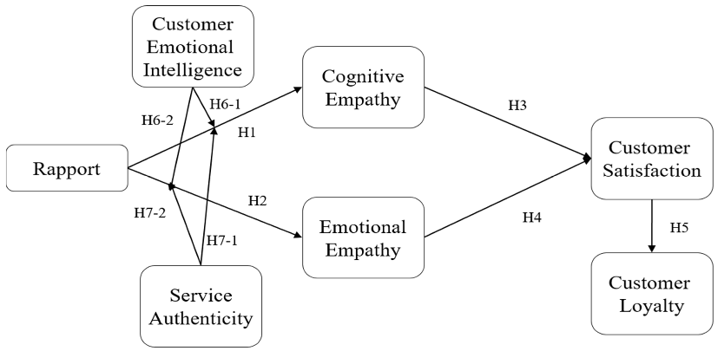
  Confusing Expression
  Clear Alternative
  “You’re all set.”
  “Your reservation is confirmed.”
  “No worries.”
  “You’re welcome.”
  “It’s a piece of cake.”
  “It’s very easy.”
 | “We are currently very busy.”
  “We’re slammed right now.”

