Employee Training, Development and Performance Management
M09 Human Resource Management
Assignment Option 2: Employee Training, Development and Performance Management
Student Name: ______________________________
Student ID: ________________________________
Module: Human Resource Management
Submission Date: 24 May 2026

Contents
Table of Contents 2
Abstract 3
Introduction 4
Literature Review 5
Methodology 10
Findings 11
Discussion 16
Conclusion 19
References 21
Appendices 23

Abstract
This report analyses the strategic role of employee training, development and performance management in workforce improvement. It argues that learning and performance systems are central to organizational capability because technological change, service complexity and labour market uncertainty require employees to update skills continuously. The report uses a secondary qualitative methodology based on academic theory, HRM literature, practitioner reports and real world examples from organizations investing in reskilling, coaching and career development. The analysis shows that effective training begins with capability diagnosis, not course delivery. Coaching, mentoring, e learning, workshops and leadership development each have value, but their impact depends on alignment with business goals, transfer to work and managerial support. Performance management is also examined as a developmental process involving goal setting, feedback, appraisal, rewards and career conversations. The report finds that traditional annual appraisals often fail because they are backward looking and perceived as unfair. More effective systems use continuous feedback, evidence based evaluation, employee participation and balanced reward mechanisms. The main recommendation is that organizations should integrate learning and performance management into one capability system. This system should identify skill gaps, provide varied development methods, support application through coaching, evaluate outcomes and connect rewards to both results and learning behaviour. Such an approach strengthens employee motivation, long term employability and organizational capability.

Introduction
Training, development and performance management are central to human resource management because they determine whether employees can meet present demands and prepare for future roles. In many organizations, the skills required for success are changing faster than job descriptions. Digital tools, artificial intelligence, automation, customer expectations and hybrid work have increased the need for continuous learning. The World Economic Forum (2025) identifies AI, big data, technological literacy, resilience, flexibility and lifelong learning as important growth areas for the future workforce. This means that organizations cannot depend only on external hiring. They must build internal capability through structured learning, career development and performance systems.
Employee training refers to planned activities that improve current job related knowledge and skills. Development is broader because it prepares employees for future responsibilities, career growth and changing organizational needs. Performance management is the process of setting goals, observing performance, providing feedback, assessing contribution and linking outcomes to rewards or development. These processes are often treated separately. Training is placed under learning and development, while performance appraisal is placed under line management or reward systems. This separation is a weakness. Employees learn best when development is connected to real performance expectations, and performance improves when employees receive the support and capability building needed to meet expectations.
This report examines the importance of employee learning, skills development and career growth. It discusses coaching, mentoring, e learning, workshops and leadership development. It analyses how appraisal, feedback, goal setting and rewards influence motivation. It also recommends HR strategies for improving employee performance and long term organizational capability. The argument is that training and performance management should be treated as an integrated workforce improvement system rather than a set of administrative activities. A strategic approach does not ask only how many employees attended training or completed appraisal forms. It asks whether employees gained capability, applied it at work and improved outcomes in ways that support organizational goals.
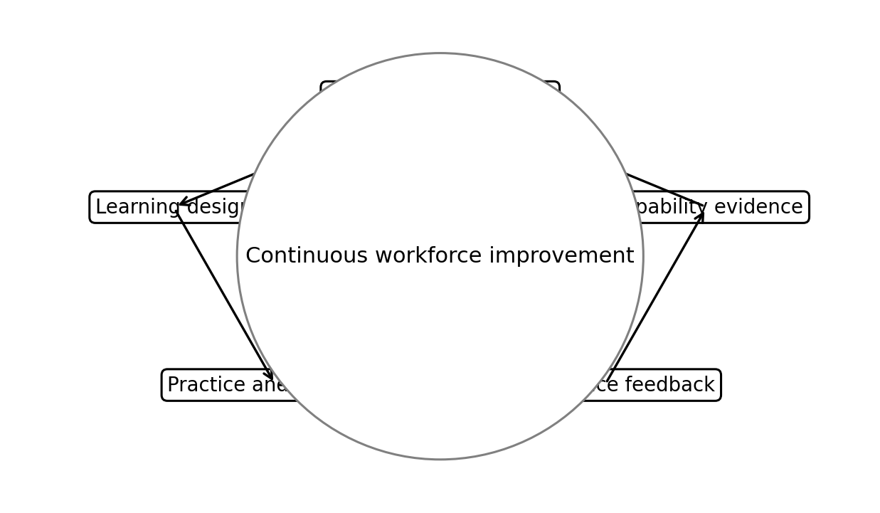
Figure 1. Conceptual model showing the report’s core HRM logic.

Literature Review
Human capital theory provides an important basis for understanding training and development. It suggests that investment in employee knowledge, skills and abilities can increase productivity and organizational value. However, training is not automatically valuable. Noe (2020) emphasizes that training effectiveness depends on needs assessment, learning design, transfer conditions and evaluation. A course may be popular, but it may not change behaviour if employees do not have time, support or opportunity to apply learning. This is why modern learning and development must be connected to business needs and performance evidence. The key question is not whether training occurred, but whether it solved a capability problem.
The distinction between training and development is essential. Training tends to focus on current role competence, such as using a system, complying with safety procedures or improving customer service. Development focuses on future potential, such as leadership, strategic thinking and career adaptability. Organizations need both. A workforce trained only for current routines may become efficient but inflexible. A workforce offered broad development without role relevance may lack immediate performance impact. The strategic challenge is to balance short term performance improvement with long term capability renewal. This is especially important where organizations face digital transformation and uncertain skill demands.
Adult learning theory suggests that employees learn more effectively when training is relevant, problem centred and connected to prior experience. Employees are not passive recipients of information. They bring work experience, motivation and practical constraints to learning. Effective learning design therefore uses active practice, reflection, feedback and application. E learning can deliver scalable content, but it may need discussion, simulation or coaching to create deeper behavioural change. Workshops can build shared understanding, but they may fade without follow up. Mentoring can support career growth, but its quality depends on mentor capability and trust. The best learning systems use blended methods because different learning goals require different approaches.
Coaching and mentoring are particularly important for development. Coaching is usually task or performance focused, using questioning, feedback and goal setting to improve capability. Mentoring is often broader and relationship based, helping employees understand career pathways, organizational culture and professional identity. Both methods support learning transfer because they occur near the work context. However, they also have risks. Poorly trained coaches may provide inconsistent guidance. Informal mentoring may reproduce exclusion if access depends on personal networks. Strategic HRM should therefore create structured, inclusive and evaluated coaching and mentoring systems rather than assuming that informal relationships will be fair or effective.
Performance management theory emphasizes goal clarity, feedback and motivation. Locke and Latham (2002) show that specific and challenging goals can improve performance when employees are committed and receive feedback. However, goal setting can become harmful if goals are unrealistic, narrow or disconnected from ethical behaviour. Employees may focus on measurable targets while ignoring teamwork, quality or customer wellbeing. Performance appraisal also has validity challenges because managers may be influenced by recency bias, similarity bias or halo effects. Aguinis (2019) argues that performance management should be a continuous process of communication and development rather than a once a year rating event.
Rewards influence motivation, but not always in simple ways. Pay, bonuses, promotions and recognition can encourage effort when they are perceived as fair and connected to contribution. Yet reward systems can also weaken intrinsic motivation, encourage gaming or increase unhealthy competition. Expectancy theory suggests that employees are motivated when they believe effort leads to performance, performance leads to outcomes and outcomes are valued. If appraisal systems are unclear or rewards are seen as politically allocated, motivation declines. Therefore, rewards should be transparent, proportionate and balanced with developmental feedback. Recognition of learning behaviour can also encourage employees to update skills rather than only deliver short term output.
Contemporary practitioner evidence supports the importance of learning and career development. LinkedIn Learning’s 2025 Workplace Learning Report emphasizes that career development, leadership training and internal mobility help organizations move skills to where they are needed (LinkedIn Learning, 2025). The World Economic Forum (2025) identifies major skill disruption across industries, implying that development systems are now strategic infrastructure. These sources align with academic theory by showing that workforce improvement is not an optional benefit. It is a response to environmental change. Organizations that cannot reskill employees may face capability gaps, reduced innovation and higher recruitment costs.
The literature also highlights the need to evaluate training and performance management critically. Kirkpatrick and Kirkpatrick (2016) propose 4 levels of training evaluation: reaction, learning, behaviour and results. Many organizations measure only satisfaction or attendance because these are easy to collect. Yet strategic value depends on behaviour and results. Similarly, performance management should be evaluated by fairness, goal alignment, employee understanding and developmental impact, not only completion rates. In summary, the literature supports an integrated model in which learning builds capability, performance management directs capability and rewards reinforce desired behaviour.
Learning culture is a key concept because it determines whether formal training becomes continuous improvement. A learning culture encourages employees to ask questions, share knowledge, experiment and reflect on mistakes. This is different from a training culture that counts course attendance. In a genuine learning culture, managers give employees time to learn, teams discuss lessons from work and leaders admit uncertainty when conditions change. Such a culture supports adaptability because employees do not wait for formal programmes before improving practice. However, culture must be supported by systems. Employees cannot be expected to learn continuously if workloads leave no time for reflection or if mistakes are punished harshly. HR therefore needs to align workload, leadership and performance expectations with learning goals.
Training transfer is one of the most important but often neglected issues in learning and development. Transfer means that employees apply what they learned to their actual jobs. Research and practice show that transfer depends on supervisor support, opportunity to practise, peer encouragement, job design and reinforcement after training. If employees return from a course to the same constraints, learning decays. For example, customer service training will not improve service if employees lack authority to solve customer problems. Leadership training will not change behaviour if senior leaders reward only short term numbers. Training design must therefore include before, during and after stages. Managers should agree learning goals before the programme, support practice afterwards and review progress in performance conversations.
Equity in development access is another important issue. Organizations often say that they support career growth, but high value development opportunities may be distributed informally to employees who are already visible to senior managers. This can reproduce inequality. Employees from minority groups, part time workers, remote workers or employees in operational roles may receive fewer stretch assignments and less sponsorship. Ethical learning and development should therefore monitor who receives training, coaching, mentoring and leadership opportunities. Fair development access supports inclusion and retention because employees are more likely to stay when they can see a credible future in the organization. Development is therefore both a capability issue and an equity issue.
Table 1
Comparison of Employee Development Methods
Method | Best use | Main limitation
Coaching | Individual performance improvement and transfer of learning | Depends heavily on manager skill and trust
Mentoring | Career development, inclusion and organizational socialization | Can reproduce informal network advantage if unstructured
E learning | Scalable knowledge delivery and compliance refreshers | May not create deep behavioural change alone
Workshops | Shared practice, discussion and collaborative problem solving | Can fade without follow up and workplace application
Leadership development | Manager capability, succession and culture change | Expensive if not connected to actual managerial accountability

Methodology
This report adopts a secondary qualitative methodology because the assignment requires conceptual analysis, evaluation of HRM methods and recommendations rather than primary data collection. The evidence base includes academic literature on training, development, adult learning, goal setting, performance management and motivation. It also uses current practitioner reports from LinkedIn Learning, the World Economic Forum and Deloitte to understand contemporary skill pressures. Real world examples are used selectively to illustrate how organizations apply learning and performance practices in practice.
The analysis was structured around 4 questions. First, why do employee learning and career growth matter for organizational capability? Second, how do different development methods contribute to skill improvement? Third, how do appraisal, feedback, goal setting and rewards influence motivation? Fourth, what HR strategies can integrate training and performance management into a coherent system? The answers were developed through comparison of theory and practice, with attention to both benefits and limitations. This prevents the report from treating any method, such as e learning or coaching, as universally effective.
The methodology has limitations. Secondary research cannot assess the actual learning culture inside a specific organization. Practitioner reports may also present broad trends that vary across sectors. To reduce these limitations, the report triangulates multiple source types and uses critical interpretation. Recommendations are therefore presented as principles that can be adapted rather than as fixed universal solutions. The analysis is most applicable to medium and large organizations where formal HR systems, training budgets and performance processes exist, although several recommendations can also be scaled for smaller organizations.

Findings
The first finding is that employee learning is now a strategic capability, not only an HR support activity. Skills become outdated when technology, regulations and customer expectations change. Organizations that do not invest in learning may depend excessively on external recruitment, which can be expensive and uncertain. Internal development allows organizations to preserve institutional knowledge while adding new capability. It also supports employee commitment because workers often value career growth. However, learning must be focused. A broad catalogue of courses can look impressive but have limited strategic effect if employees cannot see how learning connects to their roles, career goals and organizational priorities.
The second finding is that effective training begins with capability gap analysis. HR should identify current performance requirements, future strategic skills and the difference between existing and required capability. This can involve job analysis, manager interviews, employee surveys, performance data and skills inventories. Without this diagnosis, training may solve the wrong problem. For example, poor customer service may result from unclear authority or understaffing rather than lack of communication skills. A strategic learning system therefore asks whether the issue is knowledge, skill, motivation, resources, process design or leadership. Training is appropriate only when capability is the real constraint.
The third finding is that coaching improves performance when it is embedded in daily work. Coaching allows employees to receive timely feedback, reflect on challenges and adjust behaviour. It is useful for leadership, sales, service, project management and technical problem solving. The strategic value is that coaching supports transfer of learning from training to practice. However, coaching requires line manager capability. A manager who lacks listening skills or uses coaching as disguised criticism can damage trust. HR should therefore train managers in coaching methods, provide coaching frameworks and evaluate whether employees experience coaching as supportive and useful.
The fourth finding is that mentoring supports career development and retention. Mentoring helps employees understand informal organizational knowledge, career routes and professional expectations. It can be especially valuable for early career employees, employees from underrepresented groups and employees entering leadership pipelines. However, mentoring must be inclusive. If mentoring occurs only through informal networks, employees who already have social access benefit most. Structured mentoring programmes can reduce this risk by matching mentors and mentees transparently, providing objectives and monitoring outcomes. Mentoring should not replace fair promotion systems, but it can help employees prepare for opportunities.
The fifth finding is that e learning provides scale and flexibility, but it should not be treated as a complete solution. E learning works well for compliance content, technical refreshers, product knowledge and self paced learning. It is cost effective and can reach geographically dispersed employees. It also allows learning analytics, such as completion rates and assessment scores. However, e learning can become superficial if employees click through content without practice. For complex skills such as leadership, negotiation or ethical judgement, e learning is stronger when combined with simulations, peer discussion, coaching or live workshops. Blended learning is therefore more strategically useful than a purely digital catalogue.
The sixth finding is that leadership development is central to organizational capability because managers shape employee experience and performance. Leadership programmes should develop communication, decision making, inclusion, coaching, change management and ethical judgement. Many HR initiatives fail because line managers implement them poorly. A sophisticated performance system will not work if managers avoid difficult conversations or apply standards inconsistently. Leadership development should therefore be connected to actual managerial work. It should include practice, feedback, peer learning and accountability for people outcomes such as engagement, retention, wellbeing and team performance.
The seventh finding is that performance appraisal can motivate employees when it is fair, evidence based and developmental. Appraisal helps employees understand expectations and contribution. It can guide rewards, promotions and development plans. However, appraisal can demotivate employees when ratings appear arbitrary, biased or disconnected from work realities. Traditional annual reviews are especially weak because feedback arrives too late to improve behaviour. A stronger approach uses regular check ins, forward looking development conversations and multiple evidence sources. Appraisal should be a summary of ongoing conversations rather than a surprise judgement at the end of the year.
The eighth finding is that goal setting is powerful but must be balanced. Specific goals improve focus, while feedback helps employees adjust effort. However, narrow goals can create tunnel vision. For example, a call centre that rewards short call times may reduce service quality. A sales team that rewards revenue only may ignore ethical selling or customer suitability. Strategic performance management should therefore use balanced goals that include results, behaviours and learning. Goals should also be reviewed when business conditions change. This is particularly important in hybrid or project based work where tasks can shift quickly.
The ninth finding is that rewards affect motivation through fairness and meaning. Monetary rewards are important, but employees also respond to recognition, autonomy, development opportunities and career progression. Rewards should reinforce the behaviours that the organization actually wants. If teamwork is important, rewards should not be purely individual. If learning agility is important, performance systems should recognize skill development and knowledge sharing. Pay transparency and clear criteria also matter because perceived unfairness can weaken motivation. In this sense, reward is not only an economic mechanism. It is a signal of what the organization values.
The final finding is that training and performance management should be integrated into one continuous improvement system. Capability gaps should inform training priorities. Training outcomes should be discussed in performance conversations. Performance evidence should identify new development needs. Rewards should recognize both current contribution and growth behaviour. This integration prevents HR processes from becoming disconnected rituals. It also supports long term organizational capability because employees understand that development, performance and career progression are linked.
The tenth finding is that performance calibration improves fairness when used carefully. Calibration involves managers discussing performance ratings or assessments to reduce inconsistency across teams. It can help prevent one manager from rating too harshly while another rates too generously. It can also surface bias if certain groups are consistently rated lower without evidence. However, calibration can become political if senior voices dominate or if ratings are forced into a predetermined distribution. HR should therefore provide clear criteria, evidence requirements and bias checks. Calibration should improve decision quality, not simply adjust numbers to fit a budget or ranking curve.
The eleventh finding is that career pathways increase the value of training because they show employees how learning connects to progression. Employees may complete courses but feel little motivation if they cannot see how new skills affect their future. Clear pathways identify the capabilities required for lateral moves, promotion and specialist growth. This supports internal mobility and reduces dependency on external recruitment. Career pathways should include both managerial and technical routes because not all high performers want to manage people. They should also be transparent enough to reduce favouritism. When employees understand what is required for progression, development becomes more purposeful and performance conversations become more specific.
The twelfth finding is that leadership development should be evaluated through team outcomes rather than only participant satisfaction. Managers may enjoy a leadership programme and still fail to change team climate. HR should therefore assess whether leadership development improves feedback quality, retention, engagement, inclusion, performance clarity and wellbeing. This requires linking programme participation to people outcomes over time. The purpose is not to blame managers for every team issue, but to test whether leadership investment changes behaviour. This approach makes development more strategic because leadership capability is measured through its effect on employees and business execution.
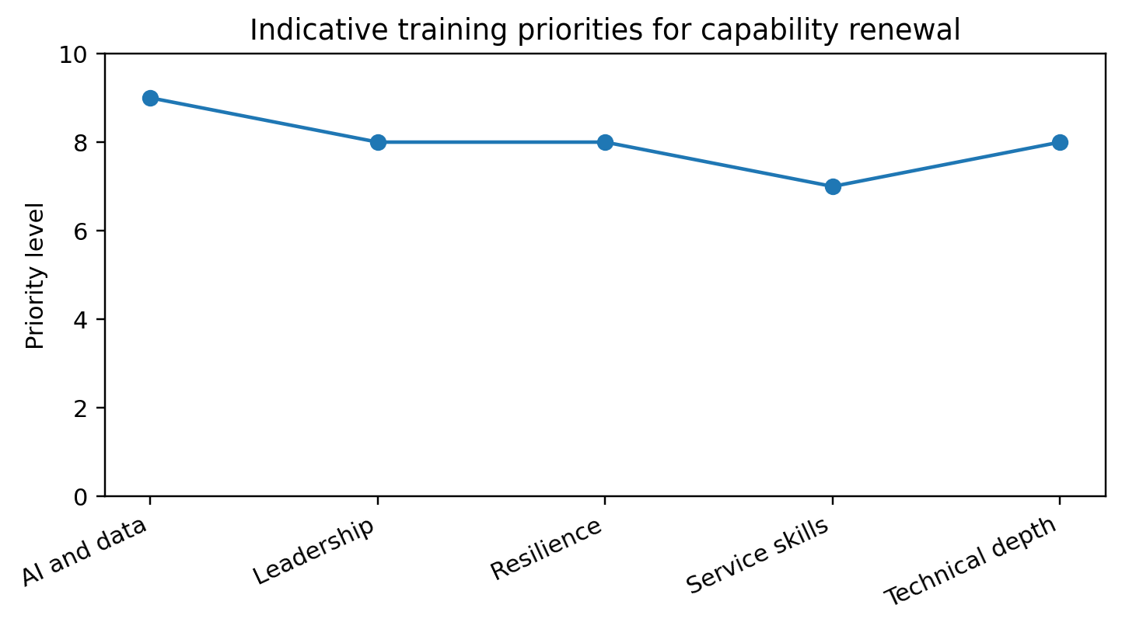
Figure 2. Indicative visual summary of key HRM priorities derived from the report analysis.
Table 2
Performance Management Improvement Framework
Stage | HR action | Expected workforce outcome
Goal setting | Create balanced goals covering results, behaviours and learning | Employees understand priorities and success standards
Feedback | Use regular check ins and coaching conversations | Employees can correct behaviour before formal review
Appraisal | Use evidence, calibration and transparent criteria | Improved fairness and acceptance of decisions
Reward | Connect pay, recognition and development to contribution | Greater motivation and clearer value signals
Review | Use performance data to identify training needs | Continuous capability renewal

Discussion
The analysis suggests that workforce improvement depends on connecting learning architecture with performance architecture. Many organizations invest in training but do not change the conditions that allow learning to transfer. Others demand performance improvement but do not provide employees with development support. Both approaches are incomplete. A strategic HR system should begin with capability diagnosis, select suitable learning methods, create opportunities to practice, provide feedback and measure work outcomes. This process turns training from an event into a performance intervention.
A major challenge is that learning outcomes are difficult to measure. Attendance and completion rates are simple, but they do not show behaviour change. Test scores may show knowledge, but not workplace application. Business results may be affected by many variables beyond training. The solution is not to ignore evaluation, but to use layered evidence. HR can measure learner reaction, knowledge gain, observed behaviour, manager feedback, productivity indicators and retention trends. These indicators should be interpreted together. For example, if employees enjoy a course but managers see no behaviour change, the issue may be transfer support rather than course quality.
Performance management also requires redesign. Employees increasingly expect regular feedback, career conversations and transparency. Annual appraisals often fail because they are too late, too bureaucratic and too focused on ratings. However, removing ratings without improving feedback quality can also create confusion. Organizations need a clear system that defines goals, behaviours, evidence, review frequency and reward links. The system should be simple enough for managers to use and robust enough to support fair decisions. This requires manager training because performance management quality depends heavily on line manager skill.
The relationship between rewards and motivation must be handled carefully. Rewards can focus attention and communicate priorities, but they can also create gaming and resentment. A balanced reward strategy should include fair base pay, performance recognition, career growth and non financial rewards. It should also recognize that employees differ in preferences. Some value promotion, others value flexibility, learning or stability. HR should therefore combine structured reward policies with individualized development planning. This supports both motivation and retention.
The report recommends 6 HR strategies. First, build a skills inventory that maps current and future capability needs. Second, use blended learning pathways that combine e learning, workshops, coaching and practice. Third, formalize mentoring to support career development and inclusion. Fourth, train managers to provide regular coaching and evidence based feedback. Fifth, redesign performance management around continuous conversations, balanced goals and fair evaluation. Sixth, evaluate learning through behaviour and business outcomes rather than attendance alone. These strategies would create a workforce improvement system that is more credible, measurable and aligned with long term organizational capability.
A significant implication is that organizations need to shift from job based training to skills based workforce planning. Traditional training is often attached to roles, but roles are changing quickly. A skills based approach identifies transferable capabilities such as data literacy, problem solving, customer empathy, project coordination and ethical judgement. Employees can then be developed for mobility across roles rather than only for their current job. This is useful when automation removes some tasks and creates new ones. HR can use skills taxonomies and internal talent marketplaces to match employees with projects, learning and career opportunities. However, this must be managed carefully so that employees are not expected to constantly reskill without support or recognition.
The report also suggests that performance management should explicitly recognize learning behaviour. If employees are judged only on current output, they may avoid time spent on development, experimentation and knowledge sharing. This is a problem when organizations need adaptability. Performance systems should therefore include goals related to skill growth, collaboration and improvement. For example, a manager might be assessed on developing successors or improving team capability. A technical employee might be recognized for sharing knowledge or applying a new tool effectively. This does not mean rewarding training attendance alone. It means rewarding evidence that learning has improved work.
A final practical issue is budget discipline. Learning and development budgets are often reduced during financial pressure because their benefits are less immediate than sales or cost reduction. This is short sighted when capability shortages are the reason performance is weak. HR should present training investment through business cases that connect learning to risk reduction, productivity, internal mobility and retention. For example, the cost of developing supervisors can be compared with the cost of turnover, grievance escalation and poor team performance. This does not mean every programme should be funded. It means learning priorities should be ranked by strategic importance, evidence of need and expected transfer. A disciplined learning portfolio is more convincing than a large catalogue of disconnected courses.

Conclusion
Training, development and performance management are strategic HRM processes because they determine whether employees can meet current demands and develop future capability. The report shows that learning is most valuable when it begins with capability gap analysis and is supported by coaching, mentoring, e learning, workshops and leadership development. It also shows that performance management improves motivation when goals are clear, feedback is regular, appraisal is fair and rewards are meaningful. The strongest approach integrates learning and performance management into a continuous system. Capability gaps inform training. Training supports performance. Performance evidence identifies new learning needs. Rewards reinforce contribution and growth. The report concludes that organizations should move beyond isolated training events and annual appraisals toward an evidence based capability system that supports employee development, motivation and long term organizational performance.

References
Aguinis, H. (2019). Performance management (4th ed.). Chicago Business Press.
Deloitte. (2025). Reinventing performance management processes will not automatically solve work performance. https://www.deloitte.com/us/en/insights/focus/human-capital-trends/2025/employee-performance-management-optimization-effective-strategy.html
Kirkpatrick, J. D., & Kirkpatrick, W. K. (2016). Kirkpatrick’s four levels of training evaluation. ATD Press.
LinkedIn Learning. (2025). 2025 workplace learning report. https://business.linkedin.com/learn/resources/workplace-learning-report
Locke, E. A., & Latham, G. P. (2002). Building a practically useful theory of goal setting and task motivation. American Psychologist, 57(9), 705-717. https://doi.org/10.1037/0003-066X.57.9.705
Noe, R. A. (2020). Employee training and development (8th ed.). McGraw-Hill Education.
World Economic Forum. (2025). The future of jobs report 2025. https://www.weforum.org/publications/the-future-of-jobs-report-2025/
Baldwin, T. T., & Ford, J. K. (1988). Transfer of training: A review and directions for future research. Personnel Psychology, 41(1), 63-105. https://doi.org/10.1111/j.1744-6570.1988.tb00632.x
Govaerts, N., Kyndt, E., Dochy, F., & Baert, H. (2011). Influence of learning and working climate on the retention of talented employees. Journal of Workplace Learning, 23(1), 35-55. https://doi.org/10.1108/13665621111097245

Appendices
Appendix A provides a sample training evaluation template using reaction, learning, behaviour and results. Appendix B provides a performance conversation checklist for line managers. These appendices translate the report recommendations into practical HR tools for implementation.
Appendix A
Training Evaluation Template
Evaluation level | Evidence to collect | Use of evidence
Reaction | Learner feedback on relevance and delivery | Improve design and facilitation
Learning | Assessment scores, demonstration or simulation | Confirm knowledge or skill acquisition
Behaviour | Manager observation and work samples | Check transfer to job performance
Results | Productivity, quality, customer or retention indicators | Assess strategic value and future investment
Equity | Participation and completion by employee group | Check inclusive access to development

