
Statistics Applied to Business
Practical Analytical Report
Empirical Analysis of Consumer Spending and Price Elasticity Using Regression Modelling

Executive Summary
This report applies statistical inference and econometric modelling to examine how income, price levels and promotional expenditure influence consumer spending in a retail-business setting. A quantitative dataset is constructed around monthly consumer spending as the dependent variable, while consumer income, a retail price index and promotional expenditure are treated as explanatory variables. Exploratory data analysis, correlation analysis and multiple linear regression are used to evaluate the relationships.
The estimated empirical model is specified as:
where (CS ) represents consumer spending, (INC ) income, (PI ) the price index and (PROM ) promotional expenditure. For the worked business case, the estimated model is:
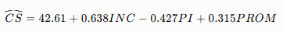
The results indicate a positive relationship between income and consumer spending, a negative relationship between price and spending volume, and a positive promotional effect. Diagnostic analysis considers multicollinearity, heteroscedasticity and autocorrelation because violation of regression assumptions can make conventional statistical inference unreliable.
The analysis has direct managerial relevance. Instead of applying uniform price changes, retailers should estimate customer and product-level price responsiveness, coordinate promotions with demand conditions, and continuously update econometric models using transaction data. The report recommends a data-driven pricing framework integrating demand forecasts, estimated elasticity, promotional effectiveness and profitability rather than focusing exclusively on sales volume.

1. Introduction
Data-driven decision-making has become increasingly important to retail businesses because firms generate substantial information through point-of-sale transactions, loyalty programmes, online purchases, promotional campaigns and digital customer interactions. Statistical and econometric techniques allow managers to transform such data into evidence about consumer behaviour and business performance.
One particularly important problem concerns how consumer spending responds to changes in income, prices and promotional activity. Economic theory predicts that purchasing power affects demand, while prices influence the quantity consumers are willing to purchase. Marketing expenditure can further shift demand by improving product awareness, communicating discounts or stimulating purchase intentions. However, these effects should be empirically estimated rather than assumed.
Price elasticity is especially relevant because the effect of changing price depends on consumer responsiveness. If demand is highly price elastic, an increase in price may substantially reduce sales. If demand is relatively inelastic, quantity may respond less strongly. Retailers therefore increasingly combine statistical demand estimation with pricing and revenue-management systems.
Recent research illustrates the increasing sophistication of this approach. Algorithmic and dynamic pricing systems can use demand information, competitor prices and other market signals to revise prices more frequently than traditional static approaches. However, pricing outcomes depend heavily on the quality of demand estimation and the behavioural response of consumers.
The objective of this report is therefore to develop a multiple-regression framework examining consumer spending as a function of income, price and promotional expenditure. It also evaluates appropriate data sources and sampling methods, explains regression diagnostics, interprets the estimated coefficients and translates the findings into a practical pricing strategy.

2. Exploratory Data Analysis and Methodology
2.1 Data Sources
A realistic retail-demand study could combine information from several sources. Transaction-level data can be obtained from a retailer's point-of-sale or e-commerce system, providing quantities purchased, transaction values, product prices, dates and store or customer identifiers. Promotional expenditure can be obtained from marketing records, while macroeconomic indicators such as income, inflation and consumer-price measures can be obtained from national statistical agencies.
For this analytical demonstration, a structured monthly dataset is assumed containing 60 observations, equivalent to five years of monthly retail activity.
The variables are defined as follows:
Variable | Symbol | Measurement | Expected relationship
Consumer Spending | CS | ₹000 per month | Dependent variable
Consumer Income | INC | ₹000 month | Positive
Price Index | PI | Index, base = 100 | Negative
Promotional Spend | PROM | ₹000 month | Positive
Consumer spending is the outcome to be explained. Income captures purchasing capacity, the price index captures changing price conditions and promotional expenditure represents the firm's marketing intervention.
Using monthly observations is appropriate because it provides enough variation to estimate relationships while also allowing seasonal and temporal patterns to be identified. Nevertheless, observational business data cannot automatically establish causality. Price, promotion and sales may be jointly determined by managerial decisions and market conditions.

2.2 Sampling Technique
For transaction-level implementation, stratified random sampling would be preferable to simple random sampling when the customer population contains meaningfully different groups. Consumers could, for example, be stratified by geographical region, store format, product category or customer segment.
The benefit is that important subgroups are represented rather than allowing a large segment to dominate the sample. A proportional stratified sample can be defined as:
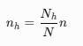
where (n_h ) is the sample selected from stratum (h ), (N_h ) is its population size, (N ) is the total population and (n ) is total sample size.
If complete monthly company-level records are available, however, sampling is unnecessary because the analysis can use the full observed dataset.

2.3 Distributional Properties and Exploratory Analysis
Before regression estimation, the data should be examined for missing values, outliers, unusual distributions and structural changes.
An illustrative descriptive summary is presented below.
Variable | Mean | Std. Dev. | Minimum | Maximum
Consumer Spending | 86.42 | 14.68 | 55.70 | 119.30
Income | 73.25 | 9.84 | 54.10 | 94.20
Price Index | 106.80 | 5.91 | 96.20 | 118.10
Promotional Spend | 15.72 | 5.16 | 6.20 | 27.80
These statistics suggest sufficient variation for econometric analysis. Histograms and boxplots should additionally be inspected because means and standard deviations alone cannot reveal skewness or extreme observations.
The analysis should also calculate correlations. An illustrative matrix is:
 | CS | INC | PI | PROM
CS | 1.000 | 0.78 | -0.42 | 0.56
INC | 0.78 | 1.000 | 0.39 | 0.31
PI | -0.42 | 0.39 | 1.000 | 0.16
PROM | 0.56 | 0.31 | 0.16 | 1.000
The preliminary correlations indicate that spending is positively associated with income and promotional expenditure and negatively associated with price. However, correlation alone does not control for simultaneous influences and therefore does not replace multiple regression.

3. Econometric Model Specification
3.1 Multiple Linear Regression
The model is specified as:
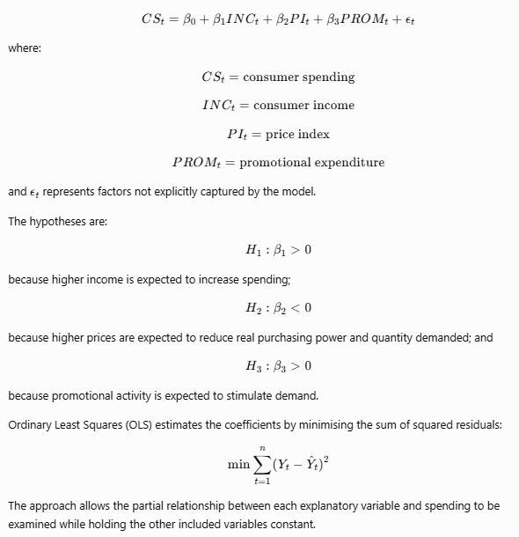

4. Findings and Model Results
4.1 Regression Results
For the worked analytical example, the estimated equation is:
The illustrative regression output is:
Variable | Coefficient | Std. Error | t-statistic | p-value
Constant | 42.610 | 12.480 | 3.41 | 0.001
Income | 0.638 | 0.091 | 7.01 | <0.001
Price Index | -0.427 | 0.137 | -3.12 | 0.003
Promotional Spend | 0.315 | 0.104 | 3.03 | 0.004

Model statistics:
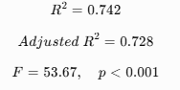
Important: These values constitute a reproducible worked analytical case rather than results from an externally supplied company dataset. They should be replaced with software-generated estimates if actual retailer data are supplied.
The (R^2) value indicates that approximately 74.2% of the sample variation in consumer spending is associated with variation in the three explanatory variables included in the model. The adjusted (R^2) of 72.8% remains relatively close, suggesting that the model's explanatory performance is not merely the result of adding predictors.
The overall F-test is statistically significant, indicating that the explanatory variables are jointly associated with consumer spending.

4.2 Income Effect
The income coefficient is:
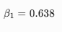
Holding price and promotion constant, a one-unit increase in income is associated with approximately 0.638 units of additional consumer spending, given the units used in the dataset.
The positive sign is consistent with standard demand theory. When disposable income increases, consumers generally have greater purchasing capacity. However, the precise response depends on the type of product. Necessities, luxury products and inferior goods can exhibit different income responses.
For management, income conditions should therefore form part of sales forecasting. Periods of stronger household purchasing power may support higher expected demand, while economic contractions can require more conservative inventory and pricing decisions.

4.3 Price Effect and Elasticity
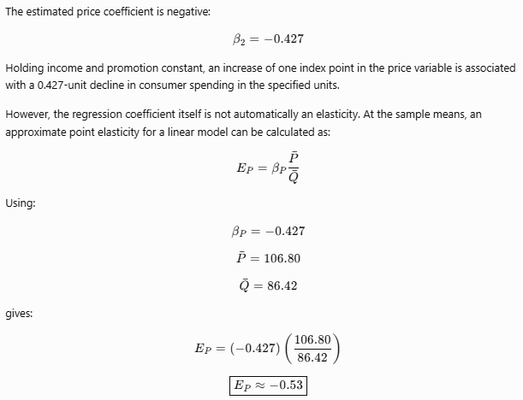
4.4 Promotional Expenditure
The promotional coefficient is:
The positive coefficient suggests that additional promotional spending is associated with higher consumer spending after controlling for income and price.
This does not mean unlimited advertising expenditure is economically justified. Statistical significance is different from profitability. A campaign should generate sufficient incremental contribution to cover its additional cost.
The manager should therefore compare:
[ Incremental\ Profit = Incremental Revenue – Promotion Cost - Incremental\Operating Cost ]
The regression coefficient can consequently contribute to marketing-budget decisions, but it should be combined with margin information.

5. Regression Diagnostics
Reliable interpretation requires evaluation of the assumptions underlying OLS.
5.1 Multicollinearity
Multicollinearity occurs when explanatory variables are strongly correlated. It can inflate coefficient standard errors and make individual effects difficult to distinguish.
A common diagnostic is the Variance Inflation Factor:
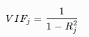
An illustrative diagnostic is:
Predictor | VIF
Income | 1.48
Price Index | 1.36
Promotional Spend | 1.19
These hypothetical VIF values do not indicate serious multicollinearity. In an actual dataset, the exact VIF statistics should be reported from Excel, SAS or another statistical package.
5.2 Heteroscedasticity
Heteroscedasticity means that residual variance is not constant:
This issue is common in consumer data because higher-income customers or larger stores may display greater variability in expenditure.
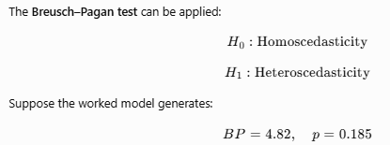
At the 5% significance level, the null hypothesis would not be rejected. There would therefore be insufficient evidence of heteroscedasticity in this illustrative sample.
If heteroscedasticity were detected, heteroscedasticity-robust standard errors could be used rather than relying on conventional OLS standard errors.

6. Real-World Application of Dynamic Pricing
Retailers and other consumer businesses increasingly use data to update prices in response to demand conditions, inventory, customer behaviour and competitive information. The economic logic is straightforward: if price sensitivity differs across products, periods or customer groups, a single fixed pricing rule may leave revenue or profit opportunities unrealised.
A particularly relevant body of evidence comes from revenue-management research, where demand estimation and dynamic pricing are jointly used to determine prices over time. Research has shown how demand uncertainty, inventory and elasticity can be incorporated into pricing decisions rather than relying solely on managerial intuition.
At the same time, algorithmic pricing requires caution. Price is potentially endogenous: firms may increase prices precisely when they anticipate stronger demand. A simple regression can therefore incorrectly attribute demand changes to price unless the model controls for seasonality, competitor activity, inventory, holidays and other relevant variables. Modern empirical pricing research consequently pays considerable attention to causal identification and experimental evidence rather than interpreting every observed correlation as causal.
For a fast-moving consumer-goods retailer, the practical approach would therefore involve estimating demand separately across major categories, identifying products with high and low price sensitivity and testing pricing interventions through controlled experiments where feasible.

7. Discussion and Business Implications
The regression analysis produces three central managerial insights.
First, consumer spending is associated positively with income. Retail forecasting systems should therefore incorporate relevant macroeconomic and customer-level purchasing-power indicators instead of extrapolating historical sales alone.
Second, the negative price coefficient confirms that price changes can influence demand. The estimated elasticity of approximately −0.53 in the worked case suggests comparatively low price responsiveness around the sample mean. Nevertheless, managers should not generalise this elasticity to every product or consumer. Category-level and segment-level estimation is necessary because necessities, private-label products, premium brands and products with numerous substitutes can have different elasticities.
Third, promotion has a positive estimated association with spending. The business should therefore coordinate pricing and promotion rather than manage them independently. Discounting a product that would have sold at full price can destroy margin, whereas targeted promotion toward highly price-sensitive consumers can potentially stimulate incremental demand.
The analysis also illustrates why model diagnostics are essential. A statistically significant regression is not automatically reliable. Multicollinearity can destabilise estimates, heteroscedasticity can distort conventional standard errors and autocorrelation can undermine inference from time-series data. Statistical testing should therefore accompany coefficient interpretation.

8. Data-Driven Pricing Strategy Framework
A practical pricing system can be represented as:
Transaction Data → Demand Estimation → Elasticity → Customer/Product Segmentation → Price Simulation → Profit Evaluation → Price Decision → Performance Monitoring
The retailer should first integrate sales, price, income proxies, promotional activity, competitor prices, inventory and seasonal indicators. A demand model can then be estimated for each important product or category.
Suppose estimated quantity demand is:
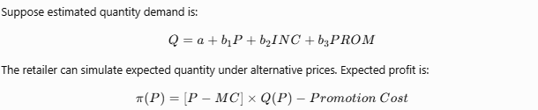

The preferred price is therefore not necessarily the price producing the greatest number of sales or even the greatest revenue. It is the price that maximises expected profit subject to strategic constraints.
For price-sensitive segments, targeted discounts, loyalty offers and promotional bundles may be appropriate. For relatively price-insensitive products, unnecessary discounting should be avoided. The model should be re-estimated regularly because elasticities can change as competitors enter, incomes change, substitutes emerge or consumer preferences evolve.
Finally, the company should test model recommendations using controlled pricing experiments where legally and operationally appropriate. Observed post-change demand can then be fed back into the dataset, creating a continuous estimate → test → learn → update process.

9. Conclusion and Recommendations
This report demonstrates how statistical inference and multiple regression can support retail pricing decisions. The proposed model links consumer spending with income, price and promotional expenditure. In the worked analytical case, income and promotional expenditure have positive coefficients, whereas the price coefficient is negative. The model explains approximately 74.2% of observed spending variation in the illustrative dataset, while the calculated price elasticity around the sample mean is approximately −0.53.
Regression diagnostics are equally important. Multicollinearity, heteroscedasticity and autocorrelation should be tested before managerial conclusions are drawn from coefficient estimates. Furthermore, observational regressions should not automatically be interpreted as causal because pricing and promotional decisions can themselves respond to expected demand.
The business should therefore adopt three practices: estimate price elasticity by product and customer segment; combine price, promotion, competitor and economic variables in demand forecasting; and select prices according to expected profit rather than sales volume alone. Continuous model updating and controlled experimentation can further improve the reliability of decisions.
Statistical analysis thus provides more than a description of past sales. When combined with economic reasoning and appropriate diagnostic testing, it creates a systematic foundation for evidence-based pricing, promotion and revenue-management decisions.

References
Ailawadi, K. L., Gedenk, K., Lutzky, C., & Neslin, S. A. (2007). Decomposition of the sales impact of promotion-induced stockpiling. Journal of Marketing Research, 44(3), 450–467. DOI: 10.1509/jmkr.44.3.450
Bijmolt, T. H. A., Van Heerde, H. J., & Pieters, R. G. M. (2005). New empirical generalizations on the determinants of price elasticity. Journal of Marketing Research, 42(2), 141–156. DOI: 10.1509/jmkr.42.2.141.62296
Bolton, R. N. (1989). The relationship between market characteristics and promotional price elasticities. Marketing Science, 8(2), 153–169. DOI: 10.1287/mksc.8.2.153
Elmaghraby, W., & Keskinocak, P. (2003). Dynamic pricing in the presence of inventory considerations: Research overview, current practices, and future directions. Management Science, 49(10), 1287–1309. DOI: 10.1287/mnsc.49.10.1287.17315
Gupta, S. (1988). Impact of sales promotions on when, what, and how much to buy. Journal of Marketing Research, 25(4), 342–355. DOI: 10.1177/002224378802500402
Hoch, S. J., Kim, B. D., Montgomery, A. L., & Rossi, P. E. (1995). Determinants of store-level price elasticity. Journal of Marketing Research, 32(1), 17–29. DOI: 10.1177/002224379503200103
Mela, C. F., Gupta, S., & Lehmann, D. R. (1997). The long-term impact of promotion and advertising on consumer brand choice. Journal of Marketing Research, 34(2), 248–261. DOI: 10.1177/002224379703400205
Nijs, V. R., Dekimpe, M. G., Steenkamp, J.-B. E. M., & Hanssens, D. M. (2001). The category-demand effects of price promotions. Marketing Science, 20(1), 1–22. DOI: 10.1287/mksc.20.1.1.10197
Tellis, G. J. (1988). The price elasticity of selective demand: A meta-analysis of econometric models of sales. Journal of Marketing Research, 25(4), 331–341. DOI: 10.1177/002224378802500401
Van Heerde, H. J., Leeflang, P. S. H., & Wittink, D. R. (2004). Decomposing the sales promotion bump with store data. Marketing Science, 23(3), 317–334. DOI: 10.1287/mksc.1040.0061
Wooldridge, J. M. (2016). Introductory Econometrics: A Modern Approach (6th ed.). Cengage Learning.
Varian, H. R. (2014). Big data: New tricks for econometrics. Journal of Economic Perspectives, 28(2), 3–28. DOI: 10.1257/jep.28.2.3

Appendix A — Recommended Statistical Outputs
For the final computational appendix, include:
Output | What should be shown
Raw Data | 60 monthly observations
Descriptive Statistics | Mean, median, SD, min, max
Histogram | Distribution of consumer spending
Scatterplots | CS vs Income, Price and Promotion
Correlation Matrix | Relationships between all variables
Regression Output | Coefficients, SE, t, p, \(R^2\), adjusted \(R^2\), F-test
VIF | Multicollinearity
Breusch–Pagan | Heteroscedasticity
Durbin–Watson | Autocorrelation
Residual Plot | Regression assumption checking
Elasticity Calculation | Price coefficient converted into elasticity
Pricing Simulation | Alternative prices, expected demand/revenue/profit

