Leadership Communication, Emotional Intelligence, and Team Performance
M05 Management and Communication Skills
Selected assignment option: Option 2, Leadership Communication, Emotional Intelligence, and Team Performance
Student Name: [Insert Student Name]
Student ID: [Insert Student ID]
Submission Deadline: 24 May 2026

Contents
Table of Contents 2
Abstract 2
1. Introduction 3
2. Literature Review 4
2.1 EI and managerial performance. 4
2.2 Performance mechanism of leadership communication. 5
2.3 Active listening, empathy, feedback and trust. 6
2.4 Psychological safety, team performance and conflict. 8
2.5 Change, stress and digital work leadership communication. 8
3. Methodology 9
4. Findings 11
4.1 EI enhances the leadership communication quality. 11
4.2 Leadership communication generates role clarity and shared meaning. 12
4.3 Listening and feedback will develop trust and learning. 13
4.4 Psychological safety aids voice, innovation and error correction. 14
4.5 Change communication must be transparent, emphatic and repetitive. 15
4.6 Digital communication enhances speed but may undermine quality of relations. 15
5. Discussion 16
6. Conclusion 18
7. Practical Recommendations 20
References 22
Appendices 25
Appendix A. Literature review search strategy 25
Appendix B. Applied communication framework for managers 25

Abstract
The report is a critical analysis of the role played by leadership communication and emotional intelligence in team performance in modern organisations. The main thesis is that high performing teams are not made by means of formal authority, technical competence, and performance targets only. They come about when managers are directional, active listeners, emotion regulators, trust builders, and when they create the environment where employees can talk, learn, challenge ideas and coordinate work under pressure. The report utilizes the emotional intelligence theory, transformational and relational leadership theory, psychological safety research, team conflict literature, and change communication scholarship. Qualitative secondary research approach is adopted, which relies on the scholarly literature and chosen organisational cases in technology and healthcare settings. The results indicate that emotional intelligence enhances the quality of managerial communication through the enhancement of self awareness, empathy, feedback and conflict management. The communication between leaders enhances performance when it is clear, meaningful, inclusive and disciplined feedback loops. The report however claims that emotional intelligence is at other times over-rated when it is considered as an individual trait of charisma as opposed to being a practical capacity that is entrenched within systems, norms and accountability. The most powerful conclusion is that managers must integrate emotionally intelligent behaviour and open communication practices, organized listening procedures, psychologically secure meetings, equitable conflict procedures and cautious online communications. Individual leadership behaviour and organisational communication design interrelate to team performance.

1. Introduction
Organisations are becoming more reliant on cross functional, culturally diverse, digitally connected and exposed to constant change teams. In this context, management does not merely have the role of distributing tasks and overseeing outputs. Before it can harm performance, managers need to create a shared meaning of strategy, address uncertainty, coordinate interdependent work, motivate workers and address interpersonal tensions. Communication thus becomes an essential management process as opposed to soft accessory to technical decision making. This report is devoted to the second option of the assignment, which is related to the leadership communication, emotional intelligence and team performance.
The issue is significant since most of the organisational issues that seem to be operational are in part communication issues. Low morale, role confusion, resistance to change, undisclosed errors, duplicated work and unresolved conflict are common occurrences where employees lack the understanding of priorities, lack trust with leaders or do not feel safe enough to express their concerns. On the other hand, alignment, lessening of uncertainty and enhancing engagement can be achieved through clear and emotionally intelligent communication. Psychological safety studies indicate that teams have a higher learning rate when the members are convinced that they will not be embarrassed or punished after speaking up (Edmondson, 1999; Edmondson and Lei, 2014). It does not imply that managers need not have tough conversations. It implies that the performance conversations should be straightforward, respectful and factual.
Emotional intelligence is applicable since managers do not just speak, but also use tone, timing, listening behaviour and emotional control to communicate. Mayer, Salovey and Caruso (2008) define emotional intelligence as the ability to perceive, use, understand and manage emotions. In managerial practice this entails being able to pick up on emotional signals, to manage own responses, to read the emotional climate of a team and to act in a manner that facilitates positive action. Emotional intelligence as a leadership ability was popularised by Goleman (1998), although scholarly studies also caution that its importance lies in the role requirements and the situation instead of personality itself (Joseph and Newman, 2010; O’Boyle et al., 2011).
This report is an attempt to critically examine the role of leadership communication and emotional intelligence in team performance and make some recommendations on effective communication strategies that managers can use in practice. The report begins by reviewing the relevant literature, then outlines the methodology of the secondary research, key findings, implications and limitations, and finally provides a conclusion on recommendations on management practice. The argument that is constructed in it is balanced. Emotional intelligence and communication are effective, yet not magic wands. They enhance the performance of teams where they are linked to role clarity, equitable decision making, feedback discipline, trust building, conflict resolution and organisational systems that reward openness and learning.

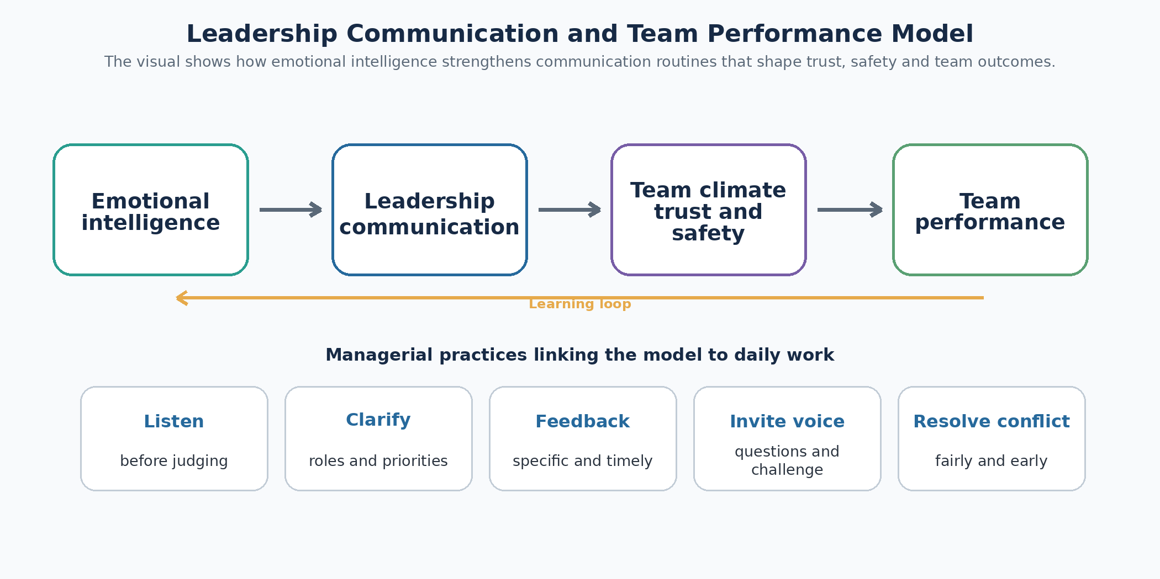
Figure 1. Conceptual model linking emotional intelligence, leadership communication, team climate and team performance.

2. Literature Review

2.1 EI and managerial performance.
Emotional intelligence has emerged as a significant idea in the study of leadership and management due to its association of cognitive judgement with the social facts of work. The model of ability created by Mayer et al. (2008) considers emotional intelligence to be a group of mental abilities that entail perception, facilitation, understanding and regulation of emotion. This comes in handy with management since it does not diminish emotional intelligence to being friendly or agreeable. Highly emotionally intelligent manager is not just a nice person. The manager is able to interpret an uncomfortable meeting, detect frustration under the guise of silence, manage defensive responses, and select a response to communicate that will keep the group focused on evidence and solutions.
Emotional intelligence and performance have a positive yet complicated relationship. According to meta analytic evidence, emotional intelligence is linked to job performance, particularly in jobs which demand emotional labour, interpersonal judgement, social interaction and interpersonal interaction (Joseph and Newman, 2010; O’Boyle et al., 2011). These demands are apparent in the leadership roles since managers have to provide feedback, convince stakeholders, address complaints, assist employees and convey challenging decisions. Nevertheless, the literature demonstrates the necessity of caution as well. The term emotional intelligence is occasionally employed as a general term to describe a lot of desirable qualities, and this may blur the conceptual clarity. Also, emotional intelligence does not substitute technical competence, ethical judgement or organisational justice. An emotionally competent manager may make bad strategic decisions or manipulatively apply empathy. Thus, practical and ethical use of emotional intelligence in management is the most effective: it is to assist leaders in communicating effectively, listening correctly and controlling behaviour in the interests of team objectives.

2.2 Performance mechanism of leadership communication.
The process of establishing mutual understanding, influencing behaviour and establishing relationships is known as leadership communication. According to Barrett (2006), the core skills of writing and speaking, the managerial skills of coaching and meetings, and the corporate skills of vision and change communication are core skills that leaders need to navigate between. This stratified perspective is handy in that it demonstrates that leadership communication is not a single activity. It comprises of strategic messages, daily talk, listening systems, feedback routines, digital communication and symbolic behaviour.
Transformational leadership studies are applicable since they describe how leaders can employ communication to relate tasks and meaning. Transformational leaders provide idealised influence, inspirational motivation, intellectual stimulation and individualised consideration (Bass, 1985). Communication is very essential to such behaviours. Inspirational motivation needs an effective and believable story. Listening and empathy are needed in individualised consideration. Intellectual stimulation involves leaders welcoming questions, as opposed to punishing dissent. According to the findings of Podsakoff, MacKenzie, Moorman and Fetter (1990), the behaviours of transformational leaders have an effect on trust, satisfaction and organisational citizenship behaviours. This implies that performance is influenced by communication in part by influencing discretionary effort and cooperative behaviour.
Meanwhile, leadership communication is not to be romanticised. Charismatic messages may generate enthusiasm, and they may conceal poor implementation or silence dissent when the followers feel coerced to assent. Tourish (2013) condemns the overuse of leader centred communication since it may lead to dependency and to lessening of critical upward communication. This means that proper communication in leadership should incorporate downward clarity and upward voice. Leaders must articulate strategy, yet must have mechanisms by which employees can challenge assumptions, report issues and add local knowledge.

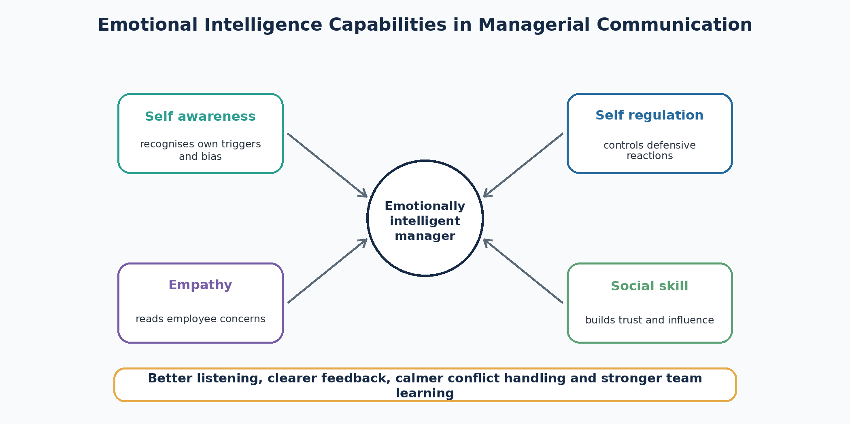
Figure 2. Emotional intelligence capabilities that shape managerial communication behaviour.

2.3 Active listening, empathy, feedback and trust.
One of the most significant communication skills to develop a team is active listening since it implies respect and enhances the accuracy of diagnosis. Managers fail frequently not due to lack of information, but because they get filtered information. The employees might not report issues when they are likely to be blamed, dismissed or retaliated. Active listening will minimize this obstacle by demonstrating that the manager is attempting to comprehend and then judge. Listening is also beneficial in a team environment because it lessens the chances of having a group of dominant voices making decisions as the quieter members withhold valuable information.
Empathy assists in listening as it aids leaders to comprehend the experiences of organisational decisions to employees. Empathy does not mean that leaders have to concur with all the preferences of employees. Instead, it calls on leaders to acknowledge justifiable issues, justify decisions in an open and transparent way, and demonstrate that individuals are not resources but human beings. Empathy is particularly essential in the context of change as resistance is a logical reaction to uncertainty, pressure of work or mistrust. According to Armenakis and Harris (2009), the readiness to change is based on beliefs about the need, the appropriateness, efficacy, support and personal value. Communication that does not take into account the emotion of employees will not be able to create these beliefs.
Another connection between performance and communication is feedback. Good feedback is focused, prompt, behavioural and goal-oriented. Ineffective feedback is imprecise, tardy, or it is provided once in a year. Emotionally intelligent managers control the tone of the feedback in such a way that it is not easy but not embarrassing. This difference is important since feedback ought to augment learning, rather than defensiveness. The trust is developed when employees perceive that communication is regular, equal and matched by actions. Men (2014) demonstrates that employee engagement and positive employee outcomes are related to leadership communication and symmetrical internal communication. Trust thus is not a product of slogans, but rather a result of recurrent encounters where leaders listen, explain and act.

2.4 Psychological safety, team performance and conflict.
The ability of team members to organize knowledge and rectify mistakes determines the performance of the team. The key research by Edmondson (1999) on psychological safety is that it demonstrates that learning behaviour depends on whether team members perceive it to be safe to take interpersonal risks or not. Psychological safety is not synonymous with comfort, lack of standards or evading responsibility. It implies that the team members are able to seek assistance, make mistakes and question assumptions without the fear of being reprimanded because they spoke. This is especially crucial in knowledge work, healthcare, engineering and digital work where mistakes can be complicated and early warning is important.
Conflict research brings a new dimension. According to Jehn (1995), there is a difference between relationship conflict and task conflict. Relationship conflict is a personal tension and dislike and task conflict is a difference of ideas, priorities or methods. De Dreu and Weingart (2003) discovered that task and relationship conflict can be negatively related to team performance and satisfaction, particularly when conflict is intense or personal. This is contrary to the naive perception that task conflict is always constructive. Managers must thus have the communication skill to distinguish disagreement over ideas with an attack on identity and to establish processes in which disagreement is informed, respectful and resolved by clear decision rules.

2.5 Change, stress and digital work leadership communication.
Communication is always highlighted in the literature of change management since employees must be aware of why a change is necessary, what will occur, how it will impact them and how they can be involved. Kotter (1995) states that efforts at transformation are doomed when the leaders fail to communicate the vision and where the employees do not perceive congruent action. Open communication and employee engagement is also emphasized by modern change research. Yue, Men and Ferguson (2019) have discovered that employee openness to change can be promoted by transformational leadership and open communication. This is significant since change communication does not solely revolve around decision announcements. It is concerned with establishing sensemaking dialogues that lessen uncertainty and establish commitment.
There is also a communication aspect of stress at the workplace. High demands, low control, unclear expectations or unsupportive supervision are some of the factors that increase stress levels among employees. Leadership communication may help to alleviate stress by prioritizing, recognizing workload strains, negotiating achievable deadlines and referrals to assistance. Nevertheless, communication may also contribute to stress when it is not consistent, overloaded or spy-like. Digital channels provide speed and flexibility, but may cause message overload, ambiguity and less social cues. According to the media richness theory, complex and emotionally sensitive issues should be addressed using richer channels whereas routine information can be addressed using leaner channels (Daft and Lengel, 1986). Managers ought to thus align the medium with the message. A conflict talk, redundancy talk or big change notification cannot be based on a short email or chat message.

3. Methodology
The methodology of the qualitative secondary research is applied in this report. The method is suitable since the task involves a strategic scholarly discourse and not primary data gathering in a particular organisation. It is an interpretive topic based methodology. It juxtaposes the existing theory with the recent organisational cases to draw practical implications to managers. The approach can be defined as a literary review in the form of a narrative with illustrative case evidence.
The review was based on 5 areas of concept. These included emotional intelligence, leadership communication, team performance, psychological safety, and conflict or change communication. Peer reviewed journals, books and credible professional sources were used to select academic sources. Priority was given to widely cited work, such as Mayer et al. (2008), Edmondson (1999), Bass (1985), Joseph and Newman (2010), O’Boyle et al. (2011), De Dreu and Weingart (2003), and Men (2014). Other more recent sources were also taken into account where they assisted in linking the topic to the current teamwork, digital communication and organisational change. The use of organisational examples was done sparingly. They were not considered as complete case studies since internal company data is not available in the report. Rather they were utilized in demonstrating the ways in which the communication and emotional intelligence of leadership are manifested in actual management practice.
The discussion was based on a thematic reasoning. The literature was initially read to determine common assertions regarding the effects of emotional intelligence and leadership communication on teams. Second, these assertions were classified into themes which included clarity, trust, listening, psychological safety, conflict handling, change communication and digital communication. Third, the individual themes were evaluated critically by posing the question of what the literature elucidates effectively, what it might exaggerate and what circumstances are needed to enhance the concept to work better. This assisted in preventing a descriptive report. As an illustration, emotional intelligence has been discussed as a positive leadership quality and at the same time as an idea that may be ambiguous or abusive in the absence of ethics, accountability and technical ability.
There are limitations to the methodology. The secondary review is unable to determine the direct causal effect of emotional intelligence on a particular team. It is also reliant on published materials which might over state successful cases and understate unsuccessful communication programs. The other weakness is that the performance of a team is multidimensional. These may consist of productivity, innovation, quality, engagement, retention and learning. Various measures are used in different studies and therefore the findings should be interpreted. In spite of these restrictions, the approach is appropriate to the report as it combines theory and practice and enables a critical management oriented answer to the assignment question.

4. Findings

4.1 EI enhances the leadership communication quality.
The initial conclusion is that emotional intelligence enhances team performance primarily through enhancing the quality of communication between employees and managers. Managers who are emotionally intelligent will be more inclined to pick up emotional cues, control tone, handle defensiveness and react positively to stress. This is important since teams tend to fail due to minor communication failures which add up in the long run. The future voice can be demoralized by a hurried remark by a manager. Criticism should be responded with a defense reaction, which will teach the employees that honesty is not a safe practice. When the stress is not recognized, the employees may feel neglected. Emotional intelligence assists managers to prevent such trends by ensuring that they are more conscious of the emotional impact of their messages.
The discovery should, however, be taken with caution. Emotional intelligence is not merely being supportive. Challenge, discipline and clear standards are also required in high performing teams. Emotional intelligence enables the best managers to make tough conversations more fruitful. They are able to tell that performance is not as expected yet maintain dignity. They are able to recognize frustration and request accountability. This is a well-balanced application of emotional intelligence, which is in line with the argument by Joseph and Newman (2010) that emotional intelligence is the most useful when the work demands the ability to perceive and regulate emotions. This is obviously the case with managerial work.

4.2 Leadership communication generates role clarity and shared meaning.
The second conclusion is that leadership communication enhances performance by transforming organisational objectives into role clarity and shared meaning. When team members are not sure of priorities, decision rights or success criteria, teams do not work well. Effective communication minimizes unnecessary work and lack of coordination. As an illustration, a manager who manages a project team should not only describe what the target is, but also why it is important, who owns what, what are the trade offs that are acceptable and how the progress will be checked. This is planning and organising work of communication.
It is also important that there is shared meaning. According to the transformational leadership theory, leaders inspire performance by relating work to a greater cause (Bass, 1985). This is evident in technology companies that are employing mission based communication to focus employees on innovation and customer value. The Microsoft under Satya Nadella is frequently mentioned as a case of cultural repositioning in terms of learning, empathy and growth mindset. The significant aspect is not that all organisations ought to imitate the language of Microsoft but that norms can be restructured through leadership communication when repeated, modelled and tied to systems like performance conversations and collaboration practices. When there is no correspondence between purpose language and behaviour, it is rhetoric.

4.3 Listening and feedback will develop trust and learning.
The third conclusion is that active listening and feedback are the main processes by which leadership communication enhances team performance. Listening will enable the managers to identify issues at an early stage. Local knowledge is often possessed by employees who are in contact with customers, machines, patients, suppliers or software systems and senior managers lack such knowledge. Without listening by leaders, this knowledge will go to waste. Listening is not a relational skill only. It is an information system.
Timely, specific and behaviour focused feedback aids in learning. Feedback loops are necessary in teams to rectify mistakes and enhance processes. But avoidance tends to undermine feedback. Managers postpone tough messages as they are afraid of ruining relationships. This is followed by giving vague signals to the employees and persisting with performance issues. Emotionally intelligent feedback never eliminates discomfort but it handles discomfort in a constructive manner. It puts a distance between the individual and the action, clarifies facts, welcomes feedback and concurs on further action. This increases the chances of feedback to lead to learning as opposed to shame.
The result of repetitive listening and just feedback is trust. Men (2014) associates leadership communication, symmetrical communication and employee outcomes, indicating that employees respond positively when not only top down communication. Remote and hybrid teams, in particular, require trust as managers cannot count on physical visibility. Communicating consistency, responsiveness and fairness are some of the aspects that employees use to evaluate leaders. When messages are altered with no clarification or when leaders demand candor and penalize negative responses, trust is lost within a very short time.

4.4 Psychological safety aids voice, innovation and error correction.
The fourth conclusion is that psychological safety is among the most evident correlations between leadership communication and team performance. Edmondson (1999) demonstrates that psychologically safe teams have higher chances of learning behaviour. Practically, this implies that employees question, make confessions, seek assistance and question assumptions. The behaviours are fundamental in innovation and quality control. A team that covers up mistakes might seem effective in the short run but it becomes weak due to failure to fix the issues at hand at the initial stages.
Psychological safety is influenced by everyday behaviour as a result of leadership communication. Managers foster safety by welcoming dissent, appreciating employees who point issues, acknowledging their own lack of knowledge and reacting to bad news without blaming employees. They ruin safety by interrupting, ridiculing, ignoring or retaliating. This is demonstrated in the healthcare industry. Direct patient safety can be impacted by speaking up, but employees might not speak up because they may be afraid of repercussions. Discussions of staff engagement and speaking up in the context of NHS recurrently reveal that the cultures of compassionate leadership and listening are associated with morale, safety and quality improvement. The moral of the story to managers in any industry is that psychological safety needs to be built into meetings and decision making. It cannot rely on the employees being courageous enough to confront influential individuals.

4.5 Change communication must be transparent, emphatic and repetitive.
The fifth observation is that leadership communication is particularly crucial at the time of change. Change brings about uncertainty and hence, it adds emotional burden to the employees. Some of the questions that employees will raise include: is their position to be sustained, can they work with new systems, will there be an increase in workload and are the leaders telling the truth. One announcement is not sufficient. Change communication needs to be explained repeatedly, have a possibility of questions, be honest about what they do not know and visible leadership support.
According to Kotter (1995), change fails frequently because of insufficient communication of the vision by leaders. Other more recent studies also focus on openness to change and transparent communication (Yue et al., 2019). The operative conclusion is that managers ought to convey change in various channels and phases. They ought to provide the rationale behind change, anticipated benefits, the risks, the implementation strategy, the role of employees and feedback process. EI is important since managers need to address anxiety without negating it. A manager who tells you not to worry without showing any evidence may decrease trust. A more appropriate message is to address the concern, clarify what is known, what is not yet known and promise a date in which the same will be updated.

4.6 Digital communication enhances speed but may undermine quality of relations.
The sixth conclusion is that online communication is required yet dangerous. Contemporary teams rely on email, messaging tools, video conferencing, shared documents and workflow. These enhance speed, documentation and flexibility. They also assist the distributed teams in locations and time zones. Digital communication may, however, cause overload, confusion and emotional detachment. Even when there is no harm intended, a short message can come out to be rude. Decision ownership can be concealed by long email chains. The continuous notifications may divide the attention and cause stress.
Managers require channel discipline. The regular updates may be managed by way of written electronic messages. The issues that are ambiguous, emotional or conflict heavy need to be better communicated and that would be through video or face to face communication where possible. This is appropriate to media richness theory, which posits that complicated issues require avenues that enable instant feedback and social indications (Daft and Lengel, 1986). Digital leadership does not just involve the use of platforms. It demands conventions regarding response time, meeting agenda, documentation, escalation and courteous tone. In the absence of these norms, digital tools have the potential to increase noise rather than enhance coordination.

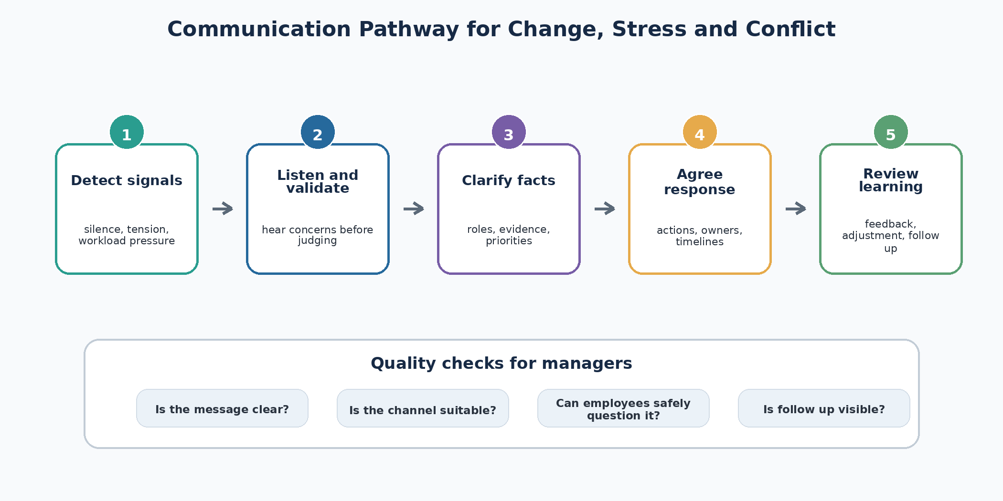
Figure 3. Practical communication pathway for managing change, stress and conflict.

5. Discussion
The results indicate that leadership communication and emotional intelligence have an impact on team performance via multiple interrelated mechanisms. They enhance openness, confidence, education, conflict management and change preparedness. The relationship is, however, not automatic. A manager is able to talk without talking. A leader is able to exhibit empathy without establishing accountability. Many digital tools may be used by a team and yet shared understanding may not exist. The question of interest is thus, how communication and emotional intelligence can be integrated into management practices.
One of the key implications is that team performance cannot be viewed as a system of motivation, but as a communication system as well. Most managers attempt to correct performance by straining more, raising goals or seeking more dedication. In certain situations these measures may be needed, but they are not the solution to the ambiguity, fear or misalignment problems. Unless employees know priorities, they are unable to deliver a consistent performance. In case they are afraid to be punished because they raise issues then the team is unable to learn. In case of delayed or vague feedback, poor practice persists. The operating system of performance thus includes leadership communication.
Another suggestion that is made in the report is that emotional intelligence is to be understood as disciplined self management and social judgement. It is not synonymous with warmth, charisma or popularity. Actually, emotional intelligence leadership can at times necessitate uncomfortable honesty. The manager might be required to inform a group that deadlines are being missed, that conflict is hurting customers or that present behaviour is not in line with organisational values. The distinction is that the message is presented in a respectful, evidence based and problem solving orientation manner. This is why emotional intelligence is to be associated with ethical communication. It must not be employed to coerce the employees into taking unfair treatment or overworking.
It is also necessary to prevent the over individualisation of the problem. Leadership behaviour is important but the climate of communication is affected by organisational structure, workload, incentives and senior management behaviour. The wider organisation will not support the creation of lasting psychological safety by a line manager who punishes bad news or rewards blame. On the same note, active listening will be seen as performative when employees provide feedback several times and nothing happens. This implies that there should be recommendations that consist of systems and behaviours. Regular listening channels, open decision records, meeting conventions, feedback training, escalation pathways of conflicts and managerial responsibility to communication quality should be developed in organisations.
Another important issue is cultural and contextual sensitivity. There are differences in communication styles among national, professional and organisational cultures. There are direct and indirect or relational communication teams. Adaptation should not justify avoidance, and emotional intelligence assists managers to adapt. To illustrate, a manager may be culturally respectful and at the same time clarify roles and deal with conflict. Leaders must establish clear communication standards in different teams and not expect everyone to interpret silence, disagreement or urgency in the same manner.
The two sidedness of digital communication is also pointed out in the discussion. Written and virtual communication have become a key component of leadership with the advent of hybrid work. This has the potential to democratise access to information, but also may lead to exclusion when informal channels substitute open communication. Speed should not be the primary indicator of quality of communication used by managers. A quick message that is confusing is not a good one. A slower and more understandable dialogue can be time-saving due to the avoidance of redundancy and confrontation.
In general, the evidence is in favor of a practical model. Managers are expected to speak direction, listen first, control emotion in a tense situation, provide a safe channel of voice, provide specific feedback, early conflict management, and communicate change using transparent repeated messages. These practices do not exist outside performance management. These are performance management. Communication lowers uncertainty and builds trust and translates knowledge into action, which is more effective when teams are involved.

6. Conclusion
This report has critically looked at the role of leadership communication and emotional intelligence in team performance. The primary conclusion is that management communication does not solely consist of the delivery of information. It is a key process by which leaders build clarity, trust, learning and coordinated action. Emotional intelligence enhances this process since it assists managers to comprehend emotional signals, control their own behaviour, be a good listener and manage challenging conversations without being defensive and blaming others.
Literature indicates that emotional intelligence is correlated to job and leadership performance, but it cannot be considered as a general personality ideal. It is useful in practice where managers apply it to help to support ethical communication, evidence based feedback, conflict resolution and team learning. Likewise, effective leadership communication is best achieved when there is a sense of direction coupled with sincere listening. Teams require vision and purpose and they require voice, psychological safety and fair decision processes.
The best practical suggestion is that organisations ought to establish communication systems instead of depending on leaders who are naturally gifted. Training of managers should be on active listening, feedback, conflict management, change communication and discipline of digital communication. Structured questions and challenge should be part of meetings. Repeated, clear and understanding communication should be employed in change initiatives. Feedback must be on time and behavioural. The message complexity should be matched with digital channels.
To conclude, the performance of a team relies on human behaviour and design of communication. Leaders with EI are able to enhance morale and teamwork, yet sustained performance needs routines that establish clarity, trust and learning as routine management.

7. Practical Recommendations
- Have definite communication routines. Short weekly team briefings should be used by the managers to help clarify priorities, risks, responsibilities and decision points. This lessens confusion and assists workers to relate day-to-day activities to broader goals.
- Develop systematic listening procedures. Regular meetings, one to one conversations, anonymous feedback tools and retrospective reviews should be used as a way of teams to air concerns. Leaders ought to note major themes and report on action taken.
- Educate train managers on emotionally intelligent feedback. Evidence, behaviour, timing, tone and agreed next steps are evidence-based areas that should be addressed in feedback training. Managers ought to engage in role plays to practise difficult conversations instead of basing on policy documents only.
- Psychological safety Design meetings. Leaders ought to welcome dissent, switch up, seek the opinion of quieter members and reward employees who spot risks. Personal criticism and challenge of ideas should be separated by meeting norms.
- Align channels of communication with complexity of messages. Written digital channels can be used to update on routine basis. Richer mediums like face to face or video meetings should be used in conflict, change anxiety, performance issues and sensitive decisions.
- Communicate change by being repetitive and transparent. Change messages must justify the necessity of change, what is known, what is unknown, how employees will be impacted and when additional information will be given.
- Measure communication quality. Communication, trust, voice and feedback items should be part of the employee survey and manager review in organisations. This renders communication as a performance concern and not a choice.

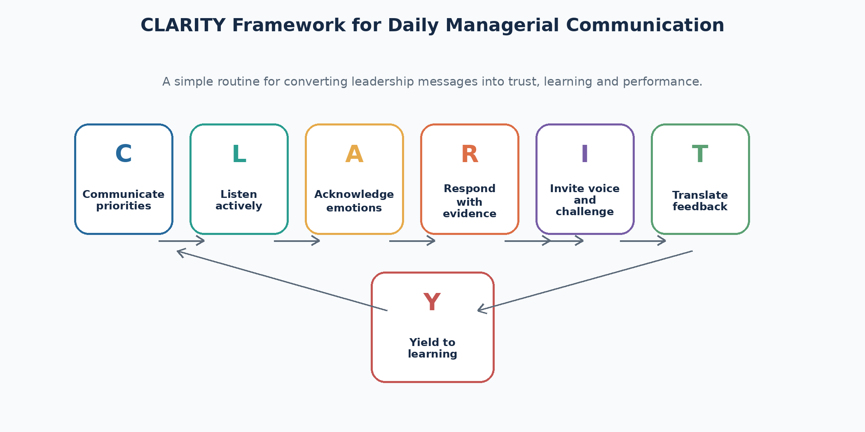
Figure 4. CLARITY framework for daily managerial communication practice.

References
Armenakis, A. A., & Harris, S. G. (2009). Reflections: Our journey in organizational change research and practice. Journal of Change Management, 9(2), 127-142. https://doi.org/10.1080/14697010902879079
Barrett, D. J. (2006). Strong communication skills a must for today’s leaders. Business Communication Quarterly, 69(4), 385-390. https://doi.org/10.1177/1080569906294459
Bass, B. M. (1985). Leadership and performance beyond expectations. Free Press.
Coronado-Maldonado, I., & Benítez-Márquez, M. D. (2023). Emotional intelligence, leadership, and work teams: A hybrid literature review. Heliyon, 9(10), e20574. https://doi.org/10.1016/j.heliyon.2023.e20574
Daft, R. L., & Lengel, R. H. (1986). Organizational information requirements, media richness and structural design. Management Science, 32(5), 554-571. https://doi.org/10.1287/mnsc.32.5.554
De Dreu, C. K. W., & Weingart, L. R. (2003). Task versus relationship conflict, team performance, and team member satisfaction: A meta analysis. Journal of Applied Psychology, 88(4), 741-749. https://doi.org/10.1037/0021-9010.88.4.741
Edmondson, A. C. (1999). Psychological safety and learning behavior in work teams. Administrative Science Quarterly, 44(2), 350-383. https://doi.org/10.2307/2666999
Edmondson, A. C., & Lei, Z. (2014). Psychological safety: The history, renaissance, and future of an interpersonal construct. Annual Review of Organizational Psychology and Organizational Behavior, 1, 23-43. https://doi.org/10.1146/annurev-orgpsych-031413-091305
Goleman, D. (1998). What makes a leader? Harvard Business Review, 76(6), 93-102.
Google re:Work. (2026). Understand team effectiveness. https://rework.withgoogle.com/intl/en/guides/understand-team-effectiveness
Hackman, J. R. (2002). Leading teams: Setting the stage for great performances. Harvard Business School Press.
Jehn, K. A. (1995). A multimethod examination of the benefits and detriments of intragroup conflict. Administrative Science Quarterly, 40(2), 256-282. https://doi.org/10.2307/2393638
Joseph, D. L., & Newman, D. A. (2010). Emotional intelligence: An integrative meta analysis and cascading model. Journal of Applied Psychology, 95(1), 54-78. https://doi.org/10.1037/a0017286
Kotter, J. P. (1995). Leading change: Why transformation efforts fail. Harvard Business Review, 73(2), 59-67.
Mayer, J. D., Salovey, P., & Caruso, D. R. (2008). Emotional intelligence: New ability or eclectic traits? American Psychologist, 63(6), 503-517. https://doi.org/10.1037/0003-066X.63.6.503
Men, L. R. (2014). Why leadership matters to internal communication: Linking transformational leadership, symmetrical communication, and employee outcomes. Journal of Public Relations Research, 26(3), 256-279. https://doi.org/10.1080/1062726X.2014.908719
NHS Employers. (2025). Developing an engagement approach for improved Staff Survey results. https://www.nhsemployers.org/case-studies/developing-engagement-approach-improved-staff-survey-results
O’Boyle, E. H., Humphrey, R. H., Pollack, J. M., Hawver, T. H., & Story, P. A. (2011). The relation between emotional intelligence and job performance: A meta analysis. Journal of Organizational Behavior, 32(5), 788-818. https://doi.org/10.1002/job.714
Podsakoff, P. M., MacKenzie, S. B., Moorman, R. H., & Fetter, R. (1990). Transformational leader behaviors and their effects on followers’ trust in leader, satisfaction, and organizational citizenship behaviors. The Leadership Quarterly, 1(2), 107-142. https://doi.org/10.1016/1048-9843(90)90009-7
The King’s Fund. (2025). What does the NHS Staff Survey 2024 really tell us? https://www.kingsfund.org.uk/insight-and-analysis/blogs/nhs-staff-survey-2024-tell-us
Tourish, D. (2013). The dark side of transformational leadership: A critical perspective. Routledge.
Yue, C. A., Men, L. R., & Ferguson, M. A. (2019). Bridging transformational leadership, transparent communication, and employee openness to change: The mediating role of trust. Public Relations Review, 45(3), 101779. https://doi.org/10.1016/j.pubrev.2019.04.012

Appendices

Appendix A. Literature review search strategy
The report used secondary research focused on emotional intelligence, leadership communication, psychological safety, team performance, conflict management, active listening, feedback and change communication. Sources were selected when they were academically relevant, widely cited, recent enough to reflect contemporary workplace concerns, or useful as real organisational examples. The search prioritised peer reviewed journal articles and books, supported by credible practitioner sources where these illustrated current organisational practice.

Appendix B. Applied communication framework for managers
The recommended framework can be summarised as CLARITY. C means communicate priorities clearly. L means listen actively before judging. A means acknowledge emotions without losing accountability. R means respond with evidence and respect. I means invite voice and challenge. T means translate feedback into action. Y means yield to learning when evidence shows that assumptions are wrong. This framework is simple enough for daily use while still reflecting the major themes of the report.

