M22- CULTURAL HERITAGE MANAGEMENT
TOPIC : SUSTAINABLE MANAGEMENT OF CULTURAL HERITAGE SITES
STUDENT NAME: TANISH MASHAL
STUDENT ID:HBT26001
Abstract
The main purpose and aim of this assignment is to evaluate and analyse the sustainable cultural heritage management strategies in the global regions to ensure positive insights deve3lopment and conceptualisation of key roles of governments, authorities and heritage organisations. Secondary qualitative data collection method has been integrated as a core dat5a collection process from newspaper articles, report of heritage organisations and article-journals to develop accurate knowledge related to sustainable cultural heritage management system. The findings summarised the case study perceptions of Great Wall of China, Taj Mahal and Stonehenge to understand different perspectives of sustainable cultural heritage management practices. However, the challenges related to climate change, reduce community awareness and over-tourism lead to inadequate execution of conservation and protection policies. Therefore, the recommendations like digital conservation technology, visitor management system and others have been recommended for greater sustainable value creation for heritage sites.
Table of contents
1. Introduction 4
1.1 Background of the Assignment 4
1.2 Aim and Objectives 4
1.3 Assignment rationale 5
2. Literature Review 6
2.1 Concept of Cultural Heritage Management 6
2.2 Sustainable Tourism and Heritage Conservation 6
2.3 Challenges in Heritage Site Management 7
2.4 Theoretical Perspective 8
2.5 Literature Gap 9
3. Methodology 9
3.1 Research philosophy 9
3.2 Research design 10
3.3 Research approach 10
3.4 Data collection method 11
3.5 Data analysis 11
3.6 Ethical consideration 12
4. Findings and Case Study Analysis 12
4.1 Case Study 1: Taj Mahal 12
4.2 Case Study 2: Stonehenge 15
4.3 Case Study 3: Great Wall of China 17
4.4 Comparative Discussion and Critical Analysis 19
5. Recommendations 20
6. Conclusion 21

1. Introduction

1.1 Background of the Assignment
Meaning of Cultural Heritage
The context of cultural heritage refers to the historical values and ethnicities that have been associated with tourism and travels along with development of socio-cultural values. Referring to this, the evolution of socio-cultural values and cross cultural bonding triggers the requirement of these practices that make the application of this assignment more meaningful and effective to describe key concepts. The heritage management authorities like UNESCO have integrated several policies for the protection and regulation of cultural heritage establishments to carry forward key historical footprints and evidence.
Cultural Heritage Management
Differentiated and multiple dynamics of sustainable heritage management practices have been introduced in the global landscape that face the challenges of governmental interventions, community engagement issues and others. For instance, since 2000 UNESCO has recognised more than 200 projects under the world cultural heritage project that signify the importance of cultural heritage management practices (UNESCO, 2025). It indicates the relevance of sustainable values and dimensions related to long-term returns and engagement for the visitors and other stakeholders that justify sustainable development of the heritage sites through conservation, reconstruction and value creation.

1.2 Aim and Objectives
Aim
The aim of this assignment is to evaluate and analyse different sustainable management of cultural heritage sites across the world.
Objectives
- To evaluate the concepts related to different sustainable cultural heritage management practices
- To analyse the challenges associated with sustainable cultural heritage management practices affecting its implementation
- To evaluate the role of government agencies, local communities and heritage organisations to implement sustainable cultural heritage management practices

1.3 Assignment rationale
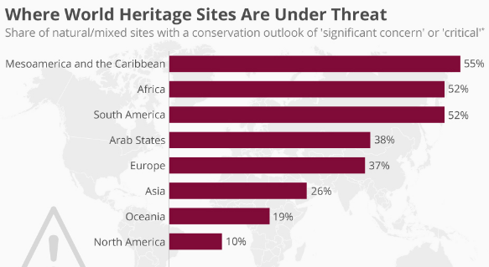
Figure 1: Heritage sites under threat across the world
(Source: Armstrong, 2021)
The above figure represents the key areas of heritage establishments that have undergone serious threats of climate change and reduced renovation affecting overall heritage values. For instance, 26% of Asian heritage establishments are exploited to the threats of climate change affecting building quality and conservation procedures (Armstrong, 2021). Regarding this, the application of this research study becomes more crucial and effective to deliver positive values related to sustainable cultural heritage management practices to restore the heritage values and significance.

2. Literature Review

2.1 Concept of Cultural Heritage Management
Cultural Heritage Management refers to the process of identifying, protecting, preserving and managing cultural heritage resources for future generations. It includes both tangible heritage, such as monuments, temples, historical buildings, paintings and archaeological sites, along with intangible heritages like language, music, rituals, folklore, and traditional knowledge. Perera et al., (2025) proclaimed that the main aim of Cultural Heritage Management is to conserve the historical and cultural identity of a society while promoting awareness and sustainable use of heritage resources. It involves activities like documentation, restoration, conservation, tourism management and community participation. Additionally, governments, international organisations, museums and local communities work together to safeguard cultural heritage from threats like pollution, urbanisation, climate change, theft and regulatory negligence’s (Amro et al., 2023). As a result, effective cultural heritage management not only preserves the legacy of the past but also supports education, cultural tourism, economic development and social unity. Thus, it plays an important role in maintaining cultural continuity and protecting human civilisation.

2.2 Sustainable Tourism and Heritage Conservation
Sustainable tourism plays a vital role in protecting cultural heritage and preserving natural environments for future generations. It encourages responsible travel practices that minimize environmental damage and respect local traditions, customs and historical sites. As opined by Vythoulka et al., (2025) heritage conservation involves safeguarding monuments, archaeological sites, traditional arts and cultural identities from destruction caused by pollution, overcrowding and commercialisation. As a result, sustainable tourism and local communities can be benefited economically while maintaining their cultural values and ecological balance in terms of increased tourism engagement. On the other hand, Hassan et al., (2024) argued that visitors also have a responsibility to value heritage sites by following rules, avoiding littering and supporting local businesses. It indicates the role of famous heritage destinations around the world to ensure higher sustainable growth and contribution in economic development through increased cash flow and foreign exchanges. Therefore, tourism growth with environmental and cultural protection defines the sustainable heritage management that creates historical and natural treasures that remain preserved and appreciated by future generations.

2.3 Challenges in Heritage Site Management
Heritage site management faces several challenges in preserving historical, cultural and natural treasures. One major issue is the increasing number of tourists which can cause overcrowding, pollution and physical damage to heritage establishments and buildings. Miran & Husein (2025) proclaimed that lack of proper funding and maintenance often leads to the gradual deterioration of valuable heritage structures. It highlights reduced authority interventions and engagement in protection of sustainable heritage management practices to value cultural identity and historical aspects. Apparently, Rashed (2026) stated that urbanisation and industrial development also threaten many heritage sites by reducing surrounding green spaces and affecting their original environment that justify the climate change issues and its negative impact on structural solidity. In some regions, illegal construction, vandalism and theft of artefacts further endanger cultural heritage values and implementation of sustainable heritage management practice implications. Climate change has become another serious concern, as floods, rising temperatures, and natural disasters can damage ancient buildings and landscapes. As a result, tourism development with conservation efforts becomes difficult for authorities and local communities. Public awareness about the importance of heritage protection is being restricted to a limit that resulted in uncivilised behaviour by visitors. Henceforth, effective management, strict regulations and community participation are essential to ensure the long-term preservation of heritage sites for long term sustainable impact in socio-cultural dimensions.

2.4 Theoretical Perspective
Conservation theory
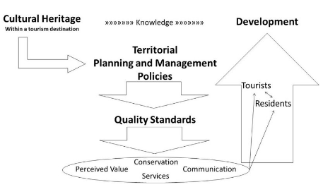
Figure 2: Conservation theory of cultural heritage management
(Source: Influenced by Szmelter, 2022)
The conservation theory of cultural heritage management focuses on protecting and preserving cultural resources to create positive values for the stakeholders and socio-communities. Szmelter (2022) narrated that emphasising authenticity, integrity and historical significance of heritage through careful planning and scientific methods create positive sustainable attributes that impact people's engagement positively. Conservation theory supports minimal intervention, proper documentation, preventive care and sustainable use of heritage resources to protect from certain exploitation internally and externally as well. It also encourages community participation and legal protection to ensure cultural continuity through interventions of international organisations like UNESCO and ICOMOS to promote conservation principles that balance preservation with modern social and economic needs.

2.5 Literature Gap
The literature authored by Vythoulka et al., (20252) prioritised on the facts of cultural heritage conservation due to overcrowding. It indicates a single direction research approach to conceptualise the aspects of sustainable cultural heritage management practices related to overcrowding. As a result, the dynamics related to governmental roles and authoritative interventions have been ignored in this literature that creates specific knowledge gaps. Therefore, it can be considered as a literature gap of this research study.

3. Methodology

3.1 Research philosophy
An interpretivism research philosophy has been selected for the completion of this assignment to include real time socio-community aspects of cultural heritage management practices and sustainable values. According to Pervin & Mokhtar (2022) interpretivism standpoint allows one to observe and evaluate a broader range of qualitative information that lead to credible insights development. It highlights the suitability of interpretivism philosophy in this assignment to generate precise concepts and understanding on the facts of sustainable cultural heritage management implementations. The philosophical adaptation of interpretivism has integrated real time case examples as evidence to strengthen the critical evaluation process and study findings. As a result, socio-community engagement and sustainable values of heritage management along with roles and responsibilities of legal aspects have been included in the discussion. Therefore, interpretivism research philosophy seems to be effectively applicable for this assignment to generate positive academic values through presenting accurate interpretation of sustainable cultural heritage management practices.

3.2 Research design
A descriptive research design is being implemented to organise all the research inputs to generate accurate information and concepts for the readers. The application of descriptive research design led to elaboration of core sustainable heritage management practices inducing credibility and subjectivity of the findings through addressing all the research objectives. As per the view of Sturmberg & Marcum (2024), descriptive research design is useful to observe specific data patterns and create a cause-and-effect model enhancing critical evaluation of the research context. It indicates the evidential synthesis and feasibility for the researcher to incorporate adequate real time information as per the study requirements. The inclusion of evidence and actual causes of sustainable heritage management practices might create precise information sharing and knowledge development scope for the readers to conceptualise key attributes of sustainability values. Hence, the application of descriptive research design seems to be effective and accurate for this assignment in terms of creating positive acceptance and reliability of the findings.

3.3 Research approach
An inductive research approach has been implemented in this research to develop adequate concepts and logical discussion to satisfy the main purpose of the study. Implementation of an inductive research approach includes the benefit of a specific bottom up approach that decodes the key procedures of sustainable heritage management practices and its value creation in the larger scale of society, tourism and ethical value creations. Naeem et al., (2023) stated that three stages of inductive approach in terms of data identification and pattern observation lead to precise development of new concepts and theoretical perspectives. It highlights the relevance of critical evaluation that generates new insights and addresses all the research objectives. Therefore, the application of an inductive research approach seems to be suitable and appropriate for this assignment to conceptualise new insights and values related to sustainable cultural heritage management practices across the world.

3.4 Data collection method
A qualitative data collection method has been adopted for retrieving crucial information related to sustainable cultural heritage management practices. The application of qualitative data collection methods from the secondary sources includes the benefits of proven insights that lead to increased credibility of the assignment findings. Ganesha & Aithal (2022) described that secondary data collection sources provide the advantage of quick responsiveness and readability of available information that impact overall data collection procedure positively. As a result, heritage organisational reports, National governmental policies and article journals have been selected as authentic sources to deliver positive attributes for the readers. On the other hand, the incorporation of qualitative data sets leads to effective information sharing and in inclusion of descriptive concepts that address the research objectives to present higher reliability of the discussion. Therefore, qualitative data collection from the secondary sources seems to be appropriate and effective to generate valid information related to the research context and derivatives.

3.5 Data analysis
A thematic data analysis technique is being used for the critical analysis of collected information to present accurate findings valid for the research objectives. Ahmed et al., (2025) stated that application of thematic analysis includes key stages of data familiarisation, coding, theme development and naming of the themes that offer higher subjectivity and validity to the discussion. As a result, 3 specific themes based including real time case study examples of sustainable cultural heritage management have been developed to deliver valid knowledge for the readers. The application of thematic analysis induces researcher’s autonomy in terms of critical evaluation and synthesis. Therefore, the application of thematic data analysis technique seems to be relevant and accurate for this assignment to generate higher acceptance through presenting subjective information across all academic levels.

3.6 Ethical consideration
Ethical perspectives and dimensions become crucial for a research project in terms of valuing authenticity and reliability for the raiders. An ethics form has been submitted to the module supervisor to get approval over the data collection process. Honesty, transparency and clarity have been maintained throughout the research procedure that leads to effective value creation for the readers. According to Srinivas (2025) research ethical dimension is associated with University plagiarism policies and academic integrity. In this context, University protocols and measurement have been followed throughout the research process to achieve higher acceptance across all academic levels.

4. Findings and Case Study Analysis

4.1 Case Study 1: Taj Mahal
4.1.1 Historical and Cultural Importance
The Taj Mahal is a creation of the Mughal emperor, Shah Jahan, in tribute to Mumtaz Mahal, and showcases outstanding Mughal architecture, artistic achievement and Islamic heritage. In 1983, the Taj Mahal was included on the UNESCO list of World Cultural Heritage Monuments and became one of the most recognised cultural heritage structures worldwide (Zaheeruddin, 2025). It is a popular tourist destination for both locals and foreigners and is significant for the Indian tourism industry as well. This has added to the cultural and historical value of the place and necessitated the adoption of a proper heritage management system that allows its sustainability and long-term preservation activities.
4.1.2 Conservation and Environmental Challenges
Although the Taj Mahal is of paramount significance, its fate is held in the balance because of several environmental and conservation issues. The white marble structure of Taj Mahal is discoloured by air pollution emissions produced by industries and traffic and by the presence of construction works which are situated in the neighbourhood (Meskell, 2024). The monument's base has also been damaged by pollution in the river and due to the diminishing water levels in the Yamuna River. Further physical deterioration has been caused by over-crowding; waste generation and surface wear caused by the vast number of tourists. The monument is further at risk of losing its physical integrity and visual appeal from climate change-related factors like acid rain and warmer climates.
4.1.3 Sustainable Management Practices
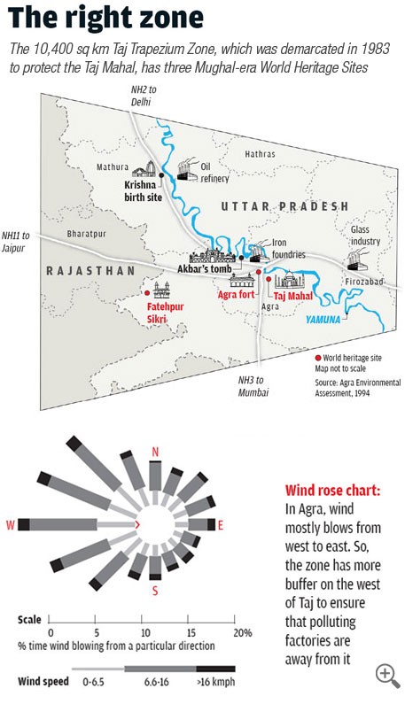
Figure 3: Taj Trapezium Zone
(Source: Pyati, 2022)
The Indian government and conservation authorities have adopted various sustainable management strategies to preserve the Taj Mahal. Industrial activity and pollution around the monument of Taj Mahal have been decreased by laying down a ‘Taj Trapezium Zone’ around the 10,400 km area of the Taj Mahal (Pyati, 2022). Visitor management has been implemented as well, such as with limited hours of opening, ticket restrictions and surveillance. Conservation has been aided by restoration and cleaning work, carried out in an environmentally sensitive manner towards preserving Taj Mahal (Bandyopadhyay et al. 2026). In addition, local authorities have been encouraging local communities to be conscious of the value of their heritage and sustainable tourist behaviour in order to reconcile development with heritage when considering tourism. The initiatives showcase the significance of stakeholder-based integrated management solutions, in ensuring cultural and environmental sustainability on heritage sites.

4.2 Case Study 2: Stonehenge
4.2.1 Historical and Cultural Importance
Stonehenge is one of the world's most important prehistoric monuments, and has been designated a UNESCO World Heritage Site since 1986. It is assumed that the Stonehenge’s development began in the period around 2500 BC when the larger sarsen stones were raised and it still has cultural, spiritual and archaeological values (British Museum, 2026). Stonehenge is popular with tourists, researchers, and historians, and is a major tourist attraction in the United Kingdom. The historical enigma and symbolic significance of its importance emphasise the need for the conservation and sustainable use of such sites to maintain its authenticity and educational value.
4.2.2 Conservation and Tourism Challenges
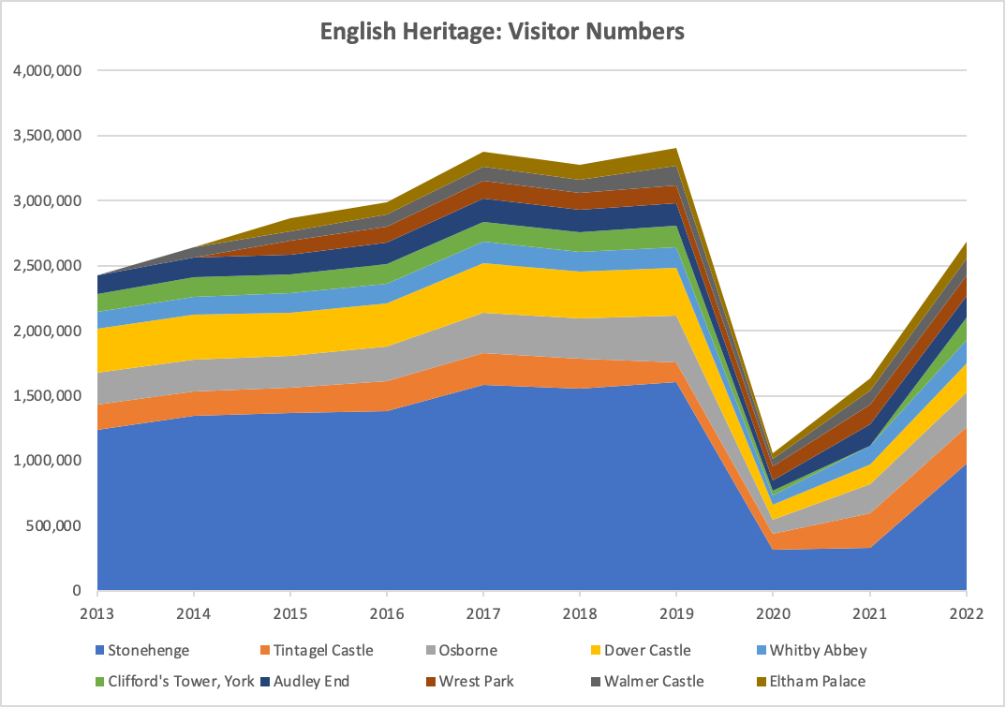
Figure 4: Number of English Heritage Visitors
(Source: BBC, 2025)
Stonehenge is exposed to several conservation problems due to environmental issues and rising number of tourists. For instance, the overall tourism revenue of Wiltshire, where Stonehenge is located, is currently valued at £1.5 billion annually with major contributions from Stonehenge, and supportive contributions from other tourist spots, as of 2025 (BBC, 2025). Persistent visiting around the site has led to a deterioration of the land and erosion in the soil. Routes of road traffic and urbanisation around the monument have also posed risks to the environmental integrity of the monument. In addition, the EU demands to balance access with protection at the Stonehenge, which is a big challenge since the unrestricted contact with the visitors may exacerbate weathering (Boland et al. 2023). Seasonal tourism, which peaks at certain times of the year, adds extra demand for site management systems and local resources.
4.2.3 Sustainable Management Practices
English Heritage and conservation authorities have put in place a number of sustainable management strategies to keep Stonehenge safe. Access by visitors has been carefully managed through designated walkways, and restricted areas at the Stonehenge to minimise the impact on the environment (English-heritage, 2026). A new visitor centre, offsite from the monument, has minimised direct human impact on the monument, enhanced knowledge of the site and interpretation. Digital technologies have also been used to improve the experiences of visitors of Stonehenge and furthered the interests of the monument without the physical presence. There has also been the use of digital technologies to help enhance experiences of visitors and to advance the interests of the monument without the physical presence. Environmental sustainability has also been promoted at the Stonehenge via the landscape conservation programme and the reduction in tourist traffic (Boland et al. 2023). The strategies outlined herein provide examples of how tourism can be managed in a sustainable manner and how technology can play a role in the management of cultural heritage sites.

4.3 Case Study 3: Great Wall of China
4.3.1 Historical and Cultural Importance
One of the biggest and the most prominent cultural heritage structures in the world is the Great Wall of China. The wall is built over the course of several dynasties, and it represents the history of China's military power, its architectural skills, and its national identity. The Great Wall of China was added to the UNESCO World Heritage List on the basis of its exceptional cultural and historical interest in 1987 (He, Hu & Zhang, 2023). The monument serves as a popular tourist attraction and helps promote the culture of China internationally. It has a great geographical extent and historical significance and requires sustainable management for long-term preservation.
4.3.2 Conservation and Environmental Challenges
The natural factors and human factors pose grave threats to the conservation of The Great Wall. The wall of China is damaged in a number of places due to environmental hazards, desertification, earthquake, and weather (Zhang, Yang & Wang, 2025). The natural deterioration caused by inanimate factors has also been exacerbated by human activities including vandalism, illegal construction, graffiti and theft of construction materials. Popular parts of the wall of China have experienced over tourism, leading to overcrowding, waste management issues and structural stress on fragile parts (Wang et al. 2025). Lack of funding and management systems are holding back the effectiveness of conservation in remote areas of the Great Wall of China. It underscores the challenges of undertaking the management of large-scale heritage properties under diverse environmental and social conditions.
4.3.3 Sustainable Management Practices
The Chinese government has implemented various measures to help preserve the Great Wall in a sustainable way. For instance, the Chinese ‘National Cultural Heritage Administration’ has directed the lower authority to collaborate with local governmental agencies and departments to carry out surveys for developing protection plans for the great wall (China Daily, 2023). Applying the traditional techniques and the materials used in the past has been used to maintain the wall's authenticity in restoration works. In high traffic zones, visitor management systems, such as certain areas of restricted access and monitoring systems are significantly minimizing physical damage. There have been public awareness campaigns and heritage education programmes, too, which have promoted responsible tourist behaviour and enthusiastic involvement by locals in conservation activity (UNESCO, 2026). Collaborations of Chinese departments with UNESCO also have increased the protection strategies for heritage of the Great Wall of China over the long-term. These measures reflect the significance of working together and in a sustainable way for the protection of globally important cultural heritage places.

5. Comparative Discussion and Critical Analysis
Out of the three monuments analysed- Taj Mahal, Stonehenge and Great Wall of China, these are geographically and culturally unique, and are having critical issues regarding sustainability and conservation. The pollution of the water of the Yamuna and industrial pollution were one of the primary concerns with the Taj Mahal and had caused pollution and environmental degradation of the monument. Similarly, soil erosion and the construction of facilities owing to the increasing number of tourists were the stress factors on development of infrastructure of Stonehenge (Boland et al. 2023). The Great Wall of China was also facing natural degradation as well as issues caused by human activity, such as overcrowding. Moreover, the results have shown that a balance of tourism development and preservation of the heritage is dependent on sustainable management.
Reducing physical impacts were achieved through all three case studies using 'Visitor management systems' and access control, together with conservation programmes in the long term to ensure increased sustainability. However, how effective these proved to be depended on how well the stakeholders collaborated with each other, the technology brought, and the intervention of the government. For example, the area surrounding the Taj Mahal was being polluted by industries; however, this can be mitigated by implementing the Taj Trapezium Zone which reduced industrial pollution near the Taj Mahal (Pyati, 2022). Overall, in general, sustainable policies are still relevant to the conservation of global cultural heritage sites for future generations.

6. Recommendations
Recommendation 1: Strengthening Visitor Management Systems
Visitor management initiatives at cultural heritage sites should be more robust in order to lessen physical impacts on sites due to over tourism and overcrowding. Daily visitor limits to be introduced, timed ticketing, restricted walking paths and better surveillance of restricted areas to be implemented. Policies and initiatives on sustainable transport should also be encouraged in areas surrounding historic areas so that pollution to the environment is reduced at global cultural heritage sites (Zhao et al. 2023). These kinds of approaches can enhance the quality of visitor calls and support sensitive structures and landscapes. Good practices in visitor control would enable a long-term conservation and sustainability of global heritage places.
Recommendation 2: Increasing Community Participation in Heritage Conservation
Interactions between local communities and conservation and sustainable tourism planning should be stronger. Education, awareness raising and creating jobs based on heritage are needed to be encouraged and facilitated with the help of government and cultural agencies (Wasela, 2023). Local residents can help monitor tourists' actions, ensure conditions around the area are clean and encourage responsible tourism. Greater community and authority’s co-operation would enhance the effectiveness of conservation, support a sense of community identity and deliver long term social and economic value to places of heritage.
Recommendation 3: Expanding the Use of Digital Conservation Technologies
Use of digital technologies associated with conservation of indicated growth in heritage administration can help to enhance the administrative procedures of preservation and visiting management in heritage sites. Aerial drone surveys, virtual reality viewings and 3D scan / mapping can assist in monitoring the structural condition of global heritage sites and alleviate the burden from tourism (Zachos & Anagnostopoulos, 2023). A digital interpretation tool can also add value to an educational experience, while minimising contact with fragile monuments. More investments in new technologies could be used for sustainable conservation efforts and better long term protection of cultural heritage sites.

7. Conclusion
In this report, the topic of sustainable management of cultural heritage sites have been analysed by mandating the cases Taj Mahal, Stonehenge and the Great Wall of China. The results showed that all three sites were facing serious state of conservation issues due to environmental degradation, pollution, climate change and the rising number of tourists. The study revealed that the physical condition and authenticity of these monuments was marred by the process of overcrowding, infrastructure development and human activities. However, it has also been found that sustainable management approaches, such as the adoption of a visitor management system, conservation programmes, involving stakeholders and digital technologies, helped to enhance heritage protection. Comparative analysis showed that the involvement of the community and international cooperation as well as governmental intervention is crucial for long-term sustainability. The report overall suggested the need for balanced and integrated management strategies to conserve cultural heritage sites and future generations' access to those sites and resources for tourism development.
References
Ahmed, S. K., Mohammed, R. A., Nashwan, A. J., Ibrahim, R. H., Abdalla, A. Q., Ameen, B. M. M., & Khdhir, R. M. (2025). Using thematic analysis in qualitative research. Journal of Medicine, Surgery, and Public Health, 6, 100198. https://doi.org/10.1016/j.glmedi.2025.100198
Amro, D. K., Sukkar, A., Yahia, M. W., & Abukeshek, M. K. (2023). Evaluating the cultural sustainability of the adaptive reuse of Al-Nabulsi traditional house into a cultural center in Irbid, Jordan. Sustainability, 15(17), 13198. https://doi.org/10.3390/su151713198
Armstrong. M, (2021). Heritages under threat globally. Retrieved from: https://www.statista.com/chart/11812/where-world-heritage-sites-are-under-threat/ (Accessed on: 21 May 2026).
Bandyopadhyay, A., Chanda, P., Aalam, U., Khatri, K., Bertling, K., Torniainen, J., ... & Sengupta, A. (2026). The Taj Mahal conservation and the scope of electromagnetic sensing. Journal of Physics: Photonics. https://iopscience.iop.org/article/10.1088/2515-7647/ae3a25/pdf
BBC (2025). Wiltshire tourism gets boost from industry body accreditation. Retrieved From: https://www.bbc.com/news/articles/c8xg49zqzypo (Accessed on: 21 May 2026).
Boland, P., Hastings, T., Kumar, M. S., & McKay, S. (2023). World Heritage Sites and the question of scale in governance and politics: A study of Stonehenge. International Journal of Cultural Property, 30(2), 155-176. https://www.cambridge.org/core/services/aop-cambridge-core/content/view/5A6E7F5CB3417C0862F73FB231A681F0/S0940739123000139a.pdf/world-heritage-sites-and-the-question-of-scale-in-governance-and-politics-a-study-of-stonehenge.pdf
British Museum (2026). A timeline of Stonehenge: from hunter-gatherers to solstice alignment and beyond. Retrieved From: https://www.britishmuseum.org/exhibitions/world-stonehenge/stonehenge-timeline (Accessed on: 21 May 2026).
China Daily (2023). China strengthens protection of Great Wall amidst human-caused threats. Retrieved From: https://global.chinadaily.com.cn/a/202312/11/WS65771859a31040ac301a7374.html (Accessed on: 21 May 2026).
English-heritage (2026). Stonehenge Access. Retrieved From: https://www.english-heritage.org.uk/visit/places/stonehenge/plan-your-visit/access/ (Accessed on: 21 May 2026).
Ganesha, H. R., & Aithal, P. S. (2022). How to choose an appropriate research data collection method and method choice among various research data collection methods and method choices during Ph. D. program in India. International Journal of Management, Technology, and Social Sciences, 7(2), 455-489. https://doi.org/10.5281/zenodo.7277944
Hassan, T. H., Almakhayitah, M. Y., & Saleh, M. I. (2024). Sustainable stewardship of Egypt’s iconic heritage sites: balancing heritage preservation, visitors’ well-being, and environmental responsibility. Heritage, 7(2), 737-757. https://doi.org/10.3390/heritage7020036
He, D., Hu, J., & Zhang, J. (2023). Assessment of sustainable development suitability in linear cultural heritage—A case of Beijing great wall cultural belt. Land, 12(9), 1761. https://www.mdpi.com/2073-445X/12/9/1761
Meskell, L. (2024). Teardrops at the Taj: wicked problems of World Heritage preservation, pollution and politics. International Journal of Heritage Studies, 30(4), 438-453. https://d1wqtxts1xzle7.cloudfront.net/111294263/Teardrops_at_the_Taj_wicked_problems_of_World_Heritage_preservation_pollution_and_politics-libre.pdf
Miran, F. D., & Husein, H. A. (2025). Evaluating deterioration causes and defect patterns in heritage buildings: A comprehensive analytical approach. International Journal of Architectural Heritage, 19(9), 1627-1646. https://doi.org/10.1080/15583058.2024.2367690
Naeem, M., Ozuem, W., Howell, K., & Ranfagni, S. (2023). A step-by-step process of thematic analysis to develop a conceptual model in qualitative research. International journal of qualitative methods, 22, 16094069231205789. https://doi.org/10.1177/16094069231205789
Perera, W. W. W. S. T., Madanayake, A. I., Vasanthakumar, M., Paul, K. A., Lokeshwara, A. A., & Jayasinghe, J. K. P. S. K. (2025). Sustainable Futures for Cultural and Heritage Tourism: A Review of Emerging Themes. In 14th INTERNATIONAL CONFERENCE ON MANAGEMENT AND ECONOMICS (p. 529). https://www.researchgate.net/profile/N-P-K-Ekanayake-2/publication/396925602_Through_the_Lens_of_Practice_Exploring_Cloud_ERP_Hurdles_in_Sri_Lanka's_Manufacturing_Sector/links/68ff0857e7f5f867e6e2996f/Through-the-Lens-of-Practice-Exploring-Cloud-ERP-Hurdles-in-Sri-Lankas-Manufacturing-Sector.pdf#page=562
Pervin, N., & Mokhtar, M. (2022). The interpretivist research paradigm: A subjective notion of a social context. International Journal of Academic Research in Progressive Education and Development, 11(2), 419-428. http://dx.doi.org/10.6007/IJARPED/v11-i2/12938
Pyati, A. (2022). Tracing environmental Jurisprudence in India. Available at SSRN 4392968. https://papers.ssrn.com/sol3/Delivery.cfm?abstractid=4392968
Rashed, A. (2026). The Impacts of Unsustainable Urbanization on the Cultural Heritage. https://www.intechopen.com/online-first/1236279
Srinivas, M. K. (2025). Academic integrity and the prevention of plagiarism in higher education: legal frameworks, challenges, and technological interventions. Indian Journal of Law and Legal Research. https://d1wqtxts1xzle7.cloudfront.net/125651000/ACADEMIC_INTEGRITY_AND_THE_PREVENTION_OF_PLAGIARIsm-libre.pdf?1765026293=&response-content-disposition=inline%3B+filename%3DACADEMIC_INTEGRITY_AND_THE_PREVENTION_OF.pdf&Expires=1779359064&Signature=NAr8Myk1~WeMSsSka~9oXYB1qSZuwdvI15Ew5Wqh8mngwXM-v9TBCbNa26bXNZf05uLu0-D2k6EIHftYWSM2F1je8kq1hwHXTCUSe7u7TnE59fWEtpFZ~Cb6wKLwZPTCchqXBflC1ms0zz-ddPGvPi5bcfczRdaa4zJKaglwyk5fkcerp2zeADDuHGaUA-dOjhDGJuqtD9Lvixc9vMMRs77sVHNVrRIljYMhT79K-pGEytp1Wsv8vCzPH5Jupy21Ee8GaHPqjvt5skNl6KIwf5wUuk2ZBoBM9ZX7I~ld4A5b99P0v8J4386q4ZO0faj3XtPID7eA-kRrWvwDEhCVyQ__&Key-Pair-Id=APKAJLOHF5GGSLRBV4ZA
Sturmberg, J. P., & Marcum, J. A. (2024). From cause and effect to causes and effects. Journal of Evaluation in Clinical Practice, 30(2), 296-308. https://onlinelibrary.wiley.com/doi/pdf/10.1111/jep.13814
Szmelter, I. (2022). Contemporary Conservation Theory in the Context of the Valuation of Cultural Heritage. w Between Science and Art, red. Marzena Ciechańska (Warsaw: Faculty of Conservation and Restoration of Works of Art, Academy of Fine Arts, 2016), 15-32. https://www.researchgate.net/profile/Iwona-Szmelter-3/publication/343722765_Contemporary_Conservation_Theory_in_the_Context_of_the_Valuation_of_Cultural_Heritage/links/5f3bf96da6fdcccc43d14d09/Contemporary-Conservation-Theory-in-the-Context-of-the-Valuation-of-Cultural-Heritage.pdf
UNESCO (2026). The Great Wall - UNESCO World Heritage Centre. Retrieved From: https://whc.unesco.org/en/list/438/ (Accessed on: 21 May 2026).
UNESCO, (2025). Encouraging sustainable cultural heritage management. Retrieved from: https://www.unesco.org/en/fieldoffice/bangkok/clt/sustainable-cultural-heritage-management [Accessed on: 21.05.2026]
Vythoulka, A., Caradimas, C., Delegou, E., & Moropoulou, A. (2025). Cultural heritage preservation and management in areas affected by over tourism—A conceptual framework for the adaptive reuse of Sarakina Mansion in Zakynthos, Greece. Heritage, 8(7), 288. https://doi.org/10.3390/heritage8070288
Wang, R., Lou, J., Huang, S., Xiao, J., & Long, F. (2025). Balancing Safety and Growth: An Ecological Resilience Framework for Great Wall Tourism Towns. Sustainability, 17(16), 7243. https://scholars.cityu.edu.hk/ws/portalfiles/portal/372072214/350675917.pdf
Wasela, K. (2023). The role of intangible cultural heritage in the development of cultural tourism. International Journal of Eco-Cultural Tourism, Hospitality Planning and Development, 6(2), 15-28. https://journals.ekb.eg/article_363738_0dbd0a81ce847507aed152f628e1ebde.pdf
Zachos, A., & Anagnostopoulos, C. N. (2023). Using terrestrial laser scanning, unmanned aerial vehicles and mixed reality methodologies for digital survey, 3D modelling and historical recreation of religious heritage monuments. arXiv preprint arXiv:2401.01380. https://arxiv.org/pdf/2401.01380
Zaheeruddin, M. (2025). The Role of the Supreme Court of India in the Preservation of the Taj Mahal: A Heritage Monument in India. Architecture Image Studies, 6(4), 789-795. https://journals.ap2.pt/index.php/ais/article/download/684/469
Zhang, S., Yang, Z., & Wang, C. (2025). Environmental risk assessment of earthen heritage sites in arid regions: a case study of the Great Wall in Xinjiang. npj Heritage Science, 13(1), 200. https://www.nature.com/articles/s40494-025-01736-5.pdf
Zhao, L., Li, Y., Zhang, N., & Zhang, Z. (2023). Public policies and conservation plans of historic urban landscapes under the sustainable heritage tourism milieu: discussions on the equilibrium model on Kulangsu Island, UNESCO World Heritage site. Built Heritage, 7(1), 6. https://link.springer.com/content/pdf/10.1186/s43238-023-00086-0.pdf

