Role of Financial Accounting in Business Decision Making
M03 Fundamentals of Financial Accounting BBA
Detailed Project Report
Selected Assignment Option: Option 1

Table of Contents
Abstract
1. Introduction
2. Literature Review
3. Methodology
4. Findings
5. Discussion
6. Conclusion
References
Appendices

Abstract
This report examines the role of financial accounting in business decision making. It argues that financial accounting is not only a record keeping function but also an information system that converts transactions into structured evidence for planning, control, investment, credit assessment and accountability. The report explains the meaning, objectives and importance of financial accounting, reviews key principles and standards, and analyses how the income statement, statement of financial position and statement of cash flows support decisions about profitability, liquidity and financial position. The discussion uses Apple Inc. as a real world example because its latest public financial statements show how users can convert accounting numbers into practical interpretations about revenue concentration, margin structure, cash generation, leverage and strategic risk. The analysis finds that accounting information is most useful when it is relevant, faithfully represented, comparable, understandable and supported by ethical reporting practices. However, the report also recognises important limitations. Financial statements are historical, depend on management judgement, and cannot fully capture non financial assets such as reputation, innovation capability and customer loyalty. Therefore, high quality decision making requires both accounting discipline and critical interpretation. The report concludes that financial accounting supports business decision making by making performance measurable, resource claims visible and financial risks easier to assess.

1. Introduction
Financial accounting is the systematic process of identifying, measuring, recording, summarising and communicating financial information about an entity to users who need reliable evidence for economic decisions. In a business environment, managers, investors, creditors, suppliers, employees, tax authorities and regulators cannot base decisions only on impressions or informal stories about performance. They require structured information about revenue, costs, profit, assets, liabilities, equity and cash flows. Financial accounting provides this structure by transforming daily business transactions into financial statements that can be compared across time, across organisations and against expectations. This report addresses Option 1 of the assignment brief, which requires a report on how financial accounting supports business decision making. The selected option is appropriate because financial accounting is often introduced as a technical subject, but its real value becomes visible when accounting information is connected to actual business choices.
The objective of financial accounting is commonly linked with the provision of useful financial information to existing and potential investors, lenders and other creditors. The IFRS Foundation explains that the Conceptual Framework guides consistent standards and helps provide useful information to investors, lenders and other creditors (IFRS Foundation, 2018). This purpose is broader than simple compliance. Accounting information allows stakeholders to assess whether a business is profitable, whether it can pay its obligations, whether assets are being used efficiently, whether financing is sustainable and whether management is acting responsibly. In this sense, financial accounting connects measurement with accountability.
The importance of financial accounting has increased because modern businesses operate in complex supply chains, use digital platforms, raise capital from global markets and face intense scrutiny from regulators and stakeholders. Financial decisions are also interdependent. A manager deciding whether to expand production needs cost and profitability information. A bank deciding whether to lend needs evidence of solvency and cash generation. An investor deciding whether to buy shares needs information on earnings quality, risk exposure and growth prospects. A supplier offering credit needs confidence that invoices will be paid. These decisions require a common language. Financial accounting provides that language through generally accepted principles, standards, financial statements and disclosure notes.
This report is structured as a complete project report. The literature review explains the meaning, objectives, principles and standards behind financial accounting. The methodology explains the secondary research and case based approach. The findings present the decision usefulness of accounting information for different stakeholders and then use Apple Inc. financial information for practical illustration. The discussion evaluates the strengths and limitations of financial accounting in decision making. The conclusion summarises the main argument and highlights the need for ethical and critical use of accounting data.
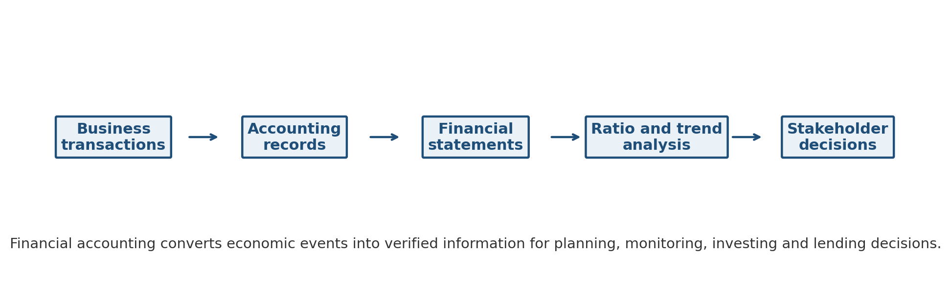
Figure 1. Financial accounting information chain for business decision making. Source: Author developed.

2. Literature Review

2.1 Meaning and Objectives of Financial Accounting
Financial accounting can be understood as a formal reporting system that records the financial effects of business activities and communicates them in a standardised form. Unlike management accounting, which may be prepared for internal and flexible use, financial accounting is normally prepared for external users and must follow recognised principles and standards. OpenStax (2019) explains that financial accounting covers the role of accounting in society, financial statements, transaction recording, adjusting entries, completion of the accounting cycle and statement of cash flows. This coverage shows that financial accounting is both a process and a communication tool. It begins with economic events and ends with reports that influence real decisions.
The core objective of financial accounting is decision usefulness. The Conceptual Framework states that useful financial information should help users assess prospects for future cash inflows and management stewardship (IFRS Foundation, 2018). The stewardship dimension is important because managers control resources that belong to owners and affect other stakeholders. When managers report profit, asset values, liabilities and cash flows, they provide evidence that stakeholders can use to judge whether resources have been managed effectively. Financial accounting therefore supports both prediction and accountability.
A second objective is comparability. Users cannot make meaningful decisions if each organisation defines revenue, assets, profit and cash flow differently. Accounting standards reduce this problem by setting recognition, measurement, presentation and disclosure rules. The IFRS Foundation states that IAS 1 sets overall requirements for financial statement presentation and minimum content (IFRS Foundation, 2024a). Standardised presentation helps users compare a company with its previous performance and with competitors. It also reduces information asymmetry because outside users have less direct access to business information than managers.

2.2 Accounting Principles and Decision Quality
Accounting principles shape the quality of the information used for decisions. The accrual principle requires income and expenses to be recognised when earned or incurred rather than only when cash is received or paid. This matters because a profitable business may have poor cash timing, while a cash rich business may still be economically weak. The matching principle links expenses with the revenues they help generate, which supports more meaningful profit measurement. Consistency requires similar accounting policies to be used across periods unless a justified change improves reporting quality. Prudence requires cautious judgement where uncertainty exists, reducing the risk that assets or income are overstated. Materiality requires information to be disclosed when its omission or misstatement could influence user decisions.
The going concern assumption is particularly important for business decisions because it assumes the entity will continue operating for the foreseeable future. If going concern is doubtful, assets, liabilities and business plans may need different interpretation. For example, inventory may be valued differently if a company is closing down, and long term debt may become immediately relevant to liquidity risk. The principle does not guarantee survival, but it makes the basis of reporting clear. This is essential for investors and creditors who rely on statements to estimate future returns and repayment ability.
The qualitative characteristics of useful financial information also support decision quality. Relevance means information is capable of making a difference in decisions, while faithful representation means information is complete, neutral and free from material error (IFRS Foundation, 2018). Comparability, verifiability, timeliness and understandability enhance usefulness. These characteristics are not abstract theory. A delayed report may be accurate but less useful for a credit decision. A complex disclosure may be technically complete but not understandable for small investors. A non comparable number may be correct in isolation but weak for benchmarking. Therefore, good financial accounting is judged by whether it supports informed decision making, not only by whether the ledger balances.

2.3 Financial Statements as Decision Tools
The income statement reports revenues, expenses and profit over a period. It helps users evaluate profitability, pricing power, cost control and operating performance. For managers, it shows whether operations are creating sufficient margin. For investors, it supports valuation and earnings trend analysis. For creditors, it indicates whether the business generates earnings that can support interest and repayment. However, profit alone is incomplete because it includes accruals, estimates and non cash items.
The statement of financial position, often called the balance sheet, reports assets, liabilities and equity at a point in time. It helps users assess liquidity, solvency, capital structure and resource base. Current assets and current liabilities support short term liquidity analysis. Non current assets show productive capacity and investment in long term resources. Debt and equity reveal financing structure. Investors use the statement to assess risk and residual ownership claims, while creditors use it to evaluate collateral and leverage.
The statement of cash flows reports cash inflows and outflows by operating, investing and financing activities. IAS 7 requires information on historical changes in cash and cash equivalents and classifies cash flows into operating, investing and financing categories (IFRS Foundation, 2026). This statement is critical because profit does not always equal cash. A company may report accounting profit but face liquidity pressure if customers delay payment, inventory rises or capital expenditure is high. Operating cash flow helps users judge whether core operations are generating real cash. Investing cash flows show capital allocation, while financing cash flows reveal borrowing, repayments, dividends and share repurchases.

2.4 Ethics, Standards and Trust
Financial accounting depends on trust. If stakeholders believe reported numbers are manipulated, incomplete or biased, the decision value of accounting collapses. Standards help create discipline, but ethical behaviour is also required because many accounting judgements cannot be reduced to mechanical rules. The International Ethics Standards Board for Accountants identifies fundamental principles including integrity, objectivity, professional competence and due care, confidentiality and professional behaviour (IESBA, 2025). These principles are important because financial reporting often involves pressure from management incentives, debt covenants, market expectations and tax considerations.
Ethical financial reporting is therefore part of decision usefulness. A revenue number is useful only if it reflects the substance of transactions. An asset value is useful only if impairment has been considered honestly. A liability disclosure is useful only if obligations are not hidden. Ethical reporting reduces the risk of fraud, misstatement and misleading disclosure. It also supports market confidence because investors and creditors rely on professional accountants to prepare information that is not shaped merely to make the organisation look better.

3. Methodology
This report uses a qualitative secondary research design supported by a case based financial illustration. The approach is appropriate because the assignment asks for explanation, analysis and application rather than primary data collection. The report draws on accounting standards, conceptual guidance, textbook based accounting knowledge, ethics guidance and public company financial statements. The selected case company is Apple Inc. because it publishes detailed audited financial statements, operates in multiple regions and product categories, and provides a useful example of how financial accounting information informs decisions about profitability, liquidity, solvency and strategic risk.
The method has 3 stages. First, the report reviews financial accounting concepts and standards to build the analytical framework. Second, it maps accounting information to stakeholder decisions, including managers, investors, creditors, suppliers, employees and regulators. Third, it applies selected financial statement data from Apple Inc. fiscal year 2025 to demonstrate how users can interpret accounting information. The numerical analysis uses standard ratio formulas, including gross margin, net profit margin, current ratio, debt to assets, revenue growth and operating cash flow to net income. The calculations are not intended to provide a full investment recommendation. They are used to show how accounting numbers are transformed into decision indicators.
The methodology has limitations. It relies on public information and does not include interviews with managers, investors or auditors. The Apple case is a large technology company, so its capital structure, margins and cash flows may not represent small businesses. The analysis is also limited to selected ratios. Nevertheless, the case is suitable for a fundamentals of financial accounting report because it shows how financial statements support interpretation in a real business context.

4. Findings

4.1 How Accounting Information Supports Stakeholders
The first finding is that different stakeholders use the same accounting system for different decisions. Managers use accounting information to plan, control and evaluate performance. Investors use it to estimate future returns and risk. Creditors use it to assess repayment capacity. Suppliers use it to decide credit terms. Employees use it to judge employment stability and reward prospects. Regulators use it to monitor compliance. The accounting system therefore creates a shared evidence base, even though each user applies that evidence differently.
Table 1. Stakeholder uses of financial accounting information
Stakeholder | Main accounting information used | Typical decision supported
Managers | Revenue, expenses, margins, assets, liabilities and cash flows | Budgeting, pricing, investment planning, cost control and performance evaluation
Investors | Profitability, earnings per share, equity, growth trends and disclosures | Buy, hold or sell decisions and assessment of management stewardship
Creditors and banks | Liquidity ratios, cash flows, debt levels and interest coverage indicators | Loan approval, credit limits, pricing of debt and covenant monitoring
Suppliers | Current assets, current liabilities, cash conversion and payment history | Credit terms, order limits and collection risk assessment
Employees | Profitability, continuity, cash generation and long term stability | Employment confidence, wage negotiation and assessment of business sustainability
Regulators and tax authorities | Reported income, disclosures, tax balances and compliance statements | Tax assessment, regulatory review and enforcement decisions
The table shows that financial accounting is not designed for a single user. For example, a manager may focus on the relationship between sales and cost of sales, while a bank may focus on current liabilities and cash generated from operations. A shareholder may use the same income statement to evaluate profitability and the same statement of cash flows to test whether profit is supported by cash. The value of financial accounting is therefore its ability to provide a disciplined core of information that can be interpreted for different decision contexts.

4.2 Financial Statements and Key Decision Areas
The second finding is that each primary financial statement supports a different decision area. The income statement is strongest for performance evaluation. The statement of financial position is strongest for financial position and capital structure. The statement of cash flows is strongest for liquidity, financial flexibility and cash conversion. A well informed user should not rely on 1 statement alone. A company with rising profit but weakening operating cash flow may be facing collection problems. A company with strong assets but high current liabilities may face liquidity pressure. A company with strong operating cash flow but declining revenue may need strategic renewal.
Table 2. Financial statement roles in profitability, liquidity and financial position analysis
Financial statement | Primary decision question | Common indicators | Decision relevance
Income statement | Is the business generating profit from its activities? | Revenue growth, gross margin, operating income, net profit margin and earnings per share | Supports pricing, cost control, investment analysis and management performance assessment
Statement of financial position | What resources does the business control and what claims exist against them? | Current ratio, debt to assets, debt to equity, asset base and equity position | Supports solvency analysis, collateral assessment and capital structure decisions
Statement of cash flows | Is the business generating cash and how is cash being used? | Operating cash flow, capital expenditure, dividends, borrowings and repayments | Supports liquidity assessment, dividend policy, financing decisions and going concern evaluation
Notes to the accounts | What policies, estimates and risks explain the numbers? | Revenue recognition policy, segment data, contingencies, commitments and accounting estimates | Supports critical interpretation and reduces misunderstanding of headline figures

4.3 Real World Application Using Apple Inc.
Apple Inc. provides a clear example of how accounting information can support decisions. Its 2025 Form 10-K reports total net sales of USD 416.161 billion, gross margin of USD 195.201 billion and net income of USD 112.010 billion for the year ended 27 September 2025 (Apple Inc., 2025). These numbers immediately help users judge profitability, scale and operating efficiency. However, the income statement becomes more decision useful when the total revenue is disaggregated. Apple reported FY2025 net sales of USD 209.586 billion from iPhone, USD 33.708 billion from Mac, USD 28.023 billion from iPad, USD 35.686 billion from Wearables, Home and Accessories, and USD 109.158 billion from Services (Apple Inc., 2025). This breakdown helps users see product dependence and growth opportunities.
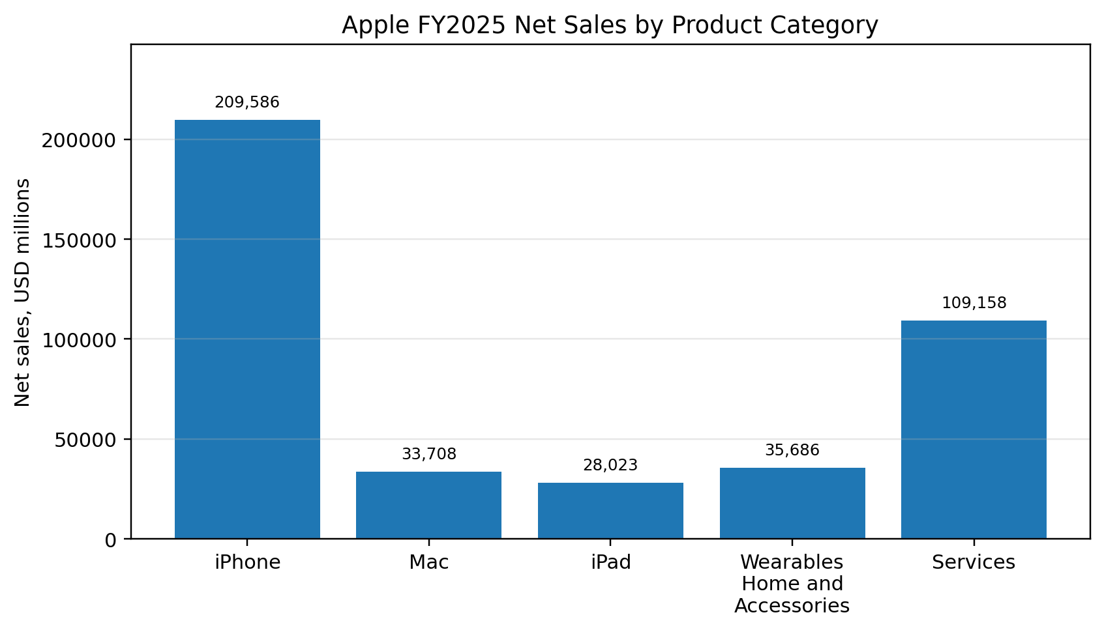
Figure 2. Apple FY2025 net sales by product category. Source: Author analysis based on Apple Inc. (2025).
Figure 2 shows that the iPhone remains the largest revenue category. This information is important for managers, investors and creditors because a concentration in 1 product category creates both strength and risk. A strong product category may support brand power and economies of scale. At the same time, a decline in demand for that product can affect total sales, gross margin and cash flow. Apple itself states that it generates a significant portion of net sales from a single product category and that decline in demand for that category could significantly affect net sales and gross margins (Apple Inc., 2025). Accounting disclosure therefore does more than report a historical number. It helps users connect revenue structure with strategic risk.
The statement of financial position also supports important decisions. Apple reported total current assets of USD 147.957 billion and total current liabilities of USD 165.631 billion at 27 September 2025 (Apple Inc., 2025). The current ratio is therefore 147.957 / 165.631 = 0.89. A ratio below 1 could indicate short term pressure in many businesses, but interpretation must consider Apple’s operating cash generation, brand strength and access to capital markets. This demonstrates a key principle of accounting analysis: ratios must be interpreted in context rather than mechanically.
The cash flow statement adds further insight. Apple reported cash generated by operating activities of USD 111.482 billion in FY2025 and net income of USD 112.010 billion (Apple Inc., 2025). The ratio of operating cash flow to net income is 111.482 / 112.010 = 1.00 approximately. This suggests that reported profit was strongly supported by cash generation in the period. For creditors, this supports repayment confidence. For investors, it supports earnings quality. For managers, it shows that operations are producing cash that can fund investment, dividends, debt repayment or share repurchases.
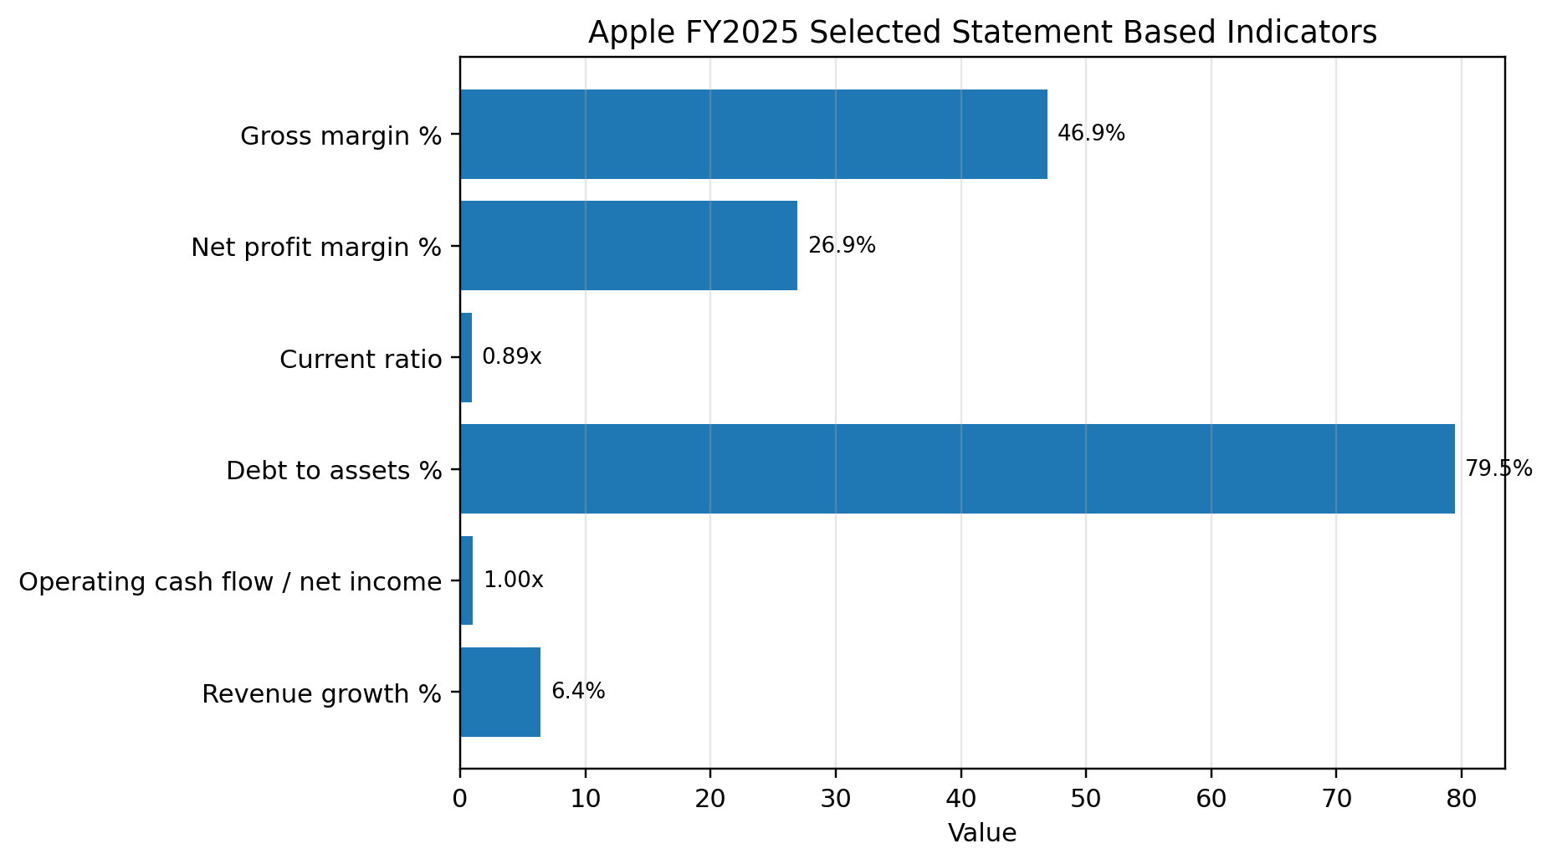
Figure 3. Apple FY2025 selected statement based indicators. Source: Author calculations based on Apple Inc. (2025).
Table 3. Selected Apple FY2025 accounting ratios and interpretation
Indicator | Formula | Calculation | Interpretation for decision making
Revenue growth | (2025 net sales - 2024 net sales) / 2024 net sales × 100 | (416.161 - 391.035) / 391.035 × 100 = 6.4% | Shows continued top line growth, supporting investor confidence and management planning.
Gross margin | Gross margin / net sales × 100 | 195.201 / 416.161 × 100 = 46.9% | Indicates strong pricing power, cost control and product or service mix strength.
Net profit margin | Net income / net sales × 100 | 112.010 / 416.161 × 100 = 26.9% | Shows a high level of final profitability after all expenses and tax.
Current ratio | Current assets / current liabilities | 147.957 / 165.631 = 0.89 | Requires contextual interpretation because strong cash generation may offset a low conventional liquidity ratio.
Debt to assets | Total liabilities / total assets × 100 | 285.508 / 359.241 × 100 = 79.5% | Shows substantial claims from liabilities, relevant to solvency and capital structure analysis.
Operating cash flow to net income | Operating cash flow / net income | 111.482 / 112.010 = 1.00 | Suggests profit is closely supported by operating cash generation.
The ratio table shows how accounting data becomes decision information. The gross margin and net profit margin indicate profitability. The current ratio and debt to assets ratio indicate financial position and financing risk. The operating cash flow to net income ratio indicates earnings quality. These measures are not separate from financial accounting. They are built directly from the income statement, statement of financial position and statement of cash flows. Without accurate financial accounting records, these interpretations would be unreliable.

4.4 Financial Accounting in Planning and Control
The third finding is that financial accounting supports internal planning even though it is usually associated with external reporting. Historical sales, margins, assets and cash flows give managers a factual baseline for budgets and strategic targets. For example, if a company identifies that a product category has a lower margin than a service category, managers may reconsider pricing, marketing allocation or product development. Apple’s disclosure that Services generated USD 109.158 billion of net sales and USD 82.314 billion of gross margin shows a Services gross margin of 82.314 / 109.158 × 100 = 75.4%, while product gross margin was 36.8% (Apple Inc., 2025). This does not automatically mean the firm should abandon products, because hardware supports the ecosystem. However, it does help managers and investors understand why service growth can change profitability.
Financial accounting also supports control by comparing actual results with prior periods and expectations. If revenue rises but margins fall, managers investigate costs, discounts, tariffs or product mix. If accounts receivable rises faster than revenue, managers may investigate credit policy and collection. If inventory increases sharply, managers may investigate demand forecasting. These controls depend on reliable transaction recording and proper classification. A weak accounting system would make it difficult to identify problems early.

5. Discussion

5.1 Strengths of Financial Accounting for Decision Making
The main strength of financial accounting is that it disciplines decision making with evidence. Business decisions often involve uncertainty, optimism and pressure. Accounting information does not remove uncertainty, but it reduces guesswork by providing a structured record of what has happened and what obligations exist. When managers assess profitability, they can examine revenue, cost of sales and operating expenses rather than relying on sales volume alone. When investors assess returns, they can examine earnings, cash flows and equity. When creditors assess repayment capacity, they can examine liquidity, leverage and operating cash generation.
This evidence based role is especially valuable when business conditions are uncertain. Inflation, exchange rate movements, supply disruption and digital competition can all change costs and revenue patterns quickly. Financial accounting gives managers and external users a disciplined way to identify whether these pressures are visible in gross margins, receivables, inventory, liabilities or cash flows. The statements do not provide every answer, but they create a reliable starting point for investigation.
A second strength is comparability. Standardised financial statements allow users to compare performance across years and across companies. This is particularly useful in capital markets where investors choose between many possible investments. Comparability also supports benchmarking. A gross margin figure is more useful when it can be compared with prior periods, competitors or industry averages. IAS 1 strengthens this by requiring a complete set of financial statements and comparative amounts for the preceding year (IFRS Foundation, 2024a). Comparative reporting helps users distinguish temporary fluctuations from longer term changes.
A third strength is accountability. Financial accounting makes managers accountable for resources entrusted to them. Profit shows whether operations created value during the period. The statement of financial position shows what resources remain and what obligations exist. Cash flows show whether profit is supported by cash and how cash has been allocated. Notes disclose policies, estimates and risks. Together, these reports allow owners and other stakeholders to assess management stewardship.

5.2 Limitations and Critical Interpretation
Financial accounting also has limitations. First, it is historical. Statements report transactions and conditions for a past period or date. Users are usually interested in future cash flows, but accounting provides past evidence rather than certainty. A company can report strong current profit and still face future decline if consumer preferences, technology, regulation or competition changes. Therefore, accounting information must be combined with strategic analysis.
Second, financial accounting involves judgement and estimates. Depreciation, impairment, provisions, inventory valuation, expected credit losses and revenue recognition may require assumptions. These assumptions can be reasonable but still uncertain. The Apple example includes management estimates because the company prepares consolidated financial statements under accounting rules that require judgement (Apple Inc., 2025). Users should therefore examine notes and policies rather than relying only on headline numbers.
Third, accounting does not fully capture all sources of business value. Customer loyalty, employee knowledge, brand strength, supplier relationships and innovation capability may be essential to future performance but only partly visible in the statements. For example, Apple’s ecosystem and brand are critical to its business model, but the internally generated value of these assets is not shown as a simple asset line equal to market value. This does not mean accounting is weak. It means accounting has boundaries. It is strongest when measuring recognised transactions and obligations, but weaker when measuring internally generated intangible value.
Fourth, ratios can be misleading if interpreted mechanically. A current ratio below 1 may be alarming in a small retailer but less alarming for a large company with predictable cash flows and access to financing. A high debt to assets ratio may indicate risk, but it may also reflect deliberate capital structure choices, share repurchases or efficient financing. A high profit margin may suggest strength, but it may attract competitors or regulators. Critical interpretation therefore requires both accounting knowledge and business judgement.
Table 4. Decision risks and safeguards in using financial accounting information
Risk in using accounting information | Possible decision problem | Safeguard
Historical focus | Users may assume past performance will continue unchanged. | Combine financial statements with market, strategy and risk analysis.
Management estimates | Profit or asset values may depend on uncertain assumptions. | Read accounting policies, notes and auditor reports carefully.
Incomplete capture of intangibles | Users may undervalue brand, innovation or employee capability. | Use non financial indicators alongside accounting ratios.
Mechanical ratio interpretation | A ratio may be judged good or bad without context. | Compare with industry norms, business model and trend evidence.
Ethical pressure or manipulation | Users may rely on biased or misleading statements. | Strengthen internal controls, audit, governance and ethical reporting culture.

5.3 Best Practice Implications for Businesses
For businesses, the analysis suggests several best practices. First, accounting systems should be designed to capture transactions accurately at source. Errors in sales, purchases, payroll, inventory or cash records flow into statements and weaken decisions. Second, businesses should maintain a strong accounting cycle, including journal entries, ledger posting, trial balance preparation, adjustments, review and closing procedures. Even when the chosen assignment option focuses on decision making, the reliability of decisions depends on the quality of the accounting cycle.
Third, businesses should present statements and notes clearly. Decision usefulness is reduced when users cannot understand accounting policies, segment information or risk disclosures. IAS 1 requires a complete set of statements and notes, which reinforces the need for transparent communication (IFRS Foundation, 2024a). Fourth, businesses should integrate financial and non financial information. Financial statements explain profit and financial position, while non financial indicators explain drivers such as customer retention, employee capability, product quality, emissions, digital engagement and operational resilience.
Fifth, ethical reporting must be treated as a strategic asset rather than a compliance burden. Misstatement may create short term appearance of success, but it damages trust, raises financing costs and exposes the organisation to penalties. The IESBA principles of integrity, objectivity and professional competence are therefore directly linked to business decision quality (IESBA, 2025). If accounting information is prepared ethically and interpreted critically, it becomes a reliable foundation for decisions. If it is manipulated or misunderstood, it can lead to poor investment, excessive lending, weak governance and loss of confidence.

6. Conclusion
Financial accounting plays a central role in business decision making because it converts business transactions into structured, comparable and credible information. It explains what a business has earned, what it owns, what it owes, how it is financed and whether it generates cash. Managers use this information for planning, control and performance evaluation. Investors use it to assess profitability, risk and stewardship. Creditors use it to evaluate liquidity and repayment capacity. Suppliers, employees, regulators and other stakeholders also depend on accounting information for practical decisions.
The report has shown that the income statement, statement of financial position and statement of cash flows each contribute different insights. Profitability analysis depends mainly on the income statement, liquidity and solvency analysis depend strongly on the statement of financial position and cash flow statement, and full interpretation requires notes and disclosures. The Apple Inc. example demonstrates that accounting information can reveal revenue concentration, margin strength, liquidity context, leverage and cash conversion. These are not abstract classroom concepts. They directly influence strategic planning, lending decisions, investment decisions and stakeholder confidence.
The report also concludes that financial accounting must be used critically. Statements are historical, depend on estimates and do not fully capture all intangible sources of value. Ratios can mislead if they are separated from business context. Therefore, financial accounting supports decision making most effectively when users combine technical analysis with ethical awareness, industry understanding and judgement. In that balanced role, financial accounting remains one of the most important information systems in business.

References
Apple Inc. (2025). Form 10-K for the fiscal year ended September 27, 2025. U.S. Securities and Exchange Commission. https://www.sec.gov/Archives/edgar/data/320193/000032019325000079/aapl-20250927.htm
IFRS Foundation. (2018). Conceptual Framework for Financial Reporting. https://www.ifrs.org/issued-standards/list-of-standards/conceptual-framework/
IFRS Foundation. (2024a). IAS 1 Presentation of Financial Statements. https://www.ifrs.org/issued-standards/list-of-standards/ias-1-presentation-of-financial-statements/
IFRS Foundation. (2026). IAS 7 Statement of Cash Flows. https://www.ifrs.org/issued-standards/list-of-standards/ias-7-statement-of-cash-flows/
International Ethics Standards Board for Accountants. (2025). International Code of Ethics for Professional Accountants. https://www.ethicsboard.org/iesba-code
OpenStax. (2019). Principles of Accounting, Volume 1: Financial Accounting. Rice University. https://openstax.org/details/books/principles-financial-accounting
Weygandt, J. J., Kimmel, P. D., & Kieso, D. E. (2022). Financial Accounting with International Financial Reporting Standards. John Wiley & Sons.

Appendices

Appendix A. Ratio Formula Summary
Ratio | Formula
Revenue growth | (Current year revenue - prior year revenue) / prior year revenue × 100
Gross margin | Gross margin / net sales × 100
Net profit margin | Net income / net sales × 100
Current ratio | Current assets / current liabilities
Debt to assets | Total liabilities / total assets × 100
Operating cash flow to net income | Operating cash flow / net income

Appendix B. Source Data Used for Apple Inc. Illustration
Item | FY2025 value, USD millions | FY2024 value, USD millions where used
Total net sales | 416,161 | 391,035
Gross margin | 195,201 | 180,683
Net income | 112,010 | 93,736
Operating cash flow | 111,482 | 118,254
Current assets | 147,957 | 152,987
Current liabilities | 165,631 | 176,392
Total assets | 359,241 | 364,980
Total liabilities | 285,508 | 308,030
Services net sales | 109,158 | 96,169
Services gross margin | 82,314 | 71,050

