M27 – Commercial Management
Title: Commercial Strategy and Business Profitability
Student Name: Navneet Singh

Abstract
The report covers the importance of commercial strategies contributing to business profitability via pricing strategies, revenue management, customer retention, cost-control systems and commercial planning. Secondary research methods were used in the study, which has been aided by academic research, company annual reports and industry evidence from 2016 to 2025. The results indicated that profitability is possible in the organizations by various strategies according to the differences in industry structure and business objectives. They have been able to be profitable by having a high price point and differentiation and by Walmart being a low cost leader and efficient in the supply chain. In the same way, Amazon proved that there were added values in diversifying its revenues by introducing AWS and subscription-based services, while Starbucks enhanced its profitability by focusing on customer loyalty and digital interaction. Toyota's lean manufacturing system demonstrated that operational efficiency and minimizing waste leads to the creation of a competitive advantage for the long term. It also concluded that CRM systems, AI technologies, and digital transformation have a profound impact on customer engagement, predictions, and business performance. The overall findings of the report are that profitability based on sustainable business is possible only if value creation for customers, technological innovation, operational efficiency and strategic commercial planning is brought together in a competitive business environment.

Table of Contents
Abstract 1
1. Introduction 4
2. Literature Review 6
2.1 Commercial Management and Business Growth 6
2.2 Pricing Strategies and Profitability 6
2.3 Revenue Management Strategies 7
2.4 Cost-Control Strategies 8
2.5 Commercial Planning and Competitive Advantage 8
3. Methodology 10
3.1 Research Design 10
3.2 Research Approach 10
3.3 Data Collection Methods 11
3.4 Sources of Data 11
3.5Limitations of the Study 11
4. Findings and Analysis 13
4.1 Apple Inc.: Premium Pricing and Brand Differentiation 13
4.2 Walmart: Cost Leadership Strategy 15
4.3 Amazon: Revenue Diversification Strategy 17
4.4 Starbucks: Customer Experience and Retention Strategy 19
4.5 Toyota: Lean Cost Control Strategy 21
5. Discussion 24
5.1 Relationship Between Commercial Strategy and Profitability 24
5.2 Commercial Planning and Competitive Advantage 25
5.3 Role of Technology and CRM in Commercial Success 26
5.4 Strategic Challenges in Modern Commercial Management 26
5.5 Critical Evaluation of Business Strategies 27
6. Conclusion 29
7. References 30

1. Introduction
Commercial management is a critical element in the revenue growth of organizations, the improvement of customer relationships and a way to maintain the competitive advantage. It directs its attention towards the activities of selling, pricing, managing customers and generating revenue that can help a business fulfil its goals (Bright et al., 2019). In today's competitive market, businesses need to be able to create strategies that will ensure their commercial operations are effective in meeting the needs of customers while also being profitable. Commercial strategy is the long-term plan that businesses use to design customer value, compete in the marketplace and maintain profitability by effectively positioning themselves in the market and managing their revenue (Kotler & Keller, 2016). Good commercial strategies enable companies to adapt to the market better, make their operations more efficient and build customer loyalty.
The profitability of a business is one of the important indicators of the performance of an organization as it tells whether a company is able to survive, expand its operation or invest in the future growth. According to Porter (1985) companies can gain more profits by using competitive strategies like cost leadership and differentiation. Financial performance is directly affected by pricing strategies, cost-controlling systems, customer retention and revenue optimizing systems. Furthermore, the use of CRM systems and digital technologies have gained significance in the view of better customer engagement and maximising CLV (Payne & Frow, 2005).
This report looks at commercial strategies to enhance profitability of business through pricing strategies, revenue management, cost control and commercial planning. The report's emphasis is on companies in the retail, service, tech and manufacturing industries, such as Apple, Walmart, Amazon, Starbucks and Toyota. Academic theories, lecture concepts and examples of business situations are introduced to illustrate and assess the link between commercial strategy and competitive advantage.

2. Literature Review

2.1 Commercial Management and Business Growth
Commercial Management is the business management of sales, pricing, customer relations and revenue activities that are aimed at enhancing and boosting business performance and profitability. It enables the growth of an organization through integrating the business decisions with customers' needs and market opportunities. Commercial management combines the activities of both sales and marketing to create value for the customers and ensure the sustainability of the business by Kotler & Keller (2016). Commercial management is employed by businesses in order to expand market share, to better acquire customers or to enhance the competitive position of the business.
Sales and revenue generation is critical as it will affect organization sustainability and expansion. Sales forecasting, market analysis, and customer data are used by firms to find good deals and allocate resources better. CRM systems also help businesses grow by gathering customer data, enhancing customer engagement, and boosting customer retention efforts. Given all the above, recent studies show that CRM implementation positively impacts on customer satisfaction, operational efficiency and financial performance as it allows businesses to tailor their customer relationship and enhance customer loyalty. Keeping customers in your business is a significant strategy as it produces a stable long-term revenue and lowers customer acquisition expenses.

2.2 Pricing Strategies and Profitability
A pricing strategy is the way businesses are able to turn customer value into revenue and profit. Cost-based pricing assumes that prices are determined by adding a profit margin to the production costs in order to make sure that costs are covered. In comparison, value-based pricing is based on customer willingness to pay and perceived value of the product, and in this way, firms can charge higher prices to their differentiated products (Nagle et al., 2016). Apple employs value-based and premium pricing to ensure a good brand positioning and high profit margins.
Competitive pricing allows companies to respond to competitor pricing changes to help them retain market share, and dynamic pricing will vary prices in response to changes in demand, customer behavior and market conditions. Amazon and airline companies are among those that utilize dynamic pricing systems, as real-time pricing optimizes revenue. Data on pricing recently revealed that strategic pricing is a major driver of profitability, customer loyalty and competitiveness as digital markets boost price transparency and customer comparison activities. Good pricing policy optimises profitability by taking into account customer demand, costs and competitiveness.

2.3 Revenue Management Strategies
Revenue management is all about maximizing revenue for an organization by forecasting, analysing customer and applying strategic selling techniques. Revenue forecasting is a crucial tool for businesses to rely on to make informed decisions about their future resource and demand allocation. Customer Segmentation groups customers by their buying habits, profitability, and preferences so that companies can apply segmentation marketing strategies and offers to their target customers.
Subscription-based revenue models offer ongoing revenues and enhance financial stability. Netflix and Amazon Prime effectively and efficiently employ subscription-based models to reinforce customer loyalty and steady revenue. Cross selling and upselling help to drive sales by encouraging purchases of more or more expensive items from the same company, or to buy more from other companies. Recent research indicates that customer engagement and personalization can have a positive impact on customer lifetime value and long-term profitability. Additional benefits of CRM are that they help with revenue optimization as analytical CRM and AI powered customer analytics enhance customer engagement, productivity in sales and marketing.

2.4 Cost-Control Strategies
The use of cost-control strategies gives the business an improved profitability by lowering the operating cost and making the business more efficient. Lean management is an initiative that aims to reduce waste, enhance the efficiency of the workflow and optimize the performance of the operations. The Toyota lean system is a great example of how continuous improvement and waste reduction reduce the cost of producing goods and products without compromising quality. Optimizing the supply chain also contributes to the profitability of the business through efficient inventory management and logistics coordination, as well as integration with suppliers.
The use of automation and digital technologies means that manual processes are eliminated and work is more precise. AI systems and data analytics enhance forecasting, stock management, and decision-making processes. Industry studies have revealed that more and more companies are turning to the benefits of automation technologies, including cost savings and increased productivity. Economies of scale are also advantageous, as larger quantities of products are produced which further lowers the average operational cost and increases the purchasing power. Bulk purchasing and efficient supply chain systems are advantages that Walmart has to reduce the cost of the products. Walmart receives the benefits of economies of scale by bulk purchasing and highly efficient supply chain systems.

2.5 Commercial Planning and Competitive Advantage
Commercial planning helps to be competitive, with advantages in strategic decision making and positioning in the market. The strategic commercial planning includes forecasting of demand, sales goals, resource allocation and market opportunities. Market positioning strategies are used to position an organization in a different way to the competition, and can help to develop a value proposition that meets the needs of the customer better.
According to Porter's Generic Strategies framework there are two key strategies to gain competitive advantage: cost leadership and differentiation. Porter’s Generic Strategies framework tells us that there are two major strategies for gaining competitive advantage: cost leadership and differentiation. Cost leadership is about running the business efficiently and producing goods cheaply, differentiation is about innovation, quality and creating value for the customer. SWOT analysis is a tool that can be used to help plan strategically by considering an organization's strengths, weaknesses, opportunities, and threats. Recent studies also indicate that companies that tie innovation, digital transformation, and customers together are better performing over the long term and more profitable.

3. Methodology

3.1 Research Design
This study is a qualitative research design and examines the contribution of commercial strategies towards the profit of a business. A qualitative research design was used because the study is about understanding business strategies, pricing decisions, customer management practices and determining the competitive advantage rather than testing the statistical relationships. According to Creswell and Creswell (2018), qualitative research would be suitable when the study is to investigate business processes, organizational behavior and strategic decision making in great detail. The research adopted descriptive and analytical design approach to explain the effect of pricing, revenue management, CRM systems and cost-control strategies on profitability on various industries.

3.2 Research Approach
The study adopts secondary research approach because the analysis is based on the academic work, company reports, industry publications and commercial management studies publications between 2016 to 2025. Secondary research was chosen because it offers data from peer-reviewed academic research and multinational corporations which are reliable and up-to-date. Saunders et al. (2019) argue that secondary research is appropriate for business studies because it enables researchers to analyse and contrast a range of viewpoints and look for trends among industry sectors.
Inductive research approach used as it draws conclusions from existing theories, case studies and business evidence in practice. First, individual topics like pricing, CRM, lean management and competitive advantage are studied, before the overall relationships between commercial strategy and profitability are explored. This approach facilitates the understanding of the “how” and “why” of commercial strategies used to enhance financial performance of businesses.

3.3 Data Collection Methods
Literature search and document analysis were used for gathering data. Theories related to pricing strategy, Customer Relationship Management, competitive advantage and revenue optimization were studied by reviewing academic journal articles. Core concepts and frameworks of commercial management were explained using texts by Kotler and Keller (2016), Kumar and Reinartz (2018) and Nagle et al. (2016).
To assess the practice of commercial strategies, company annual reports and investor publications from Apple, Amazon, Walmart, Starbucks and Toyota were analysed. These reports contained data on pricing strategies, revenue gains, streamlining operations, customer retention, and profitability. The influence of AI technologies, CRM systems and digital transformation on commercial management practices have also been investigated in recent journal articles (Chatterjee et al., 2021).

3.4 Sources of Data
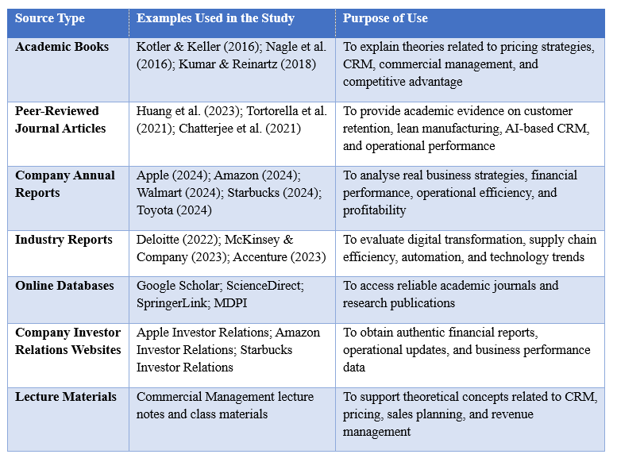

3.5Limitations of the Study
There are a number of limitations to the study. First, the research is completely based on secondary data, which implies the discoveries depend on beforehand distributed information over organizations or clients rather than primary information that would be gathered straight from the organizations or clients. This restricts the opportunity of carrying out independent internal assurance on business practices. Secondly, some commercial data, such as pricing information, strategic planning and operational data, is not available in public and is confidential.
However, the rapid pace of change in the market and business technologies is another constraint as a result of digital transformation and economic uncertainty. Consequently, there may be changes in the commercial strategies presented in it over the years. Last, the study is primarily conducted in large multinational companies; this might restrict the relevance of the results to small and medium enterprises (SMEs) with different market conditions.

4. Findings and Analysis

4.1 Apple Inc.: Premium Pricing and Brand Differentiation
To remain profitable in the international technology market, Apple Inc. follows a premium commercial strategy based on the product differentiation principle and innovation, with a good positioning of its commercial brand. Premium pricing is setting higher prices than the other companies which offer the same price for the same quality and innovation and for the customer value (Nagle et al., 2016). This is Apple's approach with its products, including the iPhone, MacBook, Apple Watch and iPad. The company is not based on a low-cost strategy, but rather on a customer experience-maximizing strategy of product design, ecosystem integration, software performance and brand reputation.
Apple's premium approach works because its customers value the brand for its quality and reliability, feel they have access to exclusive products and services, and appreciate Apple's innovations. The value based pricing enables Apple to sell products at high prices due to the customers' perception that Apple products are technologically advanced and very reliable (Kotler & Keller, 2016). The company also adds to its differentiation with its built-in ecosystem that includes the seamless integration of products and services like iCloud, AirPods, Apple Music and Apple Watch. According to the report from Brand Finance (2025), Apple's brand value of USD 574.5 billion placed it at the top of the list of the world's most valuable brands, a position it attained thanks to its impressive ecosystem growth, customer retention and premium market dominance.
Customer loyalty is significant in Apple's profitability because it is the loyal customers that continue to buy Apple products/services over and over again. By continually innovating their product, enhancing software, and providing after-sales service, as well as subscription-based services like Apple Music, iCloud, and Apple TV+, Apple is able to keep customers loyal. A recent study of smartphone consumers suggests that Apple has a higher customer retention rate than other brands due to its seamless integration with the wider ecosystem and user experience benefits (SQ Magazine, 2024). Loyal customers can be considered as valuable customers since they help in lowering the costs of acquiring new customers and stabilising the long-term revenues (Kumar & Reinartz, 2018).
It is clear that Apple has a lucrative business model, as reflected in its profitability. In its 2024 Annual Report, Apple reported total annual sales of close to USD 391 billion and service revenue, which is a function of premium products, has increased (Apple Inc., 2024). Product pricing, customer loyalty, diversified revenue and brand value enable Apple to continue holding a competitive edge in the world's technology markets, maintaining strong profit margins.
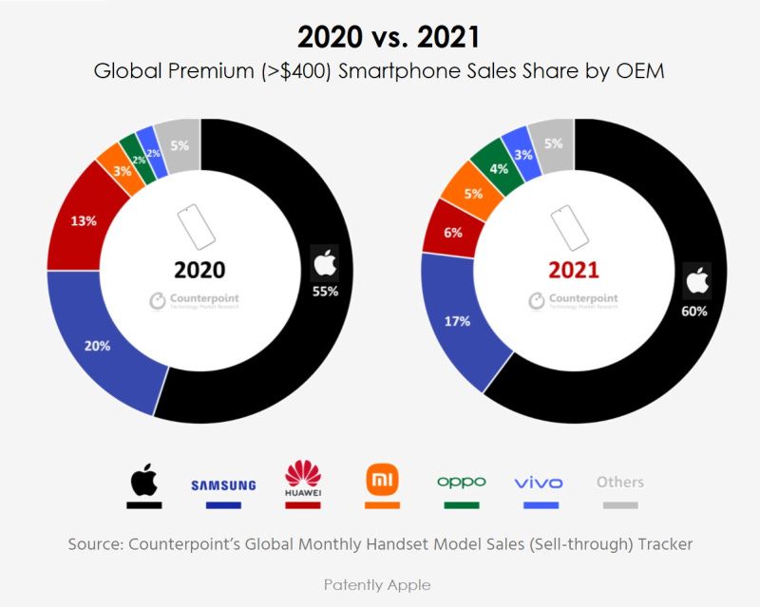
Fig 1: Apples’s Pricing Compared to Other Brands (2020-2021)

4.2 Walmart: Cost Leadership Strategy
Walmart's commercial approach is cost leadership; the company strives to minimise costs in the operations to enable it to sell its products at a lower price than other businesses. Walmart's strategy was given a greater importance to growth because the firm is dealing with the customers of large-scale retail markets who are price sensitive. According to Porter (1985) a company can gain competitive advantage by offering the lowest cost product or service in the market without sacrificing on profitability, which is achieved by selling a lot.
The strategy of Walmart goes around efficiency in their supply chain, as their operating expenses are heavily reliant on logistics and inventory management as well as supplier coordination. Walmart has a centralized distribution network with regional distribution centres, cross-docking operations and inventory management systems, which are connected to the real-time information. Cross-docking minimizes the time products spend in the warehouse, thus lowering warehousing and inventory holding costs, by moving products directly from suppliers to distribution trucks. Walmart Inc., 2024, reported that the company invested in automation and AI-powered inventory management systems to enhance its order fulfillment agility, prevent stockouts, and improve transportation efficiencies. These systems enable Wal-Mart to control thousands of stores in a variety of countries without having an excessive cost of operation.
Walmart's low-cost pricing model is based on its principle of “Everyday Low Price” (EDLP), which involves selling goods at low prices and not offering temporary special discounts. This method not only provides a better deal to the customer, but also builds their trust in the company since they know they will be able to purchase at a fixed price all year long. Walmart can keep the prices low due to its size and ability to negotiate lower prices with its suppliers. The business purchases their products in very large quantities, which helps them to negotiate with the suppliers which smaller retailers might not be able to do. According to Kotler and Keller (2016), the low-cost pricing strategy is viable if companies add to it operational efficiency and bulk-buying benefits.
A better operational efficiency directly impacts Walmart's profitability, since the costs of operation are reduced, even if the product prices are cut. Walmart employs automation technologies in their warehouses, predictive analytic systems for demand forecasting, and route optimization systems to cut down on the costs of fuel, labour and inventory. According to McKinsey & Company (2023), the use of AI-based supply chain systems by retailers resulted in increased inventory turnover and lower logistic costs, especially in high-volume retail businesses. That means, in addition to sales, Walmart's bottom line depends on the systems it has in place to continually eliminate waste and optimize operations.
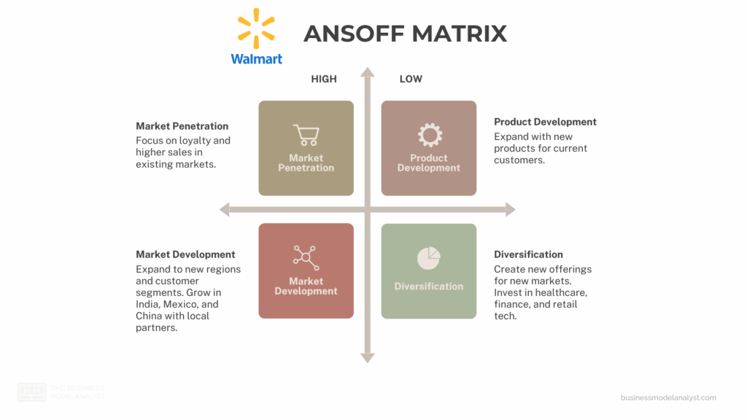
Fig 2: Walmart’s Cost Leadership Strategy

4.3 Amazon: Revenue Diversification Strategy
Amazon's business model is focused on diversifying revenue streams including ecommerce, subscription services, cloud computing, advertising and pricing models based on data. The company is not dependent upon one revenue stream and has a range of business models to boost profitability and minimise reliance on retail margins. The primary business model of Amazon e-commerce is based on high volume of transactions and commissions on the marketplace, third-party sellers’ services, logistics and digital advertising. Other online businesses, such as third-party sellers, subscription services, and advertising, contributed to the substantial increase in revenue for online stores in global markets (Amazon Inc., 2024). This diversified structure provides a solid financial stability as it creates revenue from many interacting business segments of Amazon.
Amazon's two key profit makers are Amazon Prime and Amazon Web Services (AWS). Amazon Prime is a subscription service that charges users monthly fees for access to its various features, including expedited shipping, Prime Video, music streaming and exclusive discount codes. Subscription models help them to retain customers as they are constantly interacting with Amazon's ecosystem. According to Kumar and Reinartz (2018), the subscription-based systems can boost the customer lifetime value by generating recurring value and less customers switching out. Additionally, Amazon membership boosts the product purchases since the customers purchase goods from the site to make the process easy and convenient.
The significance of AWS is the higher profitability of cloud computing services as compared to e-commerce businesses. AWS offers cloud infrastructure, data storage, artificial intelligence solutions and computing services to companies around the world. AWS continued to be one of Amazon's most profitable business units due to the strength of its enterprise cloud services in terms of operating income as compared to traditional retail businesses (Amazon Inc., 2024). However, AWS' success shows the benefit of diversifying revenue for increased profit and decreased operational risk in the long term.
Amazon is also leveraging dynamic pricing and customer data analytics to maximize the effectiveness of sales and revenue. Dynamic pricing involves real-time price adjustment because of customer behaviour, the actions of competitors, market conditions and demand. Amazon's algorithms constantly examine customers' search and buying habits, stock availability and competitors' prices, to decide on the best prices. AI-powered pricing systems can boost revenue optimization since businesses can swiftly adjust prices according to market trends and consumer behaviour. As demonstrated by Chen et al., (2021), these AI systems are essential for enhancing revenue optimisation as companies can adapt their pricing strategies rapidly to meet market demand and fluctuations.
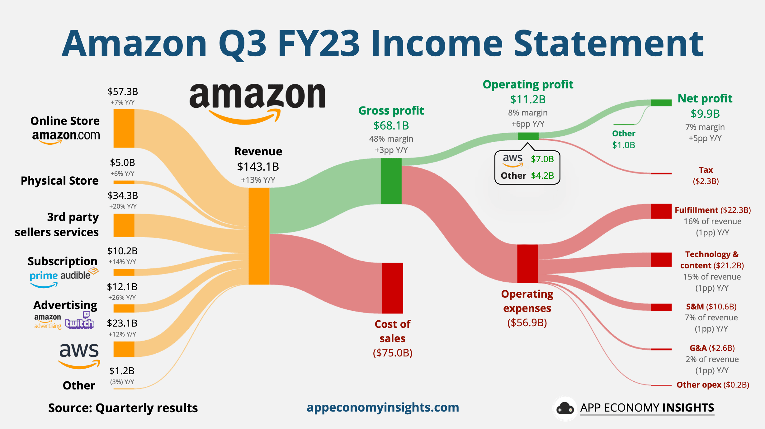
Fug 3: Amazon Revenue Breakdown Strategy

4.4 Starbucks: Customer Experience and Retention Strategy
Starbucks is pursuing a customer retention strategy through loyalty programs, digital interaction, and high-quality customer service to boost customer retention and maximize long-term value. The coffee market is very competitive, and the company is not able to differentiate its product; hence, Starbucks emphasizes the customer experience as a business opportunity. As highlighted by Huang et al. (2023), within the food and beverage industry, customer experience plays a significant role in determining their repurchase intention and customer loyalty as they are becoming more conscious of convenience, personalisation, and the emotional bond that brands can foster with them.
Starbucks Rewards is a relevant loyalty program that helps boost customer retention and the number of transactions. Customers earn points by purchasing and redeem them for free merchandise, customized offers and special offers. This approach will help to foster repeat sales and boost customer interactions. In 2024, Starbucks' active U.S. Rewards members rose to around 34.3 million, providing significant support to the store revenue growth (Starbucks Corporation, 2024). Here are the reasons why loyalty systems are important for businesses There are several reasons why loyalty systems are vital for businesses:
Starbucks' commercial strategy is further enhanced through digital customer engagement. The Starbucks mobile app combines digital payment, mobile ordering, loyalty tracking and individualized recommendations all on a single app. By leveraging AI for personalization and mobile ordering for convenience, these strategies help create meaningful interactions with customers and minimize waiting time. Both strategies, AI-driven personalization and mobile ordering, contribute to creating meaningful interactions with customers and reduce waiting time. As per Accenture (2023), digital engagement technologies are vital in enhancing customer retention as customers are now looking towards technology-enabled buying experiences that are speedy. Starbucks also leverages data from their customers to suggest what products to purchase, as well as optimise their promotions.
The company's high service quality is also beneficial in achieving its profitability as Starbucks frames itself as a lifestyle brand rather than a mere coffee seller. Starbucks can command premium prices for its products, while retaining customer loyalty and steady revenue growth, via product customization, store atmosphere and personalized customer interactions with the company.
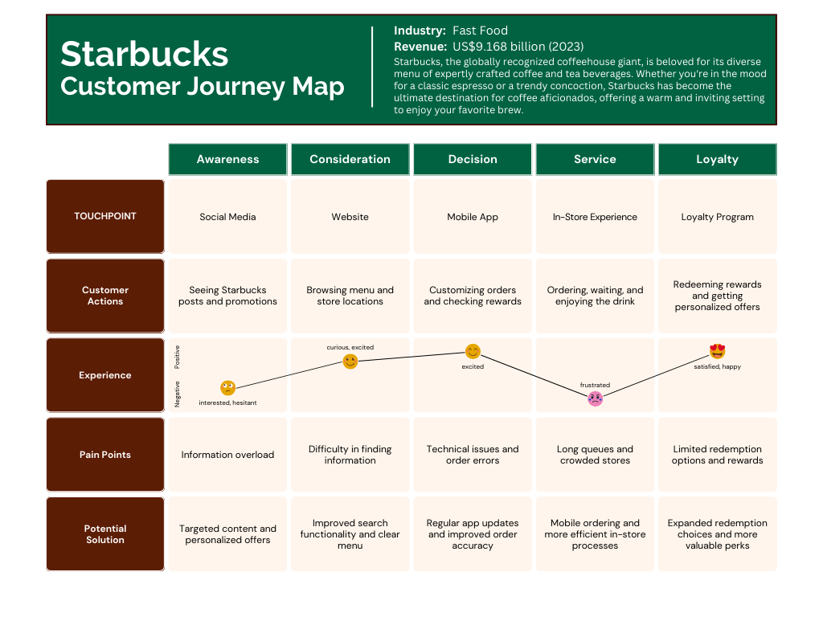
Fig 4: Starbucks’ Customer Journey Map

4.5 Toyota: Lean Cost Control Strategy
Toyota employs a lean cost control approach that emphasises the need for operational efficiency, elimination of waste and continuous improvement in order to ensure its profitability and competitive advantage in the automotive market. Lean manufacturing is a production system that has the aim of reducing all unnecessary activities and increasing efficiency, quality and productivity. The Toyota Production System (TPS) was developed by Toyota to increase the efficiency of manufacturing processes in a variety of ways, including the standardization of processes, management of inventory, and continuous improvement.
Waste reduction is a key component of Toyota's strategy since the costs of too much inventory, too long production time, too far transportation, and manufacturing defects are all increased costs. Toyota uses “Just in Time” (JIT) system that means that parts are just brought in at the time they are needed during production. This helps in lowering storage costs of inventory and flexibility in the production process. Toyota Motor Corporation (2024) states that the company is still investing in smart manufacturing systems, robotics, and carbon efficient production technologies to enhance the company's operational performance and minimise the production waste across the world.
Toyota also has a continuous improvement process known as “Kaizen” in which employees continually look for inefficiencies and make operational suggestions. This will increase productivity because the little improvements in operation will result in efficiency gains over time. Lean Manufacturing Practices were shown by Tortorella et al. (2021) to have significant impacts on performance in terms of operational performance, production flexibility, and cost efficiency in manufacturing industry globally.
Operational efficiency plays an important role in Toyota's profitability as it directly affects their margins as lower production costs mean higher quality product. Toyota was able to realize economies of scale and reduce the average production cost per vehicle, as it produced over 11 million vehicles worldwide in 2023 (Toyota Motor Corporation, 2024). According to Deloitte (2022), manufacturers who have embraced lean and automated manufacturing systems realize better supply chain resilience, reduced operating costs and better long-term profitability. It wasn't enough for Toyota to cut costs; it was essential that they have efficient operational systems.
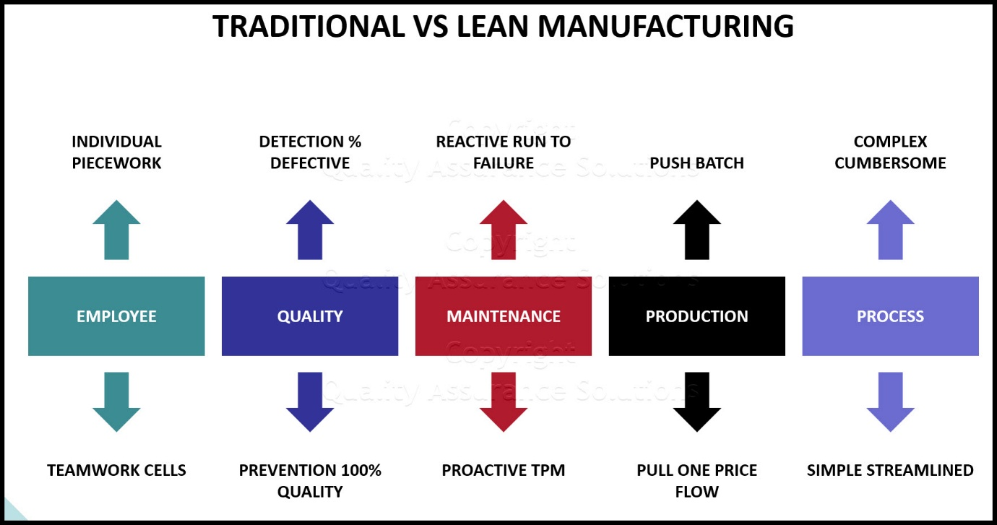
Fig 5: Traditional vs Lean waste Management used by Toyota

5. Discussion

5.1 Relationship Between Commercial Strategy and Profitability
The results indicate that the profitability is not achieved only in terms of volume, but on the basis of the way the firms shape their commercial strategies based on customer value, pricing control, operational efficiency and revenue stability. The ecosystem differentiation and premium pricing were crucial to Apple's profitability. For example, in 2024, the company reported revenues of around USD 391 billion, although they had higher margins than most of the smartphone players due to the customers' perception of Apple products as high value and less substitutes (Apple Inc., 2024). That means that innovation, brand loyalty, and customer experience integration are the key factors for premium pricing. If Apple does not continuously innovate, then they would have a hard time maintaining their premium prices as consumers would start looking elsewhere for a cheaper option.
Walmart, on the other hand, was more profitable based on operational efficiency and less on product differentiation. The results indicated that Walmart's cost-saving strategies included cross-docking systems, distribution centre centralization, and inventory forecasting using AI. Whereas high prices made Walmart profitable, they were not necessarily profitable through a higher margin; they were profitable because they had high transaction volume and their supply chain was efficient. This highlights the fact that cost leadership is only viable when businesses continually work to improve their logistics, purchasing and operational systems. However, as transportation and labour costs increase, the approach is likely to come into question if Walmart doesn't continue to make operational efficiency gains.

Amazon's approach proved to be a success, as it prevented the company from relying solely on one revenue stream, which made its financial situation more volatile and unstable. By diversifying its revenue streams, Amazon has made its financial position less risky and more stable in the long run. Operating income was much higher at AWS vs. Amazon's retail business, which enabled the company to more than compensate for the lower margins of its retail business with profitability at its cloud business (Amazon Inc., 2024). As a result, these results point to higher vulnerability of firms that depend on just one source of revenue in times of market volatility. Diversification of revenues helps business become financially resilient as they have some less successful business activities with more profitable services.

5.2 Commercial Planning and Competitive Advantage
The results reveal that competitive advantage is closely related to commercial planning in the long term and not to the short-term sales performance. Apple held a commanding lead in the market because the company was always investing in expanding its ecosystem, integration of software and product innovation before the competitors could catch up with Apple's solutions and systems. This demonstrates that strategic planning should not just be about earning money today, but also the actions customers might take in the future and the evolution of technology.
The lean manufacturing system that Toyota had set up also showcased how the ability to operate in the long term gives the company a competitive edge. By adopting Just-in-Time manufacturing and Kaizen systems, the company successfully cut down production waste while making the production more flexible, which also cut costs of operation. Toyota's lean system was integrated into the organization's processes and culture, unlike the short-term cost reduction effort. This resulted in consistency of operation, which was difficult to duplicate.
The study also revealed that commercial planning is becoming more and more dependent on digital transformation. With customer purchasing habits turning towards convenience and digital engagement, Starbucks continued to develop their mobile ordering, loyalty integration and personal promotions. In our current day and age, customers are increasingly demanding experiences that are quick, personal and technology-enabled, and companies who don't provide these services with digital systems may fall behind.

5.3 Role of Technology and CRM in Commercial Success
One of the most significant factors found to be contributing to commercial success for all of the case-study companies is the use of technology. The results revealed, however, that technology is not a way to increase profitability without effective integration with customer management and operations. Starbucks is leveraging customer buying information from its Rewards program to tailor promotions and boost re-purchasing. This led to better customer retention as the offers were targeted and not generic marketing campaigns.
Using AI-powered pricing algorithms and customer data analysis, Amazon maximized its revenue streams on a real-time basis. Amazon employed AI-based pricing strategies and customer data analysis to maximize revenue generation in real-time. Dynamic pricing algorithms continually revised product prices in response to competitor pricing, customer demand and stock levels. This enabled Amazon to optimize sales conversion and profitability while at the same time. The results thus indicate that unlike in traditional markets, data-driven pricing systems are superior to static pricing in fast-changing markets of digital retail.
Walmart took a different approach with technology, with automating operations and managing inventory. Operational costs were lowered as a result of predictive analytics that better forecast demand and minimize stock-outs. Accordingly, the assessment reveals that the strategic use of CRM and digital technologies can enhance the likelihood of commercial success in either customer retention or operational efficiency, as well as in revenue optimization.

5.4 Strategic Challenges in Modern Commercial Management
While all the case-study companies achieved positive commercial results, each had strategic issues that might impact on profitability. Smartphone markets have become saturated, and it's Apple's increasing competitive presence because there isn't a lot of room for rapid product differentiation. Continuous innovation and ecosystem expansion are needed to continue delivering premium pricing.
Small increases in running costs can have a significant impact on retail margins, and Walmart's low-cost approach is prone to inflation and rising labour costs as well as supply chain issues. Amazon also has regulations to contend with regarding its dominance in the market, its workplace practices, and data privacy issues, all of which could play a role in its flexibility and profit.
The results also suggest that there are opportunities and challenges associated with digital transformation. With the help of AI and automation, companies can enhance efficiency; however, they rely more and more on data systems and cybersecurity protection. Without protecting customers' data, it can ruin customer trust and brand reputation considerably. In the modern era, it is essential to achieve a balance of technological innovation and operational security, with customers' confidence and expectations for sustainability being taken into account.

5.5 Critical Evaluation of Business Strategies
Based on the evaluation, the most sustainable business models are a mix of customer value creation, operational efficiency, technological integration and long-term strategies. The high margins Apple was able to achieve with this premium approach were driven by a need to continuously innovate and gain loyal customers. Walmart's cost leadership strategy resulted in high market share, but continuously needed to be optimized to ensure profitable operations. Amazon's diversification of its revenue stream seemed to make it more resilient, as profits were spread across several business lines and not a single one.
Toyota's lean manufacturing approach was a success that proved that operational efficiency is a competitive advantage when it's part of the organization's culture, and the system's production. Starbucks also demonstrated that digital engagement and personal customer journeys can make a tremendous impact on profitability as a part of the overall customer retention strategy.
The results thus suggest that companies should not adopt a single business solution. Rather, price policy, customer management, streamlining business processes, and technology investments should be part of a unified commercial plan. This holistic strategy is better suited for ensuring profitability and a competitive position in dynamic and ever-evolving international markets.

6. Conclusion
The results obtained in this report showed that commercial strategy is a vital element in determining the profitability of the business and its performance in a competitive market. Premium pricing, cost leadership, customer retention, revenue diversification and operational efficiency are some of the other ways that organizations boost their profitability. Apple's approach of high-priced goods and its ecosystem was proving that customer value and brand differentiation are able to ensure high returns, and Walmart's efficient operation and supply chain were proving that low cost is an effective approach in mass market retail. Amazon also demonstrated that a diversified revenue model, like its AWS and Prime subscription services, also enhances financial strength and mitigates against operational risks. Starbucks emphasized the significance of digital customer engagement and loyalty initiatives in boosting customer retention and repeat business, while Toyota's lean manufacturing approach showcased the benefits of waste reduction and continuous improvement for long-term profitability.
Its research goals were met by examining the pricing strategies, revenue management systems, cost-control strategies and commercial planning strategies of various industries. The study further revealed that Customer Relationship Management (CRM) systems, Artificial Intelligence (AI) technologies, and digital transformation are increasingly having an impact on customer engagement, customer operation, and strategic decision-making. Therefore, companies must continually invest in technological innovation, customer relation management, operation efficiency and market analysis to ensure sustainable profitability and competitive advantage under the ever-changing global markets.

7. References
Accenture. (2023). Technology Vision for Consumer Goods and Services. Available at: Accenture Technology Vision Report
Amazon Annual Report 2024
Apple Inc. (2024). Annual Report 2024. Available at: Apple Investor Relations Annual Report
Barney, J. (1991). Firm Resources and Sustained Competitive Advantage. Journal of Management, 17(1), pp. 99–120. Available at: Barney Resource-Based View Article
Brand Finance. (2025). Apple is the World’s Most Valuable Brand in 2025. Available at: Brand Finance Apple Report
Bright, D., et al. (2019). Commercial Management: Theory and Practice. Available at: Commercial Management Reference
Chatterjee, S., Rana, N. P., Tamilmani, K., & Sharma, A. (2021). The Effect of AI-Based CRM on Organizational Performance. Journal of Business Research. Available at: AI CRM Research Article
Chen, L., Mislove, A., & Wilson, C. (2021). Algorithmic Pricing and E-commerce Competition. Available at: Algorithmic Pricing Research
Creswell, J. W., & Creswell, J. D. (2018). Research Design: Qualitative, Quantitative and Mixed Methods Approaches (5th ed.). Available at: SAGE Research Design Book
Deloitte. (2022). Smart Manufacturing and Operational Efficiency in Automotive Industries. Available at: Deloitte Smart Manufacturing Report
Huang, Y., Chen, H., & Liu, M. (2023). Customer Experience and Repurchase Intention in Food-Service Industries. Journal of Retailing and Consumer Services, 73. Available at: Journal of Retailing and Consumer Services
Kotler, P., & Keller, K. L. (2016). Marketing Management (15th ed.). Pearson. Available at: Pearson Marketing Management
Kumar, V., & Reinartz, W. (2018). Customer Relationship Management: Concept, Strategy and Tools (3rd ed.). Springer. Available at: Springer CRM Book
McKinsey & Company. (2023). The Future of Retail Supply Chains. Available at: McKinsey Retail Supply Chain Report
Nagle, T. T., Müller, G., & Brashear-Alejandro, T. (2016). The Strategy and Tactics of Pricing (6th ed.). Routledge. Available at: Routledge Pricing Strategy Book
Payne, A., & Frow, P. (2005). A Strategic Framework for Customer Relationship Management. Journal of Marketing, 69(4), pp. 167–176. Available at: CRM Strategic Framework Article
Porter, M. E. (1985). Competitive Advantage: Creating and Sustaining Superior Performance. Free Press. Available at: Competitive Advantage Book
Saunders, M., Lewis, P., & Thornhill, A. (2019). Research Methods for Business Students (8th ed.). Pearson. Available at: Pearson Research Methods Book
SQ Magazine. (2024). Apple Customer Loyalty Statistics and Consumer Behaviour Analysis. Available at: SQ Magazine Apple Loyalty Statistics
Starbucks Corporation. (2024). Annual Report 2024. Available at: Starbucks Investor Relations
Tortorella, G., Fettermann, D., & Frank, A. (2021). Lean Manufacturing Implementation and Operational Performance. Total Quality Management & Business Excellence, 32(9–10). Available at: Lean Manufacturing Research Article
Toyota Motor Corporation. (2024). Sustainability Data Book 2024. Available at: Toyota Sustainability Report
Walmart Inc. (2024). Annual Report 2024. Available at: Walmart Annual Reports
Womack, J. P., & Jones, D. T. (2003). Lean Thinking. Free Press. Available at: Lean Thinking Book

