

PLANNING AND MANAGEMENT OF SUSTAINABLE TOURISM SPACES

ASSIGNMENT 3

1. Evaluation of Natural and Cultural Resources for Tourism Development: A Case Study of Bali, Indonesia
Bali, Indonesia, with its beautiful scenery and rich traditions, is an ideal case of how natural and cultural values could be used to develop the tourism industry. The island has beautiful beaches, rice terraces, forests, and colourful marine organisms in addition to the deep-rooted Hinduism evidenced by temples, rituals and festival. Demand on these resources has however been mounted by the rapid development of tourism (Atlas, 2024).
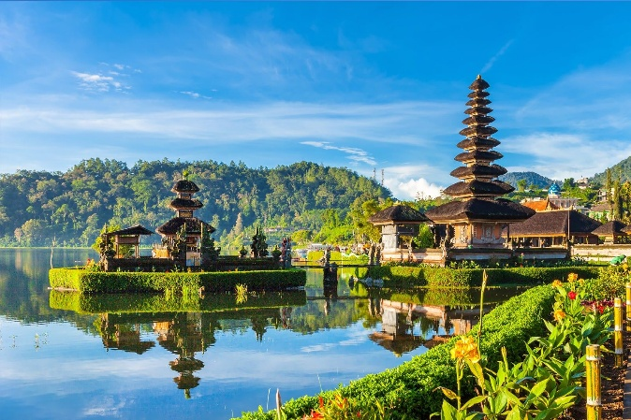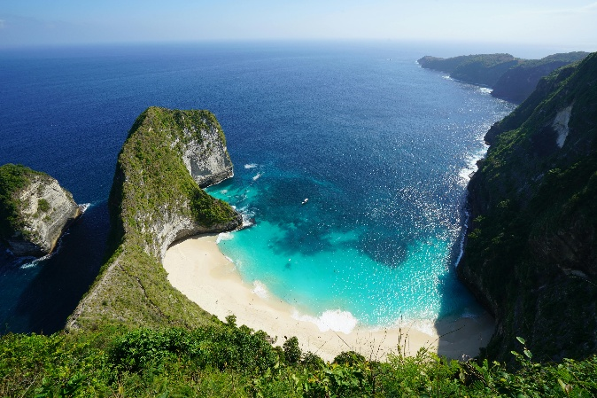

Natural Resources
The natural resources of Bali especially the beaches and oceans are the focal point of the tourism business. Third, the island boasts of its coral reefs and this has seen it become a major attraction in snorkelling and diving. Another famous aspect of Ubud is rice terraces that attracts eco-tourism visitors. Over-tourism has however resulted in the degradation of the environment, such as coral bleaching, desertification and water shortages due to over-irrigation to grow rice and pressure by hotels and resorts.

Cultural Resources
The cultural heritage of Bali is another huge attraction to tourists. Several UNESCO World Heritage groups can be found on the island including the Subak irrigation system of the Bali rice terraces. Some of the important cultural sites include temples such as Tanah Lot and Uluwatu. Visitors are also drawn to traditional arts and crafts including, Balinese dance and wood carving. The flow of tourists, however, has caused cultural commodification, whereby, traditions and rituals are at times performed to please tourists rather than their spiritual value.

Management and Sustainability
These resources have been put as an effort to manage them on a sustainable basis. The Bali Hotel Association has also launched programs on advocacy of green practices in hotels and the local government has created the marine conservation zones. Although these attempts have been made, the relationship between tourism and sustainability is still very fragile, and greater regulation is required.

Recommendations for Improvement
Bali can use stricter measures to regulate the number of tourists to avoid overtourism, as this would help make the country more sustainable in terms of tourism. As an illustration, restricted access to recreational places such as the Sacred Monkey Forest Sanctuary during times of peak should reduce the pressure. Moreover, more funding on eco-tourism including responsible wildlife tours and low-impact activities would contribute towards saving the natural environment in Bali. There is a need to have educational tourism programs on cultural respect and environment conservation as a way of ensuring the long-term sustainability (Tiger, 2025).

2. Key Elements Contributing to Successful Destination Development
Effective integration of various factors- attractions, accessibility, amenities, image and ancillary services proves the success of tourism destinations. They all contribute to the better visitor experience and enhances the competitiveness of the destination in the long run (Iannaccone et al., 2024).

Attractions
The main motivational force is the destinations people travel to are attractions, be it natural (e.g. the Great Barrier Reef in Australia) or cultural (e.g. the Louvre Museum in Paris). The tourism destination has well developed attractions that will serve various interests. An example is Switzerland that is able to mix the natural attractions with Switzerland Alps with cultural amenities such as museum and old towns. The variety and difference in destinations make a destination attractive and contribute to enjoying constant stream of visitors.
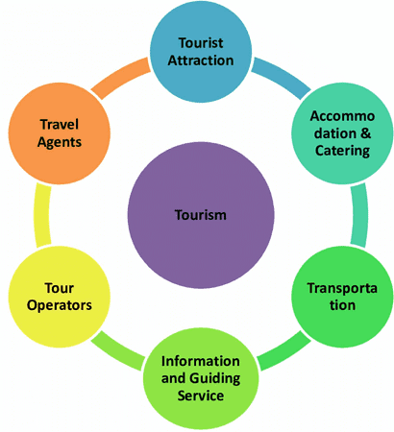
Figure 1: Composition of Tourism industry
Source: (Rajvuniversity, 2024)

Accessibility
A destination needs to be accessible. It is defined by ease of travelling to and within the destination by the tourists. Good and well-developed transportation infrastructure systems such as international airports, rail, and local transportation systems are very important. City accessibility is a major attraction of millions of tourists in urban areas such as Tokyo where the transport system is efficient and has extended coverage. Digital infrastructure, such as a simple-to-use webpage or mobile application that offers details on how to get there, where to stay, and to visit attractions, is also considered accessible and makes the whole experience of the visitor easier.

Amenities
Provision of quality amenities plays a significant role in ensuring that the tourists have a nice and pleasant experience. The accommodation facilities to be offered should include both low-end hotels such as budgets and high-end hotels such as luxury ones, as well as an immense assortment of food. A place such as Dubai is good at providing luxurious facilities such as five-star hotels, shopping centers that are of world standard and restaurants too. There are also good facilities like clean communal toilets, internet (Wi-Fi), and information desks, which are considered as additional forms of convenience and ease of tourists.

Image
The image of a destination is crucial in the furniture of tourists. A destination brand that is properly developed can help a destination to become recognizable and also have an emotional attachment with the potential tourists. A typical example of this is Paris, which is regarded as the city of culture and romance globally, due to its numerous cultural establishments, well-known landmarks and advanced marketing. The image that is of great quality can be created with the help of focused marketing campaigns, popular press coverage and even the word-of-mouths that influence the views of the prospective tourists.

Ancillary Services
The ancillary services serve the major ones and complement the entire experience of the visitor. These services are the tour guide, travel agency, event organizer and local businesses that sell products or experience that are unique. As an illustration, guided walking tours of the historic areas in London is one activity whereby the visitors get a better understanding of the history of the city. Similarly, local enterprises, which can provide the traditional crafts or food experiences, are important to increase the cultural depth of the destination.

References
Atlas (2024). Explore Bali Green Tourism: Sustainable Travel Experiences. [online] Atlas Beach Fest | The Biggest Beachclub in The World & The Biggest Nightclub in Bali - The biggest beachclub in the world | The biggest nightclub in Bali. Available at: https://news.atlasbeachfest.com/articles/bali-green-tourism/ [Accessed 30 Sep. 2025].
Iannaccone, B., Šoltésová, M., Molokáč, M. and Taušová, M. (2024). The Role of the Visitor Center in Destination Development. Sustainability, [online] 16(22), p.10062. doi: https://doi.org/10.3390/su162210062.
Rajvuniversity (2024). Composition of Tourism industry - Vrindawan University. [online] Vrindawan University - Sikhega India Toh Badhega India. Available at: https://vuniversity.in/composition-of-tourism-industry/ [Accessed 30 Sep. 2025].
Tiger, M. (2025). Bali sustainable travel: Eco-conscious adventures and green escapes for nature lovers. [online] Mango Tiger DMC. Available at: https://mangotiger.com/bali-sustainable-travel/ [Accessed 30 Sep. 2025].

