M16 - Commercial and Marketing Management
Commercial Strategy and Marketing Performance in Modern Organizations
Option 1: Commercial Strategy and Marketing Performance in Modern Organizations
Detailed Project Report

Contents

Abstract 2
1. Introduction 3
2. Literature Review 4
3. Methodology 7
4. Findings 8
5. Discussion 15
6. Recommendations 18
7. Conclusion 21
References 22
Appendices 24
Appendix A. Evidence summary 24

Abstract
This report examines how commercial management and marketing management combine to support organisational performance in modern competitive markets. Commercial management is treated as the discipline that converts market opportunities into profitable revenue through pricing, sales planning, channel decisions, contract discipline and margin control. Marketing management is treated as the discipline that identifies customer needs, creates differentiated value, communicates this value and manages demand. The central argument is that organisations perform best when these two areas operate as one integrated system rather than as separate functions. The report applies academic theory on segmentation, targeting, positioning, customer value, pricing, channel strategy and performance measurement. It also uses real world evidence from Apple, NIKE and Starbucks to show how marketing choices influence sales performance, customer acquisition, retention and profitability. The findings show that pricing power depends on differentiated value, segmentation improves the efficiency of sales resources, digital channels generate data as well as revenue, and brand trust supports repeat demand. However, the analysis also finds that growth can be damaged when commercial decisions focus too heavily on short term revenue extraction, excessive discounting or channel expansion without operational capacity. The report recommends a balanced commercial scorecard, value based pricing discipline, customer lifetime value metrics and closer integration between marketing insight and sales execution.

1. Introduction
Commercial and marketing management have become central to organisational performance because most industries now compete through a combination of price, data, service, brand reputation and customer experience. A business can have an attractive product, but it will not convert this product into sustainable growth unless it understands customer needs, selects profitable target segments, sets appropriate prices, designs effective sales channels and communicates a clear value proposition. The assignment brief requires an examination of commercial strategy and marketing performance in modern organisations. This report therefore focuses on the relationship between commercial management, marketing management and business growth, with specific attention to pricing, segmentation, targeting, positioning, revenue generation, sales performance, customer acquisition and profitability.
Commercial management is broader than selling. It includes decisions about revenue architecture, contractual terms, channel economics, customer profitability, margin protection and the financial consequences of customer offers. Marketing management is also broader than promotion. It includes market analysis, customer insight, brand positioning, product design, communication, customer relationship management and demand generation. When the two are integrated, marketing creates demand that commercial teams can convert profitably. When they are separated, the organisation may create campaigns that generate unprofitable sales, or commercial targets that damage customer value and long term brand equity.
The report uses a topic based methodology and draws on academic sources and recent company evidence. Apple is used to illustrate the relationship between product ecosystem strategy, services growth and pricing power. NIKE is used to show the opportunities and risks of channel strategy and direct digital commerce. Starbucks is used to show how customer experience, pricing, store expansion and loyalty can influence commercial outcomes. These examples are relevant because they operate across consumer markets, services, retail and global distribution, which makes them useful for analysing the wider principles of commercial and marketing management.
The report argues that the strongest commercial strategies are not built around isolated tactics. They depend on a coherent chain of decisions. Market research identifies attractive segments. Segmentation and targeting decide where the organisation should compete. Positioning defines why the organisation should be chosen. Pricing translates perceived value into revenue. Distribution makes the offer accessible. Promotion reduces uncertainty and builds preference. Sales planning converts demand into actual orders. Performance measurement then shows whether the organisation is acquiring the right customers at an acceptable cost and retaining them at a profitable margin.

2. Literature Review
Marketing management theory begins with customer value. Kotler, Keller and Chernev (2022) argue that marketing is concerned with identifying and satisfying human and social needs profitably. This definition is important because it connects customer satisfaction with organisational performance. A firm that satisfies needs without profitability may fail commercially, while a firm that pursues profit without genuine value creation may lose trust and future demand. The task for modern organisations is therefore to align value creation with value capture.
The segmentation, targeting and positioning framework remains one of the most important foundations of marketing strategy. Segmentation divides a broad market into groups with different needs, behaviours or profitability characteristics. Targeting selects the groups that the firm is best able to serve. Positioning then gives the selected customers a clear reason to prefer the firm over competitors. Wedel and Kamakura (2012) describe segmentation as a way of improving resource allocation because it prevents managers from treating all customers as identical. In commercial terms, segmentation matters because sales teams, promotions and prices can be adjusted according to customer willingness to pay, service cost and lifetime value.
Pricing is the most direct link between marketing strategy and commercial performance. Nagle and Muller (2018) argue that price should be set by considering economic value to the customer rather than only adding a margin to cost. This is relevant because a cost based approach can leave money uncollected where customers perceive high value, while aggressive low pricing can weaken quality perceptions and reduce margin. Value based pricing works best when the organisation has strong evidence of customer benefits, clear differentiation and disciplined communication. For example, a premium brand can sustain higher prices when customers believe that the product reduces risk, improves status, improves performance or creates a superior experience.
Branding theory also supports the relationship between marketing and performance. Keller (1993) argues that customer based brand equity arises when consumers hold strong, favourable and unique associations in memory. Brand equity can improve commercial results because it supports preference, repeat purchase and willingness to pay. Aaker (1991) similarly links brand equity to loyalty, perceived quality, awareness and associations. These concepts show why commercial management cannot be reduced to price negotiation. A strong brand can make selling easier, reduce the need for discounts and protect the business against competitors that imitate functional features.
The resource based view and market based view also help explain performance differences. Barney (1991) argues that sustainable advantage depends on resources that are valuable, rare, imperfectly imitable and organised. Marketing capabilities can fit this logic when customer insight, analytics, brand reputation or channel relationships are difficult to copy. Morgan, Vorhies and Mason (2009) find that market orientation and marketing capabilities are associated with superior business performance. This supports the argument that marketing is not only a communication function but a strategic capability that can influence commercial outcomes.
Customer relationship management and customer lifetime value add another layer to commercial strategy. Payne and Frow (2005) define CRM as a strategic approach to managing customer relationships in order to create shareholder value. Kumar and Reinartz (2016) argue that customer relationship management should focus on both acquiring profitable customers and retaining them efficiently. In practice, this means that marketing performance should not only be measured by leads, impressions or short term sales. It should also consider repeat purchase, retention, basket size, cross selling, margin contribution and service cost.
Digital marketing has changed the link between marketing activity and commercial control. Online channels allow organisations to test messages, personalise offers, measure conversion and track customer journeys. Lemon and Verhoef (2016) show that customer experience is shaped across multiple touchpoints before, during and after purchase. This matters commercially because a customer may discover a brand through social media, evaluate it through reviews, purchase through a website and require after sales support through chat or store service. Commercial performance therefore depends on the management of the full journey, not only the final sale.
The literature also warns against excessive short termism. Marketing activities that create immediate revenue can damage long term brand trust if they rely on misleading claims, excessive discounting or poor fulfilment. Porter (1985) argues that competitive advantage depends on fit among activities. A marketing promise that is not supported by operations creates dissatisfaction and weakens retention. The commercial implication is that revenue generation must be aligned with capacity, service quality and ethical communication. This is especially important in services and hospitality where customers evaluate both the outcome and the experience.

3. Methodology
This report uses a qualitative, topic based business analysis methodology. The purpose is not to conduct primary research or statistical testing. Instead, the report evaluates academic theory and company evidence in order to explain how commercial and marketing strategies contribute to organisational performance. This method is appropriate because the assignment asks for a detailed project report on principles and practices rather than a field survey. It allows the report to combine conceptual analysis with real world examples from organisations operating in retail, services and manufacturing linked markets.
The evidence base includes peer reviewed marketing and strategy literature, recognised textbooks and recent company reports. Apple, NIKE and Starbucks are selected as illustrative cases because they show different forms of commercial and marketing integration. Apple represents ecosystem based value creation and premium pricing. NIKE represents brand led sports marketing, wholesale relationships and direct digital channels. Starbucks represents experience based retailing, loyalty, store economics and pricing within a service environment. The selected firms are not treated as perfect examples. They are used critically to identify both strengths and risks in commercial strategy.
The analysis follows 4 stages. First, the report identifies the theoretical relationship between commercial management, marketing management and performance. Second, it examines key marketing and commercial decisions, including segmentation, targeting, positioning, pricing, channel management and revenue generation. Third, it evaluates how these decisions influence sales performance, customer acquisition and profitability. Fourth, it develops recommendations for managers. The limitations of the method are that it relies on publicly available evidence and cannot access confidential customer profitability data. However, the method is suitable for a strategic report because it supports critical evaluation across multiple sectors.

4. Findings
The first finding is that commercial and marketing management are mutually dependent. Marketing identifies and shapes demand, while commercial management monetises that demand. A campaign can increase awareness, but the financial outcome depends on pricing, channel availability, conversion, fulfilment and customer service. Similarly, a sales target can push revenue in the short term, but it may damage performance if it forces discounts or attracts customers with low retention potential. The relationship is therefore circular. Insight informs the offer, the offer shapes customer response, the response generates data, and data improves future commercial decisions.
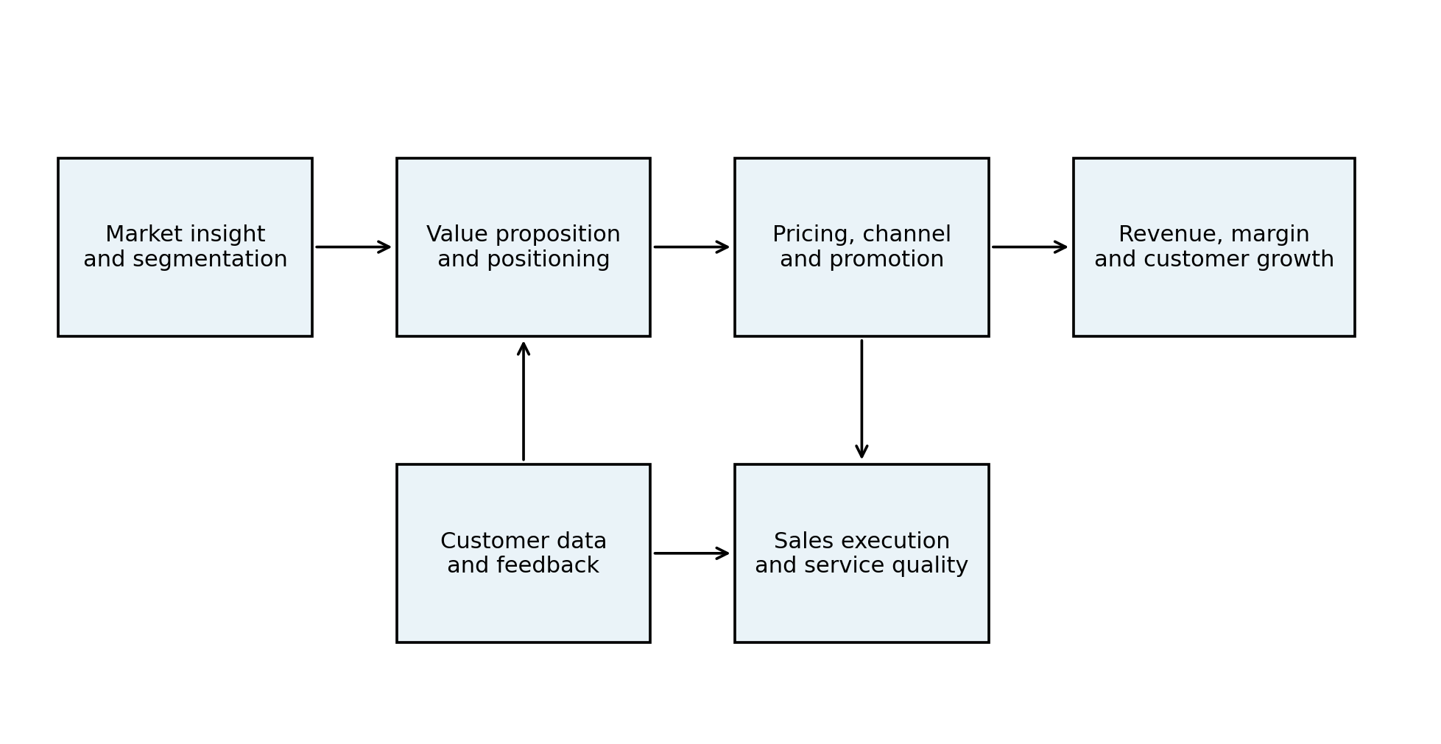
Figure 1. Integrated commercial and marketing performance logic.
Table 1. Commercial and marketing management links to performance
Decision area | Marketing role | Commercial performance effect
Segmentation | Identifies customer groups with different needs | Improves targeting of sales resources and reduces waste
Positioning | Creates a reason to prefer the offer | Supports conversion and price premium
Pricing | Communicates value and frames quality | Protects margin and controls revenue quality
Channel strategy | Makes the offer accessible at key touchpoints | Influences acquisition cost, service cost and data capture
Customer relationship management | Supports repeat engagement and personalisation | Increases retention and lifetime value

Apple provides a strong example of this circular relationship. Its 2025 Form 10 K reported total net sales of $416.161 billion, compared with $391.035 billion in 2024 and $383.285 billion in 2023. The same report shows that Services net sales increased from $85.200 billion in 2023 to $109.158 billion in 2025, and Apple attributed 2025 Services growth to advertising, the App Store and cloud services (Apple Inc., 2025). This pattern demonstrates how marketing and commercial management can extend value beyond the initial hardware transaction. The customer relationship is not complete when an iPhone is sold. It continues through the ecosystem, subscriptions, apps and cloud usage, which increases recurring revenue and strengthens switching costs.
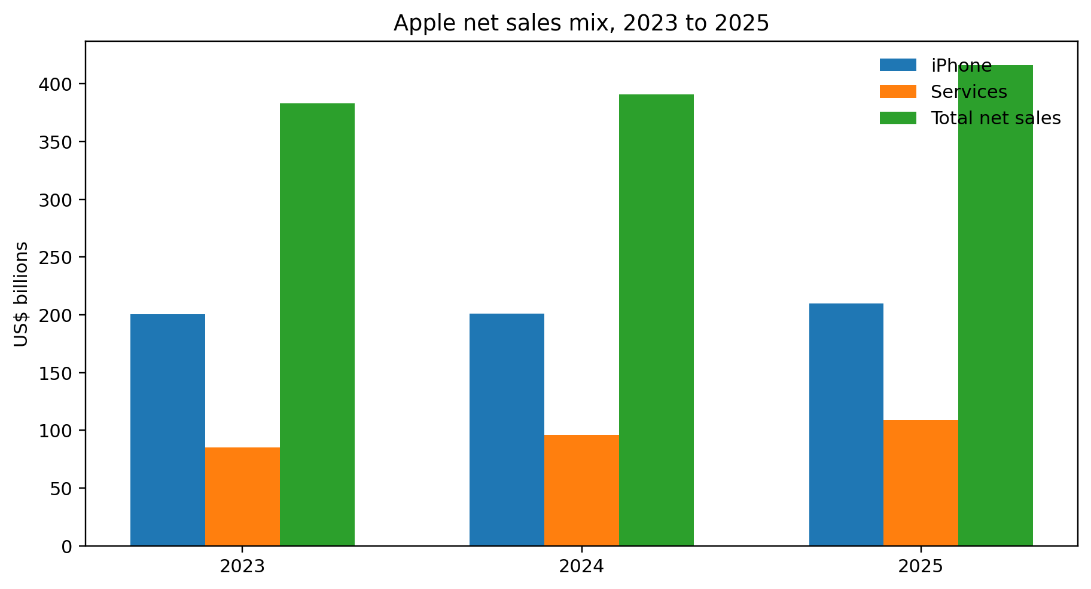
Figure 2. Apple selected net sales data, 2023 to 2025. Source data: Apple Inc. (2025).
The second finding is that pricing strategy influences performance through both revenue and perception. Premium pricing can increase margin and reinforce brand status when customers accept the value proposition. However, premium pricing must be supported by quality, design, service and trust. Apple can sustain premium pricing partly because its product, software and service ecosystem gives customers a reason to perceive differentiated value. Starbucks can also apply pricing power in some markets because the customer is purchasing not only coffee but convenience, store ambience, brand familiarity and loyalty benefits. However, price increases can become risky when customers face pressure on disposable income or when service quality declines.
The third finding is that segmentation and targeting improve the efficiency of commercial resources. A mass market approach may create awareness, but it rarely produces the best commercial outcome because customer needs and profitability differ. Apple targets high value consumer and professional segments through product tiers, services and ecosystem integration. NIKE targets athletes, lifestyle consumers and sport communities through product categories and endorsements. Starbucks targets convenience seeking urban consumers, routine coffee buyers, remote workers and loyalty app users. In each case, segmentation shapes store format, product assortment, communication and price architecture.
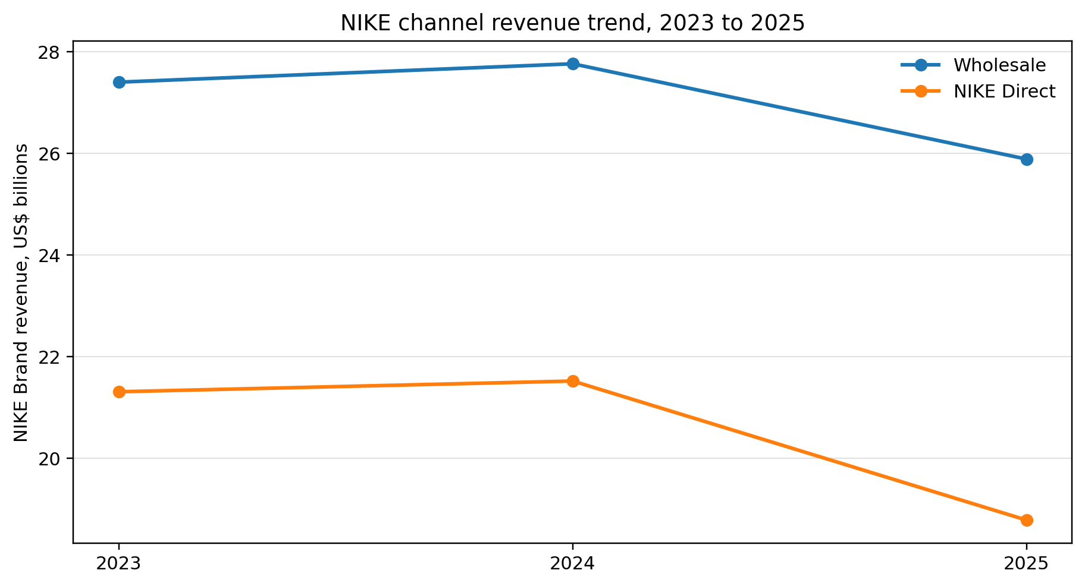
Figure 3. NIKE wholesale and NIKE Direct revenue trend, 2023 to 2025. Source data: NIKE, Inc. (2025).
The fourth finding is that distribution and channel decisions directly affect both acquisition and profitability. NIKE illustrates this point. In fiscal 2025, NIKE reported revenues of $46.309 billion, down from $51.362 billion in 2024. NIKE Brand wholesale revenue fell from $27.758 billion in 2024 to $25.883 billion in 2025, while NIKE Direct declined from $21.519 billion to $18.783 billion (NIKE, Inc., 2025). Direct channels can improve customer data and margin control, but they also require technology investment, inventory discipline and compelling digital experiences. The decline in NIKE Direct digital sales reported by the company shows that direct to consumer strategy is not automatically superior. It must be supported by product freshness, platform usability and balanced wholesale relationships.
The fifth finding is that marketing decisions shape sales performance before the salesperson or digital checkout is involved. Brand salience, trust, reviews, influencer activity, advertising and public relations reduce perceived risk and make customers more willing to consider the offer. Sales performance therefore depends on upstream marketing work. A sales team can close more effectively when customers already understand the product category and value proposition. Digital analytics also allow managers to identify the stages where customers drop out of the funnel, such as awareness, consideration, cart, checkout or repeat purchase.
The sixth finding is that customer acquisition must be evaluated against retention and lifetime value. Organisations can buy traffic through paid media, but this can become commercially weak if conversion is low or if customers do not repeat purchase. Marketing performance should therefore include customer acquisition cost, conversion rate, average order value, repeat purchase rate, churn and customer lifetime value. This is especially relevant in subscription, services and loyalty driven markets. Apple Services, Starbucks Rewards and NIKE memberships show that leading firms increasingly treat customer acquisition as the beginning of a relationship rather than a single transaction.
The seventh finding is that real world relevance depends on operational fit. Starbucks reported 40,990 stores as of September 28, 2025, with 21,514 company operated stores and 19,476 licensed stores. It also stated that company operated stores accounted for 83% of total net revenues during fiscal 2025 (Starbucks Corporation, 2025). These numbers show the commercial importance of store operations, not only brand advertising. If staffing, queue times, mobile ordering and product availability are weak, marketing cannot fully protect performance. The company's Back to Starbucks initiatives show that service quality and store experience remain commercial variables.
The eighth finding is that marketing has a direct influence on profitability through margin quality. A marketing strategy that depends on constant discounting can grow revenue while reducing gross margin and weakening brand associations. By contrast, a value based strategy can support higher willingness to pay, stronger repeat purchase and lower price sensitivity. NIKE's 2025 report indicated that higher discounts and channel mix contributed to lower average selling prices and margin pressure (NIKE, Inc., 2025). This shows why managers must distinguish between high quality revenue and low quality revenue. The best commercial outcome is not always the highest sales volume in the short term.
The final finding is that ethical marketing and transparency are performance factors, not only compliance issues. Customers are increasingly sensitive to privacy, sustainability claims, pricing fairness and authenticity. Misleading communication can damage trust and increase regulatory risk. Strong commercial strategy therefore requires truthful value communication, responsible use of data and honest treatment of customers. This supports long term customer acquisition because trust reduces resistance to purchase and encourages recommendation.
A further finding is that revenue generation is stronger when the organisation distinguishes between demand creation and demand fulfilment. Demand creation involves brand awareness, advertising, search visibility, lead generation and customer persuasion. Demand fulfilment involves product availability, stock accuracy, checkout speed, sales capability, delivery reliability and after sales support. If marketing creates demand faster than the business can fulfil it, customers may experience stock outs, delays or poor service. This can reduce customer trust and make future acquisition more expensive. Commercial management therefore has to translate marketing forecasts into inventory, staffing, distribution and service readiness.
Another finding is that positioning should guide sales conversations and not only advertising messages. A sales team that understands the intended position can explain value consistently, handle objections and avoid reducing the offer to price. In business to business markets, this is especially important because customers often compare total cost, risk reduction, implementation support and long term supplier reliability. In consumer markets, the same principle applies through store staff, online product pages and customer service scripts. When the positioning message is repeated across all touchpoints, the customer receives a coherent argument for purchase.
The analysis also shows that commercial strategy must consider revenue timing. Some marketing decisions generate immediate sales, while others build future demand. Brand advertising, customer education and community building may not produce instant conversion, but they can increase future search volume and lower resistance to purchase. Performance marketing can produce measurable short term sales, but it may become expensive if the organisation relies on it too heavily. A balanced strategy therefore combines short term activation with long term brand building. This balance is important because customer acquisition costs often rise when a firm has weak brand salience and must repeatedly pay platforms to reach customers.

5. Discussion
The findings show that commercial and marketing management should be managed as an integrated performance system. The traditional separation between marketing as communication and commercial management as sales control is too narrow for modern organisations. In digital and omnichannel markets, the customer journey crosses advertising, search, social proof, website experience, store interaction, fulfilment, payment and after sales service. Each stage affects both customer value and financial outcome. This means that commercial leaders need marketing insight, while marketing leaders need commercial discipline.
The Apple example supports the argument that value capture is strongest when the firm builds an ecosystem rather than selling isolated products. The iPhone remains central, but the growth of Services shows how customer relationships can be monetised after the initial purchase. The risk is that ecosystem strategy can attract regulatory scrutiny and customer concerns about lock in. Therefore, long term performance depends on balancing commercial monetisation with customer freedom, trust and perceived fairness. If customers feel trapped rather than served, the source of advantage may weaken.
The NIKE example provides a more cautionary lesson. Direct digital channels are often presented as the future of marketing and commercial control, but NIKE's 2025 results show that channel strategy has to be judged by actual customer behaviour and product relevance. A direct channel can collect data, improve margin and support loyalty, but it can also reduce wholesale reach if it is pushed too aggressively. The commercial issue is not whether wholesale or direct is superior in general. It is whether the channel mix fits customer buying habits, inventory flows, brand visibility and profitability.
The Starbucks example highlights that marketing performance in services cannot be separated from operational delivery. A coffeehouse brand is built through repeated small experiences, such as speed, friendliness, product consistency and store atmosphere. Advertising may create brand meaning, but the store confirms or contradicts it. A commercial strategy that raises prices while service quality falls may increase average ticket temporarily but reduce traffic and loyalty. Therefore, the commercial manager must view labour scheduling, store design and loyalty operations as part of the marketing system.
Pricing deserves particular attention because it is the most visible commercial decision and the fastest route to profit improvement. However, price increases should be based on customer value, competitive context and service quality. Value based pricing requires evidence. Managers should identify what benefits customers actually value, how those benefits compare with alternatives and which segments are less price sensitive. They should also monitor whether price changes reduce conversion or increase churn. A simple revenue increase may hide weakening demand if it is driven by higher price but lower transaction volume.
The discussion also shows that performance measurement must be redesigned. Many organisations still reward marketing teams for awareness metrics and sales teams for revenue alone. This creates a risk of misalignment. A more integrated scorecard should include customer acquisition cost, qualified lead conversion, average order value, gross margin, retention, repeat purchase, customer satisfaction, net promoter score and customer lifetime value. These metrics connect marketing activity to commercial outcomes and reduce the temptation to generate unprofitable demand.
The real world examples also confirm that strong marketing decisions influence profitability indirectly through brand equity. A strong brand can lower customer search costs, increase trust and reduce the need for price discounting. Nevertheless, brand equity should not be treated as a soft asset that sits outside commercial decision making. It is a source of pricing power and customer resilience. This is why commercial decisions that damage the brand, such as hidden fees, over promotion or inconsistent service, should be viewed as threats to future revenue.
Finally, the analysis indicates that modern commercial strategy must be customer centred but financially disciplined. Customer centricity does not mean giving every customer everything they want. It means understanding which customers the organisation can serve profitably and designing value propositions that satisfy those customers better than competitors. Financial discipline does not mean cutting marketing expenditure indiscriminately. It means investing in activities that improve profitable demand, retention and margin.
The commercial and marketing relationship also has an organisational dimension. In many firms, marketing owns campaigns, sales owns targets, finance owns margin and operations owns delivery. This division can create useful expertise, but it can also create fragmented decision making. A campaign may be approved because it increases traffic, even though operations cannot support peak demand. A price increase may be approved because it improves margin, even though marketing research suggests that the target segment is highly price sensitive. The solution is not to merge all functions, but to create shared planning forums and shared performance metrics.
The discussion of customer acquisition should also recognise the difference between volume and value. A campaign that brings 100,000 new visitors may look successful, but it may be commercially weak if the visitors do not fit the target segment or if they require high service cost. A smaller campaign that attracts fewer customers but produces higher repeat purchase and stronger margin may be better. This is why customer lifetime value and contribution margin should be used alongside traditional metrics. The key question is not simply how many customers were acquired, but whether the right customers were acquired at the right cost.
Commercial strategy should also be sensitive to sector context. In manufacturing, marketing may support distributor confidence, tender success and product specification. In services, it may support trust, experience and relationship continuity. In hospitality, it may influence occupancy, average spend and reputation. In retail, it may shape category traffic, basket size and stock turnover. The principles are consistent, but the implementation differs. This reinforces the need for managers to adapt commercial and marketing tools to the economics of their own market rather than copying tactics from another sector without analysis.

6. Recommendations
The first recommendation is to build a joint commercial and marketing planning cycle. Market insight, customer segmentation, pricing, sales targets and channel strategy should be planned together. This would prevent marketing teams from promoting offers that commercial teams cannot deliver profitably, and prevent commercial teams from setting revenue goals that undermine customer value. Each campaign should include a commercial forecast showing expected reach, conversion, revenue, gross margin and retention effect.
The second recommendation is to use value based pricing with clear governance. Managers should document the customer benefits that justify each price level, benchmark those benefits against competitors and test customer response. Price increases should be supported by service quality improvements, product innovation or stronger convenience. Discounting should be controlled through rules that protect brand positioning and margin. This is especially important for premium and service brands where excessive promotion can weaken perceived quality.
The third recommendation is to segment customers by needs and profitability, not only demographics. Segments should be evaluated using willingness to pay, acquisition cost, repeat purchase potential, service cost and strategic value. This would allow the organisation to design differentiated offers, messages and channels. For example, a high value loyalty segment may receive personalised experiences and early access, while a price sensitive segment may receive bundled offers that protect margin.
The fourth recommendation is to measure marketing performance through customer lifetime value and margin quality. Managers should not rely only on impressions, clicks, revenue or new customers. They should track whether acquired customers return, whether their gross margin is acceptable and whether they recommend the brand. A customer who purchases once because of a discount may be less valuable than a customer who buys repeatedly at full price.
Table 2. Recommended commercial marketing scorecard
Metric | Purpose | Managerial use
Customer acquisition cost | Shows cost of winning customers | Compare campaigns and channels
Conversion rate | Shows efficiency of demand conversion | Identify journey friction points
Average order value | Shows basket and pricing impact | Evaluate bundles and cross selling
Gross margin by segment | Shows quality of revenue | Avoid unprofitable growth
Retention rate | Shows relationship strength | Estimate lifetime value
Customer satisfaction or NPS | Shows experience quality | Protect trust and advocacy

The fifth recommendation is to manage channels as a portfolio. Direct digital channels, stores, wholesalers and partners should be assessed according to reach, margin, customer data, service quality and strategic control. The NIKE case shows that direct channels can decline if product relevance and digital engagement weaken. Managers should therefore avoid assuming that channel ownership automatically creates advantage. The best channel mix should follow customer behaviour and profitable fulfilment economics.
The sixth recommendation is to strengthen ethical and transparent communication. Pricing, promotions, data use and sustainability claims should be easy for customers to understand. Transparent communication supports trust, and trust supports long term acquisition and retention. This recommendation is commercially important because trust reduces perceived risk and protects brand equity.
The seventh recommendation is to create a campaign profitability review after each major marketing activity. This review should compare forecast and actual performance for revenue, margin, acquisition cost, retention and customer feedback. It should also identify whether any operational problems affected the result. The purpose is learning rather than blame. Over time, this process would improve forecasting accuracy and help managers invest in marketing activities that create profitable demand.
The eighth recommendation is to link brand promises with sales training and customer service standards. If the brand promises expertise, employees need the knowledge to explain products clearly. If the brand promises speed, processes and staffing must support fast service. If the brand promises premium experience, sales incentives should not encourage aggressive pressure that damages trust. This would make positioning more credible and improve conversion quality.
The ninth recommendation is to protect long term brand equity during revenue pressure. When sales are below target, managers may be tempted to rely heavily on discounts, hidden charges or overstated claims. These tactics can create immediate revenue but weaken future trust and price integrity. Senior managers should therefore set limits on promotional frequency, require transparency in offers and review whether revenue growth is consistent with the desired brand position.

7. Conclusion
Commercial and marketing strategies contribute to organisational performance when they are integrated around customer value and profitable revenue generation. Marketing management identifies needs, creates positioning and builds demand. Commercial management converts this demand through pricing, channel control, sales planning and margin discipline. The examples of Apple, NIKE and Starbucks show that performance depends on the fit among value proposition, pricing, customer experience, channels and operations. The strongest organisations do not treat marketing as a cost or commercial management as only sales pressure. They use both disciplines together to acquire customers efficiently, retain them through superior value and protect profitability through disciplined pricing and channel decisions.

References
Aaker, D. A. (1991). Managing brand equity: Capitalizing on the value of a brand name. Free Press.
Apple Inc. (2025). Form 10 K for the fiscal year ended September 27, 2025. U.S. Securities and Exchange Commission. https://www.sec.gov/Archives/edgar/data/320193/000032019325000079/aapl-20250927.htm
Barney, J. (1991). Firm resources and sustained competitive advantage. Journal of Management, 17(1), 99-120.
Keller, K. L. (1993). Conceptualizing, measuring, and managing customer based brand equity. Journal of Marketing, 57(1), 1-22.
Kotler, P., Keller, K. L., & Chernev, A. (2022). Marketing management (16th ed.). Pearson.
Kumar, V., & Reinartz, W. (2016). Creating enduring customer value. Journal of Marketing, 80(6), 36-68.
Lemon, K. N., & Verhoef, P. C. (2016). Understanding customer experience throughout the customer journey. Journal of Marketing, 80(6), 69-96.
Morgan, N. A., Vorhies, D. W., & Mason, C. H. (2009). Market orientation, marketing capabilities, and firm performance. Strategic Management Journal, 30(8), 909-920.
Nagle, T. T., & Muller, G. (2018). The strategy and tactics of pricing (6th ed.). Routledge.
NIKE, Inc. (2025). Form 10 K for the fiscal year ended May 31, 2025. U.S. Securities and Exchange Commission. https://www.sec.gov/Archives/edgar/data/320187/000032018725000047/nke-20250531.htm
Payne, A., & Frow, P. (2005). A strategic framework for customer relationship management. Journal of Marketing, 69(4), 167-176.
Porter, M. E. (1985). Competitive advantage: Creating and sustaining superior performance. Free Press.
Starbucks Corporation. (2025). Form 10 K for the fiscal year ended September 28, 2025. U.S. Securities and Exchange Commission. https://www.sec.gov/Archives/edgar/data/829224/000082922425000114/sbux-20250928.htm
Varadarajan, R. (2010). Strategic marketing and marketing strategy: Domain, definition, fundamental issues and foundational premises. Journal of the Academy of Marketing Science, 38(2), 119-140.
Wedel, M., & Kamakura, W. A. (2012). Market segmentation: Conceptual and methodological foundations (2nd ed.). Springer.

Appendices

Appendix A. Evidence summary
Apple evidence used in the report includes 2023 to 2025 total net sales, iPhone sales and Services sales from the 2025 Form 10 K. NIKE evidence includes 2023 to 2025 total revenue and channel revenue from the 2025 Form 10 K. Starbucks evidence includes fiscal 2025 store count, company operated store mix and revenue discussion from the 2025 Form 10 K.
The examples were selected to support analytical comparison across product ecosystem strategy, sports brand and channel strategy, and service based retail experience.

