

Strategic Crisis Management and Safety in Tourism: Recovery Strategy Post-Pandemic for Eco Adventures

Student Name: Ajay Kumar
Student ID:DE240022
Submission date:04.04.2025

Abstract

Global tourism became an industry that encountered difficulties, as a result of the worldwide economic slowdown, which brought the operational capability to a low, in addition to that, safety and security concerns were raised among the tourists that visited very famous tourism centres. This study is conducted to provide a very wide recovery plan for Eco Adventures (one of the major tourism spots in the area), through the use of safety standards to guide the comprehensive set of measures. These measures would include market re-entry, health safety procedures, and the restoration of international tourist trust. This report will form an introduction at the beginning wherein the background and the scope of the research will be outlined; the literature review will then follow where the safety and crisis management theories will be critically analysed and compared to the tourist and recreation industry studies; the methodology section will be the next section that caters to risk assessment appraisal and safety protocol development work carried out in addition to the risk assessment and safety protocol development that will inform the central portion of the study; The results are the part that includes detailed risk assessments and analysis along with the development of safety management technologies; a discussion which among other things talks about the wider picture of the application of such strategies in the tourism industry ends the paper. The report is finished off with recommendations for future investigations and identifies strategic paths to foster the upholding of sustainable safety practices. This complete plan not only caters to the immediate demands of the post-pandemic recovery period but also develops a course for the proactive handling of crises in the tourism setting thus making the resilience of the tourism industry towards the future global interruptions.

Contents
Abstract 2
Introduction 4
Literature Review 5
Methodology 9
The Risk Assessment Framework 9
Safety Protocol Development 10
Stakeholder Analysis and Engagement 12
Data Collection and Analysis 13
Findings 14
Risk Profile of Eco Adventures 15
Evaluation of Current Safety Protocols 15
Recommendations for Recovery and Safety Management 16
Discussion 18
Conclusion 19
References 22

Introduction

The tourism and recreation industry is the most vulnerable to the effects of global crises, with the key role of safety concerns and crisis management strategies in the recovery and sustainability process. The recent global pandemic has been an eye-opener, and now it is a time to revisit the well-being of the safety protocols and crisis management procedures of tourism centres all around the globe. Eco Adventures, which is identified as a major tourism hub, has borne the brunt of the pandemic. The inevitable decline in international travel, serious health safety issues, and decreasing tourist confidence reasons have brought the industry stakeholders face to face with the impact of traditional crisis management approaches.

This report appointment is to establish a recovery plan that is technologically up to date but is also socially responsive by incorporating the current international safety standards and the general-proactive solutions to the particular needs of Eco Adventures. The downturn in international travel, the rise in health safety concerns, and the loss of tourist confidence have gradually forced industry stakeholders to search for other possible solutions. This report tries to present different possibilities for solving these issues. The aim is to put forward a system that not only meets the requirements and attracts visitors but also increases the sector's competitiveness apart from improvements in the safety and health standards among the tourist areas.
The recovery strategy is drawn from a combined theoretical framework of strategic crisis management and safety protocols, with the overall objective of providing a broad scope for risk assessment and crisis management. The primary strategy facets are the re-entry planning of the market, the execution of strong health safety protocols, and the restoration of trust on the international tourist level. This report begins with a critical evaluation of applicable literature in the field to the reviews of the theoretical frameworks as well as practical applications of safety management in tourism. The overall objective is to mix the concepts with practical solutions; consequently, in the end, a plan that is feasible and can be adaptable and scalable to other tourist destinations should emerge.

Literature Review

The body of literature that addresses crisis management and safety in tourism is moving through many stages, and so it is extremely rich and constantly changing. The innovative conceptual frameworks laid down by Faulkner and Ritchie (2004) were the first ones that analysed the issue of the inherent vulnerabilities that exist in not properly managed tourist destinations. These frameworks underline the necessity of risk identification, stakeholder coordination, and the integration of health and safety protocols into overall crisis management plans. On the contrary, newer studies bring its knowledge one step further through the use of international safety standards, digital communication techniques, and community-based approaches to risk management.
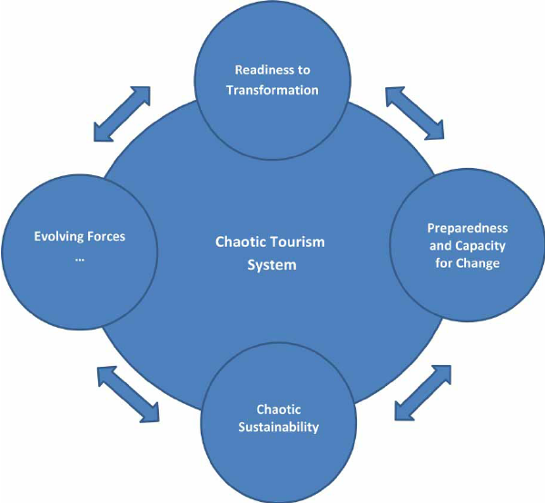
Source: https://www.researchgate.net/figure/Tourism-crisis-management-as-a-chaotic-process_fig1_268147116
- One of the most popular topics in the literature that was initially glaring is the presence of a non-reactive concept of crisis management and the cognizance of the importance of such a model in the process. Scholars think that traditional reactive models are not sleuthed enough to address the intricate interconnectedness across the globe as posed by pandemics (Pearson & Mitroff, 1993). A shift in paradigm to a pro-active mode which includes the very essential mitigation strategies is a prerequisite to the survival and success of an evasion of imminent crisis. Such an idea, in the face of a shortage of cases relative to the regions employing the early warning systems and contingency plans, argues that the measures reduced the recovery time and the stakeholders' belief in the safety of the area.
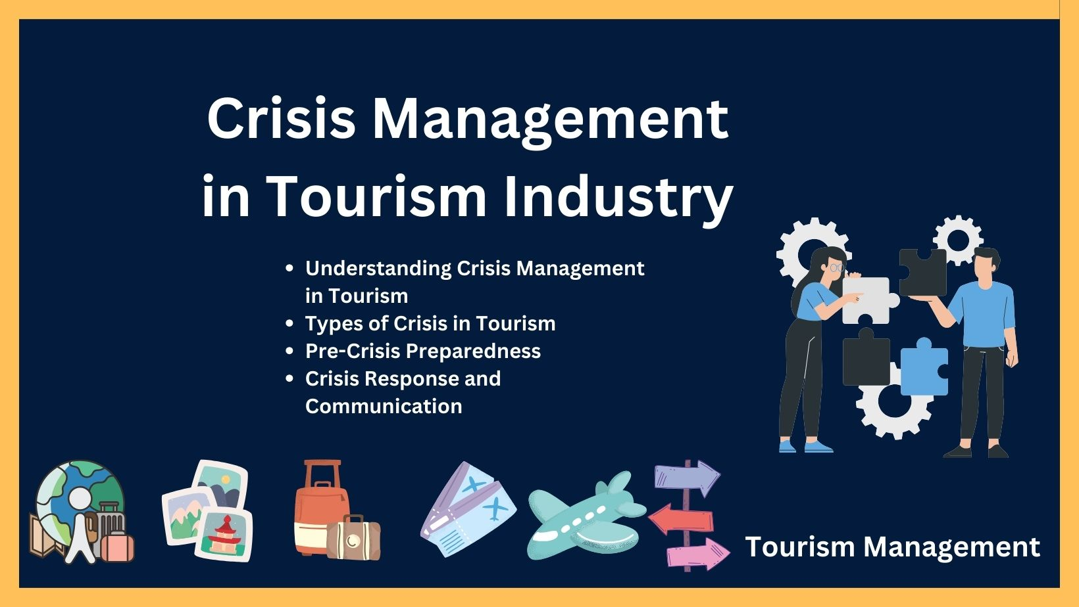
Source: https://www.managementnote.com/crisis-management-in-tourism-industry/
- World Health Organization (WHO) and the International Air Transport Association (IATA) are some of the international safety standards publishers who have recently gained traction in the post-pandemic context. These standards lay out a sweeping list of health safety regulations, starting with basic hygiene practices to emergency response protocols. Studies propose that the follow-up of these regulations is not only beneficial to tourists since it prevents an increase in the number of accidents. Also, in general, tourists feel safer which in turn adds to improving the reputation of those places (Gössling, Scott, & Hall, 2020) and this is significantly tied to Eco Adventures, where trust-building initiatives are utterly necessary to restore international tourism.
Another significant piece of literature is the role of communication in crisis management.
However, the researchers considered other problems as well. Hence, they devoted a specific part of the literature to the Decade for National Hygiene in Sierra Leone. The researchers established the importance of crisis communication in reducing the negative effects of crises on tourism.
- The study findings emphasized the fact that technology has also been in abundance in the handling of crises especially the eco-crisis.
- The development of digital platforms and social media has fundamentally influenced how crisis communication is handled. This way the dissemination of information became real-time updates and two-way communication between the authority and the public. Over the years the problem of crisis management has been solved by technologies guns and bullets (Aldrich, 2012). The idea is supported by a project description on the relation between digital and non-digital tools in the tourism sector
Besides, it has also been said that one of the critical points is the development of the local community, and its resilience in the recovery process in the course of a disaster. It is sometimes documented by articles that local governments’ collaborations with various local communities will be a strong basis for developing a sense of belonging and trust. Community-based improvements are not only going to make the crisis mandate more credible but also transmit essential information about local problems and perceptions (Wisner, Blaikie, Cannon, & Davis, 2004). An Eco Adventures recovery plan is characterized as including the close involvement of local businesses, residents, and cultural organizations to facilitate standard practices of safety that are not only respectful of the local people´s traditions but also are sufficiently relevant as well.
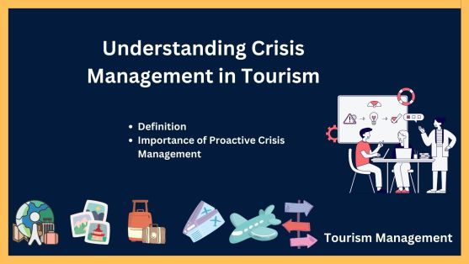
Source: https://www.managementnote.com/crisis-management-in-tourism-industry/
Consequently, the literature underscores the economic and social elements of crisis management. Much of the research on disasters is concentrated on the effects of the same on tourist destinations and the economic recovery strategies. Several studies indicate that economic recovery and efficient crisis management are paralleled, as getting the tourists ' trust is linked up with the process of economic revitalization (Novelli, Burgess, J., Thapa, Jones, & Ritchie, 2018). This kind of symbiosis points out not only the necessity of safety measurements but also the necessity of economic recovery. In the case of Eco Adventures, re-entry strategies into the market are meant not only for safety but also for the encouragement of economic activity through the attraction of tourists both domestically and internationally.
Summing up, the literature on the subject of strategic crisis management in tourism sets a solid foundation for the formulation of efficient recovery measures. The study incorporates theoretical findings and their practical applications and connects existing frameworks while introducing new ones, which are adjusted to the specific constraints that are being experienced in Eco Adventures. The next chapters will elaborate on the methodology, the findings, and the proposed strategies. They will use both the academic literature and international best practices to create a resilient and adaptive recovery plan.

Methodology

This research project opts for a mixed-methods approach to the design of a comprehensive recovery strategy for Eco Adventures. Among other things, the methodology is composed of three parts, namely, risk assessment, safety protocol development, and stakeholder analysis. The reason why all these components have been thought of is that the recovery strategy should be well-planned and based on clearly drawn conclusions, and last but not least, to be aligned with international safety standards.

The Risk Assessment Framework

- Initially, the team of experts initiated the risk assessment process by first isolating the probable hazards impacting the activities of Eco Adventures. This constituted both internal risks (e.g., a lack of appropriate safety equipment, lack of preparedness of the workforce, etc.) and external risks (e.g., travel restrictions internationally, the development of health crises, etc.) A mix of both quantitative and qualitative data was used to analyse the severity and likelihood of each identified risk. Quantitative data have been collected from industry reports, health statistics, and tourism analytics, while qualitative data have been gained through interviews with key players like the local government authorities, tourism operators, and public health experts.
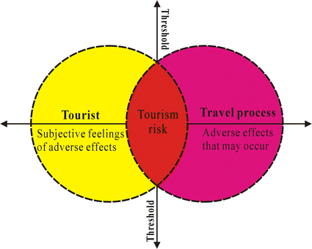
Source: https://link.springer.com/article/10.1007/s11069-016-2208-1
- The data collection method for risk analysis involved the use of the Failure Modes and Effects Analysis (FMEA) method. That tool was adopted to trace the weak links in the existing safety protocols and appraise their effects on not only the safety of tourists but the continuity of operations as well. The risk matrix developed during the analysis was visually displayed to show the severity of risk and likelihood, thus, facilitating the safety precaution prioritizing.

Safety Protocol Development

- A process of safety protocols developed for Eco Adventures is based on international standards with the WHO, IATA, and regional health authorities. For the comparative matrix, I analysed best practices carried out in the same kind of tourism destinations. Hygiene standards, emergency response protocols, and health surveillance systems formed the crux of this plan. These protocols were developed to be scalable and adaptable so that they could be continued or modified to accommodate new challenges or threats as they arise.
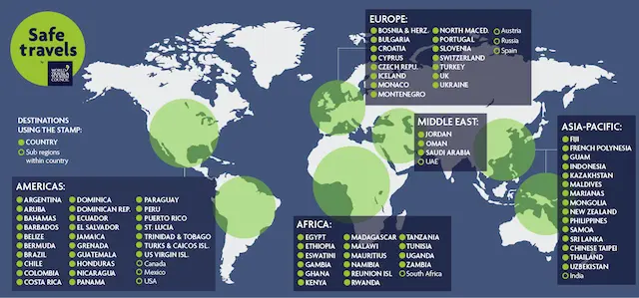
Source: https://wttc.org/initiatives/crisis-preparedness-management-recovery/safetravels-global-protocols-stamp
- Thereby, the developmental methodology also encompassed a stakeholder-driven approach toward the development of the protocol. Workshops and focus group discussions with local stakeholders, including local business owners, healthcare providers, and community leaders, were organized to gain their insight and validate proposed solutions. This ensured a participatory approach which made certain the safety protocols were contextually relevant and socially acceptable. The resulting framework integrates technological solutions, such as real-time monitoring systems and digital communication tools, into the traditional safety practices, to form a comprehensive and responsive safety management system.

Stakeholder Analysis and Engagement

- The recovery strategy was designed to be as inclusive as possible, so a thorough stakeholder analysis was adopted to ensure that the relevant parties, most of whom were impacted, were identified. The study employed an approach looking at the internal stakeholders (e.g., employees, the board of management, and local businesses) as well as those from outside (e.g., tourists, international agencies, local government, and health organizations). Each category of stakeholder (secondary, primary, and key) is mapped through participatory techniques in a quantitative method for measuring the importance and influence of stakeholders on the scale of organizational objectives, and to get a steady line of organizational success, especially minimalist. The stakeholder engagement matrix was used to identify their importance and potential for problem-solving or providing advantages for a successful recovery process in the third paragraph.
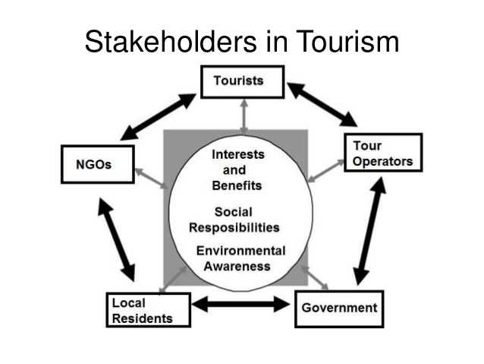
Source: https://www.howandwhat.net/stakeholders-tourism-development/
- To improve the quality of the safety protocol, the main idea is to engage these stakeholders in the planning and implementation processes. Interviews and surveys were conducted to discover the feelings of the stakeholders about the prevailing safety measures and their recommendations for bettering the situation. The international tourists were the focal point of our effort as their self-esteem is the barometer for the return of the market. The information collected from such interactions was scrutinized using thematic analysis which in turn laid the way for the identification of commonalities and priorities to embed them on the final plan.

Data Collection and Analysis

- Both primary and secondary data were collected for the risk assessment and the stakeholder analysis. The primary data came through interviews, surveys, and focus groups with the stakeholders directly connected with Eco Adventures. Whereas the secondary sources included published academic articles, industry reports, government publications, and international safety guidelines. The mingling of several data sources was done to have a 360-degree vision of the arising problems and prospects in the post-pandemic recovery of Eco Adventures.
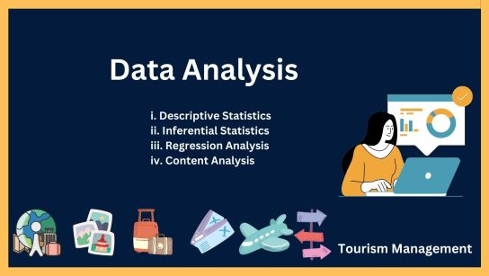
Source: https://www.managementnote.com/research-methodology-in-tourism-industry/
- Tourist arrivals and revenue recovery potential impacts were forecast using trend analysis and descriptive statistics for a statistical analysis of quantitative data. Meanwhile, the qualitative data were coded and analysed to generate relevant insights. Such insights were related to stakeholder sentiment, perceived risks, and desired safety measures. Consequently, these data sources complemented each other and helped enhance our recovery plan to a certain degree.

Findings

The study, which had the examination of the entire situation as its core, identified the crucial discoveries, on the basis of these the Comprehensive Strategy for the Recovery of Eco Adventures has been crafted. These are risk profile of the tourism hub, safety protocols testing result, and innovative recovery measures' suggestions.
- Reviewing the analysis, which bases on FMEA, we can mention many crucial parts of the unsuccessful part of the project, such as insufficient disinfection measures, inadequate staff training on health protocols, and a non-existing coordinated communication strategy during emergencies. The risk matrix that was created from this analysis constituted that the areas that involved the highest risks were the ones connected with health and safety, thereby pinpointing the pressing need for a solid and internationally merged protocol.

Risk Profile of Eco Adventures

The evaluation confirmed, that Eco Adventures is facing a spectrum of risks both from its internal failing points as well as the pressure coming from the outside. From within, the lack of a functioning medical system, and the intimidation of outdated emergency procedures as well as being the strongest risks. Additionally, these vulnerabilities worsened as the globe saw the pandemic emanating worldwide, for example with travel restrictions returning to limit and with tourist attendance decreasing. Externally, the conditions of the world health crisis as well as numerous low points in the tourist market, have touched the recovery in length.

Evaluation of Current Safety Protocols

The input on the safety precautions at Eco Adventures made evident that there was a lot of room for improvement in the institution's compliance with the recommended procedures as per the WHO. Although some preventive measures were provided such as, for example, the basic necessary hygienic practices and the restricted distances, these were mostly reactive and incapable of scaling to the needed amount for full recovery. There was also a noticeable absence of digital tools for communication for monitoring and management, which became crucial in real-time crises.
- Some of the conclusions of interviews with the representatives emphasized the fact that the current safety rules are very complete for internal and foreign visitors. Accessibility was raised by many survey-takers as an issue due to the non-enforcement of safety measures and the lack of clear and united crisis communication. This inconsistency not only deflates traveller confidence but also aloes that the recovery is hindered because no necessary reassurance and information have been given during the crisis time.

Recommendations for Recovery and Safety Management

Based on the risk assessment and survey of the present rules, the report presents some creative ideas that will help to solve the identified gaps. The recommendations can generally be divided into three areas:
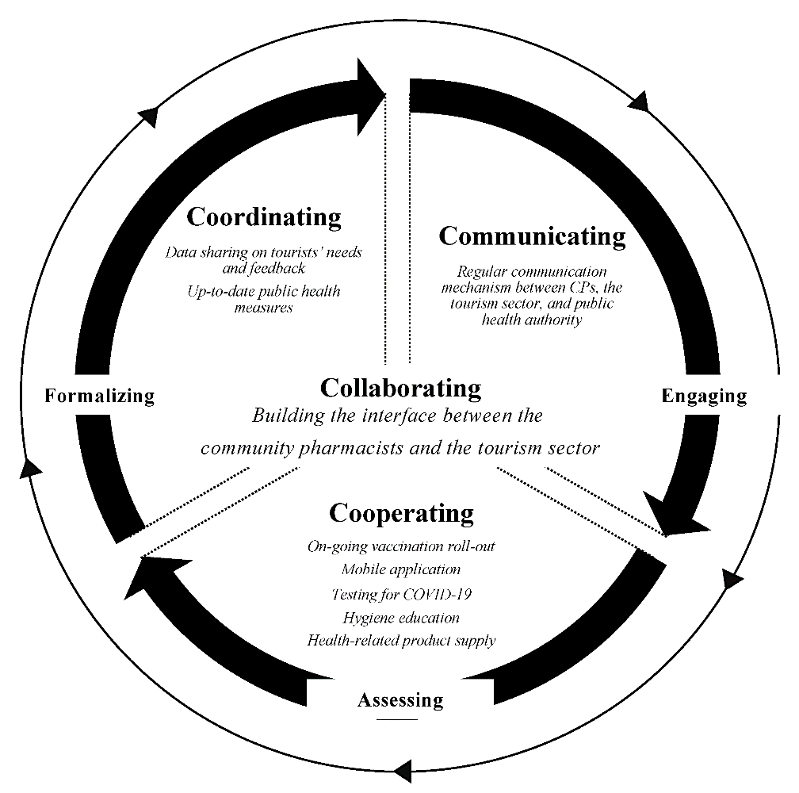
Source: https://www.mdpi.com/2673-5768/3/1/4
Re-Entry Strategies for the Market:
The establishment of the phased market re-entry approach, digital marketing promotion of enhanced safety measures, and partnership with international travel agencies are going to be the convincing strategy. Eco Adventures plans to work on this through the right digital marketing campaign and collaborations with international travel agencies as well as the qualification of “safe travel” for them by partnership with reputable international bodies.
Health and Safety Protocols:
These health safety protocols are different because they are being adopted through a set of comprehensive measures, are internationally recognized, and involve regular health screenings, heightened sanitation protocols, and contactless technologies. Further, staff should be subjected to reinforced training programs so that they could easily follow the latest health and safety guidelines. The tying up of a centralized health monitoring system to the IoT and real-time data analytics is handy, and it also will enable quick responses to the new disease.
Crisis Communication and Stakeholder Engagement:
If you wish to rebuild trust, it is important to have efficient crisis communication. The plan for recovery includes the introduction of a specialized communication team that will be responsible for providing the most recent and transparent information to people through many communication channels such as websites, mobile apps, social media, etc. Through conducting regular briefings, sending real-time notifications and engaging the stakeholders in interactive forums, these modes of communication will be made possible.
Furthermore, the implementation of flexible contingency plans which can be quickly adjusted according to new developments, and the formation of a specialized crisis management committee, a loyal group that combines a broad spectrum of local, national, and international experts in tourism and public health. This committee has to ensure that Eco Adventures is in the lead in the crisis management innovation by practising continuous monitoring and evaluation of safety protocols.

Discussion

The outcomes of this inquiry imply a notable influence on the whole tourism field specifically in the frame of overcoming global crises. The identified loopholes in the on-going safety measures shed light on the need for a proactive and integrated approach to crisis management. The recovery plan towards Eco Adventures not merely caters to the concerns raised by the stakeholders but, also lays down a strong foundation for sustainable endeavours.
One of the primary outtakes in the analysis is the critical function of stakeholder engagement. The optimal inclusion of opinions from the local communities, the business owners, and the voyagers from abroad, each of whom is an equally important factor, is crucial to the formation of procedures that are both realistic and favourably accepted. The recovery strategy insists on a participatory style that not only burgers it but makes every party’s needs, fears, doubts, and the like part of the specification and creation of the said measures. This method is so effective because it contributes greatly to the improvement of confidence and makes recovery sustainable over time.
The greater inclination towards digital transformation presents a more profound change in the proposed strategy. The application of digital tools in real-time monitoring, communication, and marketing constitutes a shift in the whole experience of crisis management. Along with other things, Eco Adventures can now start the process of improvement by simply using technology thus it can also be more active in attending to the needs of the overseas tourist. The approach of a digital-first process is quite suitable for the pace we are in today. That being said, it is a world where information is communicated rapidly, and expectations of the stakeholders are in a process of stale for the most of the time.
Also, the corporate practice of international safety standards becoming a strong constituent in the recovery strategy is not only a way of making sure that operational efficiency is real. The use of the same protocols which can be implemented as per the WHO and IATA guidelines is a sign of good practices and it is a way of demonstrating that the Eco adventures are within the global standards that need to be adhered to making tourism the tourist's top priority. The same pattern is essential for the re-build of the confidence in the international tourists' side, as it is the only way to close the local practices and the global expectations gap in the tourism sector.
After recovery concept also prepares for the future with the help of change and adaptability at its base which makes it flexible and appointable of being adapted. The dynamic nature of the worldwide threats insists that safety protocols should not only be reviewed but also be updated. The formation of a special crisis management committee is a planned measure to provide continuous oversight and rapid response to any emerging dangers. This vision not only the present threats but also sets Eco Adventures as the leader in the innovation of crisis management.
Thus, from the conversation, it stands out that during this period of restoration of Eco Adventures the recovery strategy is the raft that holds on to the short-term challenges as well as the sustenance and resilience in the field of tourism. Through the combination of the theoretical basics and practical experiences, the recovery plan leads to the promotion of a successful implementation of the suggested strategy and enables it to become a new norm in the crisis management of the tourism industry- a norm that puts the priority on the engagement of the stakeholders in the course of action, on digital innovation in the field of tourism and adhesion to the international safety standards.

Conclusion
In summary of the report, the report that came up with a recovery strategy for Eco Adventures, a tourism centre that suffered heavily due to the global pandemic, is the subject of this concise essay. The argument is such that without the existence of a strong and complete crisis management scheme, tourists will never return due to the lack of confidence in travel safety and the productivity of the local economy. This research is unique in that it questions whether the classic models of crisis management, which are reactive, are any longer valid given today's world challenges. Instead, a proactive, cohesive strategy based on international safety standards, digital innovation, and community engagement is required.
Eco Adventures' recovery strategy is based on three core components: market re-entry, health safety protocols, and effective crisis communication. Part of the proposal comes in the form of digital marketing strategies that are tailored to specific targets, practising raised health safety standards based on WHO and IATA guidelines, and setting up the crisis communication team which is engaged in active participation among stakeholders. In the same breath, the strategy is the introduction of a coordination committee that is specially set up to manage the crisis and is responsible for the comprehensive monitoring and improvement of the system in case such an event reoccurs.
This complex plan not only deals with the immediate recovery need but becomes a sustainability plan in the long run showing the way for the tourism sector. In today's continuously changing environment due to new threats, the data and the proposals from this article can be a great example for other tourism areas that encounter the same type of problems. The coming studies would aim for geo-spatial-based optimization of these mechanisms through pilot systems and real-world applications to ensure the persistent provisioning of the risk and the crisis domain in the whole tourism industry.
The rebound journey of Eco Adventures proves to be a global model of the tourism sector that calls attention to continuous creativity, stakeholders’ unity, and the adherence to the best crisis management strategies. In the final analysis, the success of this recovery plan will be evaluated not only by the speed of economic upswing but also by the reinstatement of trust and the creation of a safe, resilient tourism environment for many years to come.

References
Aldrich, D. P. (2012). Building resilience: Social capital in post-disaster recovery. University of Chicago Press.
Coombs, W. T. (2007). Protecting organization reputations during a crisis: The development and application of situational crisis communication theory. Corporate Reputation Review, 10(3), 163–176.
De Sausmarez, N. (2007). Crisis management, tourism and sustainability: The role of
indicators. Journal of Sustainable Tourism, 15(6), 700–714.
Evans, N., & Elphick, S. (2005). Models of crisis management: An evaluation of their value for strategic planning in the international travel industry. International Journal of Tourism Research, 7(3), 135–150.
Faulkner, B. (2001). Towards a framework for tourism disaster management. Tourism Management, 22(2), 135–147.
Gössling, S., Scott, D., & Hall, C. M. (2020). Pandemics, tourism and global change: A rapid assessment of COVID-19. Journal of Sustainable Tourism, 29(1), 1–20.
Huang, Y. C., Tseng, Y. P., & Petrick, J. F. (2008). Crisis management planning to restore tourism after disasters: A case study from Taiwan. Journal of Travel & Tourism Marketing, 23(2–4), 203–221.
Kirant Yozcu, O., & Cetin, G. (2019). A strategic approach to managing risk and crisis at tourist destinations. Tourist destination management: Instruments, products, and case studies. 273–287.
Novelli, M., Burgess, L., Jones, A., Ritchie, B. W., & Thapa, B. (2018). Tourism resilience: From crisis management to resilience building.
Pearson, C. M., & Mitroff, I. I. (2018). From crisis prone to crisis prepared: A framework for crisis management. The Executive, 7(1), 48–59.
Pforr, C., & Hosie, P. J. (2008). Crisis management in tourism: Preparing for recovery. Journal of Travel & Tourism Marketing, 23(2–4), 249–264.
Racherla, P., & Hu, C. (2009). A framework for knowledge-based crisis management in the hospitality and tourism industry. Cornell Hospitality Quarterly, 50(4), 561–577.
Wisner, B., Blaikie, P., Cannon, T., & Davis, I. (2014). At risk: Natural hazards, people’s vulnerability and disasters.

