

Advanced Business English for Tourism:
Customer Service Training Module Report

Student Name: Ajay Kumar
Student ID:DE240022
Submission Date : 04.04.2025

Contents
Introduction 3
Background and Objectives 3
Module Structure and Qualification 4
Understanding German Customer Service Culture 5
Communication Techniques and Cultural Sensitivity 6
a. Active Listening and Empathy 6
b. Adapting Communication Style 7
Scripts for Common Customer Interactions 8
a. Greeting New Customers 8
b. Handling Inquiries 8
c. Managing Complaints 9
d. Resolving Escalations 9
Role-Playing and Interactive Exercises 9
Role-Playing Exercise Example: 9
Reinforcement and Ongoing Coaching 10
Case Study: Eco Adventures 11
Conclusion 12
References 12

Introduction

Global tourism, due to steady levels of globalization, necessitates the understanding of customer communication principles from people of different cultural backgrounds. The report explicates the module which is aimed at training the staff on proper customer service in a scenario where the staff has to deal with the diversity of customers not only from the tourism industry but also from the general public, an example being the German market. Indeed, Germany's image, characterized by efficiency, formal communication style, and correctness makes it an outstanding field in which to initiate the effective communication of advanced customers. The module which is referred to as "Theoretical Framework for Excellence in Global Tourism: A Case Study on Germany" was created as a company project of GTS - Eco Adventures to implement it in cooperation with diverse international tour operators. The company presents the brand focus - personal customer service - and customer loyalty as key components of their overall strategy for the achievement of this goal.
This paper provides information about the background and aims of the training module, a detailed explanation of the content areas, sample scripts, role-play exercises and lastly strategies for reinforcement coaching. Last but not least, the goal is to help customer service employees improve their duties, thus, affecting the company's performance both in terms of business results and in the branding of a strong image in the competitive market for tourism in Germany.

Background and Objective
The tourism industry is one of the biggest in the world, and organizations worldwide depend on their customer service teams to guarantee that visitors are catered to the cultural differences with which they come into contact. Eco Adventures has noted that the straightforward and efficient service approach that many local customers in Germany appreciate the most is, however, far from being a convenient solution for international guests who normally have different communication styles and expectations. This cultural divergence may create miscommunication, lateness, or customers being unsatisfied with the service if it is not properly dealt with.


One of the main goals of this training module is to:
- To get an outlined perception of the German customer service culture and its directness, efficiency, and formality which is the basis of it.
- Help the staff by providing a flexible way of communication that mixes the clarity and emotional intelligence with the cultural sensitivity.
- Produce hands-on, ready-to-use scripts that any employee can use when dealing with customers who have different backgrounds or would like assistance with different questions or when they lodge a complaint. They can apply the same when customers come from the local or foreign market (Bowen et al., 2014).
- Put in place some Lifesize role-playing to optimize the staff's confidence and at the same time ensure that theoretical knowledge can be accurately transformed into working abilities.
- Introduce the process of continuous improvement through regular coaching, performance monitoring, and refresher sessions.
The company aims to shift its focus to the customer and thus to be able to establish a customer-centric environment, where customer satisfaction, loyalty and overall business success are the result of each interaction being managed efficiently and with a lot of empathy and sensitivity. Thus, Eco Adventures are targeting such a position as customer care is one of their main topics (Eidam, A., & Partner, 2025).

Module Structure and Qualification

The training module has five sections, each focusing on a certain customer service skill:
- Understanding German Customer Service Culture
- Communication Techniques and Cultural Sensitivity
- Scripts for Common Customer Interactions
- Role-Playing and Interactive Exercises
- Reinforcement and Ongoing Coaching
Each part is based on the former one, meaning that the participants not only understand the aspects of the theory but also practice and improve their skills through realistic scenarios that take place.

Understanding German Customer Service Culture

Germany, through its style that is clear, time-saving, and strictly organized, is nationally recognized for delivering the best customer service. German customers usually expect the messages to be straightforward and specific with a quick resolution of the issue. On the other hand, in the case of a multicultural client group, the customer service staff should also be interested in the different cultural features those international travellers bring with them (Akkermans, 2018).

Source: https://www.youtube.com/watch?v=V5uZJSJ0cDY
Key Characteristics of German Customer Service:
Direct Communication: In contact with Germans, it is vital to be honest and straightforward. Keeping the interaction short and to the point, and without any unnecessary detailing will give you the best results.
- Efficiency: Time consideration is a notable aspect of German society. Quickest and at the same time, most helpful solutions are what both the customers and service providers are striving for (University of Athens, 2024).
- Formality: It is a normal thing in a professional communication environment in Germany. It is a common practice in the country to address others properly (Herr for Mr. and Frau for Ms.) and in a very polite manner.
- Precision: The requirement for detailed and accurate information doesn't clearly advocate the use of a vague, overly casual, or slang language that is unfamiliar or not understandable to a broader public.
It is crucial for the recognition of these traits for the customization of the ideal contact of the companies with their clients. For example, Eco Adventures' customer service representatives should adjust to the ways of these countries to meet their local customer's needs, as well as the needs of visitors from other countries (Hofstede, 2001). They need to do it in a manner that allows each guest to feel comfortable and heard while receiving service and being highly effective culturally.

Communication Techniques and Caltural Sensitivity
Expert communication in a cross-cultural environment is not just a matter of speaking the same language. It involves various approaches to dealing with communication because of concrete cultural contrasts and provides great service at the same time (Hu, 2025).

a. Active Listening and Empathy

- Active listening: Customer service agents should direct their full attention to the customer. That is the act of double-checking by repeating a segment of the conversation or summing up the main points or inquiries as well as promoting the involvement of the customer in the process of discovering a resolution to a problem. It can be said that the customer service providers are showing intense attention to detail, through their subtle way of listening, the customer can be the inner being of the workers (Schultz & Patti, 2009). Even though the technician is the one communicating, he or she constantly reassures the client that he or she is being heard since the technician uses the term "we will find a solution to this together by ending it as soon as possible".
- Empathetic Response: Be aware of the customer’s emotions and show them that you understand their feelings as you also agree with them. When the customer is treated with empathy and compassion, they can not only survive but also develop a life wherein they are heard and celebrated as a total person (Saunders et al., 2025).
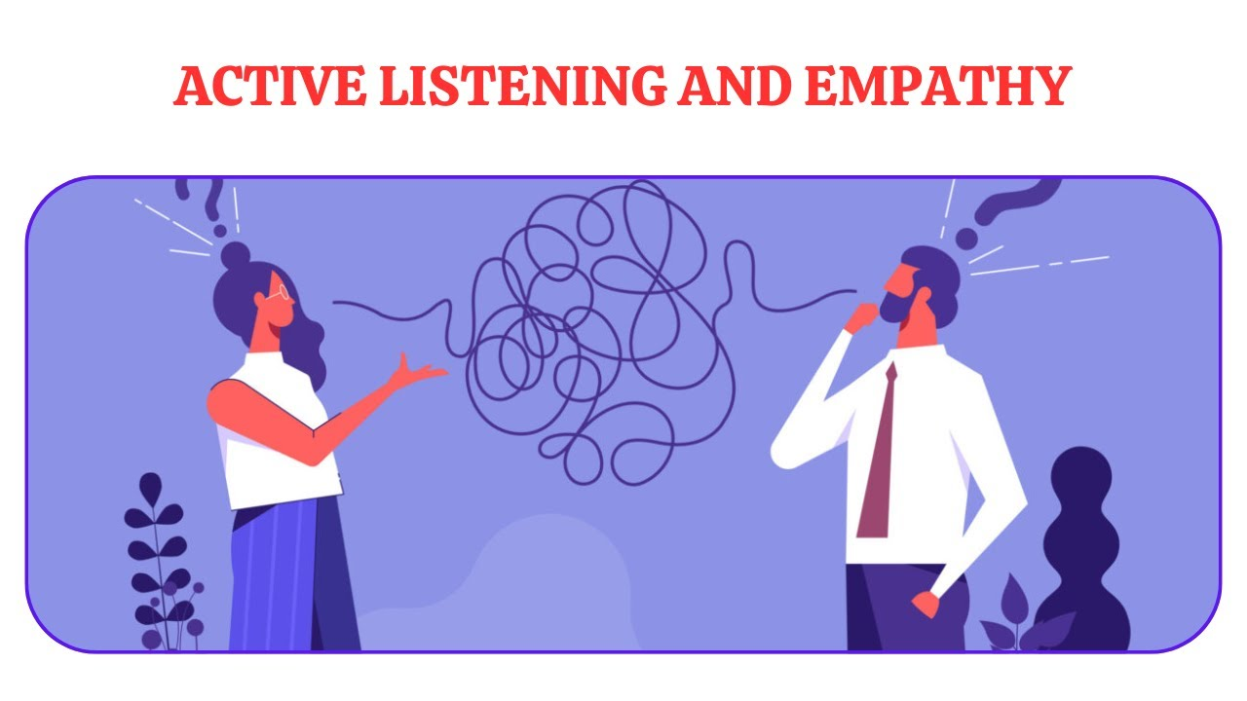
Source: https://www.youtube.com/watch?v=_TmYsNUTXZ0

b. Adapting Communication Style

- Formal Language Imitation: Scrutinize the status of the customer you are addressing your message to and select the language that corresponds to your customer. In case a client speaks more formally, choose a formal language; in case they are more informal, a bit of an informal tone could be ok but keep professional.
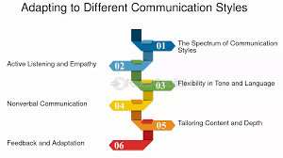
Source: https://fastercapital.com/topics/adapting-communication-styles.html
- Omitting Slang and Idioms: Region-specific expressions and idioms may not be universally known. Only when it is required, one should use informal language when interacting with people from other countries so as not to speak in a language they don't understand.
- Conciseness & Clarity: Give necessary and concise answers to questions. This fact is vital in a community that puts the value of efficiency and exactness as a key priority.
By using these practices, the support staff can establish an atmosphere of mutual respect and cooperativeness that will be beneficial for right-sizing the city's services to meet the different tourist requirements in Germany. This is the best approach to the provision of service as well as the main principle of accessing this type of service that all visitors should be entitled regardless of their ethnic background (Wirtz & Lovelock, 2021).

Scripts for Common Customer Interactions

Prepared scripts are a backup tool for Eco Adventures' customer service agents. This way all their tasks can be done in a manner that is consistent and contains one tone and message. Below you will find some sample scripts that are created for various common scenarios. These act as the basis and can be adjusted depending on the exact demands of each customer (Eidam, A., & Partner, 2025).

a. Greeting New Customers

The script example below:
"Good morning and welcome to Eco Adventures. My name is (Your Name). How may I assist you today?"
Tips: Politeness and formality are always necessary and courteously ask for the customer's name to start the interaction on a more personal basis, making the customer remember us.

b. Handling Inquiries

The script example is provided below:
"Hello (Customer Name), thank you for contacting us. The question you have is in connection with tour packages. Could you give me some more details so I can get you the best option?"
Tips: Insert some open questions and be sure to confirm the information through friendly and yet an efficient tone. But also, it is about being invited over the phone to get the answer.

c. Managing Complaints

The script example is presented below:
"Good afternoon, (Customer Name). I am so sorry for what happened to you in connection with (specific service). Thanks for the information you offered. Let's go ahead and sort these things out as fast as possible. Could you give me the situation first?"
Tips: Start with an authentic apology and recognition of the issue. Closely, problem-solving is your goal, and you should ask for more details as to understand the situation better.

d. Resolving Escalations

Script Example:
“Thank you for contacting us, (Customer Name). The exact problem means I understand your concern about the issue. Can you wait a moment until I get our specialist on the line to make sure that we will deal with your case properly?”
Advice: Always tell the customer about the hold-on and assure them that their request is the first in line.

Role-Playing and Interactive Exercises

Practical experience, as expected, remains the basic vital element of an efficient training process. Role-playing exercises are a captivating and interactive way to buttress the theories and to hone one's skills to better function in the everyday world (Akkermans, 2018).

Role-Playing Exercise Example:

- Scenario Setup: Grouping the participants and assigning one to act out the customer (who may be given a situation, such as late transport service or booking confusion) and the other to act as the help desk agent is proper initiation.
- Script Application: The representative presents the user with the greetings, inquiry handling, and complaint resolution scripts. The consumer makes genuine responses and gives a review.
- Feedback Session: After each role-play session, the pair talks about the highlights and weak points of their acting skills. Concentrate on voice modulation, articulation, and cultural sensitivity.
- Group Discussion: Unite the participants to talk about their experiences, exchange common challenges, and give solutions to future interactions.

Source: https://hi-qgroup.com/team-offsite-activities-role-play-exercises/
These interactive workshops not only allow employees to get acquainted with it, but also permit them to develop the confidence by practising in a controlled social environment and thus be able to adapt their styles by getting instant feedback (Akkermans, 2018). Regular role-play exercises act as a factor of preparedness for agents to deal with a variety of customer scenarios and consequently, to modify the communication strategies on their own.

Reinforcement and Ongoing Coaching

Training is not a one-time event, but it is still necessary for the betterment of service provided. Ongoing learning and giving and receiving of input on a regular basis are fundamental requirements for keeping and enhancing service quality across time.
Strategies for Ongoing Coaching:
- Regular Refresher Sessions: Regularly convene information exchanges to teach trainers about new techniques as well as to address more complicated challenges. Such sessions are valuable for maintaining and improving customer service as they help companies adjust to customer needs and preferences which change over time (Schultz & Patti, 2009).
- Performance Monitoring: Informal analyses of training videos, customer feedback, and also first contact resolution rates (against average handling time, and customer satisfaction scores) can help you become aware of and, thus, be as well as deal with the strengths and areas you might improve on.

Source: https://businessacceleratorhub.com/35-effective-coaching-strategies/

Case Study: Eco Adventures

Eco Adventures used this course to counteract the issue with a lot of the customer demographics being from foreign countries. After deploying the module, the company observed substantial advantages in the following areas:
- Increased First-Contact Resolution: Thanks to the coherent and exact nature of all the written material, the rate of first-contact resolution rose to more than 12%.
- Enhanced Customer Satisfaction Scores: Customer feedback survey reveals a 15% increase in satisfaction levels, especially due to the fact that the treatment of inquiries and complaints was not only prompt but respectful as well.
- Reduced Call Handling Time: The simplified process came by which, as a result, an overall drop of about 10% was noticed in call handling time, which depicted the general functioning as more efficient (Wirtz & Lovelock, 2021).
- Positive Employee Feedback: The staff reports that they are more confident in dealing with diverse situations as well as more empowered thus reducing the turnover rate and engaging more with customers (Saunders et al., 2025).

Conclusion

A module that offers full training to customer service staff in Eco Adventures, which in turn is aimed at the creation of a customer-proximate, culturally sensitive, tourism support system in Germany is being developed. Staff members, who go beyond customer expectations with both local and international guests, benefit from their clear grip on the language and their implementation of positive communication modes.

The module further topics that are crucial to understanding include how to talk, efficiently, and formally; the importance of active listening and empathy; and the use of practical scripts in solving diverse customer hiccups. Ongoing coaching and role-playing are additional activities to ensure that not all is theoretical knowledge but it is properly transformed into practical skills.
Consistency in delivering customer-centric service and maximum cultural awareness in the relationship between parties are the key elements in the training module to be implemented. Customer satisfaction and loyalty to the company's brand are the direct results of such an approach. Besides, the excellence in business performance is also a positive consequence, and the company's brand strength and market competitiveness among others are some of the secured key benefits.

References

Akkermans, H. (2018). Customer interactions: How to enrage customers with a great service. In Service Operations Dynamics (pp. 55–70). Springer International Publishing.
Bowen, J. T., Makens, J. C., & Kotler, P. (2014). Marketing for hospitality and tourism: International edition (6th ed.). Pearson.
Eidam, A., & Partner. (2025). Cross-Cultural Training on Germany. https://www.eidam-und-partner.de/en/cross-cultural-training/target-countries/cross-cultural-training-germany
Hofstede, G. (2001). Culture’s Consequences: Comparing Values, Behaviors, Institutions, and Organizations Across Nations.
Hu, N. (2025, February 26). Ultimate guide: Importance of German customer service culture and how to successfully resonate with German customers via localized customer service. Customer Service Solutions. https://callnovo.com/german-customer-service-culture-guide
Saunders, E., Hebert, C., & Davies, E. (2025, February 5). Customer Service Training course - Germany. Theknowledgeacademy.com. https://www.theknowledgeacademy.com/de/courses/personal-development-training/exceptional-customer-service-training/
Schultz, D. E., & Patti, C. H. (2009). Strategies for rewarding customer satisfaction. Journal of Business Research, 62(7), 714–721.
University of Athens. (2024, December 18). Communication and Customer Service Training. https://elearninguoa.org/course/business-economics/communication-and-customer-service-training
Wirtz, J., & Lovelock, C. (2021). Services marketing: People, technology, strategy (ninth edition): People, technology, strategy. World Scientific Publishing.

