Tourism Distribution Channels
Option 1: The Role of Online Travel Agencies (OTAs) in Shaping the Future of Tourism
Distribution Channels
Student Name: Kajal
Matriculation Number: DE240155
Tutor’s Name: Prof. Wolfgang

Abstract
This study examines the transformative impact of Online Travel Agencies (OTAs), such as Expedia, Booking.com, and Airbnb, on the tourism industry. OTAs have disrupted traditional travel agencies by offering consumers convenient, self-service platforms for comparing prices, reading reviews, and making bookings. The study explores the pros and cons of OTAs for both consumers, who benefit from flexibility and price transparency, and businesses, which gain global visibility but face high commission fees and loss of customer control. The research also discusses post-pandemic shifts and sustainability trends, offering recommendations for businesses to adapt to the evolving landscape.

Table of Contents
Abstract 2
1. Introduction 5
2. Literature Review 5
2.1 Historical Overview of Tourism Distribution Channels 5
2.2 Consumer Behavior Theories and OTA Adoption 5
2.3 Trends in Tourism Distribution: Rise of OTAs, Direct Sales, and Niche Platforms 6
2.4 Post-Pandemic Changes in Consumer Behavior and Distribution Channels 6
2.5 The Role of OTAs and Their Impact on Traditional Travel Agencies 7
3. Methodology 7
3.1 Research Approach 7
3.2 Data Collection 7
3.3 Data Analysis 8
3.4 Limitations 8
4. Findings and Analysis 8
4.1 Introduction 8
4.2 Findings 9
4.2.1 Data Familiarisation 9
4.2.2 Coding as a Method of Pattern Identification 10
4.2.3 Forming of Initial Themes 10
4.2.4 Finalized Themes from Coding 12
4.3 Thematic analysis. 13
Theme 1: Disruption of Traditional Travel Agencies by OTAs 13
Theme 2: Convenience and Consumer Empowerment in OTAs 14
Theme 3: Financial Impacts and Business Adaptation to OTAs 14
Theme 4: Post-Pandemic Shifts in Consumer Behavior and OTA Adaptation 15
Theme 5: Sustainability and the Role of OTAs in Advancing Sustainable Tourism 15
Theme 5: Pros and Cons of Working with OTAs for Both Consumers and Tourism Businesses 15
5. Discussion 16
Impact of OTAs on Traditional Travel Agencies 16
Pros and Cons for Consumers 16
Pros and Cons for Businesses 17
Strategic Recommendations for Businesses 18
Conclusion 18
References 19

Introduction
The idea of distributing tourism in many shapes has been strongly transformed in the previous decades, as the past traditional (travelling agents) based project giving place to digital sphere is subjected to the dominance of the Internet based instruments defined as Online Travel Agencies (OTA) (Aithor, 2025). Expedia, Booking.com, and Airbnb, among others, have revolutionized the process by which people get access to travel products, which has led to a highly convenient experience where the customers can research all the available information, compare destinations and services, and make a booking, all within the same online platform (Archi & Benbba, 2022). This has introduced much convenience, transparency and competition with this sector transforming the face of tourism.
The rise of OTAs has been a major threat to the conventional travel agencies, nevertheless. These agencies are facing reduced market share to be enjoyed as the OTAs gain momentum over them as their primary distributors of the travelers to the service providers (Bahl & Bahl, 2024). OTAs provide numerous services, fair prices, and technological changes, such as mobile apps and data-enabled customization, that the traditional agencies struggle to keep up with (Banez, 2023). The greatest challenges that the traditional agencies will need to overcome are loss of customer relationship, reliance on the commission-based revenue, and technological behind (Garci̇A et al., 2022).

2. Literature Review

2.1 Historical Overview of Tourism Distribution Channels
The distribution channels through which tourism is distributed have evolved radically in the last decades. Travel agencies historically fulfilled the role of localized negotiators between suppliers (airline, hotels and tour operators) and consumers in customized services to help a traveler decide and reserve his travel arrangements (Dewantara et al., 2022). The industry was monopolized by this model until the emergence of Online Travel Agency (OTA) like Expedia, Booking.com, and Airbnb began in the mid-1990s. The advent of the internet and mobile technology occurred and allowed OTAs to revolutionize the industry by providing consumers with research, comparison, and booking services of travel (De Amorim et al., 2022). As such, the need of the traditional agencies has been greatly reduced as the OTAs go and present their own self-service society, taking in the consumers, especially Airbnb serving them the peer-to-peer accommodation, which has further shaken the classical booking platforms (Xie & He, 2022). This has led to part of the market share being sued by the traditional agencies who were unable to withstand the digital revolution and were competing in a price war against the OTAs where they had lost control of the customer relationships and price-setting models.

2.2 Consumer Behavior Theories and OTA Adoption
The mass adoption of the utilization of Online Travel Agencies (OTAs) is prone to the renowned in the paradigms of consumer behavior, such as Technology Acceptance Model (TAM) and Theory of Planned Behavior (TPB). The theories offer valuable insights into the elements that may influence how consumers make their choices and adopt online solutions to reserve their trips (Lut, 2024). According to TAM, the driving force in consumers adopting new technology is ease of use and perceived usefulness (Singh et al., 2024). The two areas are where OTAs perform excellently since they offer consumer-friendly systems allowing them to easily compare the prices of various travel services and book them within a short period of time (Cai et al., 2022).
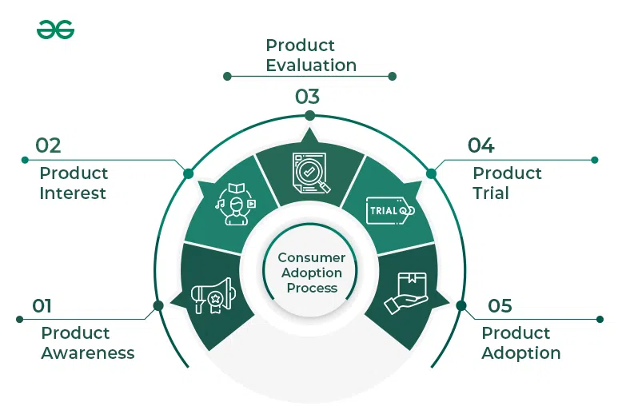
Figure 1 Stages of Consumer Adoption Process
Source: https://www.geeksforgeeks.org/macroeconomics/stages-of-consumer-adoption-process/
Expanding the theory to perceived risk also applies to the dubious times like the COVID-19 pandemic, where consumers may readily book online due to the perceived risk of their safety and reliability, and in this instance, OTAs have issues with refunding promptly (Lu & Ahn, 2024). Theory of Planned Behavior complements the TAM in that it dwells upon the matter of how attitude, subjective norm, and perceived control can impact behavior (Wang & Khan, 2024). The existence of flexible prices, wide choice, and convenience builds the positive attitude of the consumers towards OTAs. The social rules are also effective in the promotion of OTA use, including eWOM (electronic word-of-mouth) (Hernández-Tamurejo et al., 2025). Among the studies, one of them found out that the reviews and ratings influenced considerably the attitudinal and booking preferences of the consumers.

2.3 Trends in Tourism Distribution: Rise of OTAs, Direct Sales, and Niche Platforms
The last two decades have been marked by significant shift in tourism distribution (Turnšek & Radivojević, 2025). As internet penetration, mobile, and digital literacy rates across the globe increased, OTAs became the most popular, as they provided the possibility to receive aggregated travel options, easy user interfaces, live availability, price comparisons, and user feedback (Yadav, 2025).
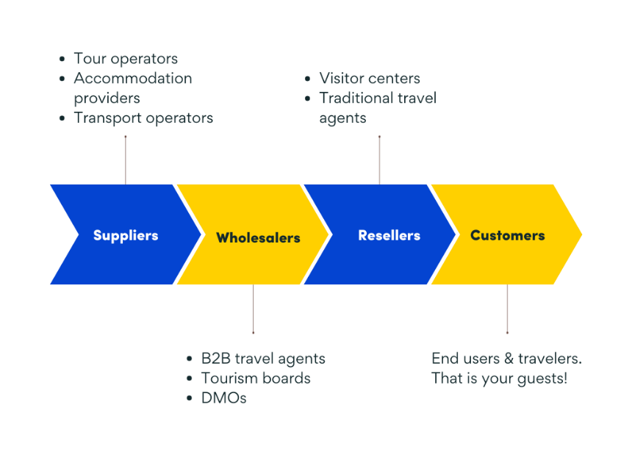
Figure 2 Types of Tourism Distribution
Source: https://rezdy.com/blog/what-are-travel-and-tourism-distribution-channels/v
The studies suggest that OTAs continue to be the primary focus of the distribution related to tourism. Simultaneously, the digital revolution has given classic tourism enterprises, including hotels, tour operators, attractions a chance to broaden their direct channels of sales (brand websites, direct booking engines, mobile applications) (Kontis & Skoultsos, 2021). Such change has proven the readiness of the businesses to reduce the dependence on OTAs, get rid of commissions, and rebuild the relations with customers. According to recent statistics, some travelers are currently ready to resort to direct booking methods, especially where the direct route offers them both flexibility, full refund / cancellation protection, and high-quality customer service (Tao, 2022).

2.4 Post-Pandemic Changes in Consumer Behavior and Distribution Channels
The COVID-19 pandemic changed many things in the sphere of tourism as it significantly altered consumer behavior and distribution channels (Tran et al., 2023). Flexibility and safety and hygiene have now been the priority of travelers, and short-term booking numbers, domestic travel, and the option of flexible cancellation are being demanded (Mansoori & Ahmad, 2021). OTAs have been changed by offering more flexible configuration and enhanced safety (Gupta & Mukherjee, 2022). Moreover, the customers are more than eager to make direct reservations with a company to receive an assurance of a simpler reimbursement process and receive a higher quality of customer service, since the OTAs were traditionally credited with problems with timeliness and rigid rules throughout the pandemic (Purcărea et al., 2022).
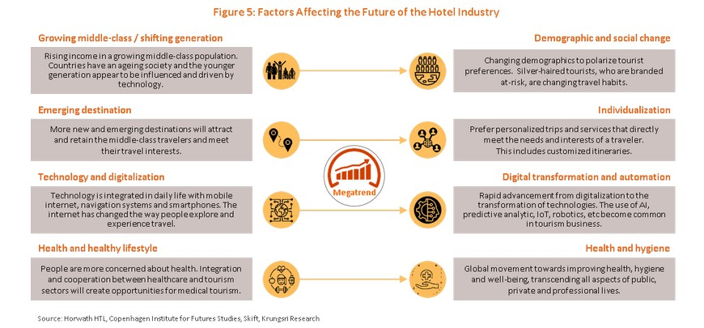
Figure 3 Tourism & Hotel industry in the post-COVID world
Source: http://krungsri.com/en/research/research-intelligence/ri-future-of-tourism-21

2.5 The Role of OTAs and Their Impact on Traditional Travel Agencies
Online Travel Agencies (OTAs), Expedia, Booking.com and Airbnb re-invented tourism distribution by providing an extensive array of travel-related services within one platform (Archi & Benbba, 2022). Expedia and Booking.com also offer flights, hotels, and car rentals with Airbnb offering peer-to-peer accommodation (Zhou et al., 2024). This convenience gives the opportunity to the consumers to locate the prices and view the reviews conveniently, and to book with 2 or 3 clicks. The presence of OTAs has compounded the competition of the usual travel agencies whose consumers can easily bypass it and go directly to the OTAs. In terms of variety of offers, competitive prices, many agencies cannot compete with the OTAs that possess the economies of scale (Garci̇A et al., 2022).

3. Methodology

3.1 Research Approach
The study adopts a qualitative research approach and will explore the impact of Online Travel Agencies (OTAs) on the traditional travel agencies and their role in the channel of distribution in the tourism industry. Secondary research is also applied to get information regarding the available sources, which include research papers, industry journals and case studies. The review of these resources will help the study to investigate the relationship of the OTAs like Expedia, Booking.com, and Airbnb with the traditional travel agencies and discuss the challenges of the traditional agencies and the benefits and drawbacks of cooperation with the OTAs between consumers and companies.

3.2 Data Collection
Data is collected using different secondary sources. The theoretical foundations on consumer behavior, the rise of OTAs, and how tourism distribution channels have changed can be provided by peer-reviewed journals (Archi & Benbba, 2022). The periodicals help trace the radical shifts in consumer interaction with OTAs and their effect on the distribution patterns of the past. Market research agencies’ reports covering the industries will provide current statistics and data regarding the growth of OTAs and their influence on the market (Zeqiri et al., 2025). There are instances of case studies on OTAs such as Expedia, Booking.com, and Airbnb, which offer a real-life image of how such online platforms changed consumer behavior, pricing models, and competitive situation within the tourism market. Both the consumers and the tourism-related businesses can use these case studies to put the pros and cons of using OTAs into perspective.

3.3 Data Analysis
The data will be analyzed using thematic analysis (qualitative approach) because thematic analysis can be used to identify patterns or themes of data. This method is well suited to explore the overall patterns of distribution in the tourism sector, such as the move toward the utilization of online services, the growth in the demand of convenience, and new technological changes propagated by OTAs. The key issues, including the benefits and drawbacks of the consumers (ex: convenience, the possibility to compare prices, the lack of personalization) and the benefits and challenges of businesses (ex: their visibility, the high number of commissions) will be determined and discussed to better understand the role OTAs will play in the future of the tourism distribution channels.

3.4 Limitations
This study has some weaknesses realized as relying solely on secondary data, the conclusions will be drawn upon the quality of sources and the availability of existing literature, which is not always reflective of the current trends and local specifics (Lozano, 2025). Moreover, the literature available is widely concentrated in North America and Europe and therefore would not be deputized elsewhere. Despite these weaknesses, the use of the diverse and credible secondary sources provides a comprehensive picture of how OTAs may be exploited to define the future of the tourism distribution channels (Lozano, 2025).

4. Findings and Analysis

4.1 Introduction
The place of the Online Travel Agencies (OTAs) in the tourism industry has been dramatically shifting, and the popularity of the companies Expedia, Booking.com, and Airbnb has emerged. The OTAs have rejuvenated the manner in which they shop and secure travelling arrangements, allowing them to gauge rates, evaluate reviews, and even make immediate reservations without necessarily going through the traditional travel agents (Aithor, 2025). This transition has diminished the significance of travel agencies acting as intervening agents between the consumer and the service provider that were once required to mediate the interaction (Zhou et al., 2024). Because OTAs are convenient and available to use, they have gained popularity, and traditional travel agencies have begun to lose market share and compete with each other (Garciabling et al., 2022). The data that would be used in the study were derived as the secondary data in achieving the objectives of the study by going to the secondary data in the form of six research articles and three case studies and three industry reports. The readings were highly instructive on the dynamic nature of the role of Online Travel Agencies (OTAs), consumer preferences, and challenges of traditional travel agencies. Data collection was to be done by collecting data in a series of areas that were relevant in the research questions (Bahl & Bahl, 2024).
First, consumer behavior was researched on the basis of the following research articles that discuss the effect of the OTAs on consumer preferences through the provision of uncomplicated access to travel services and the ability to make a more informed choice: Zhou et al. (2024), Garcianging et al. (2022), etc. OTAs features like price comparison and on-the-fly bookings have transformed the consumer decision making process, too (Zhou et al., 2024). In addition, the effect of OTAs on customer satisfaction is also described by Archi and Benbba (2022), who note that they are more flexible and transparent, which makes them more appetizing than a standard agency. Second, the data on growth and impact of OTA have been prepared on the basis of the studies such as that by O'Connor et al. (2025) and Lozano (2025), which address the growing role of OTAs in the tourism sector and its contribution to hospitality businesses in terms of money. In these studies, it proposes that OTAs are required under the setting up of hotels and other service providers that are willing to go international at a low cost yet primarily at the cost of high commissions (O'Connor et al., 2025). The rise of OTAs has redesigned the landscape of distribution, and companies will be forced to adapt to the new reality in order to be in the competition.
Third, case studies such as Bahl and Bahl (2024) and Aithor (2025) served to inform and learn the challenges businesses must face in the context of high commission pressure and why it is required to diversify distribution channels. These studies also underscore the intricacy of the relationships with customers in the event of massive reliance on OTAs. Fourth, Pros and Cons of the Future Role of OTAs in the Tourism Industry there is a positive and negative aspect of the future of OTAs in the tourism industry. OTAs are easy, transparent in fees, and provide at-consumer recommendations, yet both possess shortcomings of hidden fees, and are non-personalized. OTAs might appear as window dressing (global presence and marketing) to businesses but profitability and brand recognition can be undermined by low commission levels, little control over clients, and lack of price differentiation. Finally, the post-pandemic trends were explored through sources such as Mathison (2023) and Banez (2023) commenting on the fact that the flexibility of the booking options and details regarding health safety in the aftermath of the COVID-19 states are needed to adjust OTAs to changing consumer needs. Zeqiri et al. (2025) also studies some of the functions played by digital platforms like OTAs in furthering sustainable tourism goals in the Industry 4.0 era, which is indicative of the present shift in consumer behavior.

4.2 Findings

4.2.1 Data Familiarisation
This makes it the first mandatory stage of qualitative research, which allows the researcher to enjoy a rich conceptualization of the information. Primary research Secondary data In this study, six research articles, three case studies, and three industries reports were reviewed. The main points and patterns and themes of OTAs and their impact on tourism as an industry were determined after reading the whole set of the documents several times (Montérémal, 2024). The core focus was placed on the following research questions: What role have OTAs like Expedia, Booking.com and Airbnb played in the success or failure of traditional travel agencies and what are the pros and cons of utilizing OTAs to consumers and eight businesses? The contributions of other researchers like Zhou et al. (2024) and Garciizing et al. (2022) were analyzed to learn more about consumer behavior and technological advances in the OTA industry. Similarly, case studies and industry reports provided a broader view of the business problem and the financial impact of OTAs, which contributes to forming the image of the tourism market as a complex.

4.2.2 Coding as a Method of Pattern Identification
The data is subjected to a systematic procedure of coding the repetitive patterns and themes of the data. In this study, the researcher used open coding to determine what information should be classified under research articles, case studies and industry reports and then placed them into manageable units. The key concepts, such as consumer behavior, technological innovations, business issues, and after-pandemic changes, were coded into every unit. These codes were verified and divided into bigger themes of the research goals that provide a systematic way to interpret the data.

4.2.3 Forming of Initial Themes
Theme | Sub-Themes | Thematic Codes (Initial) | Description | Sources
Disruption of Traditional Travel Agencies by OTAs | Decline of Traditional Agencies, Self-Service Platforms | "Disintermediation", "Market Shift", "Consumer Autonomy" | The rise of OTAs has reduced the need for traditional travel agencies such as intermediaries, promoting self-service options for consumers. | Zhou et al. (2024), Garci̇A et al. (2022), Bahl & Bahl (2024)
Convenience and Consumer Empowerment in OTAs | Price Transparency, User Control, Ease of Use | "Convenience", "Price Comparison", "Consumer Control" | OTAs consolidate travel services and empower consumers by providing easy access, price comparison, and instant bookings. | Zhou et al. (2024), Garci̇A et al. (2022), Bahl & Bahl (2024)
Financial Impacts and Business Adaptation to OTAs | Visibility for Small Businesses, Data-Driven Marketing | "Global Reach", "Marketing Tools", "Commission Fees" | OTAs provide small businesses with a global market reach and marketing tools, but businesses face challenges with high commission fees and loss of control over customer data. | Lozano (2025), Zeqiri et al. (2025), Montérémal (2024), O’Connor et al. (2025)
Post-Pandemic Shifts in Consumer Behavior and OTA Adaptation | Health and Safety, Flexibility, Domestic Travel | "Health Certifications", "Flexible Booking", "Local Tourism" | Post-pandemic shifts emphasize flexibility and health safety measures, with a focus on local and short-term trips. OTAs have been adapted by offering flexible cancellation policies and focusing on domestic tourism. | Zeqiri et al. (2025), Banez (2023), Mathison (2023)
Sustainability and the Role of OTAs in Advancing Sustainable Tourism | Sustainable Travel Options, Green Certifications | "Eco-Friendly Travel", "Carbon Offset", "Greenwashing" | OTAs have incorporated sustainable travel options such as green-certified activities and eco-friendly hotels but face challenges with authenticity and greenwashing. | Zeqiri et al. (2025), Archi & Benbba (2022)

4.2.4 Finalized Themes from Coding
Theme | Sub-Themes | Thematic Codes (Final) | Description | Sources
Disruption of Traditional Travel Agencies by OTAs | Market Transformation, Loss of Control, Digital Adaptation | "OTAs Supremacy", "Self-Service Platforms", "Digital Transition" | The dominance of OTAs has disrupted traditional agencies by offering consumers self-service platforms, reducing reliance on agents and forcing agencies to adapt. | Zhou et al. (2024), Garci̇A et al. (2022), Bahl & Bahl (2024)
Convenience and Consumer Empowerment in OTAs | Ease of Use, Instant Access, Transparency | "Consumer Control", "Ease of Booking", "Transparency" | OTAs empower consumers by offering a convenient, user-friendly platform that consolidates travel options and provides transparency in pricing. | Zhou et al. (2024), Garci̇A et al. (2022), Bahl & Bahl (2024)
Financial Impacts and Business Adaptation to OTAs | Global Reach, High Fees, Marketing Integration | "Profit Erosion", "Commission Strain", "Data Dependency" | OTAs provide global visibility and marketing support, but businesses struggle with high commission fees and a lack of control over customer relationships. | Lozano (2025), Zeqiri et al. (2025), Montérémal (2024), O’Connor et al. (2025)
Post-Pandemic Shifts in Consumer Behavior and OTA Adaptation | Health Concerns, Domestic Tourism, Flexibility | "Health Security", "Last-Minute Bookings", "Travel Flexibility" | Post-pandemic, consumers prioritize health safety and flexibility. OTAs have been adapted by offering flexible bookings and focusing on local travel options. | Zeqiri et al. (2025), Banez (2023), Mathison (2023)
Sustainability and the Role of OTAs in Advancing Sustainable Tourism | Eco-Friendly Travel, Authenticity Challenges | "Green Travel", "Sustainable Practices", "Eco-Transparency" | OTAs are integrating sustainable travel options but face challenges with authenticity in greenwashing and balancing sustainability with cost-effectiveness. | Zeqiri et al. (2025), Archi & Benbba (2022)

4.3 Thematic analysis.

Theme 1: Disruption of Traditional Travel Agencies by OTAs
The advent of the OTAs has dramatically disrupted the traditional travel agencies in the distribution of tourism. Back in the day, travel agencies acted as a go-between of a service provider (e.g. airline, hotel, etc (Montérémal, 2024). Consumers and surprisingly, consumers had customized service and expertise. However, this has been transformed by the appearance of OTAs that offer consumers a self-service platform to compare prices, book hotels and organize holidays without the input of the operators (Zhou et al., 2024). This disintermediation has spurred the unwarranted existence of the traditional agents, compelling most of the agencies to lose market share and struggle to adapt to the digital age (Garciastic et al., 2022). The OTAs provide real-time informatics, broad-scale booking, and low-cost (e.g. dynamic pricing, instant booking) services that could hardly be matched by traditional agencies (Archi & Benbba, 2022). This has caused reduced revenue and loss of control to the traditional travel agencies who are now compelled to operate in competition with the convenience, affordability and transparency offered by the OTA. Many agencies transform by increasing their online footprint or focusing on subsets by offering more customer-facing services to reach the niche customer base interested in customized trips (Bahl & Bahl, 2024).

Theme 2: Convenience and Consumer Empowerment in OTAs
The biggest strength of OTAs to the consumers lies in convenience. OTAs provide an integrated experience for travel services, including flights, hotels, and car rentals, with prices, user-reviews, and instant booking being accessible to the consumer on a single platform (Zhou et al., 2024). This kind of transformation has helped a consumer to control the process of his or her travel planning through easy booking of his or her trips at the comfort of his or her time and pace and with ease without necessarily having to utilize traditional travel agents (Bahl & Bahl, 2024). The digital platform has made it popular to use OTAs as a means to study and reserve travel products anywhere or at any time. Furthermore, through OTAs, the price becomes more transparent so that consumers can view the available options within a relatively short span and can locate the best offer among various service vendors (Garciancinga et al., 2022). Promotions and reward schemes are also common on the OTAs, and they provide incentives to customers to book their rooms through their websites. However, over-reliance on the reviews may sometimes lead to erroneous judgments since, in some cases, the reviews are either biased or fraudulent and therefore undermine the reputation of some OTAs (Bahl and Bahl, 2024).

Theme 3: Financial Impacts and Business Adaptation to OTAs
The OTA partnership has come with opportunities and challenges in the case of tourism operations. The large advantage is that of increased visibility. OTA provides the opportunity to a small business, such as boutique hotels and independent tour operators, to access a global consumer base without necessarily exposing them to expensive marketing activities (Lozano, 2025). Businesses also can be improved with OTAs to maximize the booking and the revenues through DNA analytics and marketing tools (Zequiri et al., 2025). The tools assist businesses to target specific customer groups, more effective pricing strategies and customer preferences. The drawbacks of the different uses of OTAs are immense, however. The best weakness is high commission rates ranging most of the time between 10-30 percent per booking (Montéremal, 2024). Such charges can severely drain profit sales, especially among the small businesses, which lack the financial means to do so. The OTAs have monopolized most of the customer data as well, making the companies unable to establish customer loyalty or do personalized marketing (O’Connor et al., 2025).

Theme 4: Post-Pandemic Shifts in Consumer Behavior and OTA Adaptation
This dependence on OTAs has been hastened due to the COVID-19 pandemic which has significantly impacted consumer behavior within the tourism sector. The health and safety problem has become number one in the ranking of travelers, and OTAs are now providing more resilient cancellation policies, health certifications, and flexible booking (Zeqiri et al., 2025). This aspect of increased demand as a result of post-pandemic flexibility has seen OTAs restructure their platform to make their travel booking more flexible and secure, which has further entrenched them in the market. Additionally, the pandemic has triggered the shift in consumer preferences, as more travelers prefer to travel domestically and in short-term (Banez, 2023). OTAs have quickly adapted to these new demands by targeting domestic tourism and including more last-minute offers in their services (Banez, 2023). However, the after-pandemic issues continue to be felt, such as the competition among OTAs is increasing, and customer acquisition is growing costly, so companies should balance their OTA reliance with creating unique customer experience (Mathison, 2023).

Theme 5: Sustainability and the Role of OTAs in Advancing Sustainable Tourism
The rising demand of sustainability in the tourism sector has prompted OTAs to consider adding more green travel products to their product. As part of growing demand among consumers to seek green methods of traveling, filters to sustainable hotels, green-certified activities, and carbon offsets are being offered by OTAs like Booking.com and Expedia (Zeqiri et al., 2025). It is part of the bigger pattern in the sector, as corporations and websites attempt to reconcile themselves to the United Nations Sustainable Development Goals (SDGs), notably accountable consumption and climate action. However, since OTAs are marketing the idea of sustainability, challenges of achieving authenticity and avoiding greenwashing still remain (Garci̇A et al., 2022). Customers may experience issues verifying the reality of the sustainability of services promoted by businesses that have registered on the OTAs (Archi & Benba, 2022). The OTAs must find a balance between the necessity to achieve sustainability and the necessity to compete based on price, which sometimes may happen due to the creation of activities that are more environmentally responsible, which are at a higher cost to businesses (Zequiri et al., 2025).

Theme 5: Pros and Cons of Working with OTAs for Both Consumers and Tourism Businesses
The rise of Online Travel Agencies (OTA) such as Expedia, Booking.com and Airbnb has disrupted the tourism sector. OTAs are associated with numerous benefits to consumers and tourism businesses in terms of convenience and exposure, but the issues surrounding the same are quite significant (Lozano, 2025). The reason behind this is that the convenience that OTAs bring is the key benefit of the consumers. The consumers can compare prices, review and book travel services, including flights, hotels and activities in a single platform (Zhou et al., 2024). This booking makes the process simplified in four ways; this is time and effort saving and gives consumers a chance to make informed choices without trying hard. Besides, price transparency is provided by OTAs who ask clients to make simple price comparisons to access the best deals (Mathison, 2023).
The majority of OTAs offer a free deal and loyalty, so it is an added value to the consumer (Garcięż et al., 2022). However, OTAs are not very personal. As opposed to the traditional travel agents, OTAs offer individuals standardized experience, which could not meet individual demands of a particular traveler (Mathison, 2023). It is also possible that the consumer experiences a negative experience of indecisive attitudes based on the hidden expenses incurred at checkout either in the form of service charges or taxes (Bahl and Bahl, 2024). Besides the 24/7 service provided by OTAs, restaurants have the added computerized aspect of customer service, which compounds the solution of any issue (O’Connor et al., 2025).

5. Discussion

Impact of OTAs on Traditional Travel Agencies
OTAs have orchestrated shaken the place of traditional travel agents since they provide a self-service engine within which consumers can compare the rates, book and arrange their trip and do everything independently. This change is causing the market share of the traditional agencies to reduce as more customers go after the convenience of the OTAs compared to receiving a more personalized experience (Zhou et al., 2024). Nevertheless, OTAs present more appealing terms like real-time informational services, cost-saving tools like dynamic pricing and instant books, which older agencies could offer expert advice and personalized itineraries (Garcianging et al., 2022). The presence of entry by OTAs has also forced the traditional agencies to maintain the digital presence or niche markets (Bahl & Bahl, 2024).

Pros and Cons for Consumers
Pros for Consumers: OTAs provide unmatched convenience to the consumers. They combine different travel services such as flights, hotels, and car rental into an easily compared system that can be booked and accessed with user comments (Zhou et al., 2024). It spares the time and efforts of planning of travel with more flexibility and freedom. OTA price transparency also allows comparing different options and finding the most favorable offers among the available (Garciprite et al., 2022). Moreover, many OTAs offer various discounts and other promotions and loyalty cards that may persuade individuals to utilize their web and enhance the experiences of the tours.
Cons for Consumers: The disadvantages to the Consumers OTAs are not personalized in most of its cases, as compared to the traditional travel agencies, which can tailor the travel plans to their specific needs to a particular person (Mathison, 2023). OTAs tend to be generic in nature, and they may not fit the unique demand of passengers with complicated itineraries or those who need complicated services. In addition, there exists a large pool of consumers that might encounter some hidden payables upon checkout, such as service and surcharges, which they may not be aware of in the first place (Bahl & Bahl, 2024). Absence of price transparency can lead to frustration and the diminished perception of the value of the OTA booking process. In addition, although 24/7 customer service can be automated by OTAs, and a traveler may desire a more personalized experience (O’Connor et al., 2025).

Pros and Cons for Businesses
Pros for Businesses: OTAs have a global footprint, translating to the fact that the existence of smaller firms such as a boutique hotel or an independent tour operator can tap into international markets and stir a commotion without involving intense marketing efforts (Banez, 2023). The other characteristic of the OTA is that marketing services are provided, including the provision of dynamic price optimization, customer retention, and personal offers which allow the business to gain superior booking and profit (Zequiri et al., 2025). The instruments assist the businesses to become more competitive and adapt to the market need in an efficient way.
Cons for Businesses: The commission (10-30 %) has been one of the major disadvantages to companies operating with OTAs (Montéremal, 2024). These charges eat up profit margins particularly among small companies with limited budgets. More so, OTAs are customer-centric, thereby, it is challenging to establish any connection with the customer directly and consequently, build customer loyalty. This loss of control in the customers’ interaction limits the opportunities of the business to organize individualized marketing campaigns or stimulate repeat booking (O’Connor et al., 2025). OTAs also expose businesses to rate parity, i.e., businesses are unable to provide lower prices than what the OTA provides, and constrain freedom to set prices, as well as make competition among the businesses more difficult (Mathison, 2023).
Post-Pandemic Shifts: The COVID-19 pandemic has accelerated consumer behavior changes. The new priorities of the travelers have been reduced to flexibility, health and the last-minute booking. Following the trend of safe travel experiences, OTAs have adapted, providing more lenient booking and cancellation terms, and health certifications (Zeqiri et al., 2025). Another effect of the pandemic is the shift in consumer behavior towards traveling in the country and trips in short seasons, which OTAs have pivoted so rapidly and began to offer last-minute deals and use domestic destinations (Banez, 2023).

Strategic Recommendations for Businesses
In order to survive competition in a market dominated by OTAs that require them to lay direct sales strategies, businesses are forced to diversify their distribution channel. Customer loyalty and the opportunity to regulate prices and relationships with the customers directly by using direct channels (websites, mobile applications) may help the business to achieve customer loyalty and decrease the impact of any company offering alternative prices (Lozano, 2025). The second method of doing so is by targeting niche markets. Eco-tourism, luxury tourists, or adventure travelers offer a way of differentiating businesses against larger and more generic OTAs (Zeqiri et al., 2025).

Conclusion
The revolution that the Expedia, Booking.com and Airbnb have played in the tourism industry has been discussed in this study. Part of the findings include that OTAs have transformed the traditional travel agencies entirely by offering self-service, transparency and convenience to the consumers. Some demerits are also attributed to OTAs, such as any uncovered charges, lack of customization, and high commissions imposed on businesses. It is positive that consumers can easily access it, compare prices, and flexibility, and businesses may lose customer data and reduce profits on a global level. The business advice includes the focus on direct sales channel, the deployment of digital tools as the method of creating customized experience, niche targeting and adaptability to post-pandemic consumer needs. Businesses that are able to strike a balance between OTA systems and high levels of online presence will easily survive in the changing tourism climate.

References
Aithor. (2025, April 15). The role of travel agencies in shaping modern tourism experiences. aithor.com. https://aithor.com/essay-examples/the-role-of-travel-agencies-in-shaping-modern-tourism-experiences
Archi, Y. E., & Benbba, B. (2022). The role of OTAs in the transformation of tourism: a study on customer satisfaction in the digital era. ResearchGate. https://www.researchgate.net/publication/366014685_The_role_of_OTAs_in_the_transformation_of_tourism_a_study_on_customer_satisfaction_in_the_digital_era
Bahl, S., & Bahl, S. (2024, September 22). Pros and cons of online travel agencies in hotel business. Hotelogix Blog: Tips & Trends in Hospitality. https://blog.hotelogix.com/otas-pros-and-cons/
Banez, B. (2023, May 2). Advantages of online travel agency for tour operators. TicketingHub. https://www.ticketinghub.com/blog/advantages-and-disadvantages-of-online-travel-agency-for-tour-operators
Cai, D., Li, H., & Law, R. (2022). Anthropomorphism and OTA chatbot adoption: a mixed methods study. Journal of Travel & Tourism Marketing, 39(2), 228–255. https://doi.org/10.1080/10548408.2022.2061672
De Amorim, L. A., Sousa, B. B., Dias, Á. L., & Santos, V. R. (2022). Exploring the outcomes of digital marketing on historic sites’ visitor behaviour. Journal of Cultural Heritage Management and Sustainable Development, 14(6), 934–949. https://doi.org/10.1108/jchmsd-11-2021-0202
Dewantara, M. H., Gardiner, S., & Jin, X. (2022). Travel vlog ecosystem in tourism digital marketing evolution: a narrative literature review. Current Issues in Tourism, 26(19), 3125–3139. https://doi.org/10.1080/13683500.2022.2136568
Garci̇A, G., Anjos, S. D., & Doğan, S. (2022). Online travel agencies and their role in the tourism industry. Advances in Hospitality and Tourism Research (AHTR), 10(3), 361–386. https://doi.org/10.30519/ahtr.865546
Gupta, A. S., & Mukherjee, J. (2022). Long-term changes in consumers’ shopping behavior post-pandemic: an exploratory study. International Journal of Retail & Distribution Management, 50(12), 1518–1534. https://doi.org/10.1108/ijrdm-04-2022-0111
Hernández-Tamurejo, Á., González-Padilla, P., & Sepúlveda, Á. S. (2025). The economics of AI adoption in OTAs: Market dynamics and future research. Global Economics Research, 1(1), 100001. https://doi.org/10.1016/j.ecores.2025.100001
Kontis, A., & Skoultsos, S. (2021). Digital evolution in tourism marketing channels: Greek tourism industry and Online Travel Agencies. European Journal of Tourism Research, 30, 3004. https://doi.org/10.54055/ejtr.v30i.2591
Lozano, M. (2025, October 14). Future of online travel agencies in the hospitality industry. Roommaster. https://www.roommaster.com/blog/future-of-online-travel-agencies
Lozano, M. (2025, October 14). Future of online travel agencies in the hospitality industry. Roommaster. https://www.roommaster.com/blog/future-of-online-travel-agencies
Lu, S., & Ahn, J. (2024). The effects of relationship characteristics on customer behaviour: a comparison of independent and corporate online travel agencies. Current Issues in Tourism, 1–15. https://doi.org/10.1080/13683500.2024.2441472
Lut, L. T. Y. (2024). The impact of recommender system on consumer behavior in the OTA industry. LUTPub. https://lutpub.lut.fi/handle/10024/168696
Mansoori, M. S. A., & Ahmad, S. Z. (2021). Adapting to the “new normal” post-pandemic consumer behavior: the case of Rafeeg’s strategy of service marketing. Emerald Emerging Markets Case Studies, 11(3), 1–17. https://doi.org/10.1108/eemcs-08-2020-0311
Mathison, R. (2023, September 26). Advantages & Disadvantages of Online Travel Agencies. Rezgo. https://www.rezgo.com/blog/advantages-and-disadvantages-of-online-travel-agencies-otas/
Montérémal, J. (2024, November 5). OTAS definition and impact on online tourism. Appvizer. https://www.appvizer.com/magazine/recreational-activities/hotel-mgt/otas
O’Connor, P., Assaker, G., & Haddad, R. E. (2025). Online Travel Agency Participation: An Empirical investigation of its financial contribution to U.S. hotel profitability. Cornell Hospitality Quarterly, 66(4), 527–538. https://doi.org/10.1177/19389655251318185
‌Purcărea, T., Ioan-Franc, V., Ionescu, Ş., Purcărea, I. M., Purcărea, V. L., Purcărea, I., Mateescu-Soare, M. C., Platon, O., & Orzan, A. (2022). Major shifts in sustainable consumer behavior in Romania and retailers’ priorities in agilely adapting to it. Sustainability, 14(3), 1627. https://doi.org/10.3390/su14031627
Singh, S., Prince, P., Aggarwal, N., & Dabas, D. (2024, September 6). Uncovering online travel agency antecedents and their consequences in terms of consumer behavior: A retrospective analysis for future research. https://dspace.uni.lodz.pl/handle/11089/54064
Tao, L. (2022). Online Travel Agencies (OTAs): a new product of e-commerce. International Conference on Cloud Computing, Internet of Things, and Computer Applications (CICA 2022), 35. https://doi.org/10.1117/12.2642595
Tran, A. T. N., Nguyen, U. H. D., Ngo, V. M., & Nguyen, H. H. (2023). Explaining consumers’ channel-switching behavior in the post-COVID-19 pandemic era. Cogent Business & Management, 10(1). https://doi.org/10.1080/23311975.2023.2198068
Turnšek, M., & Radivojević, V. (2025). Platformization in tourism: typology of business models, evolution of market concentration and European regulation responses. Platforms, 3(1), 1. https://doi.org/10.3390/platforms3010001
Wang, S., & Khan, A. (2024). Exploring the factors driving the sustainable consumer intentions for over-the-air updates in electric vehicles. Energy Exploration & Exploitation, 43(1), 319–339. https://doi.org/10.1177/01445987241284101
Xie, D., & He, Y. (2022). Marketing strategy of rural tourism based on big data and artificial intelligence. Mobile Information Systems, 2022, 1–7. https://doi.org/10.1155/2022/9154351
Yadav, S. J. (2025). Digital platforms and open innovation. In IGI Global eBooks (pp. 75–92). https://doi.org/10.4018/979-8-3693-8633-0.ch004
Zeqiri, A., Youssef, A. B., & Zahar, T. M. (2025). The role of digital tourism platforms in advancing sustainable development goals in the industry 4.0 era. Sustainability, 17(8), 3482. https://doi.org/10.3390/su17083482
Zhou, Q., Shankar, A., Dixit, A., Bhatia, M., & Mehrotra, A. (2024). Current dynamics and future growth of online travel agencies. Journal of Global Information Management, 32(1), 1–28. https://doi.org/10.4018/jgim.341797

