
Labour Market in Tourism
Topic : “Strategic Workforce Recovery Plan for a Post-Crisis Tourism Destination”:
Student name : Pradeep Shubash

Contents
Abstract 3
Introduction 4
2. Labour Market Dynamics (Pre- and Post-Crisis) 7
2.1 The prime time labour market conditions before the crisis are discussed under 2.1 Pre-Crisis Labour Market conditions. 7
2.2 Consequences of Crisis on the Labour Market Dynamics 9
2.3 Wage Dynamics and Recovery in Employment 10
2.4 Current difficulties, and Future employment prospects 11
3. Structural Weaknesses and Dependencies 12
3.1 Reliance on labour seasonally 13
3.2 Employment of the Informal Kind 14
3.3 Employee Lacks Protections and Benefits 15
3.4 Crisis Multiplication of the Existing Weaknesses 16
4. Strategic Solutions 16
4.1 Short term Strategies 17
4.2 Long Term Strategies 19
5. Policies on Workforce Planning 21
5.1 Existing labour mobility programs (Inter-Region and International) 21
5.2 Stabilization Mechanisms on Wages 22
5.3 Skills Retention /Upskilling and Reskilling Programs 22
5.4 Structures of Social Protection 23
6. Conclusion 24
References 26

Abstract
The highly sensitive tourism sector that is easily affected by world shocks like pandemic, economic downturn and political unrest has had serious labour crisis due to aftermath of such long-term crisis such as COVID-19. This report shows how the tourism destination, which has been affected by a mass worker exodus, can get its labour market back into balance and its long-term workforce could be robust enough so that this does not happen in the first place, and that is through a strategic workforce recovery plan. The assessment of the pre- and post-crisis with respect to labour market dynamics will start with an evaluation of alterations in labour supply and demand, labour demands and wage structures and the appearance of a new skill gap. Especially noted are structural vulnerabilities including seasonal dependence and informal patterns in workforce that intensified the vulnerability of workforce during the crisis.
According to these challenges, the report provides two-fold recommendations the short term one which involves the re-employment programmes, wage stabilization programmes, and worker incentive and the long term which involves investing in up-skilling initiatives, institutionalizing the policies on social protection and facilitating labour mobility schemes.
The suggested framework does not just focus on a re-integration of the workers who were displaced but it also attempts to make the tourist industry in the destination future-proof to withstand future shocks. The evidence-based policy recommendations and the strategic interventions provided by this report will make us understand post-crisis recovery of the tourism labour market better and will provide new avenues of economy stabilization and rejuvenation of the workforce. Finally, the plan points at the ultimate necessity to develop a proactive workforce planning so as to guarantee destination sustainability and competitiveness in an unpredictable global world.

Introduction
The international tourism sector was considered as important pillar of economic growth, job creation and cultural exchange between nations. Then again, it is also among the most sensitive sectors that are prone to crisis owing to its reliance on human mobility and consumer confidence as well as cross-border coordination. In the recent years, the sustained crises that have resulted in the shutdown of businesses and causing limitations in mobility and a huge reduction in the labour force in the tourism sector are unprecedented and include the COVID-19 pandemic, geopolitical instability, and economic collapses. This has led to a lot of mass exit of the workers in the industry with a good number finding jobs in more solid industries or not at all. This means that in the new situation, tourism destinations are left with both the burden of reconstituting their visitor economy and coping with the fundamentally disruptive nature of the labour market (Baum et al., 2020). The present report shows a strategic workforce recovery plan of a tourism destination which has suffered a major workforce loss in the aftermath of such a crisis. Upon its implementation, the plan will bring the in-depth analysis of labour market trends, the discovery of structural weaknesses and the creation of innovative and sustainable ways of restoring and strengthening the workforce. Therein, the report tackles essential areas in workforce recovery, covering both short term and long-term approaches to re-employ, retain, and upskill workers on one hand, and essential policy recommendations, which cover labour mobility, wage stabilization, and social protection, among others.
Learning the dynamics of the pre-crisis labour market and the post-crisis labour market to apply in workforce planning is important. Tourism destinations in most cases prior to the crisis were in a weak state of balance and were highly dependent on seasonal labour, informal labour markets, and migrant workers to get sufficient labour at the right time to serve their variable demand. Although these conditions made an operation flexible on a short-term basis, it also made the workforce susceptible to external shocks. The unsecured employment process, the lack of social net and the unexpected closure of the ventures brought many workers to leave the tourism sector when the crisis strike. This was not just a temporary movement, and in most instances, these workers were either upskilled to work in other sectors or they moved which meant that they left gaping holes in the tourism talents pool. (Deyshappriya et al., 2021)
Tourism destinations have been recovering unevenly after the crisis. Although there is a likelihood of slow recovery in tourist arrivals following changes in restriction and re-creation of demand, availability of skilled and willing labour has not equally increased. New problems to the employers have emerged like shortage of talent, wage inflation, loss of institutional knowledge, and destruction of employer-employee trust. Moreover, the way tourism work is changing as digitalization and health and safety precautions and the effects of changed customer demands add new pressures on the workforce. All these changes require a more strategic and sustainable solutions to workforce management.
The recovery of the labour market of tourism will thus have to go beyond mere rehiring of workers. It needs a complex approach, which introduces long-term resilience and flexibility to the workforce ecosystem. An important aspect of the process is a need to identify structural weaknesses in the local labour market and address them. To take one example, a destination that is too dependent upon seasonal labour supply (such as in the case of seasonal tourist work) might find it beneficial to diversify tourist products to attract more year-round visitors and thus provide more permanent employment. In a similar way, formalization of informal work practices by the means of contracts, benefits, and training may contribute to a higher degree of worker retention and professional growth.
Policy innovation is another key element of recovery. It is necessary to create and apply policies that will help rebuild workforce and competitiveness conducted by governments, employers and educational institutions. This incorporates the positioning of labour mobility, not only at domestic levels but also at regional levels that allow the transfer of skills. To stabilize the wages and avoid increased prices of labour, one can implement mechanisms of wage sustainability, which may include a guarantee minimum wage or an employer subsidy. Upskilling and re-skilling will also be key areas to invest in so as to collocate talent available in the work force to ensure that they match the changing demands in the industry.
Social protection policies are also important. The pandemic revealed major deficiencies in preserving the safety of tourism workers, as many of them did not receive unemployment benefits, healthcare coverage, or paid leaves. A good level of a recovery plan will incorporate the provision of a safety net to the workers during a crisis period. These will include, among others, insurance schemes, emergency funds, or welfare programs in particular industries, particularly to vulnerable groups like both migrant workers and females, as well as the youth.
Overall, the strategic workforce recovery plan, that has been described in this report, is aimed at a holistic approach of coping with the challenges, that may arise before tourism destinations, that have gone through a serious crisis. This report will seek to help in revamping the tourism workforce by analysing the facts in the labour market, accepting that the crisis has been exacerbated by the systemic and underlying faults and come up with solution oriented, prospective measures.

2. Labour Market Dynamics (Pre- and Post-Crisis)
The tourism industry is a labour-intensive industry, which flourishes on the basis of human contact, culture sharing and individual services. Thus, the dynamics of its workforce are of great importance to its sustainability and competitiveness. Learning how labour supply, demand, wage patterns, and supply of skills have changed prior and after a significant crisis (eg, the COVID-19 pandemic) is critical in developing a strategic plan of recovery. This part analyzes these labour market developments and identifies some of the major changes that have impacted on the tourism destination in question. (Monastiriotis et al., 2019)

2.1 The prime time labour market conditions before the crisis are discussed under 2.1 Pre-Crisis Labour Market conditions.
The tourism destination had a constant growth in tourist volumes prior to the crisis, which meant an increase in the jobs available in hospitality, transport, recreation, food services as well as cultural experiences among others. The operation of labour was mostly piloted by seasonal tourism trends, busy travel seasons and festivities-based morriles. This formulated an entire cycle of placing workers most especially in first line job positions like workers in hotels, guided vehicles, transport systems, and in restaurants.
In the supply side, the destination was significantly dependent on casual, part-time, and mostly in-formal labour. A high percentage of the work force consisted of migrant workers and youth because the barrier of entry was not high and flexible working conditions were offered. But this dependability was at the expense of long term workforce development. There were also common instances where employees had no formal contracts, benefits, and training not to mention the high turnover rates and low rates of retaining the employees.

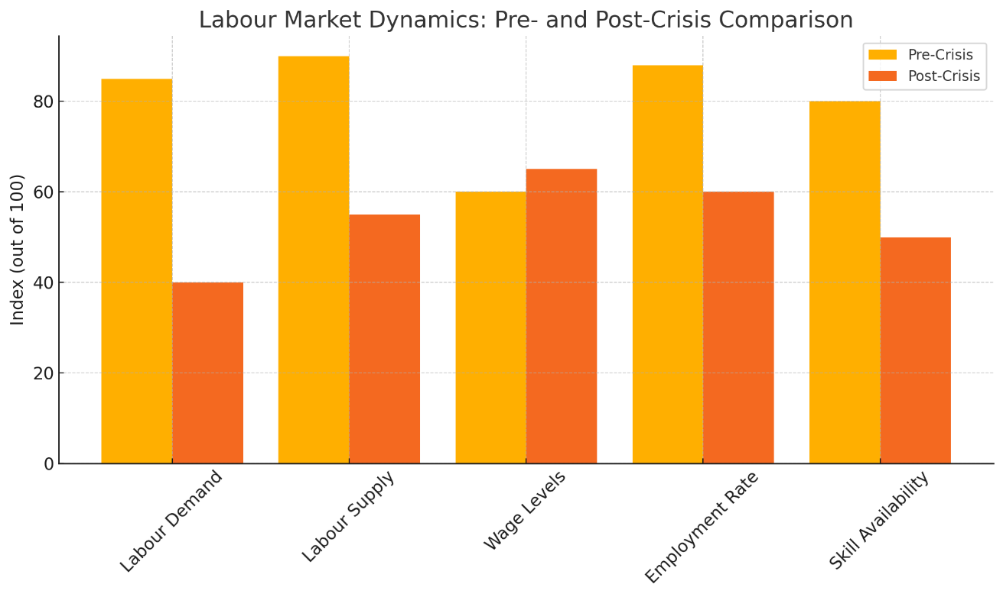
The level of wages in the tourism sector was not high relative to other sectors with wages considerably falling below minimum wages. This stagnation of wages came out in full force in service jobs, which did not increase very much over time as cost of living was rising. There were also relatively high employment rates around peak seasons but off seasons involved under employment and job insecurity. However, the flow of newcomers to the industry was regular, mostly the students, the seasonal and international interns.

2.2 Consequences of Crisis on the Labour Market Dynamics
The very beginning of the crisis has triggered the radical and instantaneous shifts in the labour market. Travel bans, quarantine, and overall confusion in the world caused the tourism industry to almost stall. Hotels, airlines, travel agencies, attractions, and tours, among other businesses, closed their doors or hugely downsized. This provoked the mass layoff, furloughed and a decline in unfilled positions.
The demand of labour in the whole tourism sector collapsed. With the decline in visitor arrivals, employers had no option but to reduce the staff working hours or had to cancel contracts. Most of the tourism jobs could not be worked remotely as it is the case with other industries, a factor that exposed them to greater hazard. As an illustration, hotel receptionists, housekeepers, and tour operators did not have much or any work when there were lockdowns. (Adăscăliței & Heyes, 2021)
The work force on the supply side declined drastically. After losing their jobs, many employees switched to other jobs like the ones in healthcare, logistics or through delivery applications in the gig economy. Others also left the job markets completely because of inability to retain employment opportunities, mental health issues and needs to care of their families. The fact that informal many tourist related jobs is took away safety nets to workers and further prompted the labour out flow
One of the essential consequences of the crisis was the appearance of the severe shortages in skills. When the businesses started reopening after the crisis, they experienced challenges of recruitment of experienced personnel that had moved elsewhere. The lack of technical employees in the form of IT support to booking systems, digital marketing samples, and revenue managers who can carry out a dynamic pricing approach were seriously evident. Similarly, soft skills, like communication, conflict resolution, and provision of multilingual customer service gained more importance in a post-crisis state where tourists were more worried about safety and quality of service delivery. (Lafourcade et al., 2016)

2.3 Wage Dynamics and Recovery in Employment
Dynamics of wage at the time and following the crisis were mixed. First, wages were put under downward pressure as a result of oversupply and economic insecurity. When tourism started recovering however, the demand of skilled labour increased. Employers began to incentivize workers with increased wages and other advantages like signing bonuses, health advantages, and working hours to lure workers and satisfy them so that they do not leave.
Nevertheless, the employment rates were not back to pre-crisis levels in some considerable time. The number of part-time jobs exceeded full-time employment offers and numerous employers introduced slimmer workforce frameworks with the help of automation or self-service-enabled technologies. As an example, hotels introduced mobile checks-ins and QR-menus, which has led to the decreased number of employees at the front-desks and waiters.
Let us assume that we have a well-known seaside resort and where the level of tourism developed workplaces has dropped by 70 percent with the peak of the crisis. Prior to the crisis, the region had 10,000 jobs in the tourism sector; based on the crisis, it has now declined to 3,000. One year since, the situation is still in 60% recovery of tourism as such jobs have recovered only 5,500 out of an expected 1/3 recovery of the number of jobs compared to the times before Covid-19. This deficit is not only a decreased rate of business but also the time lag of staff re-entry caused by reskilling shortage and new preferences of workers. (Flaschel et al., 2011)

2.4 Current difficulties, and Future employment prospects

With the tourism destination shifting to the recovery period, the labour market is experiencing a number of unresolved issues. These include:
- A mismatching of jobs and skills.
- A mistrust relationship between employees and employers because of layoffs in the past.
- Increased demands on employees in view of job security, healthcare benefits and work-life balance.
- The lack of interest among younger generation to consider the growth opportunities in the tourism sector.
The recovery in the workforce will be a matter of not just reestablishing labour demand into occupation but also the rebranding tourism occupation as viable and lucrative, enhancing the quality of employment, and settling inequities that were engaging in place before the sexual equality movement. Such changes in the labour market dynamics are important to comprehend in order to achieve specific and effective recovery policies and interventions in the following parts of this report.

3. Structural Weaknesses and Dependencies
Although tourism is an economic sector, it has maintained structural weaknesses which lead to a lack of its resilience to crisis over the years. These are high dependency on seasonal labour, high level of informal employment and lack of holistic protection to employees. When a crisis occurs, e.g., in the form of a pandemic or an economic crisis, or as a geopolitical shock, these vulnerabilities are intensified and the level of instability in the tourism labour market increases. This section will look at the structural weaknesses that predisposed the sector to weakness and how these weaknesses increased worker disruptiveness in the period of the crisis.
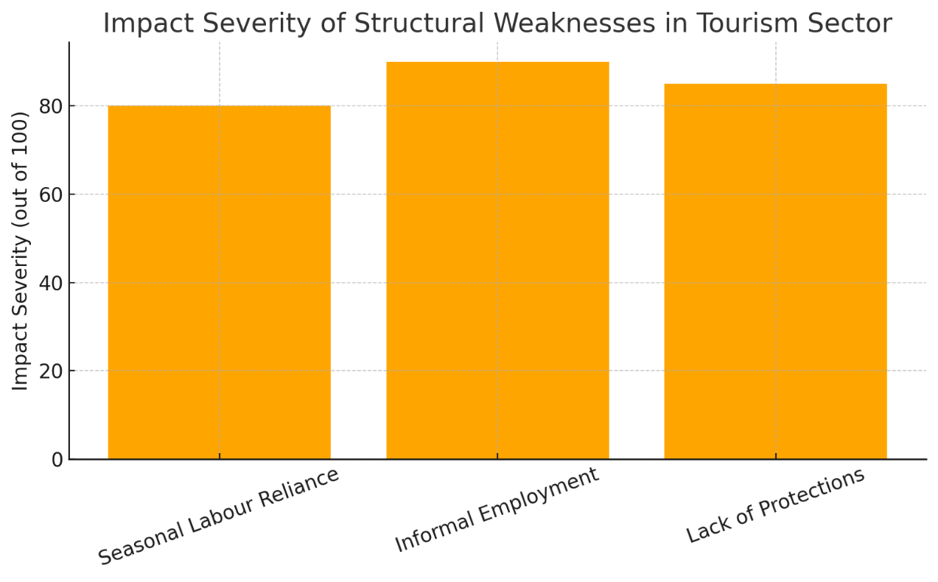

3.1 Reliance on labour seasonally
A seasonal employment pattern is one of the most essential peculiarities of the tourism industry. The demand at destinations tends to be volatile depending on the weather conditions, school holidays, fairs and festivals or even world travelling trends. Consequently, it forces businesses to take on temporary employees to work during busy seasons and lay them off when there is no strong demand. Such cyclical job system hinders job security in the long-run and dampens career development opportunities in the industry.
The ills of seasonal reliance became excruciatingly obvious during the crisis. Tourism activities virtually ended within a short time dwindling when restrictions on travelling and lockdowns were established. The first to get laid off were the workers who were on temporary or seasonal contracts and unlike the permanent employees, the workers had minimal and even no way of getting access to severance packages or relocation measures. As in the case of ski resorts, beaches and event-based tourism providers, mass layoffs occurred as whole seasons were cancelled. These workers were not able to come back after the crisis, due to the instability of seasonal jobs, in the case where these people have already migrated to other industries, more reliable. (Panda & Mishra, 2018)

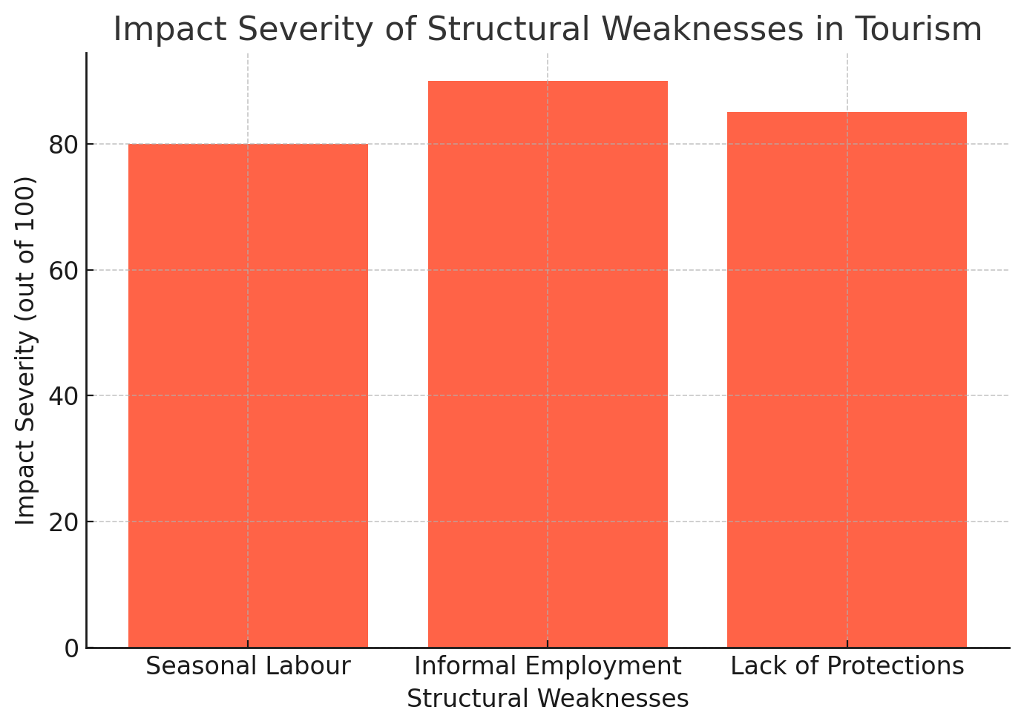

3.2 Employment of the Informal Kind
Much of tourism labour is informal in character, mostly on casual basis or freelance employees and hired workers under table which is especially common in developing areas or with small and medium business units. Although informal employment is flexible and provides the employer with reduced overhead, the informal workers also lack protection against the law, any health cover, and are not able to even have unemployment benefits.
The group that suffered more than it should have in crisis was the informal workers. Most of them did not qualify to get government relief efforts which demanded evidence of regular pay. These employees lost their jobs and were out of a source of income instantly as the businesses in the tourism sector started closing down, and they did not have any financial nets to rescue them. In addition, having no contracts or documented employment they found it hard to approach a court or any form of legal framework to take action. This led to massive economic distress to the overall population particularly those that are susceptible like women, youth and migrant workers who often comprise the bulk of workers in the informal tourism sector.
The lack of institutional forms also broke communication between the employers and the displaced workers and re-engaging the workers in the post crisis stage was much harder. The informality therefore turned out as both the cause and the effect of collapse of labour market in tourism.

3.3 Employee Lacks Protections and Benefits
The other significant structural shortcoming in tourism sector can be seen in the overall absence of broad-based employee protections, including paid sick leaves and retirement plans, job protection policies, and mental wellness provisions. Most of the workplaces in many destinations that depend on tourism are under adverse work conditions and wages are low with little benefits. Such circumstances result in low morale, low retention rate and high turnover of workers.
This vulnerability exposed the tourism workers given that they did not have the protection when the crisis hit. Individuals who were sick or need to quarantine tended to lack paid leaves. Others were left to decide between putting themselves at risk of being exposed and generating money. Complications with mental health, stress, and burnout increased in those who lost their jobs as well as in frontline staffers, but little had an apparatus to deal with them with employers.
Additionally, there was no such thing as redundancy payment or employment insurance, and so the loss of jobs led to personal financial crisis. Employees were not attracted to go back to the industry after the crisis unless there were new protection measures.

3.4 Crisis Multiplication of the Existing Weaknesses
These structural problems were not made by the crisis; the crisis made them louder. This led to the following in tourism destinations:
- Quite a lot of draining of skilled labour.
- A loss of confidence between employees and the employers.
- An increasing unwillingness of workers to go back to the tourist industry jobs after the crisis.
- The inequity and exclusion in the workforce also widened, with the most affected being the marginalized people.
- The overall weaknesses of the sector very badly hampered the capacity of the sector to recover itself fast enough. In contrast with those industries, where the labor structures were rather stable and well-regulated, the additional problem arose in the sphere of tourism as it had to restore not only employment but also institutional trust and working conditions.
In the future, these structural problems should be acted upon. To establish tourism as an employment with resilient workers, the employment should be changed, labor contracts, social protection confused, and work in the tourism industry has to be recognized as a decent and safe profession, not a temporary, risky business.

4. Strategic Solutions
A resilient and comprehensive restoration of the tourism labour force presupposes a twofold approach involving both the shortsighted measures aimed at making the labour market stable and the long-term policies that will make it less vulnerable in the future. These remedies should be oriented to cushioning the expected outfall of the crisis short-term, as well as condition the workforce and sector to be long-term affected by the demand changes, technology breakdown, and worker requirements. (Baum, 2018)

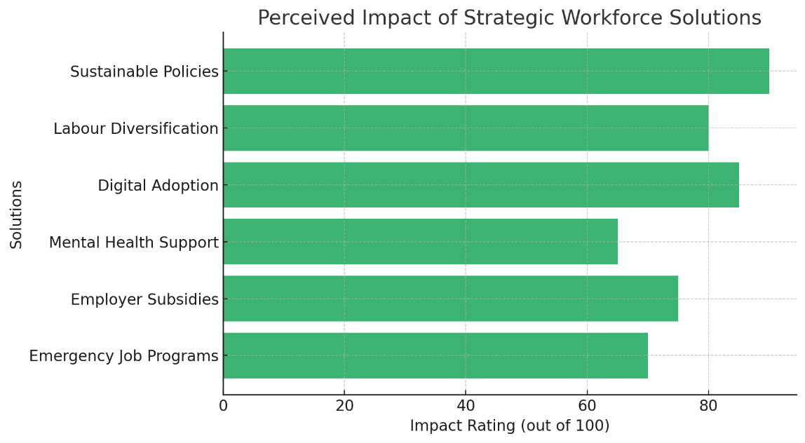

4.1 Short term Strategies
Emergency placement jobs Programs:
Because of mass layoffs during the crisis, it is necessary to establish emergency job placement systems. Such programs link those disaffected by the tourism industry to work opportunities in similar or different fields including logistics, health care, or local government. Collaborations between the government agencies and training bodies can be used to temporarily place employees in the sector at other employers in unrelated lucrative practices until the sector recovers and the employees who were provided emergency placement can resume their positions in the sector. As an example, those hotel staff, who lose their jobs, might be redirected as customer service operators in vaccination centres or event logistic operators.
Employer Government Subsidies and Stimulus:
Indeed, every government can support tourism employers directly by providing them with financial help to stay afloat and avoid permanent shutdowns. This can also consist of payroll subsidies, tax payments, and low-interest loans so that businesses can keep their employees when there is low demand. There should be stimulus packages that focus on small and medium enterprise (SME), which are not usually able to get by when they lose revenue over a long period. Employee retention can be guaranteed by wage subsidies, which makes sure money goes towards employer and employee.
Support of Reintegration and Mental Health:
Psychological effects of losing the job, inconsistencies, and the decline in income have been substantial among the people employed in tourism. Recovery should also be inclusive of mental health services whereby free counselling programs will be provided in the community, and stress management workshops and community support groups will be provided. Also, in the reintegration programs, the workers ought to be ready to move back into the workforce with confidence; this can be done through skill refreshing, coaching and reorientation at the workplace. Raising an accent on the well-being of the workers contributes to re-establishing morale and improving the level of job satisfaction at the post-recovery stage.

4.2 Long Term Strategies
The Adoption of Digitized and Automation of Workforce:
It is necessary to introduce electronic change that allows the tourism industry to be competitive and efficient. The digitalization of processes with the help of online booking services and contactless check-ins, online tours, etc., not only advances the customer experience to a new level but also opens up new sectors of employment that involve digital technology. Workers need to be trained to have the competencies on data management, social media marketing and the virtual customer service. These repetitive activities can be automated to give human workforce a chance to work on complex and personalized services. (Acemoglu et al., 2022)
Diversification of the Labour Market:
The crisis has taught one lesson, and one of them is the need to diversify sources of labor, as well as of skills. Too much dependence on a limited pool of labor or role specialization creates eminent vulnerability. A combination of full time, part time and contract jobs should be promoted by tourism destinations and local talent must be actively nurtured. Tourism would improve resilience of its workforce and be more representative of community values through gender-inclusive hiring, youth employment programs, and minority group support.
The Policies of Sustainable Tourism Workforce:
Lastly, policy frameworks should be changed to promote decent employment and sustainability in the tourism. This also involves the rationalization of employment agreement, the provision of minimum benefits, guaranteeing the manner of employment safety and the provision of professional development opportunities. Subsidies may be provided to the companies who focus on the long-term employment of people, protection of environment, and social inclusion. Juxtaposing policies on the workforce to the aims of sustainable tourism will mean that economic recovery would not require the sacrifice of ethical employment policies.
To sum up, a workforce recovery strategy should not include either urgency or foresight. Short-term actions help stabilize employment and safeguard life chances, whereas the longer-term ones set the premises about a more digitalized, inclusive and durable tourism industry. Such strategic measures will assist the destination both to recover out of the upheaval, as well as emerge stronger wherever the next upheavals come up. (Edgell & Sr., 2015)

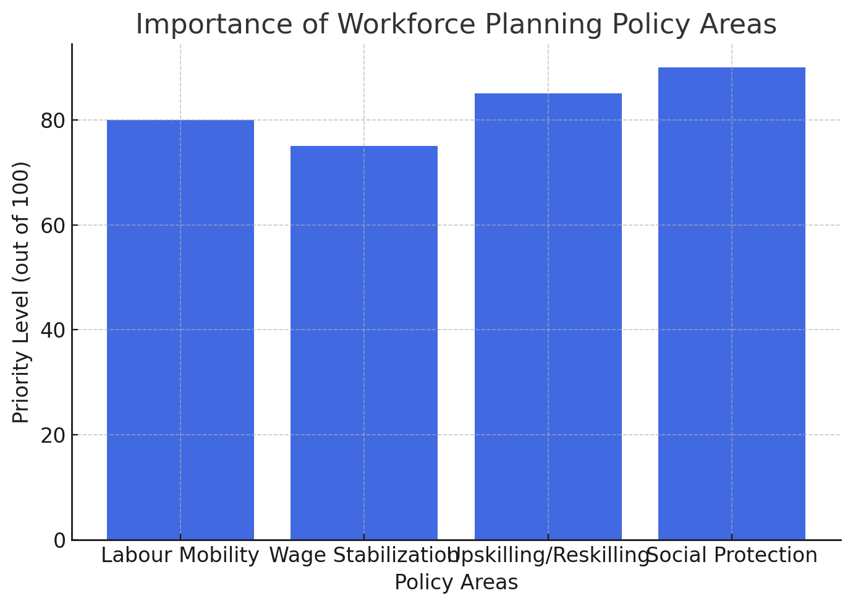

5. Policies on Workforce Planning
A well-planned long-term workforce planning policy should be included in a successful tourism workforce recovery attempt as far as long-term responses to labour disruption should be complemented immediately. It is important that these policies create an opportunity to make sure that the labour market does not lose its ability to adapt, stay inclusive, and strong against any future crisis. Tourism destinations can establish a stable workforce by institutionalizing prospective actions that will support growth, innovation, and equity besides creation of a stable employment environment. The four important areas of policy development are described in this section, and they include labour mobility, wage stabilization, upskilling and reskilling, and social protection frameworks.

5.1 Existing labour mobility programs (Inter-Region and International)
In order to solve the issues of current and future mismatch of skills, the labour mobility programs should be created and promoted. These schemes allow migration of the labor force between areas or without limits over national boundaries so as to satisfy the seasonal or skill requirements. There is a great need of labour mobility across regions especially in the tourism industry where, in some destinations, there will be seasonal shortages and in others excess labour supply. (Teljeur et al., 2010)
As an example, the resorts with summer and winter peaks can work out the coordinated mobility programs so that the same workers could go back and forth between resorts and still be employed all the time and all the resources could be used in the best possible way. The governments and industry organizations could take the centre stage by establishing cross-border arrangements, visa regimes and mobility systems which safeguard the rights and privileges of mobile employees. Also, online labour exchanges are possible to be created to synchronise the working places and workers in real time, which makes the whole process much more efficient and minimises the duration of hiring.

5.2 Stabilization Mechanisms on Wages
Lack of stability in wages is one of the oldest problems in the tourism industry, and crises make the problem even more insidious as the demand immediately decreases. To remedy this policies should be established to help stabilise wages and proffer the basis of income security. The industry stakeholders and governments can work together to come up with minimum wage floors that are industry specific in the tourism industry. Such floors are required to be adjusted in line with inflation, cost of living and seasonality of the industry.
The next instrument is wage guarantee schemes, in which the government covers part of employer wage bills during a recession to prevent a large number of staff being cut off. Students such as Germany have taken such measures to success (e.g., Kurzarbeit). These systems enable the employers to maintain employees at lower hours and prevents the workers against the sudden loss of income. Further, fair compensation can also be encouraged by providing businesses that preserve the level or increase the wages after the crisis with tax credits.

5.3 Skills Retention /Upskilling and Reskilling Programs
Continuous investment in education, training and career development is one of the best steps to prepare tourism work-force to future disruptions. Upskilling means increasing skills of current workers to accommodate changing workplace needs, including digital literacy skills, skill to maintain a good customer experience, or health and safety measures. Reskilling on the other hand assists in transferring displaced or underemployed workers to other positions either in or without tourism.
Different tourism board and vocational-school-tech providers can work out low-cost and flexible training modules via public-private partnerships. As an example, the subjects of digital booking systems, language skills, and crisis communication may be opened as online courses in order to cover more people. It should also make training to be inclusive and accessible by vulnerable groups, women, youth, and migrant workers. National tourism skills framework may ensure that all certification are standardized, portable and recognized by the tourism employers all over.

5.4 Structures of Social Protection
Workers in the tourist industry who work on a part time or informal basis do not usually enjoy social security benefits. During the COVID-19 pandemic, this gap was especially evident as prevalent workers received no unemployment benefits, health insurance, or paid leaves. In order to maintain stability and fairness in the labour markets, strong systems of social protection should be designed and applied.
These will consist of incorporating tourism employees into unemployment insurance, providing healthcare insurance, and allowing sick pay leave even in temporary or seasonal positions. All employers should be forced to pay national insurance schemes and governments should ensure that informal workers are gradually remodeled and subjected to labour laws. Portable benefit schemes- in which benefit transfers with the employee between jobs or areas- might be particularly suitable in a mobile and seasonal labor force. (Petmesidou, 1996)
Also, crisis- response funds could be established to avail quick economic support to its employees in untimely interference. These funds ought to be open, in reach and controlled with a coordinated effort with industry and employee representatives.
Finally, the importance of establishing efficient workforce planning policies should be viewed as the key to the development of a resilient, skilled, and secure tourism workforce. Tourism destination can protect the labour supply to the destination as well as the livelihoods of the people who make tourism possible, by assisting labour mobility, maintaining their incomes, making their lives lifelong learners, and securing their social protection. These policy measures do not only serve as crisis interventions but also represent the investments into health and sustainability of the tourism industry in the long term.

6. Conclusion
The exposure of the tourism sector to exogenous shock (that is, pandemics, economic crises, geopolitical crises, and so on) has revealed important gaps in the labour market structure. This report has evaluated pre and post-crisis of the tourism workforce and identified that labour supply and labour and demand, wage structure and skills have been very seriously interrupted. It has also looked into such structural dependencies as seasonal work, informal labour arrangements, lack of protection of employees all of which intensified during the crisis and life to work instability.
To address that, an integrated package of both short- and long-term strategic solutions have been offered. One of them is emergency jobs placement, government subsidies, mental health, digital transformation, labour diversification and sustainable employment policies. To boost such initiatives, it was advisable to have workforce planning policies with emphasis on labour mobility, wage stabilization, upskilling programs, and a strong social protection program. Taken together, these constitute a multi-pronged approach to not just replacing the jobs that have been lost, but in creating a superior reconstituted tourism labour market.
The offered recovery strategy will carry the theme of sustainability, inclusivity, and resilience. Through institutionalization of proactive policies and rectification of structural lapses that have hampered in the long run, tourism destinations will be better placed to preserve their human capital, as well as react appropriately to future shocks. This strategy will in effect seek to ensure that crisis recovery becomes an avenue of long-term workforce reform and establishing a tourism sector that is equal, prepared to meet the changing world, and scalable to adjust to the evolving global conditions.

References
Lafourcade, P., Gerali, A., Brůha, J., Bursian, D., Buss, G., Corbo, V., Haavio, M., Håkanson, C., Hlédik, T., Kátay, G., Kulikov, D., Lozej, M., Micallef, B., Papageorgiou, D., Vanhala, J., & Zeleznik, M. (2016). Labour market modelling in the light of the financial crisis. www.econstor.eu. https://doi.org/10.2866/24101
Panda, S. S., & Mishra, N. R. (2018). Factors affecting temporary labour migration for seasonal work: a review. Management Research Review, 41(10), 1176–1200. https://doi.org/10.1108/mrr-04-2017-0104
Baum, T., Mooney, S. K., Robinson, R. N., & Solnet, D. (2020). COVID-19’s impact on the hospitality workforce – new crisis or amplification of the norm? International Journal of Contemporary Hospitality Management, 32(9), 2813–2829. https://doi.org/10.1108/ijchm-04-2020-0314
Deyshappriya, N. R., Sammani, U., & Minuwanthi, R. (2021). Impact of COVID-19 on Tourism Sector of Asia &amp; Pacific Countries Evidence from 20 Asia-Pacific Countries. SSRN Electronic Journal. https://doi.org/10.2139/ssrn.3780713
Monastiriotis, V., Macchiarelli, C., & Lampropoulou, N. (2019). Transition dynamics in European labour markets during crisis and recovery. Comparative Economic Studies, 61(2), 213–234. https://doi.org/10.1057/s41294-019-00084-1
Adăscăliței, D., & Heyes, J. (2021). Labour markets in post-crisis Europe: liberalisation, deregulation, precarisation. In Edward Elgar Publishing eBooks. https://doi.org/10.4337/9781789906745.00031
Flaschel, P., Greiner, A., Logeay, C., & Proano, C. (2011). Employment cycles, low income work and the dynamic impact of wage regulations. A macro perspective. Journal of Evolutionary Economics, 22(2), 235–250. https://doi.org/10.1007/s00191-011-0236-2
Baum, T. (2018). Sustainable human resource management as a driver in tourism policy and planning: a serious sin of omission? Journal of Sustainable Tourism, 26(6), 873–889. https://doi.org/10.1080/09669582.2017.1423318
Acemoglu, D., Anderson, G., Beede, D., Buffington, C., Childress, E., Dinlersoz, E., Foster, L., Goldschlag, N., Haltiwanger, J., Kroff, Z., Restrepo, P., & Zolas, N. (2022). Automation and the Workforce: A Firm-Level View from the 2019 Annual Business Survey. https://doi.org/10.3386/w30659
Edgell, D. L., & Sr. (2015). International Sustainable Tourism Policy. The Brown Journal of World Affairs, 22(1), 25–36. https://www.jstor.org/stable/24590998
Petmesidou, M. (1996). Social protection in Southern Europe: Trends and prospects. Journal of Area Studies, 4(9), 95–125. https://doi.org/10.1080/02613539608455784
Teljeur, C., Thomas, S., O’Kelly, F. D., & O’Dowd, T. (2010). General practitioner workforce planning: assessment of four policy directions. BMC Health Services Research, 10(1). https://doi.org/10.1186/1472-6963-10-148

