M09 Digital Transformation and Innovation MBA
Digital Transformation as a Driver of Business Competitiveness
Selected assignment option: Option 1
Report type: Detailed project report
Student Name: __________________________
Student ID: __________________________

Table of Contents
Section | Page
Title Page | 1
Table of Contents | 2
Abstract | 3
1. Introduction | 3
2. Literature Review | 5
3. Methodology | 9
4. Findings | 11
5. Discussion | 15
6. Conclusion | 20
References | 22
Appendices | 24

Abstract
Digital transformation is now a strategic source of competitiveness rather than a narrow information technology upgrade. This report examines how cloud computing, artificial intelligence, big data analytics, automation and the Internet of Things strengthen competitive advantage by improving efficiency, customer experience, decision making and market responsiveness. The argument developed here is that digital technology creates value only when it is combined with business model redesign, data governance, process integration, leadership commitment and organisational learning. The report uses a qualitative secondary research methodology and compares examples from Amazon, Walmart, Microsoft and Toyota to show how digital investments become competitive capabilities. The findings indicate that cloud platforms increase scalability, artificial intelligence improves prediction and personalisation, analytics strengthen managerial visibility, automation reduces process variability and connected products open new service opportunities. However, the discussion also shows that digital transformation can fail when firms treat technology as a substitute for strategy, ignore employee adoption, keep fragmented data architectures or underinvest in cybersecurity and skills. The report concludes that competitiveness comes from the disciplined integration of technology, people and operating routines. Organisations should therefore build digital transformation roadmaps around measurable business outcomes, strong data foundations, responsible innovation governance and continuous capability renewal rather than isolated technology projects.

1. Introduction
Digital transformation has become one of the central strategic challenges for modern organisations because competitive advantage increasingly depends on speed, data, connectivity and the ability to redesign value creation around digital capabilities. Earlier information technology projects often focused on automating existing tasks or reducing administrative cost. Contemporary digital transformation is broader because it changes customer interactions, supply chain coordination, product design, service delivery, decision processes and the way organisations sense and respond to market change. Vial (2019) defines digital transformation as a process through which digital technologies trigger strategic responses that alter value creation paths. This definition is important because it avoids the simple view that buying technology is transformation. A firm can adopt cloud systems, analytics dashboards or automation tools without becoming more competitive if the underlying business model, skills and routines remain unchanged.
The strategic importance of the topic is also reflected in the rapid diffusion of artificial intelligence and cloud platforms. McKinsey and Company (2025) reported that 88% of surveyed organisations used artificial intelligence in at least 1 business function, but most had not yet scaled adoption through disciplined management practices. This gap shows why the competitiveness question is not whether organisations are experimenting with digital technologies, but whether they can convert experimentation into durable capability. The distinction matters because digital tools are widely available and can therefore become a source of parity rather than advantage. Competitiveness comes when technology is embedded into distinctive processes, proprietary data, managerial routines, customer ecosystems and learning loops that are hard for rivals to copy.
This report addresses Option 1 by critically examining digital transformation as a driver of business competitiveness. It first reviews key theories of digital transformation, digital business strategy, dynamic capabilities and technology enabled competition. It then explains the role of cloud computing, artificial intelligence, big data analytics, automation and the Internet of Things. The methodology section explains the use of a qualitative secondary research design and comparative case analysis. The findings evaluate the effect of digital transformation on operational efficiency, customer experience, decision quality and market responsiveness. The discussion then considers why transformation succeeds in some firms and fails in others. The report argues that digital transformation produces competitiveness when it is treated as strategic renewal rather than a technical modernisation programme.
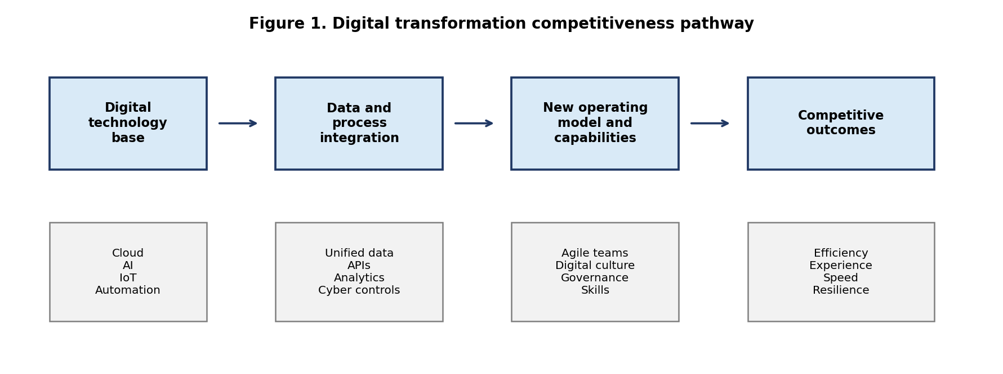
Source: Author synthesis based on Vial (2019), Verhoef et al. (2021) and Teece (2018).

2. Literature Review

2.1 Digital transformation and digital business strategy
The literature shows that digital transformation has 3 connected dimensions. The 1st is technological because firms deploy cloud computing, analytics, artificial intelligence, mobile interfaces, robotic automation, connected sensors and enterprise platforms. The 2nd is organisational because firms redesign structures, roles, routines, governance and skills to absorb those technologies. The 3rd is strategic because firms use digital capabilities to change value propositions, channels, cost structures and competitive positions. Verhoef et al. (2021) describe this as a progression from digitisation to digitalisation and then to digital transformation. Digitisation converts analogue information into digital form. Digitalisation uses digital tools to improve existing processes. Digital transformation goes further by changing the logic of how an organisation competes.
Bharadwaj et al. (2013) argue that digital business strategy is no longer a functional technology strategy but a fusion of business strategy and information technology strategy. This argument is highly relevant because competitive advantage in digital environments emerges from integration. A retailer, for example, cannot improve responsiveness simply by launching an e commerce site if inventory visibility, payment systems, last mile logistics and customer service remain disconnected. A manufacturer cannot create smart connected products if engineering, software, cybersecurity and after sales service are governed as separate silos. Digital strategy must therefore connect technology architecture with market positioning and operating model design.
Dynamic capability theory is useful for explaining why digital transformation can support long term growth. Teece (2018) argues that firms need capabilities to sense opportunities, seize them through investment and reconfigure assets as conditions change. Digital technologies strengthen sensing by capturing real time data from customers, operations and markets. They strengthen seizing by enabling faster product iterations, targeted offers and scalable platforms. They strengthen reconfiguration by allowing cloud based modular systems, agile teams and automated workflows. However, the theory also warns that technology assets alone are insufficient. Organisations need leadership judgement, cross functional coordination and absorptive capacity to turn digital signals into strategic action.

2.2 Digital technologies and competitiveness mechanisms
Cloud computing is a foundational technology because it changes the economics and speed of digital innovation. Instead of building all infrastructure internally, organisations can access computing, storage, analytics and artificial intelligence services on scalable platforms. This reduces fixed investment barriers and allows firms to test products, scale demand and integrate services faster. Microsoft (2025) reported that Azure surpassed USD 75 billion in revenue in fiscal year 2025, showing the scale of enterprise demand for cloud platforms. For adopters, cloud computing can improve competitiveness by reducing deployment time, supporting remote collaboration, enabling data integration and allowing experimentation at lower marginal cost. Yet cloud also creates governance issues, including vendor dependence, cyber exposure, cost management and compliance risk.
Artificial intelligence contributes to competitiveness by transforming prediction, classification, optimisation and content generation. Its value is visible in demand forecasting, fraud detection, predictive maintenance, customer personalisation, chatbots, recommendation systems and knowledge work automation. The strategic value of artificial intelligence depends on the quality of data, model governance, integration into workflows and human oversight. When artificial intelligence remains in isolated pilots, it is unlikely to transform performance. When it is embedded into decision routines, it can support faster and more consistent managerial action. NIST (2023) emphasises that trustworthy artificial intelligence requires attention to validity, reliability, safety, security, accountability, transparency and fairness. These requirements show that artificial intelligence competitiveness must be linked with responsible design.
Big data analytics strengthens competitiveness by improving organisational visibility. Traditional decision making often depends on delayed reports, managerial intuition and fragmented departmental indicators. Analytics platforms can integrate customer, operational, financial and external data so that managers can identify trends, detect anomalies and allocate resources more accurately. However, analytics is not automatically superior to human judgement. Poor data quality, biased sampling, weak data definitions and dashboard overload can create false confidence. The competitive advantage therefore lies not simply in having more data, but in building decision systems that connect data quality, analytical skill, domain expertise and accountable action.
Automation and the Internet of Things extend transformation into physical operations. Robotic process automation can reduce repetitive administrative tasks, while industrial automation and connected sensors can improve production control, asset maintenance and logistics coordination. Porter and Heppelmann (2014) argue that smart connected products change competition by expanding product functionality, enabling monitoring and creating new service models. For example, manufacturers can move from selling equipment to offering uptime, predictive maintenance and usage based services. This changes the basis of competition because value shifts from the product alone to the data enabled service ecosystem around the product.
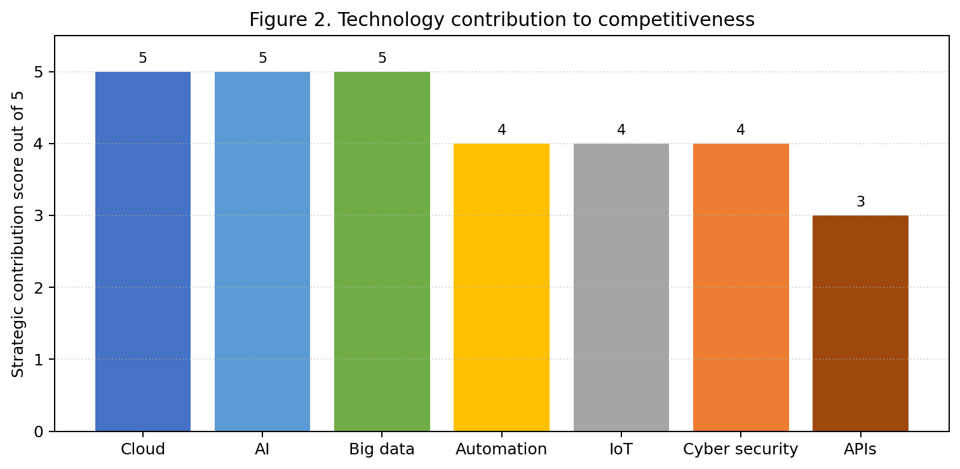
Source: Author assessment based on the reviewed literature and case evidence.

2.3 Constraints and transformation risks
The literature also identifies major constraints. Hess et al. (2016) note that digital transformation strategy must address technology use, changes in value creation, structural changes and financial aspects. If any dimension is weak, transformation becomes fragmented. Hanelt et al. (2021) show that digital transformation often involves strategic renewal under environmental turbulence, which means firms must repeatedly adjust rather than complete a one time project. Resistance to change, legacy systems, cyber risk, technical debt, regulatory pressure and skills shortages can reduce the benefits of digital investment. A critical view is therefore required. Digital transformation can create competitiveness, but it can also increase complexity and cost if firms pursue fashionable technologies without a clear value logic.
Table 1. Theoretical basis for analysing digital transformation and competitiveness
Theory or concept | Main idea | Relevance to competitiveness
Digital business strategy | Business and technology strategy must be integrated rather than separated. | Explains why technology investments must support customer value and operating model redesign.
Dynamic capabilities | Firms must sense opportunities, seize them and reconfigure resources. | Explains how digital tools improve speed, learning and strategic renewal.
Smart connected products | Products become data generating service platforms. | Explains the shift from product competition towards ecosystems and services.
Digital maturity | Value depends on skills, governance, data and process integration. | Explains why some firms gain more benefit from similar technologies than others.

3. Methodology
This report uses a qualitative secondary research design. The method is appropriate because the assignment requires critical examination of theory and real world relevance rather than primary statistical testing. The analysis draws on peer reviewed academic literature, recognised management research and recent corporate disclosures from technology intensive organisations. The academic sources provide conceptual depth on digital transformation, digital business strategy, dynamic capabilities and smart connected competition. The corporate examples provide evidence of how digital technologies are used in practical business contexts.
The comparative case logic focuses on Amazon, Walmart, Microsoft and Toyota. The cases were selected because they represent different sectors and therefore show that digital transformation is not limited to digital native firms. Amazon demonstrates artificial intelligence, cloud and logistics automation at platform scale. Walmart shows how a traditional retailer uses omnichannel systems, e commerce, supply chain technology and stores as a connected fulfilment network. Microsoft represents a provider and user of cloud and artificial intelligence capabilities. Toyota represents an industrial manufacturer using software defined vehicles, connected mobility and production digitalisation. The comparison allows the report to assess common mechanisms across different competitive environments rather than describe 1 firm only.
The evaluation framework assesses 4 competitiveness outcomes: operational efficiency, customer experience, decision quality and market responsiveness. These outcomes are drawn from the assignment task and from the literature on technology enabled strategic renewal. The analysis also considers 5 implementation conditions: data quality, process integration, leadership commitment, employee capability and governance. These conditions are included because transformation results depend on organisational adoption as much as technology choice. The method has limitations. It cannot prove causality between specific technology investments and financial performance because public reports do not isolate all variables. It also depends on secondary sources, which may emphasise positive corporate narratives. The report manages these limitations by using multiple sources and by discussing risks and failure conditions alongside benefits.

4. Findings

4.1 Operational efficiency and digital coordination
The 1st finding is that digital transformation improves operational efficiency when technologies remove process friction and allow real time coordination. Cloud based enterprise systems reduce delays caused by disconnected legacy applications. Automation reduces manual handoffs and repetitive tasks. Internet of Things sensors improve visibility over assets and supply chains. Artificial intelligence can identify patterns that are difficult for manual planners to see. In Amazon, digital infrastructure connects online demand, recommendation engines, fulfilment centres, robotics, route planning and AWS capabilities. Amazon.com, Inc. (2026) described artificial intelligence as a multiplier that will reshape customer experiences and unlock new ones. This shows that efficiency is not treated as a back office objective only. It is tied to speed, fulfilment reliability and the ability to launch new services.
Walmart provides a different example because its competitive challenge involves integrating physical stores, e commerce sites, supply chain assets and a large workforce. Walmart Inc. (2025) stated that it is enhancing omnichannel capabilities through stores, e commerce websites, service offerings and supply chain assets, supported by approximately 2.1 million associates. This indicates a hybrid transformation model. Rather than replacing stores with digital channels, Walmart uses stores as local fulfilment points, customer service assets and data collection points. The competitiveness effect is therefore based on combining scale, proximity and digital coordination. The example supports the argument that transformation is sector specific. Retail competitiveness depends on inventory accuracy, fulfilment choice, price trust and convenience rather than technology novelty alone.

4.2 Customer experience and decision quality
The 2nd finding is that digital transformation improves customer experience by enabling personalisation, convenience and service continuity. Artificial intelligence recommendation engines, mobile applications, digital payments, self service tools, personalised marketing and connected service channels allow firms to reduce customer effort. However, customer experience improves only when technology is designed around customer journeys rather than internal departmental convenience. A chatbot that cannot solve problems or hand over context to a human agent may damage experience. A mobile app that does not match live inventory may increase frustration. Effective transformation therefore requires customer journey mapping, data integration and feedback loops.
The 3rd finding is that digital transformation improves decision making when it creates timely and reliable insight. Managers can move from periodic reporting to continuous monitoring of sales, operational capacity, customer sentiment, supplier risk and financial performance. Microsoft illustrates this point through the growth of cloud, artificial intelligence and productivity platforms that embed analytics into daily work. Microsoft (2025) reported record revenue of USD 281.7 billion and Azure revenue above USD 75 billion in fiscal year 2025. These figures show the business demand for platforms that support enterprise data, artificial intelligence and productivity integration. For customer organisations, the competitive benefit is not simply cheaper computing. It is the capacity to connect decisions across marketing, operations, finance and customer service.

4.3 Market responsiveness and ecosystem effects
The 4th finding is that market responsiveness improves when digital tools shorten the distance between signal and action. Firms can detect changes in demand, test digital products, alter pricing, adjust inventory and release updates more rapidly. Cloud architecture allows firms to scale successful services quickly. Analytics allows firms to identify emerging segments. Agile operating models allow teams to act without waiting for long planning cycles. Toyota shows the importance of responsiveness in a manufacturing environment. Toyota Motor Corporation (2025) emphasised software defined vehicles and mobility software as part of its future value agenda. This indicates a shift from mechanical product competition towards software, data and connected services. The automobile industry increasingly competes on digital interfaces, safety systems, over the air updates, energy management and mobility ecosystems.
The 5th finding is that digital transformation strengthens competitiveness through ecosystem effects. Cloud platforms, application programming interfaces, developer communities, suppliers, partners and customers can become part of a wider digital business system. Ecosystem competition matters because a firm can create value beyond its internal boundaries. Amazon Web Services, Microsoft Azure and platform based retail media networks show how digital infrastructure can become an external revenue source as well as an internal capability. Nevertheless, ecosystem advantage can create dependency risks for participants. Firms using large platforms must manage data portability, vendor lock in, cost transparency and cyber resilience.
The 6th finding is that technology benefits are uneven across firms because organisational readiness varies. Organisations with fragmented data, weak process ownership and low digital skills may receive limited benefit from advanced tools. McKinsey and Company (2025) found that less than 1 third of respondents reported following most of the adoption and scaling practices for generative artificial intelligence. This is significant because it suggests that many firms remain stuck between experimentation and scaled value. The problem is not a lack of technology availability. The problem is the managerial challenge of redesigning work, defining metrics, funding change, governing risk and building trust.
Table 2. Real world examples of digital transformation linked to competitive advantage
Organisation | Digital transformation focus | Competitive outcome
Amazon | AI, AWS, logistics automation, robotics and data driven fulfilment. | Speed, platform scale, customer personalisation and ecosystem revenue.
Walmart | Omnichannel retail, e commerce, supply chain technology and store based fulfilment. | Convenience, inventory reach, price consistency and local responsiveness.
Microsoft | Cloud, AI, productivity platforms and enterprise software ecosystems. | Scalability, customer lock in through value integration and productivity support.
Toyota | Software defined vehicles, connected mobility and digital production capability. | Mobility service opportunities, production learning and long term adaptation.
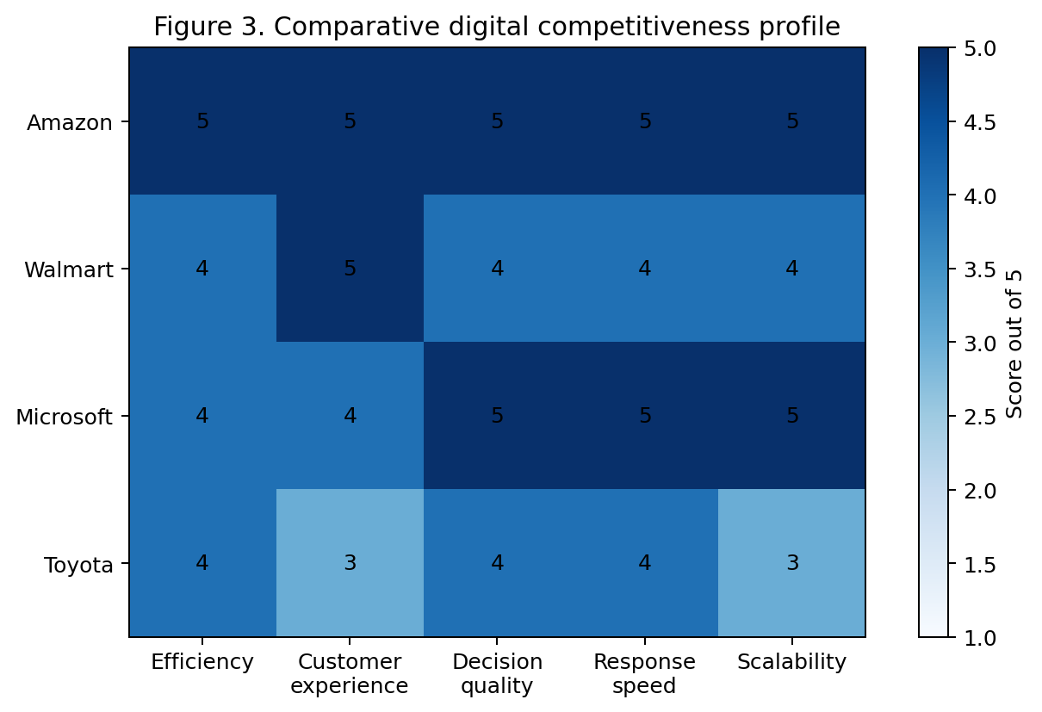
Source: Author synthesis from corporate reports and academic literature.

5. Discussion
The evidence supports the view that digital transformation can be a driver of business competitiveness, but the relationship is conditional. Technology improves competitiveness when it is linked to a clear strategic problem, integrated into operating routines and measured against business outcomes. A firm that deploys artificial intelligence without changing decision rights may only generate analysis that managers ignore. A firm that migrates to cloud without redesigning architecture may transfer inefficient processes to a new infrastructure. A firm that automates without involving employees may face resistance, workarounds and declining morale. These examples show why transformation should be seen as organisational change supported by technology rather than technology supported by minor organisational change.
The strategic mechanism can be understood through 4 pathways. The 1st pathway is cost and productivity. Digital tools can reduce transaction costs, improve asset utilisation and decrease cycle time. The 2nd pathway is differentiation. Personalisation, digital service quality, smart products and seamless omnichannel experiences can make the firm more attractive to customers. The 3rd pathway is speed. Real time data and agile delivery can help firms respond faster than rivals. The 4th pathway is resilience. Cloud platforms, digital supply chain visibility and scenario analytics can help organisations recover from disruptions. The strongest firms usually combine several pathways. Amazon combines speed, data, scale and ecosystem reach. Walmart combines physical proximity with digital convenience. Microsoft combines platform scale with enterprise trust. Toyota combines manufacturing knowledge with mobility software.
A critical issue is that digital transformation can also erode competitiveness if it creates uncontrolled complexity. Large transformation programmes often generate competing platforms, duplicate data sets, unclear accountability and rising cyber exposure. The move to cloud can increase variable cost if usage is not governed. Artificial intelligence can produce reputational damage if outputs are biased, inaccurate or opaque. Automation can reduce flexibility if processes are standardised before they are understood. Internet of Things devices can expand the attack surface if security is not designed from the start. These risks show that digital maturity requires governance. Organisations need architecture standards, data stewardship, security controls, vendor management, ethical review and benefits tracking.
Employee capability is another central condition. Digital tools change tasks, but people still interpret data, manage exceptions, design services and maintain customer relationships. If employees perceive transformation as surveillance or job threat, they may resist adoption. If they are not trained, systems may be underused or used incorrectly. Competitive advantage therefore depends on human and digital complementarity. Training should focus not only on technical operation but also on data literacy, process thinking and customer value. Leaders must explain why transformation is needed, what outcomes will be measured and how employees will be supported. This is particularly important in organisations like Walmart and Toyota where large workforces, physical operations and established routines must be aligned with digital change.
The discussion also shows that digital transformation changes the meaning of competition. In many sectors, firms no longer compete only through product features or price. They compete through data access, platform participation, ecosystem partnerships, speed of experimentation and the ability to learn from customer interactions. This does not mean that traditional strategic fundamentals disappear. Cost discipline, brand trust, operational reliability and customer value remain essential. Digital transformation changes how these fundamentals are achieved. For example, low prices in retail increasingly depend on algorithmic replenishment, automated distribution and data based demand planning. Product quality in manufacturing increasingly depends on sensors, software and predictive maintenance. Customer loyalty increasingly depends on seamless digital and human service design.
The recommended approach is therefore a staged and outcome based transformation roadmap. First, organisations should define the competitive problem, such as high fulfilment cost, weak customer retention, slow product development or poor demand visibility. Second, they should assess digital maturity, including systems, data quality, skills and governance. Third, they should prioritise technologies that directly support the competitive problem instead of adopting tools because they are fashionable. Fourth, they should redesign processes and decision rights before scaling technology. Fifth, they should measure impact through operational, customer, financial and risk metrics. Finally, they should build continuous learning routines so that transformation remains adaptive rather than a fixed programme.
The figures and matrix in this report summarise this logic. Figure 1 shows that digital technologies must pass through data integration and operating model change before they become competitive outcomes. Figure 2 presents a strategic contribution assessment in which cloud, artificial intelligence and big data score highly because they support scale, decision quality and responsiveness. Figure 3 compares selected cases and shows that the strongest digital competitors usually combine multiple capabilities. The matrix is not intended as a precise statistical ranking. It is a structured interpretation based on the literature and case evidence. Its value is to show that competitiveness is multidimensional and that digital transformation must be evaluated across more than 1 performance indicator.
A further implication is that competitiveness should be measured through a balanced set of digital performance indicators. Financial measures such as revenue growth, operating margin and return on invested capital remain important, but they are lagging indicators. Digital transformation managers also need leading indicators such as process cycle time, system availability, data accuracy, customer digital adoption, employee digital confidence, automation exception rates, cybersecurity incidents and cloud unit cost. This wider scorecard reduces the risk of claiming success because a system has been installed. It forces leaders to ask whether the technology has improved work, decisions and customer value. For example, an artificial intelligence demand forecast is valuable only if it reduces stockouts, waste or planning effort. A customer app is valuable only if it improves retention, conversion, service speed or satisfaction. A cloud migration is valuable only if it increases flexibility or reduces total cost after governance is considered.
The role of data governance deserves special emphasis because data is the raw material of most digital competitiveness. Firms often overestimate readiness because they possess large volumes of data, but volume is not the same as value. Competitive analytics requires common definitions, accurate master data, clear ownership, access rights, security classification and a process for correcting errors. If product codes, customer records or supplier names differ across systems, artificial intelligence and dashboards can produce misleading outputs. This problem is visible in many transformation programmes where data cleansing receives less attention than software purchase. A robust data governance model should assign data stewards, maintain metadata, define quality thresholds and link data issues to operational accountability. This makes analytics more reliable and gives managers confidence to act on insights.
Another implication concerns cybersecurity and resilience. Digital transformation creates connected operating models, and connected operating models can fail at scale if resilience is weak. Cloud platforms, internet connected devices, automation systems and application programming interfaces increase operational dependence on digital infrastructure. A cyber incident, cloud outage or corrupted data pipeline can therefore become a business continuity problem. Competitive firms treat resilience as part of value creation rather than a compliance cost. They build identity controls, backup processes, incident response plans, third party risk reviews and recovery testing into transformation roadmaps. This approach protects customer trust and allows digital operations to scale without exposing the firm to unacceptable risk.
The final managerial implication is that transformation portfolios should be sequenced. Many organisations attempt too many digital initiatives at once, causing resource dilution and employee fatigue. A stronger approach is to identify a small number of high value use cases, prove measurable impact, standardise the operating model and then scale. Quick wins matter, but they should not be superficial demonstrations. They should prove that the organisation can combine technology, process redesign, governance and adoption. Over time, the firm can build a transformation engine that repeatedly identifies problems, tests solutions, learns from data and expands successful practices. This repeated capability is more valuable than any single digital project because competitors can copy tools more easily than they can copy routines, trust and learning discipline.
The strongest transformation roadmap should also include benefits realisation discipline. Each initiative should have a baseline, target, owner, measurement method and review date. This prevents inflated claims and helps managers stop projects that do not create value. Benefits should be separated into efficiency, growth, customer, resilience and learning categories because not every digital project has the same purpose. For example, cloud modernisation may mainly improve resilience and scalability, while artificial intelligence personalisation may improve customer conversion. Transparent benefits tracking also strengthens executive governance because leaders can compare projects, redirect resources and maintain strategic focus.

6. Conclusion
Digital transformation improves competitiveness when it enables firms to operate faster, understand customers better, make higher quality decisions and reconfigure resources as markets change. Cloud computing, artificial intelligence, big data analytics, automation and the Internet of Things are important because they expand organisational capacity to sense, decide and act. However, the report has shown that technology alone is not sufficient. The competitive benefit depends on strategic clarity, integrated data, process redesign, skilled employees, leadership commitment and responsible governance. The examples of Amazon, Walmart, Microsoft and Toyota demonstrate that transformation is valuable in both digital native and traditional sectors, but only when it supports a coherent value logic. The main conclusion is that digital transformation is not a one time upgrade. It is a continuing strategic capability that must connect technology investment with customer value, operational discipline and long term adaptability.

References
Amazon.com, Inc. (2026). 2025 annual report. https://s2.q4cdn.com/299287126/files/doc_financials/2026/ar/Amazon-2025-Annual-Report.pdf
Bharadwaj, A., El Sawy, O. A., Pavlou, P. A., & Venkatraman, N. (2013). Digital business strategy: Toward a next generation of insights. MIS Quarterly, 37(2), 471-482. https://doi.org/10.25300/MISQ/2013/37:2.3
Hanelt, A., Bohnsack, R., Marz, D., & Antunes Marante, C. (2021). A systematic review of the literature on digital transformation: Insights and implications for strategy and organizational change. Journal of Management Studies, 58(5), 1159-1197. https://doi.org/10.1111/joms.12639
Hess, T., Matt, C., Benlian, A., & Wiesbock, F. (2016). Options for formulating a digital transformation strategy. MIS Quarterly Executive, 15(2), 123-139.
Kane, G. C., Palmer, D., Phillips, A. N., Kiron, D., & Buckley, N. (2015). Strategy, not technology, drives digital transformation. MIT Sloan Management Review and Deloitte University Press.
McKinsey & Company. (2025). The state of AI: How organizations are rewiring to capture value. https://www.mckinsey.com/capabilities/quantumblack/our-insights/the-state-of-ai-how-organizations-are-rewiring-to-capture-value
Microsoft. (2025). Annual report 2025. https://www.microsoft.com/investor/reports/ar25/index.html
National Institute of Standards and Technology. (2023). Artificial Intelligence Risk Management Framework (AI RMF 1.0). https://nvlpubs.nist.gov/nistpubs/ai/nist.ai.100-1.pdf
Porter, M. E., & Heppelmann, J. E. (2014). How smart, connected products are transforming competition. Harvard Business Review, 92(11), 64-88.
Teece, D. J. (2018). Business models and dynamic capabilities. Long Range Planning, 51(1), 40-49. https://doi.org/10.1016/j.lrp.2017.06.007
Toyota Motor Corporation. (2025). Integrated report 2025. https://global.toyota/pages/global_toyota/ir/library/annual/2025_001_integrated_en.pdf
Verhoef, P. C., Broekhuizen, T., Bart, Y., Bhattacharya, A., Dong, J. Q., Fabian, N., & Haenlein, M. (2021). Digital transformation: A multidisciplinary reflection and research agenda. Journal of Business Research, 122, 889-901. https://doi.org/10.1016/j.jbusres.2019.09.022
Vial, G. (2019). Understanding digital transformation: A review and a research agenda. The Journal of Strategic Information Systems, 28(2), 118-144. https://doi.org/10.1016/j.jsis.2019.01.003
Walmart Inc. (2025). 2025 annual report. https://stock.walmart.com/_assets/_513a414897667f69e48953e02796048d/walmart/db/950/9949/annual_report/Walmart%2B2025%2BAnnual%2BReport.pdf
Warner, K. S. R., & Wager, M. (2019). Building dynamic capabilities for digital transformation: An ongoing process of strategic renewal. Long Range Planning, 52(3), 326-349. https://doi.org/10.1016/j.lrp.2018.12.001

Appendices

Appendix A. Evaluation criteria used in the comparative analysis
Criterion | Meaning used in this report | Typical evidence considered
Operational efficiency | Ability to reduce cycle time, errors, waste or resource duplication. | Automation, cloud integration, process visibility and supply chain coordination.
Customer experience | Ability to reduce customer effort and improve relevance, convenience and reliability. | Personalisation, omnichannel access, service speed and digital interfaces.
Decision quality | Ability to improve the timeliness and accuracy of managerial action. | Analytics, artificial intelligence, dashboards, data quality and governance.
Market responsiveness | Ability to respond quickly to changing demand, technology or competitor behaviour. | Agile teams, scalable platforms, experimentation and product update speed.

Appendix B. Notes on visual scoring
The visual scoring matrix is a qualitative synthesis used to compare strategic emphasis across cases. It is not a statistical estimate of financial performance. A score of 5 means that the capability is strongly visible in the case evidence. A score of 3 means that the capability is present but less central to the visible transformation narrative.

