M27 – Commercial Management
Ethical and Sustainable Commercial Management Practices

Submitted By

Student Name: _______Manpreet Kaur_____________________

Student ID: ________ DE240252____________________

Abstract
This report will delve into the importance of ethics and sustainability in the functioning of today's business enterprises. The study is based on the notion of commercial management, business ethics, corporate social responsibility (CSR), sustainability, transparency and accountability. The aim of the report is to analyse the impact of ethical decision making and sustainable business practices on the long term success of an organisation, its stakeholders' trust and the organisation's competitive advantage.
The secondary research methodology was employed for this study and the sources of information were used were academic journals, books, company reports, websites, and case studies. A qualitative and comparative analysis of the ethics and sustainability of the companies Unilever, Patagonia and Amazon has been studied.
The findings revealed that the application of ethical business practices in terms of fair treatment of employees, ethically sourced products, environmental responsibility and transparency, significantly improves corporate reputation, customer trust and long-term profitability. Issues of ethics that are raised in the report are misrepresentative pricing, labour, supplier issues and damage to the environment. The study suggests that in order to ensure long-term business success, it is necessary to place emphasis on good governance, sustainability approaches, and stakeholder interests. In summary, it is now imperative for companies to have a commercial management with ethical and sustainable aspects, in order not to be affected by the competitiveness of the modern global business environment, nor to cause its organisation al sustainability.
Table of Contents
Abstract 2
Introduction 4
Literature Review 5
A. Commercial Management 5
B. Business Ethics 6
C. Corporate Social Responsibility (CSR) 8
D. Sustainability 9
E. Ethical Issues in Commercial Management 10
F. Transparency and Accountability 11
Methodology 12
Findings / Case Studies 13
Case Study 1 – Unilever 13
Case Study 2 – Patagonia 16
Case Study 3 – Amazon 18
Discussion 19
Conclusion 23
References 24

Introduction
Commercial management involves planning, controlling and managing business activities which are important for the organisation's profitability and success in the long term. It covers key aspects like pricing policies, cost management, contract administration, stakeholder relations, and revenue optimization. In highly competitive markets, effective commercial management can help organisations to be more efficient, to maintain their competitive edge, and ultimately to promote sustainable growth. CIPS (2022) reports that commercial management helps organisations to manage the financial performance, achieve strategic business goals and also uphold ethical and professional standards.
Business ethics is about ethical ideals and moral standards that business act and make decisions on. It emphasises fair and honest business practices, and corporate responsibility and accountability, transparency. Ethics play a crucial role in business practices because companies are expected to make a profit, as well as to safeguard the interests of customers, employees, suppliers and society. According to Crane and Matten (2016), business ethics is one of the most important elements to create trust, enhance corporate reputation and conduct responsible business.
Business sustainability is defined as operating a business without harming future generations. In sustainable commercial management there is a balance between economic purpose and the protection and care for the environment and social responsibility. Ethical sourcing practices, waste minimisation, carbon emission management, etc. are becoming common practice in modern organisations to enhance long-term performance and the confidence of stakeholders. Elkington's Triple Bottom Line theory is based on the idea of looking at people, planet, and profit—focusing on things other than profits. So ethics and sustainability are now an integral part of today's business world and will be vital to future business success.
This report aims to explore the significance of ethics and sustainability in commercial management in the modern business organisation s. This report also covers how ethical decision making and sustainable business practices contribute to long term business success and business performance.
The goals set out in this report are to:
- To explore ethical issues on commercial management.
- To understand current practices within organisations towards sustainability.
- To assess the importance of Corporate Social Responsibility (CSR) in business success.
- To evaluate the effect of ethical and sustainable actions on long-term profitability and stakeholder relationships.

Literature Review

A. Commercial Management
Commercial management is the practice of organizing, managing, and controlling business operations to ensure profitability and sustainable growth. It covers business aspects related to procurement, pricing, income, supplier relations, cost control, contracting and business planning. CIPS (2022) states that commercial management is about the effective use of financial and operational decision making to help the business meet its objectives, while remaining competitive in the marketplace. Commercial Management is vital for achieving efficiency, profitability and sustainable growth in modern organisation s.
Commercial operations are also vital factors in an organisation's performance since they affect the general success of business operations. These operations include resource management and contract negotiations, controlling costs and maintaining customer satisfaction. Scientists found that effective commercial operations help businesses become more productive and have a quick response to the changing market conditions. Johnson, Scholes and Whittington (2020) contend that firms equipped with effective commercial management systems will be better prepared to reach their strategic goals and sustain long-term profitability.
Business decision making is also a significant part of the commercial administration. Decision making entails using decision strategies and actions to achieve organisation al objectives and to address the interests of the stakeholder. The managers have to take decisions in the areas of pricing, investment, supply chain management, risk management and business expansion. Stakeholders have come to expect a company to act ethically and transparently, leading to ethical and sustainable issues playing an ever-increasing role in commercial decisions. Financial loss, damaged reputation, and business failures are all likely to result from poor decision making.
A strong part of stakeholder management is also included in commercial management. Stakeholders are people who may be affected by the business and may influence the business, including customers, employees, supplier, shareholders, governments and local communities. Freeman (1984) implies that the goal of an organisation s should be to create value for all the stakeholders rather than profit maximization. A successful stakeholder management approach ensures trust, relationship building and continuity of the business. Any business that fails to consider the interests of the stakeholders could be subject of conflicts, bad publicity and loss of customer loyalty.

B. Business Ethics
Business ethics is a concept which deals with the moral principles and standards that shape the behaviour and decision making processes of businesses in the business environment. It assists in identifying right and wrong in commercial activities, and promotes responsible business practices. Business ethics, as per Crane and Matten (2016), is about the application of enforcement of values like fairness, honesty, integrity, and accountability in the business field. Ethical organisations attempt to attain the combination of profit and social responsibility and welfare of their stakeholders.
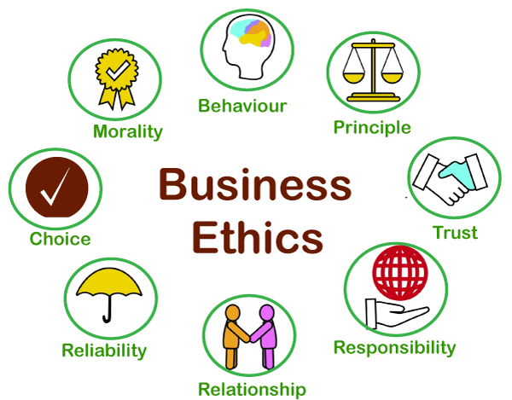
Figure 1:Business Ethics
Source: (Peak Frameworks, 2023)

Managers are often faced with situations that require moral decision making and therefore it is important in the field of business ethics. Ethical decisions are making choices about what is fair and responsible with respect to the effects of the choice on stakeholders. Ethical decision making helps organisation s to prevent legal problems, unethical practices and damage to their reputation (Treviño and Nelson, 2021). Ethical companies will be better able to earn their customers' trust and success over time.
Ethical conduct in business also means fairness, honesty and transparency. Organisation s should pay out fair wages, offer equal opportunities, showcase clear pricing, and communicate honestly with stakeholders. Misleading advertising and deceptive pricing occurs when people are tricked into purchasing products or services for money (Ferrell & Fraedrich, 2019). In addition to this, organisations will need to use sustainable practices, ethical sourcing and corporation social responsibility to minimize negative social and environmental effects, and play a role in ensuring long-term organisational sustainability.

C. Corporate Social Responsibility (CSR)
Corporate Social Responsibility (CSR) is the duty of companies to act ethically, positively and effectively towards society and to fulfil their economic aims. CSR urges organisation s to look at the social, environmental and ethical implications of what they do in their business. Carroll (1991) identifies four responsibilities of the CSR: Economic, Legal, Ethical and Philanthropic.
According to Carroll's CSR pyramid, a company has to make a profit, follow the law, behave ethically and do charitable work. Balancing these responsibilities is more likely to lead to stakeholder trust and long term sustainability by an organisation. The Freemen's Stakeholder Theory (Freeman, 1984) further emphasizes that companies need to take into account the interests of the various stakeholders of the company, such as employees, customers, suppliers, investors, and communities.
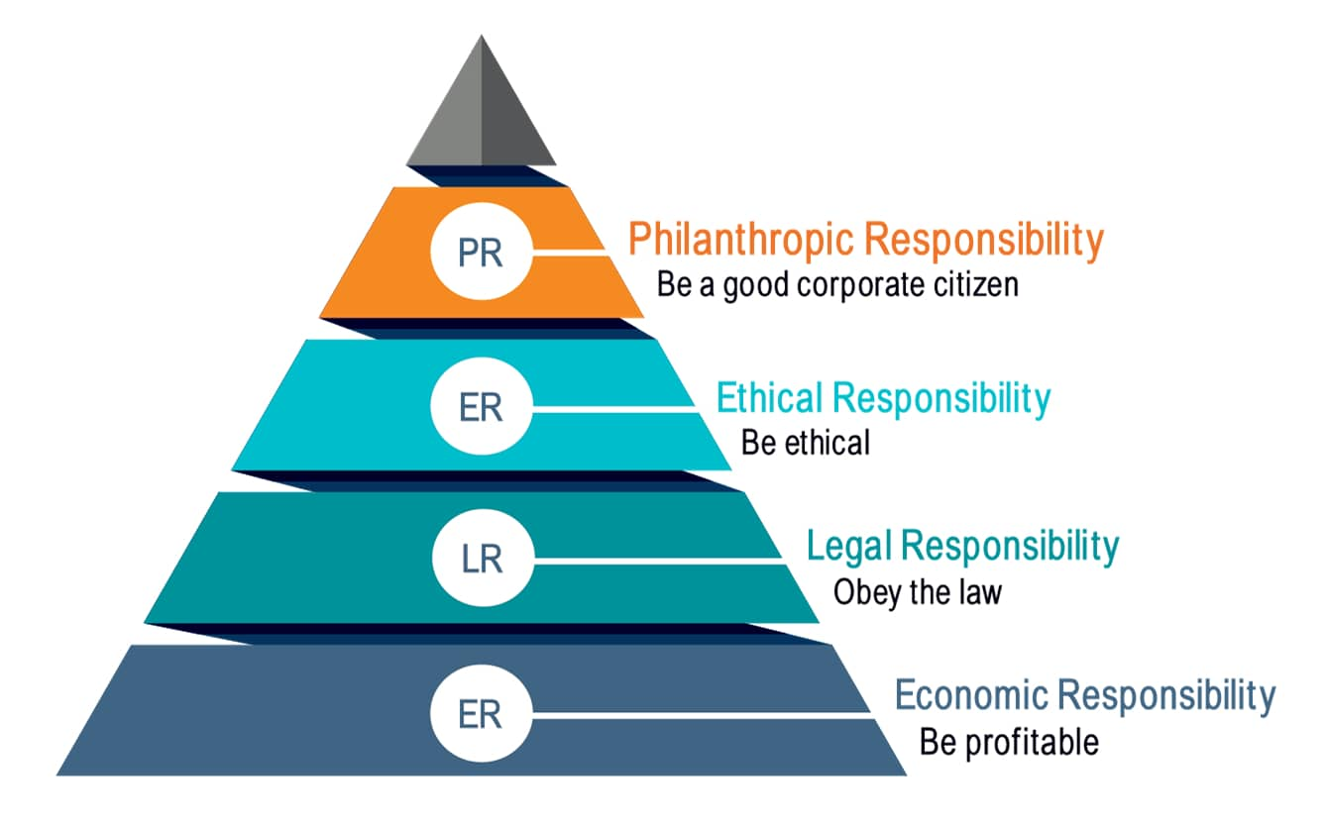
Figure 2:Corporate Social Responsibility (CSR)
Source: (The CSR Journal, 2024)

CSR activities comprise of environmental protection programs, ethical sourcing, Employee Welfare Programs, and community development programs. In the present day, CSR is being employed by modern organisation s for the purposes of enhancing their corporate image, creating customer loyalty among their customers, and providing them with the competitive edge. Thus, CSR has a significant role to play in practicing responsible and sustainable business.

D. Sustainability
Sustainability is the capacity of organisation s to satisfy today's business demands without jeopardizing their capacity to satisfy future generations' demands. Brundtland (1987) defined sustainability as a part of responsible resource management, with long term environmental and social responsibility. Sustainable business practices are about a balance between economic growth and the care of the environment and social welfare.
Environmental sustainability is about minimizing pollution, waste, CO2 emissions, and resource consumption such as the use of renewable energy, sustainable production or sourcing. Social sustainability is related to employee well-being, safety in the workplace, equality, diversity and fair working practices. Economically sustainable is defined as being able to be run profitably and financially in the long term, with responsible and ethical actions.
Elkington's (1997) Triple Bottom Line Theory is one that brings the 3 P's into attention for the organisation – people, planet and profit. This framework is designed to stimulate businesses to think about social and environmental effects in addition to monetary performance. Sustainable commercial management can therefore benefit organisations in making stakeholders more trustful, diminish environmental risks and secure long-term business success and competitive advantage.

E. Ethical Issues in Commercial Management
There are multiple ethical issues in the context of commercial practices of modern organisation s. Misleading pricing is one big problem—businesses can charge hidden fees, advertise false discounts, and make other errors to get the customer to sign up. Customers lose trust in the company and could face court penalties for these practices. Therefore, ethical pricing is significant for the sake of transparency and customer satisfaction.
An additional ethical challenge is the unfair treatment accorded to suppliers. Other organisations may put arbitrary contracts, late payments or undue pressure on their suppliers when it comes to prices, this can cause a negative impact on the business relationship or on the performance of the supply chain. The exploitation of workers is another concern of businesses in the world. Poor working conditions, low pay and long hours are violations of human rights and hurt company reputation (Crane and Matten 2016).
Uncontrolled profits can lead to unethical behavior, including a lack of caring for the environment and treatment of workers. There is also a high prevalence of corruption and bribery in business management. To support long term sustainable growth and stakeholder trust, ethical organisations tackle those issues with Internal policies to combat corruption, ethics training, compliance procedures, fair work practices, and open business operations.

F. Transparency and Accountability
There is a clear need for transparency and accountability in the ethical and commercial management. Transparency is the practice of sharing clear and accurate information about business activities, performance, sustainability efforts and decision making processes openly. Reputable organisations build trust with stakeholders and have a positive reputation when they are transparent.
For transparency, ethical reporting is especially significant, as stakeholders place heightened importance on businesses reporting information on environmental, social and governance (ESG) performance. By creating sustainability or CSR reports, organisations can prove themselves to be ethical and responsible businesses. Gray et al. (2014) state that ethical reporting is a way to enhance organisation al credibility and accountability.
Corporate governance also greatly contributes to the promotion of accountability and ethical conduct. Governance is the process, policies and mechanisms that are employed in the management of organisation s in a responsible and ethical way. Efficient governance systems reduce corruption, enhance compliance and support good governance in decision making. Good governance is also in the interests of the stakeholders and positively contributes to long-term sustainability.
Another key element of ethical commercial management is responsible leadership. Leaders shape organisational culture, behaviours and ethics. Ethical leaders promote what is right, fair, transparent and accountable within organisations. Northouse (2021) suggests that responsible leadership fosters ethical decision-making and contributes to positive stakeholder relationship. Companies that have ethical leadership are more likely to grow sustainably and be successful for the long haul.

Methodology
This research is based on secondary research methodology which is used for the analysis of ethical and sustainable Commercial Management in modern business organisation s. Secondary Research means that the information gathered is from other information that has already been published and analyzed rather than collecting the data using surveys or interviews. The secondary research being conducted by Saunders et al (2019) is an appropriate method for studying business and management problems as it provides researchers access to a large amount of reliable academic and professional resources. This methodology is suitable for the current research, since it allows the analysis of the ethics practiced by various organisation s, the strategies followed in terms of sustainability, and the approaches to commercial management.
Qualitative analysis is the most important methodology used in the research. Qualitative research is descriptive and interpretive research that is not measured numerically and it aims to understand concepts, behaviors, opinions, and organisation al practices. According to Creswell and Creswell (2018), qualitative analysis is appropriate for the study of problematic business situations like ethics, corporate social responsibility (CSR), sustainability and stakeholder management. The study will take qualitative approach to assess business practice of ethics and sustainable commercial management and its impacts on business performance and business viability.
This report is derived from a number of secondary data sources that included academic journals, books, company reports, websites and case studies. There were theoretical models and academic discussions regarding business ethics, sustainability, commercial management, stakeholder theory, and corporate social responsibility in academic journals and textbooks. Ethical theories and concepts of CSR were explained using books authored by Crane and Matten (2016) and Carroll (1991). Additionally, company sustainability reports were analysed, as well as annual reports of groups like Unilever and Patagonia, to explore actual ethical and sustainable business practices.
Comparative analysis was also employed to analyse the ethical and sustainability approaches of the companies. Comparative analysis is used to find out similarities and differences in organisation al approaches to commercial management, strengths and weaknesses. The approach is improving the depth of analysis as it assesses different approaches of organisation s to ethical issues, sustainability goals, the expectations of stakeholders, and the long-term business performance.

Findings / Case Studies

Case Study 1 – Unilever
Unilever's commercial management becomes ethical and sustainable when sustainability is embedded in Unilever's core business practices, through the supply chain, pricing and value creation, sourcing and long-term commercial planning. As opposed to many companies that see sustainability as an independent C-S-R business activity, Unilever integrates sustainability into its operational business model, which brings benefits to the company in terms of optimizing operations, cutting costs, building long-lasting partnerships with suppliers and enhancing longterm profitability.
The Unilever Sustainable Living Plan (USLP) is one of the most significant commercial management strategies introduced by the company to align sustainability goals with business development. One of Unilever's biggest commercial management strategies was the introduction of the Unilever Sustainable Living Plan (USLP) to help connect sustainability targets with business growth. The plan aims to minimise the impact on the environment, increase productivity or performance of the brand. The objective of this strategy was to decrease the operational costs including energy, water, and packaging waste in the Unilever manufacturing and distribution processes (Unilever, 2023). This illustrates the application of sustainability as both an ethical and as a commercial cost control measure as part of the company's operations.
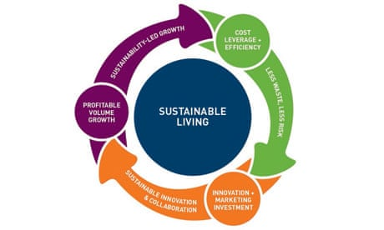
Figure 3:Unilever Sustainable Living Plan (USLP)
Source: (Unilever, 2013)
Another key feature of Unilever's commercial management approach is provision for sustainable supply chain management and ethical procurement. The company buys raw materials from certified sustainable suppliers to minimise reputational and operational risks, including palm oil, tea, cocoa and soy. Through Sustainable Sourcing, Unilever can help make its supply chain more reliable, provide high quality products and ensure products comply with international environmental and labour standards. Ethical sourcing builds up supplier accountability and the sustainability of stakeholder relationships (Crane & Matten, 2016). Unilever's close collaboration, for instance, with farmers and suppliers via training programs and sustainable agriculture strategies enables a farming community to become more productive and to ensure long-term, secure sourcing relationships.
Unilever's positioning of its brands with sustainability as a priority, like Dove, Ben & Jerry's and Hellmann's, is an effective approach to revenue generation and market competitiveness. Commitment to ethical branding and sustainability has been proven to not only attract more customers, but also build customer loyalty and enhance market share through the company's commercial strategy. Unilever's sustainable innovations in products and packaging and its greener marketing strategies have set it apart from its peers in the consumer goods industry. Elkington (1997) supports this argument with his book “Business and the Soul of a Nation”, in which he states that it is possible to build long-term business success by focusing on people, planet and profit.
The other significant area of Unilever's business is environmental management. The firm is well-known for its investments in renewable energy systems, carbon reduction programs, sustainable manufacturing technologies and plastic waste reduction initiatives. These measures benefit both the environment and operational efficiency, but also lower the long-term production costs. By reducing waste and energy usage, Unilever is making a strategy profit driven and such approach is considered a strategic commercial management.
Corporate Social Responsibility (CSR) is also closely linked with Unilever’s commercial objectives. The organization runs programs concerning hygiene, nutrition, education and community development especially in developing countries. The CSR efforts contribute to building brand reputation and customer confidence, and to expand the global market. Any effort that corporations make to strike a balance between corporate social responsibility (CSR) and corporate economic performance is more likely to be successful in a sustainable business (SB) model, according to Carroll's (1991) CSR Pyramid.
Though it's well-known for its sustainability efforts, Unilever has been criticized for its transparency and environmental practices in some regions. For multinational companies (MNCs), controlling ethical requirements in a global supply chain continues to be difficult, according to critics (Freeman, 1984). However, Unilever is one of the best examples of how ethical and sustainable commercial management can be embedded within procurement, operations, marketing, supplier management and in the overall long term business strategy, creating a competitive advantage and profitability.

Case Study 2 – Patagonia
Patagonia's success in embedding sustainability in its business strategy and management is well known globally. Patagonia's commitment to sustainability is not solely about minimizing its environmental footprint, but also about making it more effectively into a business strategy that gives it a competitive advantage, builds customer loyalty, contributes to the value of the brand and enhances long-term profitability. The company's commercial management philosophy is strongly grounded in responsible sourcing, ethical production, activism on the environment and openness towards its stakeholders.
A key commercial strategy at Patagonia is to use sustainable materials and circular production systems. The company strives to minimize environmental risks and ensure the responsible production of their products through their use of recycled polyester, organic cotton and other environmentally-friendly raw materials. Patagonia also launched its “Worn Wear” initiative, which promotes customers to fix, reuse and recycle garments in preference to buying new often (Patagonia, 2023). This practice not only helps to minimize waste but also enhances customer relationships and fosters the company's moral image. This could result in sales reduction in the short term, but lead to more loyalty and trust from your customers in the long term which could lead to more sales in the future.

Figure 4:Worn Wear” initiative
Source: (The Fashion Law, 2026)

Ethical commercial practices are also evident in Patagonia's supply chain management. The company only collaborates with suppliers who uphold strong labor rights practices, ensure fair wages, and maintain healthy working conditions. Patagonia conducts regular audits of factories and institutions from its suppliers, and they provide information about the supply chain to increase transparency and accountability (Crane & Matten, 2016). This clear business strategy mitigates reputational risk and enhances stakeholder trust.
Besides this, environmental activism is also part of Patagonia's marketing and commercial positioning strategy. It gives percentage profits to environmental groups and actively promotes causes of climate change in public. This has enabled Patagonia to stand out from its rivals and appeal to environmentally conscious shoppers. Freeman's (1984) Stakeholder Theory argues that prioritizing the interests of the stakeholders is the way a business will be able to achieve sustainable long-term success. Patagonia works out how sustainability, ethical sourcing, clear supply chain management and responsible marketing practices can be woven into commercial business for competitive advantage and yield powerful brand performance.

Case Study 3 – Amazon
Amazon is a different case in the business management that has faced numerous ethical and sustainability dilemmas due to their business efficiency, fast growth and profitability. It can be clearly seen from the company's commercial management model, it adopts aggressive pricing strategies, logistics operation scale is large, supply chain system is advanced, and delivery services are rapid, which are used for customers' convenience to achieve maximum market dominance and business profits. These practices, however, have also brought criticism in the fields of labor management, treatment of suppliers and environmental sustainability.
Labour management in distribution centres and warehouses is one of the biggest challenges for Amazon's business. Employees and labour groups have reported on high workloads, tight productivity targets, the use of surveillance devices and working conditions (BBC News, 2022). Amazon's business approach leads to higher productivity and shorter delivery times, but its critics argue less is being done to consider the happiness of its workers. The controversy around these labor issues has been detrimental to Amazon's brand and credibility.
Amazon itself has faced some criticism for its business practices and dealing with both suppliers and marketplace. 3rd Parties have high charges and Amazon's market power which is a competitive threat to smaller suppliers (Crane & Matten, 2016). This results in an unequal power balance in the supply chain, and ethical issues in business practices arise. Amazon is opening new markets for business and, as a global giant, it makes smaller suppliers and retailers reliant on Amazon.
Amazon further faces challenge in its commercial management system because of the environmental sustainability. Global logistics network, packaging in bulk and rapid delivery systems are one of the main sources of CO2 emissions, packaging waste (Greenpeace, 2021). Despite Amazon's efforts to invest in renewable energy and electric delivery vehicles, as well as sustainability programs, environmental groups have been criticizing the marketplace giant for its environmental impact.

Discussion
The case studies of Unilever, Patagonia and Amazon have shown that business is impacted by ethical and sustainable business management practices in many important ways, including: in their impact on organisation reputation, in their effect on customer trust, in their impact on profitability, and in their impact on long term business success. This analysis of the companies showcases the benefits of responsible business practices as well as some of the difficulties organisation s encounter in putting sustainability strategies into place.
One of the most important benefits of ethical commercial practices is the improvement of corporate reputation. Brands such as Patagonia and Unilever have won us over because of their dedication to sustainability, responsible sourcing, the environment and social responsibility. They have proved to be good stewards of their resources and this is reflected positively in the public's opinion and the relationships they have with their stakeholders. Carroll (1991) suggests that organisation(s) that do their duty to society and behave ethically will be more likely to have longer term stakeholder support and corporate legitimacy. In spite of its great commercial success, Amazon has been criticized for its working conditions, treatment with suppliers, and its environmental problems, among others, which have cost the brand its image.
Ethical and eco-friendly practices can also make a big difference to customer trust. Modern consumers increasingly prefer organisation s that operate transparently and responsibly. With greater environmental advocacy, fair labor practices and sustainable materials, Patagonia has been able to foster customer loyalty. A company's customers will be more likely to believe in their company if they're honest, have a sense of accountability, and are environmentally responsible (Crane & Matten, 2016). Likewise, Unilever's sustainability efforts and CSR have bolstered customer trust in its brands and their activities. Conversely, businesses involved in ethical scandals can have problems of customer dissatisfaction, criticism from the public and loss of confidence.
The case studies also demonstrate the relationship between ethics and sustainability and long-term profitability. While sustainable practices can result in upfront investment costs, they can actually benefit long-term profitability through a variety of ways, including better brand reputation, customer loyalty, and operational efficiency, and the risk reduction advantage. Elkington's (1997) Triple Bottom Line (TBL) theory is important as it is an explanation for businesses that want to grow sustainably and create long-term value for the organisation. Through its investments in sustainable sourcing and environmental initiatives, Unilever has been able to minimize waste, optimize processes and enhance competitiveness in the market. In addition, Patagonia's integrated business model has attracted eco-sensitive consumers who are happy to support eco brands. However, ethical problems can result in economic losses for businesses as a result of lawsuits, tarnished reputation, and lost trust from shareholders.
Ethical and sustainable commercial management is another primary result of getting a competitive advantage. Companies implementing best practices will stand out against their competitors and have a better standing in the market. Patagonia has developed an exclusive competitive edge by embedding sustainability into their business model. The company's environment and ethical side is attractive for those customers who want to have a company with social responsibilities and a good reputation. Likewise, Unilever's sustainability initiatives have bolstered its reputation and contributed positively to its future strategy. Freeman's (1984) Stakeholder Theory states that for an organisation to succeed at stakeholder relations it is more likely to gain a sustainable competitive advantage. Ethical business practices, therefore, have not only a beneficial effect on social responsibility but also on organisation al performance and market success.
Even with the benefits, there are some challenges that companies have to address in relation to implementing sustainability and ethical commercial management practices. The high cost of sustainable operations is one big hurdle. Some eco-friendly materials and sustainable sourcing, investment in renewable energy and working with ethical labor practices can be expensive. The use of sustainable materials and responsible manufacturing processes, for example in Patagonia, results in higher production costs. Smaller organisation s may be disadvantaged in implementing these practices due to lack of resources.
One of the challenges is controlling and being transparent with the Global Supply Chain. It is hard to ensure the compliance of the labour standards, environmental practices and supplier behaviour in all countries where multinational firms like Unilever and Amazon operate and have a large supplier base. The longer and more complex a supply chain is, the more opportunities for unethical practices, exploitation of workers and environmental practices may there be.
Profitability and ethical concerns are also huge concerns to balance. Some organisation s focus on the short term gains at the expense of its stakeholders, which leads to unethical practices like over-emphasizing on cost-saving, degrading working environment and neglecting the surrounding environment. Amazon's case teaches us how this can generate ethical issues surrounding working conditions and sustainability as the company entered into a commercial expansion and operational efficiency. In order to achieve this, businesses need to start implementing strategies that take into account not only the financial goals but also the moral responsibilities and sustainability objectives.

Conclusion
This report explored the meaning of ethics and sustainability in business organisation management in contemporary business. The study litters the essential concepts such as commercial management, business ethics, Corporate Social Responsibility, sustainability, transparency and accountability. The report highlighted the impact of ethical and sustainable practices on Unilever, Patagonia, and Amazon's organisation performance, stakeholder relationships, and success over the long term.
The results showed that ethical labor, ethical sourcing, transparency and social responsibility have a great impact in improving a company's reputation and the trust of customers. Businesses which implant sustainability within their business models are more likely to be profitable over time, more efficient and more competitive. The study also revealed ethical issues such as misrepresentations of price, exploitation of workers, concern over suppliers and environmental harm. Amazon has shown us an example of how a business can grow quickly and without good moral control and can have reputational risks and dissatisfaction of its stakeholders.
The report also suggests businesses can enhance ethical governance, increase transparency in their supply chains, invest in sustainable technologies, and foster responsible leadership. In summary, ethical and sustainable commercial management is crucial for long-term organisation success and the trust of stakeholders in today's business environment.

References
BBC News. (2025, October 28). Amazon confirms massive job losses in corporate division. https://www.bbc.com/news/articles/c1m3zm9jnl1o
Brundtland, G. H. (1987). Our common future: Report of the World Commission on Environment and Development. https://gat04-live-1517c8a4486c41609369c68f30c8-aa81074.divio-media.org/filer_public/6f/85/6f854236-56ab-4b42-810f-606d215c0499/cd_9127_extract_from_our_common_future_brundtland_report_1987_foreword_chpt_2.pdf
Carroll, A. B. (1991). The pyramid of corporate social responsibility: Toward the moral management of organizational stakeholders. UNHCR. https://www.unhcr.org/media/global-trends-report-2023
Chartered Institute of Procurement & Supply (CIPS). (2022). Commercial management principles and practices. CIPS Publications.
Crane, A., & Matten, D. (2016). Business Ethics: Managing Corporate Citizenship and Sustainability in the Age of Globalization (4th ed.). Oxford University Press.
Creswell, J. W., & Creswell, J. D. (2018). Research Design Qualitative, Quantitative, and Mixed Methods Approaches. Sage, Los Angeles.
Elkington, J. (1997). Cannibals with Forks the Triple Bottom Line of 21st Century Business. Capstone, Oxford.
Ferrell, O. C., & Fraedrich, J. (2019). Business Ethics Ethical Decision Making and Cases. Cengage Learning.
Freeman, R. E. (1984). Strategic management: A stakeholder approach. Pitman Publishing.
Gray, R. H., Owen, D. L., & Adams, C. A. (2014). Accounting and Accountability: Changes and Challenges in Corporate Social and Environmental Reporting. Worktribe.com. https://durham-repository.worktribe.com/output/1123501
Greenpeace. (2021). Environmental Performances of China’s Leading E-commerce Platforms (2023). Greenpeace East Asia. https://www.greenpeace.org/eastasia/blog/8097/long-distance-trucking-at-the-core-of-chinas-e-commerce-emissions-greenpeace-report/
Johnson, G., Scholes, K., & Whittington, R. (2020). Exploring corporate strategy (12th ed.). Pearson Education.
Northouse, P. G. (2021). Leadership Theory and Practice Ninth Edition. SAGE Publications, Inc.
Patagonia. (2025). Our Footprint. Patagonia. https://www.patagonia.com/our-footprint/
Peak Frameworks. (2023, June 21). Business Ethics (Definition, Principles, and Frameworks). Peak Frameworks. https://www.peakframeworks.com/post/business-ethics
Saunders, M., Lewis, P., & Thornhill, A. (2019). Research methods for business students (8th ed.). Pearson Education.
The CSR Journal. (2024, August 27). Carroll’s Pyramid: Understanding the Four Levels of CSR - The CSR Journal. The CSR Journal. https://thecsrjournal.in/understanding-the-four-levels-of-csr-2/
The Fashion Law. (2026, May 12). Worn Wear: Patagonia and Worn Again Reach a Trademark Truce. The Fashion Law. https://www.thefashionlaw.com/worn-wear-patagonia-and-worn-again-reach-a-trademark-truce/
Trevino, L. K., & Nelson, K. A. (2021). Managing Business Ethics: Straight Talk About How to Do It Right. (8th ed.). John Wiley.
Unilever. (2013, April 22). Unilever’s Sustainable Living Plan helps cut costs and drive growth. The Guardian; The Guardian. https://www.theguardian.com/sustainable-business/unilever-sustainable-living-plan-growth
Unilever. (2023, July 11). Sustainability Report and boundaries of reporting. Unilever; Unilever PLC. https://www.hul.co.in/sustainability/sustainability-reporting-centre/sustainability-report/
World Economic Forum. (2022, June 9). Why sustainability is crucial for corporate strategy. World Economic Forum. https://www.weforum.org/stories/2022/06/why-sustainability-is-crucial-for-corporate-strategy/

