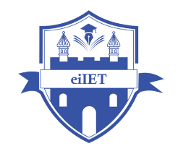

PLANNING AND MANAGEMENT OF SUSTAINABLE TOURISM SPACES

ASSIGNMENT 2

Table of Contents
1- Applying United Nations Sustainable Development Goals (SDGs) to “Rothenburg ob der Tauber” along with feasible SDGs 3
2- Discussing importance of sustainable tourism development in protecting and promoting local heritage and traditions by maintaining culture 4
References 7

1- Applying United Nations Sustainable Development Goals (SDGs) to “Rothenburg ob der Tauber” along with feasible SDGs
In the context of tourism construct, SDG can be regarded as a significant paradigm to ensure a high standard of protection for the planet along with cultural heritage. Sustainable Development Goals (SDGs) developed by the United Nations (UN) can be considered as an important framework in fostering call to action for blurring poverty, protecting the planet and blending peace and prosperity (UNDP, 2025). The figure below has addressed a long range of SDGs, formulated by the UN such as gender equality, reduced inequalities, climate action and no poverty.
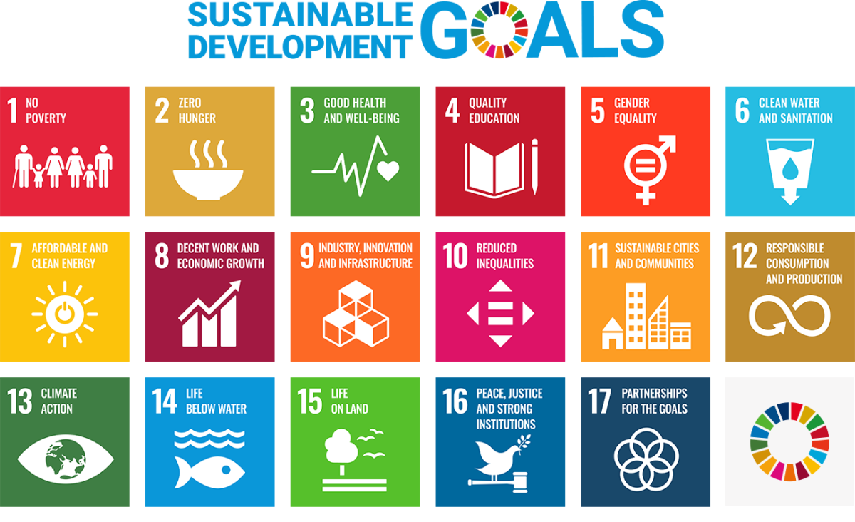
Figure 1: UN framework of SDGs
(Source: United Nations, 2025)
Fundamentally, “Rothenburg ob der Tauber"” is considered as one of the most important cultural tourism destinations of Germany in terms of preserving medieval culture across the nation. Structurally, in 2023, cultural tourism encountered 18.7 million visits in Germany, curated through the considerations of environmental quality, cultural harmony and sustainability (Germany Travel, 2024). Based on the aforementioned insights, “SDG 12 responsible consumption and production” can be considered as the most feasible SDG, concerning the existing tourism paradigm of Rothenburg. “Market square” can be considered as the epicenter of Rothenburg, driven by an impressive Renaissance facade, encompassing gothic and medieval architecture (Germany Insider, 2025). A 2025 Ecotopia report has indicated the significance of combined impact of sustainability and multicultural harmony in "Rothenburg ob der Tauber", blending responsible consumption and production, concerning zero-waste community (Ecotopia, 2025). The evidence eventually indicates a strong alliance between SDG 12 and sustainable tourism at "Rothenburg ob der Tauber". Thus, “responsible consumption and production” can be regarded as a relevant SDG for existing standards of tourism development in "Rothenburg ob der Tauber".
“SDG 11 sustainable cities and communities” and “SDG 13 climate action” can be outlined as another two relevant SDGs, concerning sustainable tourism development at "Rothenburg ob der Tauber". As opined by Schubert and Schamel (2021, p.5), environmental quality plays an important role in fostering the attributes of sustainable tourism in a country, which leads to optimisation of resources and environmental responsibility. Consequently, in Germany, environmental quality has encountered a staggering growth as CO2 emissions declined to 7.303 along with the decreasing rate of 27% (IEA, 2025). The evidence indicates a vibrant presence of climate action in Germany along with the stances of building sustainable cities and communities. Furthermore, the German government has blended climate action to develop sustainable strategies for Rothenburg to incorporate various measures including eco-friendly transportations, optimised local markets and eco-friendly agricultural practices (Ecotopia, 2025). The evidence eventually indicates the seamless amalgamation of the aforementioned SDGs in terms of creating an alignment between sustainable claims and sustainable tourism development. Thus, SDG 11 and 13 have been conceptualised as two relevant metrics for the existing tourism development construct for "Rothenburg ob der Tauber".

2- Discussing importance of sustainable tourism development in protecting and promoting local heritage and traditions by maintaining culture
Sustainable tourism development can be considered as a pivotal construct in terms of preserving local heritage and traditions within a nation. For example, the tourism paradigm of “Rothenburg ob der Tauber"” is considered to be driven by the stances of protecting local heritage and traditions through the preservation of various tourism elements such as the “Old Town city wall”, “Plönlein”, “Jacob’s Church” and the “double bridge” (Globetrotterkyle, 2025). The evidence eventually indicates the effectiveness of the sustainable footprint of Rothenburg’s cultural tourism in terms of preserving the local heritage and traditions. Furthermore, cultural tourism has emerged as an important construct in Germany to foster a high standard of economic importance. As outlined in the figure below, overall travel spending encountered a spike of 5.6% in Germany to reach the valuation € 83.4 billion during 2024 (DRV, 2025). Considering the aforementioned insights, sustainable tourism development can be recognised as an important construct in Germany to foster increased economic profitability through the preservation of local heritage and traditions. For example, in Indonesia, sustainable tourism is driven by four key pillars, concerning a high tourist engagement and cultural setting including sustainable management, cultural sustainability, environmental sustainability, and sustainable economy (Novita et al. 2024, p.69). Thus, sustainable tourism development can be considered as a feasible construct for Rothenburg in protecting local heritage and traditions through economic and sustainability paradigm.
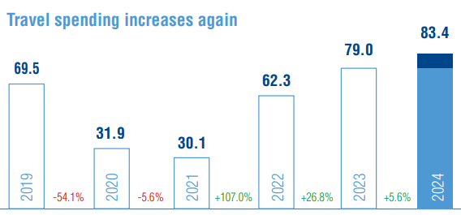
Figure 2: Travel spending in Germany
(Source: DRV, 2025)
Intangible Cultural Heritage (ICH) can be considered as another important ledger of sustainable tourism development, in preserving local heritage and tradition of "Rothenburg ob der Tauber" through culture. A study by Kim et al. (2021, p.2) has conceptualised authenticity as an important parameter of sustainable tourism development in protecting cultural identity of tourism destinations through uniqueness and cultural continuity. In a similar manner, the tourism paradigm of Rothenburg can be considered as a perfect amalgamation of sustainability and cultural harmony to foster high social value of their cultural heritage. Stakeholder Theory (ST) has conceptualised the significance of stakeholders including government, community, and society in terms of ensuring sustainability for the tourism industry (Achmad et al. 2023, p.83350). In line with ST, ICH can be regarded as a feasible parameter for "Rothenburg ob der Tauber" in terms of preserving local heritage and tradition through sustainable tourism practices. Thus, sustainable tourism development has been conceptualised as an important paradigm to preserve local heritage and tradition within the tourism setting of "Rothenburg ob der Tauber".

References
Achmad, F., Prambudia, Y. and Rumanti, A.A., (2023). Sustainable tourism industry development: A collaborative model of open innovation, stakeholders, and support system facilities. IEEE Access, 11, pp.83343-83363. https://ieeexplore.ieee.org/iel7/6287639/6514899/10207033.pdf
DRV. (2025). THE GERMAN TRAVEL MARKET. Available at: https://www.drv.de/public/Downloads_2025/Zahlen_und_Fakten_2025_ENG.pdf [Accessed on: 27 September 2025].
Ecotopia. (2025). "Rothenburg ob der Tauber": From "the Most German of Towns" to "the Most Greenest of Towns". Available at: https://www.ecotopia2121.com/single-post/rothenburg-ob-der-tauber-from-the-most-german-of-towns-to-the-greenest-and-most-diverse-of-towns [Accessed on: 27 September 2025].
Germany Insider. (2025). Rothenburg Germany. Available at: https://www.germany-insider-facts.com/rothenburg-germany.html [Accessed on: 27 September 2025].
Globetrotterkyle. (2025). The Ultimate Travel Guide To "Rothenburg ob der Tauber". Available at: https://globetrotterkyle.com/the-ultimate-travel-guide-to-rothenburg-ob-der-tauber/ [Accessed on: 27 September 2025].
IEA. (2025). Germany. Available at: https://www.iea.org/countries/germany/emissions [Accessed on: 27 September 2025].
Kim, S., Whitford, M. and Arcodia, C., (2021). Development of intangible cultural heritage as a sustainable tourism resource: The intangible cultural heritage practitioners’ perspectives. In Authenticity and authentication of heritage (pp. 34-47). Routledge. https://www.academia.edu/download/94423463/1743873X.2018.156170320221117-1-1wg05oy.pdf
Novita, A.A., Ngindana, R. and Putra, E., (2024). Preserving cultural heritage: Integrating traditional values and local arts for sustainable tourism. Jurnal Inovasi Ilmu Sosial Dan Politik (JISoP), 6(1), pp.68-77. https://riset.unisma.ac.id/index.php/JISoP/article/download/21925/16402
Schubert, S.F. and Schamel, G., (2021). Sustainable tourism development: A dynamic model incorporating resident spillovers. Tourism Economics, 27(7), pp.1561-1587. https://bia.unibz.it/esploro/fulltext/journalArticle/Sustainable-tourism-development-A-dynamic-model/991006258996401241?repId=12269277330001241&mId=13335106430001241&institution=39UBZ_INST
UNDP. (2025). THE SDGS IN ACTION. Available at: https://www.undp.org/sustainable-development-goals [Accessed on: 27 September 2025].
United Nations. (2025). Sustainable Development Goals (SDGs). Available at: https://unosd.un.org/content/sustainable-development-goals-sdgs [Accessed on: 27 September 2025].

