Talent Management

TALENT DEVELOPMENT STRATEGY FOR POST-COVID TOURISM STARTUPS
SUBMITTED BY : PRADEEP SHUBASH

Table of Contents
Introduction 3
Outline the background 3
Objectives 3
Scope 3
Main Body 3
Talent Rebuilding Strategy for Post-COVID Tourism Startups 3
Digital Talent Attraction and Performance Optimization 5
Reflection 9
Conclusion 9
Summarize key findings 9
Recommendations 10
References 11

Introduction

Outline the background
The “tourism and hospitality industry” in “South America” faced unprecedented challenges due to the “COVID-19 pandemic”, leading to workforce disruptions and a decline in employee loyalty. As the industry recovers from the pandemic, new hotel chains should look for innovative ways to attract and keep talented workers. This assignment aims to restore the workforce by including gig workers, combining traditional and online positions and using online methods for joining new employees. It also highlights that updating the EVP and providing AI-powered dashboards for workers will help a company keep its workforce strong and loyal after the pandemic.

Objectives
- To develop a talent rebuilding strategy incorporating gig workers, hybrid roles, and digital onboarding.
- To create engaging social media job posts and rebrand EVP content to attract skilled talent.
- To analyze AI-enabled staff performance dashboards and recommend strategies for long-term workforce resilience and wellness.

Scope
The scope of this assignment includes analysing the impact of the COVID-19 pandemic on the tourism startup workforce in “South America” and identifying strategies to enhance workforce resilience. It will focus on “gig workers”, roles that combine remote and in-office tasks and using digital means to bring new employees on board. Additionally, the assignment involves creating posts for social media jobs, rebranding the “EVP and using AI tools” to track how employees are doing. It also suggests methods to incorporate wellness practices for a sustainable development strategy.

Main Body

Talent Rebuilding Strategy for Post-COVID Tourism Startups
The COVID-19 pandemic significantly impacted the tourism and hospitality industry, leading to massive job losses and disruptions in workforce stability. While the industry is recovering, startups in tourism should develop flexible plans to hire, keep and develop talented workers (Liu-Lastres, Wen & Huang, 2023). The main aspects of the strategy are “gig workers, hybrid roles and digital onboarding”.
1. Leveraging Gig Workers:
In the post-COVID landscape, “gig workers” offer flexibility and scalability for tourism startups. They, including freelance guides, part-time service workers and event planners on a contract basis, help staff hotels during busy seasons but only work for a limited time. It is important to have clear agreements that allow gig workers flexible schedules and ensure they are paid fairly (Mahato, Kumar & Jena, 2021). With such a platform, scheduling and registering “gig workers” can become much simpler for organizations. In addition, giving workers training on the company’s values and customer service helps them keep up standards even when their work is temporary.
2. Adopting Hybrid Roles:
“Hybrid roles” are crucial for increasing workforce efficiency while maintaining flexibility. People in tourism startups use both customer service skills and digital abilities, such as managing accounts on “social media and handling reservation systems”. Employing this method makes it easy to perform different tasks at the same time and cut down on hiring costs. In order to set up hybrid roles in startups, companies should check which skills are needed and provide staff with the necessary training (Radonić, Vukmirović & Milosavljević, 2021). Sharing the responsibilities of the front desk and virtual customer service can support the company’s operations in challenging times.
3. Implementing Digital Onboarding:
Digital onboarding is vital for integrating both gig and hybrid workers quickly and effectively. An effective system for digital onboarding offers virtual orientation, e-courses on ethics, security and interacting with customers (Zuiker & Westerlaken, 2024). Using AI for training gives employees a personalized approach, and checklists make it certain that all required elements are finished. Besides, guiding employees through their onboarding tasks using a mobile app improves participation and cuts down on the time it takes to train them. Training materials offered as part of digital onboarding assist remote workers in staying informed (Godinho et al. 2023).
Building a resilient workforce in the tourism startup sector requires a multifaceted approach, integrating “gig workers, hybrid roles, and digital onboarding”. Tourism startups that focus on flexible, skill-based and supportive workplaces are better equipped to recover after COVID and maintain loyalty among their employees.

Digital Talent Attraction and Performance Optimization
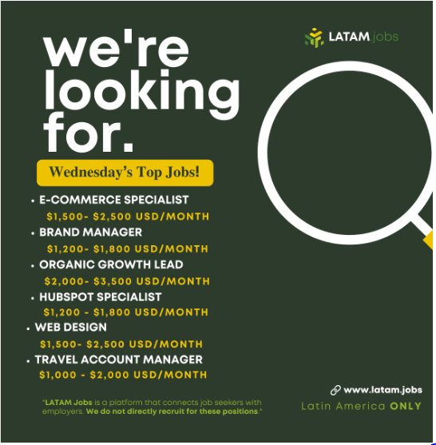
Figure 1: Social media job posts
(Source: linkedin, 2025)
The social media job posts analysed focus on attracting remote talent from “Latin America (LATAM)” by offering competitive “USD salaries”, a significant pull factor for job seekers in the region. Six remote job posts include clear salary information, helping to bring in the right candidates.
The roles include:
1. E-Commerce Specialist - $1,500 - $2,500 USD/month
2. Brand Manager - $1,200 - $1,800 USD/month
3. Organic Growth Lead - $2,000 - $3,500 USD/month
4. HubSpot Specialist- $1,300 - $1,800 USD/month
5. Web Designer - $1,500 - $2,500 USD/month
6. Travel Account Manager - $1,000 - $2,000 USD/month
The job posts are described in interesting ways, using images and symbols like emojis to emphasise that one can work from home and enjoy fair compensation. This shows that the company is targeting skilled workers who prefer remote work. The posts further highlight the importance of advancing in a career and gaining diverse abilities, especially for digital marketers, web designers and staff involved in managing clients (linkedin, 2025). The jobs are advertised as paying USD salaries to appeal to workers in “Latin America” who want steady income and to advance financially (linkedin, 2025). Overall, job listings on social media use transparency, nice graphics and clear guidance on salaries, which attracts the best remote employees in the tourism sector after COVID-19.
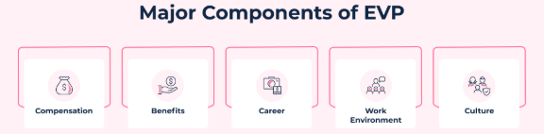
Figure 2: Components of EVP
(Source: hrone, 2025)
For the startup to scout qualified employees and keep them, it should highlight in its EVP that there is room for career advancement, flexible work practices and concern for employees’ well-being. Shared experiences from workers and vibrant images of the workplace from social media campaigns often increase the appeal of a company’s brand with employees. Wellness initiatives make the brand prepare for the post-pandemic workforce’s new expectations.
Pay, benefits, career progression, work setting and workplace culture all require adjustments to match a strong and flexible team.
1. Compensation:
Many professionals are drawn to companies that pay competitive wages. Transparency in salary and the use of performance-based incentives should be standard for startups. Sharing salary information in USD could strongly attract Latin American applicants by making their pay equal in international terms and secure.
2. Benefits:
A rebranded EVP ought to stress the wide range of benefits provided for employees’ well-being and their work hours (Näppä, Styvén & Robertson, 2025). This covers healthcare packages, assistance for mental health, options for altered schedules and compensation for those working remotely. If a company provides health-related benefits for both mind and body, it can lead to improved employee happiness and loyalty.
3. Career Development:
It is vital to concentrate on moving up in your career. Any tourism startup ought to highlight opportunities to learn, such as classes in digital skills, leadership seminars and access to online certifications. Having clear career plans and being part of mentorship programs encourages employees to grow professionally.
4. Work Environment:
Having a supportive and inclusive remote workspace culture is necessary. Provide employees with digital tools for getting started and join them in virtual events that focus on team-building (hrone, 2025). Moreover, a flexible and hybrid approach to working supports people with different lifestyles.
5. Culture:
The new EVP should embody a lively, open and cooperative company culture. Highlighting the well-being of employees, team efforts, and communication strengthens the sense of belonging, even when working away from each other (Binu Raj, 2021). Promoting practices centred on feedback proves that the organisation is focused on always improving itself.
Adding these features to the EVP allows tourism startups to develop a dedicated team and keep employees happy and loyal after the pandemic.

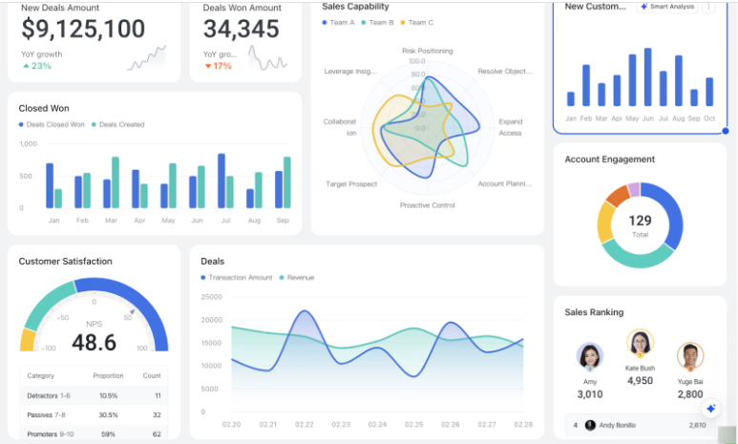
Figure 3: AI-enable Staff-performance dashboard
(Source: larksuite, 2025)
Using staff performance dashboards with AI can greatly help an organization manage its workers, increase productivity and make decisions. They rely on sophisticated tools and algorithms to regularly check, assess and improve how employees are performing. The main goal of these dashboards is to deliver useful information about productivity, tasks being finished, employees’ attendance and engagement. With information gathered from “management tools, CRM systems and employee reviews, AI dashboards allow managers” to spot the places where improvement is needed (larksuite, 2025). Furthermore, data displayed on AI-enabled dashboards helps you make informed decisions about staff. This way, divisions can reveal when employee productivity changes, so managers can organise their tasks wisely. Because these tools track data and report on it, managers do not have to enter or inspect information manually.
Besides, these dashboards help promote employee engagement and motivation. By checking their stats, workers can develop goals for themselves and monitor their development, which inspires them to act more responsibly. Such feedback allows managers to notice when staff members succeed and resolve issues as soon as they appear. Using Lark with “AI dashboards in tourism startups affected by COVID-19” can give them a much bigger advantage (larksuite, 2025). Automation, based on performance insights, can handle situations such as declining productivity or delays in providing services. Additionally, when an organisation integrates well with collaboration tools, it creates a culture where people are encouraged to be honest and work together. Using AI-supported staff performance dashboards helps with managing the modern workforce, offering insights that increase workforce productivity, engagement and achievements over the long term.

Reflection
I selected this topic since the COVID-19 pandemic greatly influenced tourism, disrupting employment and reducing staff loyalty. While recovering, South America’s tourism industry needs to enhance its talent strategies to become stable. It gives me a chance to check out creative strategies for managing a workforce, using gig workers, hybrid jobs, and online joining methods. It is normal now for companies to introduce “AI-driven dashboards” and alter their “EVP (Employee Value Proposition)” to focus on staff retention and higher performance. Exploring this subject increases my awareness of the effects of the pandemic and teaches me skills to handle people in tourism in the coming years.

Conclusion

Summarize key findings
It is concluded in the study that startup hotels in “South America’s tourism sector” should adopt innovative approaches to workforce management. Due to the pandemic, the workforce became less stable, which made employees less loyal. The study suggests using “gig workers, staff with hybrid roles and digital onboarding” as the main building blocks of a strong strategy to rebuild the workforce. Gig workers simply work when they want and as many shifts as needed, helping businesses deal with busy seasons on shorter notice. Hybrid jobs involve both providing customer service and having digital skills to improve efficiency among the workers. AI services for digital onboarding support quick integration of remote workers by delivering tailor-made training. Also, the study suggests rebranding EVP to focus mainly on employee compensation, benefit programs, opportunities for promotion, the office culture and physical surroundings. If tourism startups pay decent wages, help their staff manage their work hours and offer ways to grow, workers are more likely to remain satisfied. Lastly, using AI-powered staff performance dashboards makes it possible to closely monitor and control the business at any moment. Joining these dashboards with Lark makes it possible for people to automate their work, easily share information and improve team communication. Overall, applying these approaches is important for re-establishing a dependable and adaptable workforce, which is necessary to maintain recovery in the tourism sector after the pandemic.

Recommendations
For the sustainable management of workers in post-COVID startups, including resilience and wellness practices in daily work, is necessary. Key recommendations are:
1. Promote a Flexible Work Environment: Create job opportunities where employees can work both in the office and remotely. Being able to adapt to different schedules helps people manage their careers and family.
2. Invest in Employee Well-Being: Add activities and resources that aim to enhance employee mental health, stress levels and physical condition. If employees face challenges at work, providing them with virtual counselling, mindfulness apps and workshops can support their well-being.
3. Adopt Data-Driven Wellness Initiatives: Introduce wellness activities that use AI to record employee engagement, tasks assigned and feelings of stress. Act on the findings by supporting people who may be at risk of burnout and redistributing their work or giving them extra time to rest.
4. Foster a Supportive Work Culture: Work to ensure employees feel comfortable and appreciated at work. Foster conversations, review progress with team members often and notice and commend hard work individually or as a group to improve team morale.
5. Continuous Professional Development: Continuously introduce courses to improve employees’ ability to handle challenges, relate well with others and show flexible leadership. Preparing employees for challenges builds a sustainable work environment.
Applying these strategies helps create a stable, strong and active workforce, leading to better growth and loyalty among employees.

References
Journals
Binu Raj, A. (2021). Impact of employee value proposition on employees’ intention to stay: moderating role of psychological contract and social identity. South Asian Journal of Business Studies, 10(2), 203-226. DOI 10.1108/SAJBS-10-2019-0183
Godinho, T., Reis, I. P., Carvalho, R., & Martinho, F. (2023). Onboarding handbook: An indispensable tool for onboarding processes. Administrative sciences, 13(3), 79. https://doi.org/10.3390/admsci13030079
Liu-Lastres, B., Wen, H., & Huang, W. J. (2023). A reflection on the Great Resignation in the hospitality and tourism industry. International Journal of Contemporary Hospitality Management, 35(1), 235-249. https://doi.org/10.1108/IJCHM-05-2022-0551
Mahato, M., Kumar, N., & Jena, L. K. (2021). Re-thinking gig economy in conventional workforce post-COVID-19: A blended approach for upholding fair balance. Journal of Work-Applied Management, 13(2), 261-276. DOI 10.1108/JWAM-05-2021-0037
Näppä, A., Styvén, M. E., & Robertson, J. (2025). Employment in the tourism and hospitality industry: Toward a unified value proposition. Journal of Human Resources in Hospitality & Tourism, 24(1), 26-56. https://doi.org/10.1080/15332845.2024.2405804
Radonić, M., Vukmirović, V., & Milosavljević, M. (2021). The impact of hybrid workplace models on intangible assets: The case of an emerging country. Amfiteatru economic, 23(58), 770-786. DOI: 10.24818/EA/2021/58/770
Zuiker, M., & Westerlaken, R. (2024). The impact of onboarding practices on employee retention in the cruise industry. Research in Hospitality Management, 14(2), 198-208. https://doi.org/10.1080/22243534.2024.2406333
Websites
https://www.linkedin.com/posts/latamdotjobs_remotejobs-latamjobs-jobopportunities-activity-7239651925820870656-UA4d
https://hrone.cloud/blog/employee-value-proposition/
https://www.larksuite.com/en_us/blog/ai-dashboard

