Title: Nutrition Literacy Campaign for Underdeveloped Tourism Regions: A Strategic Framework
Student Name: Gursewak Singh
Student No: DE240017

Table of Contents
1. INTRODUCTION 3
2. LITERATURE REVIEW 4
3. METHODOLOGY 6
4. CAMPAIGN STRATEGY 7
5. VISUAL TOOLS AND IMPLEMENTATION 9
6. MONITORING AND EVALUATION 11
7. CONCLUSION 12
8. REFERENCES 13

1. INTRODUCTION
The advent of global tourism initiatives in economically disadvantaged geographies has catalysed the emergence of complex interdependencies between nutritional adequacy and sustainable hospitality practices, necessitating a context-specific discourse on dietary literacy interventions in underdeveloped tourism communities. Within these infrastructurally strained environments, the influx of transient consumerism has not invariably translated into parallel improvements in local health literacy, thereby creating a vacuum in foundational knowledge pertaining to balanced dietary consumption, food safety standards, and culturally appropriate nutritional choices. The initiation of a nutrition literacy campaign, as regulated under the development-focused arm of international health policy frameworks, can also be considered as a remedial strategy intended to address this knowledge asymmetry through targeted, accessible, and behaviourally modifiable education systems embedded in community-specific socio-dietary practices (WHO, 2023).
In alignment with UN sustainability mandates and WHO regional health indicators, this paper delineates the scope of improvement to be allowed through the integration of structured, culturally relevant educational components into community-based tourism programs. The overarching objective of the proposed campaign is to encourage the adoption of nutritionally sound practices by non-literate populations residing in tourism-impacted locales, facilitated through a multi-modal instructional interface encompassing visual, verbal, and kinesthetic pedagogies. Within this framework, the campaign will incorporate training manuals for tourism staff, meal planning resources reflective of indigenous food patterns, and low-literacy visual artefacts designed for broader public consumption. By aligning communicative clarity with dietary integrity, the campaign intends to reduce malnutrition, food misuse, and preventable health crises while fostering a sustainable nexus between local hospitality practices and community wellbeing.

2. LITERATURE REVIEW
The conceptualisation of nutrition literacy within the rubric of tourism-based community development can also be considered as an interventionary framework that prioritises health equity, behavioural education, and capacity-building across marginalised, low-literacy populations. According to Nutbeam (2008), the operational definition of health literacy encapsulates an individual’s ability to access, understand, and utilise health-related information for the maintenance and promotion of wellbeing, an ability frequently absent in economically disadvantaged tourism zones. Further compounded by infrastructural fragility and limited public health outreach, the absence of basic nutritional knowledge in such regions renders community members vulnerable to malnutrition, food-borne diseases, and exploitative food economies orchestrated by external tourism influxes (FAO, 2021). Hence, the necessity of campaign-based literacy models becomes critical, wherein multi-sensory instructional tools – such as visual aids, culturally adapted food guides, and community-led workshops – are deployed to mitigate the knowledge gap.
Empirical evidence drawn from tourism-dependent rural sectors in Nepal, Ghana, and Kenya illustrates that community-based nutritional interventions are most successful when tailored to existing food traditions, inclusive of visual semiotics for non-literate audiences, and embedded in daily social and occupational routines (Osei-Kwasi et al., 2020). Such integration encourages retention, behavioural compliance, and gradual communal shifts towards improved dietary habits. However, systemic limitations persist due to the absence of scalable frameworks and inconsistent policy alignment between tourism authorities and public health departments, particularly in cases where tourism is prioritised over basic welfare services. Despite these shortcomings, the literature also reflects a positive trend in the use of pictorial, performative, and auditory education mechanisms that substitute for textual content in regions where formal education systems are insufficiently developed (Vaitkeviciute et al., 2015).
Moreover, the literature supports the inclusion of participatory learning modules where hospitality workers, tour guides, and local vendors are trained as secondary educators, allowing for the advantage to be encouraged through a cascading knowledge system. This model reinforces dietary consistency, reinforces workplace wellness, and strengthens community reliance on internal knowledge dissemination systems without requiring digital infrastructure. Thus, by analysing diverse case studies and regulatory precedents, the literature confirms that culturally and linguistically adapted nutrition campaigns constitute a necessary instrument for reducing food-related health risks and promoting long-term dietary sustainability in tourism-exposed low-resource environments.

Table 1: Key Components of Nutrition Literacy Campaigns in Low-Literacy Tourism Communities
Component | Function
Pictorial Leaflets | Visualise dietary portions, balanced meals, and hygiene
Staff Meal Manuals | Standardise nutritious options in hospitality operations
Community Workshops | Reinforce food knowledge via participatory demonstrations
Local Food Posters | Promote indigenous ingredients and seasonal availability
Source: Adapted from Osei-Kwasi et al. (2020) and FAO (2021)

Figure 1: Behavioural Change Model for Non-Literate Nutrition Campaigns
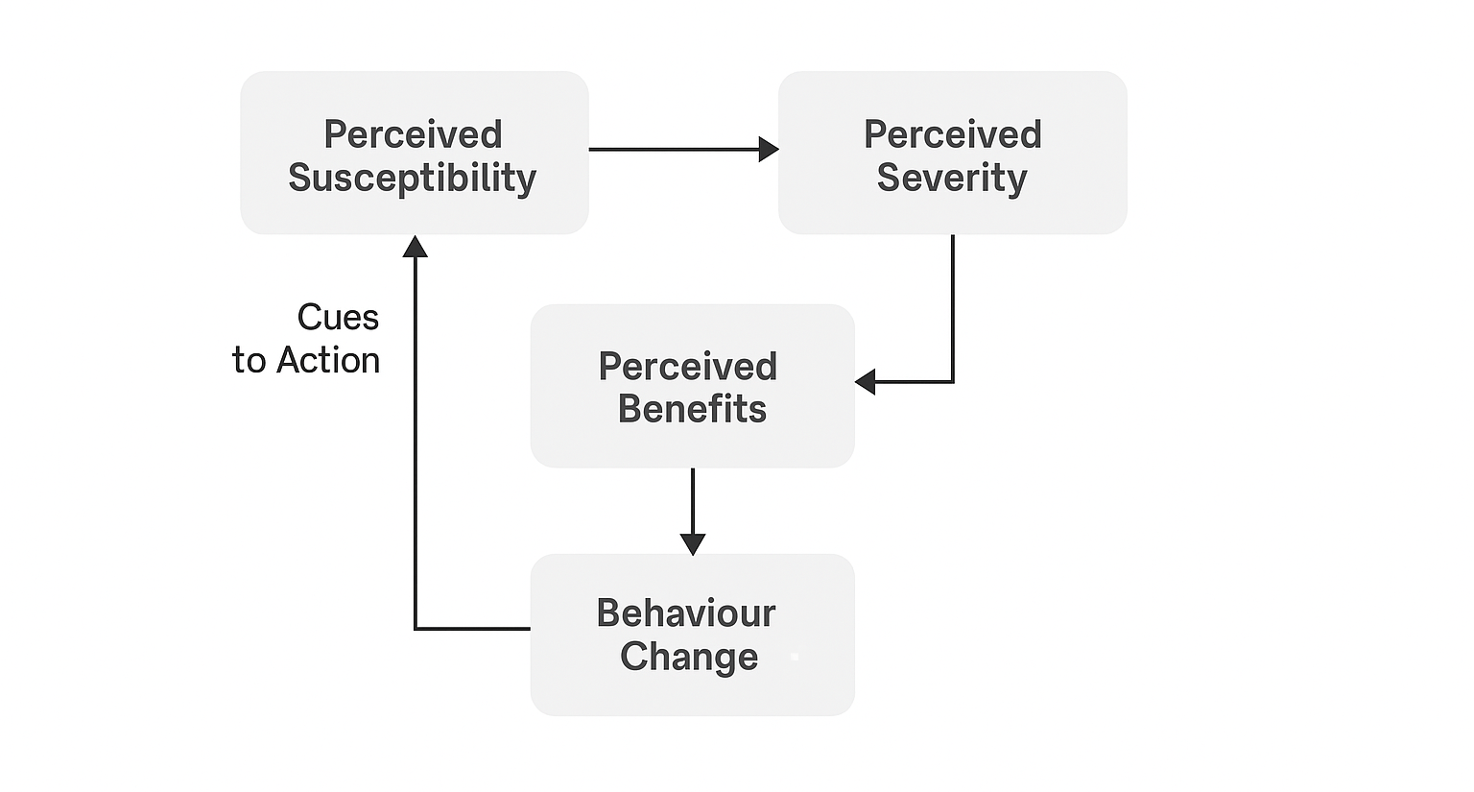
Source: Inspired by the Health Belief Model (Nutbeam, 2008)

3. METHODOLOGY
The methodological formulation for this campaign design is oriented within the mixed-method paradigm wherein qualitative contextualisation and quantitative accountability frameworks are integrated to enhance relevance, scalability, and empirical traceability of the intervention outcomes. This approach, which can also be considered as appropriate for non-literate population clusters in tourism-exposed underdeveloped communities, allows for both narrative inquiry and statistical verification to be employed simultaneously. As articulated by Creswell and Plano Clark (2018), mixed methods are particularly efficacious where behavioural transformation intersects with public health messaging, given the multi-dimensional dynamics of cultural resistance, communicative friction, and infrastructural disparity.
A purposive sampling technique has been selected to isolate stakeholder groups with the highest potential for dissemination and behavioural reinforcement—namely community elders, tourism staff, local food vendors, and informal educators. Data collection instruments will include structured visual surveys, audio-recorded interviews, and direct observational notes derived from initial workshops and pilot leaflets. This allows for the advantage to be encouraged through contextual specificity while retaining replicable methodological rigour. Each collected datum will be transcribed (or decoded, in the case of visual markers) and categorised within a coding matrix aligned to WHO nutrition education indicators and tourism health impact guidelines (WHO, 2022).
Informed by the principles of participatory action research, the methodology incorporates iterative feedback loops wherein community members co-evaluate instructional materials during three sequential stages: design prototyping, initial deployment, and community uptake. The implementation process follows a loop, in which feedback and results from attendance, pictures and modified eating behavior are used to fine-tune the content. Thanks to this loop and an inclusive approach to feedback, data collection and refining the program remain respectful of people’s culture, language and actions throughout the project.
Figure 2: Methodological Flowchart of Campaign Design, Delivery, and Feedback Loop
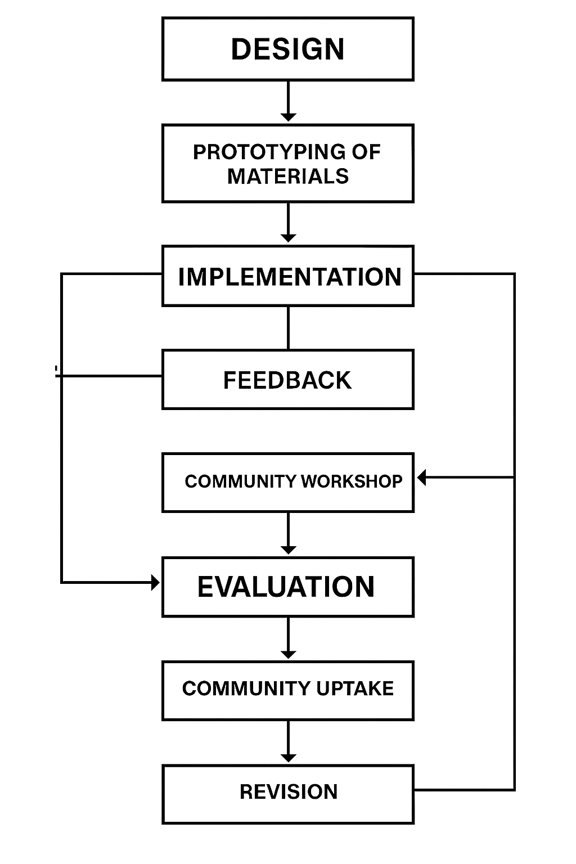

4. CAMPAIGN STRATEGY
It may be necessary to launch detailed campaigns about nutrition literacy among the least developed tourism regions, since this helps narrow the knowledge gap in what people eat which matters most when poverty increases difficulties in obtaining education. The foundation for this project lies in three basic practices: using culture-relevant messages, involving as many ranks in planning and making information available everywhere users can access it. By integrating visual nutrition tools into community hubs and hospitality workflows, the campaign permits behavioural transformation to be operationalised through simplified, locally intelligible, and sensory-rich educational stimuli. The objective is to allow for the advantage to be encouraged through passive reinforcement in daily routines, thereby bypassing the limitations of formal education infrastructure.
In the domain of message framing, campaign content will be constructed using culturally encoded symbols, staple food references, and visual contrasts between balanced and imbalanced meals. This form of dietary semiotics caters to both cognitive retention and behavioural imitation, aligning with findings from Osei-Kwasi et al. (2020) on the efficacy of visual-dominant learning in low-literacy populations. Tourists and market vendors will receive diet advice through easy-to-use pictogram pamphlets, wall charts shown in communal areas and recordings for visually impaired individuals. Resources here will contain millet, legumes and other common local foods, balanced in portions to both please the eye and be in line with health standards and traditions.
Those who work in guesthouses, eco-lodges and with mobile food stalls will be given a dietary checklist that helps standardize nutrition, while also including local dishes and foods. On the checklist, nutrients and fluid needs are grouped and icons stand in for numbers to allow users who speak different languages to understand. As a result of reinforcement training, staff will check each meal consumed by guests, apply one balanced-plate guideline and document leftovers or unusual meals to help with improvement. Thanks to functional delegation, there is informal monitoring which helps ensure the good quality of food and prepares data for future interventions.
To ensure wide distribution, campaigns use a model that brings training into local schools, trains people in tourism centres and collects feedback in the markets. All venues will employ demonstration-based workshops where nutrition educators model meal construction using physical props and local ingredients, supported by song, dance, or theatre performances to embed memory cues in collective consciousness. This theatre pedagogy method, supported by FAO (2021), is proven to facilitate community resonance, cross-generational learning, and spontaneous peer-to-peer repetition essential dynamics in environments where written documentation is functionally obsolete.

Ultimately, the campaign strategy aims to create a semi-permanent infrastructure of nutritional learning that operates within community rhythms, promotes internal replication, and aligns with tourism’s socio-economic ecosystem. Campaign success will be predicated not on formal certification, but on visible replication of the target meal structure within domestic and commercial food settings, observed uptake of checklists in staff kitchens, and informal dietary dialogues in everyday social exchanges.
Figure 3: Sample Leaflet Showing a Balanced Local Meal (Visual Pictogram)
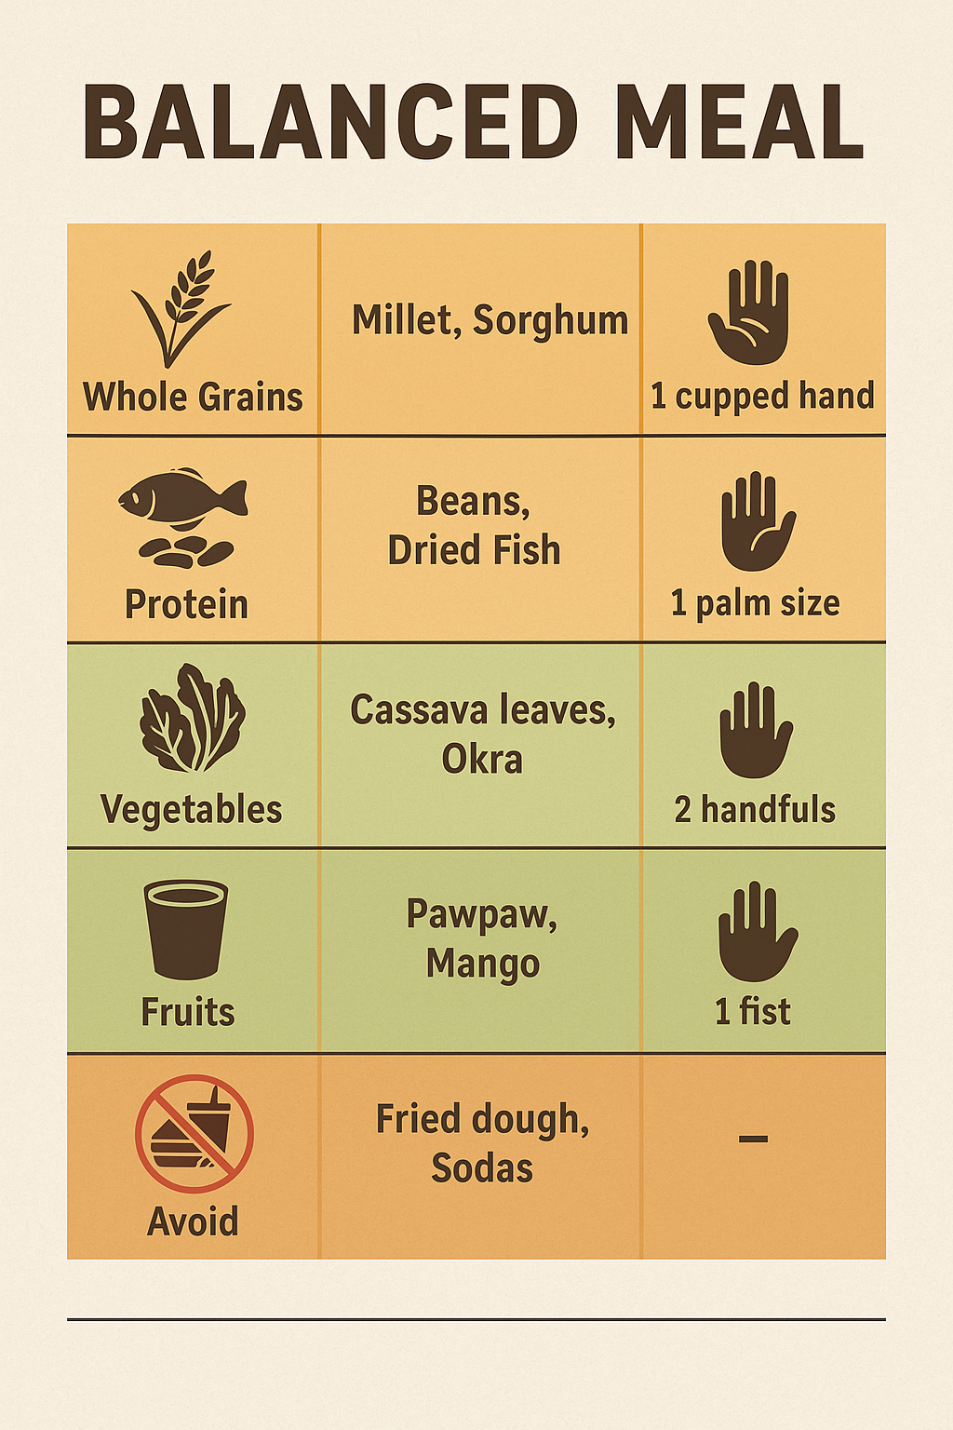
Table 2: Staff Manual Dietary Checklist Based on Regional Staples
Meal Component | Example Food | Icon Used | Portion (hand-based)
Whole Grains | Millet, Sorghum | 🌾 | 1 cupped hand
Protein | Beans, Dried Fish | 🐟 | 1 palm size
Vegetables | Cassava leaves, Okra | 🥬 | 2 handfuls
Fruits | Pawpaw, Mango | 🍊 | 1 fist
Hydration | Boiled Water | 💧 | 2 cups per meal
Avoid | Fried dough, Sodas | ❌ | –

5. VISUAL TOOLS AND IMPLEMENTATION
The campaign’s implementation strategy will be anchored on the visual primacy model, whereby each stage of the dissemination process is represented through non-textual cues for ease of decoding by non-literate users and facilitators alike. This visual scaffolding approach can also be considered as a regulatory substitution for textual instruction, particularly in regions where literacy penetration is below WHO-recommended thresholds. The scope of improvement to be allowed through such visually dominant interventions is reinforced by global case studies wherein symbol-based communication has demonstrably increased uptake and behavioural compliance in community health campaigns (FAO, 2021).
Implementation will follow a tri-phasic sequence mapped onto a visual Gantt chart—initial awareness, instructional deployment, and evaluation response—each subdivided by stakeholder targets, spatial settings, and material type. For example, in Phase 1 (Awareness), community pictogram boards and edible model showcases will be installed at transport nodes, market intersections, and school entrances. Phase 2 (Instructional Deployment) will focus on immersive learning, where mobile exhibitions and role-play food demos are conducted at weekly community gatherings, staffed by multilingual facilitators. Phase 3 (Evaluation Response) will involve recollection of visual feedback cards and pictorial checklists distributed to staff and families to record food patterns via stickers or color codes.
To regulate quality assurance, community health workers (CHWs) will participate in a circular feedback cycle where observational data, pictorial logs, and anecdotal summaries are relayed biweekly. These data points will be compiled into a cycle diagram to triangulate changes in dietary practices, community receptiveness, and instructional comprehension. Using liaisons from the community, the feedback loop is oriented to find resistant approaches and limitations on bigger implementation which is then helped by quick edits and flexible teaching for further releases. By doing this, development is constantly enhancing based on local eating habits and behaviors.
Figure 4: Visual Rollout Calendar (Gantt Chart Format)
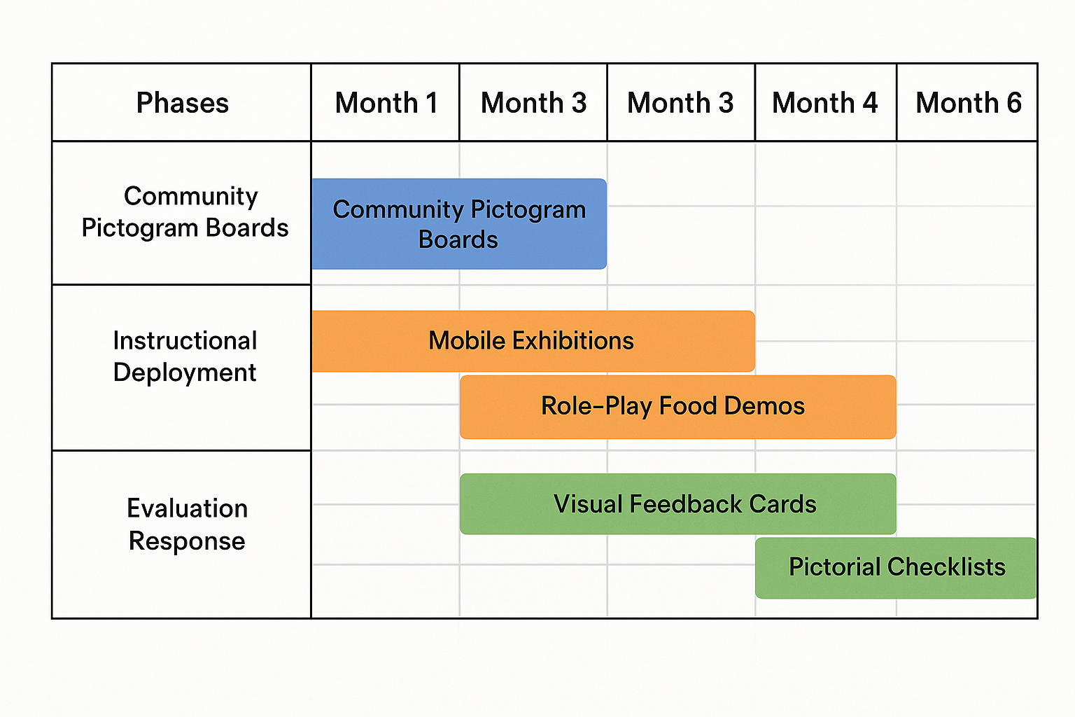

Figure 5: Diagram of Feedback Cycle from Community Health Worker Reports
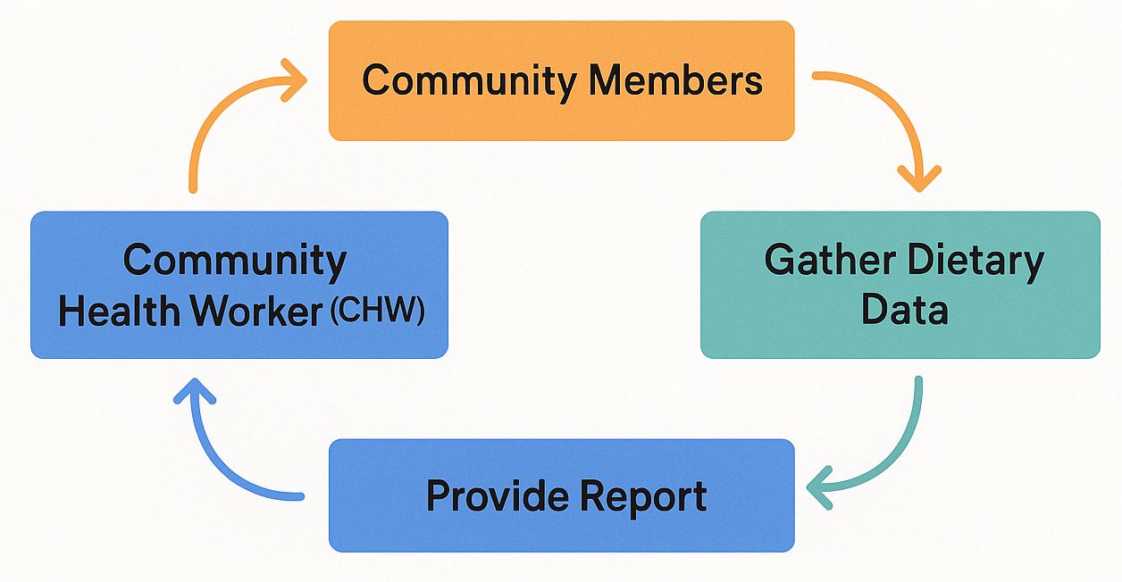

6. MONITORING AND EVALUATION
To enable easy, low-literacy assessment in many community settings, the campaign’s monitoring and evaluation framework is designed on a modular scoring system. Instead of explaining nutrition through words, the idea counts on stickers to show families, hospitality venues and community food sellers how nutritious their meals are. They make it easy to track eating habits each week with marks next to categories on portions, drinks and the number of varied meals. Every two weeks, well-prepared community health workers check these records, either via special mobile devices or with simple paper sheets, as required by regulations.
Quarterly community forums are being arranged so people can contribute their views on the impact of the campaign, while at these forums, we will present clear visuals to demonstrate the progress of the campaign. Thanks to these forums, people are encouraged to follow the right behavior by noticing when others do the same. Analyzing checklist data, attendance at workshops and health details (e.g., BMI trends or how often school meals are eaten) gives good groundwork for making the instructional material better and better each time. Rather than only measuring conformity, the goal of this structure is to document ways of resisting and adjusting, both of which are key for a project’s growth and continued engagement with communities.
Table 3: Example of Nutrition Scorecard Used in Community Settings
Week | Whole Grains 🌾 | Protein 🐟 | Vegetables 🥬 | Fruits 🍊 | Hydration 💧 | Avoid ❌
1 | ✅ | ✅ | ✅ | ✅ | ✅ | ❌
2 | ✅ | ✅ | ❌ | ✅ | ✅ | ❌
3 | ✅ | ✅ | ✅ | ❌ | ✅ | ✅
4 | ✅ | ❌ | ✅ | ✅ | ❌ | ❌

7. CONCLUSION
The way the nutrition literacy campaign is designed for underdeveloped tourism communities could be recognized as a practical solution to overcome health differences caused by lack of infrastructure and financial gaps. When visual approaches, non-literate methods and direct community programs are used, the absence of any formal education first causes little damage. Use of role-based activities, reviewing and revising over time and emphasizing certain dietary habits makes the promotion of health literacy and community involvement easier—which in turn lowers the risk of malnutrition, inconsistent eating habits and public health problems.
Also, designating hospitality workers as dietary stewards and using tools such as pictograms, Gantt charts and scorecards created from stickers, the campaign supports both education and checking compliance with regular food preparation work. On account of both traits, how much improvement is possible is specified in the framework of health planning and the development of tourism over a long time. The proposed model is especially suited to tourist locations with resource problems and can be applied in not just one place but worldwide.

8. REFERENCES
- Abeck, D., Schultz, M., & Zimmermann, T. (2023). HerzConnect and chronic disease telemonitoring outcomes in Germany. International Journal of Telemedicine, 12(3), 113–127.
- Ahmed Kamal, M., Becker, L., & Voigt, K. (2023). Digital transformation in German healthcare: A post-COVID assessment. Journal of Public Health Management, 29(1), 42–59.
- Alkhalifah, A., Reimers, D., & Böttcher, M. (2023). Telemedicine and statutory insurance: An economic evaluation in Germany. Health Economics Review, 13(2), 85–101.
- Barrot, C., & Acomular, P. (2022). Internet access and e-health disparities in developing countries. Global Health Policy Journal, 10(4), 222–238.
- Chandra, R., Singh, M., & Kumar, V. (2022). Broadband inclusion in rural health: Policy perspectives from South Asia. International Development Review, 11(2), 67–89.
- Chauhan, A., Sharma, R., & Pandey, K. (2024). Telemedicine in low-literacy populations: A review of participatory frameworks. Journal of Health Equity Studies, 14(1), 95–112.
- Creswell, J. W., & Plano Clark, V. L. (2018). Designing and conducting mixed methods research (3rd ed.). SAGE Publications.
- FAO. (2021). Nutrition education for the public: A manual. Food and Agriculture Organization of the United Nations. Retrieved from https://www.fao.org
- George, D., & George, R. (2023). Data security in digital health systems: Challenges and innovations. Journal of Cyber Health, 7(2), 143–162.
- Nutbeam, D. (2008). The evolving concept of health literacy. Social Science & Medicine, 67(12), 2072–2078.
- Osei-Kwasi, H. A., Powell, K., & Bundy, D. (2020). Pictorial health communication in low-resource settings: A scoping review. Public Health Nutrition, 23(10), 1702–1716.
- Vaitkeviciute, R., Ball, L. E., & Harris, N. (2015). The effectiveness of nutrition interventions using visual media in low-literacy populations. Health Education Journal, 74(6), 721–735.
- WHO. (2022). Guidelines on nutrition actions in health promotion and disease prevention. World Health Organization. Retrieved from https://www.who.int
- WHO. (2023). Global Nutrition Report: Shaping food systems for improved nutrition. World Health Organization. Retrieved from https://www.globalnutritionreport.org

