M08 Cost Accounting
Modern Costing Techniques and Competitive Advantage
Assignment Option 3
Detailed Project Report
Student Name: ____________________
Student ID: ____________________
Submission Date: 24 May 2026

Table of Contents
Abstract 3
1. Introduction 4
2. Literature Review 5
3. Methodology 9
4. Findings 11
5. Discussion 15
6. Conclusion 18
References 19
Appendices 21

Abstract
Modern organizations compete in markets where customers expect high quality, speed, reliability and lower prices at the same time. Traditional cost accounting remains useful for inventory valuation and basic cost control, but it often gives weak support to strategic decision making when overheads, service complexity, product variety and customer driven customization increase. This report critically examines how modern costing techniques improve business efficiency and competitive advantage, with particular attention to activity based costing, target costing, life cycle costing and kaizen costing. It adopts a secondary, topic based methodology that synthesizes academic literature, professional accounting guidance and real organizational examples from manufacturing, hospitality and service contexts. The analysis finds that modern costing techniques improve costing accuracy by linking costs to activities, customer requirements, product design choices, asset life cycle decisions and continuous improvement routines. However, the benefits are not automatic. These systems require reliable data, cross functional cooperation, managerial interpretation and cultural acceptance. Activity based costing improves visibility of indirect costs, target costing shifts cost control to the design stage, life cycle costing supports long term value decisions, and kaizen costing builds everyday cost discipline after launch. The report concludes that modern costing creates competitive advantage when used as a management system rather than a narrow accounting calculation.

1. Introduction
Cost accounting is no longer only a record keeping function that calculates the cost of materials, labour and overheads after production has taken place. In contemporary organizations, cost information affects pricing, product design, outsourcing, process improvement, capacity planning, sustainability investment and customer profitability analysis. The assignment brief requires a critical examination of cost accounting principles, methods and managerial importance, with specific emphasis on modern techniques and their contribution to efficiency and competitiveness. This report therefore selects Option 3, Modern Costing Techniques and Competitive Advantage, because it allows the strongest analysis of how cost systems have moved from traditional control toward strategic management.
The need for modern costing has grown because cost structures have changed. Many firms now carry high fixed overheads, digital infrastructure costs, distribution costs, service costs and compliance costs. In hotels, airlines, hospitals, e commerce fulfilment centres and advanced manufacturing firms, the direct material or direct labour cost of a single product or service may be less important than the activities needed to serve customers. Traditional absorption costing can allocate overhead using one broad base such as labour hours, but this can distort product margins when different products consume support activities in very different ways (Cooper & Kaplan, 1988). Such distortion is dangerous because managers may overprice simple products, underprice complex products, discontinue profitable segments or subsidize demanding customers without noticing it.
Modern costing techniques respond to this problem by connecting cost measurement with value creation. Activity based costing identifies activities and cost drivers. Target costing begins with the market price and required profit, then designs the product or service to meet a permitted cost. Life cycle costing evaluates costs across acquisition, operation, maintenance and disposal rather than focusing only on initial purchase price. Kaizen costing uses continuous incremental improvements to reduce cost during production or service delivery. These approaches differ, but they share one principle. Costs should be managed before they are locked into processes, and cost information should guide managerial decisions rather than merely report accounting outcomes.
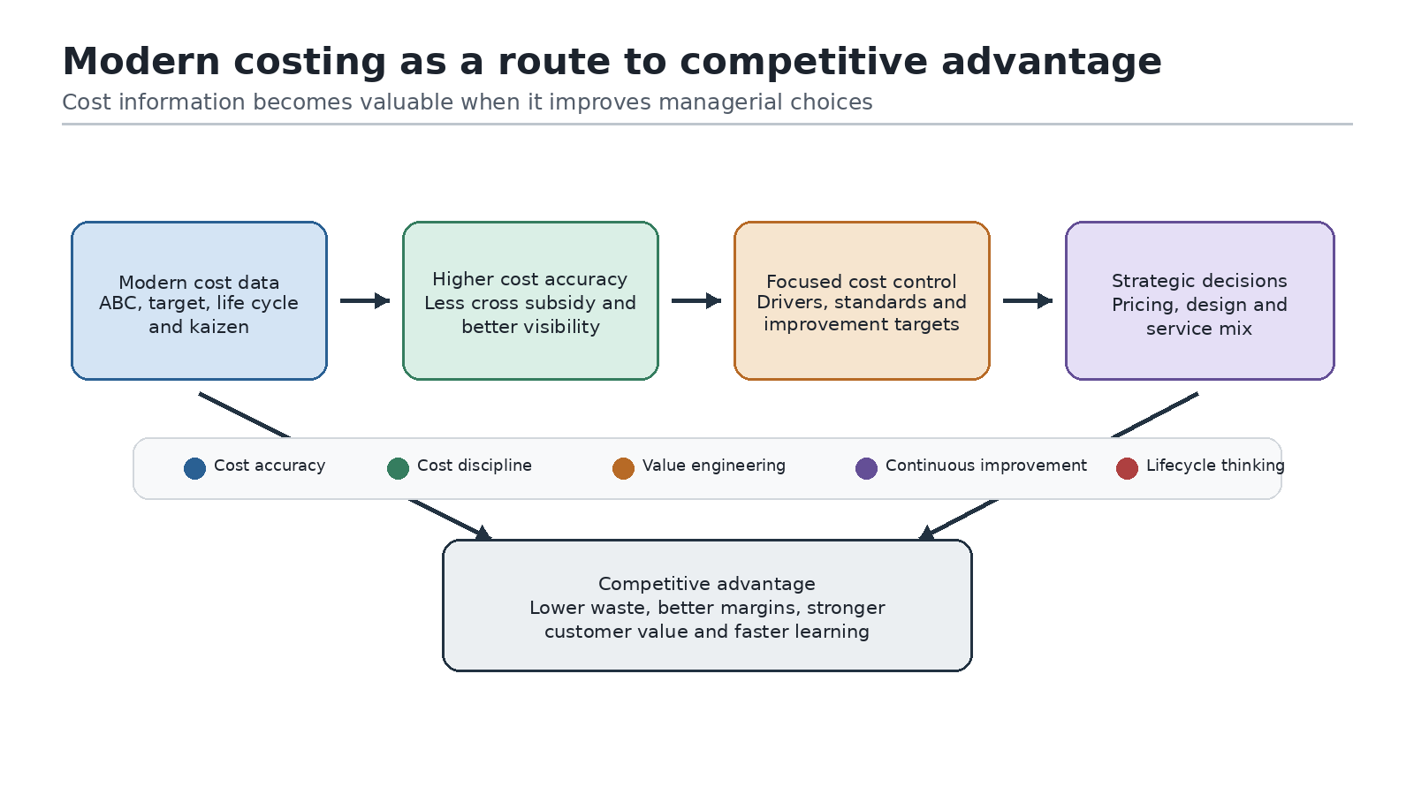
Figure 1. Modern costing techniques and competitive advantage.
The aim of this report is to analyze how modern costing techniques improve cost accuracy, cost control and strategic decision making. The objectives are to explain the main techniques, evaluate their managerial benefits, assess implementation challenges and show real world relevance through examples from Toyota, hospitality services, facilities management and activity based service analysis. The central argument is that modern costing can support competitive advantage, but only when it is embedded into planning, operations and behaviour. A technically correct costing model has limited value if managers ignore it, employees resist it or the data are too weak to support reliable decisions.

2. Literature Review
The literature on cost accounting shows a clear movement from financial reporting support toward strategic cost management. Traditional costing systems were designed mainly for stock valuation and control in production environments where direct labour and direct materials were major cost elements. In these conditions, overhead allocation through broad volume based rates was often acceptable. However, Johnson and Kaplan argued that many management accounting systems became less relevant as automation, product diversity and competitive pressure increased. Later work by Cooper and Kaplan (1988) developed this criticism by showing that high volume simple products can be overcosted while low volume complex products are undercosted when overhead is spread using a single volume related base. The implication is strategic rather than merely technical. Bad cost information can produce bad market strategy.
Activity based costing is one of the most influential responses to this limitation. ABC assumes that activities consume resources and cost objects consume activities. In practical terms, resources are first assigned to activity pools, and then activity costs are assigned to products, services or customers using cost drivers such as purchase orders, room service requests, machine setups, inspections, reservations, invoices or delivery drops (AICPA & CIMA, 2013). This gives managers a more refined view of cost behaviour than a simple direct labour hour rate. Kaplan and Anderson (2004) later proposed time driven activity based costing, which simplifies implementation by estimating the cost of supplying capacity and the time required to perform transactions. Their approach matters because one criticism of traditional ABC is that it can become expensive, slow and difficult to maintain.
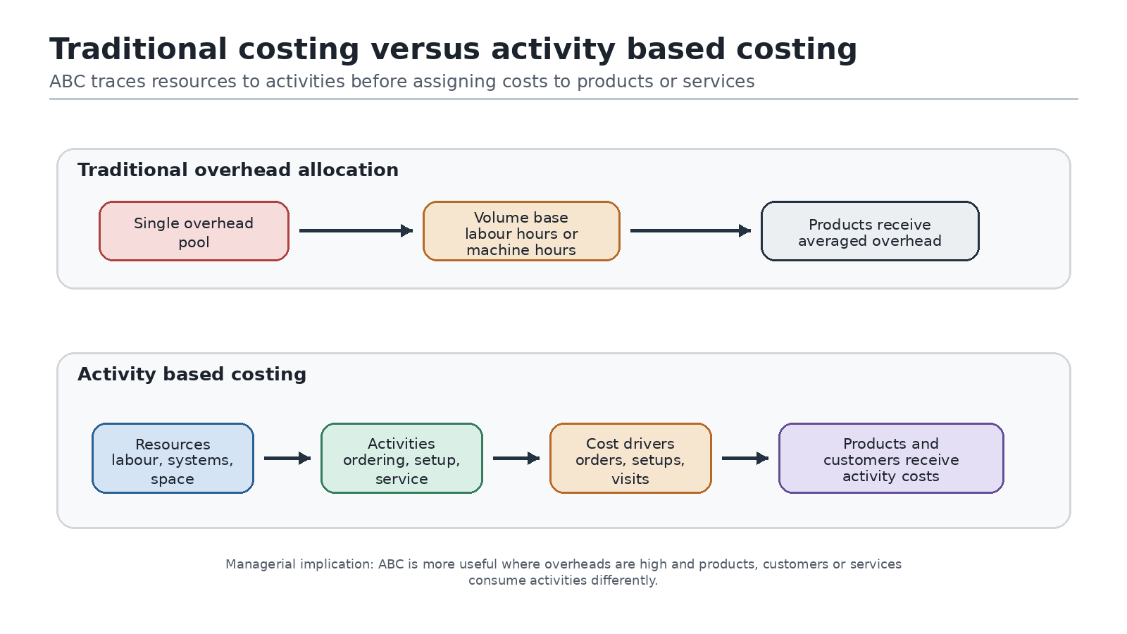
Figure 2. Traditional costing versus activity based costing.
Evidence from hospitality and services confirms the relevance of activity based thinking. Pavlatos and Paggios (2009) studied ABC adoption in the Greek hotel sector and found that ABC had practical relevance for understanding service costs. In hotels, costs are not only attached to rooms, food and beverages. They are also created by reservations, cleaning, maintenance, laundry, guest support, banqueting, loyalty programmes and distribution platforms. Two guests paying the same room rate may consume very different levels of service activity. A traditional average room cost may hide this difference, while ABC can identify which packages, customer types or channels are truly profitable. This is important for hotel managers who must protect service quality while controlling labour, utilities, food waste and commission costs.
Target costing extends cost management to the design and planning stage. Instead of adding a profit margin to estimated cost, target costing begins with what customers are willing to pay and subtracts the required profit to determine the allowable cost. The basic logic is expressed as Target cost = Market price - Required profit. Feil, Yook and Kim (2004) explain that Japanese target costing developed as a cross functional system involving engineering, production, marketing and accounting. Ibusuki and Kaminski (2007) also show that target costing is closely connected with value engineering, because teams must find ways to deliver required functions at a cost that fits market conditions. This is strategically powerful because many costs are committed during product design before production starts.
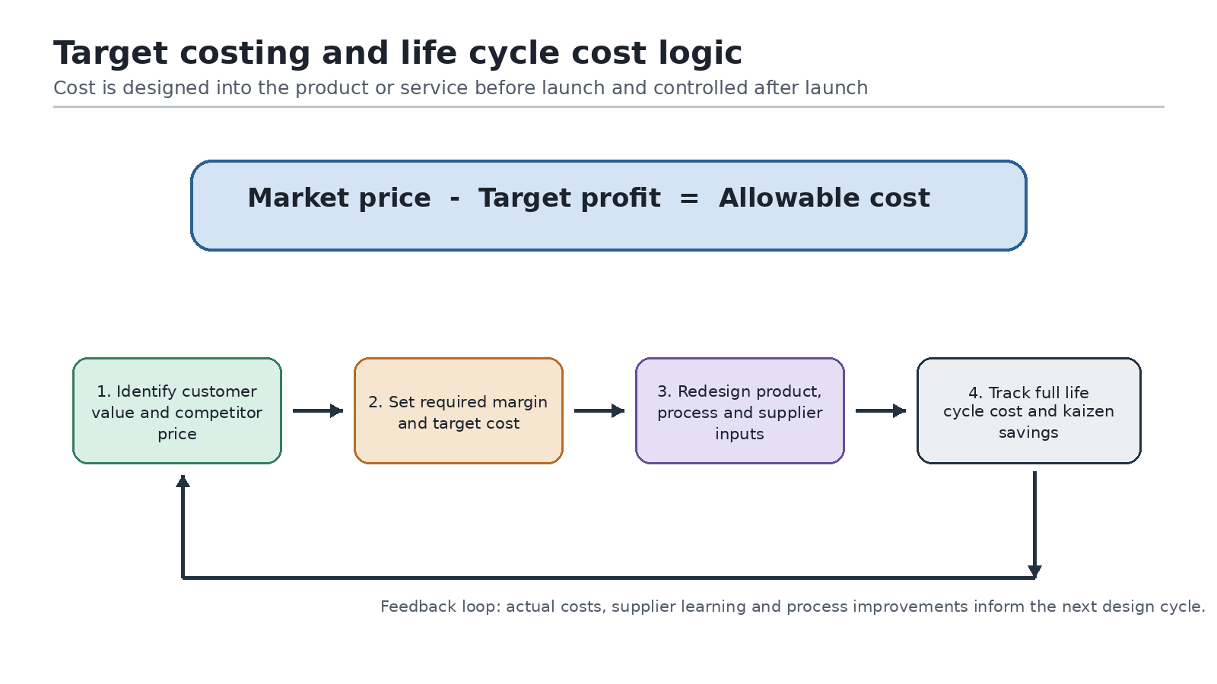
Figure 3. Target costing and life cycle cost logic.
Toyota is frequently used as a reference case for target costing and product cost planning. The IFAC study on Toyota Australia explains that target costing linked profit planning, feasibility, market surveys, value analysis, budgetary control and financial management (IFAC, 2002). The lesson is not that every organization should copy Toyota mechanically. Rather, target costing becomes effective when market intelligence, engineering choices and cost targets are integrated. In hospitality, an equivalent approach might be used when designing a hotel package, restaurant menu, spa treatment or event service. Managers can begin with the price customers are willing to pay, define the desired margin and then redesign ingredients, labour process, supplier contracts and service flow to meet the allowable cost without damaging perceived value.
Life cycle costing takes a broader time horizon. It recognizes that an asset, product or service can generate costs before purchase, during operation and after use. In facilities, hotels and capital intensive service businesses, the cheapest initial option is not always the lowest cost option over its useful life. Life cycle costing therefore includes acquisition, installation, training, energy, maintenance, downtime, replacement, disposal and sometimes environmental costs. Kambanou (2020) notes that life cycle costing methods are often tailored in practice, which means there is no single universal model. This flexibility is useful, but it also means that assumptions about discount rates, asset lives, maintenance patterns and residual values must be transparent. RICS (2025) similarly frames life cycle costing as a systematic economic evaluation over an agreed period of analysis.
Kaizen costing is different from target costing because it is normally applied after the product or service has entered regular operations. It is based on continuous small improvements rather than one large redesign. In manufacturing, kaizen costing can reduce waste, setup time, defects, motion and rework. In services, it can reduce waiting time, unnecessary approval steps, food waste, energy waste or repeated guest complaints. The connection with lean thinking is clear because both focus on reducing non value adding work. However, kaizen costing should not be confused with indiscriminate cost cutting. The objective is not to reduce cost by weakening quality or overloading employees. The objective is to remove waste while protecting value. This is why participation, learning and process knowledge are central to successful kaizen cost management.
Strategic management accounting also argues that cost systems should be linked with external competitive positioning, not only internal expense control. Guilding, Cravens and Tayles (2000) show that practices such as competitor cost assessment, strategic pricing and customer profitability analysis connect accounting information with market strategy. This insight is important for modern costing because the same cost number can support different decisions depending on the competitive context. A luxury hotel may accept higher service cost if it protects brand differentiation, while a budget hotel may design standardized processes to achieve reliable low cost. A manufacturer may keep an expensive component if it protects product performance, while a mass market competitor may redesign the feature to meet a target cost. Modern costing therefore supports competitive advantage by making trade offs explicit. It does not tell managers always to choose the lowest cost option. It helps managers identify which costs create customer value and which costs represent waste. This distinction is central to strategic cost management because sustainable competitiveness depends on protecting valuable costs while eliminating unnecessary costs.
The literature also identifies important limitations. ABC can create false precision if cost drivers are poorly selected. Target costing can create pressure that damages supplier relationships or product quality if the allowable cost is unrealistic. Life cycle costing can be weakened by uncertain long term forecasts. Kaizen costing can become a ritual if employees are asked for improvements but management does not remove structural barriers. Management accounting research therefore emphasizes that costing techniques are social and organizational systems as well as calculation methods (Burns & Scapens, 2000). The quality of modern costing depends on data quality, managerial skill, cross functional trust and alignment with strategy. This critical perspective is essential because competitive advantage does not arise from the label of the technique; it arises from better decisions and better execution.

3. Methodology
This report uses a topic based secondary research methodology. A secondary approach is suitable because the assignment requires critical examination of cost accounting theory, methods and managerial importance rather than primary fieldwork with one organization. The research design is qualitative and analytical. It synthesizes evidence from academic literature, professional accounting guidance and published examples to evaluate how modern costing techniques support efficiency and competitive advantage. The method is therefore closer to an integrative management report than a statistical study.
The source base was selected using 3 criteria. First, sources had to explain cost accounting concepts such as activity based costing, target costing, life cycle costing, kaizen costing, cost allocation and strategic cost management. Second, sources had to support application to real organizational decisions rather than only definitions. Third, at least part of the evidence had to connect with service or hospitality contexts because the module is linked to management and hospitality learning. Academic sources were used for theory and critique, while professional bodies such as AICPA, CIMA, ACCA, IFAC and RICS were used because they provide practitioner focused guidance. This combination is appropriate because costing systems must be theoretically sound and operationally usable.
The analysis followed a comparative framework. Each costing technique was assessed against 5 questions: What cost problem does it solve? What information does it require? How does it improve decision making? What implementation challenges does it create? How can it contribute to competitive advantage? This framework ensures that the report does not simply describe techniques in isolation. Instead, it compares their strategic usefulness. For example, ABC is evaluated mainly for cost tracing and customer profitability, target costing for market led design discipline, life cycle costing for long term asset and sustainability decisions, and kaizen costing for continuous operational improvement.
The methodology also includes illustrative application. Short examples from Toyota style target costing, hotel activity costing, building life cycle costing and continuous improvement are used to show how theory can be translated into decisions. These examples are not presented as full case studies because the available public evidence is limited and because the word count requires breadth across several techniques. They are used as analytical illustrations to show managerial relevance.
There are 3 main limitations. First, secondary research depends on the quality and currency of published sources. Some classic costing literature remains highly relevant, but organizational technologies and data systems have changed. Second, public examples rarely disclose full internal cost data, so the report cannot verify exact cost savings. Third, modern costing is context dependent. A method that works well in an automotive manufacturer may need adaptation before use in a hotel, restaurant, hospital or digital service company. These limitations are managed by using critical comparison rather than claiming that any one technique is universally superior.

4. Findings
The first finding is that modern costing techniques improve cost accuracy by shifting attention from broad averages to the real causes of resource consumption. Traditional overhead absorption may be acceptable when products are similar and overhead is small. However, in a complex service or manufacturing environment, broad averages hide cross subsidies. ABC corrects this by identifying activities such as procurement, quality inspection, housekeeping, maintenance, booking administration, complaint handling, machine setup or delivery scheduling. Once activity pools and cost drivers are identified, managers can see whether a product, customer or service line is consuming more resources than its revenue justifies. This visibility can improve pricing, process redesign and customer segmentation.
In a hotel, for example, ABC can show that a low room rate sold through an online travel platform may be less profitable than expected because it brings commission cost, additional front desk handling, loyalty administration and room turnover pressure. A corporate guest with negotiated rates may still be profitable if the stay is longer, payment is reliable and service demands are predictable. The value of ABC is therefore not only better arithmetic. It changes managerial questions. Instead of asking what the average room costs, the manager asks which activities are creating cost, which guests consume them and which processes can be redesigned. This supports competitive advantage because the hotel can protect margins without blindly increasing prices.
The second finding is that target costing supports competitive advantage by connecting cost management to customer value and market price. In competitive markets, organizations often cannot set prices simply by adding profit to cost. Customers compare alternatives, online platforms increase transparency and competitors can imitate visible features. Target costing therefore begins with the expected market price and required profit, then sets an allowable cost. This forces early cross functional collaboration. Marketing identifies customer requirements, accounting translates profit targets into cost limits, operations evaluates process feasibility and design teams search for value engineering options. The process can prevent the common problem where a service or product is designed first and only later discovered to be too expensive to deliver profitably.
Table 1. Comparative role of modern costing techniques
Technique | Main cost problem | Information needed | Strategic use
Activity based costing | Indirect cost distortion and hidden customer service costs | Activities, cost pools and cost drivers | Pricing, customer profitability and process redesign
Target costing | Products or services designed above affordable cost | Market price, required profit and allowable cost | Design discipline and value engineering
Life cycle costing | Low purchase price but high operating cost | Asset life, operating cost, maintenance and disposal data | Capital investment and sustainability decisions
Kaizen costing | Recurring waste after launch | Actual cost, target operating cost and improvement data | Continuous improvement and lean cost control
The Toyota related evidence shows that target costing is strongest when it is part of a broader product planning system rather than an accounting exercise. It links market research, design, supplier input and budget control (IFAC, 2002). In hospitality, the same logic can apply to menu engineering. If customers will pay a fixed price for a breakfast package, the target cost must include ingredients, preparation labour, waste, utilities and service time while still protecting quality. Managers can then change recipe design, supplier specification, buffet layout or waste controls to meet the target. The technique therefore encourages cost prevention rather than late cost correction.
The third finding is that life cycle costing improves decisions where a low purchase price can create high future cost. This is especially important for hotels, resorts, hospitals, universities and other organizations with expensive buildings, kitchens, air conditioning systems, laundry systems and digital infrastructure. A cheaper HVAC system may have higher electricity consumption, more maintenance and greater downtime. A more expensive system may reduce energy cost and guest complaints over several years. Life cycle costing helps managers compare alternatives by calculating the total cost of ownership across the relevant period. This supports strategic decisions because facilities and service assets affect both cost and customer experience.
Life cycle costing also connects cost accounting with sustainability. Many organizations now face pressure to reduce carbon emissions, energy consumption and waste. A life cycle view can show that an initially expensive energy efficient asset may be financially and environmentally preferable over time. However, the finding is not that life cycle costing automatically gives a clear answer. It depends on assumptions about energy prices, maintenance patterns, discount rates, usage intensity and asset life. The main managerial benefit is disciplined transparency. Decision makers are forced to state assumptions and compare options over time rather than choosing the cheapest initial price.
The fourth finding is that kaizen costing strengthens operational discipline after launch. Target costing is strongest before launch, while kaizen costing is strongest during ongoing delivery. It encourages managers and employees to identify small cost reductions in labour flow, material use, waiting time, rework, waste and defects. In hospitality, examples include reducing food waste through better forecasting, reducing laundry rewash rates, redesigning housekeeping carts, shortening guest check in steps, improving preventive maintenance or standardizing high waste menu items. These improvements may appear small individually, but repeated improvements can protect margin in a sector where labour, utilities and food costs are significant.
The fifth finding is that the techniques work best as an integrated system. ABC can reveal that a service line is costly because it consumes many support activities. Target costing can redesign future offers so that cost is built around customer value. Life cycle costing can prevent capital decisions that create long term cost burdens. Kaizen costing can continuously improve the process after implementation. In this sense, modern costing supports competitive advantage through a cost management cycle: understand cost drivers, design for allowable cost, evaluate full life cost and continuously reduce waste.
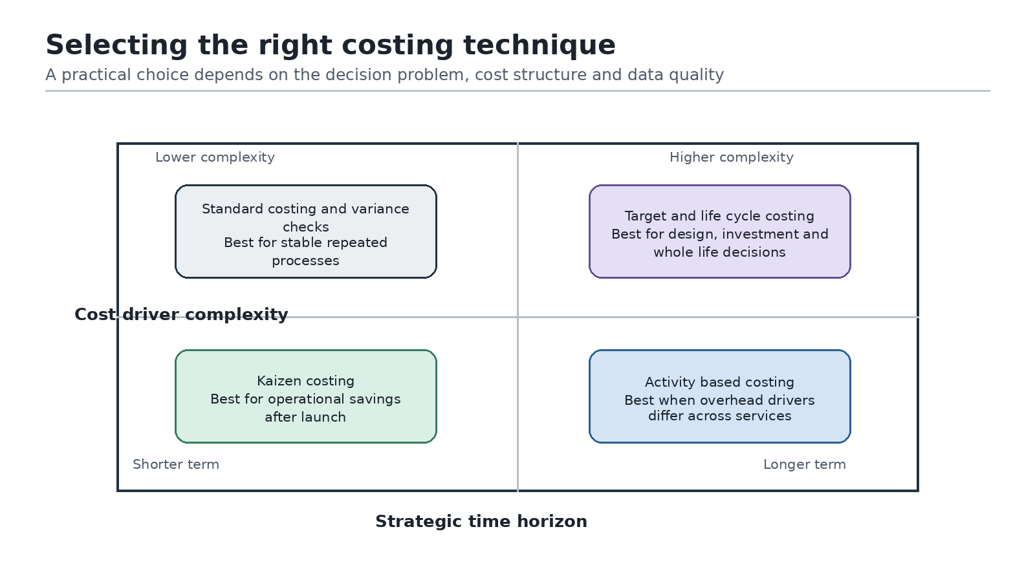
Figure 4. Selection matrix for modern costing techniques.
The role of digital systems is another important finding. Modern costing becomes more feasible when transaction systems, property management systems, point of sale systems, enterprise resource planning platforms and maintenance software capture operational data. For example, hotel booking data can be connected with channel commission, housekeeping time, food and beverage consumption and guest complaint data. This can make activity analysis more current and less dependent on manual estimates. However, digital data do not remove the need for accounting judgement. Data may be incomplete, inconsistent or collected for operational purposes rather than costing purposes. Managers still need to define cost objects, select relevant drivers and interpret whether a cost is avoidable, controllable or strategically necessary. The best use of digital costing is therefore human supported analysis, not automatic decision making.
The sixth finding is that implementation challenges are substantial. Data requirements are high because cost drivers, activity times, service volumes and capacity use must be measured. Employee resistance can arise if costing is perceived as a tool for blame or job reduction. System complexity can make models expensive to update. Managers may also misuse results if they treat allocated costs as perfectly objective facts. These challenges are especially important in service organizations, where many activities are intangible, shared or variable in quality. Successful implementation therefore requires training, transparent purpose, phased rollout and managerial judgement.

5. Discussion
The findings show that modern costing techniques can create competitive advantage, but the mechanism is indirect. A costing system itself does not make a firm competitive. It improves the information environment in which managers make choices about price, design, customers, processes and assets. Competitive advantage appears when better information is converted into superior action. This point is critical because organizations often invest in new systems expecting automatic savings. If managers continue to reward volume rather than profitability, ignore process data or use costing only for annual reporting, modern costing will not change performance.
ABC offers the clearest improvement in cost visibility, but it must be applied carefully. The danger is model overload. A hotel or service firm could identify hundreds of activities, but a system that is too detailed becomes costly and hard to maintain. Time driven ABC partially solves this problem because it uses time equations and capacity cost rates to estimate resource consumption (Kaplan & Anderson, 2004). For many service organizations, this may be more practical than a traditional interview heavy ABC model. The managerial recommendation is to begin with the decisions that matter most, such as channel profitability, event profitability, menu profitability or customer segment profitability, and then design the ABC model around those decisions.
Target costing is strategically powerful because it challenges the cost plus mindset. However, it can also be risky if management treats the target as a command rather than a design problem. Unrealistic cost targets can transfer pressure to suppliers, reduce employee morale or weaken quality. The best use of target costing is cross functional and value focused. The cost target should encourage value engineering, simplification, supplier collaboration and process innovation. In a hospitality context, this means meeting cost targets by redesigning service delivery rather than merely reducing portion sizes, staffing levels or amenity quality in ways that damage guest satisfaction.
Life cycle costing is particularly relevant in a period of energy cost volatility and sustainability pressure. Hotels and service businesses cannot assess assets only through purchase price because energy, maintenance and downtime can exceed the initial saving from a cheaper option. Life cycle costing also supports responsible investment because it makes environmental and operational consequences more visible. The limitation is uncertainty. Long term assumptions are never perfect. Managers should therefore use sensitivity analysis by testing different energy prices, usage levels and discount rates. This turns life cycle costing from a single number into a decision conversation.
Kaizen costing adds a behavioural dimension because it depends on employee participation. Frontline employees often know where waste occurs, but they may not share ideas if they fear blame or if previous suggestions were ignored. A kaizen costing culture therefore requires visible leadership support, simple measurement and feedback. It should be linked to service quality indicators, not only expense reduction. For example, reducing housekeeping time per room is beneficial only if cleanliness scores remain acceptable. Reducing kitchen waste is beneficial if food quality and guest choice remain strong. This balanced approach prevents cost management from becoming cost cutting.
A practical implementation roadmap should begin with diagnosis rather than software purchase. Management should identify the decisions currently weakened by poor cost information, such as unprofitable customer channels, uncontrolled food waste, inaccurate event pricing or high maintenance cost. The organization should then pilot one technique in a bounded area, test whether the outputs change decisions and refine the model before wider rollout. Training is also essential because non accountants must understand what the system means. A chef, housekeeping supervisor, maintenance manager or sales manager does not need to become an accountant, but they must understand how their activities create cost and value. This reduces resistance and turns costing into a shared management language.
Overall, the most defensible approach is selective integration. Organizations should not adopt every modern costing technique at maximum complexity. Instead, they should match the technique to the decision problem. ABC suits overhead complexity and customer profitability. Target costing suits new product or service design. Life cycle costing suits capital intensive and sustainability related decisions. Kaizen costing suits recurring operational waste. When these methods are supported by digital data, cross functional accountability and clear strategy, they can improve cost control while strengthening value for customers.

6. Conclusion
Modern costing techniques are important because organizations now compete through cost, quality, speed, customization and customer experience at the same time. Traditional cost accounting remains useful, but it is insufficient when overheads, service activities and long term asset costs are strategically significant. Activity based costing, target costing, life cycle costing and kaizen costing each solve different cost management problems. ABC improves the tracing of indirect cost to activities, services and customers. Target costing builds cost discipline into design and market positioning. Life cycle costing improves long term asset and sustainability decisions. Kaizen costing supports continuous cost reduction during operations.
The report concludes that modern costing contributes to competitive advantage when it is used as a managerial system rather than as a technical spreadsheet exercise. The benefits include more accurate pricing, better product and service design, stronger process control, improved capital investment decisions and clearer customer profitability analysis. However, these benefits depend on reliable data, realistic assumptions, staff involvement, cross functional cooperation and careful interpretation. Poorly implemented modern costing can create complexity, resistance and misleading precision.
For organizations in hospitality and service industries, the main implication is practical. Cost accounting should not only answer what a service costs. It should explain why the cost occurs, whether the customer values the activity, whether the cost can be prevented at design stage, whether the asset choice is economical across its life and whether everyday improvements can reduce waste without damaging service quality. This broader approach makes cost accounting a strategic tool for efficiency, resilience and sustainable competitiveness.

References
ACCA. (n.d.). Target costing and life-cycle costing. Association of Chartered Certified Accountants. https://www.accaglobal.com/gb/en/student/exam-support-resources/fundamentals-exams-study-resources/f5/technical-articles/target-lifestyle.html
AICPA & CIMA. (2013). Activity-based costing (ABC). https://www.aicpa-cima.com/resources/article/activity-based-costing-abc
Blocher, E. J., Stout, D. E., Juras, P. E., & Smith, S. (2022). Cost management: A strategic emphasis (9th ed.). McGraw Hill.
Burns, J., & Scapens, R. W. (2000). Conceptualizing management accounting change: An institutional framework. Management Accounting Research, 11(1), 3-25. https://doi.org/10.1006/mare.1999.0119
Cooper, R., & Kaplan, R. S. (1988). Measure costs right: Make the right decisions. Harvard Business Review, 66(5), 96-103. https://hbr.org/1988/09/measure-costs-right-make-the-right-decisions
Drury, C. (2018). Management and cost accounting (10th ed.). Cengage Learning.
Feil, P., Yook, K. H., & Kim, I. W. (2004). Japanese target costing: A historical perspective. International Journal of Strategic Cost Management, Spring, 10-19. https://www.uakron.edu/cba/docs/ins-cen/igb/scm/TCHistory_formatted.pdf
Guilding, C., Cravens, K. S., & Tayles, M. (2000). An international comparison of strategic management accounting practices. Management Accounting Research, 11(1), 113-135. https://doi.org/10.1006/mare.1999.0120
Horngren, C. T., Datar, S. M., & Rajan, M. V. (2021). Cost accounting: A managerial emphasis (17th ed.). Pearson.
Ibusuki, U., & Kaminski, P. C. (2007). Product development process with focus on value engineering and target-costing: A case study in an automotive company. International Journal of Production Economics, 105(2), 459-474. https://doi.org/10.1016/j.ijpe.2005.08.009
IFAC. (2002). Product cost planning at Toyota Australia. International Federation of Accountants. https://www.icjce.es/images/pdfs/TECNICA/C01%20-%20IFAC/C.01.072%20-%20PAIB%20-%20Studies/FMA-Study_10.pdf
Kaplan, R. S., & Anderson, S. R. (2004). Time-driven activity-based costing. Harvard Business Review, 82(11), 131-138. https://hbr.org/2004/11/time-driven-activity-based-costing
Kambanou, M. L. (2020). Life cycle costing: Understanding how it is practised and its relationship to life cycle management. Sustainability, 12(8), Article 3252. https://doi.org/10.3390/su12083252
Pavlatos, O., & Paggios, I. (2009). Activity-based costing in the hospitality industry: Evidence from Greece. Journal of Hospitality & Tourism Research, 33(4), 511-527. https://doi.org/10.1177/1096348009344221
RICS. (2025). Life cycle costing (1st ed.). Royal Institution of Chartered Surveyors. https://www.rics.org/content/dam/ricsglobal/documents/standards/Life-cycle-costing_1st-edition.pdf

Appendices

Appendix A: Core formulas used in modern costing
Target cost = Expected market price - Required profit
Contribution per unit = Selling price per unit - Variable cost per unit
Capacity cost rate = Cost of supplied capacity / Practical capacity
Life cycle cost = Acquisition cost + Operating cost + Maintenance cost + Disposal cost - Residual value
Kaizen cost gap = Current actual cost - Target operating cost

Appendix B: Illustrative application to a hotel breakfast package
Assume that a hotel sells a breakfast package at 20 per guest and requires a profit of 5 per guest. The target cost is therefore 20 - 5 = 15 per guest. If the current cost is 17 per guest, the cost gap is 17 - 15 = 2 per guest. A target costing response should not simply reduce quality. A better response would review supplier specification, portion waste, buffet replenishment routines, staff scheduling and menu mix. After launch, kaizen costing can track daily waste and labour efficiency so that the package remains close to the target cost while maintaining guest satisfaction.

