

Planning and Management of Sustainable Tourism Space

Developing Sustainable Tourism Spaces: Strategies for Balancing Environmental, Economic, and Social Factors

Contents
Introduction 3
Background 4
Aim and Objectives 5
Literature Review 5
Introduction 5
Strategies for Balancing Environmental, Economic, and Social Factors in Sustainable Tourism 6
The Effectiveness of Sustainability Strategies in Tourism Destinations 6
Successful Sustainable Tourism Projects Involving Local Communities and Minimizing Environmental Impact 7
Theoretical Frameworks 7
Literature Gap 9
Summary 10
Methodology 10
Findings 12
Discussion 14
Conclusion 17
References 18

Abstract
The research paper seeks to discuss the feasibility of the sustainability policy in project tourism, with special attention to this policy as a way of striking an equilibrium between environmental, economic, and social aspects. The background identifies the increased significance of sustainable tourism in reducing environmental effects as well as enhancing economic development and social integration. The key findings via secondary qualitative research have indicated that stakeholder partnership and sustainable development of infrastructure the important aspect that promotes tourism sustainability in projects. Good contact with the community makes sure that the tourism activities are in line with the local values and environmentally friendly infrastructure through renewable energy and waste disposal systems decreases the environmental footprint. The study finds that the incorporation of these strategies also plays a major role in ensuring the competitiveness and sustainability of tourism destinations in the long term, bringing into perspective an important understanding towards the enhancement of tourism practices within the fast-changing market.

Introduction

Background
Sustainable tourism is gaining a lot of attention worldwide, particularly when destinations continue to strive to create a balance between the environment, economic growth and social welfare. Tourism is a very fundamental part of the economy in the context of Germany, a country that is known to be very keen on matters of sustainability and social development. The German government has put in place different policies to help in encouraging sustainable tourism such as eco-tourism projects, community projects and green certification programs of tourism companies. But still, there is a need to balance so that long-term environmental conservation is achieved and at the same time, economic growth and the livelihood of the local people are not affected.
The tourism industry in Germany has been described as a multifaceted tourism industry that features tours such as cultural tourism and adventure tourism in the numerous national parks and reserves in Germany that the country boasts of. Tourism activities have an environmental impact and as the world tourism keeps increasing, it has become a pressing issue, especially in the management of resources, minimisation of wastes and conservation of biodiversity. The tourism policy of the country will focus on incorporating sustainability throughout the policy-making proces,s through to the adoption of sustainable business practices in the local businesses and tourism operations. This study will address how the tourism business in Germany strikes a balance between these conflicting needs and how successful the existing measures are. Through the Case studies of the successful sustainable tourism projects, the research seeks to find out the best practices and offer suggestions to improve sustainability in the industry. The results will add to the current attempts of developing the tourism spaces that, in addition to being economically sustainable, will also be environmentally friendly and socially inclusive.

Aim and Objectives
The study aims to develop sustainable tourism spaces in Germany by identifying strategies for balancing environmental, economic, and social factors.
- To analyse strategies for balancing environmental, economic, and social factors in sustainable tourism in Germany
- To evaluate the effectiveness of sustainability strategies in tourism destinations in Germany
- To explore successful German sustainable tourism projects involving local communities and minimising environmental impact
- To recommend improvements for enhancing sustainability in tourism projects in Germany

Literature Review

Introduction
Sustainable tourism is a crucial measure to reducing negative environmental, social, and economic effects and increasing growth on a long-term basis (Baloch et al., 2023). This literature review investigates the strategies, effectiveness, and success stories of sustainable tourism development, especially on how to balance the environment conservation, the social welfare, and the economic benefits. This review will be critical in the literature review and practical cases by providing recommendations on how people can enhance sustainability practices and promote responsible development of tourism.

Strategies for Balancing Environmental, Economic, and Social Factors in Sustainable Tourism
The objective of sustainable tourism is to establish a balance in protecting the environment, social interests and the economy. Environmental strategies are aimed at minimizing the use of resources, minimizing waste and enhanced environmentally friendly practices (Shekhar, 2024). On the economic side, tourism has to bring more advantages to local economies without resource and community exploitation. In social aspect, tourism must add value in the local communities, cultural conservation and facilitate wellbeing in the locals. Some of the major strategies would be the eco-certification programs, responsible consumption, community involvement and incorporation of sustainable technologies (Volka & Mironova, 2024). The difficulty in this is in solving antagonistic interests, which are how to build economic growth and simultaneously safeguard the natural resources and fair community building. The notion of Triple Bottom Line (TBL) is commonly used and it proposes the interrelationship among people, planet, and profit to have a balance in tourism sustainability.

The Effectiveness of Sustainability Strategies in Tourism Destinations
The measure to evaluate the effectiveness of the sustainability strategies in the tourism destinations is the reduction in the environmental impacts, economic benefits to the local communities, and increased social welfare. Best sustainability programs have been demonstrated to diminish carbon footprints, control resource consumption and conserve biodiversity (El-Aidie et al., 2021). With regards to economics, the destinations that adopt a sustainable activity tend to receive more responsible tourists which mean increased profitability in the long run. Tourism projects that involve the local population in the decision-making process have proved more effective in cultural heritage conservation as well as offering equal opportunities both socially (Nguyen et al., 2024). The success of these strategies however can greatly depend on the local conditions, the administration systems and the involvement of stakeholders. Monitoring and adjusting of strategies in tourism development are vital to guarantee further success and sustainability of tourism development.

Successful Sustainable Tourism Projects Involving Local Communities and Minimizing Environmental Impact
In an effort to be more sustainable in tourism projects, it is important to strengthen the cooperation of the stakeholders, incorporate new-fangled technologies, and raise the awareness of the population. Tourism operators ought to move towards being more holistic in their sustainability certifications by not only focusing on environmental practices but also social and economic effects as per Lijun & Ahmed (2024). The long-term impacts of the tourism should be monitored more efficiently to make changes. There is need to invest more in green infrastructure as well as develop technologies that include renewable energy sources, trash management systems, and environmentally friendly modes of transport. Moreover, as Sharma & Bhat (2023) argued the concerns of the local communities in the processes of tourism planning and decision making will be enhanced which will guarantee a fair distribution of the benefits of tourism. The governments are supposed to develop more robust policy frameworks that act as safeguards to ensure that companies operate in an eco-friendlier manner.

Theoretical Frameworks
Triple Bottom Line (TBL)
Triple Bottom Line (TBL) which was developed by Elkington (1997), forms the basis of sustainable tourism. It denotes that financial gain is not the only aim of businesses and tourism destinations they should pursue. Social equity and the impact on nature should also be considered. TBL framework is based on a balanced economic success that does not harm the people or the planet (Noguiera et al., 2022). This in tourism, refers to combining tourism strategies that enhance conservation of the environment, benefit the local communities and in the process guaranteeing economic growth. The TBL offers an inclusive guideline through which decisions are made in terms of policy-making, business practices, and sustainable tourism through the prism of long-term effects on local and global levels.
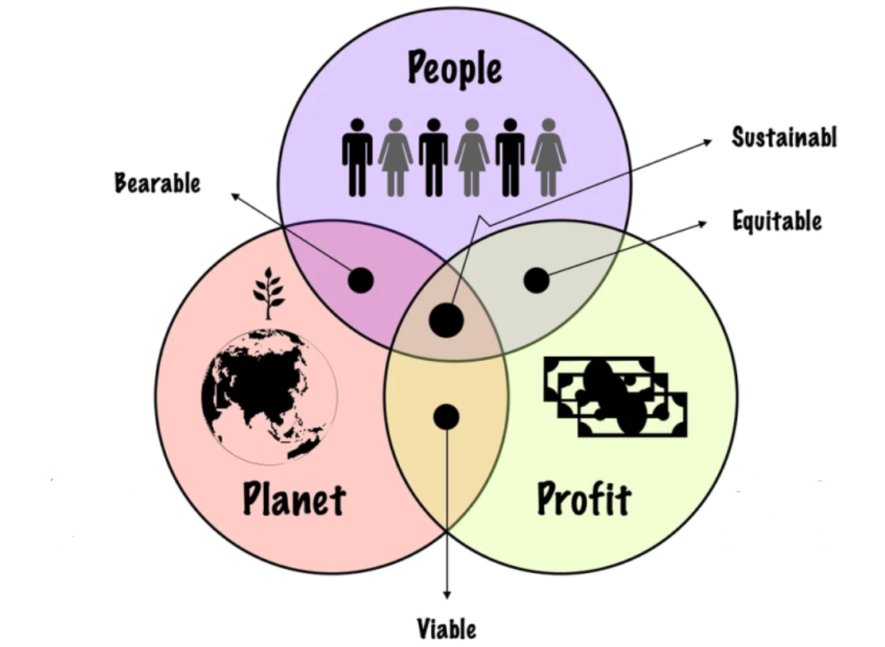
Figure 1: Triple Bottom Line
Source: (Elkington, 1994)
Sustainable Development Goals (SDGs)
The Sustainable Development Goals (SDGs) of United Nations (2015) are an international strategy to support sustainable development and some of them have direct correlation with tourism. Sustainable tourism principles are related to such goals as Decent Work and Economic Growth (Goal 8) or Responsible Consumption and Production (Goal 12). Practically, tourism stakeholders could adopt the SDGs as a guideline in their effort to come up with measures to guarantee social inclusiveness, environmental safeguarding, and economic gains (Buhalis et al., 2023). Implementing the SDGs will make tourist enterprises integrate sustainability on every part of their operations such as minimizing waste to boosting the welfare of communities and contributing to their economic stability in tourist destinations.
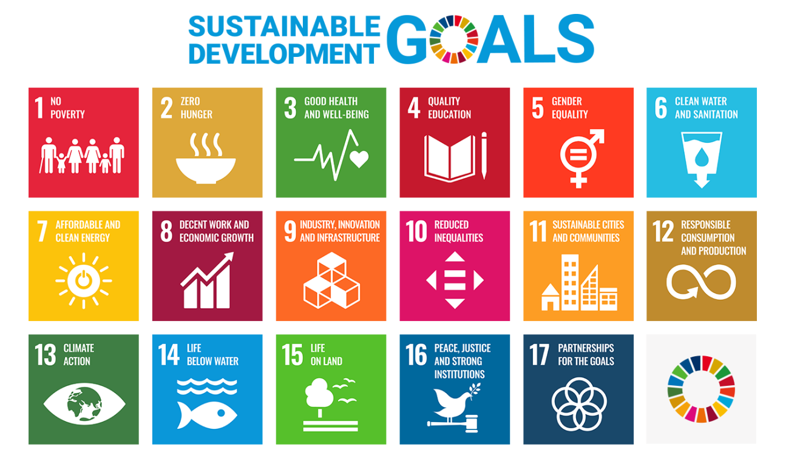
Figure 2: Sustainable Development Goals
Source: (Unosd.un.org, 2024)

Literature Gap
Despite the comprehensive literature on sustainable tourism operations around the world, a distinct absence of the literature regarding sustainable tourism practices with reference to Germany is conspicuous. Although, the sustainable tourism policies in nations such as Spain and Costa Rica have been well researched, very little has been done in regards to Germany and how it achieves its unique approach to sustainability tourism through participation of the local community, protection of the environment, and economic development. This gap shows the necessity to further conduct region-specific studies to find out how effective and difficult sustainable tourism practices are in Germany.

Summary
This literature review brings to fore the strategies, effectiveness and good examples of sustainable tourism. It addresses such frameworks as Triple Bottom Line and SDGs and highlights the necessity of conducting further research regarding the specifics of sustainable tourism practice in Germany, particularly community and environmental integration.

Methodology
Research Philosophy:
This study uses the interpretivism philosophy in that there is an aim to learn about the subjective experiences and meaning of sustainable tourism in Germany. Interpretivism best suits the study of the perception and reaction of different stakeholders like the local communities, tourists and businesses towards sustainability practices. Through such personal opinions, the study would explore the multifaceted contextual issues that affect the effective implementation of sustainable tourism in Germany.
Research Approach:
The research is based on the deductive methodology since it will begin with the available literature on sustainable tourism, especially the Triple Bottom Line (TBL) theory. This will enable these theories to be tested in the German setting by applying them to the real-world practices. The deductive methodology would be appropriate in terms of assessing the success of existing sustainability measures and their correspondence with the developed frameworks, and provide clear insights on how sustainable tourism operations should be based on theories.
Research Design:
The descriptive research design is selected because it aims to systematically study and provide a description of the existing sustainability strategies in German tourism destinations. A descriptive research is suitable to explain the current situation regarding sustainable tourism, the most important practices, and give a clear insight into how these strategies can balance the environmental, economic and social. This design is extensive, and it will not manipulate variables as it is satisfactory in the understanding of natural practices in the field.
Sampling Method:
The study involves non-probability convenience sampling, where secondary data from 8 journal papers are collected. According to this approach, it is feasible to gather data of a variety of sources that are readily available and can be applied to the subject matter. The study is able to employ convenience sampling in order to access the relevant literature that will provide perspectives of the sustainability strategies adopted in the German tourism industry.
Data collection and analysis methods:
Secondary qualitative data has been obtained through 8 academic journals from Google Scholar. This data is discussed in themes to determine the common themes about sustainability in tourism, including environmental protection, community engagement, and economic gains. A sample size of 8 journal papers will be chosen to offer a different number of perspectives regarding the topic. Thematic analysis is the best technique to discover patterns and make conclusions on the basis of qualitative data in a systematic way.
Ethics:
The study will also make sure that the sources are appropriately cited and will not plagiarise. The ethical considerations will also involve the respect of the laws of copyrights and the utilisation of publicly accessible data. All the findings will be given in an objective manner, which will be transparent and avoid bias in the interpretation of results.

Findings
Theme 1: Strategies for balancing environmental, economic, and social factors in sustainable tourism
There are mainly two strategies necessary in balancing of environmental, economic, and social factors in sustainable tourism. National and regional levels of integrated policy frameworks make the sustainability efforts consistently managed, with environmental conservation in line with economic growth and social inclusion (Gajić et al., 2025). Such systems encourage governments, businesses, and local communities to engage in green activities, where at the same time encourage local economic development by using eco-tourism. Second, the community-based tourism places greater authority in the hands of the locals (Palazzo et al., 2022). It is because they are incorporated in the decision-making processes to make sure that all social gains of tourism are shared. The strategy ensures that the culture is maintained and helps in creating employment. This has contributed to the social and economic sustainability of the destinations that tourists visit.
Theme 2: Sustainability strategies successfully promote tourism destinations in Germany
According to Azmi et al. (2023), tourism destination sustainability strategies especially in Germany have enhanced the attractiveness of the industry. This shift has been a major development in the soaring trend of consumer preference for eco-friendly and responsible tourism. Tourists are putting on vacation destinations that value sustainability, such that their selection of visits correlates with matters of environmental morality. Germany, being interested in the integration of green practices, has succeeded in capturing the attention of tourists who are concerned with green activities, which contributes to the competitiveness of the nation in terms of tourism. On the other hand, according to Baena and Cerviño (2024), sustainability strategies contribute to the competitiveness of tourism destinations because they bring different stakeholders together in the process of collaborating. Social responsibility and environmental conservation as witnessed in the tourism policies in Germany help in establishing mutual trust and appeal to environmental tourists. This strategy will promote the reputation of the country and give long-term business development.
Theme 3: Sustainable tourism projects include local communities and minimise environmental impact
According to Turčinović et al. (2025), community-led sustainable tourism provides competitiveness on a local level by encouraging the involvement of the local communities, hence aligning tourism development to the principles of the local people. This makes sure that it is environmentally stewardly but economically rewarding. It emphasises the benefits of involving the local people in the process of tourism planning to see sustainable growth through local empowerment to enhance economic strength and retain the cultural heritage. Also, according to Bacos et al. (2024), eco-friendly tourism can reduce environmental effects, especially with such eco-friendly programs as organic farming and garbage disposal. Such activities ensure the conservation of natural resources and the development of cultural heritage, which attracts environmentally friendly tourists and increases the competitiveness of villages.
Theme 4: Stakeholder collaboration and sustainable infrastructure development can enhance sustainability in German tourism projects
Shi et al. (2022) propose that sustainability in tourism projects can be made more sustainable by enhancing stakeholder collaboration. The sustainable practices can more easily be included into the decision-making process through the improved cooperation between the local communities, the government bodies, and the tourism businesses. This strategy will make sure that the positive effects of tourism are more evenly spread and the environmental effects are reduced by a mutual effort. The improvement of stakeholder engagement may cause the improvement of resource management, maintaining the culture and having economic profits in the long run of the locals. Another manner of significant improvement is identified by Kulakov et al. (2024), which is the sustainability of the development of infrastructure. The ecological footprint of tourist projects can be minimised by investing in green infrastructure, including renewable energy sources, waste control systems and transportation which is environmentally friendly. Not only do they make the tourism destinations more sustainable, but will also appeal to the eco-friendly tourists, which strengthens the destination in regard to its commitment to conserving the environment and increasing its competitive advantage.

Discussion
The information in theme 1 regarding the approach to the equilibrium between environmental, economic, and social aspects of sustainable tourism indicates the success of a comprehensive and community-focused tourism policy. Nevertheless, although integrated policies work on accelerating the realisation of sustainability objectives, the process is usually characterised by difficulties associated with the coordination of the activities of various stakeholders. Regional variation in the implementation of the policies in Germany can create disparities between the regions, and areas are emerging with major milestones in sustainability, whereas other ones remain behind. This difference jeopardises the homogeneity necessary towards long-term sustainability. After the same pattern, community-based tourism is praised as being able to empower local people and protect culture. However, there is evidence that there are instances where the positives of local populations are minimal. A lot of small-scale companies have challenges of resources required to fully embrace sustainability practices and in other cases, the revenues of tourism cannot extend to the greater society but end up in the hands of a few stakeholders. These aspects show that the strategies are effective but demand processual adjustments and developments in their execution.
The theme 2 results indicate that the environmental practices are effective in life in attracting tourists, but there are still some issues in maximising the benefits of the environmental strategies. The findings underline the increased need in eco-friendly destinations, and tourists tend to prefer the available destinations that correspond to their environmental values (Azmi et al., 2023). Although it is true that Germany has been inclined on the aspect of sustainability, which has been lured by environmentally conscious travellers, the country needs to sort out the problem of over-tourism in some of these areas. This affects the sustainability factor. In others, tourists continue to bring degradation to the environment, which is a challenge to sustainability in the long term. The aspect that the addition of social responsibility and environmental practices will provide a competitive advantage is also supported by Baena & Cervino (2024). Nonetheless, although collaboration between stakeholders is important, it is not always possible to establish a smooth coordination between public and commercial sectors, so the implementation is inconsistent. As long as the tourism sector of Germany is to realise maximum value, there is a need to have more convergence of policies among all the parties involved so as to have a long-term effect.
The findings of theme 3 of sustainable tourism projects involving local communities and minimisation of environmental impact show some important advantages but also suggest areas of development. It can be observed that the role of the community in the development of tourism is paramount in matching the projects with the values of the community, giving people a sense of ownership and making them more competitive (Turčinović et al. 2025). Nevertheless, as much as the role of local communities may play a critical role in attaining sustainability, the issue is to make all members of the community gain equally, rather than in localities with limited resources or where natural tourism cannot serve the interests of a large number of individuals. Also, such environmentally friendly approaches as organic agriculture and waste management can be mentioned as ways to reduce negative effects on the environment (Bacos et al. (2024). Such programs attract environmentally friendly tourists and may enhance the competitiveness of the destinations. However, these practices involve a lot of investment and capacity building that in most cases might not be affordable to small and less developed destinations. In this way, although these measures can lead to sustainable tourism, they are only scalable to different locations, so their regional consistency is questionable.
Theme 4 stresses the need to work with stakeholders and build sustainable infrastructures. Proper stakeholder cooperation can make tourism projects aimed at conserving the environment and at the same time making certain that the local communities derive economic advantages. The participation of local communities, business organisations, and governmental institutions in the decision-making process will help to ensure that the concept of sustainability is embedded at all levels to eliminate possible conflicts and achieve success in the long run. In addition, an environmentally appropriate infrastructure development is crucial to the minimisation of the environmental impact of tourism (Kulakov et al., 2024). Environmentally friendly infrastructure projects (like renewable energy, waste management systems, sustainable transport modes and others) have the potential to reduce the carbon footprint of tourist activities by a substantial margin. These enhancements help in environmental conservation in addition to bringing tourists who focus on sustainability to ensure that destinations do not lose their competitiveness in the increasing market of responsible Travel. The two strategies are essential in making sure homogenous tourism practices are sustainable.

Conclusion
This study attempted to review the effectiveness of sustainability initiatives in a tourism project, particularly in the context of how the projects reconcile environmental, economic and social issues and speculation was done on what could be done to improve its sustainability in tourism. In order to do this, secondary qualitative data has been gathered from scholarly articles, all of which have offered knowledge regarding sustainable tourism practices. Thematic analysis was used to analyse the data to determine important strategies and solutions of sustainability, especially on stakeholder collaboration and sustainable development of infrastructure.
The most significant results have been the observation that sustainable tourism projects, which incorporate the local communities and foster the cooperation of the stakeholders, are more effective towards mitigating the impact of tourism on the environment, besides uplifting the local economies. Also, sustainable infrastructure, implementation of renewable energy and waste management systems are important goals of lowering the ecological footprint of tourism. This research was able to achieve its goal because it was able to prove the effectiveness of sustainability policies in providing long-term benefits to destinations as well as the communities. In addition, it also established practical ways in which sustainability can be increased like the ways of better stakeholder participation and development of green infrastructure. The implications of these findings are very important to decision-makers in government, tourism service providers and local communities that aim to create or improve quality tourism to maintain stability and competitiveness of such destinations in the dynamic global landscape.

References
Azmi, E., Che Rose, R. A., Awang, A., & Abas, A. (2023). Innovative and competitive: A systematic literature review on new tourism destinations and products for tourism supply. Sustainability, 15(2), 1187. https://doi.org/10.3390/su15021187
Bacos, I. B., Veres, C., Curta, P. A., Gabor, M. R., & Oltean, F. D. (2024). Impacts of Air Pollution on Community Well-Being in the Tourism Sector: A Comprehensive Literature Review. Sustainability, 16(23), 10752. https://doi.org/10.3390/su162310752
Baena, V., & Cerviño, J. (2024). Tourism in the Era of Social Responsibility and Sustainability: Understanding International Tourists’ Destination Choices. Sustainability, 16(19), 8509. https://doi.org/10.3390/su16198509
Baloch, Q. B., Shah, S. N., Iqbal, N., Sheeraz, M., Asadullah, M., Mahar, S., & Khan, A. U. (2023). Impact of tourism development upon environmental sustainability: a suggested framework for sustainable ecotourism. Environmental Science and Pollution Research, 30(3), 5917-5930. https://doi.org/10.1007/s11356-022-22496-w
Buhalis, D., Leung, X. Y., Fan, D., Darcy, S., Chen, G., Xu, F., ... & Farmaki, A. (2023). Tourism 2030 and the contribution to the sustainable development goals: the tourism review viewpoint. Tourism review, 78(2), 293-313. https://doi.org/10.1108/TR-04-2023-620
El-Aidie, S., Alseiari, H. A. S. M., & Khalifa, G. S. (2021). Tourism Sustainability and Competitiveness: A strategic platform. City University eJournal of Academic Research, 3(2), 1-19. https://www.researchgate.net/profile/Gamal-Khalifa-2/publication/354199361_Tourism_Sustainability_and_Competitiveness_A_strategic_platform/links/612b058b38818c2eaf68bba3/Tourism-Sustainability-and-Competitiveness-A-strategic-platform.pdf
Elkington, J. (1997) Towards the Sustainable Corporation: Win-Win-Win Business Strategies for Sustainable Development. California Management Review, 36, 90-100.
http://dx.doi.org/10.2307/41165746
Gajić, T., Vukolić, D., Spasojević, A., Blešić, I., Petrović, M. D., Bugarčić, J., ... & Milivojević, M. (2025). Exploring Attitudes on the Sustainable Balance Between Nature Conservation and Economic Development Through Ecotourism—Lessons from EU and Non-EU Countries. Land, 14(2), 395. https://doi.org/10.3390/land14020395
Kulakov, K. Y., Uvarova, S. S., Orlov, A. K., Kankhva, V. S., & Sudakova, A. A. (2024). Determining the level of and potential for the development of tourism clusters, taking into account infrastructure and urban planning factors. Sustainability, 16(19), 8660. https://doi.org/10.3390/su16198660
Lijun, L., & Ahmed, E. M. (2024). THE ROLE OF LOCAL COMMUNITIES IN SUSTAINABLE TOURISM DEVELOPMENT. https://www.researchgate.net/profile/Elsadig-Ahmed-3/publication/386292289_THE_ROLE_OF_LOCAL_COMMUNITIES_IN_SUSTAINABLE_TOURISM_DEVELOPMENT/links/674c62973d17281c7df0aebe/THE-ROLE-OF-LOCAL-COMMUNITIES-IN-SUSTAINABLE-TOURISM-DEVELOPMENT.pdf
Nguyen, D. T., Kuo, K. C., Lu, W. M., & Nhan, D. T. (2024). How sustainable are tourist destinations worldwide? An environmental, economic, and social analysis. Journal of Hospitality & Tourism Research, 48(4), 698-711. https://doi.org/10.1177/10963480231168286
Nogueira, E., Gomes, S., & Lopes, J. M. (2022). The key to sustainable economic development: A triple bottom line approach. Resources, 11(5), 46. https://doi.org/10.3390/resources11050046
Palazzo, M., Gigauri, I., Panait, M. C., Apostu, S. A., & Siano, A. (2022). Sustainable tourism issues in European countries during the global pandemic crisis. Sustainability, 14(7), 3844. https://doi.org/10.3390/su14073844
Sharma, V., & Bhat, D. A. R. (2023). The role of community involvement in sustainable tourism strategies: A social and environmental innovation perspective. Business Strategy & Development, 6(2), 119-127. https://doi.org/10.1002/bsd2.227
Shekhar, C. (2024). Sustainable tourism development: Balancing economic growth and environmental conservation. Available at SSRN 4901174. http://dx.doi.org/10.2139/ssrn.4901174
Shi, Y., Zhang, J., Cui, X., & Zhang, G. (2022). Evaluating sustainability of tourism projects in rural land development base on a resilience model. Land, 11(12), 2245. https://doi.org/10.3390/land11122245
Turčinović, M., Vujko, A., & Stanišić, N. (2025). Community-led sustainable tourism in rural areas: Enhancing wine tourism destination competitiveness and local empowerment. Sustainability, 17(7), 2878. https://doi.org/10.3390/su17072878
United Nations. (2015). The 17 sustainable development goals. United Nations. https://sdgs.un.org/goals
United Nations. (2024). Sustainable Development Goals (SDGs) | UN Office for Sustainable Development. Unosd.un.org; United Nations. https://unosd.un.org/content/sustainable-development-goals-sdgs
Volka, A., & Mironova, J. (2024). Sustainable Tourism: Balancing Economic, Socio-Cultural, and Environmental Impacts. Publishing House “Baltija Publishing”.

