Elasticity, Market Equilibrium and Responsible Dynamic Pricing in Tourism: Emirates and Accor
Fundamentals of Economics – Detailed Project Report
Option 1: Price Elasticity, Market Equilibrium, and Dynamic Pricing in Tourism

Student: Student 1 – Name: ____________________
Student ID: ____________________
Module: Fundamentals of Economics
Submission: Academic Year 2026
Main-text word count: 4040

Table of Contents
Executive Summary 3
Introduction 4
Microeconomic Analysis & Market Structure 6
Macroeconomic Environment & Policy Impact 12
Empirical Data & Case Study Analysis 14
Strategic Implications for Tourism 18
Conclusion & Recommendations 21
References 22
Appendices 24

Executive Summary
Tourism firms sell highly perishable capacity: an aircraft seat or hotel room that goes empty tonight cannot be stored and sold tomorrow. This characteristic makes price elasticity, market equilibrium and revenue management central to managerial economics. This report examines how price elasticity of demand (PED) and income elasticity of demand (YED) differ between luxury travel and budget hospitality, and how those differences shape dynamic pricing. The analysis argues that algorithmic pricing can improve capacity utilisation and revenue when prices respond to genuine changes in willingness to pay, booking time and scarcity, but the same system can weaken long-run demand when customers perceive opaque or arbitrary discrimination. Research on airline revenue management shows that integrating demand elasticity into allocation decisions can materially improve the quality of pricing decisions, while hotel studies show that price sensitivity varies strongly across market conditions and segments (Jayaram et al., 2024; Singh & Corsun, 2023).
Two contemporary cases are used. Emirates illustrates premium air travel in a network business where cabin segmentation, schedule convenience and peak-period scarcity support differentiated pricing. For 2025–26, Emirates reported AED 130.9 billion in revenue, AED 19.7 billion in profit after tax, 53.2 million passengers and a 78.4% seat factor, indicating both scale and the commercial importance of managing yield rather than simply maximising occupancy (Emirates Group, 2026). Accor provides a complementary hotel case: its 2025 results reported EUR 5.639 billion in revenue and 4.2% RevPAR growth, with especially strong performance in Luxury & Lifestyle (Accor, 2026). The managerial recommendation is a “guardrailed” dynamic-pricing model: estimate segment-level elasticity, protect transparent rate fences, cap extreme short-horizon jumps, monitor fairness complaints alongside RevPAR/yield, and use experimentation to distinguish revenue gains from customer-churn effects. This approach targets profitability without treating short-run willingness to pay as unlimited.

Introduction
Pricing in tourism is unusually difficult because demand is volatile while capacity is largely fixed in the short run. Airlines decide schedules and fleet deployment months in advance, and hotels cannot instantly add rooms when a festival, conference or holiday generates a demand spike. The market-clearing price therefore changes as the booking date approaches and as information about realised demand becomes clearer. Traditional fixed tariffs simplify communication, but they often leave money on the table during high-demand periods and create unsold inventory during weak periods. Revenue management responds to this mismatch by using forecasts, booking controls and differentiated prices to move the firm toward a more profitable combination of price and quantity (Selçuk & Avşar, 2019).
The economic question is not whether a firm can charge different prices, but whether its pricing rules are consistent with the demand curve and with sustainable customer relationships. PED measures the percentage change in quantity demanded caused by a one-percent change in price. Demand is elastic when the absolute value of PED exceeds one and inelastic when it is below one. YED measures the response of demand to income changes and helps distinguish necessities from discretionary or luxury consumption. Luxury travel is normally expected to have a relatively high positive YED because premium cabins, suites and experience-led trips can be postponed or downgraded when real income falls. Budget hospitality can display lower YED for some travellers because accommodation is a necessary component of a trip, yet its PED may still be high because consumers can compare many close substitutes.
This report therefore evaluates the movement from fixed to algorithmic pricing through three linked lenses: elasticity and segmentation, welfare and market equilibrium, and customer acceptance. Emirates and Accor are not treated as identical businesses; rather, they show how the same economic principles operate differently in air and hotel capacity. The central proposition is that dynamic pricing creates value when it improves matching between heterogeneous willingness to pay and scarce capacity, but it becomes strategically fragile when rate changes are unexplained, discriminatory in appearance or disconnected from service value. Evidence on perceived fairness shows that customers accept differential pricing more readily when rate fences are understandable and consistent (Kimes & Wirtz, 2003).
A further distinction is required between price optimisation and revenue management. Price optimisation chooses the rate that best balances margin and expected quantity for a product, while revenue management also controls which products remain available over time. An airline may keep the nominal fare for a booking class unchanged while closing that class and exposing only a higher fare family; a hotel may stop selling a discounted flexible rate while keeping a prepaid offer open. Both actions alter the effective price faced by the next customer. Talluri and van Ryzin (2004) describe this broader problem as managing scarce capacity under stochastic demand, which is particularly relevant in tourism because the opportunity cost of accepting a low-yield booking depends on demand that has not yet arrived.

Microeconomic Analysis & Market Structure

Price Elasticity of Demand in Luxury Travel
Luxury air travel and upscale hospitality combine functional transport or lodging with status, privacy, flexibility and service quality. The availability of substitutes is therefore segment-specific. A business traveller needing a particular departure time may have inelastic demand even for a premium cabin because the cost of delay exceeds the fare difference. A leisure traveller considering first class as an indulgence may be much more price sensitive and can substitute premium economy, another carrier, a different destination or a later travel date. This heterogeneity means an airline should not estimate one PED for the entire route. Elasticity must be conditioned on advance-purchase window, trip purpose, loyalty status, cabin, origin-destination pair and competitive schedule.
Time is a decisive determinant. Demand often becomes less elastic close to departure among customers with urgent travel needs, while very early bookers can be more elastic because they have time to compare. Dynamic inventory controls exploit this pattern by protecting a portion of capacity for later, higher-yield demand. Selçuk and Avşar (2019) formalise airline dynamic pricing as a revenue-management problem under uncertain demand, illustrating why the value of remaining capacity rises or falls with the state of bookings. Jayaram et al. (2024) further show the usefulness of explicitly incorporating elasticity into airline pricing and allocation heuristics, because a price increase that raises unit yield can reduce total revenue when the affected segment is sufficiently elastic.
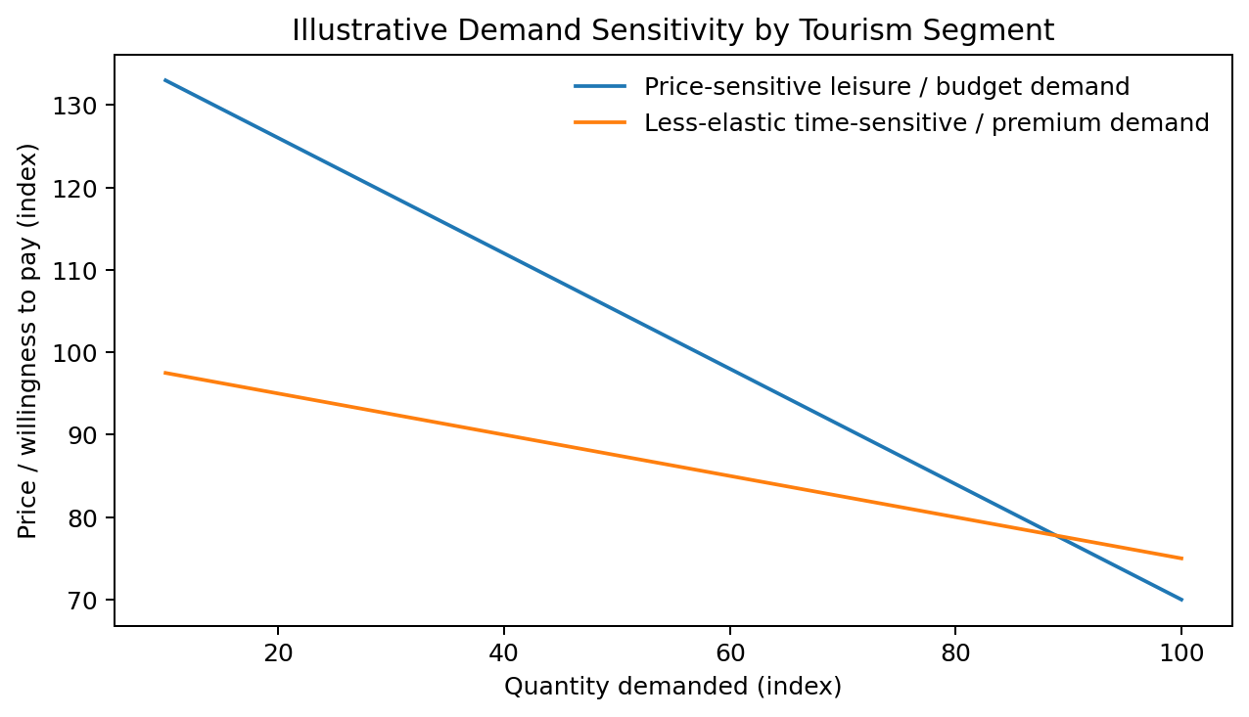
Figure 1. Illustrative demand curves showing how a more elastic segment reduces quantity more strongly when price rises. Source: author’s economic illustration based on elasticity theory.

Income Elasticity and Budget Hospitality
YED provides a different managerial signal. Premium experiences are generally discretionary, so a reduction in real disposable income can shift households from suites to standard rooms, from long-haul to short-haul holidays, or from paid upgrades to basic products. The relevant response is not necessarily cancellation of the trip; it can be trading down within the tourism bundle. Budget accommodation can consequently receive substitution demand during a downturn even while total tourism demand weakens. This makes YED for an individual budget brand ambiguous across income groups: it may be positive for lower-income travellers, close to zero for necessity-driven stays, or even negative in some markets if consumers trade down from more expensive hotels when income falls.
Price sensitivity in hotels is also shaped by search costs and platform transparency. Online travel agencies expose room rates across many properties, reducing the information advantage of an individual hotel and making the budget segment especially comparison-intensive. Singh and Corsun (2023), examining hotel demand around the COVID-19 disruption, show that elasticity is not a fixed structural number; it can change with market conditions and the intensity of the shock. Managers should therefore treat elasticity as an estimated behavioural parameter that is refreshed frequently rather than a static assumption embedded permanently in the pricing system.
Table 1. Economic determinants of PED and YED in the two focal markets
Determinant | Luxury travel | Budget hospitality | Pricing implication
Close substitutes | Cabin, carrier, date or destination alternatives | Many comparable properties and channels | More substitutes increase PED
Urgency / booking horizon | Late business demand may be less elastic | Late leisure demand varies by event scarcity | Estimate elasticity by booking window
Income sensitivity | Typically high positive YED for discretionary premium spend | Lower/ambiguous YED; can benefit from trading down | Use macro indicators in demand forecasts
Switching/search costs | Loyalty and schedules can raise switching costs | Online comparison lowers search costs | Avoid uniform mark-ups across segments
Capacity scarcity | Aircraft seats strictly perishable | Rooms strictly perishable | Use scarcity, not customer identity, as a transparent pricing signal

Market Equilibrium, Consumer Surplus and Rate Fences
In a simple competitive model, equilibrium occurs where quantity demanded equals quantity supplied. Tourism capacity complicates the supply side because the short-run supply curve is steep: a hotel with 300 rooms cannot provide 330 rooms on a sold-out night, and an aircraft cannot safely exceed its seat capacity. When demand shifts outward, the scarcity value of remaining inventory therefore rises sharply. A fixed price set too low produces excess demand and transfers scarcity rents to customers who happen to book first; a price set too high leaves perishable capacity unused. Dynamic pricing attempts to continually update the effective market-clearing price as the firm learns about demand.
Consumer surplus is the gap between willingness to pay and the price paid. A uniform tariff leaves substantial surplus to high-willingness-to-pay customers. Dynamic pricing can capture part of that surplus through intertemporal price discrimination. This is not automatically a deadweight-loss problem: if lower off-peak prices stimulate additional trips or increase occupancy, total gains from trade can rise. Conversely, an algorithm that pushes peak prices above the willingness to pay of consumers who would have generated positive incremental contribution may create inefficient empty capacity. The welfare effect is therefore empirical rather than ideological. Managers need to distinguish revenue extracted by better segmentation from revenue destroyed through demand suppression.
Rate fences are the practical bridge between theory and customer acceptance. An advance-purchase discount, non-refundable rate, loyalty benefit or minimum-stay rule provides an observable reason why two customers pay different prices. Kimes and Wirtz (2003) found that revenue-management practices are more likely to be perceived as fair when the conditions separating rates are understandable. For upscale hotels, Oh (2003) likewise shows that fairness perceptions affect broader judgments of value and quality. Therefore, market equilibrium cannot be managed only with a revenue objective; perceptions feed back into repeat demand and hence into the future demand curve.

Elasticity Estimation, Sensitivity Testing and Decision Quality
A major managerial challenge is that observed bookings do not reveal the full demand curve. The firm sees customers who accepted the offered price, but it does not directly observe the willingness to pay of people who searched and left, chose another date, booked a rival, or abandoned the trip. Reliable PED estimation therefore requires data on search and conversion as well as completed sales. For an airline, the unit of analysis should include itinerary, departure date, cabin and booking horizon; for a hotel, it should include stay date, length of stay, room type, channel and cancellation terms. Aggregating across these dimensions can create an elasticity estimate that is statistically precise but operationally misleading (Phillips, 2005).
Price is also endogenous because revenue managers increase rates when they expect demand to be strong. A naive regression may then find that high prices coincide with high sales and incorrectly infer that customers prefer higher prices. The solution is to control for the variables that generated the rate decision or to use controlled experiments where commercial risk is limited. Similar low-demand dates can be assigned modestly different price paths, with conversion and contribution compared after controlling for channel mix. The aim is not experimentation for its own sake; it is to identify the causal response of quantity to price so that the revenue engine does not confuse demand strength with price effectiveness.
Sensitivity analysis should accompany every recommended price. Instead of presenting one “optimal” rate, managers can calculate expected contribution under a central elasticity and under plausible higher- and lower-elasticity cases. If the recommended price changes dramatically with a small change in the elasticity assumption, the decision is fragile and should be constrained. This is especially relevant for new routes, newly opened hotels and unusual events where historical observations are sparse. A conservative rate path with frequent updating can have higher expected value than an aggressive model built on uncertain parameters.
The demand model should also recognise cancellation and no-show behaviour. A low refundable rate can attract bookings that later cancel, giving a false impression of demand strength and causing the system to close cheaper inventory prematurely. A non-refundable rate may produce fewer gross bookings but higher realised occupancy. Revenue management therefore needs an expected-show measure rather than raw reservations. Talluri and van Ryzin (2004) emphasise that stochastic demand and capacity control are inseparable; in practice, uncertainty includes not only who will book but who will ultimately consume the capacity.
Competitor reaction creates another source of instability. If Emirates raises a fare and rivals do not respond, the observed quantity loss may be larger than expected; if rivals match, the demand effect may be smaller. Accor properties face the same strategic interaction at destination level. Cross-price elasticities should therefore be estimated for the most relevant alternatives. A rate can be optimal against yesterday’s competitive set and suboptimal after a rival adds capacity, launches a promotion or changes product quality. Dynamic pricing needs dynamic competitive measurement.
Finally, the model should be evaluated on calibration, not only revenue. A well-calibrated forecast says that dates predicted to have a 70% probability of selling out actually sell out at approximately that frequency. Persistent overprediction leads to high prices and spoilage; underprediction leads to premature discounting. A forecast-error dashboard by segment, event and booking horizon provides an early warning before mistakes become embedded in automated decisions. Elasticity estimation is therefore a governance process as much as a statistical exercise.

Macroeconomic Environment & Policy Impact
Although the report is microeconomic in focus, elasticity estimates are conditional on the macroeconomic environment. Inflation reduces real purchasing power and raises airlines’ and hotels’ operating costs. Interest rates affect corporate travel budgets and discretionary household spending, while exchange rates change the destination price faced by international visitors. A depreciation of a destination currency can make hotels cheaper to foreign visitors but may simultaneously raise imported food, energy, technology and aircraft-related costs. YED and cross-price elasticity therefore interact with macro variables rather than operating in isolation.
For Emirates, exchange rates matter because revenue and costs arise across a global network. The carrier’s 2025–26 results explicitly noted currency movements as one of the factors influencing financial performance (Emirates Group, 2026). A revenue-management system that forecasts demand using only historical booking curves can therefore misread a macro shock as a route-specific change in willingness to pay. A stronger approach combines booking data with forward-looking indicators such as consumer confidence, major-event calendars, inflation, exchange-rate movements and origin-market income growth.
Public policy also constrains pricing behaviour. Consumer-protection rules require that advertised prices and mandatory charges are communicated clearly, while competition policy limits collusive coordination and abuse of market power. These policies do not eliminate dynamic pricing, but they increase the value of explainable algorithms and auditable pricing logic. A pricing engine that can identify the economic reason for a rate movement—inventory scarcity, booking horizon, refundable conditions or demand forecast—creates a better compliance position than one that relies on opaque proxies that may unintentionally discriminate among customers.
Macroeconomic conditions also affect the composition of customers, which can change observed elasticity even when individual preferences are stable. During a strong expansion, more households may enter the premium-travel segment, while corporate budgets permit greater flexibility and shorter booking horizons. During a downturn, the remaining premium travellers can be disproportionately high-income or necessity-driven, creating the misleading appearance that premium demand has become less elastic. A revenue manager should therefore separate within-segment behavioural change from changes in the mix of customers. Cohort-based demand models and origin-market indicators help avoid attributing every shift in booking response to price alone.
Fuel, labour and financing costs influence the supply side as well. When unit costs rise, a firm may increase its minimum acceptable rate even if the demand curve has not moved. In the very short run the relevant benchmark is incremental contribution because the aircraft is already scheduled or the hotel is already open; over a longer horizon, prices must contribute to fixed fleet, property and technology costs. Phillips (2005) emphasises that pricing decisions should be evaluated against the objective and time horizon of the business. For tourism managers this means that temporary tactical discounts can be rational in low demand periods, but persistently selling below sustainable contribution cannot be justified by occupancy targets.

Empirical Data & Case Study Analysis

Case Study 1: Emirates – Yield Management in a Premium Network Airline
Emirates demonstrates why occupancy alone is an incomplete objective. In 2025–26 the airline reported 53.2 million passengers and a 78.4% seat factor, alongside AED 130.9 billion of revenue and AED 19.7 billion of profit after tax (Emirates Group, 2026). A manager could raise seat factor by discounting heavily, but the resulting reduction in yield may lower total contribution. Conversely, protecting too many seats for expensive late demand risks departure with empty capacity. The economic problem is to set booking-class availability and prices so that the expected marginal revenue from selling a seat now is compared with the option value of retaining it for a later customer.
Emirates’ premium positioning also means that the demand curve is multidimensional. A customer buys not only transport but a specific departure time, cabin, baggage allowance, lounge access, flexibility and network connection. These product attributes create legitimate segmentation opportunities. A lower price for a restrictive ticket can attract an elastic leisure segment without necessarily cannibalising a business customer who values changeability. Escobari et al. (2019) document dynamic price discrimination in airline markets and show how fares evolve as departure approaches, reinforcing the point that the observed fare is an outcome of inventory state and customer timing rather than a single stable route price.
Table 2. Selected Emirates 2025–26 indicators and their pricing interpretation
Indicator | Reported outcome | Economic interpretation
Revenue | AED 130.9 billion | Large network creates high value from small improvements in yield
Profit after tax | AED 19.7 billion | Pricing must be read with cost and capacity discipline
Passengers | 53.2 million | Substantial heterogeneous demand supports segmentation
Seat factor | 78.4% | Occupancy below 100% can still be revenue-optimal
Passenger yield | 38.1 fils per RPKM | Yield is a direct complement to load-factor analysis

Case Study 2: Accor – Dynamic Room Pricing Across Brand Tiers
Accor offers a useful comparison because one group manages brands spanning economy through luxury and lifestyle. In 2025 the group reported EUR 5.639 billion in revenue, a 4.2% increase in RevPAR and particularly strong growth in its Luxury & Lifestyle division (Accor, 2026). The portfolio structure means elasticity varies not only by city and date but by brand promise. An economy hotel competing with multiple nearby alternatives may need a flatter price path to remain visible in online comparisons, whereas a luxury property attached to a unique experience or sold-out event can face substantially less elastic peak demand.
RevPAR—revenue per available room—captures the joint outcome of average daily rate and occupancy. Dynamic pricing should therefore be judged by its effect on RevPAR and gross operating profit rather than average rate alone. A high rate that causes a disproportionate occupancy loss can reduce RevPAR, while a discount can be profitable if the incremental room sale contributes more than its variable servicing cost. This is exactly where elasticity estimation becomes operational: the revenue-maximising price for a given date is found where the percentage gain in price is balanced against the percentage loss in demanded rooms.
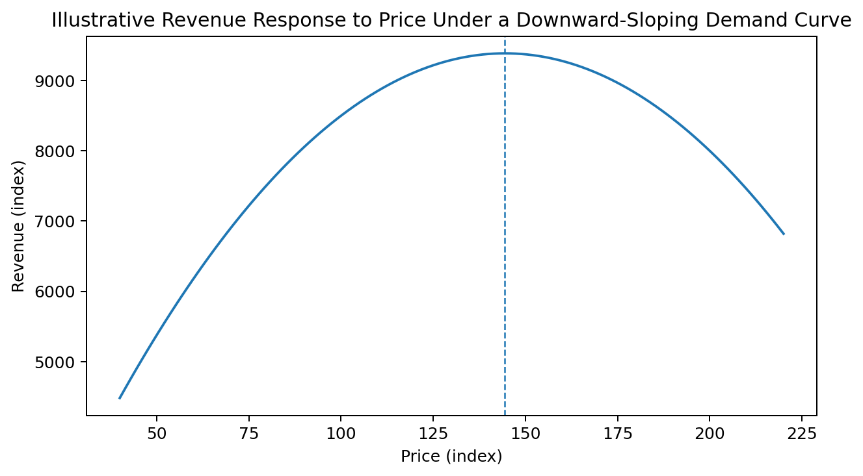
Figure 2. Illustrative total-revenue curve. Beyond the revenue-maximising point, a further price rise reduces revenue because quantity demanded falls too strongly. Source: author’s economic illustration.

Revenue Maximisation Versus Consumer Perception
The strategic risk is that a technically rational price can still be commercially damaging if it violates reference-price expectations. Customers remember prior rates, compare across channels and share screenshots publicly. A dramatic price increase during a concert or disruption may be consistent with scarcity pricing, but the customer may interpret it as opportunism. In an upscale context, Oh (2003) shows that perceived fairness influences evaluations beyond price itself. Thus, the algorithm changes the future demand curve when it changes trust.
A second barrier is data quality. Demand forecasts trained on unusual periods can systematically over- or under-predict willingness to pay. The COVID-era evidence analysed by Singh and Corsun (2023) demonstrates that elasticities can shift in a structural disruption. A system that learns from pre-shock history without regime detection may protect inventory for demand that never arrives. Hotels and airlines therefore need human override rules, event validation and post-stay/post-flight analysis of forecast error by segment.
Another empirical difficulty is endogeneity: firms often raise prices precisely when they expect strong demand. A simple correlation between high prices and high bookings can therefore suggest, incorrectly, that demand slopes upward. Reliable elasticity estimation needs instruments, experiments or controls for the demand conditions that caused the price change. In practice, firms can use carefully bounded A/B tests on similar low-risk dates, exploit natural variation across comparable markets, or estimate models that include event, season, day-of-week and remaining-capacity variables. Jayaram et al. (2024) demonstrate why elasticity information becomes useful only when it is integrated with allocation, rather than treated as a descriptive statistic.
Channel economics provide an additional layer. A direct booking and an online-travel-agency booking at the same gross rate may produce different net contribution because of commission, loyalty cost and payment expense. An economically sound pricing system should therefore optimise net revenue while maintaining rate-integrity commitments. For Accor, this can mean using member benefits or value-added packages rather than visibly undercutting channels. For Emirates, direct-channel merchandising can bundle seat selection, baggage or flexibility. Such differentiation can reduce pure price comparison and make customer choice more closely reflect product value.

Strategic Implications for Tourism

A Guardrailed Dynamic-Pricing Policy
The recommended policy is not to abandon algorithms but to constrain them with economic and relationship-based guardrails. First, estimate demand curves at the smallest segment for which there is sufficient data, rather than assigning one elasticity to all customers. Second, separate product attributes from pure price discrimination: refundability, baggage, room view, meal inclusion or loyalty benefits provide observable value differences and make rate fences easier to defend. Third, introduce rate-change thresholds that trigger human review when a price moves beyond a historically plausible range without a corresponding scarcity or event signal.
Fourth, optimise a multi-period objective. A revenue engine should include expected repeat value and cancellation risk, not only current-transaction revenue. If a price increase produces an additional EUR 50 today but raises churn enough to destroy a future booking with EUR 200 contribution, the short-run optimum is not the long-run optimum. This can be measured through controlled tests using holdout groups, provided experiments do not expose consumers to misleading or discriminatory practices. Fifth, fairness should be measured as a leading indicator. Complaint ratios, abandonment after price refresh, channel-switching and loyalty redemption can reveal customer resistance before it appears in annual market share.
Table 3. Recommended managerial control system for dynamic pricing
Control | Economic purpose | Suggested KPI
Segment-level elasticity refresh | Avoid stale average PED assumptions | Forecast error and realised elasticity
Transparent rate fences | Differentiate products without arbitrary treatment | Fairness/complaint rate
Extreme-change review | Prevent erroneous scarcity signals | Share of prices outside control bands
Long-run value objective | Protect repeat demand | Customer lifetime contribution / churn
Capacity-release rules | Balance late high-yield demand with spoilage risk | Yield, load factor/occupancy, spoilage
Post-event audit | Learn from shocks and special events | Forecast bias by event and segment

Barriers, Governance and Implementation
Implementation requires coordination across revenue management, marketing, finance, operations and data governance. Revenue managers understand booking curves; marketing teams understand brand promises; finance understands contribution margins; operations know capacity constraints; and data teams understand model limitations. A pricing committee should agree the objective function and escalation rules in advance so that the organisation does not react inconsistently when a peak-demand event attracts public attention.
Algorithmic governance should also include bias testing. Personalised offers can become problematic when variables correlated with protected characteristics or consumer vulnerability influence price. A safer tourism design bases core price movements on inventory, time, channel costs, product conditions and aggregate demand signals rather than inferred individual desperation. The fact that dynamic pricing can increase producer surplus does not justify every form of discrimination. The sustainable approach is one where the economic logic can be stated plainly to a customer or regulator.
Governance should finally include a formal learning cycle. Before a major event, managers should record the forecast, the assumed elasticity and the rate strategy. After the event, they should compare realised pick-up, cancellations, channel mix, ancillary spend and customer feedback with the assumptions. Large errors should be classified as forecast error, elasticity error, competitor response or operational constraint. This converts exceptional peaks into future training data and reduces the temptation to judge success only by a record average rate. A strategy that achieved a very high rate but left profitable capacity empty may be inferior to a lower-rate strategy that generated more total contribution and stronger repeat intent.
For senior management, the dashboard should consequently combine financial and behavioural indicators. Yield, RevPAR and contribution margin show immediate performance; load factor or occupancy shows utilisation; forecast error indicates model quality; cancellation and abandonment indicate customer response; and complaint/fairness metrics signal reputational risk. No single KPI is sufficient. The economic objective is to maximise sustainable producer surplus subject to capacity, legal and relationship constraints, not to maximise the highest visible rate on an individual transaction.

Conclusion & Recommendations
Price elasticity and income elasticity are not textbook abstractions; they determine whether a tourism price change raises or lowers revenue. Luxury travel tends to combine high income sensitivity with heterogeneous price sensitivity, while budget hospitality frequently faces stronger substitution and comparison effects. Because seats and rooms are perishable and short-run supply is constrained, dynamic pricing can move firms closer to market-clearing outcomes, stimulate off-peak demand and protect scarce peak inventory. However, the welfare and strategic effect depends on whether the algorithm improves matching or simply pushes prices past customers’ willingness to pay.
The Emirates and Accor cases reinforce the need to manage yield and RevPAR jointly with occupancy. The recommended managerial actions are to estimate elasticity by segment and booking horizon; embed macroeconomic signals in forecasts; use clear value-based rate fences; set review thresholds for extreme changes; optimise customer lifetime contribution as well as immediate revenue; and monitor fairness, abandonment and complaints as economic indicators of future demand. Dynamic pricing is most defensible when it is explainable, reversible when forecasts fail and grounded in observable scarcity. Under those conditions, a tourism firm can increase profitability without eroding the trust that sustains long-run market demand.

References
Accor. (2026). Full-year 2025 results. Accor Group. https://group.accor.com/en/finance
Emirates Group. (2026, May 7). Emirates Group announces 2025–26 results. https://www.theemiratesgroup.com/annual-report/
Escobari, D., Rupp, N. G., & Meskey, J. (2019). An analysis of dynamic price discrimination in airlines. Southern Economic Journal, 85(3), 639–662. https://doi.org/10.1002/soej.12309
Jayaram, A., Amit, R. K., Agarwal, A., & Luo, X. (2024). Elasticity-integrated pricing and allocation heuristic for airline revenue management. Journal of Revenue and Pricing Management, 23, 305–317. https://doi.org/10.1057/s41272-023-00454-6
Kimes, S. E., & Wirtz, J. (2003). Has revenue management become acceptable? Findings from an international study on the perceived fairness of rate fences. Journal of Service Research, 6(2), 125–135. https://doi.org/10.1177/1094670503257038
Oh, H. (2003). Price fairness and its asymmetric effects on overall price, quality, and value judgments: The case of an upscale hotel. Tourism Management, 24(4), 387–399. https://doi.org/10.1016/S0261-5177(02)00109-7
Phillips, R. L. (2005). Pricing and revenue optimization. Stanford University Press.
Selçuk, A. M., & Avşar, Z. M. (2019). Dynamic pricing in airline revenue management. Journal of Mathematical Analysis and Applications, 478(2), 1191–1217. https://doi.org/10.1016/j.jmaa.2019.06.012
Singh, A., & Corsun, D. L. (2023). Price elasticity of demand and its impact on hotel revenue performance during the COVID-19 pandemic. Cornell Hospitality Quarterly, 64(4), 415–435. https://doi.org/10.1177/19389655231184475
Talluri, K. T., & van Ryzin, G. J. (2004). The theory and practice of revenue management. Springer.

Appendices
Appendix A. Economic notation: PED = percentage change in quantity demanded / percentage change in price. YED = percentage change in quantity demanded / percentage change in consumer income. Revenue = price × quantity sold. RevPAR = room revenue / rooms available.
Appendix B. Figure notes: Figures 1 and 2 are analytical illustrations constructed for this report. They are not reproductions of proprietary Emirates or Accor demand curves. Company performance statistics in the case analysis are attributed to the organisations’ published results.

