

Sales Management
Option 3: Sales Management in the Post-Pandemic Tourism Industry: Adapting to
Changing Consumer Preferences

Table of Contents
Sales Management 1
Abstract 4
1. Introduction 5
1.1 Context and Importance of the Study 5
1.2 Rationale 5
1.3 Aim and Objectives 5
2. Literature Review 6
2.1 Significance of post-pandemic consumer preferences on sales strategies in the tourism industry 6
2.2 Impact of digital tools and platforms on adapting to new consumer behaviours in post-pandemic tourism landscape 7
2.3 Challenges faced by tourism businesses in responding to new consumer preferences post-pandemic 7
2.4 Strategies for overcoming the challenges in adapting sales strategies to meet post-pandemic consumer preferences in the tourism market 8
2.5 Theoretical Implication 9
2.6 Literature gaps 10
3. Methodology 10
4. Findings 12
4.1 Theme 1: The significance of post-pandemic consumer preferences in Germany's tourism sales strategies 12
4.2 Theme 2: The impact of digital tools on adapting sales strategies in the tourism industry 13
4.3 Theme 3: The challenges tourism businesses face in responding to new consumer behaviours 13
4.4 Theme 4: Strategies for overcoming challenges and adapting sales strategies in post-pandemic tourism 14
5. Discussion 15
5.1 Discussion 15
5.2 Limitations 16
6. Conclusion 17
6.1 Summary of Key Findings 17
6.2 Recommendations and future scope 17
References 19

Abstract
In this work, the author examined how the consumer preferences of post-pandemic would affect the sales policies in the German tourism sector, in terms of wellness travel and eco-tourism. It also discussed how online platforms, including CRM systems and online booking platforms, contributed towards business capacity to adjust to the emerging trends in consumer behaviours. The results showed that there was an upsurge in the demand of the green and well-being-related travelling, but tourism enterprises, especially SMEs, suffered financial and resource constraints in covering the demands. The paper has indicated that sustainability and profitability should be balanced and suggested incorporating digital technology and authentic experiences as the competitive tourism market continues to change.

1. Introduction

1.1 Context and Importance of the Study
The effect of the COVID-19 pandemic on the tourism industry globally, and Germany is not an exception, is transformative since the preference of consumers has completely changed. Increased attention to wellness travel and eco-tourism in the aftermath of the pandemic has led to the necessity to change the approaches of tourism companies towards sales (Somrak & Khaewmesuan 2022). With the recovery of travel underway, it is important to know how the transforming preferences are going to affect the tourism sales environment. The current research seeks to examine how the German tourism enterprises can react to these changing trends and modify their strategies to appeal to the new post-pandemic traveller.

1.2 Rationale
This research is based on the idea that the businesses of tourism in Germany should learn how to cope with the evolving consumer preferences due to the pandemic. Tourism businesses will have the challenge of adjusting their sales patterns as wellness travel and eco-tourism become key elements in the priorities of travellers (Yu et al., 2024). As competition intensifies and the need to be environmentally friendly in the tourism sector increases, this study will offer a solution on the strategies that are needed to address such new demands. The research is also a part of the larger discussion on post-pandemic tourism recovery, which focuses on practical solutions to businesses in Germany.

1.3 Aim and Objectives
This research is intended to examine the way in which retailer preferences in the tourism sector in Germany are shaping up the sales strategy in the post-pandemic period and to provide a set of workable measures that a business can use to adapt to the new environment and be successful in the competitive market.
- To examine the significance of post-pandemic consumer preferences on sales strategies in the German tourism industry
- To assess the impact of digital tools and platforms on adapting to new consumer behaviours in post-pandemic Germany
- To identify the challenges faced by tourism businesses in Germany in responding to new consumer preferences post-pandemic
- To propose strategies for overcoming the challenges in adapting sales strategies to meet post-pandemic consumer preferences in the German tourism market

2. Literature Review

2.1 Significance of post-pandemic consumer preferences on sales strategies in the tourism industry
Due to the pandemic, consumer behaviour has been greatly altered, where wellness and eco-tourism are more emphasized. Uysal (2022) identify that the pandemic has made people more aware of health and sustainability, so these two concepts have taken centre stage in tourism decisions. Wellness travel as a trend has gained popularity due to the interest in health and well-being, whereby more people demand destinations that provide nature-based, restorative experiences (Dragut & GURGU, 2023). Meanwhile, eco-tourism has been increasing at a high pace, with tourists looking at more eco-friendly alternatives. Nonetheless, there is no easy sailing in the adoption of these preferences. Orîndaru et al. (2021) states that these trends are visible and significant, but their future effects cannot be fully determined, as most consumers can be inclined towards returning to the preferences before the pandemic as soon as the restrictions are removed. The literature also emphasizes that tourism companies have to modify their selling models to suit such new demands.

2.2 Impact of digital tools and platforms on adapting to new consumer behaviours in post-pandemic tourism landscape
The pandemic has increased the pace of digital transformation of the tourism industry because companies shifted to online booking services and CRM systems and digital methods of marketing to get in touch with consumers. Hoțoi (2024) assert that these tools will be necessary in personalizing the customer experience and adjusting to the new behavioural changes due to the pandemic caused by consumers. The CRM systems allow companies to understand the preferences of customers, customize their offerings, and develop the loyalty programs that will appeal to the modern eco-conscious and health-aware tourists. OTA has also been influential since it offers consumers a platform that enables them to compare, book, and review travel services effectively, thus influencing their buying choices (Toubes et al., 2021). Nevertheless, the use of digital tools has been of concern. An excessive dependence on online platforms will push away those traditional customers who may need personal contact. Moreover, privacy issues are arising as companies discover more and more information about consumer behaviours.

2.3 Challenges faced by tourism businesses in responding to new consumer preferences post-pandemic
German tourism companies have a number of issues in reacting to post-pandemic preferences. The financial burden of the pandemic is also one of the main challenges, as many companies cannot afford to invest in the required infrastructure to accommodate modifications in consumer needs. Corbisiero & Monaco (2021) notes that small and medium-sized enterprises (SMEs), especially, do not have the funds to move to more sustainable operations, including introducing environmentally friendly technologies or providing services that are more wellness-centred. Moreover, the rate of transformation in consumer tastes has congested companies. Bigger companies find it difficult to readjust, as the economic recovery is shifting very quickly to wellness and eco-tourism, with the uncertainty about the economic recovery adding to the problem. The conventional tourism system, which predominantly values convenience and cost, is becoming less and less congruent with the need to have more personalized, sustainable experiences (Dias et al., 2022). The other problem is that it is difficult to strike a balance between profitability and sustainability. In addition, companies have to deal with the challenges of the growing competition as new companies appear to take advantage of the new trends. It is a complicated dilemma of innovation and financial security of the established players.

2.4 Strategies for overcoming the challenges in adapting sales strategies to meet post-pandemic consumer preferences in the tourism market
To address the constraints of changing the sales approach, the tourism companies in Germany need to embrace innovation and online transformation coupled with sustainability. As Eppang et al. (2024) note, sustainability should be incorporated into the business activity. This may involve provision of environmentally friendly travelling packages, minimising carbon footprints, and engaging local communities to support genuine and sustainable experiences. Nevertheless, sustainability is a valuable concept but it might not be sufficient by itself to appeal to the consumers in case it is combined with high prices. According to Vanegas-López et al. (2024), companies ought to consider offering different experiences that are wellness and sustainability-oriented including a retreat of nature or holistic holidays. Personality-based experiences provide the possibility to increase customer loyalty and elevate the level of sales. Moreover, by working with the local stakeholders and communities, businesses will be able to provide differentiated products that the rising demand of authentic and sustainable tourism will identify with. Despite such promising strategies resource limitations are one of the major problems as they might limit small businesses and businesses which might not be able to undertake such changes. As such, companies should tread cautiously on these issues as a way of ensuring that their sales plans are in tandem with the changing consumer demands.

2.5 Theoretical Implication
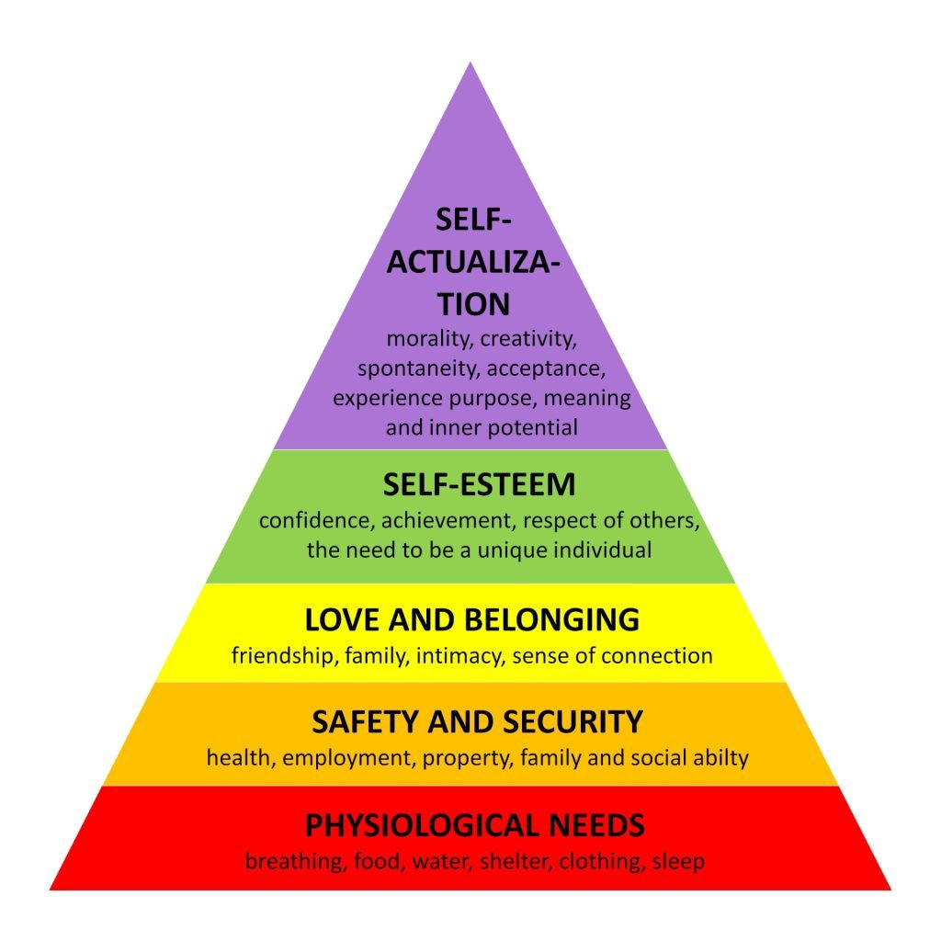
Figure 2.6.1: Hierarchy of Needs
(Source: Inspired by Noltemeyer et al., 2021)
The post-pandemic consumer behaviour changes can be analysed through two important theoretical frameworks, which are the Hierarchy of Needs by Maslow and Diffusion of Innovations Theory. According to Noltemeyer et al. (2021), Maslow's theory, the increased attention to wellness and sustainability is the behaviour of post-pandemic consumers that are focused on their needs of self-actualization and esteem in higher levels. Wellness tourism that is based on health and well-being falls into this model since it gives consumers the opportunity to develop and realize self-fulfilment. The spread of new consumer behaviours, including eco-tourism, in the tourism market is attributed to the Diffusion of Innovations Theory (Acikgoz et al., 2023). This theory puts emphasis on the innovators and early adopters with regard to the adoption of sustainable practices and preferences in the tourism industry. Using these frameworks, the research will be able to examine the ways in which tourism enterprises can implement and popularize the new strategies to match the emerging requirements of wellness and eco-friendly travel.
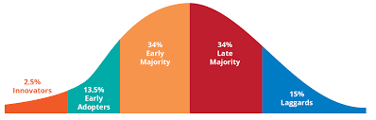
Figure 2.6.2: Diffusion of Innovations Theory
(Source: Inspired by Acikgoz et al., 2023)

2.6 Literature gaps
Although the current literature is rich in terms of the information about the post-pandemic consumer preferences and digital tools, there is an apparent absence of literature that concentrates specifically on the tourism industry in Germany. To a large extent, the current work is of the international nature, thus there is scant localizability of the specific dynamics of the German market. Also, little studies have been done on the operational issue that small and medium-sized companies confront in order to adjust to these new preferences, especially in relation to the available resource base. This is an aspect that the study will require greater elaboration in the long-term efficacy of digital applications in the development of sustainable sales in the German tourist industry.

3. Methodology
The present research used the interpretivist approach, where it was important to interpret the subjective experiences and perceptions of tourism businesses in Germany with regard to how they adjusted to changed consumer preferences in the post-pandemic environment. Interpretivism proved to be the appropriate theory to be used in terms of examining the perception of the shift to wellness and eco-tourism through individuals and organizations because interpretivism does not focus on objective measures, but rather context and meaning (Ali et al., 2021). This corresponded to the research objective of knowing the subtleties of how the tourism enterprises react to changing consumer needs.
The theoretical framework of the study was inductive, whereby the researcher started with certain observations and made generalizations. The research was aimed at informing future sales strategies and marketing methods using the patterns and theories, derived by the research basing on real-world data by examining the experiences of tourism companies (Proudfoot, 2023). This method was quite suited as the effects of the pandemic on tourism were novel, and there were no existing theories that considered the combination of consumer behaviour, sustainability, and digital transformation in that regard.
To achieve an in-depth description of the post-pandemic sales strategies used in Germany by tourism companies, the descriptive research design was selected. The descriptive style enabled an in-depth discussion between the issues the businesses had to face, the electronic devices that were used, and the plans that were developed to address the demand of consumers towards wellness and eco-tourism (Flick, 2022). This assisted in establishing trends relating to how businesses were altering their activities so as to fit the emerging consumer values; especially those associated with sustainability.

The study utilized secondary qualitative research method where the existing literature, reports and industry case studies were utilized. The secondary data was also beneficial, providing a broad spectrum of views, including market tendencies, reports by tourism authorities and the views of other works on the topic of post-pandemic consumer behaviour. This facilitated thorough coverage of the topic content and resource limitation contributing to primary data gathering.
Theoretical analysis Thematic analysis technique described by Braun and Clarke (2006) was used to analyse the data, thus giving some form of structured approach to identifying, analysing, and reporting patterns (themes) in qualitative data. This study was suitable to thematic analysis since it facilitated the investigation of common themes in a range of research studies in clarifying the main problems and the strategies that tourism firms used in transforming to meet new consumer demands. The strategy allowed to find not only the obstacles that companies faced but also the solutions that they found, which allowed looking at the overall picture of how the sector returned to its regular operations.
Ethics was a major consideration in the study, especially in the consideration that secondary information was utilized in a responsible manner (Hasan et al., 2021). The study has followed ethical principles in terms of utilizing and mentioning sources thus avoiding giving credit to original authors. Also, the privacy and intellectual property rights were upheld by securing the confidentiality of the data where necessary.

4. Findings

4.1 Theme 1: The significance of post-pandemic consumer preferences in Germany's tourism sales strategies
The sales approaches in the tourism sector in Germany have been affected greatly due to sales preferences such as wellness travel and eco-tourism, which are emerging after the pandemic. Richartz et al. (2025) state that the pandemic has fuelled attention to health and sustainability in consumers, and hence, demanded wellness and eco-friendly experiences in travelling. Nonetheless, the results also reveal that there are a few practical difficulties encountered by tourism businesses in adjusting to such new preferences. Odeyemi et al. (2024) justifies this by stating that a business that incorporates sustainable practices in their provision has a better chance to fulfil this increasing consumer demand. Due to this, tourism firms in Germany are changing their sales approach to include more environmentally friendly and healthy travel packages in order to appeal to these post-pandemic tourists.

4.2 Theme 2: The impact of digital tools on adapting sales strategies in the tourism industry
Electronic solutions have been a critical factor in how sales are adjusted in the German tourism industry, such as CRM and the internet booking systems. Adeniran et al. (2024) suggest that such tools help a business to monitor the preferences of consumers and to customize the offering to each individual and have more interactions with the customers. The literature indicates the company could have an edge towards implementing such changes, however, the results indicate that even well-established businesses encounter challenges with regard to the pace of implementation and expense. Conversely, Olayinka (2021) claims that, although digital tools can be used to facilitate the interaction with the customers, excessive dependence on them can drive out business people who are more conventional in terms of communication. Apparently, these issues notwithstanding, both articles conclude that businesses need to continue changing digitally to ensure that they can be competitive in an environment that is changing quickly and consumers require tailor-made, technologically oriented experiences.

4.3 Theme 3: The challenges tourism businesses face in responding to new consumer behaviours
The existing tourism enterprises in Germany are having a hard time adjusting to the new consumer behaviours after the pandemic. Trupp et al. (2025) points out that financial pressure, and especially to the small and medium-sized enterprises (SMEs), has contributed to the challenge in investing in the infrastructure to accommodate the increasing demand of wellness and eco-tourism. Nonetheless, although the literature mentions that the use of digital tools can improve customer engagement, the results indicate that there can be an excessive use of these tools. However, in contrast, Vallaster et al. (2021) notes that even large companies find it hard to keep up with the dynamic changes and combination of sustainability and profitability. Although the consumer demand to adopt sustainable travel is increasing, tourism businesses are usually torn between the emerging demands and the expensive nature of implementing the demands into their operations.

4.4 Theme 4: Strategies for overcoming challenges and adapting sales strategies in post-pandemic tourism
Tourism companies in Germany need to embrace strategic innovations to overcome the challenges caused by the changing nature of consumer behaviours that affect their businesses. According to Onukwulu et al. (2021), it is fitting to incorporate sustainability in businesses through the provision of environmentally friendly travelling packages and minimization of carbon footprints. To pay attention to unique and wellness-oriented experiences which could distinguish businesses in a highly gathered market. The literature gives a theoretical insight on these obstacles whereas the results give empirical support of how these obstacles present themselves in the German tourism sector. Moreover, Obersteiner et al. (2021) propose taking advantage of digital technology, such as the CRM system, to engage customers more individually and strengthen loyalty. With sustainability, digital transformation, and special customer experiences, companies can overcome these difficulties more easily and adjust their sales approaches to accommodate the post-pandemic consumer requirements.

5. Discussion

5.1 Discussion
The results of the literature analysis and the research clearly indicate that the post-pandemic consumer preferences have a strong influence on the tourism sector in Germany. The move towards wellness travel and eco-tourism is not a fad, but a structural shift because there has been a growing consumer regard of sustainability and wellbeing. The results are in line with the literature especially in the fact that the consumer today is putting health and sustainability at the centre of their choice of travel locations. Although, given the current state of the literature surrounding the increased demand of eco-conscious and wellness-focused products, the results indicate that a significant portion of tourism businesses cannot comply with the mentioned demands because of financial and resource limitations, which in turn are the primary problems of SMEs.
A critical comparison indicates that whereas the literature has made claims about the relevance of sustainability as a competitive advantage, the data has highlighted the fact not all the businesses can be in position to incorporate sustainability in its operations. This misalignment of the theoretical capacity of eco-tourism and the business potential is an important lesson to learn. The speed at which the consumer preferences have changed has surprised many tourism businesses and now the only remaining task is to strike a balance between the sustainability practice and profitability.
The presence of the digital tools as the ones that help to change the sales strategy is another aspect to be discussed. The literature underlines the growing use of CRM systems and online booking services in order to work with clients and transform offerings. These results establish that the tools are essential in modernising sales strategy particularly when it comes to meeting the demands of the post-pandemic traveller who seeks customised and technology-driven experiences. Thus endangering some categories of the customers who still appreciate face-to-face communication. This conflict of digital comfort and physical customer service is a factor of significant significance to companies operating in the tourism business.
The problems in the literature like the lack of funds, the capacity to operate, the need to balance sustainability and profitability is supported in the findings. A lot of companies are in the predicament between the rising consumer demand of sustainable products and the economic constraints of the initiatives. The results also indicate that there is a substantial difference between the big corporations which can afford the cost of making such changes and the SMEs which find it difficult with the scarce resources at their disposal.
The approaches to sustainability, utilising digital tools, and providing unique experiences suggested in the literature are consistent with the recommendations in the findings. Digital transformation and sustainability are two keywords that businesses cannot do without to be competitive. Nevertheless, the results point to the fact that companies have to pay attention to the provision of distinct and authentic experiences as well, to support the evolving demands of the post-pandemic tourists. Specifically, companies ought to think of how they can customize their products to suit the needs of the wellness and eco-tourism seeking consumers, and remain profitable. It is the capacity to keep a balance between these factors that will be a key to success in changing the tourism environment.

5.2 Limitations
Although this research offers important perspectives of the post-pandemic tourism situation in Germany, it has certain drawbacks. First, the study mostly depends on secondary data sources which might not be able to capture the presently fast-growing consumer behaviours and business strategies. Also, the study is not conducted on the German tourism market and the results cannot be extended to other regions and countries that may have different market forces. Lastly, the research also fails to dive deeper into the opinions of consumers themselves, which would give a better idea of what they specifically like or dislike and how they react in the post-pandemic setting.

6. Conclusion

6.1 Summary of Key Findings
The radical change in consumer preferences in the years after the pandemic is emphasised in this research, where the consumer preferences tend to incline towards wellness vacation and eco-tourism. The tendency towards these preferences and preferences is becoming more an adjustment of tourism businesses in Germany to sales, although financial and resource limitations continue to be a problem, especially among SMEs. Online resources, including CRM and online booking plans, have played a very important role in customising products but excessive dependence on these services might drive some groups of consumers away. The conclusions prove that companies have to find the equilibrium between sustainability and profitability and incorporate the distinctive, genuine experiences into their experience to be able to thrive in the post-pandemic tourism domain.

6.2 Recommendations and future scope
As the results showed, the tourism sector in Germany needs to focus on sustainability and wellness tourism that may meet the consumer demands following the pandemic. This is through incorporation of environmentally friendly practices into their business and provision of customised and wellness-based travel packages (Ernawati et al., 2025). Nevertheless, corporations must not be too dependent on digital tools, as the traditional customer service must be considered as a central element of their plan. Moreover, smaller enterprises must consider the collaboration with bigger organisations in order to share the resources and overcome the financial limitations regarding the realisation of the sustainable practices.
Further studies should concentrate on the primary data to gain an insight into the attitudes and behaviour of consumers towards eco-tourism and wellness travel. A more unified analysis of several areas would give a bigger picture of how these trends are being portrayed in various markets. Long-term sustainability of digital transformation in the tourism industry and its impact on customer loyalty and customer satisfaction could also be examined further. The study would help businesses to acquire essential information that can help them remain competitive in a changing market.

References
Acikgoz, F., Elwalda, A., & De Oliveira, M. J. (2023). Curiosity on cutting-edge technology via theory of planned behavior and diffusion of innovation theory. International Journal of Information Management Data Insights, 3(1), 100152. https://doi.org/10.1016/j.jjimei.2022.100152
Adeniran, I. A., Efunniyi, C. P., Osundare, O. S., & Abhulimen, A. O. (2024). Transforming marketing strategies with data analytics: A study on customer behavior and personalization. International Journal of Management & Entrepreneurship Research, 6(8), 41-51. https://doi.org/10.56781/ijsret.2024.4.1.0022
Ali, M., Shah, A. A., & Shah, S. A. A. (2021). Positivism and interpretivism. Qlantic Journal of Social Sciences, 2(1), 20-26. https://doi.org/10.55737/qjss.928180731
Braun, V. &Clarke, V. (2006) Using Thematic Analysis in Psychology. Qualitative Research in Psychology, 3, 77-101.
http://dx.doi.org/10.1191/1478088706qp063oa
Corbisiero, F., & Monaco, S. (2021). Post-pandemic tourism resilience: Changes in Italians’ travel behavior and the possible responses of tourist cities. Worldwide Hospitality and Tourism Themes, 13(3), 401-417. http://dx.doi.org/10.1108/WHATT-01-2021-0011
Dias, Á., Patuleia, M., Silva, R., Estêvão, J., & González-Rodríguez, M. R. (2022). Post-pandemic recovery strategies: Revitalizing lifestyle entrepreneurship. Journal of Policy Research in Tourism, Leisure and Events, 14(2), 97-114. https://doi.org/10.1080/19407963.2021.1892124
Dragut, M., & GURGU, E. (2023). Tourist mаrket in the current post-pandemic context. Annals of Spiru Haret University. Economic Series, 23(2). https://doi.org/10.26458/2328
Eppang, B. M., Widjaja, H. R., Arifin, M., Azinuddin, M., & Salim, M. A. M. (2024). Model of resilience strategies of small and medium-sized tourism enterprises post pandemic crises in marine-based destination. Journal of Applied Sciences in Travel and Hospitality, 7(2), 105-126. http://dx.doi.org/10.31940/jasth.v4i1.105-126
Ernawati, N. M., Mudana, I. G., Sari, P. Y. W., Indrawati, Y., & Pamularsih, T. R. (2025). Exploring hydrotourism: Health and wellbeing. Journal of Commerce, Management, and Tourism Studies, 4(2), 199-209. https://ympn.co.id/index.php/JCMTS/article/view/365
Flick, U. (2022). The SAGE handbook of qualitative research design.
Hasan, N., Rana, R. U., Chowdhury, S., Dola, A. J., & Rony, M. K. K. (2021). Ethical considerations in research. Journal of Nursing Research, Patient Safety and Practise (JNRPSP) 2799-1210, 1(01), 1-4. https://www.researchgate.net/profile/Moustaq-Karim-Khan-Rony/publication/364406105_Ethical_Considerations_In_Research/links/67b6f077645ef274a489bbb6/Ethical-Considerations-In-Research.pdf
Hoțoi, A. L. (2024). Exploring the Impact of Digital Technologies on Consumer Behavior in the Post-Pandemic Era. Annals of the University Dunarea de Jos of Galati: Fascicle: I, Economics & Applied Informatics, 30(3). https://doi.org/10.35219/eai15840409469
Noltemeyer, A., James, A. G., Bush, K., Bergen, D., Barrios, V., & Patton, J. (2021). The relationship between deficiency needs and growth needs: The continuing investigation of Maslow’s theory. Child & Youth Services, 42(1), 24-42. https://doi.org/10.1080/0145935X.2020.1818558
Obersteiner, G., Gollnow, S., & Eriksson, M. (2021). Carbon footprint reduction potential of waste management strategies in tourism. Environmental Development, 39, 100617. https://doi.org/10.1016/j.envdev.2021.100617
Odeyemi, O., Usman, F. O., Mhlongo, N. Z., Elufioye, O. A., & Ike, C. U. (2024). Sustainable entrepreneurship: A review of green business practices and environmental impact. World Journal of Advanced Research and Reviews, 21(2), 346-358. https://doi.org/10.30574/wjarr.2024.21.2.0461
Olayinka, O. H. (2021). Data driven customer segmentation and personalization strategies in modern business intelligence frameworks. World Journal of Advanced Research and Reviews, 12(3), 711-726. https://doi.org/10.30574/wjarr.2021.12.3.0658
Onukwulu, E. C., Agho, M. O., & Eyo-Udo, N. L. (2021). Framework for sustainable supply chain practices to reduce carbon footprint in energy. Open Access Research Journal of Science and Technology, 1(2), 012-034. https://doi.org/10.53022/oarjst.2021.1.2.0032
Orîndaru, A., Popescu, M. F., Alexoaei, A. P., Căescu, Ș. C., Florescu, M. S., & Orzan, A. O. (2021). Tourism in a post-COVID-19 era: Sustainable strategies for industry’s recovery. Sustainability, 13(12), 6781. https://doi.org/10.3390/su13126781
Proudfoot, K. (2023). Inductive/deductive hybrid thematic analysis in mixed methods research. Journal of mixed methods research, 17(3), 308-326. https://doi.org/10.1177/15586898221126816
Richartz, C., Stark, S., & Kuhlen, M. (2025). Sustainability and crisis: Shifting consumer preferences for food products under the influence of the COVID-19 pandemic in Germany. Journal of Cleaner Production, 496, 145089. https://doi.org/10.1016/j.jclepro.2025.145089
Somrak, W. & Khaewmesuan, R., (2022). Tourism consumption trends changing and tourism promotion after the outbreak of Covid-19. ASEAN Journal on Hospitality and Tourism, 20(3), 1-13. https://doi.org/10.5614/ajht.2022.20.3.01
Toubes, D. R., Araújo Vila, N., & Fraiz Brea, J. A. (2021). Changes in consumption patterns and tourist promotion after the COVID-19 pandemic. Journal of theoretical and applied electronic commerce research, 16(5), 1332-1352. https://doi.org/10.3390/jtaer16050075
Trupp, A., Salman, A., Stephenson, M. L., Chan, L. F., & Gan, J. E. (2025). A systematic review of challenges faced by Micro and small Enterprises in Tourism Destinations: Producing solutions through resilience building and sustainable development. Tourism Planning & Development, 22(3), 301-323. https://doi.org/10.1080/21568316.2024.2307970
Uysal, D. (2022). Gen-Z's consumption behaviours in post-pandemic tourism sector. Journal of Tourism Leisure and Hospitality, 4(1), 67-79. https://doi.org/10.48119/toleho.1099783
Vallaster, C., Maon, F., Lindgreen, A., & Vanhamme, J. (2021). Serving multiple masters: The role of micro-foundations of dynamic capabilities in addressing tensions in for-profit hybrid organizations. Organization studies, 42(6), 911-947. https://doi.org/10.1177/0170840619856034
Vanegas-López, J. G., López-Cadavid, D. A., Mathew, M., Vo-Thanh, T., Restrepo-Morales, J. A., & Sthapit, E. (2024). Bounce-back strategies: Revitalizing the hotel industry post-pandemic. Tourism and Hospitality Research, 14673584241277019. https://doi.org/10.1177/14673584241277019
Yu, Y., Zhang, F., Adu-Poku, K. A., & Appiah, D. (2024). 4-Years into the Pandemic Impacts: A Holistic Reflection and Educational Lessons Learnt in the Tourism and Agriculture Sectors. Sustainability, 16(23), 10617. https://doi.org/10.3390/su162310617

