

Urban Tourism Safety Enhancement Plan
The Travel Tribe
Course: Tourism and Recreation
Student Name: Arvinder Singh
Student ID: DE240016

Table of Contents
Abstract 2
Introduction 3
Literature Review 5
Cross-Cultural Views on Tourism Industry Health and Safety Practices 5
The Importance of Safety in Urban Tourism 6
The Safe City Program's sustainability in an urban tourism setting. 7
Methodology 7
Methodology for determining the elements that affect the safety 8
Data Collection and Sources 8
Method for Tourism Safety System Design 9
Development of Innovative Safety Solutions 10
Findings 10
Integration of economic development with the local economy 11
Saftey Assessment Outcomes 11
Ensure Social Inclusion and Prevent Gentrification 12
Discussion 12
Good practices for the development of saftey 13
Leverage Smart City Technologies for saftey Management 13
Future Trends in Urban Tourism Safety Enhancement 14
Conclusion 15
References 16

Abstract
This report presents a comprehensive Urban Tourism Safety Enhancement Plan under the management of The Travel Tribe.Because different types of travellers have different reasons for visiting, urban tourism draws different kinds of tourists. One way to advertise the city and draw in new tourist groups is by using special events and the awareness they may bring to the host location. Certain sports events, like the Olympic Games and the America's Cup, can draw a broader audience, but special events can draw different types of tourists.This article examines the opinions of visitors regarding their experiences and emotions of safety at an urban site. The findings in this research can be utilised to analyse visitor perceptions, which are especially significant considering the efforts and importance of recruiting tourists to the city, while most studies concentrate on inhabitants' impressions of tourism and safety. City and security officials will therefore be better equipped to determine where their safety efforts need to be concentrated by combining their knowledge of the perceptions held by The Travel Tribe, businesses, and tourists. But before looking at the survey results, it's helpful to look at the background of the study and the theoretical problems surrounding event tourism in an urban setting.This study employs a constructivist paradigm to investigate the social construction of a sense of safety along various time–space dimensions. Given little knowledge of how individuals form views about destination safety and how these feelings may change during a trip, tourists' sense of safety also develops during their journey and varies by destination. This is in contrast to a pre-trip sense of safety, which is based on the information that individuals obtain prior to leaving, and is dependent on how tourists interact with them.

Introduction
The term "safety" usually refers to the state of not being in danger, risk, or injury. Tourism safety is a fundamental feature of a destination and encompasses elements like personal safety, political stability, riots, civil rights violations, and crime rates. The term "safety" in tourism has been studied from a variety of perspectives and defined using various terms, but for The Travel Tribe, these terms generally cover similar phenomena. People's perceptions of safety are also greatly influenced by their prior travel experiences: experienced travellers are typically more risk-tolerant than novices. A quantitative analysis of foreign tourists' propensity to visit particular areas based on their prior experiences (Damos et al., 2021). Individuals who had encountered crime and violence in their lives tended to be more accepting of risk.The Travel Tribespace also has an impact on travellers' perceptions of destination safety. When people are not in their natural surroundings, they often feel more safe. Trying to make judgements in a familiar setting when away from home can lead to irrational emotions. When people are in real locations, their opinions differ. One's cultural orientation is also connected to the "where" query. When presented with the same thing, people from various nations, areas, or cultures are likely to have distinct views of safety and security.
The possibility of risk does not always deter travellers; some find such locations to be enigmatic or daring. According to a qualitative study that conducted in-depth interviews with international travellers, informants classified different regions according to perceived safety: Asia appeared risky but exotic and inviting, Africa appeared dangerous and a place to avoid, and Europe and North America seemed safe. This study contends that tourists' perceptions of safety towards a destination are socially constructed and involve subjective assessments of the external environment based on the time and location of the experience.There is a need for an extensive mobile application which includes weather and safety information, medical advice, and a life rescue system.With the goal to improve tourist safety and security forThe Travel Tribe, especially in larger areas with multiple destinations, we aim to develop a novel mobile application that will outperform current literature-based applications by offering a warning system with critical weather details and information about destination services that mitigate risks such as dehydration, heart attack, and heatstroke; evaluating the risk of heatstroke based on smartwatch data; generating timely reports on abnormal conditions; and establishing seamless interaction with nearby rescue organisations to ensure immediate help for tourists in need. Also, tourism will have real-time information regarding patients’ locations within their service area.Nature, surroundings, economy, culture, society, the landscape, the physical environment of cities and villages, communication modes, regional and urban facilities, financial transactions, human relationships, and investment styles are all parts of the diverse tourism industry. More tourists are drawn to a destination with sufficient natural resources. Consider it an example of the many academics who have written about what sustainable tourism means. Only in civilisations that are sustainable can tourism be sustained. Sustainability urban and regional growth is the umbrella term for sustainable tourism. The research objective of this study is to create a portable solution which fills this gap and improves tourist safety in humid and warm destinations. The research objective was determined by carefully examining the current difficulties faced by tourists in warm as well as humid locations as well as the solutions currently available in the past market.

Literature Review
Each location organises different kinds of tourism according to its own features. Engaging in cultural and natural activities becomes a more compelling incentive to visit for The Travel Tribe. In terms of climatic and green architectural design, the best urban the use of land policy, and the growth of the regional economy, the study methodologies look at tourism strategic planning concepts for new tourist complexes. We also use such theories in practice with a Chabahar beach tourism complex. The evaluation model, which guides the growth of urban tourism in a more sustainable and healthier direction by emphasising not only the economic benefits of tourism but also its impacts of the environment, society, and public health, is where the idea of sustainable development has its deepest roots.

Cross-Cultural Views on Tourism Industry Health and Safety Practices
Risk management strategies used in well-known tourist locations have been the subject of numerous studies, which emphasise how crucial health and safety precautions are. Research has carefully investigated how visitors perceive health risks in well-known locations and the complex variables affecting their behaviour in connection to these risks. Research is still needed, even though the current studies offer valuable viewpoints for evaluating urban tourism's competitiveness (Noor & Anuar, Faiz Izwan, 2020). The fact that the idea of sustainable growth is still not thoroughly and thoroughly included into the assessment system is among the noteworthy gaps.
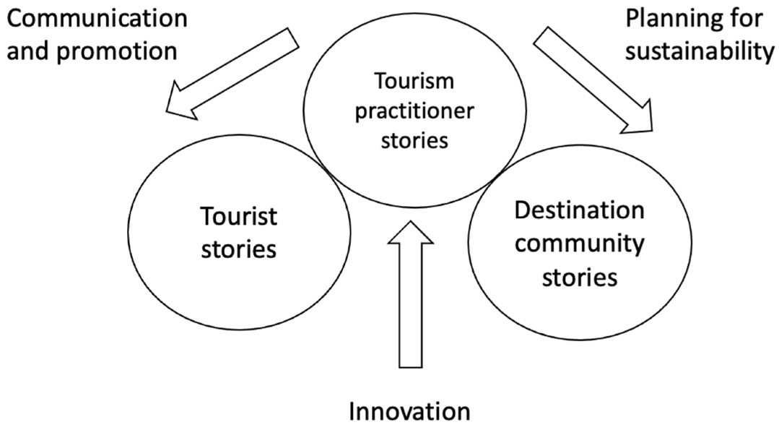
Figure 1 A Strategy for Tourism Growth(McTeigue et al., 2021)
Economic viewpoints such as tourism assets, financial effectiveness, and market size are typically the emphasis of traditional research, which overlooks the combination of environmental, social, and financial elements of sustainable development (Anuar et al., 2012).For example, when it comes to environmental sustainability, detailed research is still required to determine how to incorporate environmental variables into the system used to evaluate urban tourism competition and quantify their effects on the long-term, healthy growth of tourism, even though some studies have started to acknowledge the significance of protecting the environment to tourism competitiveness.

The Importance of Safety in Urban Tourism
A location can draw a wide variety of tourist groups with a range of traveler kinds and goals thanks to urban tourism. Urban areas and associated activities, such city walks, shopping, dining, and more, can be a major component of a visitor's city experience. Regarding the social dimension, the evaluation methods that have been put in place have not sufficiently taken into account the ways that tourism can support social fairness, preserve cultural heritage, improve public services, and foster community development. Thorough research has been done on specific risk management techniques aimed at ensuring adventure tourism safety, especially in pursuits like zip-lining.In order to manage tourist risks and safety, some thought has also been given to integrating wearable technology, such as smartwatches, to enable real-time monitoring, personalised advice, risk evaluation, and emergency support.
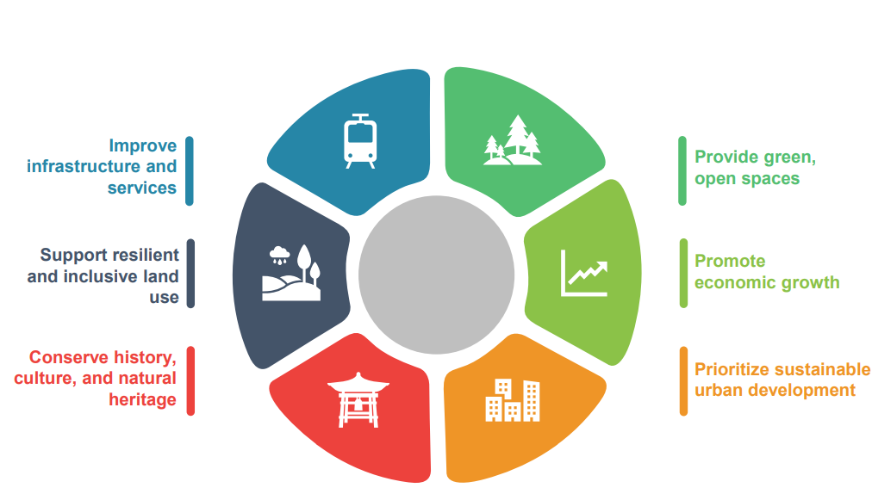
Figure 2Positive experiences that benefit residents and tourist(Integrated and Innovative Solutions, 2023)
People are primarily concerned about preventing crime, and there is still a way to effectively battle crime in general. Notwithstanding the growing worry, a number of crime prevention strategies have been implemented by destinations to reduce crime and improve safety and security measures for urban tourists. An illustration of a crime prevention strategy and a component of the idea of a liveable city is the safe city program. Researchers focused on creating an interactive design for tourism apps that specifically addressed improving safety protocols at different tourist locations. Their creative approach included essential first-aid support to quickly handle any possible criminal occurrences in addition to an emphasis on preventive measures.

The Safe City Program's sustainability in an urban tourism setting.
Certain types of auditing are required by the Safe City Program in order to assess the program's efficacy. He went on to say that in order to maintain and deter crime, a public opinion survey must be carried out frequently to guarantee the program's longevity. It is occasionally given to sufferers at increased risk of re-burglarization. Vulnerable groups, such as the elderly or single parents, high-risk neighbourhoods, or the entire neighbourhood, are given priority. One of the key tactics for implementing the Safe City Program is target hardening, according to the Department of Town and Country Planning (JPBD).It discovered that the project is effective based on the concepts or policy, which is significant. Nevertheless, it isn't more effective. Their analysis revealed that the program's viability may be further questioned, as it has not been able to lower crime rates, with multiple cities still experiencing high rates of crime. Traveler loyalty, engagement, and contentment are important factors that influence the whole experience. Still, not much research has explicitly looked at how using mobile apps affects these outcomes, especially when taking gender and age as well as moderating factors. More research is necessary to fully comprehend how various age and gender groups react to using mobile apps and how it affects their contentment, involvement, and loyalty to tourist destinations.Furthermore, the necessary amenities or components that could improve a park's safety aspect align with the objective of hardeningBased on this, the success of safe city efforts was evaluated, and it was noted that the government has taken numerous steps to guarantee the degree of safety for tourists by providing clear definitions for the ideas.

Methodology
The mixed methods used to develop the saftey issue of the Travel Tribe urban safety are described. The methodology includes a number of activities, including a comprehensive risk analysis, adherence to international safety standards, and the creation of novel, creative solutions to the issues identified.

Methodology for determining the elements that affect the safety
These two elements are necessary for the development and enhancement of any tourist attraction. Many people and tourists are primarily worried about the potential financial and physical harm they could sustain in strange regions. Also, raising awareness is essential to trying to persuade residents and visitors to support the safe city initiative. In this case, awareness refers to the general public's comprehension of the program. The public's view of the program's significance can be improved by the awareness. This would help this industry grow and prosper. Increasing tourism while preserving and expanding existing tourism businesses might be viewed as a suitable strategy to combat unemployment, poverty, and the state of the economy (Lin et al., 2022). This is particularly important in developing nations. Opportunities for employment and economic growth improve community well-being and quality of life in general. Increasing awareness entails more than just outlining the problems and disseminating program details; it also highlights the significance of the program for the community and the general public. For instance, one of these issues has grown victimised in criminal, terrorist, or accident instances.

Data Collection and Sources
This study met two distinct research needs by collecting and analysing both primary and secondary data, Primary information, Resort management, local emergency personnel, and safety managers participated in formal, organised interviews. First off, formal structured interviews are the main data sources that stand to gain a great deal from the creation of our approach.Secondary information, International safety rules, government reports, and scholarly publications were all thoroughly reviewed by the researchers. These publications were available. In addition to conducting structured interviews, we also spoke with resort management, safety managers, and local emergency responders.

Methodfor Tourism Safety System Design
The provision of easily accessible and free drinking water stations at tourist destinations is essential for maintaining visitor safety and preventing heat-related illnesses. In also, there should be easy access to places to rest in the shade, such as shelters umbrellas, or organic tree cover. Additionally, cooling stations such as misting fans, air-conditioned spaces, or fan-equipped shaded places should be put in place. Attraction managers must make staff training and emergency readiness a top priority, keep a careful eye on the weather, and provide information about nearby medical facilities. Furthermore, the safety of people, especially women, was impacted by environmental elements such land use, the variety of perimeter uses, activity hours, and the spatial neighbourhoods of the land. In this context, it is thought that altering the location's featuressuch as the appropriate design of the public, commercial, and residential areaswould lead to defensive areas, which will both prevent and address harmful situations. Two approaches were used to gather data, field research and library research. The physical and non-physical elements of the tourist area have been taken into consideration after a review of the current theories on women's safety in touristic public spaces. This study only looks at the physical characteristics of tourist destinations.By providing tailored accommodations and support, special attention should be paid to protecting vulnerable groups, such as the elderly, children, expectant mothers, and people with pre-existing medical conditions.

Development of Innovative Safety Solutions
The effectiveness of tourism has been thoroughly examined by academics and has a strong theoretical underpinning. Numerous academics have examined how geography affects the geographical variation of tourism environmental efficiency; however, the majority of these studies have only examined cross-sectional features of spatial differences and correlations, and they have not yet illustrated spatial relationships, patterns, or changes from the standpoint of spatiotemporal interactions.The perception of modern visitors as "travellers" as opposed to merely tourists is growing. They want to learn more about the physical and human surroundings of the tourism industry as well as have a deeper understanding of the culture. Their desire to interact meaningfully with the place and their quest for personal fulfilment are what motivate them to take a vacation. To identify the influencing components, previous research has primarily used regression models or conventional decomposition techniques to study and analyse the influencing factors of tourist environmental efficiency. Nevertheless, these frequently overlook the variety of motivating elements at various degrees of environmental efficiency in tourism.

Findings
The progress of urbanisation typically coincides with an increase in crime in urban areas, which can lead to a variety of issues within the city. Because of this, safety has emerged as the primary issue that has received a lot of attention lately due to its impact on the local population's quality of life. Throughout the research, some important insights about sustainable tourism and urban development were discovered. The main takeaways and the approach used to tackle issues like economic diversification, environmental sustainability, and social equality are compiled in the table that follows. These insights shaped the project's strategy for striking a balance between tourism growth and more general urban objectives, guaranteeing that revitalisation initiatives benefit both the environment and locals.

Integration of economic development with the local economy
The technique places a strong emphasis on an all-encompassing, inclusive approach to urban development that incorporates smart technologies, green infrastructure, and cultural preservation.As a result, safety is now one metric used to determine quality of life. The integration of tourism into the local economy is ensured and sustained economic growth is facilitated by its sustainable development. Through encouraging local companies and communities to participate in the value as a tourist chain, tourism may spur economic growth and create jobs and industry in the area. By doing this, the local population's standard of living is raised and poverty is lessened.As long as crime rates continue to rise, both locals and visitors will experience increased senses of anxiety. This makes it abundantly evident that rising crime rates will have an impact on both locals' and tourists' safety.

Saftey Assessment Outcomes
When assessing the degree of urban travelling competitiveness, it is typically needed to establish an objective and scientifically valid indicator system, the building of which should adhere to the following principles. This is because the choice and design of the evaluation measure of urban tourism competitiveness have a direct impact on the study's objectivity and scientificity.The concept of quantitative comparability. For the purpose of comparing and analysing competitiveness of urban tourism across various places and time periods, evaluation indicators must to be quantifiable and comparable. To guarantee the comparability and dependability of assessment outcomes, the selection of indicators for assessment should be founded on trustworthy sources of data and statistical techniques.To guarantee the scientific validity and dependability of the indicators, the selection for evaluation metrics should be grounded in rigorous data analysis and scientific theories. The assessment metrics ought to be consistent with the competitiveness of urban tourism as it actually exists, taking into account its determinants and inherent connections.

Ensure Social Inclusion and Prevent Gentrification
This outcome not only demonstrates the model's validity but shows the potential and difficulties that many towns face as they work to build their tourism industries sustainably.One of the fundamental elements of urban life and essential to long-term social and economic growth is the need to reduce crime, stop violence, and give city dwellers the safest possible environment. These goals are addressed by the safe city program. From a practical standpoint, this research will help destination managers and marketers of urban tourism by raising their knowledge of the significance of safe city initiatives and how they raise the standard of safety and security in urban tourism environments. Aside from that, the government and local governments should enhance many aspects of the safe city program tactics. It is evident from relating these findings to the study's goals that the evaluation model put forth in this work significantly advances the area of public health by assisting in the identification and prioritisation of important problems that have a direct impact on environmental sustainability and public health in tourist locations.

Discussion
More persons were able to speak in this area of the street overall because of the aforementioned factors. Because of this, this section of the road was livelier than the first. In contrast to another two sections of the roadway, the third section was in a totally different state. In a fast changing tourism environment, Urban Tourism Safety Enhancement can be achieved through the convergence of innovative technologies and international safety standards. It could be easier to reword it into plain and straightforward prose to improve readability if you didn't have to refrain from using short phrases or repeating any ideas.Conversely, several elements that impacted women's perception of safety were comparatively tolerated, which made this section of the street more appealing and bustling. Moreover, there were more tourists from both domestic and foreign countries in this section.

Good practices for the development of saftey
The sustainable development of cultural tourism can preserve, protect andpromote cultural heritage by encouraging contemporary cultural creation, butalso by enhancing the networking of national, regional and local cultural life. In answer to the research questions regarding the tourists' sense of safety in this tourist area, it should be mentioned that as one moved from the north side of the street to the south side, women's needs were better met by expanding the variety of activities and providing appropriate lighting, making this section of the street a suitable public area for tourism. In order to make this street a desirable place for women, it is necessary to improve its amenities. Also, tourism will have real-time information regarding patients’ locations within their service area. Nature, surroundings, economy, culture, society, the landscape, the physical environment of cities and villages, communication modes, regional and urban facilities, financial transactions, human relationships, and investment styles are all parts of the diverse tourism industry. More tourists are drawn to a destination with sufficient natural resources. Consider it an example of the many academics who have written about what sustainable tourism means. Only in civilisations that are sustainable can tourism be sustained. Sustainability urban and regional growth is the umbrella term for sustainable tourism. This includes making the entire street more readable, encouraging a variety of activities, and offering physical and visual comfort. These actions will draw more people to the area, which will in turn draw both domestic and foreign tourists.Several good practices for the development of urban cultural tourism are identified, with the main ones being cultural routes.

Leverage Smart City Technologies for saftey Management
Researchers typically look at each tourist destination in three different ways to understand its uniqueness and find its similarities: as diverse territorial parts, which means that each one is distinct and different in terms of its size, location, appearance, history, and functions. as expansive urban spaces, which are multifunctional and ambiguous due to the several roles provided simultaneously. A more thorough examination of visitor satisfaction and its potential to mediate the relationship between safe city program tactics and program sustainability would improve our understanding of crime prevention initiatives in urban tourist environments. It is intended that by implementing an efficient safe city course, crimes in urban tourist destinations will be reduced, which might increase visitor numbers, draw in more investors, create job possibilities, and most importantlyimprove the nation's reputation. as products or services of urban tourism, that are rarely created or used exclusively by visitors but rather by a vast number of people.

Future Trends in Urban Tourism Safety Enhancement
The public's comprehension of the program serves as awareness in this context. Raising awareness may improve the public's understanding of the program's significance. Raising awareness includes not just outlining the problems and disseminating information about the program, but also highlighting its significance for the public and the city.The pertinent findings are shown as a conceptual paradigm for measuring vitality in various metropolitan public areas. Research components were acquired for this study after the findings of investigations were compiled and conclusions on the most and least significant factors were reached. Accordingly, adequate lighting, a range of uses and tasks, entertainment, readability of the space, the ability to call for emergency assistance, easy access to environmental information, the cleanliness of passages, and appropriate urban furniture were all necessary elements making urban public spaces physically feel safe. Therefore, raising public awareness is one of the Safe City Program's strategies. The public awareness of the security program is greatly aided by this method. Security and safety campaigns and the distribution of program booklets are two ways to increase awareness. The goal of these activities is to deter crime.

Conclusion
Despite the sample size being small, the representativeness of the research was relatively high due to the fact that the respondents were not only directly related to tourists and culture, but also held important decision-making positions. Nevertheless, it is not possible to generalise the survey's findings. Its dependability is frequently impacted by variables for The Travel Tribe, notwithstanding the benefits it provides. Lack of cooperation among the relevant authorities and the emphasis on other tourism products are the primary issues that come up and are highlighted in the responses. tactics to promote cultural pathways, particularly in the Attica Region. Given what has been said thus far, and in particular, considering the research's limits and findings, it is suggested that a new study be created, which willconcentrate on the elements that hinder institutions and personnel working in the tourist and culture industry from smoothly coordinating their efforts.Notwithstanding any efforts to date at the local and national levels, the majority of respondents believe that urban tourism and cultural routes are related ideas that require additional support and promotion as a diversified tourism product in the tourism market.There are relatively few studies that have taken note of the importance of visitor happiness, safety, and security in preventing criminal activity. Since safety and security concerns have gotten less attention in tourist research, this study urges more research to increase our understanding of them. It's possible that the participants gave dishonest answers to the questions, which frequently happens due to a lack of time or motivation to engage or as a way to agree with widely held beliefs.

References
Anuar, A. N. A., Bookhari, S. N., & Aziz, N. A. (2012). The Effectiveness of Safe City Programme as Safety Basic in Tourism Industry: Case Study in Putrajaya. Procedia - Social and Behavioral Sciences, 42, 477–485. https://doi.org/10.1016/j.sbspro.2012.04.213
Damos, M. A., Zhu, J., Li, W., Hassan, A., & Khalifa, E. (2021). A Novel Urban Tourism Path Planning Approach Based on a Multiobjective Genetic Algorithm. ISPRS International Journal of Geo-Information, 10(8), 530–530. https://doi.org/10.3390/ijgi10080530
Integrated and Innovative Solutions for More Livable Cities Pokhara Sustainable Tourism Action Plan Prepared by ICF Consulting Services Limited For Asian Development Bank. (2023). https://www.adb.org/sites/default/files/project-documents/53212/53212-001-tacr-en_2.pdf
Lin, H.-H., Hsu, I-Cheng., Lin, T.-Y., Tung, L.-M., & Ling, Y. (2022). After the Epidemic, Is the Smart Traffic Management System a Key Factor in Creating a Green Leisure and Tourism Environment in the Move towards Sustainable Urban Development? Sustainability, 14(7), 3762. https://doi.org/10.3390/su14073762
McTeigue, C., Sanchez, C., Santos, E., Walter, C. E., & Au-Yong-Oliveira, M. (2021). A Strategy for Tourism Growth, Rebound, and Revival: Promoting Portugal as a Destination Post-COVID-19. Sustainability, 13(22), 12588. https://doi.org/10.3390/su132212588
Noor, & Anuar, Faiz Izwan. (2020). The safe city programme strategies and sustainability in urban tourism environment / Nurin Uzma Eizzaty Noor Eizamly and Faiz Izwan Anuar. - UiTM Institutional Repository. Uitm.edu.my. https://ir.uitm.edu.my/id/eprint/29174/1/AJ_NURIN%20UZMA%20EIZZATY%20NOOR%20EIZAMLY%20JTHCA%20B%2019.pdf
Schmöcker, J.-D. (2020). Estimation of city tourism flows: challenges, new data and COVID. Transport Reviews, 1–4. https://doi.org/10.1080/01441647.2020.1850221

