Strategic Human Resource Management and Organizational Performance
M09 Human Resource Management
Assignment Option 1: Strategic Human Resource Management and Organizational Performance
Student Name: ______________________________
Student ID: ________________________________
Module: Human Resource Management
Submission Date: 24 May 2026

Contents
Table of Contents 2
Abstract 3
Introduction 4
Literature Review 5
Methodology 10
Findings 12
Discussion 17
Conclusion 20
References 21
Appendices 23

Abstract
This report critically examines how strategic human resource management contributes to organizational performance in contemporary organizations. Strategic HRM is treated not as a support function, but as a coordinated system of workforce planning, recruitment, selection, training, performance management, employee engagement and retention that converts business strategy into employee capability and behaviour. The report adopts a secondary qualitative methodology, drawing on academic HRM theory, practitioner evidence and current corporate examples from organizations such as Microsoft and Unilever. The central finding is that strategic HRM improves performance when HR practices are vertically aligned with business objectives and horizontally aligned with one another. Workforce planning clarifies future capability needs, recruitment and selection improve person organization fit, training closes capability gaps, performance management translates strategy into measurable behaviour, and retention protects firm specific human capital. However, the relationship between HRM and performance is not automatic. HR practices can become ceremonial, unfair or disconnected from employees if they are measured only through narrow efficiency indicators. The report therefore argues for a balanced HR scorecard that combines productivity, capability, employee voice, diversity, ethical treatment and long term adaptability. The conclusion is that strategic HRM provides sustainable competitive advantage only when it is evidence based, inclusive, ethically governed and continuously adjusted to organizational strategy and external labour market change.

Introduction
Human resource management has moved beyond the traditional administrative role of processing payroll, maintaining personnel records and enforcing basic employment rules. In modern organizations, the workforce is often the main source of innovation, service quality, adaptability and organizational reputation. This shift is visible in technology, consumer goods, healthcare, hospitality and professional service firms, where competitive advantage depends on the capacity to attract, develop and retain people who can respond to complex customer and operational demands. Strategic human resource management, therefore, focuses on the deliberate connection between people management and business performance. It asks whether HR policies build the capabilities, motivation and opportunities required for organizational success rather than merely asking whether HR processes have been completed.
The importance of strategic HRM has increased because organizations now face labour market uncertainty, digital transformation, hybrid work, demographic changes, skills shortages, cost pressures and growing scrutiny of employment ethics. The World Economic Forum (2025) identifies rising demand for AI, data, resilience, flexibility and lifelong learning skills, which means that workforce strategies cannot be static. Similarly, Deloitte (2026) argues that adaptability and rapid orchestration of people and resources are becoming central to competitive advantage. These trends make HR planning and capability development strategic issues. A business can have strong financial targets, attractive products and advanced technology, but it will struggle to implement strategy if the workforce is misaligned, disengaged or inadequately skilled.
This report addresses the question of how strategic HRM contributes to organizational success. It analyses the meaning and importance of strategic HRM, considers how HR planning, recruitment, training, performance management and retention support business objectives, and evaluates the relationship between HR practices, employee productivity and competitive advantage. The report also uses real world examples to show that successful HRM is not a single policy, but a system of mutually reinforcing choices. The analysis is intentionally critical. It recognizes that HRM can create value, but also that HR practices may fail when they are imitated without context, used mainly for compliance, or implemented in ways that employees experience as unfair or performative.
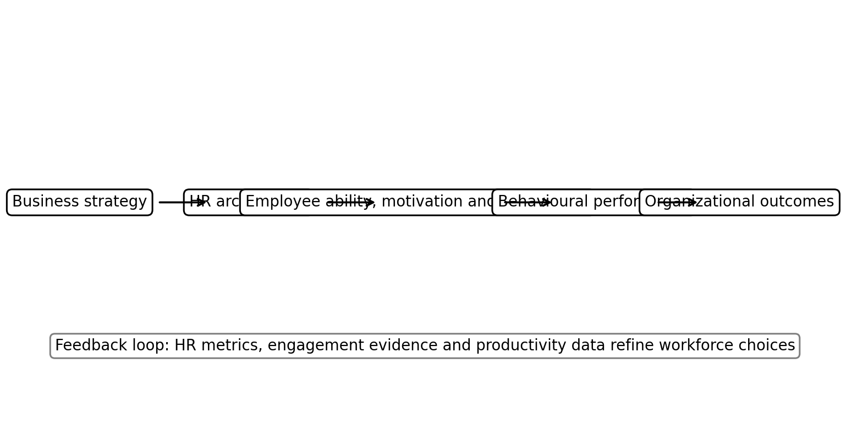
Figure 1. Conceptual model showing the report’s core HRM logic.

Literature Review
Strategic HRM can be defined as the pattern of planned human resource deployments and activities intended to enable an organization to achieve its goals (Wright & McMahan, 1992). This definition matters because it shifts attention from isolated HR techniques to the strategic architecture of work. Recruitment, appraisal, rewards and training are not assessed only by whether they are professionally designed. They are assessed by whether they create workforce behaviour that advances the organization’s strategy. For example, a low cost retail strategy may require standardized roles, efficiency focused scheduling and operational discipline, while a consultancy or technology strategy may require autonomous teams, learning systems and knowledge sharing. In this sense, strategic HRM is a bridging function between business intent and employee action.
The resource based view provides an important theoretical foundation for strategic HRM. Barney (1991) argues that resources create sustained competitive advantage when they are valuable, rare, inimitable and organized. Human capital can meet these conditions when it contains firm specific knowledge, social relationships, problem solving routines and cultural understanding that competitors cannot easily purchase or copy. However, individual talent alone is insufficient. HR systems must organize that talent into collective capability. A company may employ skilled people but still fail if it has poor leadership, unclear goals or weak coordination. Strategic HRM therefore focuses on the conversion of individual skill into organizational routines and shared performance norms.
High performance work systems are another major stream of HRM theory. Becker and Huselid (1998) and Appelbaum et al. (2000) show that bundles of HR practices can improve performance when they increase employee ability, motivation and opportunity. This is often linked to the AMO framework, which suggests that employees perform well when they have the ability to do the job, the motivation to apply effort and the opportunity to participate in meaningful work. The strength of the AMO model is that it avoids a narrow view of HRM. Training without motivation can produce unused skills. Rewards without capability can encourage pressure without competence. Employee involvement without authority can become symbolic. Performance improvement therefore requires integrated HR practice bundles rather than isolated initiatives.
Horizontal and vertical fit are central to strategic HRM. Vertical fit means that HR practices support the strategic priorities of the organization, while horizontal fit means that HR practices support one another. A firm pursuing innovation, for instance, may recruit for curiosity and learning agility, reward experimentation, use team based appraisal and create psychological safety for knowledge sharing. If the same firm uses rigid individual rankings and punishes failed experiments, the HR system contradicts the innovation strategy. Boxall and Purcell (2022) caution that fit should not become rigid determinism. Organizations must balance alignment with flexibility because strategies and labour markets change. Strong HRM therefore combines strategic direction with capacity for adaptation.
The relationship between HRM and performance is widely researched but difficult to prove in a simple causal sequence. Jiang et al. (2012) explain that HRM affects outcomes through mediating mechanisms such as human capital, motivation, employee attitudes and operational behaviour. This means that HR practices do not directly create profit. They shape the conditions through which employees solve problems, serve customers, reduce waste, innovate and remain committed. The causal chain is also affected by industry, technology, leadership quality and external labour market conditions. A critical HRM analysis must therefore avoid claiming that any single practice automatically increases performance. Instead, it should examine whether the HR system improves the behaviours and capabilities that matter for a specific strategy.
Another important issue is the distinction between strategic rhetoric and employee experience. Organizations frequently state that people are their greatest asset, but their actual HR systems may prioritize short term cost cutting, excessive work intensification or superficial engagement surveys. Critical HRM scholars argue that strategic HRM can sometimes be managerialist, meaning that it views employees mainly as instruments of performance rather than stakeholders with legitimate rights and interests. This critique is important because sustainable performance depends on trust. If employees experience HR initiatives as surveillance, manipulation or unfair measurement, productivity gains may be short lived. Strategic HRM should therefore be assessed through both business outcomes and employee outcomes.
Current corporate reporting reinforces the growing strategic role of people management. Microsoft’s annual reporting highlights investment in AI, digital learning and skilling initiatives to support productivity and transformation (Microsoft, 2025). Unilever’s 2025 reporting emphasizes a winning culture, talent acceleration and performance based ways of working (Unilever, 2026). These examples show that large organizations increasingly discuss people management as part of strategy execution rather than as a separate administrative activity. However, they also illustrate a limitation of public reporting. Corporate reports describe intentions and selected achievements, while employees may experience implementation unevenly. Academic analysis must therefore treat real world examples as evidence of HR strategy, not as proof that all outcomes are achieved.
Overall, the literature suggests that strategic HRM contributes to organizational performance through alignment, capability building, motivation, participation and retention. The best evidence supports the idea of coherent systems rather than best practice universalism. Some HR practices, such as fair selection, training, feedback and employee involvement, are generally valuable, but their specific design must fit the organization’s business model, workforce composition and ethical responsibilities. A strategic HRM approach is strongest when it recognizes employees as both value creators and stakeholders. This dual view allows HRM to support performance without reducing the workforce to a cost or productivity variable.
Strategic HRM also depends on the quality of line management. Formal HR policies are designed centrally, but employees experience them through supervisors who allocate work, interpret rules, provide feedback and decide whether employees have real opportunities to contribute. A strategic HR policy can therefore fail at the implementation stage if managers are overloaded, inconsistent or untrained. This point is important because organizations sometimes invest heavily in HR systems while assuming that managers will automatically implement them well. In practice, line manager capability is part of the HR architecture. Managers need training in selection, coaching, appraisal, inclusion and workload management. They also need incentives that reward people management rather than only short term output. Without this, HRM remains a paper system that looks aligned at corporate level but becomes fragmented in daily work.
The external labour market is another factor that shapes strategic HRM. Organizations do not design HR systems in isolation. Skill shortages, wage inflation, remote work expectations and demographic change affect whether a business can attract and retain people. A strategy that depends on scarce digital capability, for example, must consider whether the organization can compete through salary, purpose, flexibility, learning opportunities or employer reputation. This makes the employee value proposition a strategic tool. It also means that workforce planning should not focus only on internal headcount. It should analyse labour market supply, competitor hiring behaviour, immigration rules, education pipelines and technology substitution. Strategic HRM is therefore both internal and external because it connects the organization’s goals with the realities of the talent market.
There is also a debate between best fit and best practice approaches. Best practice thinking suggests that certain HR practices, such as training, participation, fair rewards and selective hiring, are generally associated with better performance. Best fit thinking argues that HR systems must be tailored to strategy and context. A critical position combines both. Some principles, such as fairness, role clarity and employee development, are widely valuable, but their design should be contextual. For example, employee participation may mean formal consultation in a unionized manufacturing workplace, agile sprint retrospectives in a technology firm and team briefings in a hospitality setting. Strategic HRM should therefore avoid copying fashionable practices from admired firms without testing whether they fit the organization’s strategy, culture and workforce.
Table 1
Strategic Alignment of Core HRM Practices
HRM practice | Strategic contribution | Performance risk if weak
Workforce planning | Forecasts capability demand and shapes build, buy, borrow or automate choices | Skill shortages, reactive hiring and poor strategy execution
Recruitment and selection | Improves person role fit, diversity of talent and strategic capability inflow | High turnover, weak fit and biased hiring outcomes
Training and development | Closes strategic capability gaps and supports change readiness | Low transfer of learning and obsolete skills
Performance management | Converts strategy into goals, feedback and accountable behaviour | Unclear priorities, perceived unfairness and low motivation
Retention and engagement | Protects firm specific knowledge and discretionary effort | Loss of high performers and reduced organizational memory

Methodology
This report uses a secondary qualitative research design. The method is appropriate because the assignment requires critical examination of HRM concepts, application of theory and real world relevance rather than collection of primary employee data. The analysis draws on peer reviewed academic literature, major HRM theory, practitioner reports and selected corporate examples. Academic sources are used to define strategic HRM and explain the theoretical relationship between HR practices and performance. Practitioner sources such as the World Economic Forum, Deloitte, CIPD and corporate annual reports are used to contextualize current workforce challenges and organizational examples.
The review followed 4 stages. First, core HRM theories were identified, including the resource based view, high performance work systems, AMO theory and strategic fit. Second, HR activities required in the assignment were grouped into workforce planning, recruitment and selection, training and development, performance management, engagement and retention. Third, each HR activity was analysed in relation to business objectives, employee productivity and competitive advantage. Fourth, real world examples were evaluated for relevance to strategic HRM rather than simply presented as success stories. This approach supports critical analysis by connecting theory, practice and limitations.
The methodology has limitations. Secondary sources cannot directly measure employee perceptions inside the selected organizations, and corporate reports may emphasize positive narratives. Academic studies also vary in industry context, measurement methods and time period. To reduce these weaknesses, the report triangulates evidence from theory, practitioner research and corporate examples rather than relying on a single source. The report also avoids making exaggerated causal claims. It uses the evidence to identify plausible mechanisms through which strategic HRM affects performance, while acknowledging that leadership, market conditions, technology and organizational culture also shape outcomes.

Findings
The first finding is that workforce planning is the foundation of strategic HRM because it translates business objectives into future capability requirements. Workforce planning involves forecasting demand for skills, assessing current workforce supply, identifying gaps and choosing whether to build, buy, borrow or automate capabilities. In a stable environment, workforce planning may focus on headcount and succession. In a digital environment, it must focus on skills, role redesign and internal mobility. The strategic value is that it prevents reactive hiring and reduces the risk of capability shortages. For example, organizations investing in AI cannot rely only on hiring data scientists; they also need managers, analysts and frontline employees who can interpret and apply data responsibly.
The second finding is that recruitment and selection support business objectives when they are designed around strategic fit rather than only vacancy filling. Recruitment affects the quality, diversity and expectations of the workforce. Selection affects whether employees have the competencies and values required for performance. A strategic approach uses structured interviews, realistic job previews, validated assessments and inclusive sourcing channels. This reduces poor fit, turnover and bias. It also improves productivity because selected employees are more likely to understand performance standards and adapt to organizational culture. However, selection must be ethical. Overuse of algorithmic screening without audit can reproduce bias, while unrealistic employer branding can create psychological contract breach after hiring.
The third finding is that training and development contribute to organizational performance by building both technical and behavioural capability. Training is not strategic when it is simply a calendar of workshops. It becomes strategic when it is linked to future business capabilities, performance gaps and career pathways. Microsoft’s emphasis on generative AI training and LinkedIn learning pathways illustrates how learning can support digital transformation (Microsoft, 2025). Similarly, Unilever’s focus on talent acceleration supports a broader performance culture (Unilever, 2026). Training creates value when employees can apply new skills in redesigned work systems. Without managerial support, time to practice and performance feedback, training investment may have limited impact.
The fourth finding is that performance management is a major mechanism through which strategy becomes daily work. Effective performance management clarifies objectives, provides feedback, supports coaching and connects rewards to contribution. It can improve productivity by making priorities visible and by helping employees understand how their work affects organizational outcomes. Yet traditional annual appraisal systems are widely criticized because they can be backward looking, biased and disconnected from development. A strategic performance system should therefore include regular conversations, goal adjustment, evidence based evaluation and developmental feedback. It should also avoid excessive individual competition where teamwork and knowledge sharing are strategically important.
The fifth finding is that employee retention protects organizational performance by preserving knowledge, relationships and continuity. Turnover can be healthy when it removes poor fit or creates renewal, but avoidable turnover is costly when high performers and critical skill holders leave. Retention is influenced by compensation, career growth, leadership quality, flexibility, recognition and meaning. In strategic HRM, retention is not only about keeping people for its own sake. It is about identifying which capabilities are strategically important and designing employee value propositions that encourage commitment. This may include internal career markets, reskilling pathways, fair rewards and inclusive cultures that make employees feel respected.
The sixth finding is that HRM contributes to competitive advantage when practices operate as a coherent system. Isolated practices are easier for competitors to copy. A competitor can copy a bonus plan or training course, but it is harder to copy a deeply embedded system of selection, learning, leadership, culture, employee voice and performance routines. This is why firm specific human capital matters. For example, a technology company’s advantage may come not simply from hiring engineers, but from how it combines cross functional teams, learning resources, psychological safety, data informed performance management and career mobility. The system produces social complexity, which is difficult to imitate.
The seventh finding is that employee engagement links HR practices to productivity, but engagement must be handled carefully. Engagement can improve discretionary effort, service quality and innovation when employees experience meaningful work, support and fairness. However, engagement should not be used as a soft label for asking employees to work harder without addressing workload, pay or wellbeing. Strategic HRM should measure engagement alongside burnout risk, inclusion, psychological safety and employee voice. A workforce may report commitment while also experiencing unsustainable pressure. Sustainable performance requires an HR system that manages energy, not only effort.
The final finding is that HR analytics can improve strategic HRM when it is used ethically and interpreted with context. HR metrics such as turnover, time to hire, training transfer, absence, internal mobility and productivity can help managers detect risks and evaluate interventions. However, metrics can distort behaviour if they are treated as targets without qualitative understanding. For example, reducing time to hire may lower selection quality, and reducing labour cost may damage service quality. A strategic HR scorecard should therefore combine financial, operational and employee indicators. It should also include governance around privacy, transparency and bias, especially when people data is used in recruitment, performance management or workforce planning.
The eighth finding is that strategic HRM requires credible measurement, but measurement must not become a substitute for judgement. HR dashboards can help leaders understand turnover, recruitment cycle time, capability gaps, absence, engagement and productivity. However, numbers need interpretation. A low turnover rate may show loyalty, but it may also show limited labour market mobility or weak performance management. High training hours may show investment, but they may also show inefficient learning design. A mature HR function therefore combines quantitative indicators with employee listening, manager interviews and operational evidence. The purpose of HR analytics should be decision quality, not the production of attractive dashboards. Metrics should help leaders ask better questions about workforce capability and employee experience.
The ninth finding is that organizational culture mediates the effect of HR practices on performance. Policies may describe desired behaviours, but culture shapes what employees believe is actually rewarded or punished. If an organization says it values collaboration but promotes only individual sales heroes, employees will follow the informal signal. If it says it values innovation but criticizes mistakes harshly, employees will avoid experimentation. Strategic HRM should therefore align formal systems with cultural messages. Recruitment should assess values and behaviours. Performance management should evaluate how results are achieved. Leadership development should model the desired culture. Culture is not a soft addition to HR strategy; it is the social environment in which HR practices either gain or lose meaning.
The tenth finding is that strategic HRM must consider resilience and change readiness. The pandemic, supply chain disruption, inflation and rapid AI adoption have shown that organizations need workforces able to adjust quickly. Resilience does not mean asking employees to absorb unlimited pressure. It means designing roles, skills, teams and leadership practices that allow adaptation without damaging wellbeing. HR can support resilience through cross training, flexible job design, internal mobility, leadership communication and wellbeing safeguards. This links directly to competitive advantage because organizations that can redeploy talent and learn quickly are better positioned during disruption. A purely efficiency focused HR system may reduce slack but become fragile when conditions change.
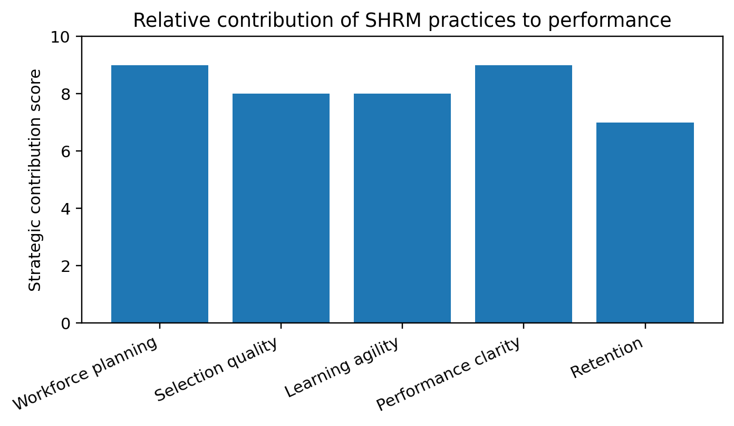
Figure 2. Indicative visual summary of key HRM priorities derived from the report analysis.
Table 2
Indicative Strategic HRM Scorecard
Dimension | Example measure | Strategic interpretation
Capability | Critical skill coverage percentage | Shows readiness for planned growth and transformation
Productivity | Output quality per team or service unit | Shows whether workforce systems improve operational contribution
Engagement | Engagement and psychological safety index | Shows whether employees have energy and voice
Retention | Voluntary turnover in critical roles | Shows risk to firm specific human capital
Ethics | Recruitment adverse impact and grievance trends | Shows fairness and legal risk

Discussion
The findings show that strategic HRM contributes to organizational performance through a chain of alignment. Business strategy shapes workforce requirements. HR practices build and direct capability. Employee capability and motivation influence behaviour. Behaviour affects productivity, quality, innovation, customer experience and financial outcomes. This chain is useful because it explains why HRM should be represented in strategic decision making. If HR is involved only after business strategy is finalized, workforce feasibility may be ignored. Strategic HR leaders must therefore contribute to questions about growth, technology, restructuring, new markets and organizational design, not simply implement hiring after decisions are made.
A critical issue is that strategic HRM can fail when it focuses too heavily on best practice lists. Practices such as training, engagement surveys and performance related pay are not automatically strategic. They must fit the organization’s context. Performance related pay may motivate sales roles with clear individual output, but it may damage collaboration in knowledge work. E learning may scale technical content efficiently, but it may not build leadership judgement unless supported by coaching and practice. Strategic HRM requires diagnosis before prescription. The central question should be what workforce behaviours and capabilities are needed for this strategy, in this context, with this workforce.
Another issue is the balance between efficiency and commitment. Organizations often expect HRM to reduce labour cost while also building engagement and innovation. These aims can conflict. Aggressive headcount reduction may improve short term financial ratios but harm trust, workload and knowledge retention. Similarly, tight performance targets may increase output but reduce psychological safety. Strategic HRM should therefore avoid presenting employees as both the main asset and the most flexible cost without acknowledging the tension. Sustainable competitive advantage is more likely when HR decisions consider long term capability and employee wellbeing alongside cost discipline.
The real world examples used in the report indicate that major organizations increasingly connect HRM to digital transformation, talent acceleration and performance culture. Microsoft’s focus on AI skilling shows how HRM can support a major technological shift. Unilever’s focus on performance and talent shows how HRM can support cultural renewal. However, these examples should be interpreted critically. Large organizations can have sophisticated HR language while implementation differs across divisions, countries and managers. The strength of strategic HRM depends not only on corporate policy, but on line manager capability. Employees usually experience HRM through their managers, which means manager selection, training and accountability are central to HR strategy.
The report also highlights the ethical dimension of strategic HRM. The pursuit of performance must not justify biased recruitment, unfair appraisal, excessive surveillance or exclusionary cultures. If HR practices are perceived as unfair, employees may withdraw effort, resist change or leave. Ethical HRM is therefore not separate from performance; it is a condition for sustained performance. Fair selection, transparent rewards, inclusive development and employee voice create trust, and trust improves the credibility of strategic change. Organizations that ignore the employee perspective may achieve compliance but not commitment.
For practice, the report recommends 5 actions. First, organizations should create a workforce strategy that is directly linked to business strategy and reviewed at least annually. Second, recruitment and selection should use validated, inclusive and role relevant methods. Third, training should be tied to strategic capability gaps and measured through transfer to performance, not attendance. Fourth, performance management should emphasize continuous feedback, goal clarity and fairness. Fifth, HR analytics should be governed by a balanced scorecard that includes productivity, capability, engagement, inclusion, retention and ethical risk. These actions would make HRM both strategic and responsible.
A further implication is that HR directors should be involved before strategic decisions are finalized. Mergers, automation projects, market entry and restructuring all depend on workforce feasibility. If people implications are considered only after financial and operational plans are approved, implementation risks increase. Strategic HRM requires HR leaders to challenge unrealistic assumptions about skills, culture, leadership capacity and change fatigue. This role may create tension because HR must sometimes question decisions that appear financially attractive. However, this challenge function is part of strategic contribution. A people strategy that simply follows business decisions cannot protect organizational capability.
The report also suggests that employee voice should be built into strategic HRM. Employees often understand work problems before senior leaders see them in formal indicators. Voice mechanisms, such as surveys, forums, listening sessions and consultation processes, allow organizations to detect emerging risks and improve decisions. Yet voice is meaningful only if employees see action. Strategic HRM should therefore close the feedback loop by explaining what was heard, what will change and what cannot change. This supports trust and makes HR data more valid because employees are more likely to participate honestly when they believe their input matters.

Conclusion
Strategic HRM contributes to organizational success by aligning people, work systems and business objectives. It creates value through workforce planning, effective recruitment and selection, training, performance management, engagement and retention. The strongest contribution occurs when these practices operate as a coherent system that builds employee ability, motivation and opportunity. The report also shows that strategic HRM should not be reduced to performance rhetoric. HR practices must be fair, inclusive and evidence based because employee trust is central to sustained performance. Organizations such as Microsoft and Unilever illustrate how people strategy can support digital transformation and cultural renewal, but the effectiveness of HRM depends on implementation, line manager behaviour and employee experience. The recommended approach is a balanced HR scorecard that connects productivity with capability, employee voice, inclusion and ethical governance. In conclusion, strategic HRM is a source of competitive advantage when it treats employees not only as resources for performance, but also as stakeholders whose development, wellbeing and fairness make long term organizational success possible.

References
Appelbaum, E., Bailey, T., Berg, P., & Kalleberg, A. L. (2000). Manufacturing advantage: Why high performance work systems pay off. Cornell University Press.
Barney, J. (1991). Firm resources and sustained competitive advantage. Journal of Management, 17(1), 99-120. https://doi.org/10.1177/014920639101700108
Becker, B. E., & Huselid, M. A. (1998). High performance work systems and firm performance: A synthesis of research and managerial implications. Research in Personnel and Human Resources Management, 16, 53-101.
Boxall, P., & Purcell, J. (2022). Strategy and human resource management (5th ed.). Bloomsbury.
Deloitte. (2026). 2026 Global human capital trends. https://www.deloitte.com/us/en/insights/topics/talent/human-capital-trends.html
Jiang, K., Lepak, D. P., Hu, J., & Baer, J. C. (2012). How does human resource management influence organizational outcomes? Academy of Management Journal, 55(6), 1264-1294. https://doi.org/10.5465/amj.2011.0088
Microsoft. (2025). Annual report 2025. https://www.microsoft.com/investor/reports/ar25/
Unilever. (2026). Annual report and accounts 2025. https://www.unilever.com/investors/annual-report-and-accounts/
World Economic Forum. (2025). The future of jobs report 2025. https://www.weforum.org/publications/the-future-of-jobs-report-2025/
Wright, P. M., & McMahan, G. C. (1992). Theoretical perspectives for strategic human resource management. Journal of Management, 18(2), 295-320. https://doi.org/10.1177/014920639201800205

Appendices
Appendix A presents an indicative HR scorecard that can be adapted by organizations seeking to connect HR activity to strategic performance. The scorecard includes business alignment, workforce capability, employee experience, ethical risk and long term adaptability. Appendix B presents an implementation checklist for managers. These appendices are designed as practical tools to support the recommendations in the discussion section.
Appendix A
Strategic HRM Implementation Checklist
Action | Responsible owner | Evidence of completion
Map future skills against business plan | HR director and senior leadership team | Documented workforce strategy and skills gap map
Audit recruitment criteria for strategic fit and bias | Talent acquisition manager | Structured interview guide and adverse impact review
Link training to strategic capability gaps | Learning and development manager | Training transfer evaluation and manager feedback
Review performance goals for alignment and fairness | HR business partner and line managers | Balanced goal templates and calibration records
Monitor retention in critical roles | People analytics team | Quarterly retention dashboard and action plan

