M16 - Commercial and Marketing Management
Branding, Customer Value, and Competitive Advantage
Option 2: Branding, Customer Value, and Competitive Advantage
Detailed Project Report

Contents
Abstract 2
1. Introduction 2
2. Literature Review 4
3. Methodology 6
4. Findings 7
5. Discussion 12
6. Recommendations 16
7. Conclusion 20
References 21
Appendices 23
Appendix A. Brand analysis assumptions 23

Abstract
This report analyses the role of branding and customer value in creating commercial success and sustainable competitive advantage. It argues that branding is not only a promotional activity but a strategic asset that shapes customer perception, willingness to pay, loyalty and resilience against competitors. The report examines brand identity, brand positioning, customer perception, product and service value, experience design, digital marketing, advertising, public relations and customer relationship management. It applies established branding and marketing theory, including customer based brand equity, value creation and customer experience literature. Real world examples from Apple, NIKE, Starbucks and global brand valuation rankings are used to show how strong brands convert meaning into commercial outcomes. The findings show that brand strength depends on consistent identity, credible differentiation, customer experience and trust. Digital marketing and CRM can deepen relationships, but only when supported by useful data practices and operational delivery. The report also finds that brands lose advantage when they rely on communication without product relevance, service quality or ethical transparency. Recommendations include building a coherent brand identity system, using customer value evidence to guide product and experience design, integrating digital touchpoints, developing trust based CRM and measuring brand performance through both financial and customer indicators.

1. Introduction
Branding and customer value are central to commercial success because customers rarely make decisions on functional product features alone. They also respond to identity, trust, convenience, experience, reputation, social proof and emotional meaning. In crowded markets, many products are quickly imitated and price comparisons are easy. A strong brand helps customers simplify choice and gives organisations a commercial basis for premium pricing, repeat purchase and long term loyalty. This report addresses the assignment option on branding, customer value and competitive advantage in commercial and marketing management.
The report focuses on 4 connected questions. First, why are brand identity, brand positioning and customer perception important? Second, how do organisations create and communicate customer value through products, services and experiences? Third, what roles are played by digital marketing, advertising, public relations and customer relationship management? Fourth, what strategies can build strong brands and sustainable competitive advantage? These questions are important because commercial success depends on the customer's willingness to choose, pay, stay and recommend.
Branding is often misunderstood as a logo, name or advertising campaign. These elements matter, but they are only symbols of a deeper promise. A brand becomes commercially powerful when customers recognise the promise, believe it, experience it and remember it. Customer value is equally broad. It includes functional value such as quality and reliability, economic value such as savings or productivity, emotional value such as pride and confidence, and relational value such as service and community. Competitive advantage emerges when these forms of value are delivered more consistently than competitors can match.
The report uses Apple, NIKE and Starbucks as illustrative examples. Apple demonstrates how brand identity and ecosystem value can strengthen perceived quality and willingness to pay. NIKE demonstrates how brand meaning, athlete endorsement, innovation and community can support differentiation, while also showing risks when digital and channel strategies lose momentum. Starbucks demonstrates how a brand is built through repeated service experiences, store atmosphere and loyalty mechanisms. The report also uses Kantar BrandZ and Interbrand evidence to show the financial relevance of brand value.

2. Literature Review
Brand identity refers to the core set of associations that an organisation seeks to create and maintain. Aaker (1996) argues that brand identity provides direction, purpose and meaning for the brand. This concept is commercially important because customers need stable cues about what the organisation stands for. A brand without a clear identity may attract short term attention, but it is difficult to build loyalty if customers cannot understand its personality, values and promise.
Brand positioning is the process of designing the brand's offering and image so that it occupies a meaningful and distinctive place in the minds of target customers. Keller (1993) explains that customer based brand equity arises when consumers have strong, favourable and unique brand associations. This shows why positioning must be both relevant and differentiated. A brand that is relevant but not different becomes replaceable. A brand that is different but not relevant becomes interesting but commercially weak.
Customer perception is central because commercial success depends on the value customers believe they receive, not only the value managers believe they deliver. Perception is influenced by product quality, design, price, reviews, advertising, word of mouth, service interactions and cultural meaning. Kotler, Keller and Chernev (2022) argue that marketing creates value by understanding and satisfying customer needs profitably. For branding, this means that communication cannot compensate permanently for poor product or service performance. If perception and experience diverge, trust weakens.
Customer value theory shows that value is multidimensional. Vargo and Lusch (2004) emphasise that value is co created with customers through use, rather than embedded only in products. This is relevant to modern branding because customers experience value through apps, communities, store visits, after sales support and social interaction. Lemon and Verhoef (2016) also show that customer experience is formed across the full customer journey. A brand therefore becomes a system of touchpoints, not a single message.
Brand equity theory explains the commercial benefits of branding. Aaker (1991) identifies loyalty, awareness, perceived quality and associations as sources of brand equity. Keller (2001) argues that strong brands are built through salience, performance, imagery, judgments, feelings and resonance. Commercially, this means that brand strength can reduce acquisition cost, support price premiums, increase repeat purchase and create advocacy. These benefits are not automatic. They require consistent investment and alignment between promise and delivery.
Competitive advantage theory helps explain why branding can be difficult to copy. Porter (1985) argues that advantage can come from differentiation when customers value unique attributes. Barney (1991) adds that sustainable advantage depends on resources that are valuable, rare, difficult to imitate and organised. A brand can meet these conditions when it is supported by history, culture, customer relationships, distinctive capabilities and trust. Competitors can copy a logo or campaign style more easily than they can copy decades of customer memory and experience.
Digital marketing has expanded both the opportunity and the risk of branding. Digital channels allow brands to target customers, personalise messages, build communities, collect data and measure response. However, digital visibility can also amplify complaints, expose inconsistency and increase customer expectations for speed and relevance. Payne and Frow (2005) show that CRM should be strategic rather than only technological. A customer database has little value if it does not support relevant communication, better service and stronger relationships.
Public relations and ethical communication are also important for brand trust. Brands operate in social environments where customers evaluate corporate behaviour, not only product benefits. Claims about sustainability, privacy, diversity or social responsibility must be credible. If customers perceive a gap between brand claims and actions, the brand can face reputational damage. Therefore, sustainable competitive advantage through branding requires authenticity, transparency and responsible commercial decisions.

3. Methodology
This report uses a qualitative strategic analysis methodology. It reviews academic literature on branding, customer value, customer experience, CRM and competitive advantage, then applies these concepts to real world organisations. This method is appropriate because the assignment requires a strategic paper rather than a primary research study. The aim is to explain how branding and customer value contribute to commercial success and to develop practical recommendations.
Apple, NIKE and Starbucks are selected because they represent different brand contexts. Apple is a technology ecosystem brand with strong design associations and service revenue. NIKE is a sports and lifestyle brand with global athlete relationships, product innovation and direct to consumer ambitions. Starbucks is a service and hospitality brand where daily experience, store design and loyalty are central. The report also refers to Interbrand and Kantar BrandZ rankings because they provide external evidence that brand value is treated as a major commercial asset.
The analysis is structured in 4 stages. First, the report explains the theoretical importance of identity, positioning and perception. Second, it evaluates how organisations create customer value through products, services and experiences. Third, it assesses the role of digital marketing, advertising, public relations and CRM. Fourth, it recommends strategies for building strong brands and sustainable competitive advantage. The limitation of this approach is that it relies on public evidence and cannot directly measure customer attitudes. However, the method supports critical analysis across sectors and links theory to practice.

4. Findings
The first finding is that brand identity gives commercial strategy coherence. A clear identity helps managers decide which products, prices, partnerships, service standards and messages fit the brand. Apple shows this through its consistent association with design, simplicity, privacy cues and ecosystem integration. This identity supports commercial value because customers understand what the brand promises before they enter the purchase journey. In fiscal 2025, Apple reported Services net sales of $109.158 billion, up from $96.169 billion in 2024, indicating that customer relationships continue beyond device purchase (Apple Inc., 2025). This supports the idea that identity and ecosystem value can create recurring commercial opportunities.
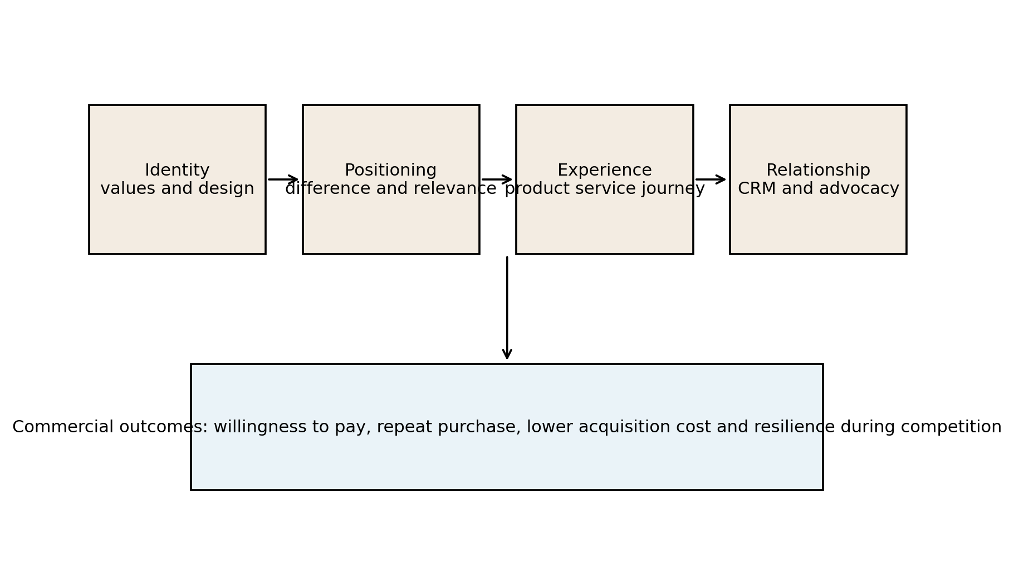
Figure 1. Brand value chain from identity to commercial outcomes.
The second finding is that positioning must be supported by customer experience. A brand can claim premium status, but customers judge whether the product or service deserves it. Starbucks illustrates this issue. The brand is positioned around coffeehouse experience, routine, personalisation and community. However, the company also reported that its 2025 strategy involved investments in coffeehouse partners, staffing and the Green Apron Service model as part of Back to Starbucks initiatives (Starbucks Corporation, 2025). This shows that brand recovery requires operational delivery, not only communication. A premium service brand is commercially vulnerable if the experience becomes slow, inconsistent or impersonal.
The third finding is that customer value is created across products, services and experiences. Apple creates functional value through hardware and software integration, economic value through ecosystem convenience, emotional value through design and status, and relational value through services and support. NIKE creates functional value through product performance, emotional value through athlete stories and identity, and community value through sport culture. Starbucks creates convenience, ambience, routine and loyalty benefits. These examples show that customer value is not a single feature. It is a bundle of benefits that customers compare with price, effort and risk.
Table 1. Customer value forms and commercial impact
Value form | Customer meaning | Commercial effect
Functional value | The product or service performs reliably | Reduces dissatisfaction and returns
Economic value | The benefits justify price and effort | Supports conversion and perceived fairness
Emotional value | The brand helps customers express identity | Supports loyalty and price premium
Relational value | The customer feels recognised and supported | Improves retention and advocacy

The fourth finding is that brand value is financially relevant. Kantar BrandZ 2026 ranked Google, Apple, Microsoft, Amazon and NVIDIA as the top 5 most valuable global brands, with Google valued at $1,484.895 billion and Apple at $1,380.294 billion (Kantar, 2026). Interbrand's 2025 ranking also placed Apple, Microsoft and Amazon at the top of its global brand ranking (Interbrand, 2025). The exact valuation methods differ, but both rankings indicate that brand strength is treated as a major source of market value. Commercial managers should therefore view brand investment as a strategic asset rather than a discretionary communication expense.
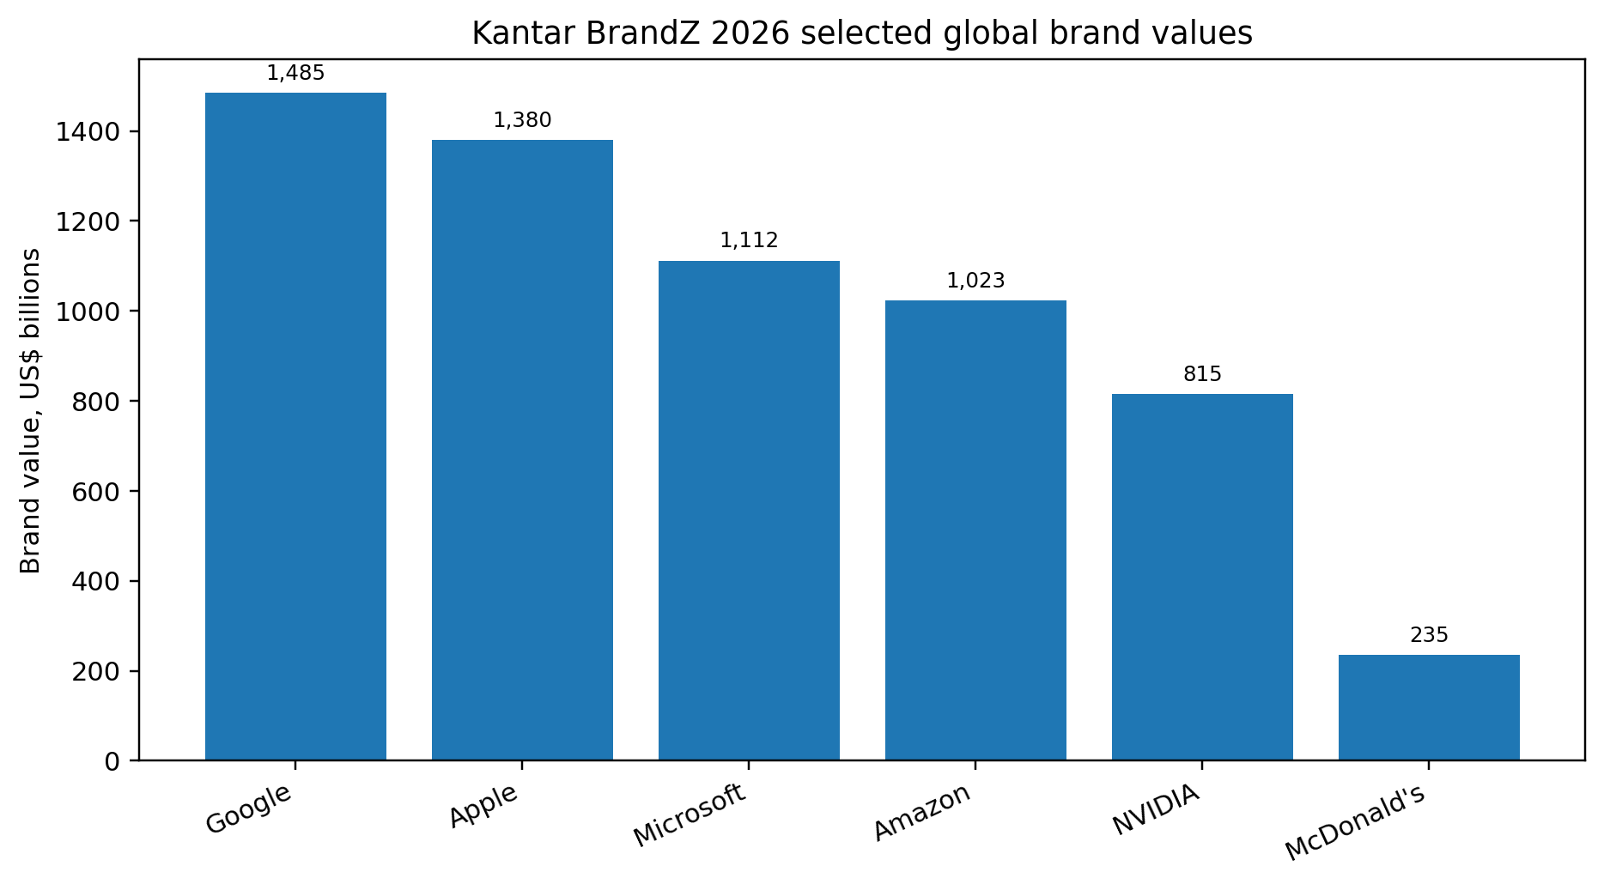
Figure 2. Selected Kantar BrandZ 2026 global brand values. Source data: Kantar (2026).
The fifth finding is that digital marketing strengthens branding when it improves relevance and convenience. Digital tools allow brands to personalise content, measure response, retarget interested customers and connect online activity with store or app behaviour. For example, Apple can use its ecosystem to link services, apps and devices. Starbucks can use its loyalty app to connect payments, rewards and personalised offers. NIKE can connect membership, training content and product launches. However, digital marketing also increases expectations. Customers expect messages to be relevant, privacy to be respected and platforms to work reliably.
The sixth finding is that advertising remains important, but it is less effective when disconnected from customer reality. Advertising can build awareness, emotional meaning and memory structures. NIKE's brand historically benefits from athlete storytelling and cultural relevance. However, NIKE's 2025 Form 10 K reported revenue decline and pressure in digital sales, while demand creation expense increased to $4.689 billion (NIKE, Inc., 2025). This suggests that communication spend alone cannot overcome issues in product momentum, channel balance or customer experience. Advertising must be connected to commercially attractive product and fulfilment decisions.
The seventh finding is that public relations influences trust and risk management. Public relations is not only about publicity. It manages relationships with customers, employees, communities, regulators and media. A brand's response to labour issues, privacy concerns, product defects or sustainability questions can strengthen or weaken customer perception. Starbucks provides a useful example because service experience and employment practices are closely connected in the customer's mind. A coffeehouse brand that promises warmth and community must ensure that employee experience and service delivery support this promise.
The eighth finding is that CRM supports competitive advantage when it creates mutual value. Loyalty schemes and customer databases can improve retention and repeat purchase. However, customers may become resistant if CRM is used only to push more messages or extract data. Payne and Frow's (2005) strategic CRM logic suggests that relationship management should improve value for both company and customer. In practical terms, CRM should provide useful reminders, relevant offers, faster service, personal recognition and problem resolution, not only promotional volume.
The ninth finding is that sustainable competitive advantage depends on consistency. Strong brands are difficult to copy because they combine identity, product quality, service routines, customer memory, data capabilities and culture. Competitors can imitate a campaign but not easily imitate the whole system. This means that brand advantage is sustained through alignment. If a brand promises innovation, it must invest in product development. If it promises community, it must invest in service culture. If it promises value, it must manage pricing fairly.
A further finding is that brand identity must be internally understood before it can be externally persuasive. Customers experience a brand through employees, service rules, packaging, store design, websites, delivery processes and complaint handling. If employees do not understand the brand promise, the experience becomes inconsistent. Starbucks illustrates this strongly because the employee, often called the partner in the company language, is part of the brand encounter. A brand promise of warmth and community depends on whether staff have the time, training and motivation to deliver that feeling.
Another finding is that brand positioning is most powerful when it creates choice shortcuts. Customers face large amounts of information and often use brands to reduce decision effort. A trusted brand can make the choice feel safer, especially when the product is expensive, complex or socially visible. Apple benefits from this because many customers expect its products to work smoothly together. NIKE benefits because customers associate the brand with sport performance and cultural aspiration. Starbucks benefits because customers know what kind of environment and product routine to expect in many locations.
The analysis also finds that customer perception is shaped by the gap between expected and experienced value. A brand may successfully create high expectations, but this increases the risk of disappointment if delivery is weak. For premium brands, the tolerance for poor service may be lower because customers believe they have paid for superior treatment. For digital brands, tolerance for friction may be low because customers expect speed and convenience. Managers therefore need to monitor experience quality as closely as campaign reach.

5. Discussion
The findings show that branding is a commercial management issue because it affects revenue, margin, customer acquisition and retention. A strong brand reduces the customer's perceived risk, increases willingness to consider the offer and can make price less central in the decision. However, brand strength is not created by communication alone. It is created when identity, positioning, product value, service experience, digital engagement and ethical behaviour reinforce one another.
Apple demonstrates the commercial power of a coherent brand ecosystem. Customers can buy devices, then continue to use paid services, apps and cloud based functions. This creates repeated revenue opportunities, but it also increases responsibility. If customers perceive the ecosystem as convenient and trustworthy, the brand becomes stronger. If they perceive it as restrictive or expensive without sufficient value, the same ecosystem can become a source of frustration. Therefore, brand strategy should be judged by whether it increases perceived value, not only whether it increases switching costs.
NIKE demonstrates the importance of maintaining product relevance within a strong brand. A brand can have deep cultural associations, but commercial performance still depends on desirable products, balanced channels and customer engagement. The decline in NIKE's digital sales in 2025 suggests that direct customer relationships require constant renewal. Customers will not remain loyal to an app, membership or campaign unless the product range and experience continue to feel relevant. Brand meaning must therefore be refreshed through innovation and community participation.
Starbucks demonstrates that service brands are built through daily operational performance. Its brand is not only in packaging or advertising; it is in the store visit, employee interaction, queue time, drink accuracy and ambience. This makes branding more difficult because the brand promise is delivered thousands of times each day by people and systems. The commercial implication is that staffing, training and store design are part of brand management. Cutting these too heavily may improve short term cost but weaken long term customer value.
Digital marketing, advertising, public relations and CRM should be treated as complementary, not separate, tools. Advertising builds mental availability and emotional meaning. Digital marketing makes communication measurable and targeted. Public relations protects legitimacy and trust. CRM builds retention and personal relevance. These tools work best when they communicate the same promise and are supported by the same customer data. They work poorly when each channel tells a different story or when marketing promises are not delivered in product and service experience.
The discussion also highlights the difference between customer value and customer extraction. Some commercial strategies increase short term revenue by raising prices, adding charges or increasing message frequency. These can be profitable temporarily, but they may erode trust if customers feel manipulated. Strong brands create value before capturing value. They give customers a reason to pay, return and recommend. This is why ethical communication and transparent pricing are not separate from competitive advantage. They are part of it.
Sustainable competitive advantage requires both distinctiveness and discipline. Distinctiveness means the brand has recognisable assets, associations and experiences that make it easy to choose. Discipline means the organisation protects those assets through consistent decision making. For example, a premium brand should avoid excessive discounting that teaches customers to wait for sales. A community brand should avoid service practices that make customers feel processed rather than welcomed. A digital brand should avoid data practices that damage trust.
A central implication is that brand managers should not treat customer value as a static promise. Value changes as competitors improve, customer incomes change, technology develops and cultural expectations shift. A feature that once felt innovative can become normal. A service that once felt convenient can become frustrating if competitors offer faster alternatives. Sustainable brand advantage therefore requires continuous learning. The brand should have a stable core identity, but the proof points that support this identity must evolve.
The examples also show that brand value and commercial performance can move differently in the short term. A brand may remain famous while revenue declines because product relevance, price, distribution or customer experience is weakening. Conversely, a firm may increase revenue through aggressive promotion while damaging brand meaning. Managers should therefore avoid assuming that strong awareness equals strong commercial health. Brand tracking should be connected to sales quality, margin and retention data.
The role of public relations deserves stronger attention because modern customers often evaluate brands as social actors. A product may be attractive, but customers can still reject the brand if they believe the organisation behaves irresponsibly. Labour practices, privacy controversies, greenwashing and misleading pricing can all become brand issues. Public relations should therefore be involved in strategic decisions before problems occur, not only used to manage criticism afterwards. This proactive approach protects trust and reduces the risk that commercial decisions undermine brand equity.
The discussion also suggests that customer relationship management should be measured by relationship quality, not simply by database size. A company may have millions of loyalty members, but many may be inactive or only respond to discounts. A smaller group of active members who engage frequently, recommend the brand and buy at healthy margins may create stronger value. CRM should therefore be evaluated through active engagement, repeat behaviour, complaint resolution, personal relevance and permission based trust.

6. Recommendations
The first recommendation is to create a formal brand identity system. This should define the brand purpose, promise, personality, visual assets, tone of communication and customer experience principles. It should also identify what the brand will not do. A clear identity system helps managers make consistent decisions across product, pricing, communication and service. It prevents the brand from becoming a collection of unrelated campaigns.
The second recommendation is to base positioning on evidence of customer value. Positioning statements should not be abstract slogans. They should be supported by customer research showing which benefits matter, how the brand is perceived against competitors and which proof points are credible. For example, a brand that claims innovation should be able to show product improvements, patents, new features or service enhancements. A brand that claims community should show service practices and relationship outcomes.
The third recommendation is to design customer value across 4 dimensions: functional, economic, emotional and relational. Functional value requires quality and reliability. Economic value requires fair pricing and clear benefits. Emotional value requires identity, confidence and meaning. Relational value requires service, recognition and support. Strong brands should audit whether each dimension is present and whether any dimension is being over promised.
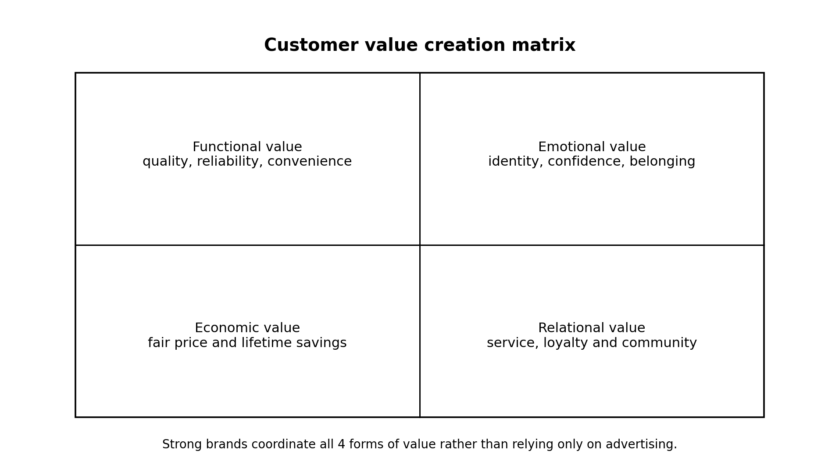
Figure 3. Customer value creation matrix for brand strategy.
The fourth recommendation is to integrate digital marketing with CRM and service delivery. Customer data should be used to improve relevance, convenience and customer experience, not only to increase promotional pressure. Organisations should connect app data, web behaviour, purchase history and service feedback where privacy rules permit. They should then use this information to improve recommendations, reduce friction, recognise loyal customers and solve problems faster.
The fifth recommendation is to protect brand trust through transparent communication. Pricing, product claims, sustainability claims and data use should be clear and verifiable. Public relations should be involved early in commercial decisions that could affect stakeholder trust. This is important because reputational risk can quickly become a commercial risk through customer churn, employee disengagement, regulatory action or negative media.
The sixth recommendation is to measure brand performance through both financial and customer indicators. Financial indicators should include revenue growth, gross margin, price premium and repeat purchase. Customer indicators should include awareness, consideration, preference, satisfaction, complaint rates, retention and advocacy. This balanced view prevents managers from treating brand as either purely creative or purely financial. It shows whether brand meaning is converting into sustainable commercial performance.
Table 2. Brand performance indicators
Area | Indicator | Purpose
Awareness | Unaided and aided awareness | Shows mental availability
Preference | Consideration and choice share | Shows strength versus competitors
Experience | Satisfaction, complaints and service recovery | Shows delivery quality
Relationship | Retention and repeat purchase | Shows loyalty strength
Commercial value | Price premium, margin and lifetime value | Shows financial contribution

The seventh recommendation is to refresh brand relevance through innovation and participation. Strong brands can decline if they rely only on past associations. Managers should involve customers in feedback loops, social communities, product testing and experience design. This supports relevance while protecting the core identity. The goal is not to change the brand constantly, but to keep the brand meaningful as customer expectations evolve.
The eighth recommendation is to conduct a brand touchpoint audit at least once a year. The audit should list every major customer contact point, including advertising, search results, social media, website, app, store, packaging, payment, delivery, customer service and complaint handling. Each touchpoint should be assessed against the brand promise. This would help managers identify where the brand is being strengthened and where it is being contradicted.
The ninth recommendation is to create a clear evidence bank for brand claims. If the brand claims sustainability, the evidence bank should include measurable environmental data. If the brand claims innovation, it should include product development evidence. If the brand claims superior service, it should include satisfaction, service speed and complaint resolution evidence. This reduces the risk of vague communication and improves the credibility of advertising and public relations.
The tenth recommendation is to balance brand building and sales activation. Sales activation is necessary because firms need revenue, but long term brand building creates mental availability and reduces future acquisition cost. Managers should therefore allocate budgets across both activities and avoid cutting brand investment whenever short term sales pressure rises. A practical approach is to set separate objectives for brand salience, customer engagement, conversion and retention, then review whether they reinforce one another.
The eleventh recommendation is to use employee experience as a brand management variable. Employees deliver many of the moments that customers remember. Training, incentives, workload, internal communication and empowerment should therefore be aligned with the brand promise. This is especially important for service brands, but it also matters for digital and product firms through customer support and retail partners. A brand cannot consistently create customer value if employees are unable or unwilling to deliver the promised experience.

7. Conclusion
Branding and customer value are central to commercial success because they shape how customers perceive, choose, pay for and remain loyal to organisations. Brand identity gives coherence, positioning creates differentiation, and customer perception determines whether the promise is believed. Customer value is created through products, services and experiences, not only through advertising. Digital marketing, public relations and CRM can strengthen the brand when they are integrated with operational delivery and ethical transparency. The examples of Apple, NIKE and Starbucks show that strong brands can support pricing power, retention and competitive advantage, but only when the brand promise is consistently delivered. Sustainable advantage comes from aligning brand meaning with real customer value.

References
Aaker, D. A. (1991). Managing brand equity: Capitalizing on the value of a brand name. Free Press.
Aaker, D. A. (1996). Building strong brands. Free Press.
Apple Inc. (2025). Form 10 K for the fiscal year ended September 27, 2025. U.S. Securities and Exchange Commission. https://www.sec.gov/Archives/edgar/data/320193/000032019325000079/aapl-20250927.htm
Barney, J. (1991). Firm resources and sustained competitive advantage. Journal of Management, 17(1), 99-120.
Interbrand. (2025). Best Global Brands 2025. https://interbrand.com/best-global-brands/global/
Kantar. (2026). Kantar BrandZ Top 100 Most Valuable Global Brands 2026. https://www.kantar.com/inspiration/brands/most-valuable-global-brands-2026
Keller, K. L. (1993). Conceptualizing, measuring, and managing customer based brand equity. Journal of Marketing, 57(1), 1-22.
Keller, K. L. (2001). Building customer based brand equity. Marketing Management, 10(2), 14-19.
Kotler, P., Keller, K. L., & Chernev, A. (2022). Marketing management (16th ed.). Pearson.
Kumar, V., & Reinartz, W. (2016). Creating enduring customer value. Journal of Marketing, 80(6), 36-68.
Lemon, K. N., & Verhoef, P. C. (2016). Understanding customer experience throughout the customer journey. Journal of Marketing, 80(6), 69-96.
NIKE, Inc. (2025). Form 10 K for the fiscal year ended May 31, 2025. U.S. Securities and Exchange Commission. https://www.sec.gov/Archives/edgar/data/320187/000032018725000047/nke-20250531.htm
Payne, A., & Frow, P. (2005). A strategic framework for customer relationship management. Journal of Marketing, 69(4), 167-176.
Porter, M. E. (1985). Competitive advantage: Creating and sustaining superior performance. Free Press.
Starbucks Corporation. (2025). Form 10 K for the fiscal year ended September 28, 2025. U.S. Securities and Exchange Commission. https://www.sec.gov/Archives/edgar/data/829224/000082922425000114/sbux-20250928.htm
Vargo, S. L., & Lusch, R. F. (2004). Evolving to a new dominant logic for marketing. Journal of Marketing, 68(1), 1-17.

Appendices

Appendix A. Brand analysis assumptions
The report treats brand value rankings as indicators of the commercial relevance of brands rather than exact accounting values. Different valuation providers use different methods. The purpose of using Kantar and Interbrand evidence is to show that recognised market analysts treat brands as major strategic assets.
The analysis is based on publicly available evidence. It does not claim access to confidential brand tracking, customer lifetime value or campaign performance data.

