Emotional Intelligence as a Tool for Effective Managerial Leadership
Selected assignment option: Option 1
Module: M25 Managerial Leadership and Emotional Intelligence
Report Type: Detailed Project Report
Submission date: 24 May 2026

Table of Contents
Section | Page
Abstract | 3
Introduction | 3
Literature Review | 4
Methodology | 10
Findings | 11
Discussion | 16
Conclusion | 20
References | 22
Appendices | 24

Abstract
This report examines emotional intelligence as a practical tool for effective managerial leadership in modern organizations. It argues that leadership effectiveness no longer depends only on technical authority, formal position, or strategic intelligence. It also depends on a manager's ability to notice emotions, regulate responses, motivate people, understand employee experience, and build constructive relationships. The report uses a qualitative literature synthesis supported by organizational examples from Microsoft, Google, and engagement research. It evaluates the 5 main components of emotional intelligence, namely self awareness, self regulation, motivation, empathy, and social skills, and links them to communication, trust, employee motivation, psychological safety, and ethical managerial practice. The central finding is that emotionally intelligent managers improve performance because they reduce emotional noise in teams, make communication more credible, and create conditions in which employees feel respected and able to contribute. However, the report also adopts a critical view. Emotional intelligence is not a substitute for competence, clear systems, fair rewards, or ethical governance. It is most valuable when it is embedded into leadership development, feedback systems, conflict resolution, recruitment, and performance management. The report concludes that emotional intelligence should be treated as a measurable managerial capability and not only as a desirable personal trait.

Introduction
Managerial leadership has become more complex because organizations now operate through hybrid work, digital systems, diverse teams, faster change, and higher employee expectations. Managers are required to deliver targets, support wellbeing, interpret ambiguity, handle conflict, and maintain trust at the same time. In this context, emotional intelligence has become a core leadership capability rather than an optional soft skill. A manager who can understand emotional signals, control impulsive reactions, communicate with empathy, and build relationships is more likely to create a team climate where employees remain motivated and productive. This is important because leadership is experienced by employees through daily interactions, not only through strategy documents or formal job titles.
The practical importance of emotional intelligence is visible in current workplace evidence. Gallup's State of the Global Workplace 2026 report shows that global employee engagement was only 20% in 2025 and estimates that low engagement costs the world economy around $10 trillion in lost productivity (Gallup, 2026). This does not mean that emotional intelligence alone solves engagement problems. It does show that the behavior of managers has economic importance. Gallup also reports that managers account for a large share of team engagement variance, which reinforces the argument that leadership quality is not abstract. It shapes how people interpret work, pressure, recognition, and fairness (Gallup, 2024, 2026).
The purpose of this report is to analyze how emotional intelligence improves managerial leadership. The report explains the meaning and components of emotional intelligence, discusses the relationship between emotional intelligence and leadership effectiveness, analyzes how emotionally intelligent managers improve communication, trust, and motivation, and provides real world examples of organizations using emotionally intelligent practices. The report is written from a managerial perspective and therefore focuses on how emotional intelligence becomes visible in decisions, conversations, coaching, conflict handling, and culture building. The key argument is that emotional intelligence strengthens leadership when it turns emotional awareness into disciplined managerial behavior.

Literature Review
Emotional intelligence is generally understood as the ability to perceive, understand, use, and manage emotions in oneself and in others. Mayer and Salovey's ability model presents emotional intelligence as a set of mental abilities related to emotional perception, emotional facilitation of thought, emotional understanding, and emotional regulation (Mayer & Salovey, 1997; Mayer et al., 2004). This model is important because it treats emotional intelligence as a form of information processing rather than as simple kindness or charisma. A manager uses emotional information to judge when a team is anxious, when resistance is based on fear, when silence indicates disengagement, and when pressure is beginning to reduce judgement quality.
Goleman's mixed model popularized emotional intelligence for leadership by grouping it into 5 components: self awareness, self regulation, motivation, empathy, and social skills (Goleman, 1998). Self awareness refers to knowing one's emotions, strengths, limits, and behavioural triggers. Self regulation refers to managing disruptive impulses and maintaining professional control. Motivation involves internal drive, persistence, and commitment to goals. Empathy involves understanding others' feelings and perspectives. Social skills involve influence, communication, collaboration, and relationship management. These 5 components provide a useful managerial framework because they connect inner emotional control with outward leadership behavior.
Self awareness is the starting point because managers who do not understand their own emotional patterns often misread team situations. For example, a manager who experiences pressure as personal threat can interpret employee questioning as disrespect. The resulting defensive communication can discourage participation. In contrast, self aware managers notice when they are becoming impatient or anxious and can separate their emotions from the facts of the situation. This increases the quality of judgement and supports reflective leadership. In leadership theory, this links closely with authentic leadership because authenticity requires awareness of values, emotions, and relational impact (Avolio et al., 2009).
Self regulation is equally important because managerial emotions are contagious. A leader's visible irritation, panic, or contempt can spread quickly through a team and create defensive behaviour. Emotional regulation does not mean suppressing every emotion. It means choosing a response that is proportionate, ethical, and useful for the task. Joseph and Newman (2010) argue that emotion regulation is central to the performance value of emotional intelligence because perceiving and understanding emotion only improves outcomes when a person can then regulate behaviour effectively. In managerial practice, this is visible when a leader pauses before responding to criticism, speaks calmly during crisis, and avoids humiliating employees in public.
Motivation is the component that connects emotional intelligence to persistence and performance. A manager with emotionally intelligent motivation is not only driven by personal ambition. The manager is able to frame goals in a way that gives meaning to employees and sustains energy during difficulty. Transformational leadership theory explains this through inspirational motivation, where leaders articulate purpose and encourage commitment beyond narrow transactional exchange (Bass, 1985; Bass & Riggio, 2006). Emotional intelligence supports this process because employees are more likely to accept challenging goals when they feel that the manager understands the pressure involved and is committed to supporting them.
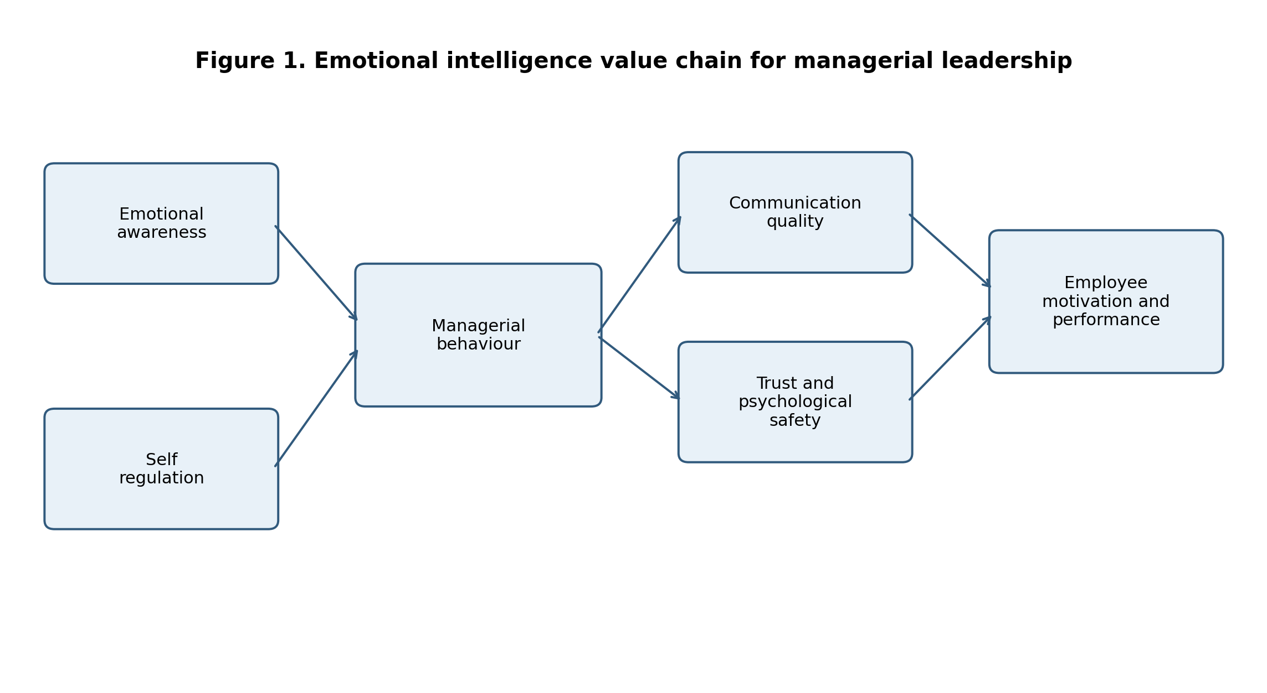
Figure 1. Emotional intelligence value chain for managerial leadership.
Empathy is often presented as the most human component of emotional intelligence, but it is also a managerial capability with performance consequences. Empathy allows managers to understand how decisions are experienced by employees, customers, and stakeholders. It helps leaders identify hidden barriers such as fear of failure, role overload, exclusion, or loss of status. However, empathy should not be confused with avoiding difficult decisions. A manager can be empathetic and still hold employees accountable. The difference is that accountability is communicated with respect, clarity, and a fair understanding of context.
Social skills convert emotional understanding into practical influence. A manager may understand emotions well, but leadership effectiveness depends on the ability to communicate, negotiate, coach, and build trust. Social skills are particularly important in matrix organizations where managers often need cooperation from people who do not report directly to them. They also matter in hybrid teams, where reduced informal contact makes intentional communication more important. Social skills include active listening, clear framing, feedback, conflict mediation, and the ability to create inclusive meetings. These skills make emotional intelligence visible to employees.
The relationship between emotional intelligence and leadership effectiveness is supported by meta analytic evidence, although the strength of the relationship varies by measurement method. Harms and Crede (2010) found that emotional intelligence is related to transformational and transactional leadership, but also showed that effects are smaller when different sources rate leadership and emotional intelligence. This is an important critical point because it warns against exaggerated claims. Emotional intelligence is meaningful, but self reported emotional intelligence can be biased. Miao et al. (2018) provide further evidence by showing that leader emotional intelligence predicts subordinate task performance and organizational citizenship behaviour after controlling for cognitive ability and personality. This suggests that emotional intelligence adds value beyond general intelligence or personality traits.
The literature also indicates that emotional intelligence is most valuable in roles with high emotional labour, relational complexity, and people management demands. O'Boyle et al. (2011) found that emotional intelligence contributes to job performance, particularly when work requires social interaction and emotion management. Managerial leadership is therefore a suitable context for emotional intelligence because managers constantly interpret emotions during performance reviews, change programmes, conflict, customer pressure, and resource constraints. Emotional intelligence helps managers transform emotionally loaded situations into constructive action.
A critical literature review must also recognize limitations. First, emotional intelligence is sometimes used as a broad label for many positive leadership qualities, which can reduce conceptual clarity. Second, emotional intelligence can be misused if managers learn to read emotions mainly to manipulate employees. Third, emotional intelligence cannot compensate for unfair pay, unsafe workloads, poor strategy, or unethical incentives. Fourth, not all emotional displays are cultural equivalents. What looks like confidence in 1 culture can be read as arrogance in another. Therefore, emotional intelligence must be combined with ethical leadership, cultural intelligence, clear governance, and evidence based people management (CIPD, 2025a).
Emotional intelligence also matters because managerial work contains emotional labour. Managers must often absorb frustration from employees, pressure from senior leaders, and uncertainty from external conditions while still presenting a stable leadership presence. This does not mean that managers should hide all emotion. It means that they need to process emotion responsibly before transferring it to the team. When leaders lack this capability, the team can become a container for managerial stress. Employees then spend energy managing the manager rather than serving customers, solving problems, or improving processes. Emotional intelligence therefore protects organizational attention by preventing unnecessary emotional disruption.
Another important theoretical connection is leader member exchange. High quality manager employee relationships are associated with trust, support, role clarity, and discretionary effort. Emotional intelligence contributes to these relationships because employees judge relationship quality through repeated signals. A manager who listens, remembers context, recognizes effort, and responds fairly creates relational credit. A manager who is unpredictable or emotionally dismissive creates relational debt. Over time, these small interactions shape whether employees treat leadership messages as credible. This explains why emotional intelligence is not limited to dramatic moments of crisis. It is also built through ordinary conversations, routine feedback, and everyday respect.

Methodology
This report uses a qualitative secondary research methodology. It synthesizes academic literature on emotional intelligence and leadership with practitioner evidence from organizations and workplace research. The approach is appropriate because the assignment question requires conceptual explanation, critical analysis, and real world application rather than primary data collection. The report therefore draws on peer reviewed studies, recognized leadership theory, practitioner reports, and organizational examples to evaluate how emotional intelligence contributes to managerial leadership.
The literature was selected according to 3 criteria. First, sources had to be relevant to emotional intelligence, leadership effectiveness, employee engagement, trust, communication, or team performance. Second, preference was given to influential theories and review studies because these provide a stronger evidence base than isolated opinion pieces. Third, real world examples were selected where there was a clear connection between leadership behaviour and organizational practice. Microsoft was selected because its public leadership narrative under Satya Nadella emphasizes empathy and growth mindset. Google was selected because its team effectiveness work highlights psychological safety, a concept strongly connected to emotionally intelligent leadership. Gallup and CIPD were selected because they provide current workplace evidence on engagement, management quality, and evidence based people practices.
The report uses thematic analysis rather than statistical analysis. The themes are emotional intelligence components, leadership effectiveness, communication, trust, motivation, real world examples, and implementation strategies. These themes are mapped against the assignment requirements. This method allows the report to compare theory with managerial practice and to identify strengths, limits, and practical recommendations. The limitation is that the report does not measure emotional intelligence directly in a specific organization. It also relies on secondary interpretation of published evidence. However, the method is suitable for a strategic management report because it produces a reasoned evidence based argument and links concepts to managerial action.

Findings
The first finding is that emotional intelligence improves managerial leadership by increasing behavioural discipline. In many organizations, managers are promoted because of technical skill or past performance rather than people leadership capability. Once they become managers, their daily emotional responses affect the team climate. Emotionally intelligent managers are more likely to pause, interpret, and respond rather than react automatically. This improves leadership credibility because employees observe consistency. When managers remain calm during uncertainty, employees are more likely to trust the process and less likely to waste energy on speculation or defensive behaviour.
This finding is important for modern organizations because change has become constant. Digital transformation, restructuring, cost pressure, and artificial intelligence adoption create uncertainty. Employees often look to managers for emotional cues about whether change is controlled or chaotic. A manager who communicates anxiety without clarity can intensify fear. A manager who denies emotion completely can appear detached. Emotional intelligence helps the manager acknowledge reality while still offering direction. This combination of honesty and composure is central to leadership effectiveness.
The second finding is that emotional intelligence improves communication quality. Communication is not only the transfer of information. It includes tone, timing, listening, psychological safety, and the perceived respect behind the message. Emotionally intelligent managers listen for both content and emotion. They can detect when employees are confused, embarrassed, disengaged, or afraid to disagree. This helps the manager adjust the communication method. For example, complex change may require repeated explanation, small group discussion, and opportunities for questions rather than a single email announcement.
Table 1. Emotional intelligence components and managerial leadership implications
EI component | Managerial meaning | Leadership implication
Self awareness | Understanding personal emotions, limits, values, and triggers | Improves judgement, authenticity, and reflective leadership
Self regulation | Managing disruptive impulses and choosing proportionate responses | Reduces fear, panic, and emotional contagion
Motivation | Sustaining commitment, optimism, and purposeful effort | Helps managers energize teams during pressure
Empathy | Understanding employee and stakeholder experience | Improves inclusion, trust, and fair decision making
Social skills | Building relationships, influence, listening, and conflict management | Improves collaboration, communication, and team alignment
Emotionally intelligent communication is also more likely to be two way. Managers with low emotional intelligence often treat questions as resistance and criticism as disloyalty. This produces silence rather than agreement. By contrast, a manager with empathy and self regulation can invite challenge without becoming defensive. Google's team effectiveness guidance places psychological safety at the centre of effective teams, describing it as the belief that team members can take interpersonal risks without being punished or embarrassed (Google re:Work, 2026). Emotional intelligence supports this condition because managers must respond constructively when people raise concerns or admit mistakes.
The third finding is that emotional intelligence builds trust. Trust develops when employees believe that a manager is competent, consistent, fair, and concerned about people. Emotional intelligence contributes to each of these dimensions. Self regulation supports consistency because the manager does not swing unpredictably between warmth and anger. Empathy supports perceived concern because employees believe that the manager understands their realities. Social skills support fairness because the manager explains decisions and listens before judging. Trust is especially important where managers do not control every reward but still influence how employees experience the organization.
Trust has a direct relationship with motivation. Employees are more likely to invest effort when they believe their manager will recognize contribution, treat mistakes as learning opportunities where appropriate, and distribute workload fairly. Motivation is weakened when employees feel invisible, blamed, or emotionally unsafe. Emotional intelligence strengthens motivation because it helps managers connect organizational goals to employee needs for meaning, mastery, autonomy, and belonging. This is consistent with transformational leadership theory, where leaders motivate by communicating purpose and recognizing individual contribution (Bass & Riggio, 2006).
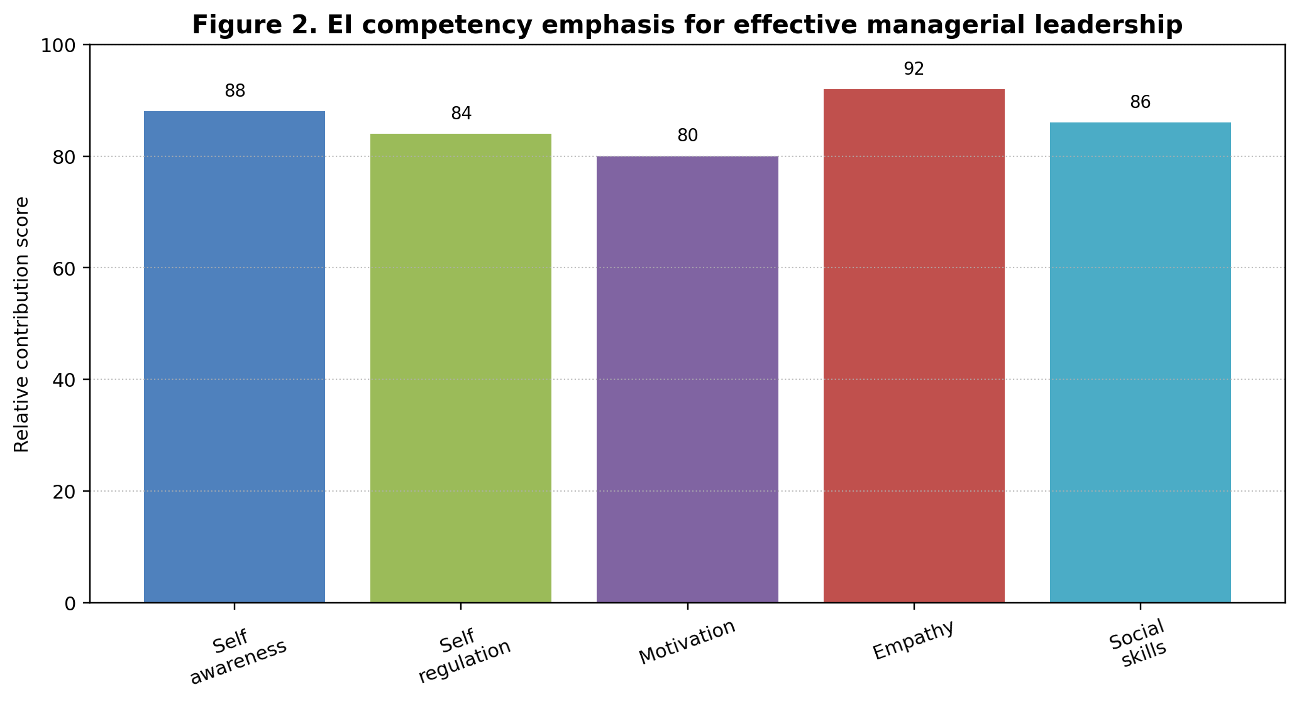
Figure 2. EI competency emphasis for effective managerial leadership. Scores are conceptual synthesis scores based on the literature reviewed in this report.
The fourth finding is that emotionally intelligent managers improve conflict management. Workplace conflict commonly arises from unclear roles, poor communication, workload pressure, personality differences, competing priorities, and perceived unfairness. A manager with low emotional intelligence can escalate conflict by taking sides too early, using blame language, or avoiding the issue until resentment grows. A manager with emotional intelligence can separate facts from interpretations, listen to each party, regulate personal bias, and reframe conflict around shared goals. This does not eliminate conflict, but it turns conflict into problem solving rather than status competition.
The fifth finding is that emotional intelligence supports ethical decision making. Ethical leadership requires more than knowledge of rules. It requires awareness of how decisions affect people and the courage to act fairly under pressure. Empathy helps managers recognize stakeholder consequences. Self regulation helps managers resist panic, retaliation, or short term opportunism. Social skills help managers communicate difficult decisions with dignity. However, emotional intelligence must be grounded in ethical principles. A socially skilled manager without ethics can manipulate emotions to secure compliance. Therefore, emotional intelligence should be connected to transparency, accountability, and organizational values.
The Microsoft example shows how emotional intelligence can be connected to culture and innovation. Microsoft describes its culture as rooted in growth mindset, where potential is nurtured rather than predetermined (Microsoft, n.d.). A Microsoft feature on empathy and innovation explains that under Satya Nadella, empathy became connected to collaboration, accessibility, and product innovation (Microsoft, 2019). This example is relevant because it shows emotional intelligence beyond interpersonal politeness. Empathy becomes a way of understanding users, encouraging collaboration, and reducing defensive internal competition. The lesson for managers is that emotional intelligence can support strategic renewal when it is embedded in routines, language, and leadership expectations.
The Google example shows the team level impact. Google's Project Aristotle challenged the assumption that the best teams are simply collections of the most talented individuals. Google re:Work identifies psychological safety, dependability, structure and clarity, meaning, and impact as important dynamics of effective teams (Google re:Work, 2026). Emotional intelligence is not named as the only cause of these dynamics, but it is strongly connected to their creation. Managers need empathy to understand team anxiety, self regulation to respond well to mistakes, and social skills to establish norms for speaking up. This indicates that emotionally intelligent leadership improves team performance indirectly by shaping the climate in which technical talent is used.
The sixth finding is that emotional intelligence improves employee motivation when it is combined with clear systems. Emotionally intelligent praise is specific, timely, and connected to effort or contribution. Emotionally intelligent feedback is direct but respectful. Emotionally intelligent delegation considers employee capacity and development needs. These behaviours improve motivation because employees understand what is expected and feel that their work matters. However, motivation will not survive if emotional intelligence is used to mask unfair workloads or unclear reward systems. Therefore, EI is strongest when it reinforces good management practice rather than replacing it.
The seventh finding is that emotional intelligence is particularly important in hybrid and digitally mediated work. In face to face teams, managers can notice emotion through informal conversation and body language. In hybrid teams, many emotional signals are reduced or delayed. Employees can become invisible if they are quiet in online meetings or if communication relies too heavily on written updates. Emotionally intelligent managers respond by creating deliberate check ins, using inclusive meeting routines, and paying attention to participation patterns. This improves leadership effectiveness because it prevents remote or quieter employees from being interpreted as disengaged simply because they are less visible.
The eighth finding is that emotional intelligence helps managers maintain boundaries. Some managers misunderstand empathy as personal over involvement. This can lead to emotional exhaustion, inconsistent decisions, or unfair exceptions. Emotionally intelligent leadership requires compassion with boundaries. A manager can understand an employee's difficulty while still clarifying priorities, deadlines, and available support. This balance is important because employees need both care and predictability. If boundaries are unclear, team members can perceive unfairness or role confusion. Therefore, mature emotional intelligence combines empathy with principled consistency.
The ninth finding is that emotional intelligence supports organizational learning. Teams learn when members can discuss mistakes without humiliation and when managers treat problems as information rather than personal failure. This does not remove accountability. It means that accountability focuses on understanding causes, improving processes, and preventing recurrence. Emotionally intelligent managers are better able to lead after action reviews because they can manage blame, defensiveness, and embarrassment. This encourages employees to share weak signals before they become major failures. The result is better risk management and stronger continuous improvement.

Discussion
The analysis shows that emotional intelligence is a practical leadership capability because it influences the mechanisms through which managers create results. The strongest mechanisms are communication quality, trust, motivation, conflict resolution, and ethical awareness. These mechanisms matter because managers rarely achieve results alone. They achieve results through teams, peers, stakeholders, and systems. A technically strong manager who cannot regulate emotion or build relationships can still damage performance through fear, silence, turnover, and poor collaboration.
At the same time, this report rejects an overly romantic view of emotional intelligence. Emotional intelligence does not mean that managers should always be agreeable or avoid hard decisions. In some situations, leadership requires urgency, discipline, and accountability. Emotional intelligence improves these situations by helping the manager communicate seriousness without disrespect. For example, a manager addressing repeated poor performance should not become passive in the name of empathy. The emotionally intelligent approach is to understand the context, state expectations clearly, offer support where appropriate, and document consequences fairly.
The evidence also suggests that emotional intelligence should not be left to personality alone. Organizations should build it into management systems. First, recruitment and promotion processes should assess people leadership capability, not only technical performance. Second, management training should include emotional regulation, coaching conversations, inclusive communication, conflict mediation, and ethical decision making. Third, 360 degree feedback can help managers compare self perception with employee experience. Fourth, engagement surveys should be linked to manager development, not used only as a performance scoreboard. Fifth, senior leaders should model emotionally intelligent behaviour because employees judge culture through executive conduct.
Table 2. Practical emotional intelligence interventions for managers
Area | Practical intervention | Expected result
Communication | Structured 1 to 1 meetings with listening prompts | Better understanding of employee concerns
Feedback | Behaviour based feedback with clear examples | Higher fairness and lower defensiveness
Conflict | Mediation conversation using facts, emotions, and shared goals | Reduced escalation and faster problem solving
Change | Transparent updates with space for employee questions | Higher trust during uncertainty
Development | 360 degree feedback and coaching plan | Improved self awareness and behavioural accountability
A practical development model should begin with self awareness. Managers can use reflection logs, feedback instruments, and coaching to identify emotional triggers. The next stage is self regulation, where managers practice pausing, asking questions, and choosing constructive language. The third stage is relational application, where managers use empathy and social skills in meetings, feedback, conflict, and change communication. The final stage is institutionalization, where emotionally intelligent behaviour becomes part of leadership competencies, promotion criteria, and cultural expectations. This staged approach prevents emotional intelligence from becoming a vague training slogan.
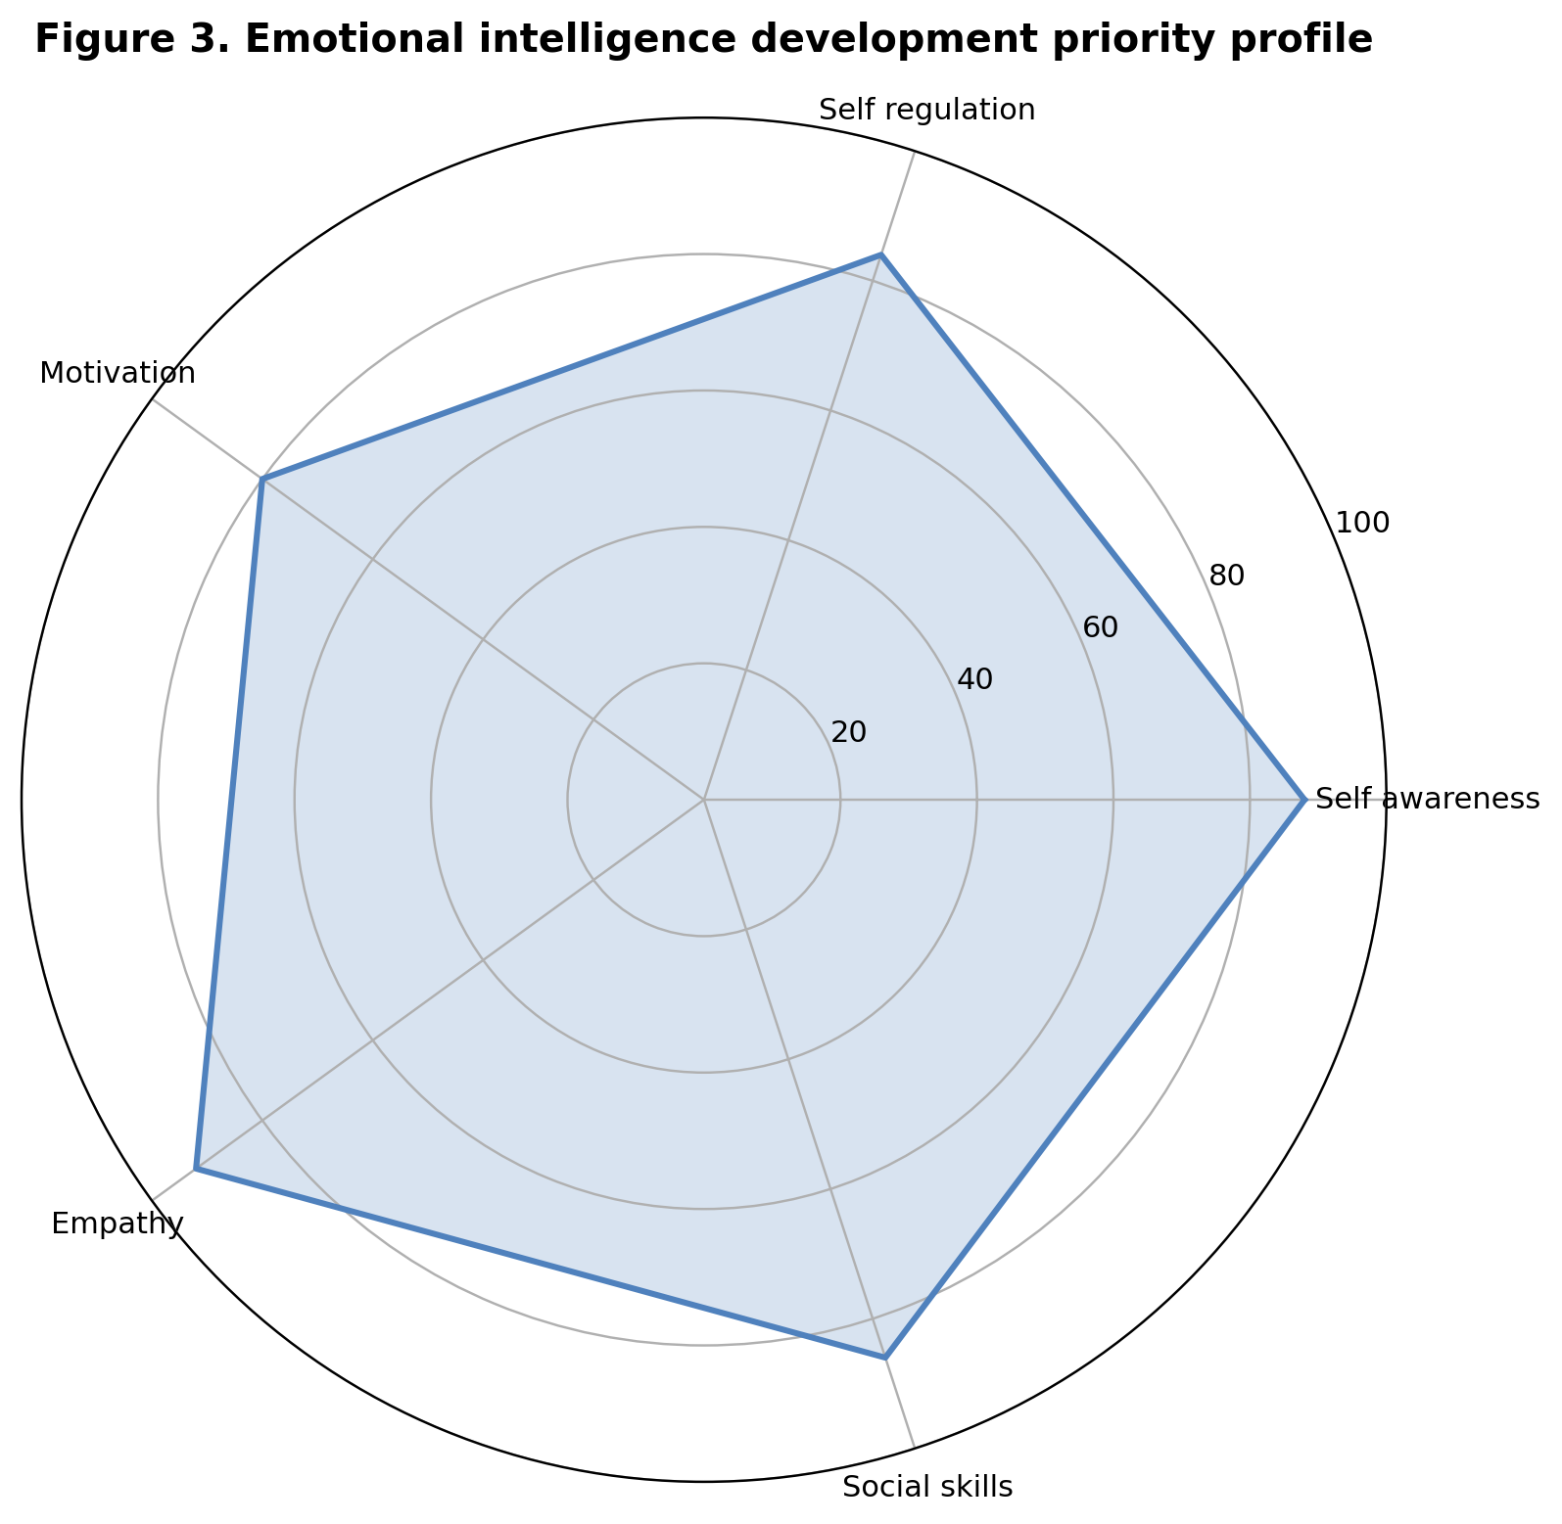
Figure 3. Emotional intelligence development priority profile for managerial leadership.
There are also risks that managers and organizations must manage. Measurement can be problematic because some emotional intelligence instruments rely on self report, which is vulnerable to impression management. Cultural differences can also influence how emotions are expressed and interpreted. In addition, emotional intelligence training can become superficial if it teaches managers to perform empathy without changing power relations or unfair processes. For these reasons, emotional intelligence should be evaluated through behavioural evidence, employee feedback, conflict outcomes, retention patterns, and ethical decision quality.
The recommended approach is therefore balanced. Organizations should treat emotional intelligence as a leadership capability that strengthens managerial practice, but they should combine it with clear strategy, fair systems, psychological safety, and accountability. Managers should use emotional intelligence to create conditions where employees can speak honestly, work with purpose, and recover from mistakes. When emotional intelligence is connected to ethical governance and evidence based management, it becomes a source of sustainable leadership effectiveness.
A further implication is that emotional intelligence should be integrated with diversity and inclusion practice. Diverse teams contain different communication styles, cultural expectations, and experiences of authority. Managers need empathy and social awareness to understand who speaks, who remains silent, whose ideas are credited, and who carries hidden emotional labour. Emotional intelligence helps leaders notice these patterns and intervene fairly. However, inclusion cannot rely only on individual empathy. It also needs structured practices such as transparent criteria, accessible meetings, fair workload allocation, and psychologically safe feedback channels.
Emotional intelligence also has strategic relevance. Organizations often invest heavily in technology, restructuring, and process improvement but underestimate the emotional transition required for employees to adopt change. Managers translate strategy into lived experience. If they communicate change with arrogance or ambiguity, employees can resist even technically sound initiatives. If they combine honesty, empathy, and clarity, employees are more likely to understand the reason for change and the support available. Emotional intelligence therefore acts as a bridge between strategic intent and employee commitment.
The overall managerial lesson is that emotional intelligence must be practiced at 3 levels. At the individual level, managers develop self awareness and self regulation. At the team level, they create trust, voice, motivation, and conflict routines. At the organizational level, leaders align emotional intelligence with ethical systems, evidence based decisions, and performance expectations. These 3 levels prevent a narrow interpretation where emotional intelligence becomes only personal warmth. Instead, it becomes a leadership discipline that links human experience with organizational performance.

Conclusion
Emotional intelligence improves managerial leadership because it helps managers understand themselves, regulate behaviour, motivate employees, show empathy, and build effective relationships. These capabilities matter because modern organizations depend on trust, communication, collaboration, and adaptability. The report has shown that emotionally intelligent managers improve communication by listening actively and responding constructively. They build trust by acting consistently and fairly. They improve motivation by connecting work to meaning and recognizing employee experience. They manage conflict by regulating emotion and focusing on shared goals. They support ethical decision making by considering stakeholder impact and resisting impulsive behaviour.
The main conclusion is that emotional intelligence is not a soft alternative to management competence. It is a disciplined capability that improves how competence is applied. It is most effective when embedded in leadership development, promotion criteria, feedback systems, conflict management, and culture. Organizations should therefore move beyond treating emotional intelligence as a personal virtue and should manage it as a measurable leadership requirement. In a workplace where engagement remains low and change is constant, emotionally intelligent managerial leadership offers a practical route to stronger performance and more humane organizations.
Word count excluding references: 4226

References
Avolio, B. J., Walumbwa, F. O., & Weber, T. J. (2009). Leadership: Current theories, research, and future directions. Annual Review of Psychology, 60, 421-449. https://doi.org/10.1146/annurev.psych.60.110707.163621
Bass, B. M. (1985). Leadership and performance beyond expectations. Free Press.
Bass, B. M., & Riggio, R. E. (2006). Transformational leadership (2nd ed.). Psychology Press.
CIPD. (2025a). Evidence based HR: Make better decisions and step up your influence. https://www.cipd.org/en/knowledge/guides/evidence-based-profession/
CIPD. (2025b). Employee engagement and motivation. https://www.cipd.org/en/knowledge/factsheets/engagement-factsheet/
Edmondson, A. C. (1999). Psychological safety and learning behavior in work teams. Administrative Science Quarterly, 44(2), 350-383. https://doi.org/10.2307/2666999
Gallup. (2024). How to improve employee engagement in the workplace. https://www.gallup.com/workplace/285674/improve-employee-engagement-workplace.aspx
Gallup. (2026). State of the global workplace: 2026 report. https://www.gallup.com/workplace/349484/state-of-the-global-workplace.aspx
Goleman, D. (1998). What makes a leader? Harvard Business Review, 76(6), 93-102.
Google re:Work. (2026). Understand team effectiveness. https://rework.withgoogle.com/intl/en/guides/understand-team-effectiveness
Harms, P. D., & Crede, M. (2010). Emotional intelligence and transformational and transactional leadership: A meta analysis. Journal of Leadership & Organizational Studies, 17(1), 5-17. https://doi.org/10.1177/1548051809350894
Joseph, D. L., & Newman, D. A. (2010). Emotional intelligence: An integrative meta analysis and cascading model. Journal of Applied Psychology, 95(1), 54-78. https://doi.org/10.1037/a0017286
Mayer, J. D., & Salovey, P. (1997). What is emotional intelligence? In P. Salovey & D. Sluyter (Eds.), Emotional development and emotional intelligence: Educational implications (pp. 3-31). Basic Books.
Mayer, J. D., Salovey, P., & Caruso, D. R. (2004). Emotional intelligence: Theory, findings, and implications. Psychological Inquiry, 15(3), 197-215. https://doi.org/10.1207/s15327965pli1503_02
Miao, C., Humphrey, R. H., & Qian, S. (2018). A cross cultural meta analysis of how leader emotional intelligence influences subordinate task performance and organizational citizenship behavior. Journal of World Business, 53(4), 463-474. https://doi.org/10.1016/j.jwb.2018.01.003
Microsoft. (2019). How Microsoft is using empathy to lead innovation. https://news.microsoft.com/source/features/innovation/empathy-innovation-accessibility/
Microsoft. (n.d.). Culture. https://careers.microsoft.com/v2/global/en/culture
O'Boyle, E. H., Humphrey, R. H., Pollack, J. M., Hawver, T. H., & Story, P. A. (2011). The relation between emotional intelligence and job performance: A meta analysis. Journal of Organizational Behavior, 32(5), 788-818. https://doi.org/10.1002/job.714

Appendices

Appendix A. Manager emotional intelligence self audit
The following audit can be used by a manager as a reflective tool before a formal 360 degree feedback process. It is not a diagnostic instrument. It is designed to translate the report into practical questions that support leadership development.
Appendix Table A1. Reflective audit questions
Area | Reflective question
Self awareness | Which situations most often trigger impatience, defensiveness, or avoidance?
Self regulation | What pause technique will be used before responding to criticism?
Empathy | Whose perspective has not yet been considered in this decision?
Social skills | What meeting behaviour will encourage quieter employees to contribute?
Motivation | How will the goal be connected to purpose and employee development?

Appendix B. Suggested 90 day EI leadership development plan
A 90 day plan should begin with feedback, move into behavioural practice, and end with evidence review. The aim is to make emotional intelligence observable through managerial routines rather than treating it as a vague personal trait.
Appendix Table B1. 90 day plan
Period | Action | Evidence
Days 1 to 30 | Collect feedback and identify 2 emotional triggers | Feedback summary and reflection log
Days 31 to 60 | Practise listening, feedback, and conflict scripts | Employee check in notes
Days 61 to 90 | Review engagement and conflict indicators | Improvement actions and next coaching goal

