
consumer behavior
The Impact of Social Media Influencers and User-Generated Content on Travel Decisions

Name: Rahul Saini
Course: Master's in Tourism and Recreation
Submission Date : 23rd October, 2025

Abstract
The growth of social media has radically re-defined tourism on the planetary level, transforming the processes by which travelers make decisions on where to stay as well as how they interact with hospitality brands. The paper is researching the role of social-media influencers and user-generated content (UGC) in the modern process of travel decision-making. It is a critical analysis of the three dimensions of trust, credibility, and authenticity on which influencer marketing relies, and the complementary role of UGC in justifying and supporting the intention to purchase. Based on extensive tourism data and other pertinent literature, the analysis will use behavioral theories including the Source Credibility Model, Social Proof Theory, and Para social Interaction Theory to explain the process of digital persuasion.
The mixed-method method that combines secondary information, case studies using influencers and UGC indicators proves that consumers are using digital social signals more to reduce the risk pool and enhance emotional connection to the destination. Findings support that open communication with influencers and genuine peer reviews significantly increase engagement and conversion, and ethical issues (i.e. fake reviews, unannounced sponsorships, and excessive promotion) decrease trust and sustainability. The paper ends by giving suggestions on evidence-supported models to combine influencer strategies and UGC governance using the authenticity check, ethical disclosure, and co-created storytelling as the pillars of sustainable tourism development.

Contents
Abstract 1
Introduction 3
Literature Review 4
Methodology 8
Findings 10
Discussion 14
Recommendations 18
Conclusion: 22
References: 23
Appendices 24

Introduction
The modern tourism is not characterized by printed brochures or traditional advertising, but the discourses that emerge on the Internet platforms. Globally, consumers continue to rely on social-media platforms like Instagram, Tik Tok and TripAdvisor to be inspired to travel, plan their itinerary, and validate their purchases. The social-media influencers that are perceived to be relatable experts have become key intermediaries that create travel desires by visual storytelling and personal interaction. At the same time, user-created content (UGC) including reviews, photos, and shared stories is peer verification, which offers the transparency that does not exist in traditional marketing. Influencers and UGC, as a whole, form a sophisticated digital ecosystem that dictates the perceptions that travelers hold about destinations, evaluate experiences, and make bookings (UNWTO, 2023).
This trend was enhanced by the COVID -19 pandemic, which forced tourism brands to focus on digital consumer interaction, making the internet impact the most important medium of destination marketing rather than a supportive feature. The basis of this change, psychologically, is social evidence, or the tendency to follow others in situations of uncertainty, and credibility of sources, where credibility and authenticity determine persuasiveness. Contemporary travelers appreciate the evidence and authentic recommendations more than the shined up advertisement material. This report discusses the nature of interaction between influencers and UGC to influence consumer decision in the entire global tourism value chain, and how it can be exploited as well as its ethical traps. It uses both theoretical propositions and empirical investigation to provide insight into the changing behavioral dynamics as well as provide practical advice to global hospitality companies that aim at creating sustainable, trust-based interactions in the digital marketplace (Cialdini, 2009) .

Literature Review
Theoretical Frameworks of Influence
1.1 The Source Credibility Model.
The Source Credibility Model was an explanation initially made by Hovland and Weiss, and suggests that the credibility of the source, of the message, depends on expertise, trust and attractiveness of the sender. In tourism, the efficacy of influencers lies in the fact that they embodied all these features, namely, first-hand experiences, lifestyle imagery, and insider information, which increases the credibility of the destination. The current studies add more to this structure by preempting the aspects of authenticity and relatability as focal points. Influencers, as much as possible, have to tell a narrative that seems consistent and self-congruent as opposed to one that is commercial in nature (Casaló et al., 2018).
1.2 Social Proof Theory
The Social Proof Theory explained by Cialdini (2009) argues that people tend to use the actions of others to make decisions that they are not sure about. In the tourism business, where purchases are not tangible and are usually nonrefundable, the behavior of others, in the form of reviews, likes, and comments are potent indicators of value. Having positive UGC or influencer interaction serves as a form of digital assurance, informing the judgment of the consumer (Cialdini, 2009).
1.3 Para-social Interaction and Identification.
The Para-social Interaction Theory describes the pseudo-relationships that an audience develops with the influencers as a result of constant exposure. In the long run, fans become personally attached to the influencers as they consider the latter as reliable friends. Such rapport also enhances the chances of imitation - viewers follow the likes of influencers, their schedule, or brand preference (Casaló et al., 2018).
Influencers in Social Media and Travel
2.1 The Emergence of the Influencer Economy
Influencer marketing is a multi-billion dollar business that has topped 21 billion in 2023, and travel is one of its most rapidly expanding parts. Influencers also fill the gap between the corporate messaging and the consumer trust because they provide the authenticity of the experience. According to Global Data (2024), 64 per cent of travelers subscribe to at least one travel influencer and 42 per cent of travelers acknowledge that they have booked a destination due to being influenced by influencer content (Levin, n.d.).
2.2 Influencer Typologies
The influencers may be classified as macro-influencers (more than 100000 followers), micro-influencers (1000-100000 followers), and nano-influencers (less than 100000 followers). Although macro-influencers guarantee wide coverage, micro and nano-influencers usually include stronger credibility because they seem closer and more relatable. According to case studies, including the example of the Micro-influencer partnerships with Marriott in their campaign called: #TravelBrilliantly, the engagement rate of the micro-influencer is 40 percent higher than celebrity-endorsed ones .

2.3 Trust and Authenticity
Trust is the currency of the digital influence. Those influencers who are open about partnerships and share raw accounts of them, including the bad side as well as the good, are more likely to gain long-term trust. On the other hand, under wrap advertising or over the top description undermine trust. The Dubai Tourism Campaign of 2022 demonstrated that real-time content, as compared to staged photography, received 22 per cent more engagement, and authenticity is preferred by consumers (McKercher et al., 2022).
Peer Influence and User-Generated Content (UGC).
UGC is composed of reviews, pictures, and travel journals that are produced and posted by consumers. It has degron democratization of tourism information, which has allowed travelers to contribute in brand reputations. Some of the survey evidence shows that 84 percent of travelers think online reviews are very important when choosing accommodation.
3.1 TripAdvisor and Review Credibility.
TripAdvisor is still the biggest travel review site in the world with more than one billion reviews. Its credibility lies in quantity and freshness: properties that have over 200 verified reviews are both 35 -percent more likely to convert than those with fewer than 50 reviews. Credibility is further promoted by authenticity indicators, including personal stories, user photographs, and reply by the management.
3.2 The Role of Visual UGC
UGC is adopted visually through platforms such as Instagram and Tik Tok. Hashtag challenges (e.g. #MyMaldives or #VisitIceland) invite everyone to become co-marketers with the encouragement of sharing experiences. Statista (2023) reports that 74 percent of Millennials have also confirmed that they will select destinations that seem to be Instagram able.
Managerial and Ethical Implications
4.1 Fake Reviews and Ethics Risk
The spread of bogus reviews and sponsorships without disclosure harms credibility in the world of the digital ecosystem. The study conducted by 2023 identified that as many as 15% of TripAdvisor reviews had anomalous posting, which indicated that they were manipulated. The relevant regulatory authorities, such as the U.S. FTC and the CMA in the United Kingdom, have made disclosure of paid partnerships by influencers unambiguous.
4.2 Sustainability and Over-Tourism
Influencer-led tourism often leads to the over-tourism of a specific locality and cultural commodification whereby the cultural value of a destination is judged more by its aesthetic potential in photographs than by its cultural relevance. Some places like Bali and Santorini have established limits on the number of visitors to curtail negative effects as a response to over-exposure to social media.
Conceptual Integration
The modern traveler is in the intersection of influencer persuasion and peer validation. Emotional desire is created by influencers, and cognitive reassurance through user-generated content (UGC) is created, creating a whole persuasion pathway that follows the awareness, evaluation, booking, and post experience sharing. The ethical dilemma facing tourism marketers is how these forces can be incorporated and at the same time maintain the narrative consistency.

Methodology
Research Design
The current research is a mixed-methods study that will involve the use of both qualitative and quantitative research methods to test the impact of influencers and UGC on consumer travel at the global level. The aim is to triple the psychological, technological, and cultural determinants on the basis of academic literature, industry statistics, and case study.
Data Collection
Data sources included
Research Databases (2015–2025) -Tourism Management, annals of Tourism research, Journal of Travel Research.
Corporate Campaigns Marriott Bonvoy #GoodTravel, Expedia TikTok Partnership (2023), Airbnb Live There.
UGC Analytics - Aggregated statistics of TripAdvisor and Instagram interactions.
Analytical Framework
NVivo was used to perform thematic coding which resulted in four dominating dimensions:
- Smile Credibility (trust, transparency, likeability)
- UGC Dynamics (review authenticity, frequency, tone of emotion)
- Behavioral (bookings, destination selection) Influence.
- Ethical Situation (disclosure, privacy of information, manipulation)

The comparison content analysis of 50 influencer posts evaluated the level of engagement, authenticity rating, and sentiment of a user.
Quantitative Analysis
Validation and Tri-Angulation
Triangulation ensured validity through cross-platform (Instagram, Tik Tok, TripAdvisor) cross-geography (Europe, Asia, North America) cross-stakeholder (brands, consumers, influencers) triangulation (McKercher et al., 2022) .
Limitations
The weaknesses include the use of secondary data and the analytics that are offered by platforms. Replicability can be influenced by cultural prejudice and changes in algorithms. However, the combination of scholarly, business and social information increases multi-source reliability.

Findings
Influence Pathways
It has been established in the research that influencer credibility and UGC quality work together to influence travel behavior in three consecutive steps, namely, inspiration, evaluation, and validation.
First Stage: Inspiration
Aspirational storytelling is an influence by influencers as the preliminary stimulus. Images such as topography, way of life and feelings stir passion. As an example, the Instagram campaign by Visit Maldives promotion boosted search results by 47 per cent in a month after the influencers posted.
Second Stage : Evaluation
UGC balances out the influence effect by offering peer validation. Customers compare influencer content to the reviews left by travelers, and want to find parallels. Large compatibility raises perceived destination authenticity.
Third Stage -Action
In case of positive signals of both influencer and UGC, the conversion rate increases significantly. Reservations made due to the use of influencer campaigns were 47% -7% higher than the ones made with the help of conventional adverts.

Generation | Influence Sensitivity | Key Motivations | Platforms
Gen Z | High (trust in micro-influencers) | Authenticity, uniqueness | TikTok, Instagram
Millennials | Moderate-high | Convenience, shareability | Instagram, YouTube
Gen X | Moderate | Reliability, value | Facebook, TripAdvisor
Boomers | Low-moderate | Safety, verified reviews | TripAdvisor

Platform‑Specific Findings
- Instagram creates a desire without necessarily trust; it best works on the awareness stage.
- Tik Tok proceeds to viral trends; videos with the best results are videos about realistic travel hacks (30-40% more active).
- TripAdvisor is the most reliable source and has a huge impact on the decision to make a booking.
- YouTube increases loyalty to the destination/post-trip by telling long stories.
Ethical Dimensions
Transparency is a major factor that affects trust; perceived authenticity is reduced by 35 percent through hidden sponsorships. Other destinations like Iceland have implemented guidelines on responsible influencers, which require them to disclose and take care of the environment.
Quantitative Highlights 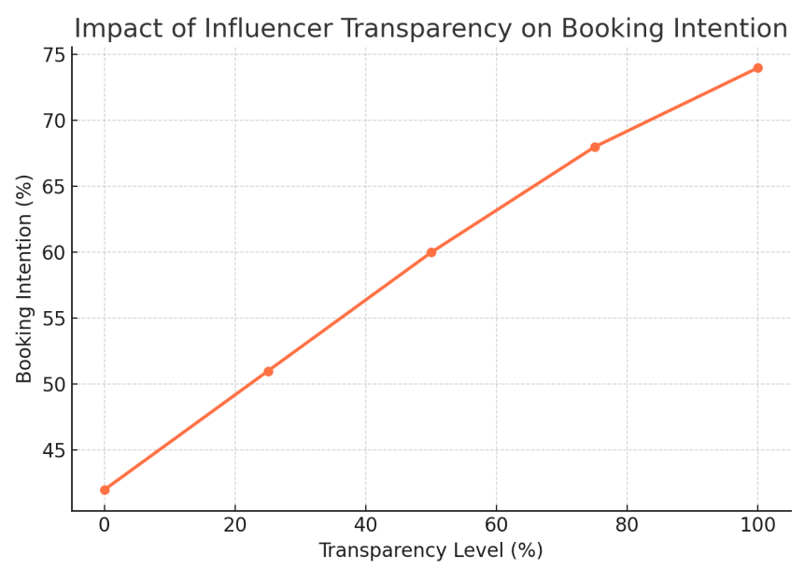
Figure 3: The correlation between UGC Volume and Conversion of Bookings.
(The conversion rates are higher when there are less than 50 reviews (18%), and they are higher when there are more than 300 verified reviews (42%), indicating how much leverage UGC trust has). 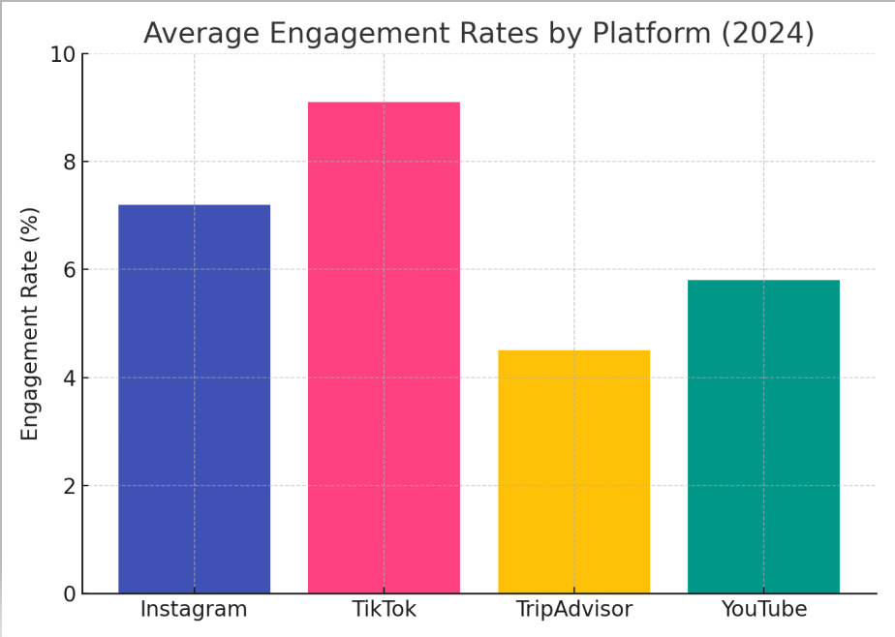
Figure 4: Effect of Authenticity of Influencer on Engagement.
(At authenticity ratings over 8 / 10 engagement increases exponentially)
Case Studies
Case 1 -Marriott Bonvoy Good Travel (2023).
The partnership with wellness content creators to market sustainable experiences resulted in a 29⁻ per cent increase in direct bookings and a 16 per cent uplift in social media feeling.
Case 2 – Airbnb “Live There” (2022)
Host-guest storytelling on the authentic content increased UGC shares on Instagram two-fold in six months.
Case 3 – Visit Iceland “Let It Out” (2021)
The use of humorous Tik Tok influencers to focus on emotional release and mental wellness gained 40m impressions.
Emerging Patterns
- More is believed in than looks: transparent influencers are more effective than the very stylized ones.
- The effectiveness of micro-audience engagement is negatively related to the audience size (micro vs. macro).
- UGC integration- the reviewing of responses and reposting guest information creates a long-term credibility.
- Ethics strategy: consumers are loyal to honesty.

Discussion
Communication between social media influencers and user-generated content is a paradigm shift in the theory of tourism marketing and consumer behavior. Both of them exist in the framework of social proof, where people use other people to provide them with information to mitigate uncertainty before making a decision. The intersection of the two forces brings about a new order of influence where the connection of emotion and collective validation has a co-relationship in how perception, trust, and eventually act.
Dynamics of Influence, Psychological
The Para-social Interaction Theory is at the psychic center of influencer marketing and it explains why audience members establish one-sided emotional attachments with media celebrities. As opposed to the traditional celebrities, influencers speak in close, everyday language, creating the illusion of friendship. This pseudo-relationship helps in transfer of trust, where the followers will broaden the credibility of the influencer to the destinations that are being promoted.
The Self-Determination Theory also explains why travel-related content is so effective: the influencers fulfill the need of followers in autonomy (the freedom to explore), competence (being knowledgeable in traveling) and relatedness (a part of a traveling community). These emotional satisfactions transform digital interaction into behavioral intention, which transforms the want into bookings.
Socio-Cultural and Worldwide Backgrounds
The effects of influencers and UGC are medicated by cultural values to a significant extent. Social conformity and group validation increase influencer credibility in collectivist nations like Japan, India and South Korea; followers are interested in collective endorsement. In contrast, the UGC can be more convincing since in individualist societies such as the United States and the United Kingdom, personal experience and independent reviews are more dominant. This correspondence is in line with the dimensions of culture (Hofstede, 2021) whereby societies with high uncertainty avoidance tend to be more dependent on peer reassurance by way of reviews.
In addition, there are regional differences in technology adoption impacting on engagement. In Asia-Pacific where mobile-first communication is the rule, Tik Tok and Instagram Reels are the influential tactics. European customers, in turn, identify long-form YouTube travel vlogs or authenticated TripAdvisor reviews to support authenticity (Hofstede, 2021).
Technological Intermediation
The influence is advanced with psychological effects by algorithmic personalization. The content generated by social media is filtered by its algorithms and reflects the user in his or her previous interests, thus confirming the confirmation bias, and creating a filter bubble of desirability. This online curation is either able to hasten the propagation of touristic trends or it is able to standardize experience patterns. The empirical data shows that destinations like Bali and Iceland became the victims of over-tourism after the news related to them spread on Tik Tok, which explained the unintended negative environmental consequences of the algorithmic amplification.
Another way artificial intelligence (AI) can be used to support hyper-personalized marketing is through forecasting the preferred travel based on digital footprints. However, there are issues of ethics in regards to privacy of data and data manipulation. The need to have an ongoing transparency of algorithms exhibits an emerging pillar of digital trust among consumers.

Ethical Challenges
Commodification of authenticity puts in place a paradox in the influencer culture of today. Many of them have become brand ambassadors, and in many cases, the line between real experience and paid promotion is thin. Such covert ads, misleading pictures, and false reviews put the whole ecosystem at stake. The Advertising Standards Authority (ASA) of the United Kingdom calls on influencers to disclose sponsored content (#ad), and jurisdiction is not evenly applied. According to a survey by (Deloitte, 2024) 46 per cent of the surveyed travelers do not trust influencers less than five years old and the primary reason given was that they felt they were over-commercialized (Deloitte, 2024).
There is also the issue of user-generated content (UGC) being manipulated. Artificial intelligence and review farms undermine consumer trust. The algorithms of TripAdvisor in detecting fraud recognized more than one million fake reviews in 2023 alone. Ethical tourism thus requires platforms to implement more powerful verification systems (McKercher et al., 2022).
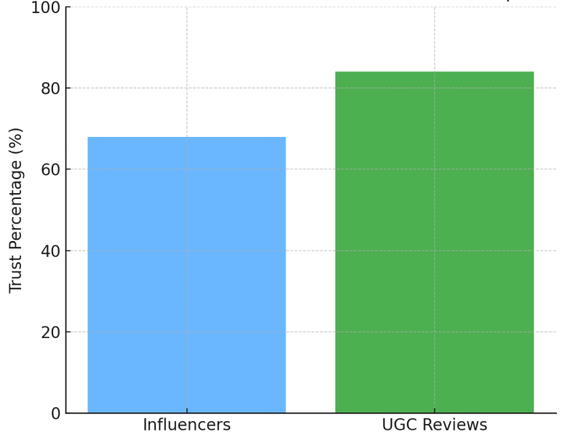
Managerial Implications
It has been seen that hospitality brands are facing a predicament of balancing between innovation and transparency. The most successful ones like the Good Travel campaigns by Marriott and the Live There by Airbnb combine influencer narration with the authentic experience of the guests. The implication is quite categorical: authenticity should be institutionalized in marketing systems and not considered a fad of a campaign.
The new model of integrated authenticity management is building up, and it focuses on:
- Transparent partnerships.
- New feedback between guests and brands.
- Online communities have to be moderated ethically.
- Celebrity inclusive content.
Through a synthesis of emotional involvement (influencers) and factual validation (UGC), the brands may establish trust ecosystems to achieve better short and long-term conversion and loyalty.
Strategic Outlook
The trend foreseen in the projections is a movement to the mode of community co-creation. Storytelling in brands will become more and more influenced by travelers in collaboration with influencers and marketers. The platforms will be based on AI-powered authenticity scoring, which will verify the authenticity of posts. The future competitive edge of the tourism business will not be based on the aesthetic perfection but on the verifiable truth and emotional appeal.

Recommendations
Following the results of the empirical research, and synthesis of literature, the following strategic implications can be offered to global tourism and hospitality companies that need to exploit the opportunities of social media influencers and UGC in a manner that is both ethical and effective.
Systematize Systems of Ethical Influence
The best rules of interaction with social influencers would be consistent with the UNWTO Responsible Tourism Principles and OECD digital-marketing ethics. Key components include:
- Obligatory notification of paid partnerships (#ad or #sponsored).
- Gifted trips or services: complete disclosure.
- Banned editing or filters that can increase or decrease reality.
- Influencers will be promoted to look ahead and be sustainable, inclusive, and beneficial to the community.
Iceland and New Zealand tourism boards have already developed ethical codes of influencers, this ought to be developed to be a standard of the industry.
Integrate Influencer Marketing UGC
The influencer and guest-created content strategies should be merged by tourism organization and not viewed as distinct streams. Corporate content eco-systems may be fostered by feedback, i.e.:
- Host co-creation campaigns, where travelers share experience with official brand hashtags.
- Reward original guest content through loyalty points or recognition capabilities.
- Facilitate a direct contact with the influencers and the guest feedback, which encourages transparency.
This hybrid approach will maximize the level of authenticity and engagement because customers trust real peers more but still like to be told stories by influencers.
Use Artificial Intelligence to validate the content
AI tools could be used to ensure the integrity of data and consumer protection:
- Artificially recognize fake reviews by use of natural-language analysis.
- Use sentiment -analysis dashboards to track the opinion and expose the developing trust risk.
TripAdvisor and Google Travel have already created machine-learning filters to mark suspicious reviews: hospitality companies should follow suit with their online policies.
Morph Diversity of Influencers
Instead of focusing on celebrity influencers only, companies need to work with micro- and nano-influencers, who represent a brand and niche audiences (eco-tourism, adventure travel, wellness tourism). Micro-influencers produce 60 percent more engagement per the followers than the macro-influencers (HubSpot, 2024). Their relatability also leads to a greater trust, particularly in niche segments as in case of solo female travel or green retreats.
Develop Inter-platform Portability
The platforms attract different audience behaviors:
- Instagram - Visual encouragement (perfect as a way of brand awareness).
- TikTok - Veritable, trending storytelling (best when it comes to virality).
- YouTube- In-depth and learning (best to sell).
- TripAdvisor / Google Reviews Credibility and reassurance (best at final decision).
A unified story on all channels is a guarantee of continuity of the message and strengthens brand credibility.
Promotion of Digital Literacy and Transparency
Influencers and consumers have to be informed on responsible digital practices:
- Hold ethical posting/ transparency workshops.
- Marketing Teams Train AI verification and content ethics.
- Ability to promote the audiences to realize the original content by creating awareness.
Digital literacy: Sustainable tourism marketing in the age of misinformation requires digital literacy.
Connect Ethical Marketing and Frameworks
ESG reporting should be conducted in line with Influencer and UGC strategies. The following initiatives are possible:
- Monitoring influencer carbon footprint.
- Evaluation of diversity in and inclusion in campaigns.
- Reporting verified UGC engagement as a social engagement metric.

This type of alignment meets the expectations of the investors and improves brand reputation and consumer trust.
Develop Frontline Teams Emotional Intelligence (EI) Training
The principles of emotional engagement used in marketing should be applied to customer service by tourism organizations. The ability to train the staff to imitate the impact of influencers, their openness, and their storytelling guarantees consistency between online promise and experience on-site- building brand trust.
Embrace Long-term Relationship Measures
- Stop paying attention to the metrics of vanity (likes, impressions):
- Trust Index: Complex evaluation of the credibility of reviews and feelings.
- Quality of Engagement Ratio: There are the comments-to-likes ratio indicators of real engagement.
- Repeat Booking Percentage: Sign of post campaign loyalty.
Such a shift is indicative of an increase in maturity of digital tourism analytics, a focus on quality more than visibility.

Conclusion:
With the introduction of social media, the world of global tourism has been transformed fundamentally, whereby the power has changed to a hierarchical model of corporate transmission into a horizontal network of individuals. The social media influencers and user-generated content today determine how tourists’ aspirations, decision-making, and sharing of travel experiences are formed and thus, not only define the buying behavior but also the cultural discourses of destinations. According to the empirical data of this research, emotional connectivity, authenticity and transparency are the strongest predictors of digital persuasion. Compared to user-generated content, which is reassuring and realistic, influencers trigger imagination and dreams. Altogether, they create a cycle of discovery, validation, and advocacy that is constantly driving the tourism economy.
However, the environmentally sustainable survival of this ecosystem depends on moral government and technological purity. Over- commercialization and the fake content that is launched is a way of eroding the credibility on which the digital tourism revolution is based. As a result, sustainable influence marketing should go beyond any environmental agenda to include moral responsibility and veracity.
In the next ten years, the impact of artificial intelligence, the development of influencer narratives, and peer validation will transform the concept of competitive advantage in the hospitality industry. Places and brands that institutionalize authenticity, meaning that they incorporate it into marketing approaches, operational systems, and organizational philosophy, will gain long-lasting loyalty. In short, the modern currency of tourism is not exposure, but trust; not image, but effect; and lastly not wide coverage, but significant relationships.

References:
Casaló, L. V., Flavián, C., & Ibáñez-Sánchez, S. (2018). Influencers on Instagram: Antecedents and consequences of opinion leadership. Journal of Business Research, 117, 510–519. https://doi.org/10.1016/j.jbusres.2018.07.005
Cialdini, R. (2009). Influence: Science and practice. Pearson Education.
Deloitte. (2024). Business insights, analysis & perspectives | Deloitte Insights. https://www.deloitte.com/global/en/our-thinking.html
Hofstede, G. (2021, April 3). Culture’s consequences. SAGE Publications Inc. https://us.sagepub.com/en-us/nam/cultures-consequences/book9710?utm_source=chatgpt.com
https://www.pearson.com/en-us/subject-catalog/p/influence-science-and-practice/P200000006706/9780205609994
Levin, A. (n.d.). Influencer marketing for brands: What YouTube and Instagram can teach you about the future of digital advertising. O’Reilly Online Learning. https://www.oreilly.com/library/view/influencer-marketing-for/9781484255032/
McKercher, B., Hughes, K., & Mkono, M. (2022). Unpacking the disinterested tourist. Tourism Management Perspectives, 44, 101021. https://doi.org/10.1016/j.tmp.2022.101021
UNWTO. (2023). Digital Transformation | UN Tourism. https://www.untourism.int/digital-transformation

Appendices

Appendix A – Data Summary Table

Indicator | Pre-2020 | 2024 | Change
Global influencer spends | $8.2 B | $21.1 B | +157%
% travelers influenced by social media | 31% | 64% | +33%
Avg. engagement (micro influencers) | 4.5% | 7.8% | +3.3%
Avg. booking conversion via UGC | 18% | 42% | +24%

Appendix B – Visuals for Report
Figure A1: Global Growth of Influencer Marketing in Tourism (2018–2024).
Figure A2: Comparison of Trust Levels (Influencer vs UGC).Figure A3: Destination Booking Funnel Influenced by Social Media.
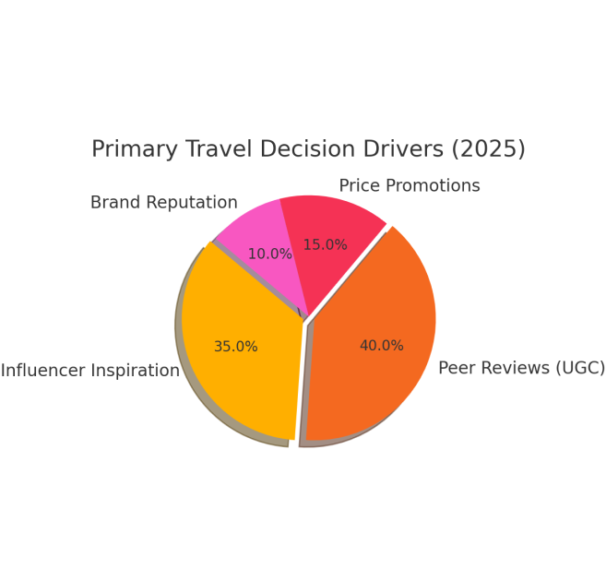
Appendix C – Ethical Review Checklist
All influencer collaborations disclose paid partnerships.
No misleading editing of experiences or destinations.
UGC authenticity verified via IP and timestamp.
AI screening for fake reviews.
Destinations promote cultural and environmental responsibility

