M10 – Applied Ethics and Bioethics
Title: Applied Ethics, Human Rights, and Social Justice
Student Name: Navneet Singh

Abstract
This paper provides a study of the link between applied ethics, human rights and social justice in today's society. The objective of the study is to examine the role ethical theories play in dealing with key social justice and creating an ethically responsible decision making. This paper outlines the ethical theories such as utilitarianism, deontology, virtue ethics, care ethics and cross-cultural ethics. Discrimination, poverty, disadvantage in health services, environmental injustice, cultural conflict and bias in Artificial Intelligence are among the major issues examined. The results indicate that the ethical theories are important frameworks for the protection of equality, human dignity, fairness, and institutional responsibility. The study also emphasizes that a single ethical point of view is not sufficient to find solutions to the modern social problems as the social, cultural, political and economic aspects are interrelated. In the conclusion, the paper states that in order to achieve effective social justice, there must be a balance of ethical considerations, responsible government, human rights, and a sense of social commitment to equality, compassion and fairness in increasingly globalised societies.

Table of Contents
Abstract 2
1. Introduction 4
1.1 Definition of Applied Ethics 4
1.2 Human Rights and Social Justice 4
1.3 Purpose of the Study 5
1.4 Thesis Statement 5
2. Literature Review 6
2.1 Utilitarianism 6
2.2 Deontology 7
2.3 Virtue Ethics 8
2.4 Care Ethics 9
2.5 Cross-Cultural Ethics 10
3. Methodology 12
3.1 Research Approach 12
3.2 Sources Used 12
3.3 Analytical Method 12
4. Findings and Analysis 14
4.1 Discrimination and Human Rights 14
4.2 Poverty and Economic Inequality 15
4.3 Environmental Justice 17
4.5 Technology, AI, and Ethical Justice 19
5. Discussion 21
6. Conclusion 22
7. References 24

1. Introduction

1.1 Definition of Applied Ethics
Applied ethics is the part of ethics which deals with practical and real-world problems of morality. Applied ethics is a branch of ethics which deals with practical issues that involve ethics like healthcare ethics, law ethics, business ethics, ethics in technology and ethics in public policy. The material for the lecture states that applied ethics is the application of moral considerations to the public and professional life. In the context of complex situations, applied ethics offers structured frameworks which can be used by individuals and institutions to make decisions that are morally responsible (Beauchamp and Childress, 2019). Likewise, Mandal, Ponnambath, and Parija (2016) claim that the moral theory of utilitarianism and deontology are needed to settle moral disagreements in medicine and society. Applied ethics is now a growing field of ethics, as there are still many complex ethical issues that are emerging in the modern world due to globalization, technology and inequality.

1.2 Human Rights and Social Justice
Human rights and social justice are the basic concepts of applied ethics since it is about protecting human dignity, equality and fairness. All human beings are born free and equal in dignity and rights, regardless of their race, gender, religion or nationality, says a passage in the Universal Declaration of Human Rights. Social justice seeks to provide a just distribution of resources, opportunities and legal protections in society. The World Health Organization places the ethical duties of governments and institutions in providing equal access to health care and social services, and preventing discrimination. Such moral duties are significant especially in tackling problems of poverty, access to health care and discrimination and exclusion in society. In addition, Dine and Dany (2024) highlight the need for ethical governance and equitable healthcare access as key elements in the concept of social justice in contemporary societies.

1.3 Purpose of the Study
This study is aimed at exploring the role of applied ethics to human rights and social justice in today's society. Ethical analysis is required because inequality, discrimination, refugee crises and environmental injustice, unequal healthcare access and all the other issues that impact vulnerable populations around the world continue to exist globally. Although there are international human rights frameworks, people continue to be excluded and treated unequally because of the inequalities in society, politics and economy. This study, therefore, examines the use of ethical theories as a way to lead to responsible, just and morally sound decision making in tackling these social issues.

1.4 Thesis Statement
This paper contends that the frameworks of applied ethics are crucial to advancing social justice and protecting human rights through ethical thinking, equality and public policy.

2. Literature Review

2.1 Utilitarianism
Jeremy Bentham and John Stuart Mill developed a consequentialist ethical theory known as utilitarianism. The theory assesses what is good in terms of consequences, and equates good acts with those that bring the most happiness to the most people. Whereas Bentham's emphasis was on the concepts of ‘pleasure' and ‘pain' as quantifiable measures of ‘moral value', Mill's work extended the theory by differentiating between ‘higher' intellectual pleasures and ‘lower' physical pleasures. The betterment of collective welfare, as well as the quality of human life, should be the betterment of moral decisions (Mill, 1863/2001). It is an outcome-based approach that makes utilitarianism very powerful in the realm of public policy, health care systems and economic decision making due to its focus on social good and efficiency.
Utilitarianism is also highly applicable to medicine because medical professionals often have decisions to make where there is a scarcity of resources and competing interests in play, as explained by Mandal, Ponnambath, and Parija (2016). Likewise, Tseng et al. (2021) have shown that utilitarian thinking emerged as the focus during the coronavirus disease (COVID-19) pandemic, when medical staff was in shortage, ventilators, and intensive care beds were scarce. Many healthcare systems determined those patients who had a better chance of survival and treated them first, in the event of crisis, to ensure that as many lives as possible were saved. In a utilitarian sense, this approach was deemed to be morally acceptable because it would minimize overall suffering and enhance the overall results.
Even with these pragmatic merits, utilitarianism has been sorely attacked because of its disregard of the rights of individuals and the rights of minorities. However, if doing so will benefit the majority population, then according to Puyol (2025), utilitarianism will allow for unequal treatment. This introduces the moral dilemma of efficiency vs. justice as there could be vulnerable groups that face discrimination in the decision-making process at a policy level. Comprehensively, for instance, during the pandemic, communities with poor economic status had less access to health care than was claimed to be beneficial for social welfare. The critics say that utilitarianism may end up treating people like numbers. Some have therefore criticized utilitarianism as a way of treating human beings as mere numbers, denying them their dignity.

2.2 Deontology
Deontology is the moral theory which focuses on the duty, best associated with the philosopher Immanuel Kant. Deontology is unlike utilitarianism, which bases its morality on results. Deontology does not decide what is moral based on results, like utilitarianism does. Kant thought that each person had an inherent worth and should never be treated as an instrument towards an end (Kant, 1993). The central to deontological ethics is the categorical imperative, which encourages people to only act on principles that they could universalize and apply to everyone. This approach prioritizes the moral will, justice, equality and respect for humanity's autonomy.
In healthcare ethics, deontology is important as it safeguards informed consent, patient autonomy and privacy even when such action does not yield good results (Mandal et al., 2016). Deontology is different from utilitarianism, which can give priority to the welfare of the community, in that there are no exceptions for its individual rights. This is a principle which has a strong impact on the contemporary human rights regime and anti-discrimination laws. The Universal Declaration of Human Rights illustrates deontological thinking in that everyone has an equal dignity and an equal set of rights, irrespective of their race, gender, nationality or religion. United Nations Universal Declaration of Human Rights
But, deontology has come under criticism for being too black-and-white in the face of moral complexity. If we take seriously universal duties, then we will find it difficult in real emergencies, as it may be that ethics or duties clash with each other and this can make life very difficult, as argued by Tseng et al. (2021). For example, patient confidentiality during an outbreak of infectious diseases may be in opposition to the wider public safety issues. Deontology is not, therefore, always able to offer flexible answers to more social and political difficulties, according to critics.

2.3 Virtue Ethics
In the virtue ethics approach, rules and consequences are not the focus, instead it is a moral character that is the focus. The theory is based on Aristotle's philosophy that moral acts are learned by practicing “virtues” (compassion, courage, honesty, justice, integrity, and responsibility). Virtue ethics does not ask if an action is required by a rule or is of greatest benefit, but whether its action is consistent with the actions of a good moral person. Ethical decision making is therefore linked to character and moral growth instead of to a set of rules or calculations of the consequences of a decision.
According to Baumane-Vitolina (2016), virtue ethics is more humane for it is based not only on the principles, but also on the development of moral character. In the realm of politics and ethics, integrity and moral accountability are significant factors that influence trust in the public and the credibility of institutions, especially in leadership. A good leader is expected to take fair decisions, have compassion and act in a responsible way towards society. Empathy and honesty are virtues that can foster trust between healthcare personnel and vulnerable populations, in the healthcare and public service sectors.
The concept of virtue ethics also plays an important role in discussions on social justice because of the fact that virtues like compassion and fairness are a powerful motivator for individuals and institutions to act on issues of poverty, discrimination and inequality. Virtue ethics differs from utilitarianism, which is concerned with the consequences of decisions, and deontology, which is concerned with duties, in that it takes the moral character of the person making the decision as its focus. Critics charge, however, that the concept of virtue ethics offers no clear-cut rules on how to solve complex ethical dilemmas since what is considered a virtue may differ from culture to culture and society to society. Notwithstanding the criticism leveled against the theory, it has value as it encourages personal and institutional ethical responsibility, moral integrity and socially responsible leadership.

2.4 Care Ethics
Care Ethics focuses on relation, vulnerability, caring for others and empathy. Care ethics is different from traditional theories of ethics, which emphasize rational rules or universal principles, because it is based on human dependency, interpersonal relationships and emotions. The theory suggests that ethical choices should take a holistic approach to lived experiences and social vulnerability, rather than just moral considerations.
The literature on ethics of care highlights that suffering of marginalised groups can be different from suffering that is captured in traditional ethics. This view is especially important for issues of health and welfare, refugee support, disability rights and combating poverty as those in need and with less means often rely on a compassionate social network for survival and dignity. World Health Organization makes an ethical case for health systems to provide equal treatment and protection for disadvantaged communities. Thus, the emphasis on emotional support, inclusion and human relationships brings ethical analysis of human rights and health care beyond the realm of legal rights offered by World Health Organization Human Rights and Health Care ethics.
The great virtue of care ethics is that it can humanize the process of developing policy and social welfare discussions. The theory underscores that social inequality can have emotional and psychological impacts on people, in addition to economic. Marginalised groups, people with disabilities and refugees might need relief on top of legal protections, such as relational support and caring. But critics claim that care ethics can sometimes be more concerned with the emotional than the fair and universal; and that, in doing so, it sometimes overlooks the political. Emotionally based reasoning, or faulty decision-making, can also occur when relying too heavily on this type of reasoning.

2.5 Cross-Cultural Ethics
The cross-cultural ethics is dealing with the moral issues that are different across cultures and investigating how moral issues can be negotiated in multicultural societies. Ethical conflicts can arise due to conflicts regarding the importance and values of different groups in society including individual freedom, religious authority, family loyalty, and social harmony. The aim of cross-cultural ethics is then to develop an understanding of ethics across cultures, not to automatically validate one moral system as being superior to another.
Authorities and autonomy, as well as collective responsibility are generally different in various societies leading to cross-cultural ethical conflicts, explains Fazal (2021). Ethnocentrism is a tendency to make judgments about other cultures based on one's own culture, which may result in intolerance and/or cultural conflict. Cultural relativism, however, suggests that one's moral beliefs ought to only be understood in terms of one's culture. Although cultural relativism is a call for tolerance and respect for diversity, some people claim that excessive cultural relativism will stop criticism of bad practices, like discrimination and exploitation.
Dialogue between cultures seek to arrive at a balance between these perspectives, fostering understanding and respect of the universal aspects of human rights and human dignity. This is becoming a more significant part of the international discourse on issues of refugee protection, gender equality, healthcare ethics and religious freedom. Ethical systems that are able to accommodate cultural diversity yet maintain justice, equality and individual rights are necessary for modern societies. The cross-cultural ethics thus becomes an important part of minimizing social conflict and achieving social cooperation in today's more interconnected societies.

3. Methodology

3.1 Research Approach
The study has qualitative research approach which aims to explore the contributions of the theories of ethics to the discussion of human rights and social justice. The qualitative method was chosen as it is not statistical analysis that is the main focus in this piece of research, but moral reasoning, ethical interpretation, and social inequality. Ethical challenges like healthcare inequality, discrimination, protection of refugees and cultural conflict are social and political matters, which demand the analysis and interpretation of social values. Fazal (2021) argues that qualitative ethical research can be used to understand the complexities of social and cultural conflicts due to the richness it provides in comprehending the moral frames and human experiences.
Ethical analysis is also used as the research framework in the study. Ethical analysis is used to assess issues of social policy, institutional choice and public action in terms of ethical principles. Mandal, Ponnambath and Parija (2016) suggest that ethical theories offer a logical framework to solve ethical dilemmas that arise between the rights of the individual, professional obligation and the welfare of the community.

3.2 Sources Used
No. | Author(s) & Year | Title | Source / Publisher
1 | Baumane-Vitolina, I. (2016) | Is ethics rational? Teleological, deontological and virtue ethics perspectives | SHS Web of Conferences, 30, 00017
2 | Beauchamp, T. L., & Childress, J. F. (2019) | Principles of Biomedical Ethics (8th ed.) | Oxford University Press
3 | Dine, J., & Dany, G. (2024) | Ethics, Healthcare, and Social Justice in Contemporary Societies | Routledge
4 | Fazal, A. (2021) | Ethical Issues in Conducting Cross-Cultural Research | International Journal of Qualitative Methods, 20
5 | Kant, I. (1993) | Groundwork of the Metaphysics of Morals | Hackett Publishing
6 | Mandal, J., Ponnambath, D. K., & Parija, S. C. (2016) | Utilitarian and Deontological Ethics in Medicine | Tropical Parasitology, 6(1), 5–7
7 | Mill, J. S. (2001) | Utilitarianism | Batoche Books
8 | Mougan, C., & Brand, T. (2023) | Artificial Intelligence Ethics and Algorithmic Fairness in Public Systems | AI and Ethics, 3(2), 455–468
9 | Tseng, P. E., Wang, Y. H., Lin, Y. S., & Chu, Y. H. (2021) | Deontological or Utilitarian? An Eternal Ethical Dilemma in Outbreak | International Journal of Environmental Research and Public Health, 18(16), 8565
10 | United Nations (2024) | Universal Declaration of Human Rights | United Nations
11 | World Health Organization (2023) | Human Rights and Health | World Health Organization

3.3 Analytical Method
The analysis was done by comparing five ethical frameworks; utilitarianism, deontological, virtue ethics, care ethics, and cross-cultural ethics. The individual theories were explored, one by one, to isolate the key principles of each theory in terms of justice, equality, responsibility, autonomy and human dignity. Theories were then compared to see how they led to various moral reactions in regard to the same social problem.
some modern social issues have been chosen which include a clear ethical conflict, such as the allocation of healthcare during COVID-19, the protection of refugees, discrimination and inequality in healthcare. These cases have been selected because they feature dilemmas between the interests of the community, freedom of citizens, different cultural norms, and social duty. Upon finding an ethical issue in each of the scenarios, the study examined the reaction of various ethical theories to the scenarios and what ethical decision each theory would lead to.
For instance, the allocation of healthcare in the case of COVID-19 was examined through a utilitarian view in terms of maximizing the number of people who will survive and a deontological approach in terms of equal human dignity and patients' rights. Likewise, refugee protection was explored using care ethics and cross-cultural ethics to look at the role of empathy, vulnerability and cultural understanding in shaping ethical responsibilities towards refugees. The comparison process enabled the study to highlight the strengths and weaknesses of each ethical approach with regard to their application to today's social issues.

4. Findings and Analysis

4.1 Discrimination and Human Rights
The criminal justice systems continue to be deeply racially discriminatory, and racial discrimination in the form of racial profiling and police violence against Black communities is prevalent. In 2020, following the death of George Floyd, the Black Lives Matter movement put on the spotlight the working of systemic racism in policing institutions and legal systems. During institutional power and inequality situations, social policies should respect the dignity of each person and do their utmost to provide for the welfare of the public, argue Tseng et al. (2021). At an economic level, discrimination reduces the capacity of people to support each other, as the greater social inequality leads to higher distrust of the public system and social conflict and economic instability. Community cohesion and sustained economic prosperity are linked to societies that encourage equal opportunities.
Gender inequality is also being perpetuated in the workplace and in relation to finances. There is a disproportionate pay gap between men and women, even at the same level of education and experience, with women often earning less than men. There are unequal opportunities for women to access leadership roles and women are underrepresented in higher-paying positions when compared to men, even if they have the same education and experience. Kant (1993) states that people should be treated as ends in themselves and not as per social stereotype or economic value. Deontological ethics, therefore, opposes gender discrimination as it is a matter of human dignity and fairness that cannot be ignored.
Vulnerable groups are further exposed to social exclusion in the form of disability discrimination and unequal treatment of LGBTQ+ people through lack of access to services, unequal access to health care and institutional barriers. Care ethics focuses on the need for the ethical community to ensure the safety of the weaker sections of society by being empathetic, inclusive and responsible. Institutions have a proactive role in shaping just and inclusive social spaces, rather than merely complying with legal obligations, according to Baumane-Vitolina (2016), in their arguments for ethical responsibility. So it is necessary to eradicate discrimination to safeguard human dignity, to build up social justice and to promote equal participation in modern society.
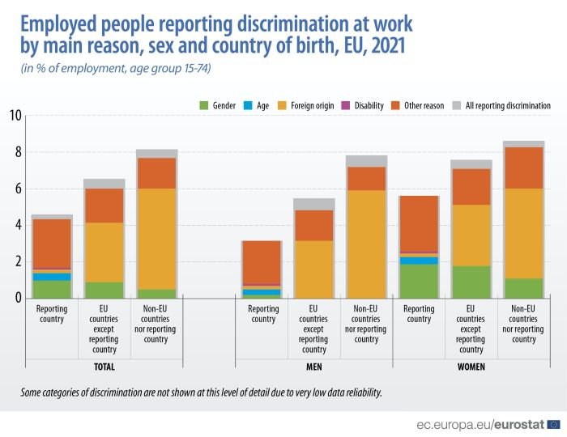
Fig 1: Discrimination at Work

4.2 Poverty and Economic Inequality
Despite this, there is still a need to address poverty and economic inequality in access to education, healthcare, employment and social participation in both developed and developing countries. This could be, among others, educational inequality between low income and high-income communities. In many developing nations, children from low-income families are not provided access to well-trained teachers and digital learning materials nor to higher education. As a result of the COVID-19 pandemic, students from lower income families suffered disproportionately due to the fact that many were without internet access and digital devices necessary to participate in the online learning environment. This increased educational disparities and a loss of employment opportunities for economically disadvantaged groups in the future.
The global distribution of vaccines during the COVID-19 pandemic has highlighted some of the ways in which health care disparities are evident. In the early days of the distribution of vaccines, while many countries in Africa had problems acquiring enough doses, wealthier countries like the United States, Canada and the United Kingdom had large stocks acquired through advance purchase agreements. The World Health Organization (2023) reports that in some low-income countries less than 20% of people were vaccinated and booster doses had already been given in high-income countries. This unequal distribution was a result of the economic power imbalance and not any equal demand for health care. As argued by Tseng et al., (2021), this posed an ethical dilemma between national self-interest and global justice as vulnerable groups in poorer places continued to be at risk of avoidable death.
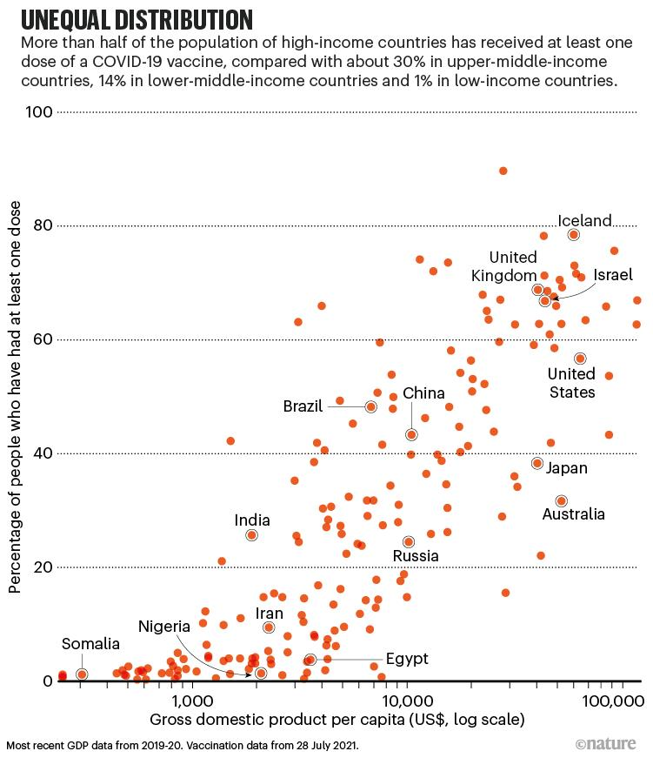
Fig 2: Global COVID-19 Vaccine Inequality

There is also a link between economic inequality and unemployment and social exclusion. Poor people more likely to be in precarious jobs, earn less, have poor access to health insurance, and housing. In terms of the concept of distributive justice, these inequalities breach fairness and equal opportunities, as they tend to keep key social resources among the rich. Mandal, Ponnambath and Parija (2016) state that ethical systems need to focus on the alleviation of suffering and the enhancement of collective welfare and not reinforce structural inequality. Thus, poverty and economic inequality is an ethical problem that is directly related to justice, human dignity and equal right to basic human rights.

4.3 Environmental Justice
The concept of environmental justice is to look at the unequal distribution of environmental harms to different social and economic groups. Though developing nations and the poorest people are responsible for the least carbon emissions, they are the ones most affected by climate change. In Pakistan, certain natural disasters have been particularly devastating, such as the catastrophic floods of 2022, which impacted 33.4 million people, resulting in the loss of homes, lives, infrastructure and economic wealth. But Pakistan's GHGs emission is under 1% of the world. By comparison, industrialized countries like the USA and China are still among the top emitters in the world. This results in ethical issues as those with the least cause of climate change are the ones to suffer the worst effects of climate change. Climate change poses a risk to food, clean water, shelter and health, especially in lower income areas, according to the United Nations (2024).
Another primary concern of environmental justice is environmental racism. This takes place when minority or low-income groups are exposed to pollution and environmental risks to a greater extent. One of the most notable cases has been the Flint Water Crisis in Michigan, United States, which commenced in 2014 when the city switched to a water source to save expenses. The exposure of thousands of predominantly Black residents to serious health risks such as neurological damage in children was caused by poor treatment of the water, which led to lead exposure. For several months, the government failed to listen to the public and show concern about environmental issues, which is a result of political neglect and economic inequality. The government also failed to heed the people's concerns for several months, highlighting the impact of political neglect and economic inequality on the environment. The crisis revealed that disadvantaged groups are not always afforded as much protection as other groups with respect to environment.
Environmental protection, from a utilitarian point of view, is beneficial to society because it can decrease the amount of disease, economic damage, and environmental disasters in the long-term. Deontological ethics also maintains that governments and companies have moral obligations that cannot be postponed due to financial considerations to save human life and to stop the damage to the environment. Virtue ethics also calls for long-term care of the environment, with greater responsibility and stewardship, as opposed to short-term industrial profit. Baumane-Vitolina (2016) says that the ethical leadership must involve the institutions to be responsible towards present and future generations. Thus, environmental justice is an issue that brings a direct link between climate change and pollution to inequality, political accountability and human rights enforcement.
The interrelationship between culture and ethics, and between culture and human rights will be examined.
Cross-cultural ethics looks into issues of ethics that arise when cultural practices conflict with international human rights. Gender rights, healthcare decisions, religious beliefs and freedom of expression are common issues in these conflicts. This had been a significant instance in Afghanistan, following the return of the Taliban in 2021 and the closure of secondary schools and universities for girls. Taliban officials explained the reasons for these bans by using religious and cultural arguments and, on the contrary, the United Nations and other international organizations stated that banning education is a violation of the principles of human rights such as equality and personal freedom (United Nations, 2024). This is a conflict to understand how cultural practices can directly challenge the universal human rights frameworks.
Medical ethics also brings about a big conflict between different cultures, especially on the issues of autonomy of patients and authority of the family. In many health-care systems in the Western world, patients have the legal right to decide independently on what to do with their body medically and as far as the end of life is concerned. In some countries, like China and Japan, however, the family often has a controlling influence over medical decisions, particularly with regard to serious illness. Cultural conceptions of responsibility, authority and collective welfare have a significant impact on ethical decision making during a healthcare crisis, according to Tseng et al. (2021). Therefore, the healthcare worker in a multicultural society has to take care to respect cultural differences and maintain ethical standards as a health care professional.

4.5 Technology, AI, and Ethical Justice
AI is playing an increasing role in the areas of healthcare, employment, policing, education and financial services, among others, in decision making processes. AI systems are great for efficiency and data processing but also raise ethical questions about bias, privacy, discrimination and fairness. AI bias is the result of unfair decisions in algorithms being made due to data that is incomplete or historically biased. Therefore, automated systems can exacerbate the inequalities that exist in social systems and not reduce them.
A key instance is the use of facial recognition systems for law enforcement that are biased. Researchers at the Massachusetts Institute of Technology have discovered that multiple facial recognition systems made serious mistakes in identifying black people and women especially black women—that they made fewer errors with white men. It can create errors that result in the mistaken identification or arrest of innocent people because algorithms are not objective. It can cause inaccuracies, which means that innocent people could be misidentified or arrested because of algorithmic bias. This is a way of showing how racial discrimination can be replicated in the technological systems already in existence in social institutions. From deontological point of view, there are systems that violate the principles of fairness and human dignity, as a result of using biased technological processes instead of objective evidence. Deontological ethics postulates that everyone has an equal moral value, and deserves equal treatment in an automated system without discrimination.
The ethical issues that arise with Healthcare AI include inequality and access to healthcare treatment. Several health care algorithms employed in the United States underestimated the medical risk of black patients, since the algorithms relied on health care spending experience, not actual disease severity. Historically, less health care investment had been made in lower income black communities, leading the algorithm to make the incorrect assumption that these patients would need less medical care. This led to inequities in health services provision and deepened structural inequalities in health care systems.
When AI technology advances public safety, enhances healthcare efficiency, and boosts the overall economic productivity of a society, then it can be said to be beneficial to the development of AI. But utilitarian answers can be formulated, and privacy may be sacrificed or treatment be unequal, when the government's interests are greater than individual harm. .

5. Discussion
The results of this research indicate that the theories of ethics are still needed to analyze the issues of human rights and social justice in the modern era. The findings of the research revealed that discrimination, health inequality, environmental injustice and technological bias were not social issues but structural ethical issues related to unequal power, economic inequality and institutional decision making. In the modern world, utilitarianism can be used to account for many public policies as the government tend to focus on actions that increase the overall welfare and stability of society. In the time of COVID-19, for instance, allocation of vaccine or emergency healthcare decisions have often been made based on utilitarian calculation where the ultimate goal is to minimize total death rates and improve public health (Tseng et al., 2021). The results also showed that utilitarian approaches might also be counterproductive for the least well-off if efficiency and majority gain outweigh equality and individual rights.
Deontological ethics gave more support to the analysis of issues related to discrimination, inequality in health care and human dignity. The results revealed that a racially discriminatory, gendered and AI biased systems would fail to uphold universal concepts of fairness by failing to treat people equally for their identity, economic status or social background. Kantian values, as a result, lead to a more robust institutional accountability, and equitable rights guaranteed, irrespective of an economic or political result (Kant, 1993).
The study also emphasized on the care ethics and cross-cultural ethics in multicultural and unequal societies. In discussions of refugees and disability discrimination, as well as the inequality of health care, care ethics proved particularly relevant, with the focus on the empathy, vulnerability and institutional responsibility in relation to marginalised groups. In the opinion of Baumane-Vitolina (2016), the need of ethical societies is not just to be dependent on legal systems, but requires the moral responsibility and compassionate leadership. In a similar vein, cross-cultural ethics also revealed that cultural diversity and universal human rights are one of the significant ethical issues in globalization (Fazal, 2021). In general, the results support this argument that ethical decision making demands the use of both moral theories and not rely entirely on one theory.

6. Conclusion
The research also emphasized the significance of ethical theories for the assessment of the current social problems. Utilitarianism brings in some practical methods which reduce suffering and promote the general well-being, such as in health care and public policy. The concept of deontology has a good degree of protection for human rights because it puts emphasis on fairness, equality and respect for human dignity. Compassion, responsibility, empathy and moral leadership are also central to an ethics of virtue and an ethics of care approach to issues of vulnerable populations and social inequality. The cross-cultural ethics showed how significant it was to respect the culture, while maintaining the universal human rights protection in societies which were becoming increasingly globalized and multicultural.
The study also revealed that in today's social issues, different rights, cultures, economic differences, and institutional responsibilities conflict in relation to the issues, which makes it difficult to solve every ethical issue by a single ethics theory. Ethical decision making, then, must be flexible, analytic and weigh various ethical views. There are ethical obligations at the individual, government, health services, corporate and international level to decrease inequalities, protect vulnerable groups and ensure fairness and justice in policy-making.

7. References
Baumane-Vitolina, I. (2016). Is ethics rational? Teleological, deontological and virtue ethics perspectives. SHS Web of Conferences, 30, 00017.
https://doi.org/10.1051/shsconf/20163000017
Beauchamp, T. L., & Childress, J. F. (2019). Principles of biomedical ethics (8th ed.). Oxford University Press.
https://global.oup.com/academic/product/principles-of-biomedical-ethics-9780190640873
Dine, J., & Dany, G. (2024). Ethics, healthcare, and social justice in contemporary societies. Routledge.
https://www.routledge.com
Fazal, A. (2021). Ethical issues in conducting cross-cultural research. International Journal of Qualitative Methods, 20.
https://doi.org/10.1177/16094069211008344
Kant, I. (1993). Groundwork of the metaphysics of morals (J. W. Ellington, Trans.). Hackett Publishing.
https://hackettpublishing.com/groundwork-for-the-metaphysics-of-morals
Mandal, J., Ponnambath, D. K., & Parija, S. C. (2016). Utilitarian and deontological ethics in medicine. Tropical Parasitology, 6(1), 5–7.
https://doi.org/10.4103/2229-5070.175024
Mill, J. S. (2001). Utilitarianism. Batoche Books.
http://socserv2.socsci.mcmaster.ca/econ/ugcm/3ll3/mill/utilitarianism.pdf
Mougan, C., & Brand, T. (2023). Artificial intelligence ethics and algorithmic fairness in public systems. AI and Ethics, 3(2), 455–468.
https://link.springer.com/journal/43681
Tseng, P. E., Wang, Y. H., Lin, Y. S., & Chu, Y. H. (2021). Deontological or utilitarian? An eternal ethical dilemma in outbreak. International Journal of Environmental Research and Public Health, 18(16), 8565.
https://doi.org/10.3390/ijerph18168565
United Nations. (2024). Universal Declaration of Human Rights.
https://www.un.org/en/about-us/universal-declaration-of-human-rights
World Health Organization. (2023). Human rights and health.
https://www.who.int/news-room/fact-sheets/detail/human-rights-and-health

