M01 Introduction to Hospitality Industry
Trends, Challenges and Sustainability in the Global Hospitality Industry
Option 3 Report
Student Name
Student ID | ________________
Module | M01 Introduction to Hospitality Industry
Submission Deadline | 24 May 2026

Table of Contents
Abstract | 3
1. Introduction | 3
2. Literature Review | 5
3. Methodology | 9
4. Findings | 11
5. Discussion | 15
6. Conclusion | 18
References | 20
List of Figures
Figure 1. Integrated Hospitality Industry Ecosystem
Figure 2. Current Trend and Challenge Priority Map
Figure 3. Resilient and Sustainable Hospitality Framework

Abstract
This report critically examines current trends, challenges and sustainability issues shaping the global hospitality industry. It focuses on hotels, restaurants, resorts, events, travel services and leisure operations because these sectors now compete through integrated experiences rather than isolated services. The report argues that hospitality is moving from a mainly capacity based industry to a data enabled, experience centred and sustainability accountable service system. Digital booking platforms, artificial intelligence, mobile service, personalisation, wellness tourism and environmental reporting are creating new opportunities for revenue growth and guest loyalty. However, these opportunities are constrained by labour shortages, rising operating costs, intense platform competition, cyber and privacy risks, changing customer behaviour and exposure to crises. A qualitative desk based methodology is used to review industry reports, academic literature and recent market evidence. The findings show that innovation improves convenience and operational efficiency only when it is combined with skilled employees, ethical data use and credible sustainability action. The discussion concludes that resilience in hospitality depends on balancing technology, people and place. Hospitality organisations should therefore invest in employee capability, transparent sustainability measurement, local community partnerships, flexible pricing, responsible artificial intelligence and crisis prepared operating models.

1. Introduction
The hospitality industry is one of the most visible parts of the global service economy. It includes accommodation, food and beverage, events, travel support services, leisure operations, attractions, resorts, wellness facilities and related guest services. Its core product is not simply a room, meal or ticket. It is the organised delivery of comfort, safety, welcome, memory and value at the moment when the customer is away from normal routines. This makes hospitality both economically important and managerially complex. It employs large numbers of people, supports tourism development, stimulates local supply chains and shapes destination images. The World Travel and Tourism Council reports that travel and tourism contributed US$11.6 trillion to global GDP in 2025 and supported 366 million jobs worldwide, which confirms the scale of the wider ecosystem in which hospitality operates (WTTC, 2026). UN Tourism also reported that international tourism recovered to 1.4 billion arrivals in 2024, showing that demand has returned strongly after the severe disruption of the COVID 19 period (UN Tourism, 2025).
This report addresses Option 3 of the M01 Introduction to Hospitality Industry assignment, which requires an analysis of trends, challenges and sustainability in hospitality. The topic is important because the industry is recovering at the same time as it is being redesigned. Guests increasingly expect frictionless booking, instant communication, personalised recommendations, authentic local experiences, wellness options and visible environmental responsibility. At the same time, hospitality operators face labour scarcity, higher energy and food costs, changing regulations, stronger online competition, reputational risks and pressure to manage crises more professionally. Therefore, the central question of the report is how hospitality organisations can remain innovative and resilient while also acting responsibly toward employees, guests, destinations and the environment.
The report first reviews academic and industry literature on hospitality transformation. It then explains the desk based methodology used to identify and evaluate evidence. The findings analyse 5 major themes: demand recovery and market fragmentation, digitalisation and artificial intelligence, sustainability expectations, workforce and cost pressures, and resilience after recent crises. The discussion connects these findings to hospitality management concepts such as service quality, experience design, stakeholder value and sustainable operations. The conclusion recommends practical strategies for hotels, restaurants, resorts and event businesses seeking long term competitiveness in a rapidly changing service environment.

2. Literature Review
Hospitality is commonly described as a people centred service industry, but contemporary hospitality is better understood as a network of interdependent service experiences. Accommodation providers depend on restaurants, events, transport, booking platforms, attractions and destination management because the guest evaluates the whole journey rather than one transaction. This supports the service ecosystem view, where value is co created by firms, employees, guests, local communities and digital intermediaries (Buhalis & Law, 2008). The implication is that hospitality management cannot focus only on internal operations. It must also manage partnerships, online visibility, destination reputation, customer data, social responsibility and labour relations.
A major theme in hospitality literature is service quality. Parasuraman, Zeithaml and Berry (1988) explain that customers judge service through dimensions such as reliability, responsiveness, assurance, empathy and tangibles. In hospitality, these dimensions are experienced through reception behaviour, cleanliness, food quality, safety, waiting time, complaint recovery and staff professionalism. However, service quality is not limited to standardisation. Pine and Gilmore (1998) argue that advanced service economies compete through memorable experiences. This is highly relevant to hospitality because guests increasingly purchase atmosphere, identity, local authenticity and emotional value. A boutique hotel, themed resort, wellness retreat or destination restaurant creates advantage when it turns basic service delivery into an experience that feels distinctive and personally meaningful.
Digital transformation has changed the structure of hospitality competition. Online travel agencies, review platforms, mobile check in, digital keys, customer relationship management systems and revenue management algorithms have shifted power toward data rich platforms and digitally informed guests. Buhalis and Law (2008) observed that information technology reshaped tourism distribution and consumer behaviour, and this argument has become stronger with the rise of platform based booking. Guests now compare prices instantly, examine reviews before purchase and expect rapid digital communication. More recently, artificial intelligence has moved from simple chatbots toward predictive personalisation, automated translation, dynamic pricing, demand forecasting and staff scheduling. McKinsey reports that agentic artificial intelligence could alter travel and hospitality because it can plan, decide and act with limited human supervision when supported by suitable governance and infrastructure (McKinsey & Company, 2025). This creates efficiency opportunities, but also raises risks around privacy, bias, cyber security and the loss of human warmth.
Personalisation and wellness tourism are closely connected trends. Guests increasingly expect hospitality providers to remember preferences, offer flexible service options and support health, rest and wellbeing. McKinsey’s state of tourism and hospitality research describes demand growth in experience rich travel, new source markets and changing traveller expectations (McKinsey & Company, 2024). Hotels and resorts have responded with wellness rooms, sleep focused packages, spa services, fitness facilities, healthier menus, nature based activities and work leisure blended spaces. These changes reflect wider social shifts in which consumers seek recovery, meaning and lifestyle alignment from travel. However, personalisation is difficult because guests want tailored treatment without feeling monitored or exploited. Hospitality firms must therefore develop trust based data practices and avoid treating personalisation as only an upselling tool.
Sustainability is now a central hospitality management issue rather than a narrow environmental add on. Hotels consume energy and water, generate food waste, purchase large volumes of materials and influence local communities. Sustainable hospitality therefore includes carbon management, water stewardship, waste reduction, ethical procurement, local employment, fair work and respect for destination culture. The World Sustainable Hospitality Alliance frames net positive hospitality around people, planet, place and prosperity, arguing that hotels should give more back to destinations than they take (World Sustainable Hospitality Alliance, 2026). This broad model is useful because it links environmental responsibility with social and economic value. Jones, Hillier and Comfort (2016) also argue that sustainability in hospitality must be embedded in governance and operations rather than presented mainly as marketing.
Consumer evidence supports the growing importance of sustainability, but it also reveals contradictions. Booking.com reported that 75% of global travellers wanted to travel more sustainably in the next 12 months, while many also felt confused, powerless or unwilling to sacrifice convenience and price (Booking.com, 2024). This is a classic attitude behaviour gap. Guests may value sustainability in principle, but purchasing behaviour is still shaped by price, location, comfort and habit. Therefore, hospitality businesses cannot assume that green claims alone will produce loyalty. They need credible certification, transparent measurement and service designs that make sustainable choices easy, visible and affordable.
The literature also highlights major workforce challenges. Hospitality relies heavily on emotional labour, teamwork, flexible scheduling and frontline problem solving. Yet the sector is often associated with low wages, unsocial hours, high turnover and limited career progression. Recent evidence shows that labour shortages remain a serious concern. The American Hotel and Lodging Association found that 65% of surveyed hotels reported staffing shortages in 2025, even after improvements in pay and benefits (AHLA, 2025). Workforce pressure is not only a staffing issue. It affects service quality, guest satisfaction, employee wellbeing, training costs and brand reputation. A hotel cannot deliver personalised luxury or efficient complaint recovery if employees are exhausted, undertrained or constantly leaving.
Crisis management has become another essential theme since COVID 19, geopolitical disruptions, climate events and cost inflation exposed hospitality vulnerability. Sigala (2020) argues that the pandemic created a transformational moment for tourism and hospitality by revealing weaknesses in existing business models. Gössling, Scott and Hall (2021) similarly suggest that crises can push tourism toward more sustainable and resilient forms if organisations learn rather than simply return to old growth models. For hospitality, resilience means more than financial recovery. It includes flexible operations, diversified demand sources, hygiene and safety systems, digital continuity, supplier resilience, crisis communication and employee support.
The interrelationship between hospitality sectors strengthens these pressures. A hotel depends on restaurants to complete the guest stay, event venues to stimulate group demand, transport services to connect the destination, and leisure attractions to make the trip worth taking. Real world hospitality businesses increasingly recognise this. Large hotel groups such as Marriott, Hilton and Accor sell rooms, restaurants, loyalty benefits, meetings, wellness facilities and destination experiences as connected offers rather than separate products. Restaurant groups use delivery platforms and reservation apps to extend demand beyond the dining room. Event venues combine catering, accommodation partnerships, hybrid technology and visitor management. This integration means that weakness in one sector can damage the overall guest experience. For example, a resort with excellent rooms can still receive poor reviews if airport transfers, food service or local excursions fail. Literature on service ecosystems is therefore important because hospitality value is created across several organisations and several moments of contact.
Overall, the literature suggests that the hospitality industry is being reshaped by connected trends. Technology can improve convenience and productivity, but it can also weaken human contact and increase dependency on platforms. Sustainability can strengthen reputation and reduce resource costs, but weak green claims create distrust. Experience design can raise customer loyalty, but it requires skilled employees and operational consistency. Resilience can protect firms from shocks, but it demands investment before crises happen. The strongest hospitality organisations will therefore be those that integrate innovation, human capability and sustainability into the core business model instead of treating them as separate projects.
Figure 1 summarises this connected view of hospitality and shows why guest experience should be managed across the full service journey rather than within one isolated department.
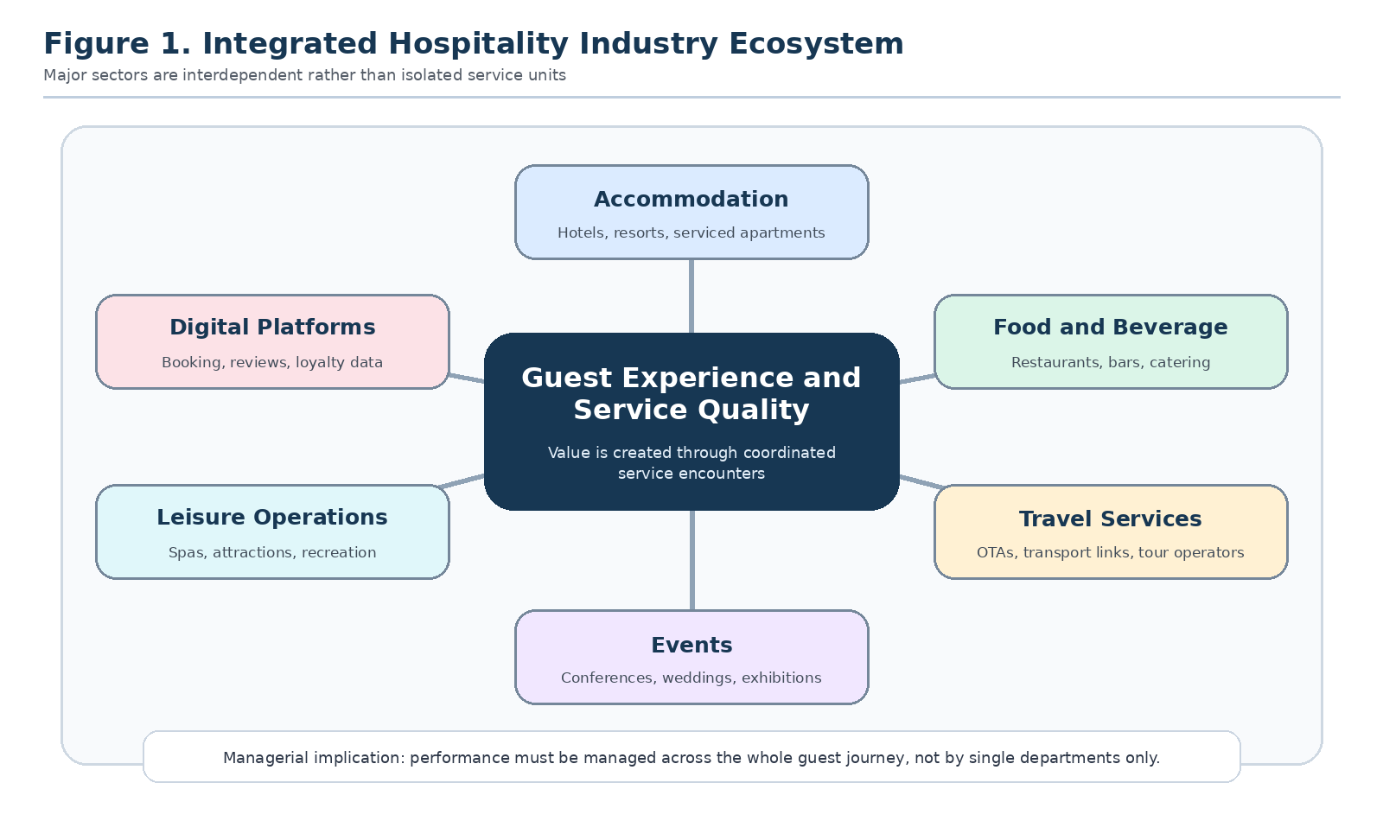
Figure 1. Integrated hospitality industry ecosystem showing the interdependence of accommodation, food and beverage, travel, events, leisure and digital platforms.

3. Methodology
This report uses a qualitative desk based research methodology. The chosen method is appropriate because the assignment requires a critical analysis of hospitality trends, challenges and sustainability rather than primary measurement of one hotel or restaurant. A desk based approach allows the report to combine academic theory with current industry evidence and real world examples across different hospitality sectors. It is also suitable for a broad introductory hospitality report because the industry includes many interconnected activities, including accommodation, food and beverage, events, leisure and travel services.
The research design followed 4 stages. First, the assignment brief was reviewed to identify the compulsory themes: digital booking platforms, artificial intelligence, personalisation, wellness tourism, sustainable hospitality, labour shortages, rising costs, competition, changing customer behaviour, crisis management, environmental responsibility, ethical service and social sustainability. Second, relevant academic literature was selected to provide conceptual foundations. Service quality theory was used to evaluate guest experience because it explains how customers judge reliability, responsiveness, assurance, empathy and tangibles (Parasuraman et al., 1988). Experience economy theory was used to interpret the movement from basic service delivery to memorable guest experiences (Pine & Gilmore, 1998). Tourism technology and sustainability literature was used to interpret platform competition, digital transformation and environmental responsibility (Buhalis & Law, 2008; Jones et al., 2016; Sigala, 2020).
Third, recent industry evidence was reviewed to ensure that the report reflects current hospitality conditions. Sources were chosen from reputable organisations such as WTTC, UN Tourism, the World Sustainable Hospitality Alliance, Booking.com, McKinsey and AHLA. These sources were selected because they provide recent data on tourism recovery, economic contribution, employment, artificial intelligence, sustainability expectations and labour shortages. Fourth, the evidence was analysed thematically. The analysis grouped findings into 5 themes: market recovery and fragmentation, technology and artificial intelligence, sustainability expectations, workforce and cost pressures, and resilience and crisis management. A thematic approach is appropriate because hospitality challenges are interconnected and cannot be understood only through isolated statistics.
The methodology has limitations. Desk research depends on the quality and framing of available sources. Industry reports can be optimistic because they are often produced by organisations that support sector growth. Consumer surveys can show intention rather than actual behaviour. Academic literature can also lag behind rapidly changing technologies such as agentic artificial intelligence. To reduce these limitations, the report compares academic concepts with recent market evidence and avoids treating one source as conclusive. It also uses critical judgement when interpreting data. For example, strong tourism recovery does not automatically mean that all hospitality firms are financially secure, because recovery can occur alongside labour shortages, cost inflation and uneven demand.
Evidence was interpreted using 3 quality criteria. Recency was considered because hospitality demand, technology use and labour markets have changed quickly since 2020. Relevance was considered because general tourism statistics do not always explain operational hospitality problems. Credibility was considered because some commercial sources can promote optimistic interpretations of industry performance. For this reason, the report uses both institutional data and academic theory. The analysis also distinguishes between industry level recovery and firm level performance. High visitor arrivals may support revenue, but they do not automatically solve profitability, labour quality or sustainability challenges.
The report does not collect primary data from guests or hospitality managers. Therefore, its purpose is not to measure one organisation’s performance. Its purpose is to develop a structured, evidence informed understanding of the pressures shaping hospitality management and to recommend practical strategies that can be applied across hotels, restaurants, resorts and event businesses.

4. Findings
The first major finding is that hospitality demand has recovered strongly, but the recovery is uneven and more complex than a simple return to pre crisis normality. UN Tourism reported 1.4 billion international tourist arrivals in 2024, which represented a recovery to 99% of pre pandemic levels (UN Tourism, 2025). WTTC then reported that travel and tourism reached US$11.6 trillion in global GDP contribution in 2025 and supported 366 million jobs (WTTC, 2026). This creates strong demand for hotels, restaurants, attractions and events. However, demand recovery does not remove structural pressure. Many guests are more price sensitive, more digitally informed and more selective about value. Luxury, wellness and experience led segments can grow while budget and mid market operators face cost pressure. Therefore, hospitality businesses need better segmentation rather than assuming that all demand is equally profitable.
The second finding is that digital platforms and artificial intelligence are changing competition across the guest journey. Online travel agencies and review sites influence discovery, price comparison and trust before a guest arrives. Mobile apps, digital check in, chatbots and digital payments influence convenience during the stay. After the stay, ratings and social media posts influence future demand. Artificial intelligence adds a new layer because it can support demand forecasting, dynamic pricing, personalised offers, automated customer service, maintenance prediction and labour scheduling. McKinsey and Company (2025) reports that travel and hospitality firms are experimenting with agentic artificial intelligence, but successful adoption requires strategy, governance and redesigned processes. This finding shows that technology is not only a tool. It is a competitive structure that changes how hospitality value is created, distributed and reviewed.
The third finding is that sustainability has become a guest expectation, an investor concern and an operational efficiency issue. The World Sustainable Hospitality Alliance argues that net positive hospitality requires action across people, planet, place and prosperity (World Sustainable Hospitality Alliance, 2026). This means that hotels cannot define sustainability only as towel reuse or removing plastic straws. It includes energy efficiency, carbon measurement, water management, food waste reduction, ethical sourcing, fair employment and community benefit. Booking.com (2024) found that 75% of global travellers wanted to travel more sustainably in the next 12 months, but the same evidence showed confusion and frustration among consumers. The practical finding is that hospitality firms need to make sustainable choices easy and credible. Guests are unlikely to accept inconvenience or vague claims. They are more likely to respond to visible and verified actions, such as refillable amenities, local sourcing, efficient energy systems, transparent certification and clear communication of impact.
The fourth finding is that workforce shortages and rising costs threaten service quality. Hospitality remains labour intensive because guests judge the experience through human interaction, speed, empathy and problem resolution. AHLA found that 65% of surveyed hotels continued to report staffing shortages in 2025 (AHLA, 2025). This problem is intensified by wage inflation, food price volatility, energy costs and competition from other sectors. A hotel may invest in digital systems, but poor staffing can still create long queues, dirty rooms, slow restaurant service and weak complaint recovery. Labour scarcity therefore connects directly to brand reputation and revenue. The evidence suggests that hospitality organisations need to treat employees as strategic assets rather than replaceable labour.
The fifth finding is that resilience has become a permanent management requirement. Recent crises showed that hospitality is exposed to pandemics, travel restrictions, climate events, geopolitical uncertainty, supply chain disruption and sudden changes in consumer confidence. Crisis management now involves hygiene readiness, cancellation flexibility, revenue diversification, insurance planning, digital communication, supplier alternatives, cyber security and staff wellbeing. The strongest organisations are not simply those that cut costs quickly. They are those that can adapt service formats, communicate honestly with guests, protect employees and maintain trust during disruption.
A sixth finding is that customer behaviour is becoming more polarised. Some guests trade up for memorable experiences, premium wellness, luxury restaurants and distinctive design. Others trade down because of inflation and search aggressively for discounts. This makes hospitality pricing more difficult. Dynamic pricing can protect revenue during peak demand, but it can also create distrust if guests feel exploited. Restaurants face a similar issue when menu prices rise because of food and wage costs. Event businesses must balance ticket affordability with security, staffing and production expenses. The evidence therefore suggests that hospitality businesses need clear value communication. Guests will accept higher prices more readily when the experience, service recovery, cleanliness, safety and sustainability benefits are visible.
A seventh finding is that real world hospitality innovation works best when it is practical rather than fashionable. Mobile keys, artificial intelligence chat, self service kiosks and robotic delivery can reduce friction in some contexts, especially for routine transactions. However, luxury hotels, resorts, conferences and restaurants still depend heavily on emotional intelligence, anticipation and hospitality culture. This means that technology adoption should be based on the guest problem being solved. A hotel should not introduce automation only because competitors are doing so. It should ask whether the technology improves waiting time, accuracy, accessibility, safety, staff workload or personal relevance.
Together, these findings show that hospitality organisations are facing a double challenge. They must innovate to meet new expectations, but they must also protect the human, environmental and local foundations that make hospitality valuable. The following table summarises the core implications for management.
Figure 2 translates the findings into a simple priority map, highlighting that technology, sustainability, labour pressure and cost volatility are simultaneous management priorities.
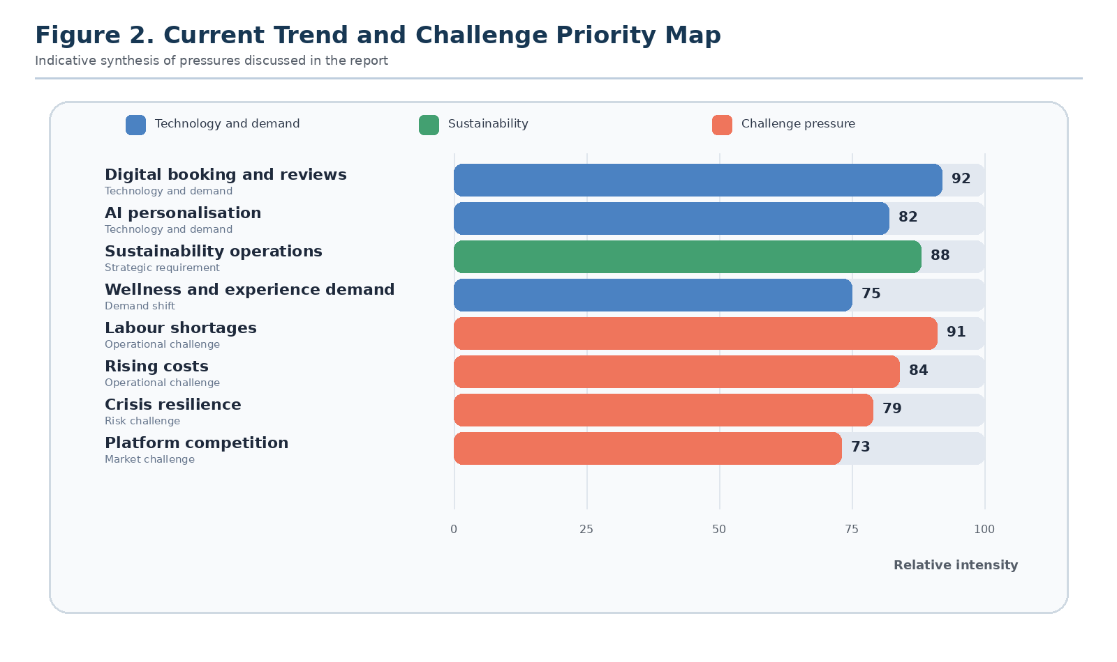
Figure 2. Current trend and challenge priority map based on the report findings.
Trend or challenge | Management implication | Recommended response
Demand recovery | Growth is strong but uneven across segments. | Use segmentation, flexible packages and value based pricing.
Digital platforms and AI | Guest journeys are shaped by data, reviews and automation. | Invest in digital service while maintaining human recovery for complex issues.
Sustainability expectations | Guests and investors expect credible environmental and social action. | Measure energy, water, waste, carbon and community outcomes transparently.
Workforce shortages | Labour gaps reduce service quality and increase stress. | Improve training, scheduling, career routes and employee value propositions.
Crisis exposure | Shocks can disrupt demand, supply and reputation quickly. | Build scenario plans, flexible operations and clear crisis communication.
Table 1. Summary of key hospitality management implications

5. Discussion
The findings show that hospitality is no longer best understood as a collection of separate sectors. Accommodation, food and beverage, events, travel services and leisure operations are now connected through guest journeys, platforms, destination systems and sustainability responsibilities. A guest who books a resort through an online travel agency, checks restaurant reviews, attends an event, visits local attractions and shares feedback online is evaluating a complete experience system. This supports the view that hospitality value is co created across multiple actors (Buhalis & Law, 2008). Managers therefore need to design service ecosystems rather than only manage departments.
Technology is central to this shift, but it should not be treated as a substitute for hospitality. Artificial intelligence can improve forecasting, personalisation and productivity, yet hospitality remains emotionally intensive. A guest may appreciate a fast chatbot for simple requests, but still expect empathy when a booking mistake, illness, safety issue or complaint occurs. The SERVQUAL dimensions remain relevant because reliability, responsiveness, assurance and empathy are still judged by human perception (Parasuraman et al., 1988). The strategic issue is therefore not whether hospitality should use technology. It is how technology can remove friction while allowing staff to focus on moments where human judgement creates trust.
Sustainability creates a similar tension between promise and practice. Many hospitality firms communicate environmental responsibility, but guests increasingly recognise superficial claims. The attitude behaviour gap identified in sustainable travel evidence means that businesses must avoid assuming that customers will pay more simply because a product is labelled green (Booking.com, 2024). Instead, sustainable hospitality should be designed into the operating model. Energy efficient buildings, food waste measurement, local procurement, reusable systems and fair employment can reduce costs, improve reputation and strengthen destination relationships. The World Sustainable Hospitality Alliance’s model is useful because it prevents sustainability from becoming only an environmental checklist and connects it to social and economic outcomes (World Sustainable Hospitality Alliance, 2026).
The workforce issue is especially important because it limits the success of every other strategy. Personalisation requires staff who understand guests. Sustainability requires employees who follow procedures and explain choices. Crisis resilience requires trained people who can act under pressure. If hospitality organisations rely on low commitment labour models, service quality will remain fragile. Higher wages alone may not solve the problem. Career development, predictable scheduling, respectful leadership, safety, recognition and digital tools that reduce workload are also required. From a resource based view, skilled and motivated employees are difficult for competitors to imitate because they carry tacit knowledge of service recovery, local culture and guest emotion.
The discussion also shows that resilience should be proactive rather than reactive. Before COVID 19, many hospitality models were built around growth in arrivals, high occupancy and efficient asset use. The crisis showed that efficiency without flexibility is risky. Future resilience requires diversified markets, flexible cost structures, adaptable spaces, scenario planning and relationships with local communities. Restaurants that shifted to delivery, hotels that served domestic leisure demand and venues that used hybrid event formats showed that innovation can protect value during disruption. However, resilience must not become an excuse for transferring risk to employees through insecure work. Ethical resilience should protect service continuity while also protecting the people who deliver the service.
The practical implication is that hospitality managers need integrated strategy. Digital systems should be linked with staff training. Sustainability claims should be supported by measurement. Guest experience should include both convenience and care. Cost control should not damage the service basics that create loyalty. This is particularly important in food and beverage operations because guests immediately notice smaller portions, slower service, poor menu knowledge and weak hygiene. It is equally important in events because crowd management, accessibility, catering and emergency procedures all affect perceived professionalism. In accommodation, the basics of cleanliness, sleep quality, safety and complaint handling remain the foundation on which personalisation and sustainability must be built.
Figure 3 presents the practical framework that follows from the discussion and links responsible innovation with people centred service and credible sustainability.
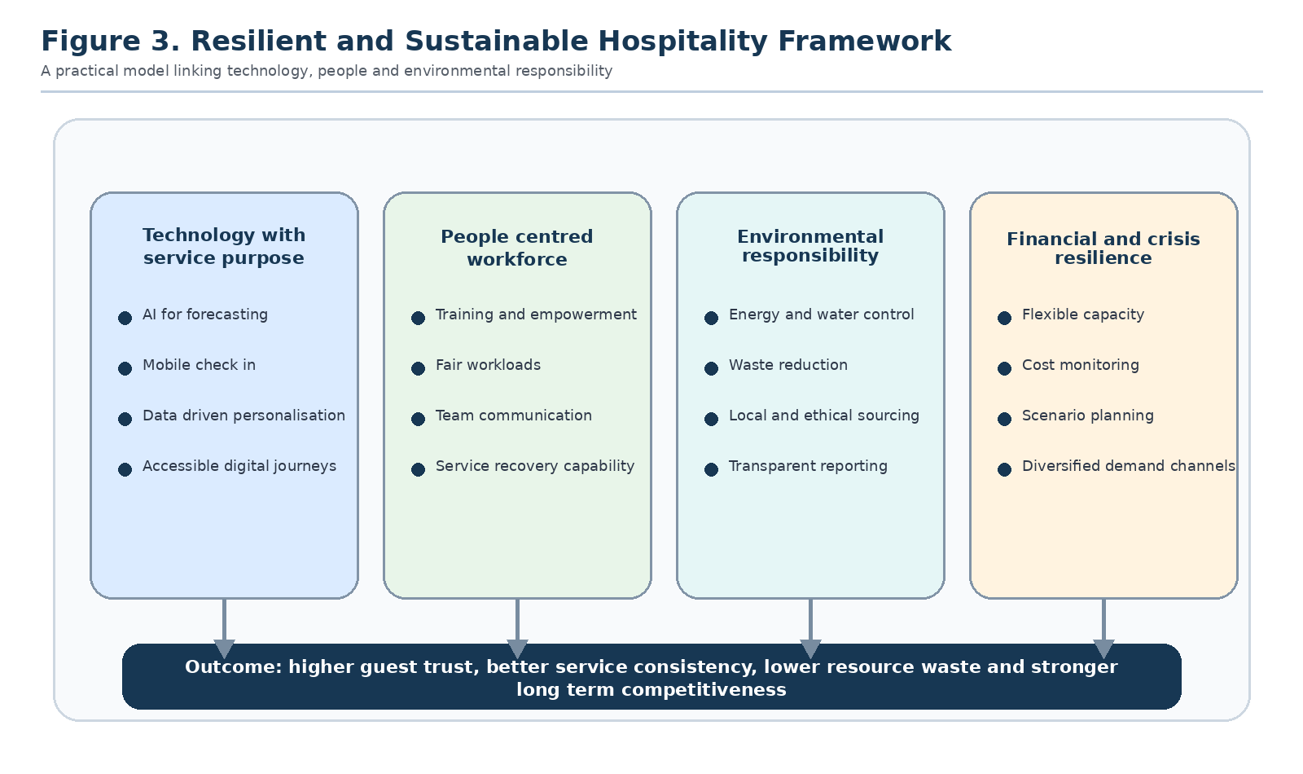
Figure 3. Resilient and sustainable hospitality framework linking technology, workforce capability, environmental responsibility and financial resilience.
There is also a governance issue. If managers measure only short term revenue, technology may be used to cut labour too aggressively, sustainability may become symbolic and guest experience may decline. A balanced hospitality scorecard should include financial, guest, employee, environmental and community indicators. The future hospitality organisation will be judged not only by occupancy, covers, average daily rate or event attendance, but also by employee retention, online reputation, environmental performance, community impact and crisis readiness.

6. Conclusion
The hospitality industry is entering a period in which growth, disruption and responsibility exist at the same time. Recovery in international tourism and travel spending shows that demand for hospitality remains strong, but the sector is not simply returning to its old model. Guests now expect digital convenience, personalised service, wellness, flexibility, authenticity and visible sustainability. At the same time, businesses face labour shortages, rising operating costs, intense online competition, reputational pressure and continuing exposure to crises.
The report concludes that the most successful hospitality organisations will be those that balance 3 priorities: technology, people and place. Technology should be used to improve access, efficiency and personalisation, but it must be governed ethically and should not remove the human care that defines hospitality. People should be treated as strategic resources through fair work, training, career development and leadership that supports service quality. Place should be protected through environmental management, local partnerships and destination sensitive operations.
Practical strategies include using artificial intelligence for forecasting and routine service while preserving human support for complex guest needs, investing in employee retention and training, adopting transparent sustainability metrics, reducing food, energy and water waste, building local supply chains, designing wellness and experience based offers, and preparing crisis response plans before disruption occurs. These strategies should be implemented as part of everyday operations rather than as separate campaigns. Hospitality organisations that integrate these actions can build resilience, improve guest trust and contribute positively to the destinations in which they operate. The wider lesson is that modern hospitality success depends on responsible growth: serving guests well, supporting employees fairly, protecting local places and using innovation in ways that strengthen rather than weaken the meaning of hospitality.

References
American Hotel and Lodging Association. (2025). 65% of surveyed hotels report staffing shortages. https://www.ahla.com/news/65-surveyed-hotels-report-staffing-shortages
Booking.com. (2024). Latest Booking.com sustainable travel data reveals ongoing challenges for consumers and highlights a heightened opportunity for cross industry collaboration. https://news.booking.com/latest-bookingcom-sustainable-travel-data-reveals-ongoing-challenges-for-consumers--highlights-a-heightened-opportunity-for-cross-industry-collaboration/
Buhalis, D., & Law, R. (2008). Progress in information technology and tourism management: 20 years on and 10 years after the Internet, the state of eTourism research. Tourism Management, 29(4), 609 to 623. https://doi.org/10.1016/j.tourman.2008.01.005
Deloitte. (2025). 2025 travel industry outlook. https://www.deloitte.com/us/en/industries/consumer/articles/travel-hospitality-industry-outlook.html
Gössling, S., Scott, D., & Hall, C. M. (2021). Pandemics, tourism and global change: A rapid assessment of COVID 19. Journal of Sustainable Tourism, 29(1), 1 to 20. https://doi.org/10.1080/09669582.2020.1758708
Jones, P., Hillier, D., & Comfort, D. (2016). Sustainability in the hospitality industry: Some personal reflections on corporate challenges and research agendas. International Journal of Contemporary Hospitality Management, 28(1), 36 to 67. https://doi.org/10.1108/IJCHM-11-2014-0572
McKinsey & Company. (2024). The state of tourism and hospitality 2024. https://www.mckinsey.com/industries/travel/our-insights/the-state-of-tourism-and-hospitality-2024
McKinsey & Company. (2025). Remapping travel with agentic AI. https://www.mckinsey.com/industries/travel/our-insights/remapping-travel-with-agentic-ai
Parasuraman, A., Zeithaml, V. A., & Berry, L. L. (1988). SERVQUAL: A multiple item scale for measuring consumer perceptions of service quality. Journal of Retailing, 64(1), 12 to 40.
Pine, B. J., & Gilmore, J. H. (1998). Welcome to the experience economy. Harvard Business Review, 76(4), 97 to 105.
Sigala, M. (2020). Tourism and COVID 19: Impacts and implications for advancing and resetting industry and research. Journal of Business Research, 117, 312 to 321. https://doi.org/10.1016/j.jbusres.2020.06.015
UN Tourism. (2025). International tourism recovers pre pandemic levels in 2024. https://www.untourism.int/news/international-tourism-recovers-pre-pandemic-levels-in-2024
World Sustainable Hospitality Alliance. (2026). Pathway to net positive hospitality. https://sustainablehospitalityalliance.org/our-work/pathway/
World Travel and Tourism Council. (2026). Travel and tourism economic impact research. https://wttc.org/research/economic-impact

