Financial Management, Investment Decisions and Business Value Creation
M02 Accounting and Finance
MBA Project Report
Option 2: Financial Management, Investment Decisions and Business Value
Student Name: ____________________
Submission Date: 24 May 2026

Table of Contents
Abstract
1. Introduction
2. Literature Review
3. Methodology
4. Findings
5. Discussion
6. Conclusion
References
Appendices

Abstract
This report critically examines how financial management contributes to business value creation through investment decisions, financing decisions, cost of capital analysis, risk return evaluation and sustainable profitability. It addresses Option 2 by explaining the objectives of financial management and the role of finance managers, analysing investment appraisal techniques such as net present value, internal rate of return, payback period and profitability index, and evaluating capital structure choices. The report argues that financial management creates value when managers allocate capital to projects whose expected cash flows exceed the risk adjusted cost of capital, while preserving liquidity, ethical discipline and long term strategic flexibility. The analysis uses theory from corporate finance and recent Apple financial data to show how capital expenditure, operating cash flow, debt, dividends and share repurchases are connected to value decisions. The report also recognises limitations in conventional techniques. Appraisal models depend on forecasts, discount rates and assumptions about risk. Financing choices can reduce WACC up to a point, but excessive leverage can increase distress risk and reduce resilience. The conclusion is that value creation requires more than profit maximisation. It requires disciplined capital allocation, transparent financing, strong risk governance and strategies that support sustainable shareholder and stakeholder value.

1. Introduction
Financial management is the discipline through which organisations obtain funds, allocate funds and control financial risk in order to create value. It is central to business performance because almost every strategic choice has a financial consequence. A company may invest in technology, open a new site, launch a new product, acquire a competitor, raise debt, issue shares, repurchase stock, pay dividends or hold cash for resilience. Each decision affects risk, return, liquidity, control and long term value. Finance managers therefore do not simply record outcomes. They shape the quality of strategic choices by estimating cash flows, comparing alternatives, setting performance thresholds and ensuring that the organisation can fund its plans responsibly.
This report addresses Option 2, Financial Management, Investment Decisions and Business Value. The main argument is that financial management contributes to value creation when it links investment appraisal, financing policy and risk management into a coherent decision system. A positive accounting profit is not enough. A business creates financial value only when it earns returns above the opportunity cost of capital and when those returns are sustainable. This means that finance managers must judge the amount, timing and uncertainty of future cash flows. They must also decide how to finance investment in a way that balances cost, control, solvency and flexibility.
The report first reviews key financial management theory, including shareholder wealth, investment appraisal, capital structure and risk return relationships. It then explains the methodology used for secondary research and illustrative modelling. The findings analyse the role of the finance manager, investment appraisal methods and financing decisions. The discussion uses Apple as a real world example because its 2025 reporting provides clear evidence of operating cash flow, capital expenditure, debt, dividends and share repurchases. An illustrative project appraisal is also included to demonstrate how NPV, IRR, payback and profitability index guide decisions. The report concludes with financial strategies for improving profitability, sustainability and shareholder value.

2. Literature Review
The objective of financial management has traditionally been expressed as shareholder wealth maximisation. In corporate finance, value is created when a project is worth more than it costs, which is why the net present value rule is normally treated as the central investment decision rule (Brealey, Myers, Allen, & Edmans, 2025). This view is practical because it recognises the time value of money and the risk of future cash flows. A pound or dollar received today can be invested, while a future cash flow may not occur as forecast. Financial management therefore focuses on expected future cash flows, not only accounting profit.
Net present value is theoretically strong because it measures the value added by an investment after discounting future cash flows at a required return. The formula is NPV = Σ[CFt/(1+r)^t] - I0. If NPV is positive, the project should increase value, assuming the forecasts and discount rate are appropriate. Internal rate of return is also widely used because it expresses project attractiveness as a percentage return. Graham and Harvey (2001) found that large firms often use present value techniques and the capital asset pricing model, while smaller firms are more likely to rely on payback. This evidence is important because it shows that practice uses multiple tools, even when finance theory gives NPV a stronger foundation.
Payback period is popular because it is simple and focuses on liquidity risk. It measures how long it takes to recover the initial investment. However, it ignores cash flows after payback and usually ignores the time value of money unless a discounted version is used. Profitability index is useful when capital is rationed because it measures present value per unit of initial investment. Its formula is PI = PV of future inflows / initial investment. However, PI can rank small projects above larger projects that create more total value. Therefore, finance managers should use it as a supporting measure rather than a replacement for NPV.
Capital structure theory examines how firms should combine debt and equity. Modigliani and Miller (1958) initially showed that under strict assumptions, firm value is independent of capital structure. Their later work recognised that interest tax shields can make debt valuable (Modigliani & Miller, 1963). However, real firms also face bankruptcy risk, agency costs, information asymmetry and financial distress. Trade off theory suggests that firms balance the tax benefit of debt against expected distress costs. Pecking order theory suggests that firms prefer internal finance, then debt, and issue equity only when other sources are less attractive because external equity can signal overvaluation or financing weakness (Myers & Majluf, 1984).
Empirical research shows that capital structure is not explained by one simple rule. Fama and French (2002) found evidence consistent with both trade off and pecking order predictions, including that more profitable firms often rely less on debt. This finding matters because it warns finance managers against formulaic leverage targets. A firm with stable cash flows and tangible assets can often carry more debt than a high growth firm with volatile earnings and intangible assets. The best capital structure depends on business risk, tax position, asset base, growth opportunities, market conditions and strategic flexibility.
Risk return relationships are also central to financial management. Investors require higher expected returns for higher systematic risk. The capital asset pricing model expresses this as re = rf + β(rm - rf), where re is cost of equity, rf is the risk free rate, β is beta and rm - rf is the market risk premium. Weighted average cost of capital links financing cost to investment appraisal through WACC = (E/V × re) + (D/V × rd × (1 - T)). If project returns exceed WACC, value may be created. However, using one corporate WACC for all projects can be dangerous. Projects with different risk should use different discount rates.
Modern value creation also includes sustainability and resilience. Porter and Kramer (2011) argue that shared value links company success with social progress by reconceiving products and markets, improving value chain productivity and supporting local clusters. In financial management, this means that sustainability should not be treated only as a cost. Energy efficiency, waste reduction, responsible procurement and employee wellbeing can reduce risk and support long term profitability. However, sustainability claims must still be financially disciplined. Projects should be evaluated through credible cash flow effects, risk reduction, regulatory avoidance, brand value and strategic option value rather than unsupported optimism.

3. Methodology
This report uses a qualitative secondary research design supported by simple quantitative modelling. Secondary research is appropriate because the assignment asks for a strategic paper on financial management and business value rather than primary fieldwork. The analysis draws on corporate finance literature, academic evidence on capital budgeting and capital structure, and recent financial reporting data from Apple. It also uses an illustrative project model to demonstrate how appraisal methods operate in practice.
The modelling component applies a 5 year investment example with an initial outlay of USD 1.000 million and expected annual cash inflows of USD 260,000, USD 300,000, USD 340,000, USD 390,000 and USD 430,000. A 10 percent discount rate is used as the required return. The purpose is not to represent a specific company project. It is to show how finance managers convert expected cash flows into NPV, IRR, payback and profitability index. The report also uses an illustrative WACC sensitivity chart to show how debt can reduce WACC through tax shields at moderate levels but raise WACC when financial risk becomes excessive.
The Apple evidence is used to connect theory to current real world decision making. Its 2025 Form 10 K reports operating cash flow, capital expenditure, term debt, dividends and share repurchases. These figures are interpreted as capital allocation evidence rather than as investment advice. The methodology therefore combines theory, modelled calculation and corporate reporting evidence to meet the assessment requirement for tool application, critical analysis and real world relevance.
Technique | Formula or measure | Strength | Limitation
Net present value | NPV = Σ[CFt/(1+r)^t] - I0 | Measures absolute value created | Sensitive to forecasts and discount rate
Internal rate of return | IRR = r where NPV = 0 | Easy to communicate as a percentage | Can mislead with scale differences or unusual cash flows
Payback period | Time needed for cumulative cash flow to reach 0 | Simple liquidity and risk screen | Ignores later cash flows and usually time value
Profitability index | PI = PV inflows / initial investment | Useful when capital is rationed | Can rank small projects above larger value creating projects
Table 1. Investment appraisal techniques and critical evaluation.
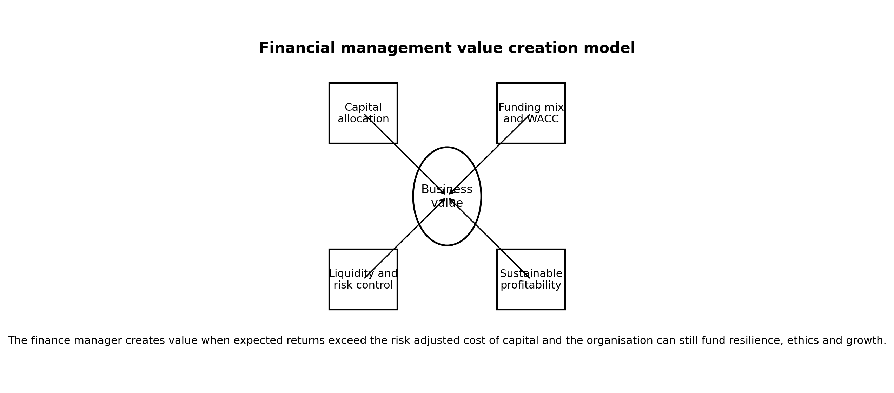
Figure 1. Financial management value creation model. Source: Author developed from corporate finance theory.

4. Findings
The first finding is that finance managers create value by linking strategy to capital discipline. Their role includes investment appraisal, funding decisions, liquidity planning, risk management, performance measurement, governance support and stakeholder communication. They translate strategic proposals into cash flow forecasts and ask whether those cash flows justify the capital required. They also decide whether investment should be funded through retained earnings, debt, equity or hybrid instruments. This role requires technical skill, but it also requires judgement because forecasts are uncertain and the best financial choice may depend on market timing, strategic urgency and risk tolerance.
Investment appraisal provides the main toolset for long term resource allocation. NPV is the strongest technique because it estimates absolute value creation. In the illustrative project, the discounted cash inflows at 10 percent produce an NPV of approximately USD 273,000 and a profitability index of 1.27. The IRR is approximately 19.3 percent, which is above the 10 percent required return. The simple payback period is between year 3 and year 4 because cumulative cash flow becomes positive after the third year and before the end of the fourth year. Taken together, the indicators suggest that the project is financially attractive.
The techniques do not have equal quality. NPV directly measures value added in money terms. IRR is easy to communicate, but it can be misleading when projects have unconventional cash flows, multiple sign changes or different scales. Payback is useful for liquidity and risk screening, but it ignores later benefits. Profitability index is helpful under capital rationing, but it may prioritise efficiency over absolute value. Therefore, managers should use NPV as the primary rule, IRR and PI as supporting indicators, and payback as a risk and liquidity check.
Financing decisions influence value through cost of capital, risk and flexibility. Debt can be cheaper than equity because lenders accept lower returns and interest may be tax deductible. Moderate debt can therefore lower WACC and increase value. However, debt also increases fixed obligations. Excessive leverage raises default risk, restricts strategic flexibility and may increase the cost of both debt and equity. The finance manager must therefore consider not only the current cost of funding but also the effect of financing on resilience during downturns.
Capital structure choices also affect control and signalling. Equity financing may avoid fixed interest commitments, but it can dilute ownership and signal that management believes shares are overvalued. Debt financing preserves ownership, but it can introduce covenants and repayment pressure. Internal financing is often preferred because it avoids issue costs and external scrutiny, but relying only on internal funds may restrict growth. The best financing policy is therefore dynamic. It should reflect project risk, business cycle position, interest rate environment, tax position, existing leverage and strategic options.
Risk return analysis is central because value depends on risk adjusted returns, not nominal returns. A project with a 15 percent expected return may destroy value if its required return is 18 percent. A project with an 8 percent expected return may create value if it is low risk and has a 5 percent cost of capital. Finance managers should therefore match discount rates to project risk. They should also conduct sensitivity analysis, scenario analysis and stress testing. A base case NPV is not enough if the project fails under reasonable downside assumptions.
Financial management also contributes to sustainability. Profitability can be improved through pricing discipline, cost control, working capital management and capital productivity. Sustainability can be improved by investing in energy efficiency, supply chain resilience, employee capability and lower risk operations. Shareholder value can be improved through positive NPV investment, efficient capital structure and disciplined capital returns. The challenge is to avoid treating these aims as separate. Long term value is strongest when profitability, resilience and responsible conduct reinforce each other.
Year | Cash flow USD000 | Discount factor at 10 percent | Present value USD000 | Cumulative cash flow USD000
0 | -1000 | 1.000 | -1000.0 | -1000
1 | 260 | 0.909 | 236.4 | -740
2 | 300 | 0.826 | 247.9 | -440
3 | 340 | 0.751 | 255.4 | -100
4 | 390 | 0.683 | 266.4 | 290
5 | 430 | 0.621 | 267.0 | 720
Summary | NPV = 273.0 | IRR = 19.3 percent | PI = 1.27 | Payback = 3.26 years
Table 2. Illustrative investment appraisal calculation.
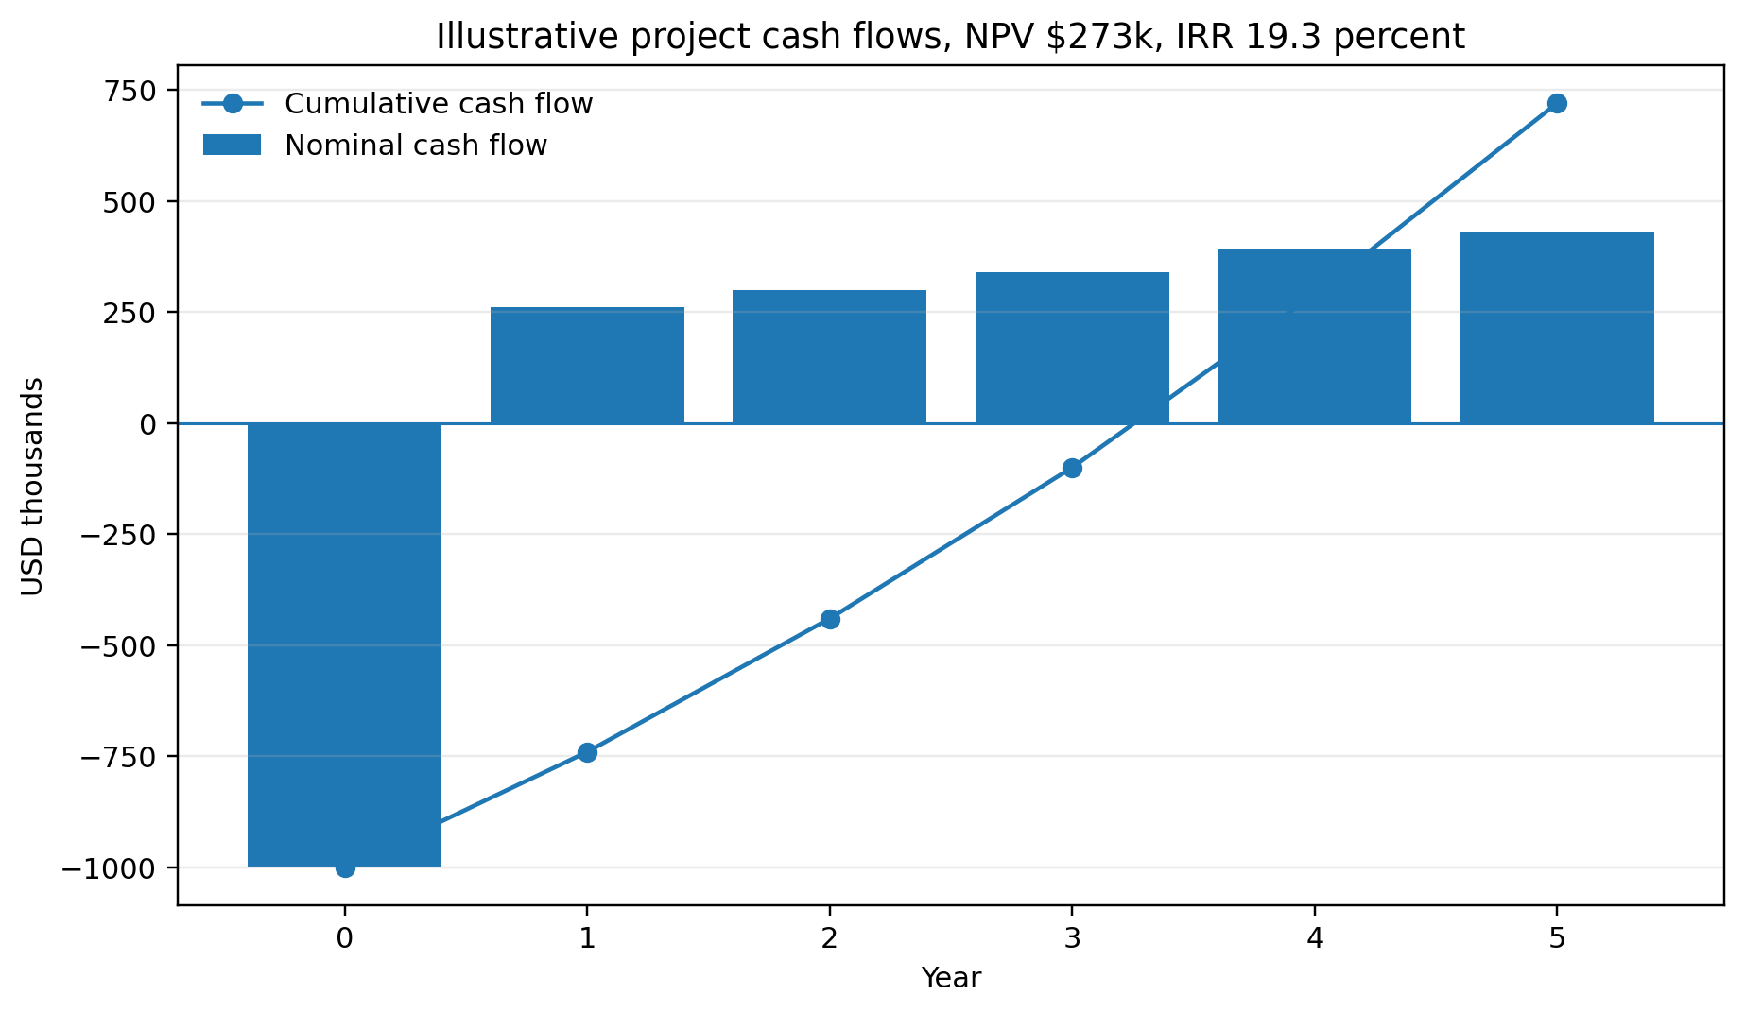
Figure 2. Illustrative project cash flows and cumulative payback profile. Source: Author calculation.

5. Discussion
Apple provides a useful example of capital allocation at scale. Its 2025 Form 10 K reports total net sales of USD 416.161 billion, net income of USD 112.010 billion and cash generated by operating activities of USD 111.482 billion (Apple Inc., 2025). This shows strong profitability and cash generation, but the finance issue is how that cash is allocated. The company reported payments for property, plant and equipment of USD 12.715 billion, share repurchases of USD 90.711 billion and dividend payments of USD 15.421 billion in 2025 (Apple Inc., 2025). These figures show that business value creation involves both reinvestment and capital returns.
The finance manager's challenge is to determine whether each use of cash supports value. Capital expenditure may support innovation, capacity, logistics and infrastructure. Share repurchases may increase earnings per share and return surplus cash if investment opportunities are limited or shares are undervalued. Dividends provide direct cash return and may signal confidence. However, every capital return also has an opportunity cost. A dollar used for repurchases cannot simultaneously fund acquisition, research, supplier diversification or debt reduction. Therefore, capital allocation should be evaluated against strategic opportunity, cost of capital and risk.
Apple's capital structure also illustrates the interaction between debt and financial flexibility. Its 2025 balance sheet reports current term debt of USD 12.350 billion and non current term debt of USD 78.328 billion, with total shareholders' equity of USD 73.733 billion (Apple Inc., 2025). The company can manage this debt because of its cash generation, brand strength and market position. A weaker company with the same debt to equity ratio could face far higher financial risk. This confirms that leverage cannot be judged through a single ratio. The stability and quality of future cash flows matter.
The illustrative investment model demonstrates why NPV should guide long term decisions. The project creates a positive NPV because the present value of expected inflows exceeds the initial outlay. If managers relied only on payback, they might accept projects that recover cash quickly but produce poor long term returns. If they relied only on IRR, they might prefer a small high percentage project over a larger project that creates more total value. NPV is not perfect because it depends on forecasts and discount rates, but it is conceptually aligned with value creation.
The WACC sensitivity chart also shows a practical financing lesson. At low to moderate debt levels, WACC may fall because debt is cheaper than equity and interest tax shields reduce after tax cost. At high debt levels, WACC can rise because equity holders demand higher returns and lenders increase credit spreads. This is why the cheapest source of funds in isolation is not always the best capital structure. A firm that maximises debt because debt appears cheap may destroy value through distress risk, reduced credit rating, covenant constraints and loss of strategic flexibility.
Risk management is therefore not separate from value creation. Finance managers should identify currency risk, interest rate risk, commodity risk, liquidity risk and credit risk. They should use hedging where it protects cash flows and supports operations, not as speculative trading. They should also maintain adequate liquidity because valuable projects can be lost if the firm cannot finance them during market stress. The cost of holding cash may appear inefficient, but financial flexibility has option value when uncertainty is high.
Recommendations for improving profitability begin with capital discipline. Organisations should require every major investment proposal to include NPV, IRR, payback, PI, sensitivity analysis and strategic rationale. They should use hurdle rates that reflect project risk rather than a single corporate average for all decisions. They should compare projects not only by expected return but also by downside resilience, cash flow timing and strategic fit. This reduces the chance that managers approve attractive stories without financial evidence.
Recommendations for sustainability require integration into financial appraisal. Environmental or social projects should not be excluded because their benefits are harder to quantify. Instead, managers should identify measurable effects such as energy savings, waste reduction, lower regulatory risk, lower employee turnover, premium pricing, customer retention and supply chain resilience. These effects can be built into cash flow scenarios. Where benefits are uncertain, scenario analysis and real options reasoning can be used. This approach is more credible than treating sustainability as either a pure cost or a guaranteed value creator.
Recommendations for shareholder value require disciplined financing and distribution policy. Firms should maintain a capital structure that lowers WACC without creating excessive distress risk. They should return cash only when internal investment opportunities do not offer superior risk adjusted value. They should communicate capital allocation logic transparently so that investors understand whether cash is being used for growth, resilience, debt management or returns. They should avoid excessive leverage used only to fund distributions because this may improve short term metrics while weakening long term financial capacity.
The overall critical point is that financial management creates business value through judgement, not formulas alone. Formulas provide structure, consistency and accountability. They force managers to confront the time value of money, opportunity cost and risk. However, the quality of the decision depends on forecast integrity, assumption testing and strategic fit. A positive NPV based on unrealistic sales forecasts is not value creation. A low WACC achieved through dangerous leverage is not value creation. A high dividend funded by underinvestment is not value creation. Proper financial management therefore combines calculation with realism, ethics and long term thinking.
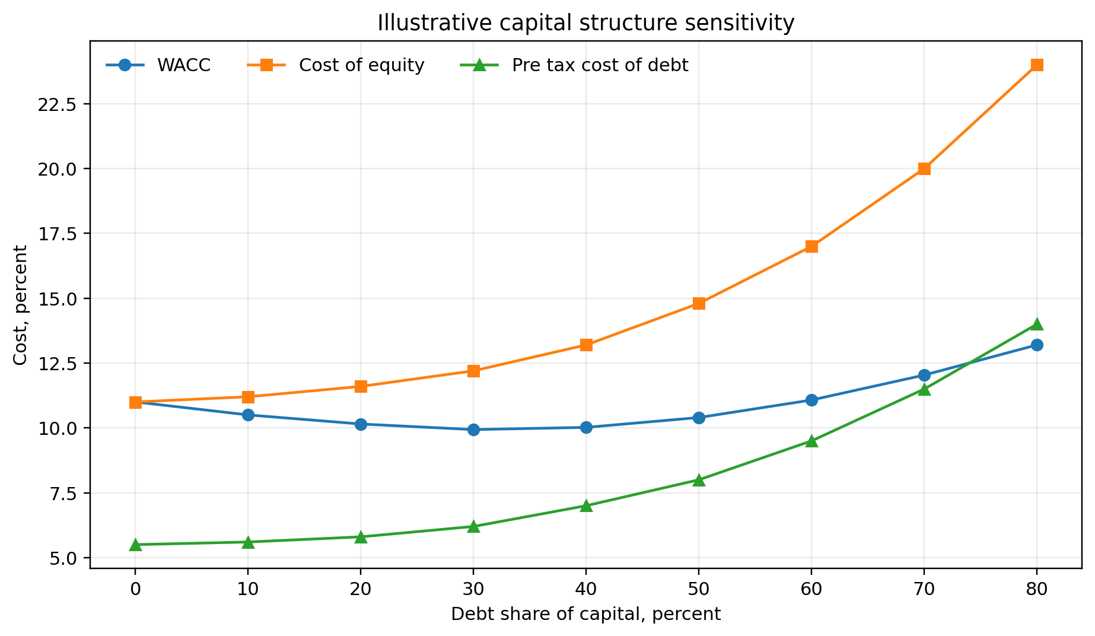
Figure 3. Illustrative capital structure sensitivity. Source: Author calculation.
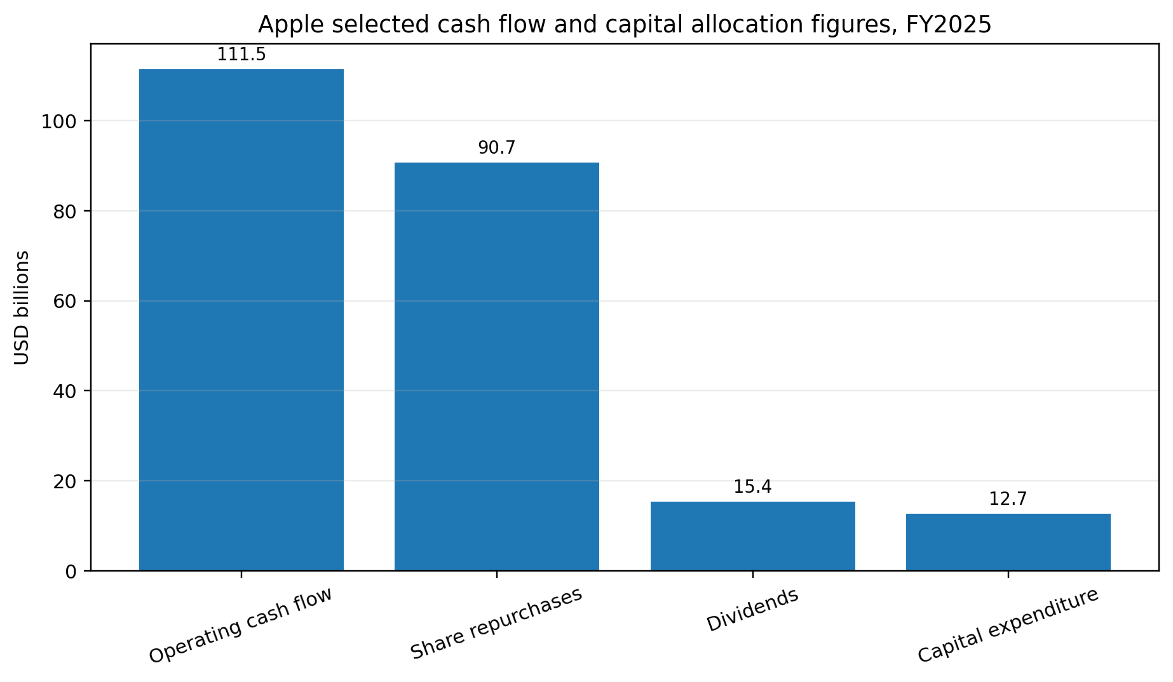
Figure 4. Apple selected cash flow and capital allocation figures, FY2025. Source: Apple Inc. 2025 Form 10 K.
Strategy area | Recommended action | Value contribution
Investment appraisal | Use NPV as primary rule with IRR, PI, payback and sensitivity as supporting tools | Improves capital allocation and prevents approval of weak projects
Capital structure | Use moderate leverage and test covenant, rating and cash flow stress effects | Can reduce WACC without sacrificing resilience
Working capital | Monitor receivables, payables and inventory through cash conversion cycle targets | Protects liquidity and releases cash for growth
Sustainability finance | Quantify energy, waste, regulatory and resilience benefits in cash flow scenarios | Connects responsible investment to financial discipline
Capital returns | Pay dividends or repurchase shares only after testing strategic reinvestment opportunities | Avoids short term distributions that weaken long term value
Table 3. Recommended financial strategies for profitability, sustainability and shareholder value.
In practice, the best value strategies are sequenced. A firm should first protect liquidity and operating cash generation. It should then fund positive NPV investments that fit strategy. It should choose a capital structure that keeps WACC competitive without creating excessive distress risk. It should return surplus cash only after these needs have been tested. This sequence helps avoid the common mistake of rewarding shareholders in the short term while leaving the business underinvested, overleveraged or exposed to avoidable shocks.
The role of the finance manager has also expanded because investors increasingly examine sustainability, governance and resilience. A project that appears financially attractive may create hidden costs if it increases emissions, labour risk, regulatory exposure or reputational damage. Conversely, a sustainability project may create value through energy savings, reduced waste, improved customer loyalty and lower compliance risk. The finance function should not approve or reject these projects based on slogans. It should convert material effects into cash flow assumptions and disclose uncertainties clearly.
Risk governance also affects value. Finance managers need policies for debt maturity, interest rate exposure, currency exposure, counterparty risk and liquidity reserves. If a company funds long term assets with short term debt, it may face refinancing risk. If it earns revenue in one currency but pays costs or debt in another, exchange rate movements can affect cash flows. If it relies on one lender or one investor group, funding access can become fragile. Good financial management therefore seeks a funding structure that supports the operating strategy under stress, not only under normal conditions.
Working capital management is another direct route to value creation. A profitable business can still face financial pressure if cash is trapped in receivables and inventory. Finance managers should monitor the cash conversion cycle, credit terms, supplier terms and inventory turnover. Reducing slow moving inventory, improving collection discipline and negotiating sensible supplier terms can release cash without raising external finance. However, working capital targets should not be pushed mechanically. Excessive inventory reduction can create stockouts, aggressive collection can damage customers, and delayed supplier payments can weaken supply chain trust.
Scenario analysis strengthens this process by examining coherent future states rather than changing one variable at a time. A base case may assume normal demand, normal cost inflation and stable exchange rates. A downside case may combine weak demand, high borrowing costs and supply disruption. An upside case may combine faster adoption, operating leverage and favourable pricing. These scenarios help senior managers judge whether the firm can survive the downside and still benefit from the upside. This is more realistic than assuming that every input changes independently.
A further value creation issue is sensitivity analysis. Investment appraisal depends on assumptions about sales volume, price, operating cost, tax, working capital and terminal value. A project may show a positive NPV in the base case but become unattractive if demand is 10 percent lower or if construction cost is 15 percent higher. Finance managers should therefore identify the variables that have the greatest effect on NPV. This prevents decisions from depending on a single optimistic forecast. It also helps managers design controls, such as fixed price contracts, staged investment, pilot testing or hedging, to protect the most sensitive assumptions.

6. Conclusion
Financial management contributes to business value by ensuring that investment, financing and risk decisions are economically disciplined. NPV, IRR, payback and profitability index help managers evaluate projects, but NPV should remain the primary rule because it measures absolute value creation. Financing decisions matter because capital structure affects WACC, risk, control and flexibility. Apple shows how strong cash generation supports investment, debt management and shareholder returns, but it also illustrates that every capital allocation choice has an opportunity cost. The strongest conclusion is that finance managers create value when they allocate capital to projects with returns above risk adjusted cost, finance those projects responsibly, manage liquidity and risk, and communicate decisions transparently. Sustainable shareholder value is therefore not created by growth alone. It is created by disciplined, ethical and resilient financial management.
Main body word count excluding references: 4,067 words.

References
Apple Inc. (2025). Form 10 K for the fiscal year ended September 27, 2025. United States Securities and Exchange Commission. https://www.sec.gov/Archives/edgar/data/320193/000032019325000079/aapl-20250927.htm
Brealey, R. A., Myers, S. C., Allen, F., & Edmans, A. (2025). Principles of corporate finance. McGraw Hill Education.
Fama, E. F., & French, K. R. (2002). Testing trade off and pecking order predictions about dividends and debt. The Review of Financial Studies, 15(1), 1-33. https://doi.org/10.1093/rfs/15.1.1
Graham, J. R., & Harvey, C. R. (2001). The theory and practice of corporate finance: Evidence from the field. Journal of Financial Economics, 60(2-3), 187-243. https://doi.org/10.1016/S0304-405X(01)00044-7
Jensen, M. C. (1986). Agency costs of free cash flow, corporate finance, and takeovers. American Economic Review, 76(2), 323-329.
Modigliani, F., & Miller, M. H. (1958). The cost of capital, corporation finance and the theory of investment. American Economic Review, 48(3), 261-297.
Modigliani, F., & Miller, M. H. (1963). Corporate income taxes and the cost of capital: A correction. American Economic Review, 53(3), 433-443.
Myers, S. C., & Majluf, N. S. (1984). Corporate financing and investment decisions when firms have information that investors do not have. Journal of Financial Economics, 13(2), 187-221. https://doi.org/10.1016/0304-405X(84)90023-0
Porter, M. E., & Kramer, M. R. (2011). Creating shared value. Harvard Business Review, 89(1-2), 62-77.
Ross, S. A., Westerfield, R. W., Jaffe, J., & Jordan, B. D. (2022). Corporate finance (13th ed.). McGraw Hill Education.

Appendices

Appendix A. Investment appraisal formula guide
NPV = Σ[CFt/(1+r)^t] - I0. IRR = r where NPV = 0. PI = PV inflows / initial investment. Payback = last year before full recovery + unrecovered amount at start of next year / next year cash flow. WACC = (E/V × re) + (D/V × rd × (1 - T)).

Appendix B. Source note for company figures
Apple cash flow and balance sheet figures are taken from the 2025 Form 10 K and are used only to illustrate capital allocation and financing analysis. The project appraisal and WACC sensitivity examples are author generated calculations for demonstration.

