

Ethical Challenges in Sales Management – Balancing Profitability and Consumer Trust

Abstract
The tourism and hospitality business is dynamic and highly competitive and therefore, there is always pressure on any given business to increase profitability. To do this, most companies use aggressive sales tactics, which albeit well in the short run are usually associated with ethical issues and multiple decreases in consumer confidence. Some of the common practices include overbooking, anonymous charges, and deceptive advertising practices which have continued to raise increasing criticism among customers and government bodies. This report identifies issues that comprise the ethical dilemmas in tourism sales management in contemporary conditions, and it discusses the impacts of such a practice on customer satisfaction, brand reputation, and business sustainability in the long term. The paper examines the common patterns of unethical behaviour through the qualitative and case-based approach and gives specific examples of such behaviour in airlines, hotels, and online travel agencies. The results indicate that there is a possibility that these practices can provide immediate revenue but at the cost of a very high degree of undermining the confidence of the customers. The report concludes by stating that ethics are not merely important issues but are also strategic values as they are most ethically transparent, charged reasonably, and tell the truth. Profitability and ethical behaviour should be matched by the tourism companies to promote sustainable development, brand loyalty, and consumer trust in the fast-changing marketplace.

Table of Contents
Abstract 1
Introduction 3
Literature Review 4
The Ethical Foundations of Sales in Tourism 4
Overbooking and Hidden Charges 6
Consumer Protection and Reputational Impact 7
Methodology 9
Findings 11
Case of Overbooking in Airlines and Hotels 11
Hidden Fees in Online Travel Sales 12
Marketing Misrepresentation in Tourism 13
Discussion 14
Rebuilding Consumer Trust 14
Frameworks for Ethical Sales Practices 14
Balancing Profitability with Fairness 16
Conclusion 17
References 18

Introduction
The internationally acclaimed tourism and hospitality industry has been flourishing on the provision of emotionally charged experiences. It is one of the largest industries on the globe, contributing to the world economies, promoting employment, and encouraging international exchange. But, under the glitz and the glamour of the tours and the fancy hotel advertisements, there is a multifaceted problem the ethical management of sales. Tourism sales are distinctively sensitive in the sense that they encompass selling of abstract vows, experiences, comfort and convenience in advance, before they come to pass. This uncertainty itself presents a moral responsibility on the service providers to make truthful communication and deliver fair expectations (Harman, 2022).
Selling in this industry is always a trade-off between the business and customer satisfaction. Profitability is important, but it should not be done at the cost of trust. However, in actuality, business might occasionally focus on short term interests by engaging in such strategies as overbooking or concealing key expenses or even exaggerating marketing materials. These strategies can raise short-term revenues and be long-term risks as it can tarnish a reputation, raise legal concerns and destroy the loyalty of a consumer.
The key one is overbooking. Hotels and airlines purposefully sell beyond their capacity making a bet on no-showing of customers. Although this practice is efficient in a business aspect, it may lead to the denial of service, customer inconvenience and backlash. On the same note, the addition of latent interests to the travel booking systems disturbs the transparency and the purchasing decision. When the end prices are much higher than the first quotes to the consumers, it gives a misleading feeling. The sales practices that involve misleading marketing like the exaggerated images or location misrepresentation contribute to the ethical strain, which is especially pressing in the digital sales setting where direct product examination cannot be conducted (Hart, 2020).
The ultimate issue is the need of companies to invest in their sales strategies and reconcile them with ethics. This report will attempt to answer that question by giving a systematic analysis of issues and solutions. It looks into ideas about how business in the tourism sector can remain profitable without the need to lure transparency and trust, and points out that using ethical behaviour is not a limiting factor rather it is a strategic resource in the consumerist world.

Literature Review

The Ethical Foundations of Sales in Tourism
The hotel and tourism sector is based on the philosophy of experience delivery and not on tangible goods. This renders the ethical practices of sales procedures paramount in nature because, in many instances, the customers are buying services like a hotel stay or guided tours or a flight even before they are actually provided. The sales ethics in tourism is therefore a concept that is based on the attainment of trust transparency, fairness and responsibility in all contacts with potential and existing clients. The abstract quality of tourism products means that there is an increased ethical responsibility in the tourism business since customers tend to be hyper sensitive when it comes to pre-sale claims and commitments (Lacalle, 2023).
Information symmetry is one of the features of ethical tourism sales. The consumers usually have less information, especially when making a reservation via online service providers in which, due to their visual appeal and persuasion marketing, the visual rhetoric takes precedence over critical analysis. Sales ethics then insist that the businesses to provide the complete, accurate and available information regarding the products or services being offered. This involves the release of all pertinent terms, description and photographs should be factual and cancellation policies as well as refund policies should be transparent. These are expectations based on larger moral doctrines of integrity in the presentation, free will in its implementation, and a system of reasonable compensation in those situations where the agreed service delivery is not performed according to the expected standards (Elshaer et al., 2025).
Practically, though, there are too many grey areas in the sphere of tourism. Frontline sales teams are under a lot of pressure to achieve sales goals especially during peak seasons or when the hotel is not fully occupied. The employees can be easily tempted to overvalue offerings and omit unpleasant information or upsell services which can be unnecessary to the customer because of the incentives which are often based on commissions or metrics of the performance of the employee. Such conduct despite the fact that it might be motivated by internal forces and not a malice leads to the culture of manicuring sales in which the momentary objective of making a sale supersedes the momentary objective of establishing trust (Michalis, 2024).
Online interactions have also added to the problem of ethics. The appearance of a personal approach to advertising, time groups, and dynamic pricing algorithms are advanced sellers’ tools that, although they are not forbidden by law, can capitalize on consumer psychology through their use. Examples of the use of artificial urgency include countdown timers, which force people to make impulsive purchases by creating a sense of urgency which does not actually exist. Equally, location-based pricing or browsing tracking to price manipulation is ethically questionable on issues of transparency and fairness. There, sales ethics should go beyond conventional basics to incorporate responsible data usage, algorithmic clarity, and not to use questionable sale provoking methods (Parasrampuria & Williams, 2023).
Furthermore, informed consent is a principal ethics of sales but in most of sales in the tourism sectors, the concept is not achievable. The customers might think that they are armed with the information needed to make a choice, and the small prints, the fine terms, or the visual attractions, usually block the crucial information. Ethical tourism suppliers are bound to make efforts to make certain that the consent is not really conferred but rather informed, voluntary and can be reversed especially in a deal that involves such aspects as non-refundable elements or commitments.

Overbooking and Hidden Charges
Overbooking is among the most debatable ethical aspects in the sale of tourism. Overbooking is common in both the airline and hotel industry and is realized through selling more reservations than space, on the assumption that a certain number of the customers are not going to turn up. This method will maximize revenue and reduce cancellations or no-show losses in terms of business efficiency. But the moral consequences are very great. Customers whose reservations have been confirmed will find themselves in a position of not able to access the service they are paying and in most cases at the last moment and in a stressed state. This may result in emotional anguish, inconvenience, and cost- incurred- particularly where one has planned flights at a very tight schedule (Arthur et al., 2002).
The moral hazard is a result of breaching the contractual expectations. As soon as a customer is sent a confirmation about booking, one would expect that it will be fulfilled. This trust is compromised by overbooking and puts the pinch of uncertainty on the consumer. Although compensation or other arrangements can be provided by the companies, the responsive character of such measures does not help in offsetting the reputational damage and regaining the confidence of the customer. In addition, the customer is faced by betrayal and frustrations in situations whereby alternatives are of low quality or compensation is not suitable.
On the same note, the use of hidden charges is among the greatest violations of ethical sales practice. A lot of online travel agencies and booking platforms place low base prices that appeal only to discover more information on them, including resort fees, baggage fees, taxes and administrative surcharges, added at the later ends of the processing. This is a good strategy in terms of lead generation but wrong in practice. It malforms the objective price comparison of the consumer, distorts competition in the market, and partakes transparency (Kenton, 2020).
Customers that perceive they have been misled by the hidden prices tend not to make loyal purchases and rather they might post bad reviews. This compromises the personal transaction, as well as the trust system of the platform or brand more generally. They are widely regarded as unethical in places where such practices are legal even in places where they are legally acceptable when they lead to a much greater final price than that which was first advertised. The model of ethical pricing in the tourism industry will therefore have to focus on complete disclosure at initial approach and allowing the consumer to make objective and decisive choices (Hardcastle et al., 2025).
Moreover, an ever-increasing problem is fee segmentation, where various parts of the service are sold separately in order to conceal the overall price. As a case in point, when a hotel room has amenities like Wi-Fi, pool, or towels, the customer might pay an extra amount that will result in unpleasant surprises. Although optional fees are okay as long as they are made obvious, the act of putting things under the umbrella of optional extra services is deceptive. Ethically, the consumer cannot be shocked at the prices that are required to create a basic, satisfactory experience.

Consumer Protection and Reputational Impact
Ethical tourism practices are gaining an increasing scrutiny by the public and the regulatory organizations as the world moves towards greater awareness of the rights of consumers. Today, tourism has become not only more educated but also empowered. The emergence of review-driven and social media and independent watchdog organizations implies that malpractice can be scampered and spread easily. Even one viral event of an overbooking or unfair rates can tarnish the reputation of a brand forever. This transparency works as a prevention and a form of accountability whereby businesses are motivated in ensuring that their sales practices are high ethical standards (Alatawi et al., 2023).
Once lost, it is extremely hard to build trust. A firm that deals with a reputation-driven industry where the reputation is usually the major point that sets the competitors apart has to regard the consumer trust as a non-renewable resource. Ethical violations can lead to debt gains in the short run, loss in the long run, loss of customers, loss of reputation, and regulation issues.
In reaction, most of the regulatory authorities have started casting stricter regulations regarding transparency, and pricing and advertising in the tourism sales. The laws require the mandatory reporting of critical expenses, compensation of refunds, and marketing communication to be factual. Regulatory compliance is however just a bare minimum. Ethical businesses should be able to take it a step higher and instil the qualities of honesty, accountability, and customer care within their organizational culture and day-to-day activities (AlHares, 2025).
Companies in the industry of tourism based on ethics tend to achieve competitive advantages when they initiate ethics-oriented policies. Honesty in communication, transparency in pricing and clear cancellation policy facilitates customer satisfaction and loyalty. They also minimize the possibility of conflicts, returns and bad publicity. Conversely, companies with sales-related values above all else at the expense of corporate ethics approach are increasingly struggling in a setting in which consumer demands keep growing (Jiddi, 2023).
Finally, the issue of ethical sales in relation with tourism is not the problem of the neglect of the ability to lie, but rather the problem of developing the relationship of mutual understanding and respect. Customers are not merely any deal but a collaborator to the success of the brand. Companies that follow the school of thought are more likely to get through the ethical complexities of contemporary tourism.

Methodology
The research methodology used to conduct this report is a qualitative and exploratory research methodology that tries to explore the ethical dilemmas that exist in tourism and hospitality sales management with particular emphasis on the phenomenon of balancing profitability and consumer trust. The study will not be based on the numerical information or statistical analysis, instead, a subtle, interpretive perspective of the ethical processes involved in the actual context within tourism sales environments will be offered. The latter method is particularly applicable to ethical dilemmas which are quite subjective and can vary depending on the context (Vaculčíková et al., 2025).
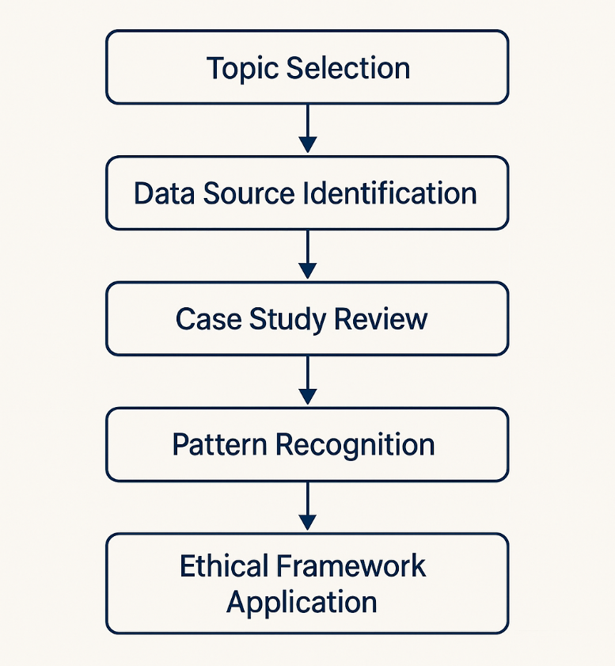
Figure 1: Qualitative Research Process for Ethical Analysis in Tourism Sales
This research will utilize secondary data analysis as the main sources of data up to a vast array of publicly available information as the main mode of data collection. These are official case studies, consumer advocacy, academic literature, and regulative publications, customer complaints files, and news media coverage of ethical scandals on tourism industry. Particular attention is devoted to real-life experiences of airlines, hotel chains, and travel agencies using the Internet as these sub-industries have been mentioned in numerous conversations concerning such topics as overbooking, additional charges, and deceptive advertising strategies.
The thematic analysis is based on the chosen case studies in which the same patterns and instances of ethical violations are determined, contextualized and interpreted. Such cases help the researcher to investigate how organizations rationalize dubious practices, consumer responses, and what outcome results in reputation, clientele retention, and adherence. It will also enable the methodology to come up with the emerging theories of ethics and operational suggestions, which are not just made based on abstract ideas, but also made based on tangible findings.
Through emphasising the importance of qualitative understanding as opposed to quantifiable indicators, this strategy will serve to promote a more holistic view of the compound made business and consumer right balance which will then result in more responsible and sustainable commercial behaviours in the tourism and hospitality sector.

Findings

Case of Overbooking in Airlines and Hotels
One ethical problem that is still very evident in the tourism and hospitality industry is overbooking. This is the practice where reservations are made, compared to the actual available capacity, to solve the problem of risks as a way of mitigation, as a way of the reservation company reimbursing the expected no-shows. The theory is good on paper but the feasibility of it may have dire consequences to consumer confidence and the reputation of the brand.
The overbooking in the airline industry has resulted in high profile allocations in which passengers with confirmed reservations were being denied the opportunity to board or, in more extreme instances, forcibly removed off the flights. These incidences have been greeted by a thunderous vocalization to the wide criticism by the people on the morality of accepting payment without delivering the service. Although, some airlines have taken up the initiative to change their compensation policies or provide rebooking option; the ultimate ethical issue still remains: customers are selling them on a promise that the company is fully aware that they may not fulfil it (Agilysys, 2023).
Overbooking in the hotel business is experienced during peak seasons or big events when the demand of accommodation is more than the supply. Visitors who have made direct reservation could be transferred to the local partners hotels-which are in most cases of lesser quality or without required facilities. In spite of the fact that be they are awarded with apologies, discounts or free services, the inconvenience of their plans as well as the violation of the established expectations under contract lead to distrust and discontent among guests. This emphasizes that this approach presents an ethical concern of focusing on revenue maximization at the expense of being offered guaranteed service, especially in an industry that is mostly about comfort and reliability (Elphick, 2022).
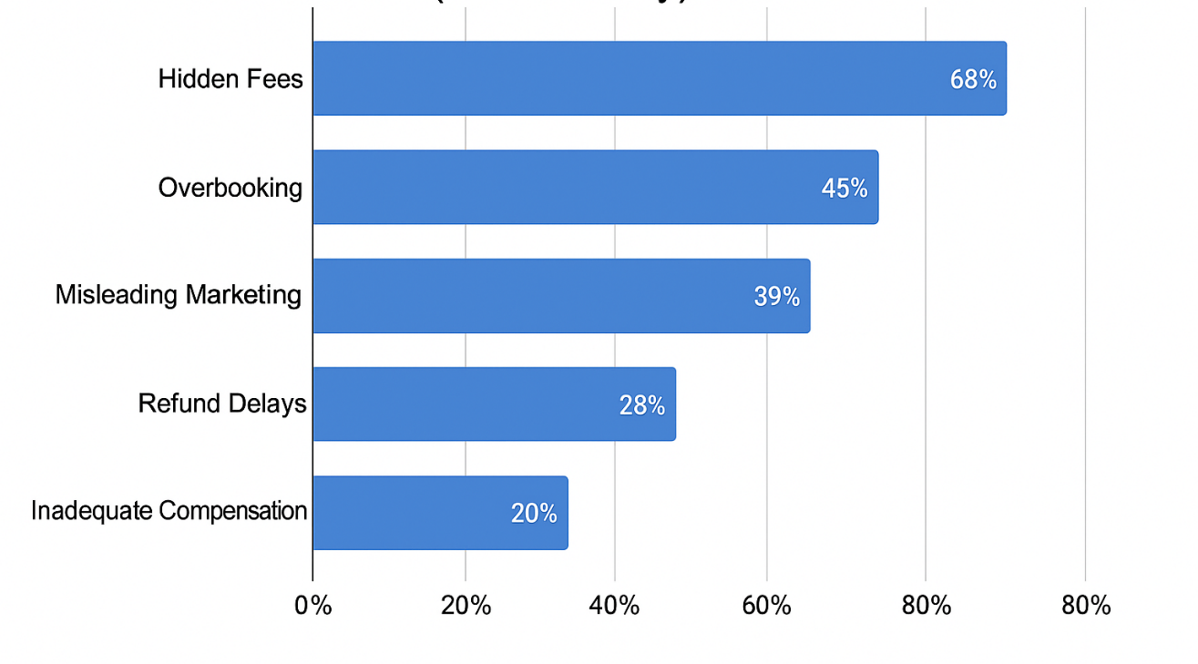
Figure 2: Top ethical complaints reported by tourists (2023 Survey)

Hidden Fees in Online Travel Sales
A second critical result is associated with the action of disguising obligatory charges towards the end of the booking procedure. Online travel agents and booking systems regularly present appealing base prices which do not include necessities like resort charges, cleaning charges, baggage charges, and administration surcharges. Such new costs usually come to light once the final payments are to be done and at this time the customer might have become psychologically involved in the purchase.
Although these tricks are effective in attracting the participants to their websites and improving the number of conversions, they contribute to a climate of deception and distortion. Consumers will be frustrated over the end price that is way over what they were expecting when they assume a good deal but in fact, they only get a good deal. As an example, an online traveller booking his/her apartment (short-stay) may see a price of 100 pounds on a daily basis, then realise that his/her amount has been marked up by 40 percent because of the additional cleaning and service fees. The practice also compromises the quality of comparisons by consumers and the trustworthiness of the online booking platforms (Tims, 2019).
Furthermore, these additional costs, in conjunction with restrictive cancellation policies or non-refundable agreements, are more than an inconvenience when summed up these additional charges cost such problems not only monetary losses but also emotional anguish, especially to the cargo-type of traveller. The moral point of the case is the deliberate omission of key cost data, which is consumer behaviour manipulation in Favor of the seller.

Marketing Misrepresentation in Tourism
The other prevalent ethical issue is the misrepresentation of the products and services by use of deceptive marketing methods. In the digital environment, pictures and descriptions tend to be the main foundations of buying decisions in tourist business. Nevertheless, most corporations distort these images by editing or partial display to portray properties or experience as more attractive than actually the case.
Indicatively, a hotel that is marketed as being beachfront, may in actual sense being a few blocks to the beach. Equally, the accommodation providers would post professional images that may not represent the true state of the property. Moreover, a positive impression of quality and customer satisfaction can be built by manipulating customer review systems by showing only positive feedback, or silencing negative commentary.
The misrepresentations of these forms are unethical in the context of the truthful communication. Travellers who encounter the reality that is much different than anticipated become victims of feelings of betrayal and regret. Once lost in such a situation, trust is hard to rebuild, and it will lead to adverse reviews or other complaints on the part of the population. In addition, the platforms which permit and cannot control such misleading activities hold the risk of having their own image tainted and losing end-user’s trust (Hassan et al., 2024).

Discussion

Rebuilding Consumer Trust
Tourism is the exchange of trust. It is not readily acquired and easily lost. Companies need to be consumer-focused and require a shift to honesty and fairness in their sales, rather than focus on aggressive selling. Firms that are honest enough to admit their past wrongs, sincerely apologise and change their manner of doing business can recover their lost popularity. Offering good explanations of delays, overbookings, providing refunds or compensation in advance and provision of choice to customers can greatly cushion the impact of service breakdown (Chahal, 2024).

Frameworks for Ethical Sales Practices
In order to make ethical conduct part of the tourism sales management, businesses need to adopt organized and progressive systems that enable transparency, accountability and customer-focused ideologies. One of the necessary things will be the adoption of transparent pricing models. All prices, taxes, and any other ancillary services must be shown in advance such that customers do not feel fooled when they get to the checkout counter.
Overbooking policies that are responsible are crucial as well. As much as overbooking could be a required business practice, it has to be coupled with well-defined customer compensatory and reporting procedures. Time and again, the guests are supposed to be notified of chances of being overbooked upon purchase and equitable remedies given in case of disruption.
It is also essential to make accurate advertising practices. Companies must not present any false images or fantasy and should endeavour to depict the positive and negative aspects of their services or products correctly. Sales employees can be further trained in ethics to enhance organization integrity by developing awareness to make moral decisions and also rewarding the ethical ways (Smith, 2023).
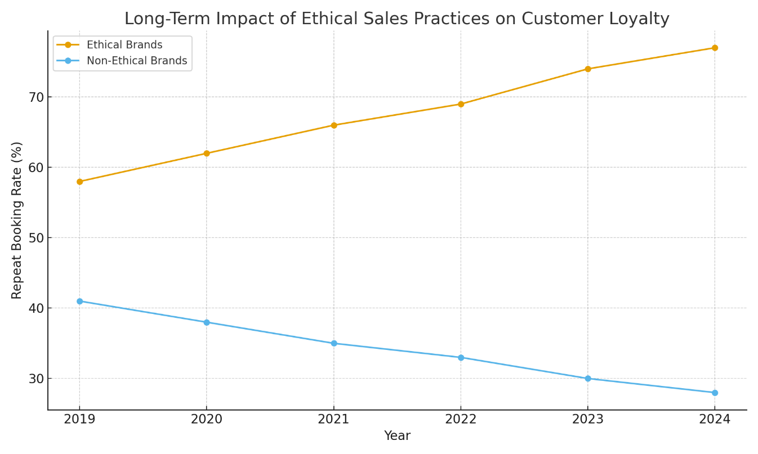
Figure 3: Ethical vs Nonethical Customer Loyalty Line Chart
Finally, one should build customer feedback loops to make sure that it is learning and improving all the time. The feedback and complaints must be viewed as useful information which is not only used to solve the specific problem but also to improve the service delivery system and avoid the occurrence of ethical violations in the future.

Balancing Profitability with Fairness
The bias held that profitability and ethics are not two ideal concepts that complement each other is a fallacy that contemporary tourism enterprises should eliminate. As a matter of fact, when organizations incorporate fairness on its sales strategies, it usually enjoys sustainable financial benefits. Ethical demeanour creates trust and trust is a potent customer loyalty, repeat booking, and favourable word of mouth. When the consumers are honestly and respectfully treated, they have a higher chance of returning to and referring the companies to other consumers.
Companies that take on open pricing practices, honest communication and equitable conflict management frequently have less churn rate and the risk of reputation damage are also minimized. As an example, hotels in which all expenses are stated during booking and are keeping their promises are likely to have better ratings in platforms where the process of rating is involved. These positive reviews, in their turn, promote online presence and bring new customers. On the same note, air transport companies that willingly pay overbooked or delayed passengers are showing a sense of accountability and this will enhance a relationship with customers even in a negative circumstance (Jerab, 2025).
Moreover, sales are also conducted in acceptable ways and this also serves internal gain. Integrity gives employees more satisfaction and motivation to work in a company that practices integrity. This enhances quality of services in general and helps in brand consistency. It is also because ethical organisations become more appealing to investors and partners whose decision making is increasingly giving corporate responsibility a serious consideration.

Conclusion
The tourism sales management is an equal point of intersection in which the commercial interest must bring forth the moral duty. Overbooking, misrepresentation, and hidden charges have become distressingly frequent, as well as harmed consumer trust and put a business at risk of reputation. Although such practices might have short term financial benefits, in the long run, they put the sustainability of the brand at risk in addition to the industry.
This report has revealed that ethical problems are not isolated incidents but are systematic tendencies, which people can solve with clear communication, just policy and responsible marketing. Tourism should cease being sales oriented which it has always been and be trust oriented. It is not an unplanned or obligatory process that should be done once an organization has to act ethically, but rather part of the organizational culture, systems, and leadership.
Tourism businesses can also have economic and ethical success through balancing consumer trust to profitability. In a world where customers cherish experience, equity and reality, the successful companies will be those ones who respect their customers not only as consumers- but as individuals.

References
Agilysys. (2023, August 23). Hotel Overbooking: Balancing Risks and Guest Satisfaction. Www.agilysys.com. https://www.agilysys.com/en/hotel-overbooking-balancing-risks-and-guest-satisfaction/
Alatawi, I. A., Ntim, C. G., Zras, A., & Elmagrhi, M. H. (2023). CSR, financial and non-financial performance in the tourism sector: A systematic literature review and future research agenda. International Review of Financial Analysis, 89(102734), 102734. https://doi.org/10.1016/j.irfa.2023.102734
AlHares, A. (2025). Ethical Leadership and Its Impact on Corporate Sustainability and Financial Performance: The Role of Alignment with the Sustainable Development Goals. Sustainability, 17(15), 6682–6682. https://doi.org/10.3390/su17156682
Arthur, D., Malone, S., Nir, O., & Kraines, D. (2002). Optimal Overbooking Optimal Overbooking. https://spu.edu/users/lauw/4830/case%20studies/2002%20Problem%20B%20Airline%20Overbooking/Airline02.pdf
Chahal, A. (2024, August 6). Why is Customer trust important? | HyperComply blog. Hypercomply.com. https://www.hypercomply.com/blog/why-is-customer-trust-important
Elphick, D. (2022, November 15). Hotel overbookings: What are the pros and cons? SiteMinder. https://www.siteminder.com/r/hotel-overbookings-pros-and-cons-strategy/
Elshaer, I. A., Azazz, A. M. S., Fayyad, S., Aljoghaiman, A., Fathy, E. A., & Fouad, A. M. (2025). From Asymmetry to Satisfaction: The Dynamic Role of Perceived Value and Trust to Boost Customer Satisfaction in the Tourism Industry. Tourism and Hospitality, 6(2), 68. https://doi.org/10.3390/tourhosp6020068
Hardcastle, K., Vorster, L., & Brown, D. M. (2025). Understanding Customer Responses to AI-Driven Personalized Journeys: Impacts on the Customer Experience. Journal of Advertising, 54(2), 1–20. https://doi.org/10.1080/00913367.2025.2460985
Harman. (2022, April 15). Importance of the Hospitality Industry in the Economy. Botshot.ai. https://botshot.ai/resources/blog/importance-of-the-hospitality-industry-in-the-economy
Hart, J. (2020, October 29). Why Trust Is the Most Important Tool for Driving Profitable Sales. Dale Carnegie Blog. https://www.dalecarnegie.com/blog/3-reasons-why-trust-is-the-most-important-tool-for-driving-profitable-sales/
Hassan, T. H., Ammar, S., Abdelhay, H. F., Fayyad, S., & Al-Azab, M. R. (2024). THE IMPACT OF DECEPTIVE HOSPITALITY AND TOURISM MARKETING TACTICS ON TOURISTS’ SOCIAL MEDIA INTERACTIONS AND TRUST AND DESTINATION IMAGE IN EMERGING MARKETS. Geojournal of Tourism and Geosites, 56(4), 1732–1743. https://doi.org/10.30892/gtg.56428-1342
Jerab, D. (2025). Balancing Profitability and Sustainability in Business. SSRN Electronic Journal. https://doi.org/10.2139/ssrn.5086920
Jiddi, F. E. (2023). Does corporate social responsibility result in better hotel guest attitudinal and behavioral loyalty? Heliyon, 9(8), e18669–e18669. https://doi.org/10.1016/j.heliyon.2023.e18669
Kenton, W. (2020, July 23). Moral Hazard: Meaning, Examples, and How to Manage. Investopedia. https://www.investopedia.com/terms/m/moralhazard.asp
Lacalle, E. (2023, December 12). 9 most important ethical practices in hospitality. Www.mews.com. https://www.mews.com/en/blog/ethical-practices-in-hotels
Michalis, B. (2024, March 14). 20 Hotel Sales Strategies to Effectively Increase Revenue. Www.canarytechnologies.com. https://www.canarytechnologies.com/post/hotel-sales-strategies
Parasrampuria, A., & Williams, K. (2023). Ethical Considerations and Societal Impact of Personalized Advertising Algorithms. Journal of Student Research, 12(4). https://doi.org/10.47611/jsrhs.v12i4.5910
Smith, L. (2023, October 3). Ethics in Sales: 8 Best Practices to Sell with Integrity. Sales & Marketing Management. https://salesandmarketing.com/ethics-in-sales-8-best-practices-to-sell-with-integrity/
Tims, A. (2019, February 10). Exposed: hidden travel agent fees send air fares sky high. The Observer. https://www.theguardian.com/money/2019/feb/10/prices-online-travel-agent-comparison-site-fees
Vaculčíková, Z., Ramkissoon, H., & Dey, S. K. (2025). Circular intentions, minimal actions: The psychology of doing less in hospitality – An integrative review. Acta Psychologica, 259(105267), 105267. https://doi.org/10.1016/j.actpsy.2025.105267

