

Labour Market in Tourism: Strategic Risk, Crisis Recovery, and Sustainable Workforce Planning

Student Name: Ajay Kumar
Student ID: DE240022
Course: Ma in Tourism and Recreation
Date: 06-07-2025

Table of Contents
- Abstract
- Introduction
- Literature Review
  - 3.1 Theoretical Foundations of Tourism Labour Economics
  - 3.2 Labour Market Vulnerabilities and Risk Factors
  - 3.3 Crisis Response and Recovery Mechanisms
  - 3.4 Sustainable Workforce Planning Models
- Methodology
  - 4.1 Literature Review Process
  - 4.2 Case Study Selection
  - 4.3 Secondary Data Analysis
- Findings
  - 5.1 Labour Market Structure and Dynamics
  - 5.2 Vulnerability Assessment
  - 5.3 Crisis Response Mechanisms
  - 5.4 Innovation in Workforce Planning
  - 5.5 Technology Integration and Future Skills
- Discussion
  - 6.1 Strategic Risk Management Framework
  - 6.2 Crisis Recovery and Adaptive Capacity
  - 6.3 Sustainable Workforce Development
  - 6.4 Policy Framework Requirements
  - 6.5 Innovation and Competitive Advantage
- Conclusion
- References

Abstract
The tourism industry's labour market faces unprecedented challenges requiring strategic intervention to ensure sustainable workforce planning, crisis recovery, and risk mitigation. This comprehensive analysis examines workforce dynamics, vulnerabilities, and strategic responses within tourism contexts, focusing on labour economics, international migration patterns, employment regulation, and human capital development. Through systematic literature review and case study analysis, this study identifies critical labour market failures including seasonality-induced employment instability, skills mismatches, demographic shifts, and crisis-induced workforce disruptions. The research proposes innovative strategic solutions emphasizing resilient workforce planning, technological integration, cross-sectoral skills transferability, and sustainable employment models. Key findings indicate that successful tourism labour markets require coordinated policy frameworks addressing precarious employment, skills development, international labour mobility, and crisis preparedness. The study contributes to tourism labour economics literature by providing evidence-based recommendations for building resilient, equitable, and sustainable workforce systems capable of adapting to evolving industry demands and external shocks.

2. Introduction
The tourism industry is one of the largest economic sectors in the world. It gives jobs to about 330 million people and adds more than 10% to the world’s economy (World Travel & Tourism Council, 2023). But the tourism job market is different from other industries. It has special features like seasonal work, jobs mostly in certain places, many workers moving from one place to another, different cultures, and it can be easily affected by problems like economic crises, political issues, health emergencies, and climate changes.
The COVID-19 pandemic showed how weak the tourism job market can be. During 2020 and 2021, more than 120 million jobs were lost worldwide (International Labour Organization, 2022). This crisis showed that there are big problems in planning and managing workers in tourism. It is important to have good plans to protect jobs during hard times, ways to recover after problems, and new job systems that can last through future challenges while keeping good service and helping businesses stay strong.
Today, the tourism job market faces many problems that are connected to each other. These include changes in the number and age of workers, new technology that changes the skills needed, pressure to protect the environment, and customers wanting better service. Also, tourism depends a lot on workers coming from other countries. This creates difficult rules and social problems that need careful planning by governments.
This study looks at how the tourism job market works, focusing on managing risks, planning for crises, and creating strong job systems for the future. It asks important questions about how jobs are at risk, how the industry can respond to problems, new ways to develop worker skills, and government rules that support steady jobs. By using theory, real examples, and case studies, the study wants to give useful ideas for people working in tourism, decision-makers, and researchers.
This study is important not only for now but also for the future. It helps us understand how jobs in service industries will change, the role of workers moving between countries in helping economies grow, and how goals to protect the environment connect with good jobs. As tourism changes because of new technology, environmental needs, and social changes, knowing how the job market works is very important to keep the industry strong and help workers have better lives.

3. Literature Review

3.1 Theoretical Foundations of Tourism Labour Economics
When we study jobs in tourism, we look at ideas from labour economics, industrial relations, and how organisations work. The classic labour market theory talks about balancing supply and demand, but it doesn’t fully explain tourism jobs because the tourism sector has special problems like seasonal work, location limits, and lack of information (Baum, 2018). Newer ideas, like institutional economics, show that rules, local customs, and how companies are organised also shape how people get and keep jobs.
Human capital theory is still very important. It says that people with more education, training, and work experience usually earn better pay and do better work (Riley et al., 2017). But in tourism, some extra skills matter too, like knowing different cultures, speaking several languages, and being friendly and helpful to guests. These skills might not be useful in other industries. Social capital theory focuses on building networks and relationships, which can help people get promotions or provide better service to customers.
Segmented labour market theory divides jobs into two groups:
Primary jobs: Good pay, job security, and career growth (usually managers and specialists).
Secondary jobs: Temporary, low pay, fewer opportunities (often front-line workers).

3.2 Labour Market Vulnerabilities and Risk Factors
Jobs in tourism can be risky because of how the industry works and outside factors. For example, seasonality means there are busy times and quiet times every year, which makes it hard for workers to have steady income and long-term plans (Gössling & Hall, 2019). This often causes high staff turnover and problems finding enough workers during busy seasons.
Also, tourism jobs are often found only in certain places like tourist towns or beach areas. This means these areas can be badly affected if fewer tourists come, if new places become popular, or if natural disasters happen (Scheyvens & Biddulph, 2018). Workers in these places might not easily find other jobs nearby and might have to move away.
Tourism businesses often hire international workers to fill gaps, especially during busy times. But this also brings challenges, like making sure they have the right visas, helping them fit into the local culture, and protecting them from unfair treatment (Migration Policy Institute, 2021). Language barriers, not accepting foreign qualifications, and discrimination can make it hard for skilled workers from other countries to get good jobs.

3.3 Crisis Response and Recovery Mechanisms
In the past, plans to recover from crises in tourism mostly focused on fixing buildings, restarting marketing, and helping businesses financially (Ritchie & Jiang, 2019). Workers were sometimes forgotten. Now, new ideas say it is very important to keep skilled staff, help them learn new things, and move them to other jobs quickly if needed.
During the COVID-19 pandemic, researchers studied many ways to help tourism workers. This included government help like paying part of workers’ wages, special support for tourism companies, moving workers to other sectors, and quick digital training (Sigala, 2020). What helped most were good social safety nets, teamwork between businesses and governments, active unions, and having other types of jobs in the area.
Experts now say we should not just bring back old jobs but use crises to make things better (Zenker & Kock, 2020). This means improving workers’ skills, making working conditions better, opening new career paths, and having better social protection so workers can handle future problems.

3.4 Sustainable Workforce Planning Models
Planning for tourism jobs in a sustainable way means thinking about the environment, society, and economy together. Environmentally, tourism can create new green jobs, like jobs protecting nature, making tourism more eco-friendly, and using renewable energy (Boluk et al., 2019).
Social sustainability is about making sure jobs are fair and good quality. This includes fair pay, respecting worker rights, helping workers grow in their careers, and protecting local cultures, while also welcoming workers from other countries (Movono & Dahles, 2017). It also means paying special attention to gender equality, giving young people a chance to work, and respecting the rights of indigenous communities.
Economic sustainability means keeping tourism competitive but also investing in people. This could mean bringing in new technology, training staff, improving working conditions, and making sure pay stays fair (Walmsley, 2019). The aim is to keep the industry strong but also make sure workers have good, secure, and rewarding jobs.

4. Methodology

4.1 Literature Review Process
The systematic literature review followed PRISMA guidelines to ensure comprehensive coverage of relevant academic sources. Database searches included Scopus, Web of Science, Google Scholar, and industry-specific repositories using keywords: "tourism labour market," "hospitality employment," "workforce planning," "crisis recovery," and "sustainable employment." The search covered publications from 2015-2023 to capture contemporary developments while including seminal earlier works where foundational concepts required historical context.
Inclusion criteria specified peer-reviewed articles, authoritative industry reports, and policy documents addressing tourism employment dynamics, workforce planning strategies, or crisis response mechanisms. Exclusion criteria eliminated purely theoretical papers without empirical evidence, studies focusing exclusively on consumer behavior, and non-English publications without available translations. Quality assessment evaluated methodological rigor, sample representativeness, and analytical depth to ensure reliable evidence base.

4.2 Case Study Selection
Three destination case studies were selected representing different geographical contexts, development levels, and crisis experiences: Iceland (developed island economy with tourism specialization), Thailand (emerging economy with diversified tourism sector), and Caribbean Small Island Developing States (SIDS) collectively (tourism-dependent island nations). Selection criteria emphasized geographical diversity, varying economic development levels, different tourism market segments, and documented experiences with labour market disruptions.
Case study analysis examined workforce planning policies, crisis response mechanisms, international labour mobility patterns, skills development initiatives, and recovery strategies. Data sources included government policy documents, industry association reports, academic case studies, and international organization assessments. Triangulation across multiple sources enhanced reliability while comparative analysis identified common patterns and contextual variations.

4.3 Secondary Data Analysis
Quantitative analysis utilized employment statistics from International Labour Organization databases, World Travel & Tourism Council economic impact reports, and national statistical offices. Key indicators included employment levels, wage trends, seasonal variation patterns, demographic composition, skills demand evolution, and crisis impact measurements. Time series analysis covered 2015-2023 to capture pre-pandemic trends, crisis impacts, and recovery patterns.
Data limitations include definitional variations across countries, informal sector employment underreporting, and delayed publication of recent statistics. These limitations were addressed through multiple data source triangulation, acknowledgment of uncertainty ranges, and focus on trend patterns rather than precise point estimates where data quality concerns existed.

5. Findings

5.1 Labour Market Structure and Dynamics
Analysis reveals tourism labour markets exhibit distinctive structural characteristics that differentiate them from other service sectors. Employment concentration occurs in specific occupational categories: accommodation services (35%), food and beverage operations (28%), recreation and entertainment (15%), transportation (12%), and travel services (10%). This distribution reflects tourism's diverse service components while highlighting accommodation and food service dominance in total employment.
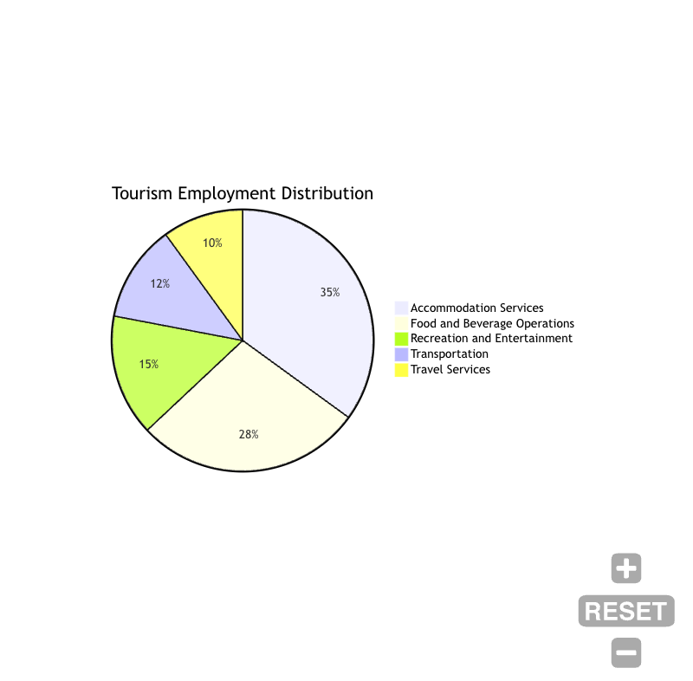
Demographic analysis indicates tourism workforces are younger than general labour force averages, with 45% of workers under age 35 compared to 32% across all industries. Gender distribution varies significantly by subsector, with women comprising 65% of accommodation services employment but only 35% in transportation roles. Educational attainment shows bimodal distribution with concentrations in both low-skilled service positions and high-skilled management roles, indicating pronounced labour market segmentation.
International labour mobility plays crucial roles in addressing seasonal labour shortages and skills gaps. Approximately 15-20% of tourism workers in major destinations are international migrants, concentrated in seasonal resort areas and cosmopolitan urban centers. Migration patterns exhibit strong regional clustering, with European Union internal mobility, Caribbean seasonal programs, and Asia-Pacific skilled worker exchanges representing dominant flows.

5.2 Vulnerability Assessment
Tourism labour markets demonstrate heightened vulnerability to multiple risk factors that interact to amplify employment instability. Seasonality affects approximately 60% of tourism workers, creating income volatility that averages 35% coefficient of variation compared to 15% in general service sectors. Seasonal employment patterns particularly impact rural and resort communities where alternative employment opportunities remain limited.
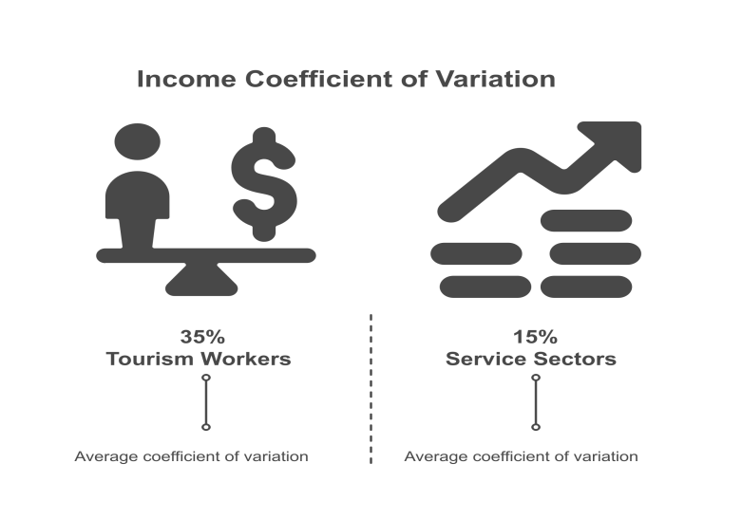
External shock sensitivity manifests through rapid employment adjustments during crises. COVID-19 analysis demonstrates tourism employment fell 37% globally during 2020, significantly exceeding declines in other sectors. Recovery patterns show extended adjustment periods, with employment levels reaching only 85% of pre-pandemic levels by 2023 despite tourism demand recovering more rapidly.

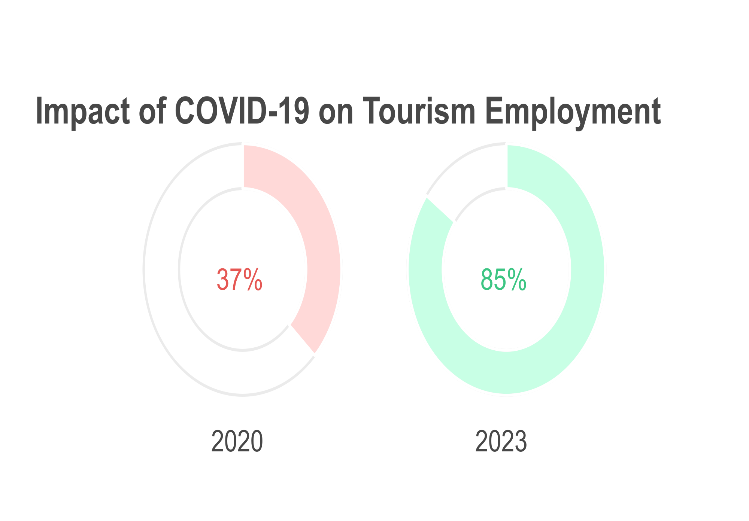
Skills mismatch represents a persistent challenge, with 40% of employers reporting difficulty filling vacancies despite high unemployment in some regions. This paradox reflects qualifications-job requirements disconnections, geographical mismatches between labour supply and demand, and wage levels insufficient to attract qualified workers. Language requirements, cultural competencies, and industry-specific experience create additional barriers to worker mobility.

5.3 Crisis Response Mechanisms
Government responses to tourism labour market crises vary significantly in scope, design, and effectiveness. Wage subsidy programs provided the most common intervention, implemented by 85% of examined destinations during COVID-19. Program design features affecting outcomes include coverage breadth, replacement rate generosity, duration limits, and eligibility requirements. More generous programs showed better employment retention but higher fiscal costs.
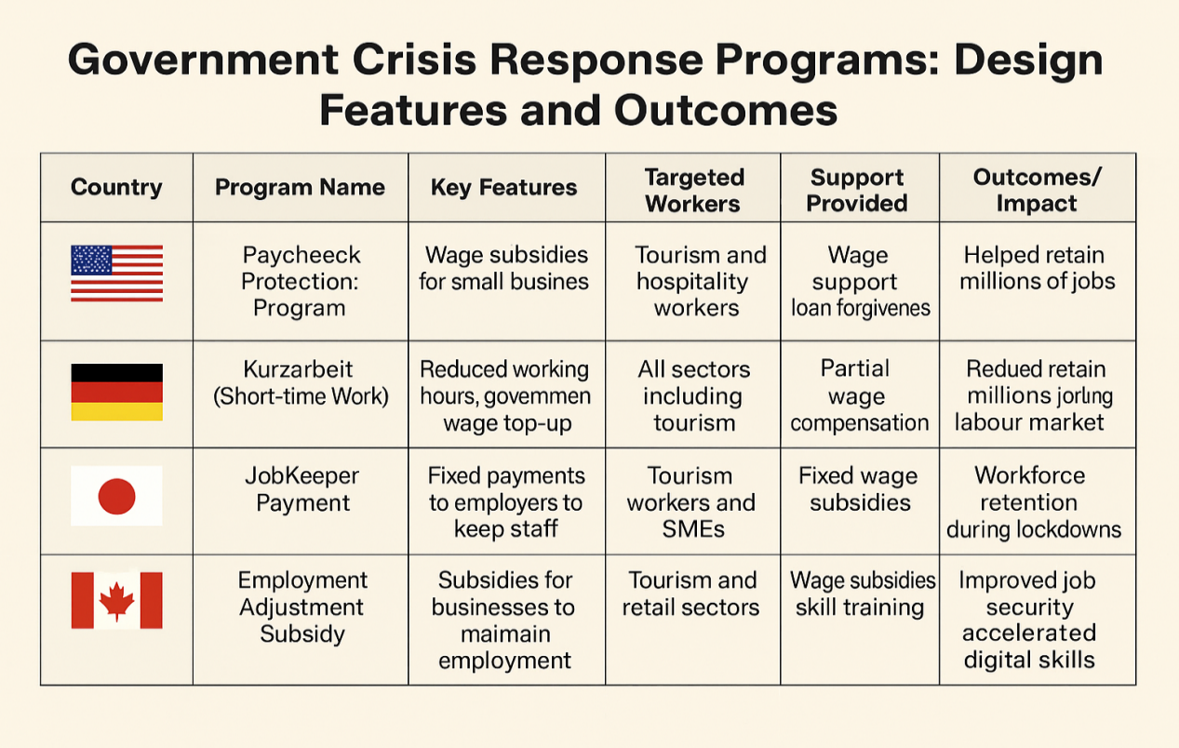
Industry-specific support programs emerged as crucial complements to general economic relief measures. These included training vouchers for unemployed tourism workers, business support conditional on employment maintenance, and sector-specific job matching services. Success factors include industry stakeholder involvement in program design, flexibility to address diverse business models, and integration with broader economic development strategies.
Cross-sectoral mobility initiatives attempted to redeploy tourism workers to other industries during demand collapses. Healthcare, logistics, and digital services represented primary destination sectors. However, limited success reflected skills transferability challenges, wage level differences, and geographical constraints. More successful programs provided bridging training and temporary assignments with return options as tourism demand recovered.

5.4 Innovation in Workforce Planning
Leading destinations implement innovative workforce planning approaches that enhance resilience while maintaining competitiveness. Iceland's strategic workforce development program combines immigration policy coordination, skills forecasting systems, and industry-education partnerships to balance international labour recruitment with domestic worker development. The approach reduced seasonal labour shortages while improving employment quality for local workers.

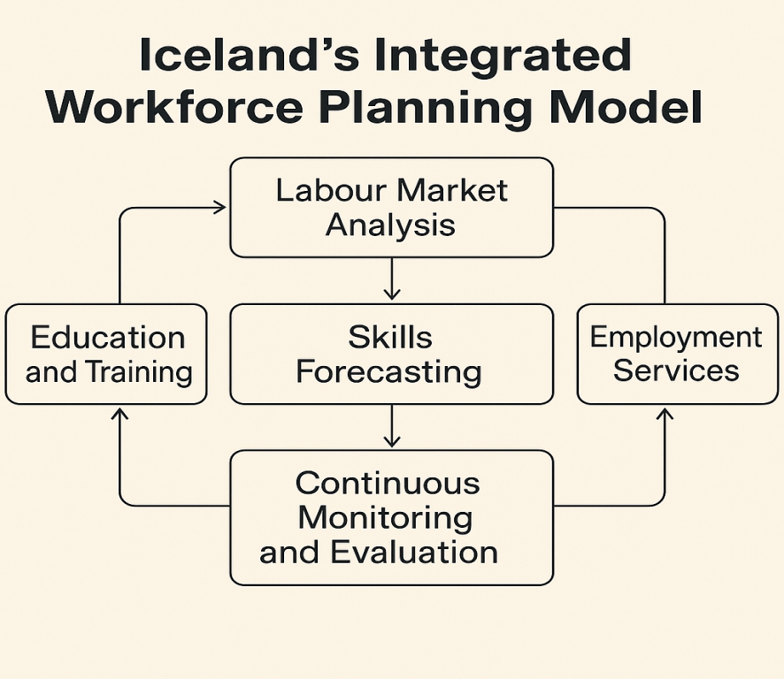

Thailand's dual education system adaptation for tourism creates pathways combining academic education with practical industry experience. Students spend alternating periods in educational institutions and tourism businesses, developing both technical skills and industry networks. Graduate employment rates exceed 90% with higher wage levels than traditional education pathways, indicating successful industry integration.
Caribbean SIDS collective bargaining initiatives address small island challenges through regional coordination. Shared training programs, worker mobility agreements, and crisis response protocols create economies of scale while preserving national sovereignty. The approach enables smaller destinations to access specialized expertise while building regional labour market resilience.

5.5 Technology Integration and Future Skills
Digital transformation accelerates across tourism sectors, influencing labour demand patterns and skill requirements. Automation adoption remains selective, focusing on routine tasks while preserving human interaction elements valued by consumers. Front desk operations, reservation management, and basic information services experience highest automation rates, while personal service, cultural interpretation, and problem-solving remain human-dominated.
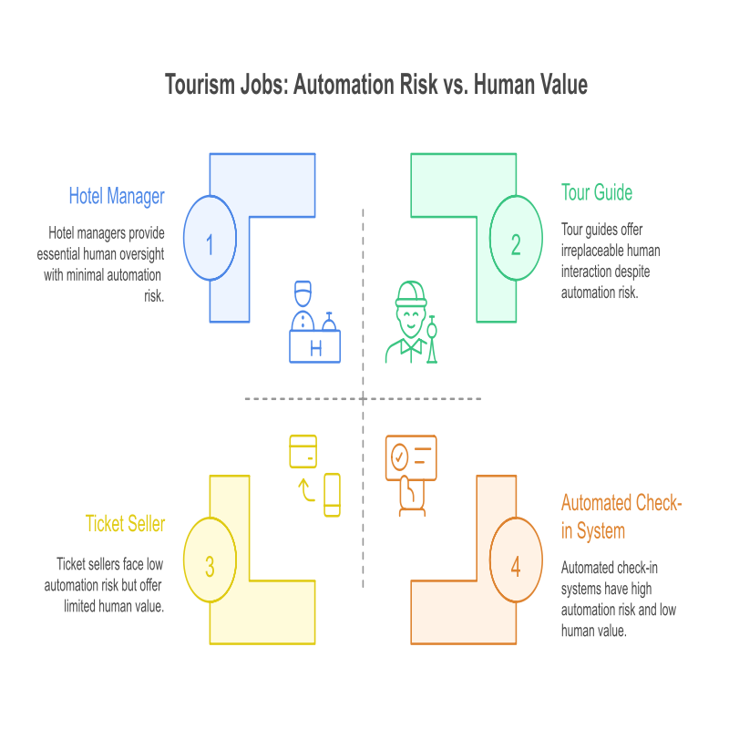
Emerging skill requirements include digital literacy, data interpretation, multilingual communication, cultural competency, and sustainability knowledge. Workers combining traditional hospitality skills with technological competencies command wage premiums averaging 25-35% above baseline service positions. This trend creates career advancement opportunities while requiring continuous learning investments.
Artificial intelligence and data analytics applications grow rapidly in revenue management, marketing, and operational optimization. However, implementation requires human oversight, interpretation, and customer interface capabilities. Successful integration enhances rather than replaces human capabilities, suggesting complementary rather than substitutive relationships between technology and labour in most tourism contexts.

6. Discussion

6.1 Strategic Risk Management Framework
The findings demonstrate that effective tourism labour market management requires comprehensive risk assessment frameworks that address both sector-specific vulnerabilities and broader economic uncertainties. Traditional risk management approaches focusing primarily on financial and operational risks prove insufficient when labour market disruptions threaten destination competitiveness and community
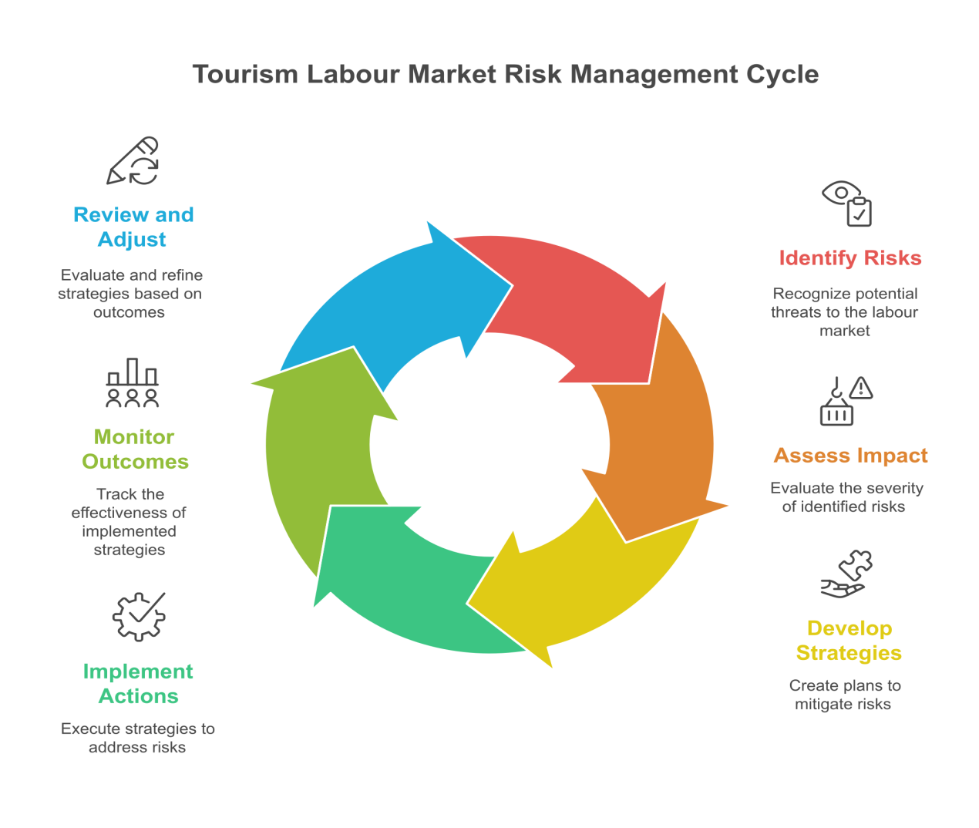
A strategic risk management framework for tourism labour markets should incorporate vulnerability mapping that identifies critical dependencies, skills bottlenecks, and external shock transmission mechanisms. This includes assessing seasonal labour flow patterns, international migration dependencies, skills gap concentrations, and community employment concentration levels. Such mapping enables proactive intervention before crises occur rather than reactive responses after disruptions manifest.
Scenario planning emerges as a crucial tool for workforce resilience building. Destinations should develop multiple scenarios including demand fluctuations, border closure impacts, economic recession effects, and climate change influences on tourism patterns. Each scenario requires specific workforce planning responses including alternative employment strategies, skills development priorities, and social protection mechanism adjustments.

6.2 Crisis Recovery and Adaptive Capacity
The COVID-19 experience provides valuable insights into factors determining tourism labour market recovery success. Destinations with pre-existing strong social safety nets, diversified economic bases, and collaborative industry-government relationships demonstrated faster recovery and lower social costs. Conversely, destinations heavily dependent on international tourism with limited alternative employment opportunities experienced prolonged adjustment periods and significant social disruption.
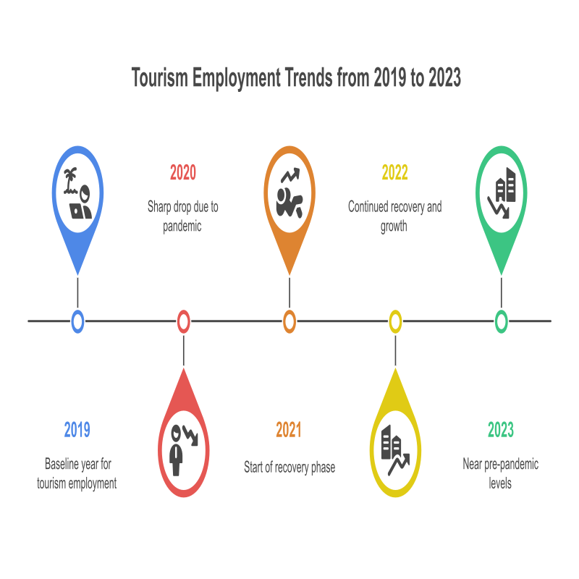
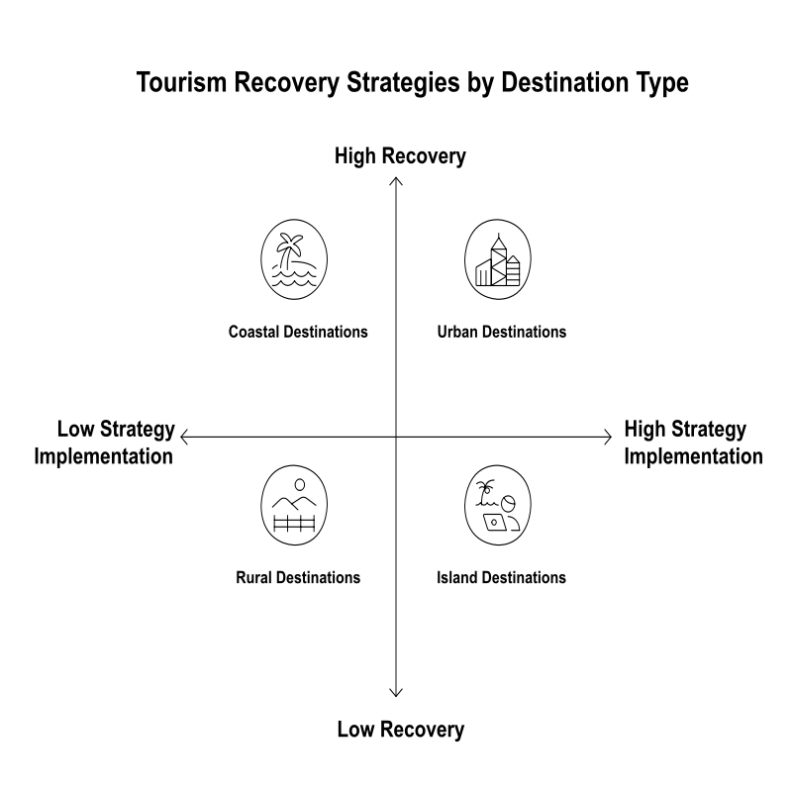
Adaptive capacity building requires investments in worker flexibility, business model innovation, and institutional coordination mechanisms. Worker flexibility encompasses both skills transferability and geographical mobility, enabling rapid redeployment during demand shifts. Skills transferability depends on educational systems that emphasize broad competencies rather than narrow specialization, while geographical mobility requires housing, transportation, and social support systems that facilitate worker movement.
Business model innovation involves developing revenue diversification strategies that reduce employment volatility during demand fluctuations. This includes expanding into business tourism, local recreational services, and online service delivery that can partially offset leisure tourism declines. Such diversification requires workforce capabilities spanning multiple market segments rather than specialization in single tourism niches.

6.3 Sustainable Workforce Development
Sustainability in tourism workforce development requires balancing multiple objectives including environmental protection, social equity, economic viability, and cultural preservation. This balance creates tension between short-term cost minimization and long-term competitiveness enhancement that requires strategic resolution through integrated planning approaches.
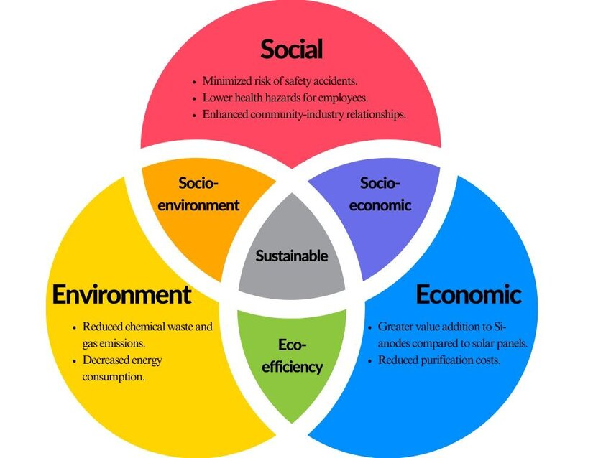
Environmental sustainability influences workforce planning through green job creation, sustainable practice implementation, and climate adaptation requirements. Green jobs in tourism include environmental management specialists, renewable energy technicians, sustainable tourism planners, and eco-guide specialists. These positions require specialized training while often commanding wage premiums, creating career advancement incentives for environmental skill development.
Social sustainability emphasizes employment quality, worker rights protection, and community integration. This includes addressing precarious employment through improved contracts, wage standards, and benefit provision. Community integration involves ensuring tourism employment benefits local residents rather than displacing them through gentrification or exclusive reliance on international workers.

6.4 Policy Framework Requirements
Effective tourism labour market governance requires coordinated policy frameworks addressing multiple regulatory domains including immigration, education, labour standards, and economic development. Policy fragmentation across different government levels and departments creates implementation challenges that undermine strategic workforce planning effectiveness.

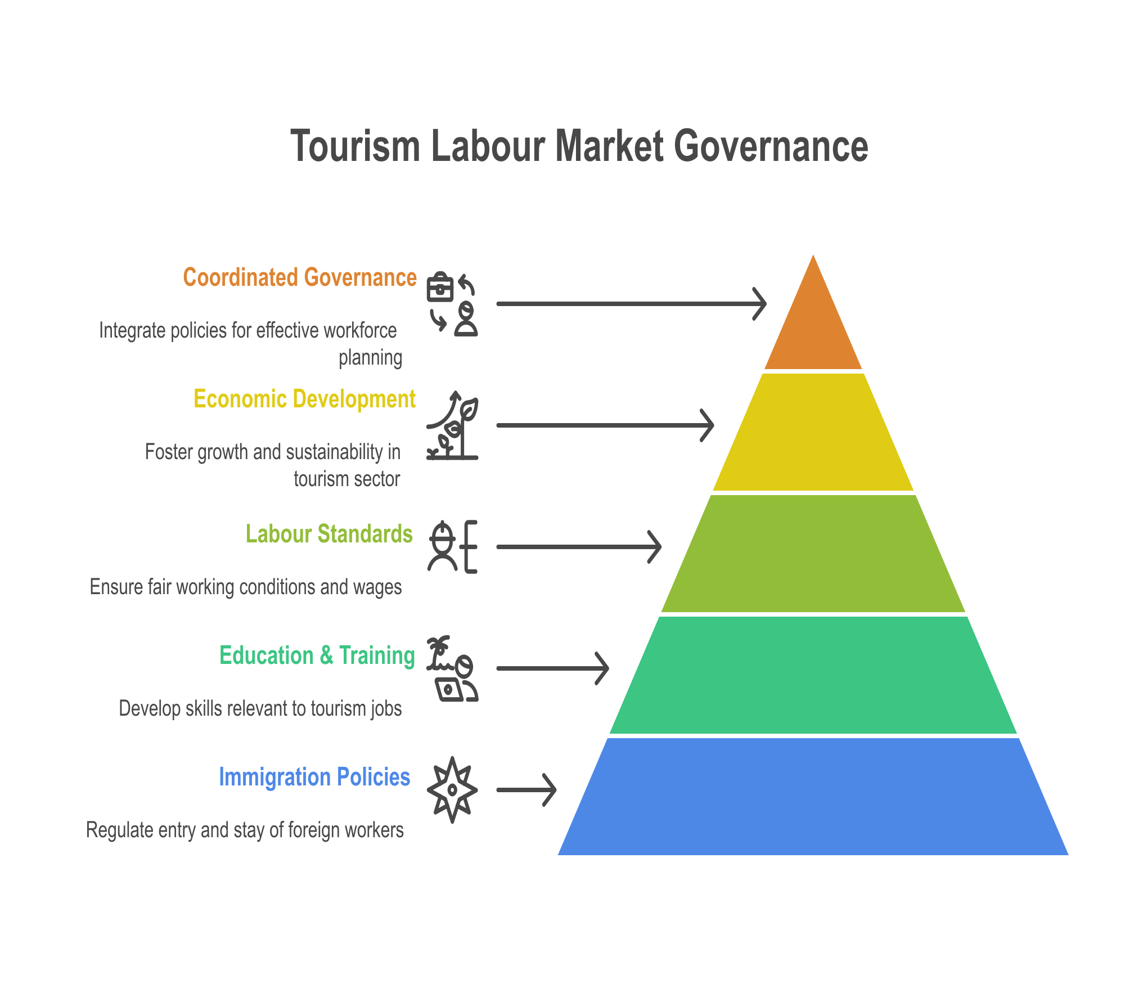
Immigration policy coordination becomes crucial for destinations relying on international labour mobility. This involves aligning work permit procedures with seasonal demand patterns, ensuring adequate labour protections for migrant workers, and facilitating family integration for longer-term residents. Bilateral agreements between origin and destination countries can streamline processes while protecting worker rights.
Education policy integration ensures tourism workforce preparation aligns with industry needs while providing career advancement pathways. This requires close collaboration between educational institutions and industry employers, curriculum development that balances technical skills with critical thinking, and recognition systems that validate learning from work experience alongside formal education.

6.5 Innovation and Competitive Advantage
Innovation in tourism workforce planning creates competitive advantages through enhanced service quality, operational efficiency, and crisis resilience. However, innovation requires investments in training, technology, and organizational change that may conflict with short-term cost pressures, particularly during economic downturns.
Successful innovation strategies balance technology adoption with human capital development, recognizing that technology alone cannot deliver superior customer experiences. Human skills in cultural interpretation, problem-solving, and emotional connection remain crucial for tourism competitiveness. Technology should augment rather than replace these capabilities through tools that enhance worker productivity and customer interaction quality.
Knowledge management systems that capture and transfer worker expertise become increasingly important as workforce mobility increases. These systems enable organizations to preserve institutional knowledge while facilitating faster onboarding for new employees. Documentation of best practices, customer preferences, and operational procedures creates organizational capabilities that transcend individual worker presence. strategic workforce planning effectiveness.
Immigration policy coordination becomes crucial for destinations relying on international labour mobility. This involves aligning work permit procedures with seasonal demand patterns, ensuring adequate labour protections for migrant workers, and facilitating family integration for longer-term residents. Bilateral agreements between origin and destination countries can streamline processes while protecting worker rights.
Education policy integration ensures tourism workforce preparation aligns with industry needs while providing career advancement pathways. This requires close collaboration between educational institutions and industry employers, curriculum development that balances technical skills with critical thinking, and recognition systems that validate learning from work experience alongside formal education.

5.5 Innovation and Competitive Advantage
Innovation in tourism workforce planning creates competitive advantages through enhanced service quality, operational efficiency, and crisis resilience. However, innovation requires investments in training, technology, and organizational change that may conflict with short-term cost pressures, particularly during economic downturns.
Successful innovation strategies balance technology adoption with human capital development, recognizing that technology alone cannot deliver superior customer experiences. Human skills in cultural interpretation, problem-solving, and emotional connection remain crucial for tourism competitiveness. Technology should augment rather than replace these capabilities through tools that enhance worker productivity and customer interaction quality.
Knowledge management systems that capture and transfer worker expertise become increasingly important as workforce mobility increases. These systems enable organizations to preserve institutional knowledge while facilitating faster onboarding for new employees. Documentation of best practices, customer preferences, and operational procedures creates organizational capabilities that transcend individual worker presence.

6. Conclusion
This comprehensive analysis of tourism labour markets reveals complex dynamics requiring strategic intervention to ensure sustainable workforce planning, effective crisis recovery, and long-term industry resilience. The research identifies critical vulnerabilities including seasonality-induced employment instability, external shock sensitivity, skills mismatches, and overdependence on international labour mobility. These vulnerabilities interact to create systemic risks that threaten both individual worker welfare and destination competitiveness.
Key findings demonstrate that successful tourism labour market management requires integrated approaches addressing multiple stakeholder needs and policy domains. Effective strategies combine workforce development investments, crisis preparedness planning, technological integration, and social protection enhancement. The evidence indicates that destinations investing proactively in labour market resilience experience faster recovery from disruptions and maintain superior competitive positions during stable periods.
The study contributes several important insights to tourism labour economics literature. First, traditional labour market theories require adaptation to address tourism-specific characteristics including seasonality, geographical constraints, and service quality requirements. Second, crisis recovery success depends critically on pre-existing institutional capacity rather than solely on post-crisis intervention design. Third, sustainability in workforce planning requires balancing environmental, social, and economic objectives through integrated policy frameworks rather than addressing these dimensions separately.
Practical implications for industry stakeholders emphasize the importance of collaborative workforce planning that engages employers, workers, educational institutions, and government agencies in coordinated strategy development. Employers should invest in worker development and retention even during challenging periods to maintain competitive advantage and social license to operate. Workers benefit from continuous learning investments that enhance skills transferability and career resilience.
Policy recommendations include developing comprehensive labour market information systems that enable proactive workforce planning, creating flexible social protection mechanisms that address employment volatility, and establishing international cooperation frameworks that facilitate ethical labour mobility while protecting worker rights. Educational policy should emphasize broad competency development alongside technical specialization to enhance worker adaptability.
Future research should address several important questions emerging from this analysis. Longitudinal studies tracking individual worker career trajectories would provide insights into effective skills development pathways and mobility patterns. Comparative analysis of different crisis response mechanisms would inform best practice development for future disruptions. Investigation of technology-labour complementarities would guide strategic decision-making about automation adoption and human capital investment priorities.
The tourism industry's future success depends critically on developing labour markets that are resilient, equitable, and sustainable. This requires moving beyond reactive crisis management toward proactive workforce planning that anticipates challenges while creating opportunities for worker advancement and community development. By implementing the strategic frameworks identified in this research, tourism destinations can build competitive advantages while ensuring that industry growth contributes to broader social and economic development objectives.
The analysis demonstrates that tourism labour markets, despite their vulnerabilities, possess significant potential for innovation and improvement. Strategic intervention can transform weaknesses into strengths through appropriate policy design, stakeholder collaboration, and long-term commitment to workforce development. Success requires recognizing that labour market investments are not costs to be minimized but strategic assets essential for sustainable tourism development.

References
Baum, T. (2018). Sustainable human resource management as a driver in tourism policy and planning: A serious sin of omission? Journal of Sustainable Tourism, 26(6), 873-889.
Boluk, K. A., Cavaliere, C. T., & Higgins-Desbiolles, F. (2019). A critical framework for interrogating the United Nations Sustainable Development Goals 2030 Agenda in tourism. Journal of Sustainable Tourism, 27(7), 847-864.
Gössling, S., & Hall, C. M. (2019). Sharing versus collaborative economy: How to align ICT developments and the SDGs in tourism? Journal of Sustainable Tourism, 27(1), 74-96.
International Labour Organization. (2022). World employment and social outlook: Trends 2022. ILO Publications.
Migration Policy Institute. (2021). International migration and the tourism sector: Policy perspectives. Migration Policy Institute.
Movono, A., & Dahles, H. (2017). Female empowerment and tourism: A focus on businesses in a Fijian village. Asia Pacific Journal of Tourism Research, 22(6), 681-692.
Poulston, J. (2019). Expressive labour and the gift of hospitality. Hospitality & Society, 9(3), 269-288.
Riley, M., Ladkin, A., & Szivas, E. (2017). Tourism employment: Analysis and planning. Channel View Publications.
Ritchie, B. W., & Jiang, Y. (2019). A review of research on tourism risk, crisis and disaster management: Launching the annals of tourism research curated collection on tourism risk, crisis and disaster management. Annals of Tourism Research, 79, 102812.
Scheyvens, R., & Biddulph, R. (2018). Inclusive tourism development. Tourism Geographies, 20(4), 589-609.
Sigala, M. (2020). Tourism and COVID-19: Impacts and implications for advancing and resetting industry and research. Journal of Business Research, 117, 312-321.
Walmsley, A. (2019). Examining the career experiences of ethnic minority workers in the tourism industry. International Journal of Contemporary Hospitality Management, 31(5), 2063-2081.

World Travel & Tourism Council. (2023). Economic impact reports 2023. WTTC.
Zenker, S., & Kock, F. (2020). The coronavirus pandemic–A critical discussion of a tourism research agenda. Tourism Management, 81, 104164.

