

CULTURAL HERITAGE MANAGEMENT – ASSIGNMENT 3

CRITICAL ANALYSIS OF A GERMAN HERITAGE MANAGEMENT PLAN: ZOLLVEREIN COAL MINE INDUSTRIAL COMPLEX (ESSEN, GERMANY)

Table of Contents
Introduction 3
Vision Statement 3
Objectives 4
Value Statement 5
Conclusion 5
References 7

Introduction
Zollverein Coal Mine Industrial Complex is a renowned European industrial heritage site and a UNESCO World Heritage since 2001 (UNESCO World Heritage, 2001). Not only the world's largest coal mine at its time, today it is an urban cultural production site and attracts over 1.5 million visitors annually (NRW Tourism, 2026). Managed by Stiftung Zollverein, the heritage management plan of the site is representative of German strategies to preserve industrial cultural heritage that consider conservation, re-development and utilisation. This essay evaluates the Zollverein management plan vision, objectives and value statements, considering the positives and negatives.
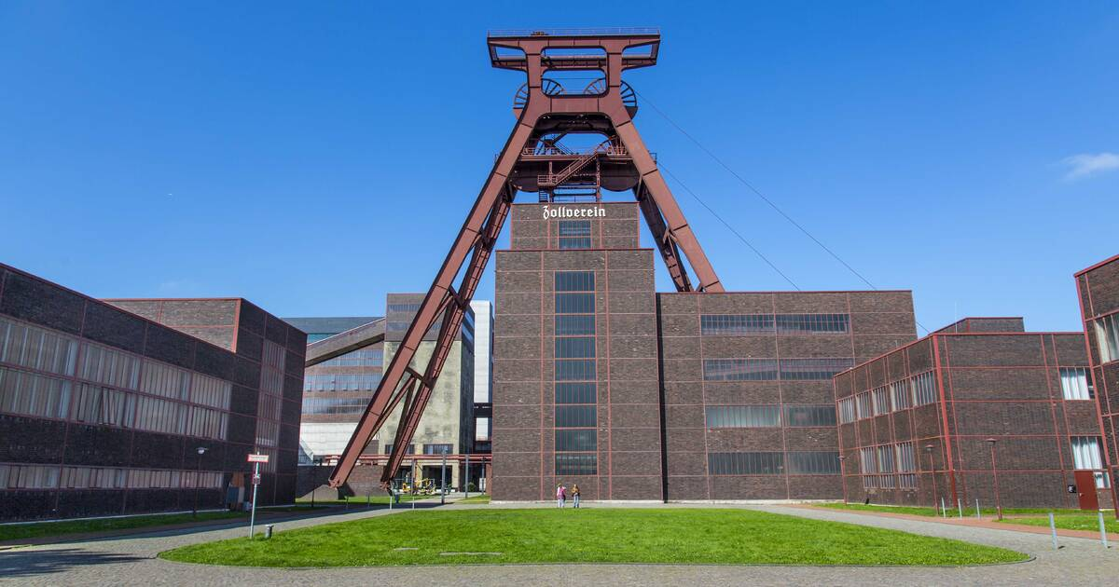
Figure 1: Zollverein Coal Mine Industrial Complex
Source: (UNESCO World Heritage, 2001)

Vision Statement
Zollverein management plan has a vision to maintain the site as an industrial heritage symbol and to convert it into a cultural, educational and economic hub. It seeks to embrace Zollverein as a world-leading model of industrial heritage transformation and integration into creative economies (Şekerci, 2021). This vision is a great asset because it is aligned with UNESCO principles as set out in UNESCO guidelines on the use of heritage sites. The vision integrates culture and the economy, as the site is transformed into design, art and tourism resource. For example, the Zollverein site has been a major asset to the North Rhine-Westphalia region, where the creative economy generates millions of Euros (Koperdraat, 2021).
However, vision also presents challenges. Economic reform is a priority but, some argue, commercialisation come at the expense of historical integrity. By prioritising tourism and events, the history of this industrial site could become obscured, and risks "heritage commodification" (Baillie, Chatzoglou and Taha, 2010). Moreover, there are challenges in preserving and using the site, such as preserving Bauhaus-style industrial design. Moreover, the international approach of the vision may conflict with local involvement. Although the site is world-renowned, it continues to deal with equal local participation concerns (Şekerci, 2021). Thus, while ambitious and futuristic, the statement needs to be continually rebalanced to not favour economic development over cultural integrity.

Objectives
The Zollverein management plan outlines several objectives: conservation of physical structures, promotion of cultural activities, enhancement of tourism, and fostering education and research. One of the strongest aspects of these objectives is their multidimensional nature. The conservation of original structures is particularly strong with clear guidelines for the preservation of structures such as Shaft XII, known as the "most beautiful coal mine in the world." Various funding programs at the state and federal level have aided in conservation work (Golobostanfard, 2025). Germany is highly committed to heritage preservation, spending billions every year on not only cultural activities.
The goal of encouraging cultural activities has also been a success. The Zollverein campus is home to many exhibitions, festivals and events, earning its reputation as a "city of encounters". This is in line with European redevelopments that adapt building to new uses. However, some objectives show gaps. The emphasis on tourism growth, which shows an increase in tourist numbers, may compromise infrastructure and conservation efforts. Over-tourism, while not yet a major concern, could be a looming issue, particularly during events (Butler and Dodds, 2022). However, although educational programs are available, their reach and engagement with a diverse range of groups might be increased. There are few programs aimed at diverse groups.
Furthermore, long-term funding needs support. While currently well-funded, public funding may be precarious given economic or policy changes. The management plan should explore other funding opportunities, such as private or community-led programs (Yang et al., 2021). Overall, the goals are ambitious, well aligned and balanced but a challenge exists in achieving them on the basis of conserving, making accessible and making profitable.

Value Statement
Zollverein's value statement emphasises its outstanding universal value as an industrial heritage site, detailing its architectural, historical and economic aspects. It mirrors the UNESCO's criteria that were used to inscribe the site, especially its role in the development of heavy industry in Europe (Ruiz, Rodríguez and Coronado, 2017). One of the strengths of this value statement is its historical perspective Zollverein is not just a preserved industrial site, it is a story of industrialisation, labour relations, and innovation. Modernist influences in the architectural design also enhance the aesthetic value, a distinction among industrial heritage sites (Rashdan and Ashour, 2024).
The statement also addresses social value and acknowledges worker and community experiences of the coal industry. This follows the latest trends in heritage studies which focus on intangible heritage and collective memory (Larsson, 2025). However, the value statement may be criticised for its lack of engagement with community involvement. Although recognising social history, it fails to include local perspectives in heritage interpretation (Smith, 2022). This might limit the level of engagement and opportunities for participatory heritage.
Moreover, the environmental component of value is weak. Given the coal mining history and environmental consequences of the site, it would be relevant to include narratives of sustainability. Tackling matters such as land repurposing and ecology could boost the value stance in relation to climate change (Ladysz, 2025). Another concern is the risk of biased narrative. Heritage narratives can be selective in what they emphasise. At Zollverein, emphasis on industrial achievement might de-emphasise workers' challenges, such as unsafe working conditions and economic depression during deindustrialisation. Value statement is strong in communicating universal value of the site, but it could be aware of diversity and sustainability.

Conclusion
The Zollverein Coal Mine Industrial Complex's heritage management plan shows a mature and multifaceted approach to cultural heritage. Its vision is an effective balance between conservation and economic and cultural regeneration, which has elevated the site to the status of global industrial heritage site. The goals are multifaceted, including preservation, tourism and education, and value statement succeeds in emphasising historic and architectural value of site. However, critical evaluation reveals several issues. Problems include balance between commercialisation and preservation, tourism impacts, and lack of inclusivity and sustainability. Additionally, increased community participation and more complex funding approaches would increase plan’s robustness. Ultimately, although Zollverein is a success story when conserving Germany's cultural heritage, its future success relies on addressing new challenges. Maintaining even-headed approach that balances cultural, community, and environmental concerns will be critical to the site's relevance and sustainability for the long term.

References
Baillie, B., Chatzoglou, A. and Taha, S. (2010). Packaging the past: The commodification of heritage. Heritage Management, 3(1), pp.51–71. doi:https://doi.org/10.1179/hma.2010.3.1.51.
Butler, R.W. and Dodds, R. (2022). Overcoming overtourism: a review of failure. Tourism Review, 77(1), pp.35–53. doi:https://doi.org/10.1108/tr-04-2021-0215.
Golobostanfard, S. (2025). Reconnecting the Urban Fabric: Adaptive Reuse of Industrial Sites through Strategic Bridge Integration - WebThesis. Polito.it. [online] doi:https://webthesis.biblio.polito.it/36569/1/tesi.pdf.
Koperdraat, S.J. (2021). How far does the influence of innovation in North-Rhine Westphalia reach? Studenttheses.uu.nl. [online] doi:https://studenttheses.uu.nl/handle/20.500.12932/41123.
Ladysz, J. (2025). Recommendations for value creation, sustainability and responsibility in land-use management. Procedia Computer Science, 270, pp.5073–5080. doi:https://doi.org/10.1016/j.procs.2025.09.634.
Larsson, F. (2025). THE ROLE OF MEMORY IN SHAPING COLLECTIVE CULTURAL HERITAGE. European Review of Contemporary Arts and Humanities, [online] 1(1), pp.12–15. Available at: http://claritaslumen.org/index.php/ercah/article/view/3.
NRW Tourism (2026). Zollverein UNESCO World Heritage Site in Essen: Pure industrial culture. [online] Nrw-tourism.com. Available at: https://www.nrw-tourism.com/unesco/zollverein [Accessed 27 Apr. 2026].
Rashdan, W. and Ashour, A.F. (2024). Heritage-Inspired Strategies in Interior Design: Balancing Critical Regionalism and Reflexive Modernism for Identity Preservation. Heritage, 7(12), pp.6825–6856. doi:https://doi.org/10.3390/heritage7120316.
Ruiz, R., Rodríguez, J. and Coronado, J.M. (2017). Modern roads as UNESCO World Heritage sites: framework and proposals. International Journal of Heritage Studies, 23(4), pp.362–374. doi:https://doi.org/10.1080/13527258.2016.1277774.
Şekerci, Y. (2021). Endüstriyel - Kültürel Mirasın Değerlendirilmesi: Almanya Zollverein Maden Ocağı Kompleksi Örneği. Journal of Planning. doi:https://doi.org/10.14744/planlama.2021.03274.
Smith, L. (2022). Heritage, the power of the past, and the politics of (mis)recognition. Journal for the Theory of Social Behaviour, 52(4), pp.623–642. doi:https://doi.org/10.1111/jtsb.12353.
UNESCO World Heritage (2001). Zollverein Coal Mine Industrial Complex in Essen. [online] UNESCO World Heritage Centre. Available at: https://whc.unesco.org/en/list/975/.
Yang, C., Stevens, C., Dunn, W., Morrison, E. and Harries, R. (2021). ‘Why don’t they ask us?’ The role of communities in levelling up - Institute for Community Studies Repository. Icstudies.org.uk. [online] doi:https://eprints.icstudies.org.uk/id/eprint/239/1/ICS-WP2-Why-dont-they-ask-us%20AMENDED.pdf.

