The Evolution and Future of the Hotel Industry

1. Introduction

Background
The hotel industry is an integral part of the world economy because it includes an enhanced number of a wide variety of accommodations for leisure and business travelers. The hotels evolved from modest inns to luxurious resorts to cater changing needs of society. The hotel industry is one of the historical origins of the travel and tourism sector, as this industry has been providing shelter, comfort and services to the guests. In economic, technological and cultural changes, the industry has experienced a high rate of change over the decades (Li, 2024). Nowadays, hotels are not only accommodation but also a key part of the tourism system and provide an important contribution to local as well as global economies, job creation, and infrastructure development.

Objective
- Study the development of the hotel industry by investigating its essential changes and steps.
- Assess the digital transformation effects that stem from online bookings and mobile applications, and digital marketing practices.
- Guests, along with staff, need to understand how AI-powered services, together with smart room technology, affect facility operations while improving guest satisfaction.
- Companies must evaluate upcoming market movements involving personalized services together with automated management systems, as well as different accommodation options.

Scope
The main job of this report shall be to cover some of the main milestones in the hotel industry’s history from the beginnings in ancient civilizations up to the global industry as we know it today. The evolution of the industry will be discussed in detail regarding how technological advancements such as online booking systems, mobile apps, and digital marketing form a major part of technological advancements for the industry.

Significance
The context of the link with the hotel industry today is relevant to this topic since it is going through a time of tremendous change. Hotel operators have their own opportunities as well as challenges due to ongoing digitalization, along with the changing consumer expectations and technological developments. Given the rise of AI, automation, smart technologies, hospitality may provide a glimpse into the future where efficiency, personalization, and sustainability are key in setting how guests will interact with the business and each other (Das, 2023), or even affect the way data can be gleaned from the individuals' technologically driven lives, thus the stages of “digitally divorced” guests who engage solely in the conventional hospitality manner, and other related circumstances.

2. Main Body

2.1 Historical Evolution of the Hotel Industry

Early Beginnings:
The story of the hotel industry actually began while ancient civilizations struggled with the need of travelers and merchants for a place to rest and relax on the way. There were inns, which are known in ancient Mesopotamia as caravanserais, established on major trade routes. Shelter, water, food and animals were the services offered in these simple inns. Ancient Greece and Rome had guesthouses and lodgings that served as short-term locations for travelers. However, these establishments were very far from what is now understood as a hotel, since the services provided were very meager, and most of these were tailored to utility rather than comfort.
Over time, when civilization advanced, lodging for travelers turned into a more refined idea. However, secular inns and taverns along main roads and in towns started to appear in medieval Europe because monasteries were often a shelter for travellers (Rubin, 2020). The early inns had been developed for local travelers and provided food, drink, and shelter. Middle Age commerce and trade were powerful, thus they mostly lived in towns or near trade routes.

Major Milestones:
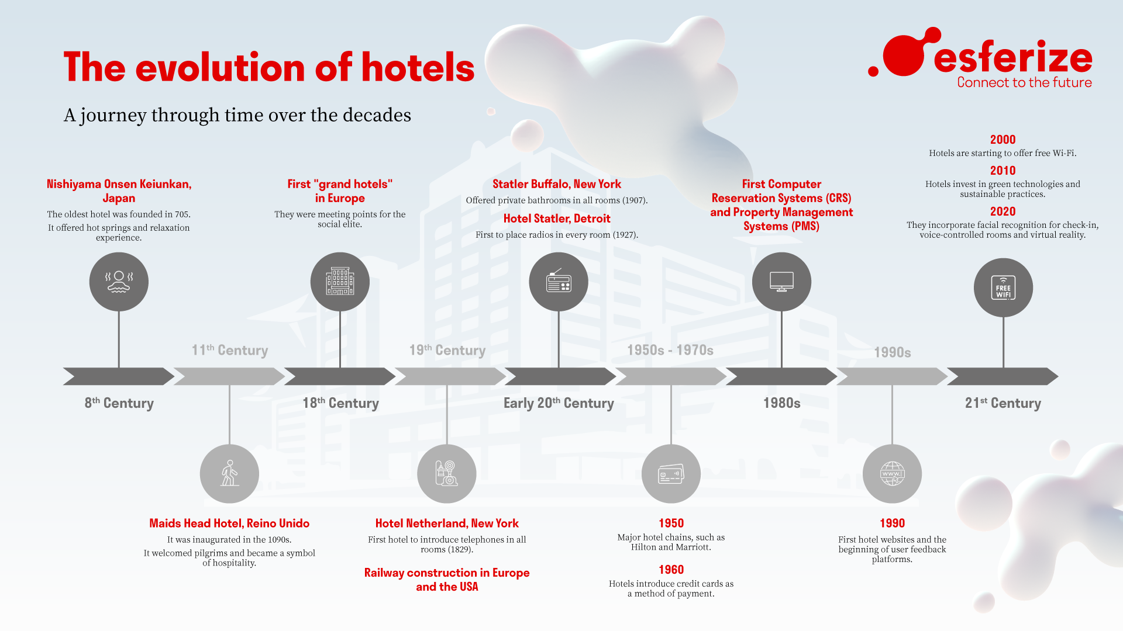
Figure 1: Timeline of the hotel industry evolution
(Source: esferize.com, 2025)
It was mainly during the 18th and 19th centuries that the modern hotel industry took shape with the introduction of the luxury hotels and the foundation of the first international hotel chains. This was a key moment in the history of the hotel industry, as the Rise of Luxury Hotels was a notable breakthrough. The Ritz Hotel in Paris was created in The early 19th century when it was one of the world’s first luxury hotels in the year 1898 (Zibaoui Cunillera & Camps López-Bago, 2020). Unlike any other hotels of that time, this hotel included a private bathroom, electricity, lavish décor, thus being a revolutionary in the hospitality world with unbeatable unmatched facilities. It was the start of transforming hotels from stables to high-class establishments.
The InterContinental Hotels is the first international hotel chain founded in the 1940s (Breda et al., 2020). It was a big step towards the emergence of a hotel idea of standardized experience that travellers now could expect in any part of the country. During the growing international travel with the post-World War II era of tourism, the demand for hotel services had increased beyond expectations with consistent and high-quality services. During this period, major global hotel chains like Hilton, Marriott and Holiday Inn started to rapidly expand, and they were providing standardized services, customer loyalty programs, as well as an unprecedented level of reliability.

Growth and Globalization:
Growth in the hotel industry can also be attributed to the degree of globalization of travel and tourism, after the World War II era (Khan et al., 2020). And with the development of air travel, more and more people were able to travel internationally, and thus there was an increase in the demand for hotels in major cities and tourist destinations. The dramatic increase in travel for leisure and business purposes during the post-war years was possible due to the economic boom and growth of the middle class.
This caused the hotel industry to move from regional to national to multinational. Basically, international hotel chains were started, namely Hilton, Sheraton, and Radisson, to dominate the global market (Chen, 2022). Gradually, these companies have expanded their operations to many other markets, especially emerging economies and of network of hotels that extend across different countries and continents. These chains were able to achieve standardization of services, pricing models and guest experiences, which helped them maintain consistency and service the international traveller wherever they went.

Impact of Economic and Social Factors:
The development of the hotel industry has been most closely related to many economic changes and social changes at different times. The post-war economic boom was a very notable economic influence on hotel development as such, it was greatly affected. After the Second World War, many countries in the West became nodes of economic resurgence. As a result, there was enhanced disposable income, more travel, and a burgeoning middle class (KIŞLALI & KÖSE, 2020). As a result, there was a large demand from people who could travel in business and leisure that could afford to travel. Rise of business travel and growth of international trade mainly exerted a positive pressure to the development of the demand for high quality hotels, especially in business districts in the major cities.

2.2 The Role of Digital Transformation in the Hotel Industry

Introduction to Digital Transformation:
The mission is to serve the changing expectations of customers, transform the operation to be as efficient as possible and make the guest experience more seamless and personalize. Such technological shift in the hospitality industry is not just a result of technological progress in the hospitality industry worldwide, including online booking and more, AI-powered chatbots for an enhanced guest satisfaction and corporate performance.

Impact of Technology:
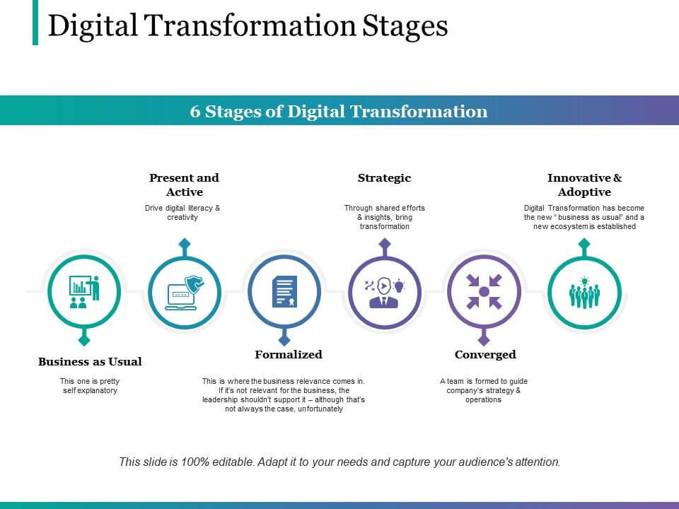
Figure 2: Digital transformation in the hospitality industry
(Source: cihms.com, 2025)
The invention of online booking systems is one of the most significant technological breakthroughs that have taken place in the hotel industry. Before the digital age, to book a room, you would have to walk into a hotel or you would have to call to make a reservation. This process was changed by platforms such as Booking.com, Expedia and Airbnb. With these systems, customers can search for hotel options, compare prices and make online bookings of the rooms, all without going to the hotels or even leaving home. What it has done, however, is made the booking process more convenient, while it also shifted the shade in the community in favour of the clients, as they are now given more flexibility and choice. After the use of property management systems (PMS) and channel managers, hotels are able to manage bookings, availabilities and rate schedules in real time, thus better control the inventory and drastically reduce the risk of overbooking.
Later, mobile apps also had a significant technological impact. Hotel chains have come up with their own or incorporated apps to improve the guest experience. In these apps, guests can check in online, use and access room keys, make requests, and order services like room service or request housekeeping from their smartphones. With such functionalities, guests receive more control over the experience, feel empowered and are closer to being more convenient. Apart from the customers, these can also be used by hotels for sending push notifications about the promotions, upgrades and local activities to give customers a personalised experience.

Guest Experience Enhancement:
Digital tools have served to personalize, cut down the number of steps needed to make a hotel guest experience, and make it a lot easier to produce and deliver (Abdalla, 2024). Another great new functionality is the mobile check-ins, which allow guests to check in to the hotel room via their smartphone, instead of queuing at the front desk. With the current world’s culture, guests today prefer convenience and safety; in this self-service option is very important. Furthermore, mobile keys, some of which the guests can unlock rooms through a smartphone from wherever they are without having to carry a physical key, aid in enhancing the guest experience.
Second is the use of digital concierge services. Daily, the trend of using chatbots and AI-powered systems to give instant replies to guest queries is increasing in hotels. These tools can be used by guests in regard to a wide variety of requests, such as booking a restaurant reservation or obtaining information about hotel amenities and local attractions. Guests have the conveniences of getting real-time assistance through digital channels, which provide them with a more personalized and trouble-free stay. Also, these chatbots can learn from guests’ preferences and provide them with more fitting and targeted recommendations and suggestions.

Operational Efficiency:
Digital transformation has increased operational efficiency by far, as well as benefiting the guest experience. Revenue management systems (RMS) constitute one of the key technological innovations in this area (Alrawadieh et al., 2021). Based on data analytics and algorithms, these systems use data to price rooms to maximize the demand, number of seasons, local events and competition. This enables hotels to increase their revenues and rates of occupancy at the same time, while the hotels remain competitive in the market.
Technology impacts customer service automation to a great extent. AI and machine learning tools help many hotels run routine tasks ‘automagically,’ including guest questions to typical questions or guest feedback processing. These tasks are easily automated by the systems, which frees up employees to devote their time to more sophisticated customer service needs. For example, you have hotels that have an automated check-out system whereby the guest pay their bills using mobile devices or a self-service kiosk, eliminating the extra work for the front desk staff, and quickening the process.

2.3 AI-Powered Services and Smart Rooms

Artificial Intelligence in Hotels:
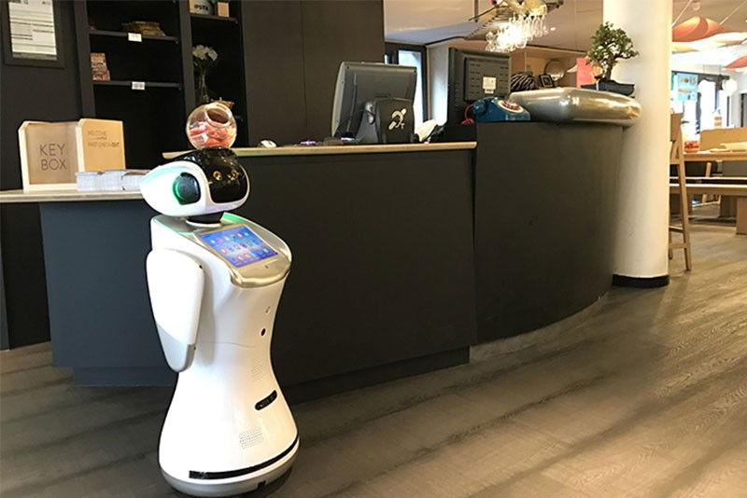
Figure 3: Artificial Intelligence in Hotels
(Source: linkedin.com, 2025)
The hotel industry continues to innovate through artificial intelligence (AI), which enables hotels to improve guest experiences by managing some of the operations or tasks. More and more AI is taking shape in various types of hotel services, from services providing more personalized and efficient answers. There are many of the most visible uses of AI in hotels, one being with AI-powered chatbots (Vashishth et al., 2024). These chatbots are virtual assistants, being able to fulfill a wide range of guest requests from answering guest questions about hotel amenities to making reservations at local restaurants. Chatbots using AI can leverage natural language processing (NLP) to allow them to understand and answer the guest inquiries in real time, eliminating the need for human assistance in real time.

Smart Rooms:
General hotel rooms function as implementations of IoT (Internet of Things) devices used to create personalized, automated guest experiences in hotel accommodations (Nadkarni et al., 2020). Smart rooms allow visitors to modify their hotel environment to their desired level. Among the various popular features of smart rooms are voice-controlled controls as a main attraction. Guests could, for instance, adjust room settings like lighting, temperature and entertainment systems just by summoning Amazon Alexa or Google Assistant to do the trick. It is a hands-free approach, and this makes it convenient for people as it has some added advantages for people with some disabilities or people who might want to experience things without experiencing any friction.
Another special feature of smart rooms is the smart temperature regulation. These rooms have thermostats connected to an IoT device that allows guests to set the temperature they would like while they’re there. After all, some systems actually learn which guest preferences they favor over time and will adjust automatically according to a guest’s comfort level. For instance, if a visitor prefers a cooler room, but the smart thermostat learns that a guest puts a cool note on the room’s thermostat the moment they arrive, they will instantly sense that the room has become more comfortable.

Automation and Efficiency:
With higher operational efficiency, AI and automation will become an important part of hotels. AI and robotics are making a tremendous difference in an area of room service that operates automatically (Wirtz et al., 2023). There are also a number of hotels where robots are used to deliver food and drinks to guest rooms for a contactless and seamless service. In many cases, these robots are provided with sensors that let them walk hotel corridors, stay clear of the obstacles, and bring each item directly to the guest’s room. By doing so, this automation decreases the workload of the hotel staff to provide fast and efficient customer service.
In addition, AI is being used for the optimization of maintenance and housekeeping operations. For example, predictive maintenance systems, which are AI-powered, can monitor the condition of hotel equipment such as HVAC, elevators and plumbing (Vinnakota et al., 2022). These also help you find out if something is worn out or if it has malfunctioned and notify hotel staff of the problem before any of these things become serious. Such an approach allows the downtime to be kept to a minimum, repair costs to be reduced, and guests to be spared from maintenance problems during their stay as long as possible.

Future Prospects:
The hotel industry is interesting, and really, the future is exciting in AI. The more advanced AI becomes, the more advanced the applications for AI will become, especially in hotels. Such development is one of the wide uses of AI-driven guest recognition systems. Facial recognition technology can also be utilized by these systems to recognize a guest’s return, automating the room settings, check-in process and personalized offers guests don’t have to move a finger for.
And yet another great prospect is that augmented reality (AR) and virtual reality (VR) will become even more important for hotel services (Balasubramanian et al., 2022). AR can be used by hotels to show guests, to potential guests, the layout of rooms and facilitate visits to hotel facilities, without having to travel in person. In a period when entertainment is in high demand, VR can be used for in-room entertainment, allowing guests to be immersed in a fun experience while they are in your place.

2.4 Emerging Trends in the Hotel Industry

Artificial Intelligence in Hotels:
CRM has also turned into a necessity in the hotel industry since the sale of a product is reliant on the services provided by the sector. Within the areas of guest service, personalization and operational management, there is some use of AI. It is among the most prominent applications of AI-enabled chatbots. Indeed, these virtual assistants can be quite capable at beefing up guests with their booking, order of reservations, giving feedback about amenities they have, as well as replying to common questions, all done in real time. Using NLP, chatbots can understand and respond to inquiries in an interactive and conversational fashion. This relieves human staff from simple requests so they can focus on more complicated conversations.
This also enables hotels to provide extremely personalized recommendations through AI. It uses machine learning algorithms for hotels to track guests’ preferences or likes such as room type, dining preferences, past activities and power it to offer tailored services. So, for example, if the same guests keep asking for a certain room temperature or a particular type of pillow, it can be made smart to know their preference so that it is applied automatically while the guest stays. Furthermore, AI helps hotels personalize their promotional offers through customized promotions for each customer based on their behavior.
AI is also significantly impacting another area of dynamic pricing. The goal of utilising AI and big data to adjust room rates is to accommodate a variety of factors, including demand, competition and booking patterns of the guests. In other words, this prevents prices from going up without being based on real-time optimization that maximizes revenue whilst remaining competitive in the market. The hotel can get a higher occupancy and better revPAR per available room with AI-driven pricing strategies as they can manage their inventory more efficiently (Sharma et al., 2025).

Smart Rooms:
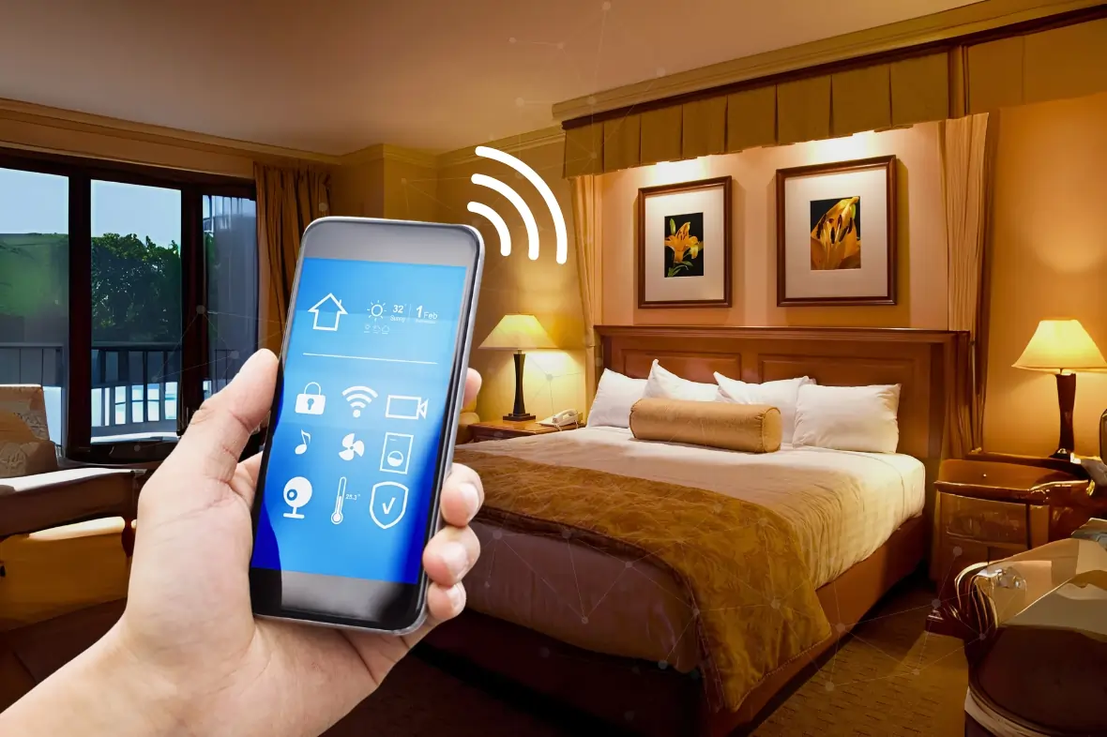
Figure 4: Smart Hotel Rooms
(Source: botshot.ai, 2025)
The integration of IoT (Internet of Things) technologies to increase the guest experience is meant for smart rooms. To that end, a smart room is a room with devices and systems that can be controlled remotely by the guests to give them more control and convenience during their stay at the hotel. It has been reported that controls in smart rooms are voice-activated. For this, guests use the voice assistants like Amazon Alexa or the Google Assistant to control the room settings, such as lighting and temperature and entertainment options, without being required to change the switches and remotes. But not only is this hands free, it saves you and anyone else who may be using it having to make a choice between touching various surfaces, not only is this convenient it also caters to guests that maybe have a disability and they don’t have to go to that effort, they don’t have to touch.
Apart from voice control, a smart room boasts the ability to regulate temperatures smartly. The connected thermostats are already installed in these rooms, so the guests can choose their preferred temperature for the room and make it as per their choice by setting it with the help of a smartphone or voice command. There are even some systems that learn the preferences of a guest with time and adjust automatically when the guest arrives, making sure that the room is tuned for the comfort of the guest. Such personalization and automization of the guest experience make it more pleasant and less stressful for the guest.
In addition, smart rooms also integrate entertainment systems with a wider diversity of options for guests. Smart TVs can be connected to streaming platforms like Netflix, YouTube or Spotify on a guest’s behalf to enjoy on-demand content from the room (Biju & Gayathri, 2024). However, some smart rooms also enable the content of guests’ private devices to be mirrored to the room’s TV for an integrated and customized watching experience. Smart rooms with applications of IoT-enabled lighting systems can change automatically according to the time, giving automatic adjustments to make a more comfortable environment. These innovations give the guests a sense of control and an overall better experience.

Automation and Efficiency:
Although technological tools such as AI and smart technologies in the hotel industry are meant for the betterment of guest experience, they also help in efficient operations. One such example of automated room service would be robots or an AI system to deliver items such as food and amenities to guest rooms. The robots can navigate hotel hallways to deliver orders to rooms, carrying those orders without human involvement. This automation saves labour costs and improves the efficiency of staff to focus on more complex tasks and speed up service.
Predictive maintenance is another area of improvement in terms of operations. This is being done for all the hotel equipment and facilities like HVAC system, elevators and plumbing through AI systems. By detecting the problems early on before they become major issues, it enables the maintenance teams to take care of these issues proactively, which prevents disruption of the guest experience. Say, when a smart system detects a defect in the air conditioning system, it alerts staff and tells them what to do so that the malfunction does not affect the guest.
AI has also helped in sending revenue management to a certain level. The use of AI in Advanced Revenue Management Systems (RMS) helps to analyze large amounts of data and make predictions of fluctuating demand (Smrutirekha et al., 2022). Real-time pricing is possible with these systems because they can understand patterns of weather, local events and market conditions and, as a result, automatically adjust prices based on those patterns to maximize revenue. In other words, it allows hotels to optimize both occupancy and pricing without human intervention. When such automation is done, it makes the operation more efficient and profitable.

Future Prospects:
Another exciting prospect is the take-up of the use of AI-based guest recognition systems, which expands their use to even the guests’ own systems. With facial recognition or other biometric data, hotels could seamlessly check in guests who return by automating the recognition of returning guests as well as by providing their room with the proper setting, preferences and offers.
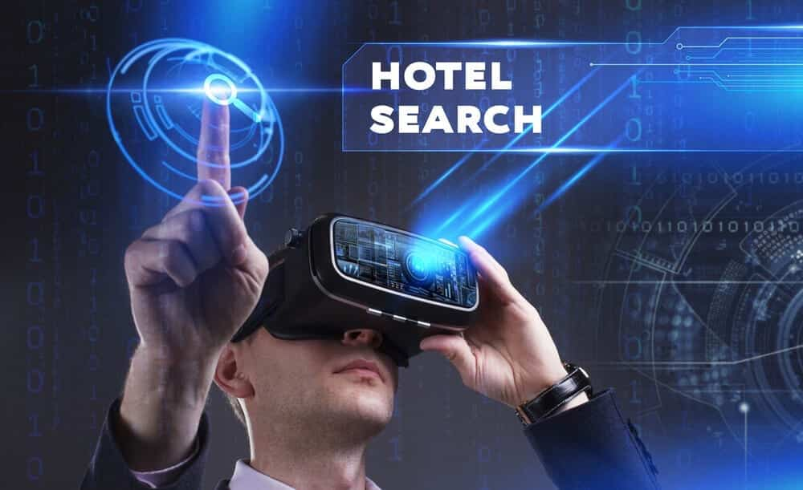
Figure 5: Virtual and augmented reality are the future of the hospitality industry
(Source: tworeality.com, 2025)
Augmented reality (AR) and virtual reality (VR) integration also have great value in hotel services. AR can be used by hotels to give guests virtual tours of hotel rooms, amenities and local attractions, thereby helping them to explore the place where they are going before arriving there. Like VR, the hotel could also use VR to conceptualize immersive in-room entertainment packages or even virtual concierge services, which create more engaging and futuristic ways for the guests to experience the hotel environment.
Security is certainly another area in which we can expect that AI and smart technologies will have a large impact, but it is potentially just as likely that AI and smart technologies will have negative impacts, and sustainability is another area in which we can expect that. Hotels will be able to make use of the energy most efficiently; through AAI-powered energy management systems, hotels will be able to save on energy waste and cut costs. According to him, it will also make use of smart room technologies, like the motion sensors and the energy-efficient systems, which will help with the reduction of energy consumption when the room is not in use.

2.5 The Future of the Hotel Industry

Predictions for the Future:
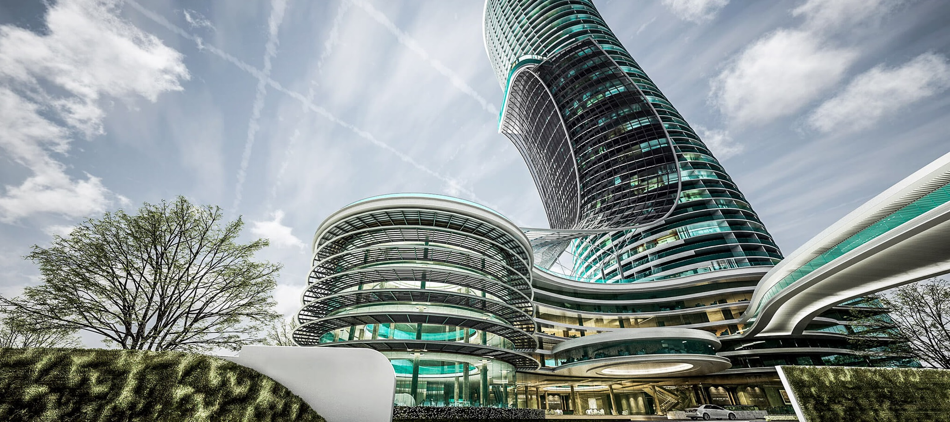
Figure 6: Artificial Intelligence in Hotels
(Source: ktchnrebel.com, 2025)
Our industry is seeing a transformational time as a result of various trends currently happening: sustainability, personalization, technology advancements, among other relevant trends. It is likely to be transformative in terms of the future of the industry. The hotel industry is likely to continue focusing on sustainability through being more environmentally conscious, as customers and businesses. As part of sustainable practice, companies will need to operate in the coming years to be a competitive advantage. Going forward, more hotels will integrate eco-friendly methods, including energy-efficient systems, conservation of water, reduction of waste, and the utilisation of renewable energy. Visitors will continue to trend toward green certified lodging via the likes of LEED, BREEAM, or EarthCheck (Leray, 2023).
In the hotel industry's future, trends will be personalization too. The hotel will have a great chance to beautifully customize its service to guests in the future thanks to big data and AI. Through tracking guests’ preferences and behavior, hotels will be able to provide personalized service, such as personalized room settings, specific food preferences, or personalized activity recommendations. Going further than that, past the booking, real-time data will also be used to predict when and how a guest will need something during their stay.

Challenges:
Yet, the hotel industry has a promising future, but also has its own stumbling blocks. The one big challenge is the increasing risk of cybersecurity issues, especially as AI and data analytics are heavily relied on. Every hotel collects massive amounts of personal and financial details from the guest, such as credit card information, identity information, preferences, etc (Cobanoglu et al., 2021). Since they are such attractive targets for cybercriminals, they are also known to compromise millions of systems. Hotels are increasingly employing more expensive, more complicated AI systems, They will be more and more vulnerable to Cyber attacks. Hotel operators will have to keep the secure digital system and protect guest data.
The second challenge with the hotel industry is the reluctance of the employees as well as customers to be automated. But they can achieve efficiency and cost reduction while also reducing job displacement, especially in front desk staff, housekeeping, and concierge service roles. In this case, the employees may be resistant to the idea of losing their jobs to machines. Furthermore, not all guests may find themselves as opposed to take the time to chat with machines or other AI systems. It will be a challenge for hotel operators to balance automation with human interaction, whereby they balance the sake of technology and the personalisation of their personalised, human-centered experience.
An important aspect of this is addressing the challenges of sustainability that also fall on the hotel industry. Although there are several steps being taken by a majority of the hotels towards being more environmentally responsible, it takes a huge investment and systemic change to achieve true sustainability. For example, old hotels can be retrofitted with energy-efficient, sustainable systems and associated technologies at great cost. Additionally, it may be challenging to make sure all levels of hotel operations from the top management to the guest services are in line with the matter of sustainability, especially with big, international hotel chains with more than one property. Finding ways through the challenge to integrate sustainability so as not to compromise profitability or the quality of the guest experience will be tricky.

Opportunities:
However, with these challenges, there is great potential to innovate and grow in the hotel industry. The most opportune opportunity is in the demand for sustainable tourism. Hotels that embrace eco-friendly practices and provide a sustainable experience will win the race as more and more consumers will prefer such hotels. Therefore, if hotels take this opportunity, it is possible to capitalize on the offer of eco-friendly practices in the operations and sustainable travel experiences for the guests in the form of eco-tours, organic dining and nature-based activities. Local communities will also benefit from partnering with them and being a part of cultural sustainability, which will have a unique value proposition for eco travellers.
The traditional hotel model is disrupted by the rise of alternative accommodations such as Airbnb, but at the same time, it offers an opportunity for innovation as well. In this vein, hotels can explore new business models like extended stay bedrooms, shared accommodation, or boutique hotel experience in line with consumers’ preference for local, unique, and affordable lodging options. The sharing economy is a major opportunity for hotels to reach out to a wider target of guests, ranging from budget travelers to long-term business travelers.
It also has huge growth opportunities in technology-driven innovation. To give an example, AI-driven analytics can help hotels better understand the behavior and preferences of the guests so as to provide a more personalised marketing and service offer to them. A hotel could integrate some virtual concierge services through AI-based apps or kiosks to enable guests to get to know about the hotel information, make requests and get recommendations without much interaction with the staff. Furthermore, robotic automation in the room service or luggage handling offers an opportunity to streamline the operations and save labor costs, which can further enhance profitability.

3. Conclusion

Summary of Findings:
Thus, this report has dealt with the historical evolution and the current state of the hotel industry, as well as the future trends that affect its development. Firstly, it looked into the ancient beginnings of the hotel industry when inns and guest houses were pioneered in ancient civilization, and later honed into the luxurious hotel chains and monotype accommodation that we now enjoy. Important milestones were in the rise of the international hotel chains, the establishment of industry regulations (Yacoub & ElHajjar, 2021). This was also the time when globalization and increased tourism grew the industry, as well as the economic boom after World War II.
Moreover, the report also went through the part that digital transformation took in the hotel industry by showing how digital marketing, mobile apps, and online booking systems changed hotel operations and customer interactions. Mobile check-ins, AI chatbots and smart room technology have increased the chance for the better by developing more convenience, personalization and efficiency innovations. Additionally, automation done with the help of AI in tasks like room service, maintenance, and revenue management is helping in operational efficiency and thereby reducing costs in a way that allows the hotel to cater better to customers.

Implications:
The findings, however, make hotel managers realize the need to adapt to digital transformation and be in the lead when it comes to technological races. Competitiveness and meeting the changing expectations of the guests will be pivotal for embracing the automation, AI and sustainability initiatives (Hussein Al-shami et al., 2022). As technological developments happen, managers will also have to tip the scale between technology and personal touch that guests will expect, especially in places where automation gets some resistance.

Final Thoughts:
In the hotel industry, there is a need for digital innovation and change in the evolving customer desire. In the evolving world of technology, the industry will increasingly start adopting smart systems, personalized experiences and sustainable practices. In the future, hotels will not just be a place for accommodation, but a place of innovation, where technology plays a major role in improving every dimension of a guest’s experience, as well as making things easier, more comfortable and efficient. To compete and provide great service, hotel operators have to embrace changes that technology brings.

4. References
Abdalla, H. (2024). The Impact of Digitalization in Improving Customer Experience at Hotel AX, Helsinki. https://www.theseus.fi/bitstream/handle/10024/862153/Abdalla_Hazem.pdf?sequence=3
Alrawadieh, Z., Alrawadieh, Z., & Cetin, G. (2021). Digital transformation and revenue management: Evidence from the hotel industry. Tourism Economics, 27(2), 328-345. https://d1wqtxts1xzle7.cloudfront.net/63481400/Digital_transformation_and_revenue_management_20200531-69911-wt65u1-libre.pdf?1590933106=&response-content-disposition=inline%3B+filename%3DDigital_transformation_and_revenue_manag.pdf&Expires=1744187724&Signature=CTJTcxjUNW0nH~xMzL0i1v1pwnk3WHC4TzzQVBg7mRloPBHpbZTv-2ihERM~PJRx5UQOFjJm82O22HpDK7BtXaiqtQl5JTx8rhPphdSg78TodUic8NhwbAHJ-C1Ub~2FJ5t3SxA9qUCksCkqKO15n9R2Vg6PaSSZLm6mP1CLgiXVF3F15eGiZKlil74S1JEqbAVBP1xAjWyDfBj9Qe7~QlIB2oaOqBm1U~1Q258MBp3SMm6l-NPMgA1jQYbcO3JqxXqzIIxdhFVhhYbzgwGxlyudPXQR3HPTnIUEWqC81q6Af5VlpvHlx8X~Z6tdVfJR4ghmuPv3DALnlrQDAgmOAw__&Key-Pair-Id=APKAJLOHF5GGSLRBV4ZA
Balasubramanian, K., Kunasekaran, P., Konar, R., & Sakkthivel, A. M. (2022). Integration of augmented reality (AR) and virtual reality (VR) as marketing communications channels in the hospitality and tourism service sector. In Marketing Communications and Brand Development in Emerging Markets Volume II: Insights for a Changing World (pp. 55-79). Cham: Springer International Publishing. https://www.researchgate.net/profile/Rupam-Konar/publication/360849500_Integration_of_Augmented_Reality_AR_and_Virtual_Reality_VR_as_Marketing_Communications_Channels_in_the_Hospitality_and_Tourism_Service_Sector/links/67b532144c479b26c9e625e0/Integration-of-Augmented-Reality-AR-and-Virtual-Reality-VR-as-Marketing-Communications-Channels-in-the-Hospitality-and-Tourism-Service-Sector.pdf
Biju, P. R., & Gayathri, O. (2024). A Study of Ethical Implications of AI Tools Enhancing User Conveniences in the Indian Digital Landscape. Journal of Social Computing, 5(3), 206-231. https://ieeexplore.ieee.org/stamp/stamp.jsp?arnumber=10767780
botshot.ai, 2025. TOPIC RELATED TO Smart Hotel Rooms. Viewed on 9th April 2025. From https://botshot.ai/resources/blog/smart-hotel-rooms
Breda, Z., Panyik, E., & Costa, C. (2020). Internationalization of the hotel industry: evidence from Portugal. Public Policy Portuguese Journal, 5(2), 81-96. https://www.researchgate.net/profile/Zelia-Breda/publication/346519840_Internationalization_of_the_hotel_industry_evidence_from_Portugal/links/5fc5f1b8a6fdcce95269345b/Internationalization-of-the-hotel-industry-evidence-from-Portugal.pdf
Chen, X. (2022). Location Strategies of Multinational Hotel Groups in China: An Application of Game Theory. https://pearl.plymouth.ac.uk/cgi/viewcontent.cgi?article=1222&context=pbs-theses
cihms.com, 2025. TOPIC RELATED TO Digital transformation in the hospitality industry. Viewed on 9th April 2025. From https://www.cihms.com/en/digital-transformation-in-the-hospitality-industry/
Cobanoglu, C., Dogan, S., Berezina, K., Collins, G., Nanu, L., Shahtakhtinskaya, K., & Parvez, O. (2021). Hospitality and tourism information technology. University of South Florida M3 Center Publishing, 17(9781732127593), 2. https://www.researchgate.net/profile/Betsy-Stringam-2/publication/344753638_Hotel_and_Guestroom_Technology/links/614a1314a3df59440ba1339b/Hotel-and-Guestroom-Technology.pdf
Das, M. P. (2023). Technology and Guest experience: innovations reshaping hotel management. International Journal for Multidimensional Research Perspectives, 1(3), 76-95. https://www.researchgate.net/profile/Chandigarh-Philosophers/publication/379411864_Technology_and_Guest_Experience_Innovations_Reshaping_Hotel_Management/links/6607af8a390c214cfd28f484/Technology-and-Guest-Experience-Innovations-Reshaping-Hotel-Management.pdf
esferize.com, 2025. TOPIC RELATED TO Timeline of the hotel industry evolution. Viewed on 9th April 2025. From https://www.esferize.com/en/the-evolution-of-hotels/
Hussein Al-shami, S. A., Mamun, A. A., Ahmed, E. M., & Rashid, N. (2022). Artificial intelligent towards hotels’ competitive advantage. An exploratory study from the UAE. foresight, 24(5), 625-636. https://www.researchgate.net/profile/Elsadig-Ahmed-3/publication/354819159_Artificial_intelligent_towards_hotels'_competitive_advantage_An_exploratory_study_from_the_UAE/links/6198d38107be5f31b79fa39b/Artificial-intelligent-towards-hotels-competitive-advantage-An-exploratory-study-from-the-UAE.pdf?origin=journalDetail&_tp=eyJwYWdlIjoiam91cm5hbERldGFpbCJ9
Khan, N., Hassan, A. U., Fahad, S., & Naushad, M. (2020). Factors affecting tourism industry and its impacts on global economy of the world. Available at SSRN 3559353. https://www.researchgate.net/profile/Shah-Fahad-21/publication/340171808_Factors_Affecting_Tourism_Industry_and_Its_Impacts_on_Global_Economy_of_the_World/links/5e8636d692851c2f527792dc/Factors-Affecting-Tourism-Industry-and-Its-Impacts-on-Global-Economy-of-the-World.pdf
KIŞLALI, H., & KÖSE, M. (2020). Recreational Second Homes and Sustainable Tourism. Hospitality & Tourism: Managerial perspectives & Practices (251-268). Lausanne: Peter Lang. https://www.researchgate.net/profile/Mustafa-Koese-2/publication/345385067_Recreational_Second_Homes_and_Sustainable_Tourism/links/5fa53fbb458515157befc584/Recreational-Second-Homes-and-Sustainable-Tourism.pdf
ktchnrebel.com, 2025. TOPIC RELATED TO Artificial Intelligence in Hotels. Viewed on 9th April 2025. From https://www.ktchnrebel.com/foodservice-future-hotel-trends/
Leray, C. (2023). How does green travel marketing influence and impact the tourism industry in the aviation, tour operators, and accommodation fields?: How trustworthy is the sustainability marketing of these companies?. https://www.theseus.fi/bitstream/handle/10024/855629/Leray_Charlotte.pdf?sequence=2
Li, L. (2024). Reskilling and upskilling the future-ready workforce for industry 4.0 and beyond. Information Systems Frontiers, 26(5), 1697-1712. https://link.springer.com/article/10.1007/s10796-022-10308-y
linkedin.com, 2025. TOPIC RELATED TO Artificial Intelligence in Hotels. Viewed on 9th April 2025. From https://www.linkedin.com/pulse/how-artificial-intelligence-revolutionizing-industry-shivam-kumar
Nadkarni, S., Kriechbaumer, F., Rothenberger, M., & Christodoulidou, N. (2020). The path to the Hotel of Things: Internet of Things and Big Data converging in hospitality. Journal of Hospitality and Tourism Technology, 11(1), 93-107. https://www.researchgate.net/profile/Sanjay-Nadkarni/publication/337239250_The_path_to_the_Hotel_of_Things_Internet_of_Things_and_Big_Data_converging_in_hospitality/links/6028c84d4585158939a2591c/The-path-to-the-Hotel-of-Things-Internet-of-Things-and-Big-Data-converging-in-hospitality.pdf
Rubin, M. (2020). Cities of strangers: making lives in medieval Europe. Cambridge University Press. https://d1wqtxts1xzle7.cloudfront.net/86120646/44_3_46_BR27_319_321_doi-libre.pdf?1652888563=&response-content-disposition=inline%3B+filename%3DReview_of_Miri_Rubin_Cities_of_Strangers.pdf&Expires=1744186959&Signature=EG0ryhWSwBN6jYh1m1t7mF8bwhjn9UfeIbD5BhkkP8HCFGsrifLzUuEY~8mG3wFWklwBUMwE9FG7dHG4VHmYgrywmeXhbxPJ5FIPNOr9upth6hNI8i4qKJiQwaKGdGfYc2TckaAjEA4BxZ0QqBF~uOD3FPcQBSwI3jbrEwglTwYm2WPN-rqtj92GiM64wZryGZQhXFuJ8Ne~Y6tcir6f0RLkpCgMdH0Umoud4Z0hoVwC6YfQzOiqwt8wE4tcbfoEmaQS~NGVYyK0NoLtBQZmKsKN1o71Owjp3u~m2JcoQqjGWPgfUBEGIXGgGERf-OZ4ZZGUnrFmkTsCGkdipkE-sA__&Key-Pair-Id=APKAJLOHF5GGSLRBV4ZA
Sharma, S., Bhatt, D., Kumar, N., & Karadağ, L. (2025). Exploring the Impact of Artificial Intelligence on the Tourism and Hospitality Industry: A Comprehensive Analysis. In 5G/6G Advancements in Communication Technologies for Agile Management (pp. 233-258). IGI Global Scientific Publishing. https://www.researchgate.net/profile/Prashant-Yadav-25/publication/388355482_Revolutionizing_Tourism_and_Hospitality_Industry_The_Impact_of_5G6G_Technology/links/67b584f696e7fb48b9c6a3de/Revolutionizing-Tourism-and-Hospitality-Industry-The-Impact-of-5G-6G-Technology.pdf#page=251
Smrutirekha, Sahoo, P. R., & Karki, A. (2022). Trends of Artificial Intelligence in Revenue Management of Hotels. In Smart Trends in Computing and Communications: Proceedings of SmartCom 2022 (pp. 299-309). Singapore: Springer Nature Singapore. https://www.researchgate.net/profile/Subhraneil-Das-2/publication/361798743_Automatic_Segmentation_of_Red_Blood_Cells_from_Microscopic_Blood_Smear_Images_Using_Image_Processing_Techniques/links/6672dad01846ca33b83c0bbc/Automatic-Segmentation-of-Red-Blood-Cells-from-Microscopic-Blood-Smear-Images-Using-Image-Processing-Techniques.pdf#page=309
tworeality.com, 2025. TOPIC RELATED TO Virtual and augmented reality are the future of the hospitality industry. Viewed on 9th April 2025. From https://www.tworeality.com/en/virtual-and-augmented-reality-are-the-future-of-the-hospitality-industry/
Vashishth, T. K., Sharma, V., Sharma, K. K., Kumar, B., Kumar, A., & Panwar, R. (2024). Artificial intelligence (AI)–powered chatbots: Providing instant support and personalized recommendations to guests 24/7. In Technology and Luxury Hospitality (pp. 211-236). Routledge.https://www.researchgate.net/profile/Tarun-Vashishth-2/publication/380479162_Artificial_Intelligence_AI-Powered_Chatbots_Providing_instant_support_and_personalized_recommendations_to_guests_247/links/66c75b3c920e05672e4612f6/Artificial-Intelligence-AI-Powered-Chatbots-Providing-instant-support-and-personalized-recommendations-to-guests-24-7.pdf
Vinnakota, S., Mohan, M. D., Boda, J., Sekuini, J., Mustafa, M., & Madala, H. (2022). Leveraging artificial intelligence in the hospitality industry: opportunities and challenges. Asian Journal of Social Science and Management Technology, 5(3), 201-261. https://www.ajssmt.com/Papers/53201260.pdf
Wirtz, J., Kunz, W., & Paluch, S. (2021). The service revolution, intelligent automation and service robots. European Business Review, 29(5), 909. https://www.researchgate.net/profile/Jochen-Wirtz/publication/346392669_The_Service_Revolution_Intelligent_Automation_and_Service_Robots/links/600107a592851c13fe105d29/The-Service-Revolution-Intelligent-Automation-and-Service-Robots.pdf
Yacoub, L., & ElHajjar, S. (2021). How do hotels in developing countries manage the impact of COVID-19? The case of Lebanese hotels. International Journal of Contemporary Hospitality Management, 33(3), 929-948. https://www.researchgate.net/profile/Laurent-Yacoub/publication/349503599_How_do_hotels_in_developing_countries_manage_the_impact_of_COVID-19_The_case_of_Lebanese_hotels/links/60c91f43299bf108abdd1347/How-do-hotels-in-developing-countries-manage-the-impact-of-COVID-19-The-case-of-Lebanese-hotels.pdf?_sg%5B0%5D=started_experiment_milestone&origin=journalDetail
Zibaoui Cunillera, N., & Camps López-Bago, S. D. (2020). Historic hotels of Barcelona: the contribution to history and heritage at the end of the 19th century. https://dau.url.edu/bitstream/handle/20.500.14342/4242/ZibaouiN_CampsS.pdf?sequence=1&isAllowed=y

