

A Comparative Analysis of Tourism Promotion Strategies in Berlin and Lisbon

Name:Vivek Vivek
Student ID NO: DE240014
1st semester: Prof. Naresh Seetharam
Due Date: 28th February 2025

Abstract

This research compares how Berlin and Lisbon promote tourism and what effects these strategies produce in European tourism destinations. Lisbon builds on its authentic cultural treats and coastal paradise while offering low prices to win visitors whereas Berlin uses business travel heritage sites plus online promotion to attract tourists. The research investigates how both cities adjust their tourism promotion and digital strategy while implementing sustainability projects to follow changing industry patterns.
Berlin outperforms other cities through successful MICE tourism and heritage tourism efforts with major events and digital marketing experiences. Lisbon stands out through its brand storytelling combined with food and sustainability expertise but needs better solutions for controlling touristic crowds in its historic areas.
Berlin should develop its tourism industry beyond corporate and historical activities while Lisbon must improve policies and distribute visitors better to reduce touristic overcrowding. The two destinations need to support tech-based tourism development and eco-friendly tourism solutions to promote business expansion without harming local heritage or nature

Table of Contents
Abstract 2
Table of Contents 3
Introduction 5
Historical and Cultural Background 7
Berlin: A City of Historical Transformation 7
Lisbon: A City of Maritime Legacy 8
Tourism Highlights in Berlin 9
Historical and Architectural Landmarks 9
Museums, Art, and Creative Spaces 11
Cultural Events and Festivals 12
Tourism Highlights in Lisbon 13
Historical and Religious Sites 13
Traditional Arts and Cultural Heritage 14
Coastal and Gastronomic Tourism 16
Cultural Comparison 17
Berlin: A Dynamic Metropolis of Cultural Evolution 17
Lisbon: A Timeless Cultural Heritage 19
Tourism Strategies and Impact 20
Berlin: Marketing, Digital Engagement, and Tourism Policies 20
Lisbon: Cultural Branding, Sustainability, and Tourism Policies 21
Berlin Cultural Survey and Research Results 25
Section 1: General Information 25
Section 2: Cultural Attractions and Experiences 26
Section 3: Local Culture and People 28
Brandenburg Tour 30
Recommendations 31
Conclusion 31
References 33

Introduction
Cities depend on tourism because this business sector provides most jobs while connecting cultures and supporting city growth. This evaluation looks at how Berlin and Lisbon market their tourism destinations as European capitals with different but comparable international tourism industries.
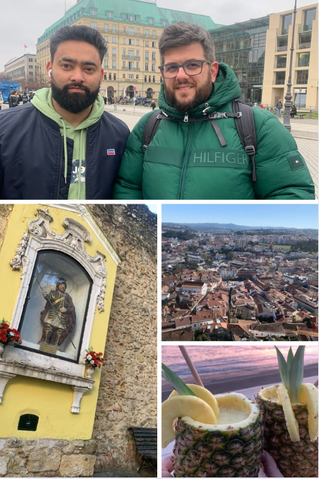
Figure 1: Visit to Berlin and Lisbon – Image Collage
Europeans flock to Berlin as it leads cultural destinations because the city mixes modern and historic architecture alongside active artistic scenes (Maister et al. 2023). It is well known for:
- Berlin has famous landmarks such as Brandenburg Gate along with the Berlin Wall Memorial and Checkpoint Charlie as vital historical locations. The World War II and Cold War sites of these attractions receive millions of visitors every year.
- Many tourists explore Berlin to see its 170-plus museums plus theatres and watch activities like the Berlin International Film Festival (Maister et al., 2023).
- Berlin provides tourists from worldwide a complete travel destination that includes nightclubs and art venues along with classic cultural experiences.
Lisbon earns its spot as one of the fastest-developing tourism destinations in Europe because the city offers visitors both beach pleasures and affordable experiences in its cultural heritage (Pavel & Romeiro, 2023). Lisbon attracts tourists because of several important factors:
- The city stands out for its Fado music traditions and its World Heritage Sites including Belém Tower in addition to its historic Alfama district.
- The rising popularity of culinary visitors to Lisbon exists because of its signature food items such as pastel de nata custard tarts and bacalhau salted codfish (Machado et al. 2024).
- Lisbon attracts more digital nomads and sustainable tourists through its push of slow tourism and environment-friendly accommodations as explained in Araújo (2020).
Both cities use tourism to drive their economic growth which leads to new job opportunities and develops better facilities. Tourism in Berlin made a powerful return in 2022 when its targeted marketing began drawing more visitors (Maister et al., 2023). The Lisbon government put digital marketing power into practice with Can’t Skip Portugal to bring foreign tourists to the city (McTeigue et al., 2021).
Each city puts brand marketing power to use so they stand out from other tourist destinations in Europe.
- Berlin describes itself as a hub of cultural and historical experiences along with present-day entertainment sectors (Maister et al. 2023).
- Lisbon promotes itself as a budget-friendly sunny getaway with fun cultural experiences that draw visitors from various types of travellers (Pavel & Romeiro, 2023).
The advancing visitor numbers push both cities to deal with problems of environmental protection and overloaded tourist locations. Berlin promotes eco-tourism through solutions that include encouraging environmentally friendly transportation and offering tourists green spaces plus earth-friendly accommodations (Maister et al., 2023). To address high crowds Lisbon targets over-tourism by directing tourists away from neighbourhoods such as Alfama and Sintra (Nofre et al., 2023).

Historical and Cultural Background

Berlin: A City of Historical Transformation
Throughout history Berlin has constantly grown through major events starting with the Prussian Empire era into its Cold War leadership status. The city changed from partition to global cultural leadership making it a prominent European historical destination. Tourists travel to Berlin because they find both its historical landmarks and its cultural institutions that show its past events personally gripping (Maister et al. 2023).
The city has experienced major growth in its artistic community alongside its modern identity development. Berlin changed into a prime spot for modern forward-thinking art and music when the Berlin Wall fell in 1989. Kreuzberg and Friedrichshain emerged as strongholds for artistic innovation which draw millions of tourists to this district each year. The city secures international fame in historical and cultural tourism through its museums, particularly the Museum Island which became a UNESCO World Heritage Site.
The German capital uses its official tourism plan to show both past heritage and present innovation. By promoting historical sites in promotional materials the city combines digital storytelling and vivid guest activities to improve visitor connection. Tourism plans now combine efforts by the city to protect historical sites and support green tourism progress so future generations can enjoy these assets (Maister et al. 2023).

Lisbon: A City of Maritime Legacy
The capital city of Lisbon in Portugal bears direct links to its marine exploration and colonial era. During the Age of Discoveries Portugal sailors Vasco da Gama and Ferdinand Magellan left from Lisbon to conduct their maritime expeditions. The maritime past of Lisbon shines through its tourist attractions starting with Belém Tower and Jerónimos Monastery alongside Monument to the Discoveries (Silva & Henriques, 2021).
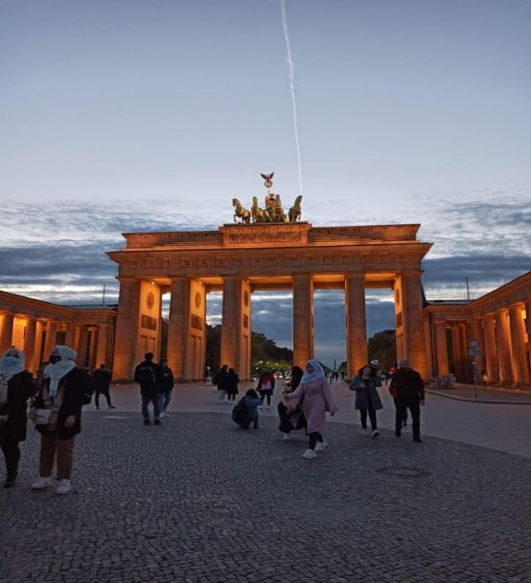
Visited– 4 on 25th January, 2025
Along with its maritime past Lisbon stands out through its cultural atmosphere, Fado music heritage and traditional neighbourhoods named Alfama and Bairro Alto. The traditional neighbourhoods in Lisbon function as cultural heritage centres by offering visitors genuine Portuguese experiences centred on their music traditions and local architecture which is widely loved by tourists (Daly et al. 2020).
The historical districts in Lisbon face problems of excessive tourism which pushes up house prices and pushes local residents out. The local government now works to protect heritage sites combined with steps to support responsible tourism development (Sequera & Nofre, 2020).
Lisbon gained popularity because it mixes historical sites and coastal views while building its artistic traditions. The city uses historic preservation practices through its digital promotion methods to bring in tourists who respect the past.

Tourism Highlights in Berlin

Historical and Architectural Landmarks
Many European tourists travel to Berlin because this city holds enormous historical value at its famous sites. The Brandenburg Gate, an 18th-century neoclassical monument, stands as a symbol of Germany’s reunification and resilience. Visitors flock to the Berlin Wall Memorial today since it teaches them about Cold War history and Berlin's divided past according to Maister et al. (2023).
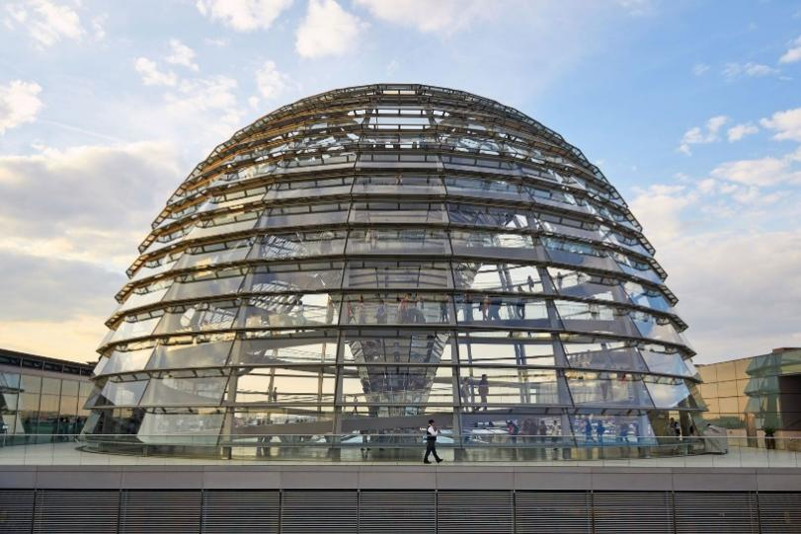
(https://www.britannica.com/topic/Reichstag-building-Berlin-Germany)

People visit the Reichstag Building because this important parliament seat combines its historical past with modern architectural features. The glass dome added to the restored building shows Germany wants to lead by open government practices and displays scenic Berlin views. The UNESCO World Heritage-listed Museum Island welcomes millions of people annually to see important museums such as the Pergamon Museum and Neues Museum along with other historical sites (Florido-Benítez, 2023).

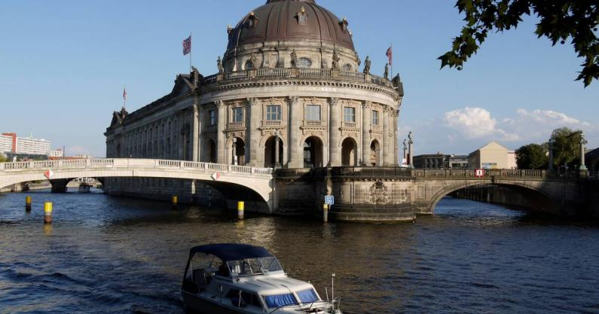
(https://whc.unesco.org/en/list/896/)
Berlin takes special care to save its smaller historic spots such as Teufelsberg’s spy station and the Holocaust Memorial along with its prominent landmarks (Florence, 2024). Berlin provides historical and cultural travellers with a complete visit experience through its famous attractions.

Museums, Art, and Creative Spaces
Berlin has many museums and art venues that match the best worldwide collections for both historical and modern experiences. Most international tourists come to Berlin to view the outstanding collection of five museums found on Museum Island. At Pergamon Museum visitors can view Ishtar Gate and the Pergamon Altar while Neues Museum holds the Nefertiti bust recognized worldwide as one of its most famous artifacts in all museums (Florido-Benítez, 2023).
Berlin leads the way in displaying modern art and operating different creative venues alongside its established museums. The Hamburger Bahnhof Museum for Contemporary Art and KW Institute for Contemporary Art display current art installations to supporters of modern art (Walsh, 2022). Street artists work freely in Friedrichshain and Kreuzberg when displaying colourful outdoor artistic works to Berlin residents and visitors.
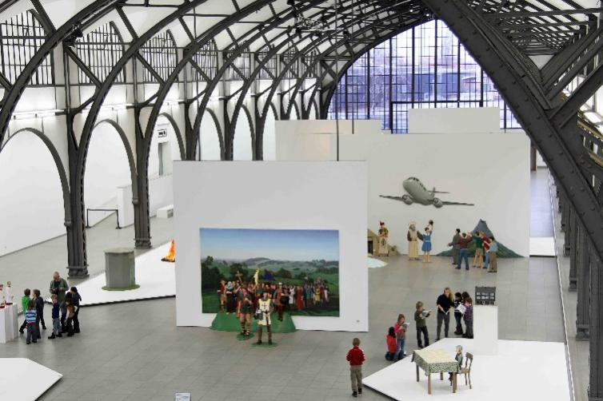
(https://withberlinlove.com/2013/03/04/hamburger-bahnhof-museum-fur-gegenwart-museum-of-contemporary-art/)

Specialized Berlin museums such as the Jewish Museum Berlin and Schwules Museum present cultural stories from varied perspectives (Hindley et al., 2024). Berlin has developed more museums and creative environments to keep cultural tourism as one of its key attractions.

Cultural Events and Festivals
Berlin stands out as a year-round travel destination since its cultural festivals showcase many different types of historical artistic and modern events. The Berlinale ranks among global film festivals as it helps connect professionals in cinema to view international and independent cinema (Maister et al. 2023).
Many international visitors flock to Berlin because its Berlin Biennale for Contemporary Art event displays experimental and political modern art exhibits (Walsh 2022). In October the Festival of Lights each year turns Berlin into a light art destination because thousands of visitors go to see famous structures displayed with creative lighting presentations (Jaehnichen 2023).
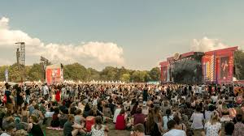
(https://www.musicfestivalwizard.com/festival-guide/berlin/)

Music festivals prominently contribute to the number of tourists visiting Berlin each year. At Berlin Atonal people enjoy global experimental electronic music at a renowned festival while Karneval der Kulturen gives visitors across all ethnicities a spectacular celebration of culture through dance music and tasty foods. Tourism numbers increased in Berlin because these events strengthened its position as a top European cultural destination according to Ulinnuha et al. 2024.
Berliner culture organizations and festivals create such real-world interactive experiences that visitors cannot resist coming to see the city firsthand.

Tourism Highlights in Lisbon

Historical and Religious Sites
Lisbon draws cultural tourists because it preserves an ancient heritage of religious and historical value. The Monastery of Jerónimos stands as a UNESCO World Heritage Site that represents Portugal's Age of Discoveries pursued by historians. People built this monastery during the 16th century to show Portugal's sea power and Vasco da Gama now rests here. Visitors to the monastery continue growing and this creates new challenges around preservation needs and air pollution which are now being examined by experts (Silva & Henriques, 2021).
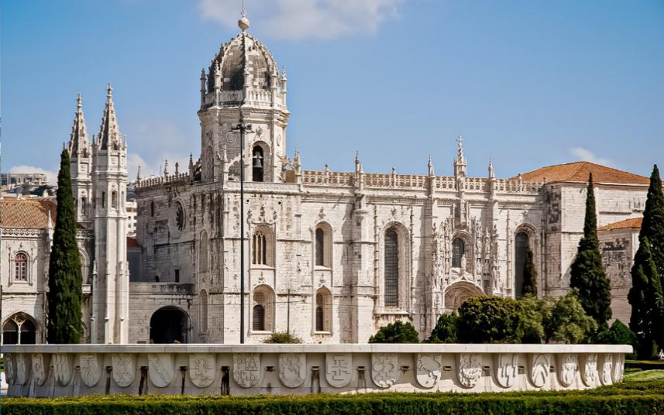
(https://www.jeronimosmonasterytickets.com/about/)

Throughout the 16th century, the Belém Tower served Portugal's defence system as an important fortress before taking on its role as a tourist destination today. The monument stands among the top attractions in Lisbon because visitors love to see its view of the Tagus River. The oldest district of Lisbon called Alfama hosts multiple places of worship including Lisbon Cathedral (Sé de Lisboa) which was built in the 12th century. Tourists who want to experience Lisbon's religious beginnings will find its important Romanesque church important to visit (Severino et al., 2024).
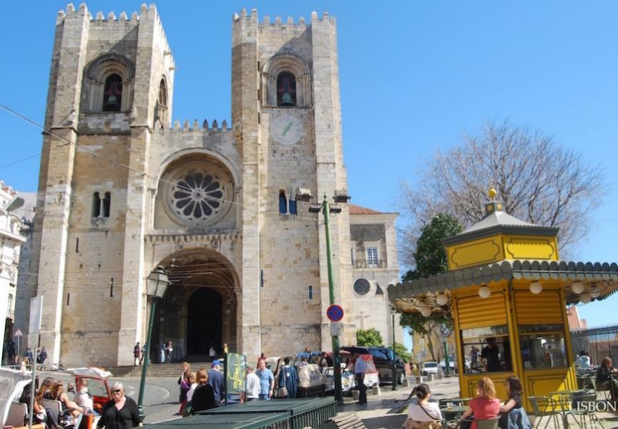
(https://euroveloportugal.com/en/poi/lisbon-cathedral)

Visitors on cultural routes through Lisbon regularly see religious buildings that represent Portugal's strong Catholic faith. Lisbon sets its foundation in history and religion and keeps these elements central to its identity around the globe.
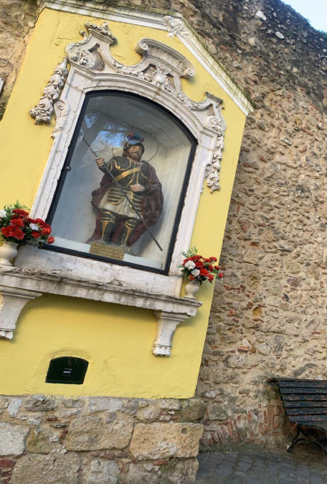
Visit to Lisbon – 1 on 25th August, 2024

Traditional Arts and Cultural Heritage
Traditional arts and Fado music plus local craftsmanship make Lisbon stand out as a tourist attraction. Lisbon's cultural background stands out in Fado music which UNESCO recognized as a valuable heritage expressing unhappy yet nostalgic feelings. You can experience Lisbon's passionate Fado music traditions through live shows at Fado Houses in the Alfama area according to Henriques et al. 2021.
Lisbon stands out not only for its music but also for its artistic brilliance shown in architecture and the examples of azulejos displayed on buildings all over the city. The National Tile Museum presents how Portuguese culture developed through tile artistry to its visitors. Many Lisbon locals create handcrafted items including painted ceramics and textiles while crafting with cork and fabric at artisan workshops.
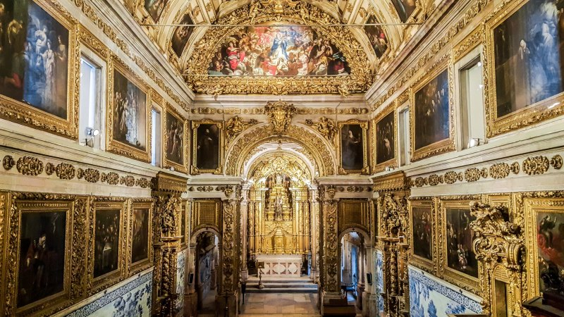
(https://www.smh.com.au/traveller/inspiration/portugal-lisbon-azulejos-in-the-national-tile-museum-show-the-best-of-this-portuguese-art-form-20190430-h1dx8a.html)

People appreciate the city's social and educational past through historic bookstores and cafes. Livraria Bertrand and Cafe A Brasileiro provide spaces for literary tours to explore Portuguese culture since both spots hosted Portuguese writers as listed in Severino et al (2024).
The city has gained popularity by keeping its art traditions alive and welcoming contemporary designs which attract tourists passionate about history and art as well as those exploring their creative side.
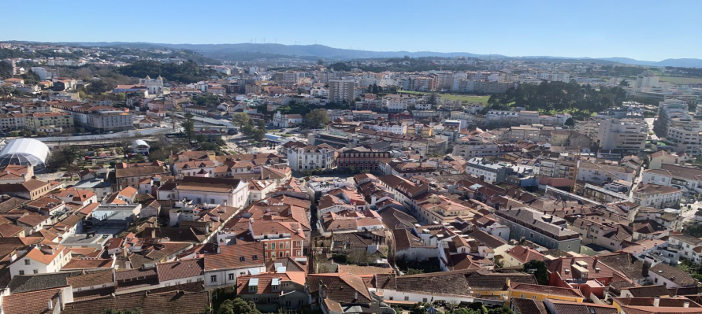
Visit to Lisbon – 2 on 25th August, 2024
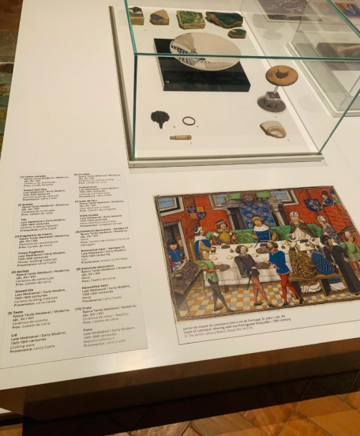
Visit to Lisbon – 3 on 25th August, 2024

Coastal and Gastronomic Tourism
The setting of Lisbon along the coastline has become central to tourism as it attracts people who want scenic ocean views combined with fresh seafood and waterfront activities. People enjoy both history and local culture at Cais das Colunas and Praça do Comércio where they can see scenic Tagus River views. Tourists flock to Cascais and Costa da Caparica beaches to enjoy sunbathing and surfing which makes Lisbon one of the top beach destinations (Ferreira et al., 2024).
Besides its oceanfront location, Lisbon stands strong as a tourist destination because of its culinary offerings that guests love and admire. Lisbon is famous for Pastel de Nata custard tarts which started as a monastery dessert and became a national dessert of Portugal. Lisbon impresses visitors with its seafood dishes including Bacalhau à Brás and Grilled Sardines as reported by Henriques et al. (2021).
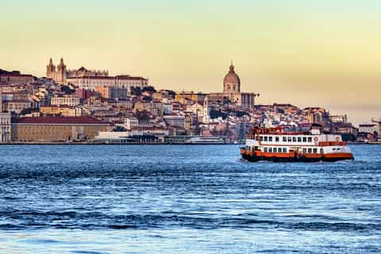
(https://www.getyourguide.com/tagus-river-l4825/)

Travellers can sample true Portuguese cuisine from the lively Mercado da Ribeira (Time Out Market). Many wineries in Lisbon provide wine tours that help visitors sample Vinho Verde wine plus local Port wines and regional wines. The beautiful coastal views and food heritage in Lisbon have made it a leading site for tourists who love food and enjoy the beach (Ferreira et al., 2024).
Lisbon combines food culture with sandy beaches to create a perfect holiday destination with history and leisure for European travellers worldwide.

Cultural Comparison

Berlin: A Dynamic Metropolis of Cultural Evolution
Berlin has shown remarkable changes in its cultural aspects to become a thriving and changing urban destination throughout Europe. The city's current cultural character emerged from its history as a Prussian state during the Empire through the Cold War era. Modern Berlin serves as a model for unity and uniqueness where people flock to witness its historical attractions artistic districts and welcome changes because of Maister et al (2023).
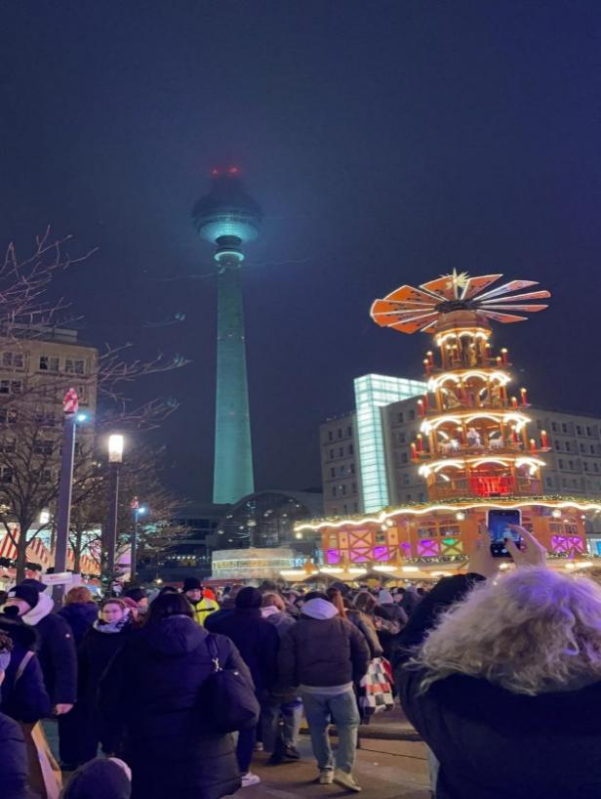
Visited– 4 on 25th January, 2025
Berlin became known around the world for its underground art platforms and street art when it developed a creative subculture and new music styles. Kreuzberg and Friedrichshain act as artistic communities while the Berlin Biennale supports modern and political art exhibitions according to Walsh (2022).
While Berlin delivers excellent art opportunities a significant number of its historic artistic neighborhoods now experience commercialization and property value increases. The increase in home values threatens existing artists and creative areas. Officials and cultural organizations in Berlin maintain programs that defend cultural authenticity to keep the city as a worldwide hub for creative work (Bourgeon-Renault et al., 2023).

Lisbon: A Timeless Cultural Heritage
The people of Lisbon stay true to their age-old customs rather than embracing cultural shifts like Berliners. Lisbon preserves its cultural importance through its seafaring legacy and its famous Fado music alongside preserved historical buildings to deliver an unchanging timeless tourist experience. Lisbon succeeds as a travel destination because it protects and displays its own cultural heritage which brings tourists looking for authentic and traditional experiences (Daly et al., 2020).
People have been enjoying the quaint traditional atmosphere of Alfama and Bairro Alto since ancient times due to their cobbled streets, Fado houses, and resident-run taverns. Fado music holds UNESCO importance as an intangible cultural treasure and supports Lisbon's identity by attracting visitors who want to hear its music's sad yet artistic songs (Henriques et al., 2021).
Over-tourism and city changes make it hard for Lisbon to keep its cultural legacy intact. The rapid boost in tourism triggered the development of new business sectors which altered traditional neighborhoods. To preserve Lisbon's culture the city managers design visitor-friendly features that protect the city's cultural core (Martins et al., 2020).
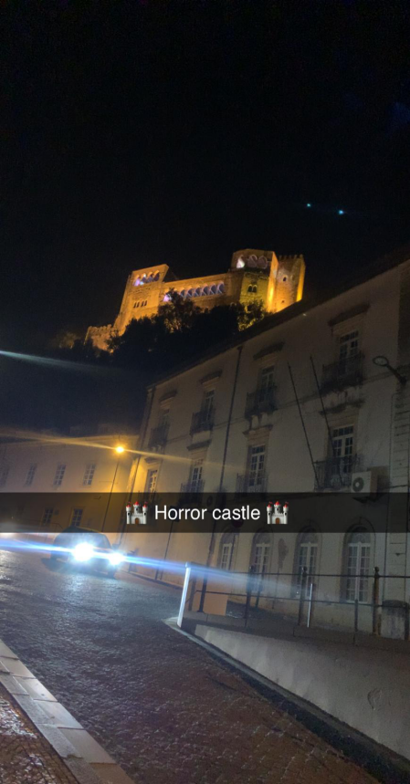
Visit to Lisbon – 4 on 25th August, 2024

Tourism Strategies and Impact

Berlin: Marketing, Digital Engagement, and Tourism Policies
By using well-designed marketing plans Berlin wins its position as a prominent European tourist hub. VisitBerlin runs Berlin's marketing programs to share the city's past, and present culture and modern nightlife offerings (Florido-Benítez 2024).
Berlin focuses on digital connection as part of its marketing plan because it helps the city reach international travellers successfully. The city uses media influencers and immersive online materials on social networks to improve how visitors feel about their experiences. Through its Instagram platform and virtual tour features Berlin shines on social media and digital platforms to reach international tourists effectively (Bourgeon-Renault et al., 2023).
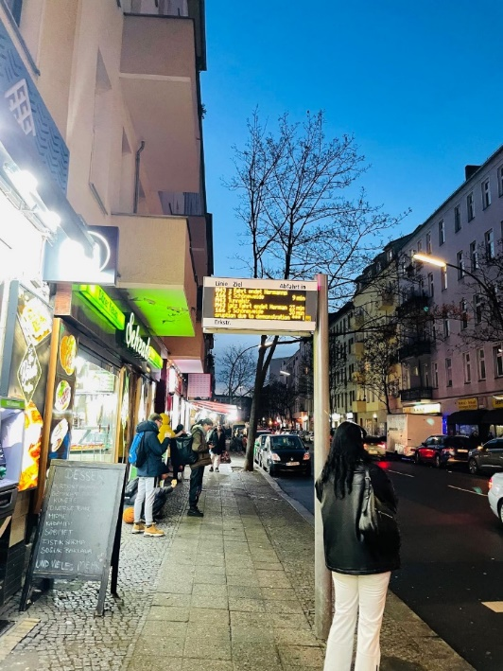
Visited– 4 on 25th January, 2025
With its tourism policies, Berlin focuses on special events and works to develop tourism in an environmentally friendly way. The city welcomes important business and cultural events including ITB Berlin and Berlin International Film Festival which drive growth in its economic landscape. The city now supports green tourism by offering environmental protection schemes and facilitating green hotels and public transportation (Florido-Benítez, 2024).
The tourism industry of Berlin produces significant wealth for both the city’s economy and workforce numbers. The MICE sector produces high amounts of income and business-related travellers contribute most of the spending made by foreign visitors according to Alemayehu et al. (2024).

Lisbon: Cultural Branding, Sustainability, and Tourism Policies
The rise of Europe's fastest growing tourist destination Lisbon starts from its planned cultural promotion sustainability efforts plus tourism changes. Unlike Berlin which relies on business conventions and events, Lisbon develops its tourism plan around memorable local culture and travel options that save money (Araújo, 2020).
Lisbon tells its historical story as a major part of its tourism promotion using campaigns like 'Can't Skip Portugal' to showcase naval traditions and local music eating. Marketing the city this way has built a real and inviting environment that draws budget-conscious visitors and upscale tourists (Mendonça et al., 2022).
Sustainability stands as a main part of Lisbon's tourism development plans. The rising number of tourists in Alfama and Sintra historic zones drives Lisbon to put anti-tourism practices into place and promote new visitor destinations with eco-friendly business support. Lisbon includes sustainable practices like issuing environmental certifications and running conservation projects to defend its natural heritage (Monteiro et al., 2021).
Tourism in Lisbon produces large economic results through its role in building Portugal's Gross Domestic Product (GDP) and workforce numbers. Short-term rentals and fancy hotels have grown rapidly in Lisbon which brings more people travelling to the city at a high-end level. Tourism growth caused housing problems for locals so the government needed to control Airbnb and other short-term rental platforms as noted by Araújo (2020).
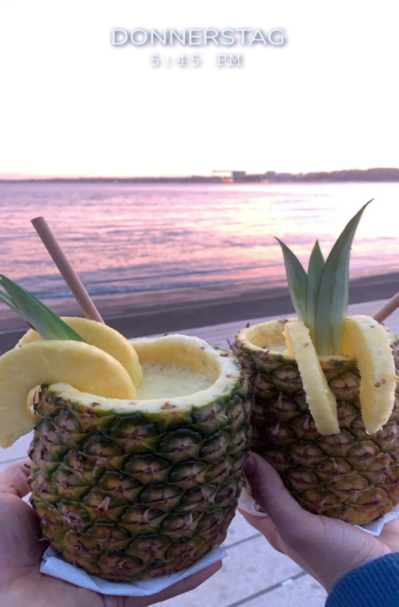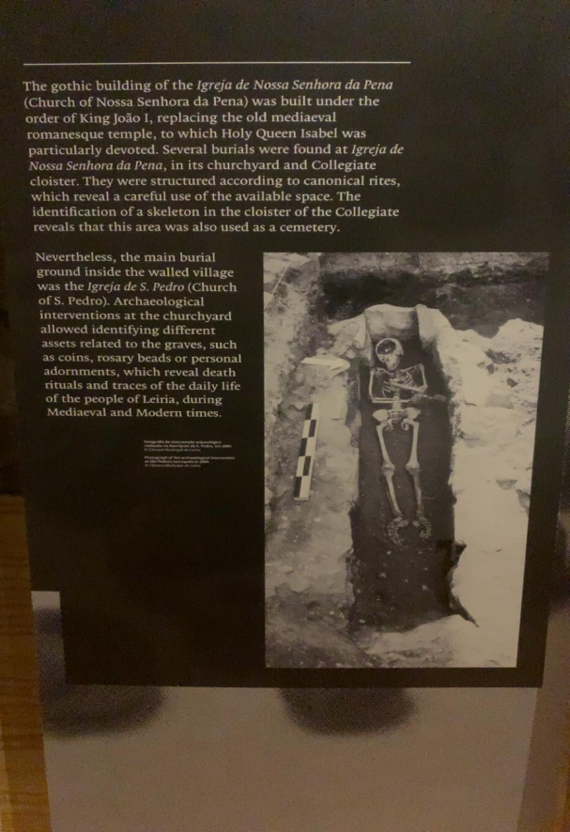
Visit to Lisbon – 5 on 25th August, 2024

Tools of Analysis
SWOT analysis:
The SWOT analysis tool views tourist promotion in Berlin and Lisbon in terms of strengths, weaknesses, opportunities, and threats.

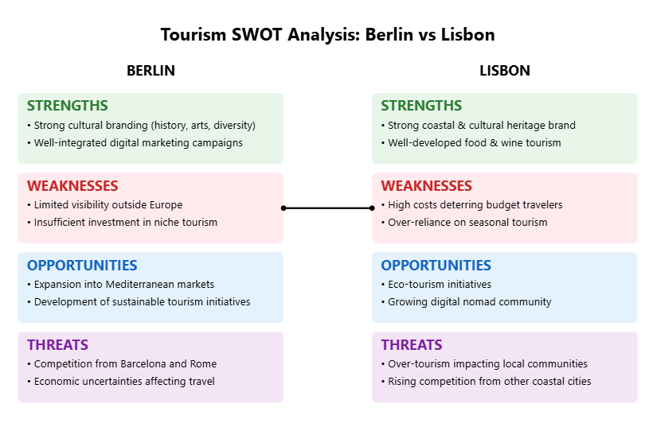
PESTLE analyses for Berlin and Lisbon
The important distinctions noted refer to:
Major differences and parallels between the two locations, Berlin and Lisbon:
- Political — both benefit from the EU integration; Portugal with its own Golden Visa; the former has federal governance, whereas the latter is municipal.
- Economic — both emerging as key tech centres; different pricing structures; there is a growing focus on digital nomads for Lisbon.
- Social — alternative culture and nightlife in Berlin; traditional maritime lifestyle in Lisbon; both have strong foundations for historical tourism.
- Technological — both working on smart city initiatives; Berlin with an established tech ecosystem.
- Environmental — Berlin with its parks and gardens; along the lines of Lisbon that has its coastal theme; both with the same commitment towards sustainability.
- Legal — shared EU framework; some of the same struggles with renting out short stays; local regulations do differ.
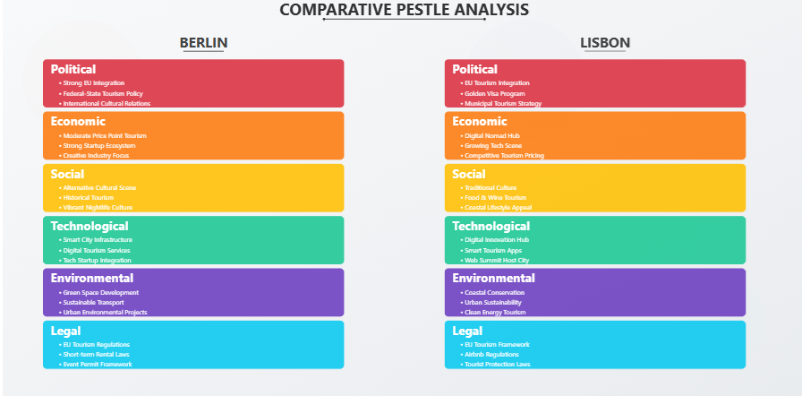

Berlin Cultural Survey and Research Results
Master's Degree in Tourism and Recreation

Section 1: General Information
1. How long was your stay in Berlin?
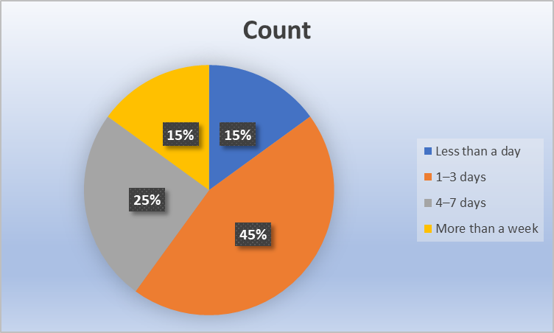
The chart shows 45% stayed over a week, 25% for 4-7 days, 15% for 1-3 days, and 15% for less than a day. It reflects varied trip lengths, with longer stays being the most common duration among those surveyed.
2.Where are you visiting from?
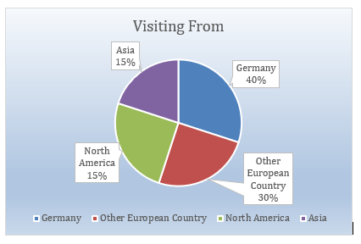
Visitors primarily come from Germany (40%), other European countries (30%), and a smaller portion from North America and Asia (15% each).

3. How would you describe your interest in culture? (Please select all that apply)
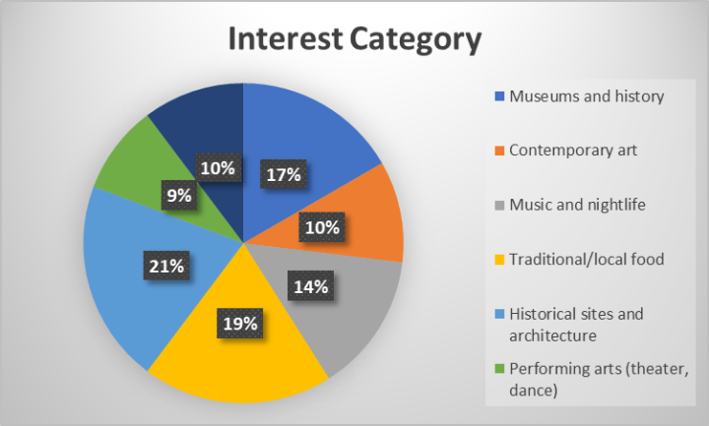
The chart reveals greatest interest in historical sites/architecture (21%), then museums/history (17%) and traditional food (19%). Contemporary art and nightlife show moderate interest, while performing arts are least popular.

Section 2: Cultural Attractions and Experiences
4.Which cultural sites or attractions did you visit in Berlin? (Please select all that apply)
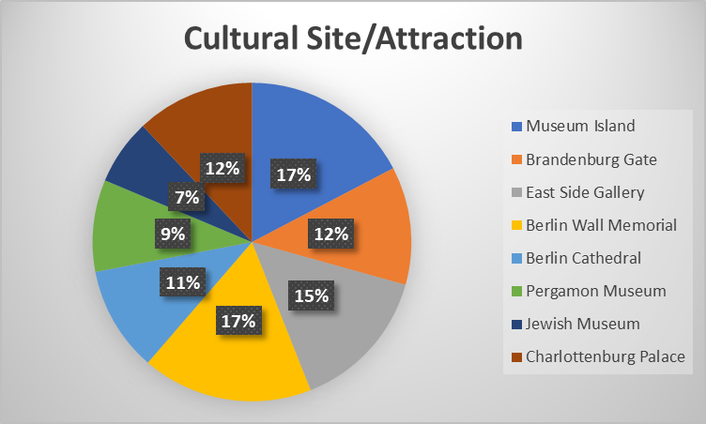
Museum Island (17%), Brandenburg Gate (12%), East Side Gallery (15%), and Berlin Cathedral (11%). Other sites like the Jewish Museum and Charlottenburg Palace were also visited (17% and 12% respectively).

5. How would you rate your experience with Berlin's cultural attractions overall?

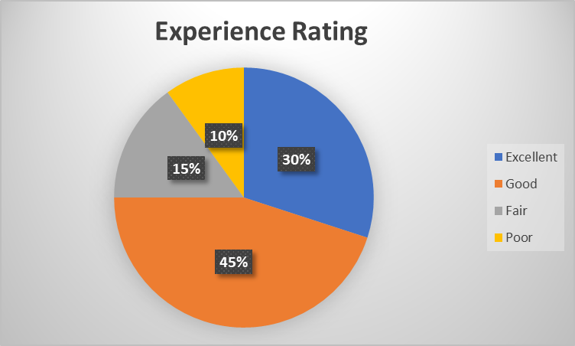
Most visitors rated their experience as "Good" (45%), followed by "Excellent" (30%). "Fair" experiences were reported by 15%, and only 10% reported a "Poor" experience. Overall, positive ratings dominate.

6.What aspects of Berlin's cultural attractions did you enjoy the most? (You may select
more than one option)
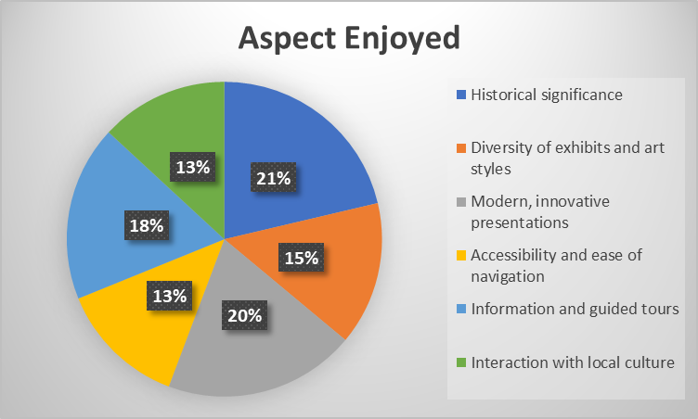
Visitors most enjoyed the diversity of exhibits/art styles (21%), modern presentations (20%), and historical significance (18%). Accessibility and local culture interaction were also appreciated (13% each), along with guided tours (15%).

7. Were there any cultural attractions or experiences you found disappointing?
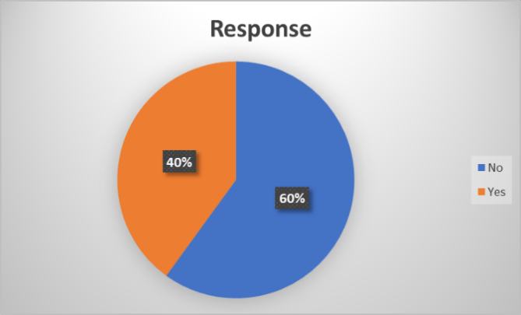
Yes, 40% of the responses indicated that there were cultural attractions or experiences found disappointing. This is shown in the chart as 40% of the responses are marked "Yes".

Section 3: Local Culture and People
8. How would you describe your interactions with locals in Berlin?
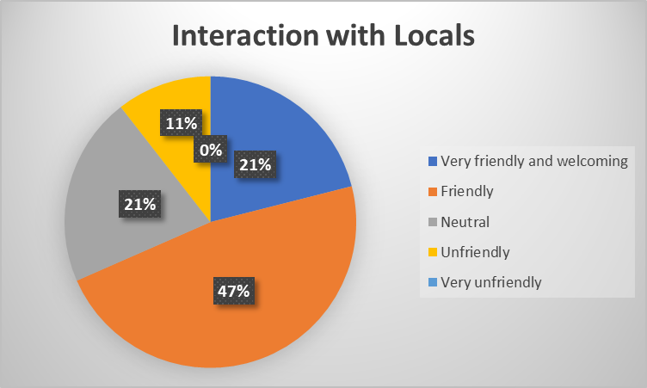
Most interactions were positive: 47% found locals friendly, and 21% very friendly. 21% had neutral interactions, while 11% found locals unfriendly. No one reported very unfriendly encounters.
9. Did you have the opportunity to attend any cultural events or festivals?
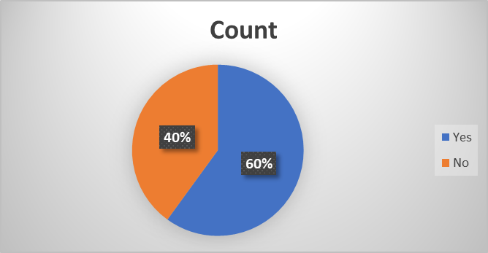
60% answered "yeso," 40% answered "no"
10. How would you rate the authenticity of your experience with Berlin's local culture?
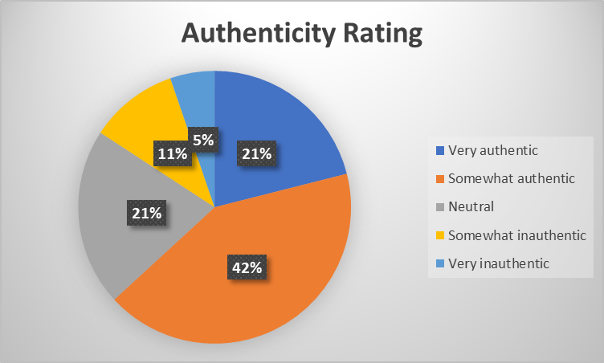
Most found Berlin's culture somewhat authentic (42%), while 21% found it very authentic. 21% were neutral, and 11% found it somewhat inauthentic. Only 5% felt it was very inauthentic, indicating a generally positive perception of cultural authenticity, though not overwhelmingly so.

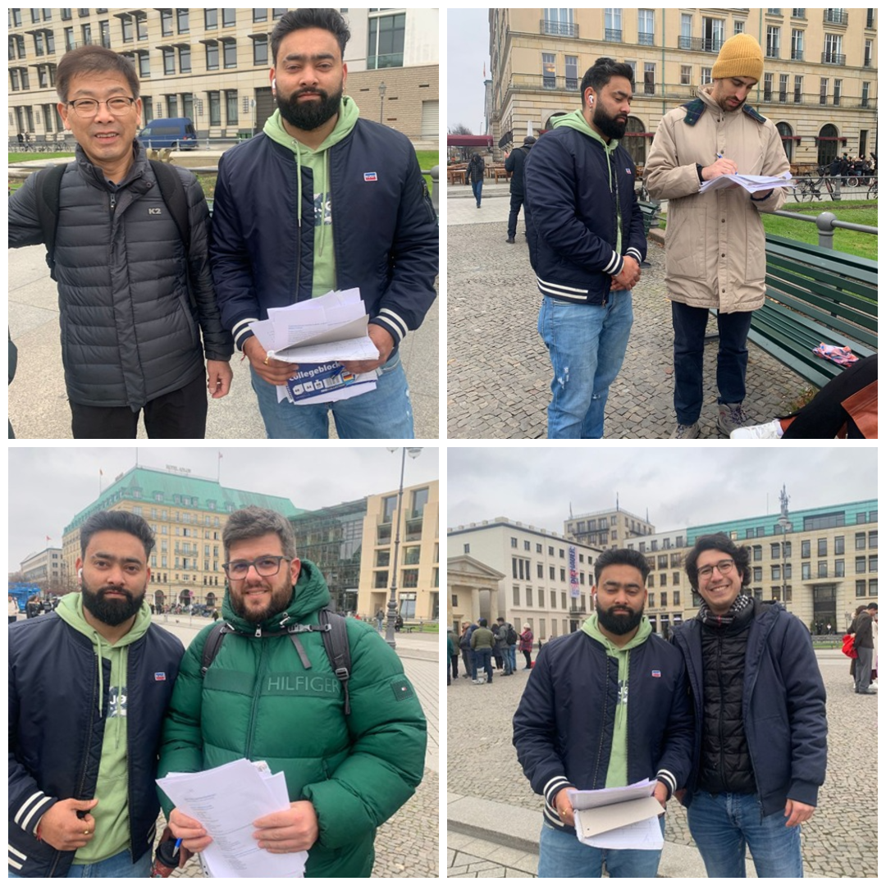
(The survey sample size consists of 20 respondents, providing insights into visitors' cultural experiences, preferences, and suggestions regarding Berlin. While small, it offers a snapshot of diverse perspectives on the city's cultural appeal, 31th January, 2025)

Brandenburg Tour

I believe this was a one-of-a-kind highlight of my Berlin trip! Staring those shiny walls at the Gate that have borne witness to history, it is indeed stunning for its history beginning from the splendour of Prussia, the shadow of the Wall, and finally to the reunification time. The guide brought it all together, explaining the Quadriga and how the gate has undergone changes in function through the ages. This made me think a bit about the survey that we had gone through earlier-this one regarding authenticity. While at the Gate, I felt that profound connection to Berlin in its history; this was simply authentic! But the survey report shows that only 21% regarded their experience as "very authentic", while even more-a total of 42%-saw it as at least "somewhat authentic." This really begs one's mind to ponder what forges those perceptions. Perhaps the crowd or the commercial aspects prevent the authenticity for some. For me, though, the Brandenburg Gate was an experience of power and authenticity when faced with the past of Berlin.

Recommendations
Following this, the strategy of the tourist office in Berlin must refocus on dealing with a wider pool of target countries beyond Europe, such as those in Asia, America, and Africa, using either global tour operators or participation in world tourism expos to gain greater visibility. As a highlight, niche areas ranging from gastronomy, featuring an emphasis on local through global cuisines, to eco-tourism, capped off with cycling tours and green accommodation, are other areas that could help attract specialised travellers.
Collaborations with globally recognised art institutions and cultural celebrations (Dedeke, 2017) would further boost Berlin's attractiveness for culturally curious audiences, akin to London, which would consider advertising not just its famous landmarks, but also more hidden gems like neighbourhood markets and historical sites when introducing a whole new slant. Establishing affordable packages targeting budget-conscious tourists in cooperation with airlines and hotels while encouraging greening through electric transport, cycle paths, and eco-friendly hotels (Albrecht, 2017) can help draw eco-aware markets. Engaging with young tech-savvy individuals would require updating London for tourism. This would balance tradition with the innovative way of presenting London tourism-orchestrated events within the ambient kinetics of the industry.

conclusion

Berlin and Lisbon use different methods to market their destinations and promote their culture while handling sustainability. Berlin uses its role as a business centre combined with historic sites and digital platforms to draw tourists who attend meetings conferences and events. Lisbon builds its tourism strategy by emphasizing its cultural heritage plus coastal attractions at affordable prices with effective story-driven planning and responsible tourism standards (Mendonça et al., 2022).
Berlin fights against growing property prices and Lisbon deals with excessive visitor numbers as reported by Monteiro et al. (2021). Their development path needs them to combine wealth generation with protecting local heritage and natural environments.
Berlin needs to develop experience-based tourism that includes exploring the city and nature while limiting business and historic tours to reach lasting sustainability (Bourgeon-Renault et al., 2023). Lisbon needs to improve over tourism control through visitor limits and promote alternate destinations while managing short-term rental services according to local officials (Monteiro et al., 2021).
To keep up their current progress both cities need to put more money into digital tourism tools and maintain good travel practices.

References
Alemayehu, F. K., Kumbhakar, S. C., & Lien, G. (2024). Economic impacts of tourism demand on the European food and accommodation industry. Tourism Economics. https://doi.org/10.1177/13548166241283145
Araújo, L. (2020). Portuguese tourism strategy (ET27) – now more than ever. Worldwide Hospitality and Tourism Themes, 12(6), 771–774. https://doi.org/10.1108/whatt-07-2020-0078
Bourgeon-Renault, D., Derbaix, M., Jarrier, E., & Petr, C. (2023). New marketing theories and practices emerging from innovations in the cultural and tourism sectors. Journal of Marketing Management, 39(5-6), 367–372. https://doi.org/10.1080/0267257x.2023.2213964
Daly, P., Dias, A. L., & Patuleia, M. (2020). The Impacts of Tourism on Cultural Identity on Lisbon Historic Neighbourhoods. Journal of Ethnic and Cultural Studies, 8(1), 1. https://doi.org/10.29333/ejecs/516
Ferreira, J., Severino, F. S., Nunes, S., Santos, Z. R., Costa, T., & Maria. (2024). An Importance–Performance Analysis Approach to a Tourism Destination: the Case of Lisbon Metropolitan Area, Portugal. International Conference on Tourism Research, 7(1), 82–91. https://doi.org/10.34190/ictr.7.1.2098
Florence, E. (2023). Traces of Aerial Bombing in Berlin. In Bloomsbury Publishing Plc eBooks. Bloomsbury Publishing plc. https://doi.org/10.5040/9781350269026
Florido-Benítez, L. (2023). Air Connectivity and Proximity of Large Airports as an Added Value for Museums. Museum Worlds, 11(1), 136–154. https://doi.org/10.3167/armw.2023.110112
Henriques, C. H., Silva, J. A., & Santos, M. de O. (2021). Fado Houses of Lisbon: Between Authenticity and Touristification. Revista Rosa Dos Ventos - Turismo E Hospitalidade, 13(2), 460–488. https://doi.org/10.18226/21789061.v13i2p460
Hindley, C., Grupp, K., & Sylwestrowicz, M. (2024). Generational translation in the Jewish Museum, Berlin. Babel Revue Internationale De La Traduction / International Journal of Translation / Revista Internacional De Traducción, 70(5), 682–703. https://doi.org/10.1075/babel.00394.hin
Jaehnichen, G. (2023). The Berlin Festival of Lights in Darker Times and How it Sounds in 2022. Journal of Research in Music, 1(1), 55–59. https://doi.org/10.4038/jrm.v1i1.6
Machado, A. T., Santos, Z. R., Nunes, S., Rosário, J. F. do, Belo, M., Costa, T., Severino, F. S., Calisto, M. de L., Roque, A. G., & Cristina, M. (2024). Unlocking Tourism Diversity in Winter: Clusters of Tourists in Lisbon Based on Motivations, Profiles, and Behaviour. European Conference on Innovation and Entrepreneurship, 19(1), 1015–1022. https://doi.org/10.34190/ecie.19.1.2589
Maister, A., Lazhnik, V., & Puhach, S. (2023). Spatial patterns of tourism development in Germany. Scientific Herald of Chernivtsi University Geography, 842, 66–77. https://doi.org/10.31861/geo.2023.842.66-77
Martins, A. N., Pereira, A. A., Forbes, C., de Lima, J. L. M. P., & Matos, D. (2020). Risk to cultural heritage in Baixa Pombalina (Lisbon Downtown) - a transdisciplinary approach to exposure and drivers of vulnerability. International Journal of Architectural Heritage, 15(7), 1058–1080. https://doi.org/10.1080/15583058.2020.1745322
McTeigue, C., Sanchez, C., Santos, E., Walter, C. E., & Au-Yong-Oliveira, M. (2021). A Strategy for Tourism Growth, Rebound, and Revival: Promoting Portugal as a Destination Post-COVID-19. Sustainability, 13(22), 12588. https://doi.org/10.3390/su132212588
Mendonça, F., Maguire, K., & Almeida, N. (2022). Sustainable Management of Tourism: Insights from Portugal. International Conference on Tourism Research, 15(1), 517–519. https://doi.org/10.34190/ictr.15.1.244
Monteiro, A., Eusébio, C., Carneiro, M. J., Madaleno, M., Robaina, M., Rodrigues, V., Gama, C., Relvas, H., Russo, M., Oliveira, K., Lopes, M., & Borrego, C. (2021). Tourism and Air Quality during COVID-19 Pandemic: Lessons for the Future. Sustainability, 13(7), 3906. https://doi.org/10.3390/su13073906
Nofre, J., Garcia-Ruiz, M., & Martins, J. C. (2023). Nofre, J., Garcia-Ruiz, M., & Martins, J. C. (2023). The Biosecuritization of the Tourist City: Some. . . ResearchGate. https://www.researchgate.net/publication/371158686_Nofre_J_Garcia-Ruiz_M_Martins_J_C_2023_The_Biosecuritization_of_the_Tourist_City_Some_Reflections_from_and_about_Lisbon_Nightlife_ACME_An_International_Journal_for_Critical_Geographies_222_992-1014_ht
Pavel, F., & Romeiro, P. (2023). Challenges of Public Policies for Tourism in Medium-Sized Cities in Europe. The Cases of Lisbon and Porto (Portugal). GOT - Revista de Geografia E Ordenamento Do Território, 25, 129–150. https://doi.org/10.17127/got/2023.25.007
Sequera, J., & Nofre, J. (2019). Touristification, transnational gentrification and urban change in Lisbon: The neighbourhood of Alfama. Urban Studies, 57(15), 004209801988373. https://doi.org/10.1177/0042098019883734
Severino, F. S., Roque, A. G., Cristina, M., Santos, Z. R., Nunes, S., & Costa, T. (2024). Perceptions and Realities of Lisbon: An Examination of the Image of a Tourist Destination. International Conference on Tourism Research, 7(1), 381–389. https://doi.org/10.34190/ictr.7.1.2097
Silva, H. E., & Henriques, F. M. A. (2021). The impact of tourism on the conservation and IAQ of cultural heritage: The case of the Monastery of Jerónimos (Portugal). Building and Environment, 190, 107536. https://doi.org/10.1016/j.buildenv.2020.107536
Ulinnuha, H., Wijaya, T. E., & Alanda, H. S. (2024). THE ROLE OF CULTURAL EVENT IN A MUSEUM TO THE TOURISTS SATISFACTION AND DESTINATION LOYALTY. Bogor Hospitality Journal, 8(1), 79–87. https://doi.org/10.55882/bhj.v8i1.123
Walsh, M. (2022). Still Present! – 12th Berlin Biennale for Contemporary Art, curated by Kader Attia in collaboration with Ana Teixeira Pinto, Đỗ Tường Linh, Marie Helene Pereira, Noam Segal and Rasha Salti. Moving Image Review & Art Journal, 11(2), 270–277. https://doi.org/10.1386/miraj_00098_5

