Employee Relations, Diversity and Ethical HRM Practices
Option 3 Report
M09 Human Resource Management
Detailed Project Report
Submission deadline: 24 May 2026

Contents
Table of Contents 2
Abstract 3
Introduction 3
Literature Review 5
Methodology 9
Findings 10
Discussion 14
Recommendations 18
Conclusion 20
References 20
Appendices 22
Appendix A. Evidence based HR implementation checklist 22
Appendix B. Suggested structure for implementation review meetings 23

Abstract
This report analyses employee relations, diversity and ethical human resource management as strategic foundations of employee centred organizations. The argument is that modern HRM cannot treat fairness, inclusion, conflict management and wellbeing as separate compliance concerns. They are core workforce risk controls that affect trust, productivity, retention, innovation and employer legitimacy. The analysis is grounded in recent 2022 to 2026 literature and professional evidence on EDI, psychological safety, AI recruitment bias, harassment, employee wellbeing and employment relations. The report uses a secondary qualitative methodology and evaluates issues such as workplace conflict, discrimination, employee wellbeing, labour relations, inclusion, biased recruitment, wage inequality, harassment, privacy and unfair dismissal. It shows that HR promotes fairness and respectful culture through 5 mechanisms: procedural justice, voice architecture, inclusive leadership, transparent people analytics and ethical governance of employment decisions. The discussion is critical of superficial diversity programmes, performative wellbeing initiatives and algorithmic HR systems that improve speed while reducing accountability. It also argues that legal compliance is only the minimum threshold. Employee centred organizations need psychological safety, credible grievance channels, pay equity analysis, transparent selection criteria, anti harassment controls, data privacy governance and manager accountability. Recommendations include a formal employee relations risk register, bias audited recruitment, inclusion metrics, ethics review of HR technology, wellbeing workload analysis, and a board level people risk dashboard.

Introduction
Employee relations, diversity and ethical HRM are now strategic issues because organizations operate in a context of social scrutiny, digital surveillance, hybrid work, skills scarcity and shifting employee expectations. Employees do not evaluate employers only by pay. They also evaluate fairness, respect, voice, wellbeing, psychological safety, career opportunity and privacy. The CIPD (2025b) argues that equality, diversity and inclusion must be reset and reaffirmed in a way that improves outcomes for employees and employers. The ethical HR challenge is therefore not only avoiding legal claims. It is building systems that employees can trust.
This report chooses Option 3 and analyses the importance of employee relations, diversity and ethics in HRM. It addresses workplace conflict, discrimination, employee wellbeing, labour relations, inclusion, fairness, equal opportunity, psychological safety and respectful culture. It also evaluates ethical challenges such as biased recruitment, unfair dismissal, wage inequality, harassment and privacy concerns. The report is written in a technical and critical style because these issues require more than general statements about respect. They require systems, governance, metrics and accountability.
The central argument is that ethical and inclusive HRM contributes to performance through trust. Trust allows employees to speak up, report risks, share ideas, challenge unsafe behaviour and commit discretionary effort. When trust is low, employees conceal problems, avoid conflict, disengage, resist change and leave. Employee relations and diversity are therefore not soft issues. They are operating conditions for collaboration and innovation. This is especially true when organizations rely on cross functional teams, AI enabled decisions and distributed work.
The report is structured according to the assignment requirements. The literature review develops a recent evidence base on employee relations, inclusion, psychological safety, wellbeing and ethical HR technology. The methodology explains the secondary research design. The findings identify the main HR mechanisms for building fairness and respect. The discussion critically assesses risks and best practices. The conclusion provides recommendations for building ethical, diverse and employee centred organizations.

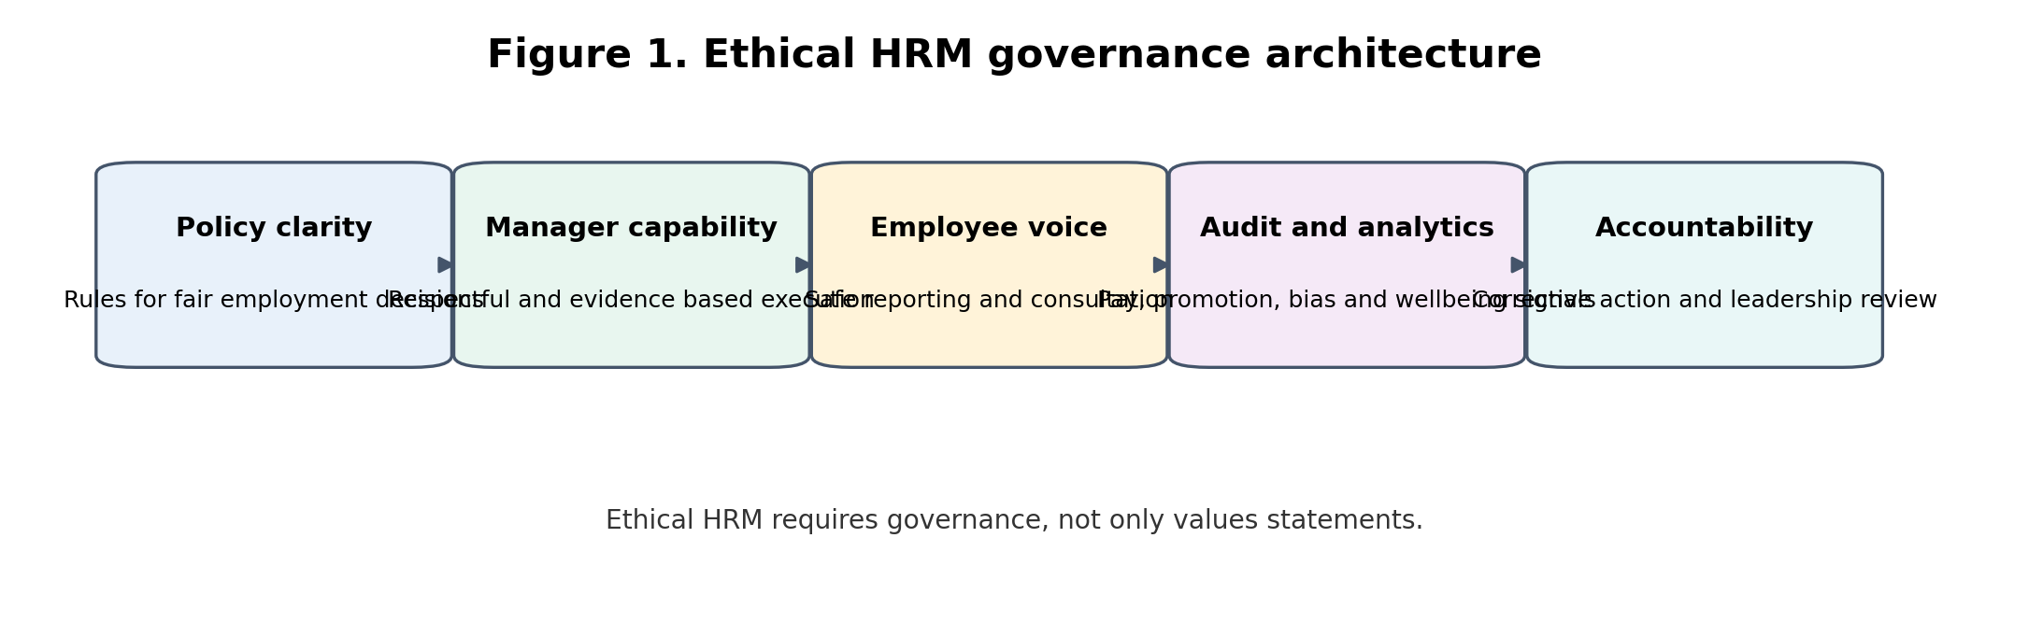
Figure 1. Ethical HRM governance architecture

Literature Review
Employee relations refers to the formal and informal relationship between employer and employee. It includes conflict management, grievance handling, consultation, employee voice, discipline, labour relations, wellbeing and the psychological contract. Diversity refers to the presence and participation of people with different identities, experiences, capabilities and perspectives. Inclusion refers to whether those people have fair access, influence, belonging and voice. Ethical HRM refers to employment practices that are fair, transparent, lawful, respectful and accountable. These 3 areas are connected because poor employee relations often reveal ethical and inclusion failures.
Recent evidence shows that employee wellbeing and job quality remain major HR challenges. CIPD (2025a) connects job quality, manager behaviour and wellbeing with productivity concerns. Gallup (2026) reports low global engagement and continuing stress pressures. These findings matter because wellbeing cannot be reduced to yoga sessions, mental health posters or employee assistance programme usage. A serious wellbeing strategy must examine workload, job design, manager behaviour, role clarity, autonomy, staffing levels and psychological safety. Otherwise, wellbeing becomes an individual coping message for organizational design problems.
Psychological safety is especially important in ethical HRM. It describes a climate where employees believe they can speak up, ask questions, admit errors and challenge decisions without humiliation or retaliation. The Campbell Institute (2024) links psychological safety and inclusion in the context of workplace wellbeing and safety. Zhao (2025) also connects inclusive leadership and psychological safety with innovation performance. These insights are critical because organizations cannot identify harassment, discrimination, safety issues or ethical risks if employees fear retaliation. Voice is a risk control, not only an engagement feature.
Diversity and inclusion have become more contested and more necessary. CIPD (2025b) argues for resetting EDI and reaffirming inclusion. This is significant because some organizations have moved from genuine inclusion to symbolic statements, while others have reduced EDI activity due to political or legal pressure. A technically strong inclusion strategy should focus on evidence: recruitment funnel data, pay equity, promotion rates, grievance patterns, retention by group, accessibility, psychological safety and manager behaviour. Inclusion should not be measured only through representation at aggregate level because aggregate data can hide occupational segregation and unequal advancement.
Ethical recruitment is a major issue because selection decisions determine opportunity. Structured interviews, clear criteria and diverse panels can improve fairness. However, AI enabled recruitment adds new risks. Chen (2023) and Sony (2025) identify algorithmic discrimination as a serious concern in recruitment and HR analytics. The problem is not simply that AI is biased. The deeper problem is that AI can make biased decisions appear objective and can obscure responsibility. HR must therefore ensure algorithmic audits, explainability, adverse impact monitoring, human review and candidate transparency.
Unfair dismissal and discipline also raise ethical HR issues. A fair dismissal process requires clear standards, evidence, opportunity to respond, consistent treatment, proportionate sanction and appeal rights. In practice, ethical failure occurs when managers use performance processes to remove disliked employees, when evidence is weak, or when protected characteristics influence decisions. HR must be more than a procedural administrator. It must challenge poor management evidence and protect procedural justice. This is especially important in remote or hybrid work where performance concerns may be based on visibility bias rather than output evidence.
Wage inequality and pay transparency are central to ethical HRM. Pay systems can reproduce inequality through starting salary negotiation, discretionary bonuses, occupational segregation, opaque promotion criteria and unequal access to high visibility assignments. A fair compensation system should include job evaluation, pay range governance, equity audits, bonus calibration and documentation of exceptions. Pay equity is not only a compliance issue. It is a trust issue. Employees who perceive wage unfairness are less likely to accept performance messages or inclusion claims.
Harassment remains a critical employee relations risk. The EEOC (2026) reports continued enforcement activity involving discrimination, harassment and retaliation. The ethical lesson is that policies alone do not prevent harassment. Organizations need reporting channels, independent investigation, anti retaliation controls, manager training, bystander intervention, timely corrective action and analysis of complaint patterns. A workplace can have a formal respect policy and still be unsafe if employees believe complaints will damage their careers.
Privacy concerns have become more technical because HR now uses digital monitoring, analytics, collaboration data, AI tools and employee surveys. Ethical HRM requires data minimisation, purpose limitation, consent where appropriate, secure storage, access control and transparent explanation. Employees may accept workforce analytics when it improves staffing, workload or fairness. They are less likely to trust analytics when it feels like surveillance. The OECD (2025) notes that AI at work can improve performance but also raises concerns such as job loss. HR must therefore govern both data use and employee experience.
The literature suggests that employee centred organizations are not simply friendly workplaces. They are organizations that design fair systems. Fairness operates at 3 levels. Distributive justice concerns outcomes such as pay and promotion. Procedural justice concerns the fairness of processes used to make decisions. Interactional justice concerns respect, dignity and explanation. Ethical HRM must address all 3. A promotion outcome may be defensible, but if the process is opaque and feedback is dismissive, employees will still perceive injustice.
Table 1. Employee relations risk register
Risk area | Typical failure mode | Employee impact | Best practice control
Workplace conflict | Managers avoid early intervention | Stress, escalation and productivity loss | Mediation, manager training and case review
Discrimination | Unequal shortlisting, promotion or assignment access | Reduced opportunity and legal risk | Funnel analytics, structured criteria and audit
Wellbeing | Resilience messaging without workload change | Burnout and cynicism | Workload analysis, staffing review and recovery time
Harassment | Policy exists but reporting is unsafe | Fear, harm and turnover | Independent reporting, anti retaliation controls and action tracking
Privacy | Monitoring introduced without transparency | Surveillance anxiety and distrust | Data minimisation, impact assessment and clear purpose

Methodology
This report uses a secondary qualitative methodology based on recent academic articles, professional workforce reports and public regulatory material. Sources were selected for relevance to employee relations, diversity, ethics, AI recruitment, psychological safety, wellbeing and discrimination. The analysis follows a thematic synthesis approach. It groups evidence into 6 themes: workplace conflict, inclusion, wellbeing, ethical recruitment, compensation fairness and privacy governance.
The approach is suitable because the assignment requires analysis and recommendations rather than primary fieldwork. It also allows comparison across different types of evidence. Academic studies provide concepts and causal mechanisms. Professional reports provide current workforce trends. Regulatory material shows practical legal and ethical risk. The report does not claim statistical representativeness. It develops a critical HRM framework for identifying risks and designing best practices.
The method has limitations. Public sources may focus on general trends and may not capture specific organizational contexts. Regulatory examples often focus on serious failures and may over represent negative cases. To manage this, the report uses multiple evidence types and focuses on principles that can be adapted to different organizations. The recommendations are therefore practical but should be implemented with local legal advice and internal workforce data.

Findings
The first finding is that workplace conflict is not always negative. Conflict can reveal unclear roles, unfair workloads, poor communication or unresolved power issues. The strategic HR challenge is to distinguish constructive task conflict from destructive relationship conflict. Constructive conflict can improve decisions when employees feel safe to disagree. Destructive conflict damages trust when employees experience disrespect, exclusion or retaliation. HR should therefore design conflict resolution systems that prioritise early intervention, mediation, manager skill and documentation of repeated patterns.
The second finding is that discrimination is often systemic rather than only individual. Biased recruitment, unequal promotion, pay gaps and exclusionary culture can occur even when individual managers do not intend harm. This is why HR must examine data patterns. If women are recruited at entry level but disappear from senior technical roles, the issue may involve promotion criteria, caregiving assumptions, sponsorship access or team culture. If ethnic minority employees are concentrated in lower paid roles, the issue may involve occupational segregation. Aggregate diversity numbers are not enough.
The third finding is that employee wellbeing requires work design intervention. Many wellbeing programmes focus on individual resilience. Resilience can help employees cope, but it does not solve excessive workload, understaffing, poor scheduling or toxic supervision. CIPD (2025a) and Gallup (2026) indicate that job quality, stress and manager behaviour are important. HR should therefore measure workload, control, role clarity, recovery time and management quality. A wellbeing programme that ignores these factors risks blaming employees for not coping with preventable strain.
The fourth finding is that labour relations and employee voice remain important even in non union organizations. Employees need credible routes to influence decisions that affect them. Voice mechanisms include surveys, employee forums, works councils, union consultation, speak up channels, pulse checks and team retrospectives. However, voice is only credible if management responds. A survey without action can reduce trust. A speak up channel without anti retaliation protection can create fear. Employee voice should therefore be treated as a governance process with response time standards and accountability.
The fifth finding is that inclusion depends heavily on managers. Policies may state equal opportunity, but managers control meeting participation, assignments, feedback, flexibility, informal sponsorship and conflict response. Inclusive leadership therefore requires observable behaviours: inviting dissent, rotating opportunities, challenging exclusionary humour, making criteria explicit, adapting communication and addressing micro inequities. Zhao (2025) indicates that inclusive leadership and psychological safety can support innovation. The practical implication is that inclusion training must be tied to manager evaluation and team climate data.
The sixth finding is that ethical recruitment now requires AI governance. Recruitment algorithms can screen candidates quickly, but speed is not the same as fairness. If training data reflects historical exclusion, AI may reproduce that exclusion. If vendors cannot explain scoring criteria, HR cannot defend the decision. If candidates are not informed that AI is used, transparency is weak. HR should require vendor audit evidence, adverse impact analysis, human review and clear candidate communication. The organization should also document why each tool is necessary.
The seventh finding is that wage inequality is a system design issue. Pay gaps can emerge through starting salary negotiation, discretionary allowances, bonus decisions, promotion timing and job evaluation errors. HR should use pay bands, compa ratio analysis, equity audits and exception governance. It should also train managers not to base pay offers only on previous salary because this can carry historical inequality into the organization. Pay transparency must be handled carefully, but secrecy is not an ethical strategy.
The eighth finding is that privacy is becoming a central employee relations issue. Digital collaboration tools, productivity monitoring, wearable technology, AI analytics and sentiment analysis can generate large amounts of employee data. HR must ask whether data collection is necessary, proportionate and understood by employees. A system that measures keystrokes may produce visibility but damage trust. A system that analyses workload patterns to prevent burnout may be more defensible if employees understand the purpose and safeguards. Ethical data use requires governance before implementation, not after complaints arise.
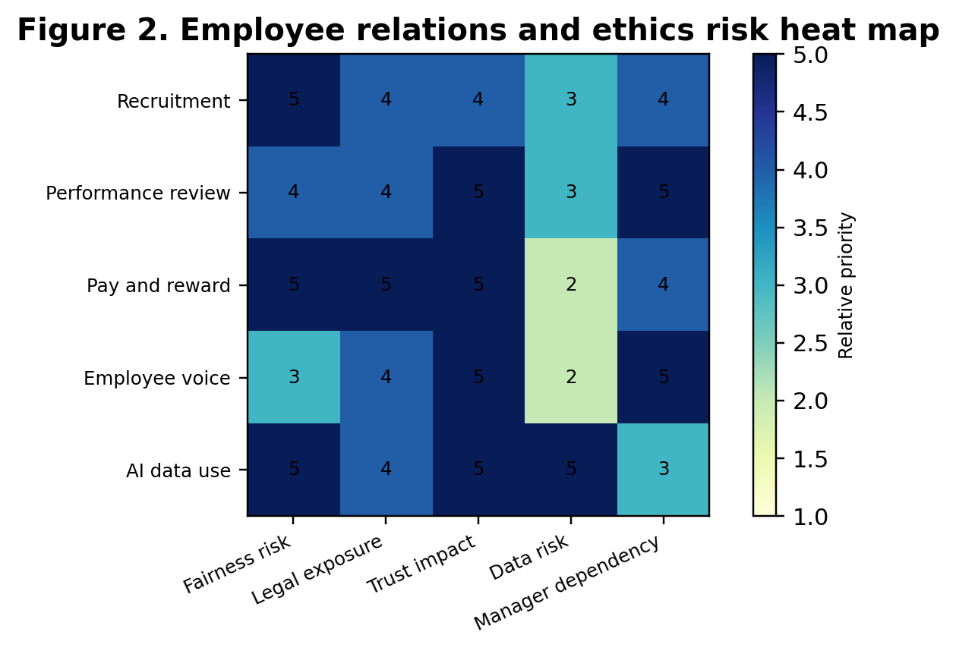
Figure 2. Employee relations and ethics risk heat map
Table 2. Ethical HRM best practice scorecard
Practice | Minimum compliance | Strategic ethical standard | Evidence required
Recruitment | No unlawful discrimination | Validated criteria, adverse impact check and human review | Funnel pass rates and audit trail
Pay | Meet minimum legal pay rules | Pay equity, band governance and documented exceptions | Compa ratio analysis and pay gap review
Discipline | Follow policy steps | Procedural justice, consistency and appeal | Case evidence, decision notes and appeal outcomes
EDI | Publish policy | Inclusion outcomes and manager accountability | Promotion, retention and psychological safety data
AI in HR | Vendor contract in place | Algorithmic impact assessment and explainability | Tool audit, privacy review and candidate communication

Discussion
Employee relations should be managed as a strategic risk system. Many organizations only involve HR after conflict has escalated into grievance, sickness absence, resignation or legal complaint. This is reactive and costly. A more mature approach uses leading indicators such as manager turnover, absence spikes, low psychological safety, repeated complaints, exit interview themes, workload intensity and pay inequity signals. These indicators allow HR to intervene before harm becomes formal dispute. This is similar to safety management: the organization should not wait for injury before addressing hazards.
Diversity strategy must also become more technical. Representation targets can be useful, but they are incomplete. An organization may increase overall diversity while still excluding certain groups from senior roles or high value assignments. A technical EDI dashboard should track recruitment funnel conversion, shortlist diversity, interview outcomes, starting salary, performance ratings, promotion velocity, attrition, grievance rates, learning access and employee voice by relevant groups. This data should be interpreted carefully to protect privacy and avoid reducing people to categories. However, without evidence, EDI becomes rhetorical.
Psychological safety is not the same as comfort. It does not mean employees avoid difficult feedback or accountability. It means they can speak honestly without fear of humiliation or retaliation. This distinction matters because some managers resist psychological safety by claiming it lowers standards. In fact, psychological safety can strengthen standards because employees are more willing to raise errors, challenge weak ideas and ask for help. Ethical HRM should therefore train managers to combine high expectations with high respect. The goal is candour with dignity.
Harassment prevention requires a control system. A policy is only 1 control. Other controls include risk assessment of high vulnerability settings, manager training, bystander training, safe reporting, independent investigation, anti retaliation monitoring, disciplinary consistency and board reporting. The EEOC (2026) enforcement examples show that harassment and retaliation remain active employment risks. HR must therefore ask whether employees believe reporting is safe. If employees do not trust the process, reported complaint numbers may be low because silence has increased, not because problems have disappeared.
AI enabled HR technology is a major ethical frontier. HR technology vendors often promise efficiency, objectivity and predictive accuracy. These promises should be tested. A recruitment tool may reduce time to shortlist but increase adverse impact. A performance analytics tool may identify low activity but ignore deep work or caregiving constraints. A sentiment analysis tool may capture emotional signals but violate expectations of privacy. Ethical HRM should require algorithmic impact assessments, data protection review, employee consultation and clear human accountability before deploying such systems.
Biased recruitment is especially damaging because it affects both organizational capability and social legitimacy. Structured interviews and validated criteria remain powerful safeguards. Every candidate should be assessed against the same role relevant criteria. Interviewers should record evidence, not impressions. Questions should be linked to job requirements. AI outputs should never be the sole basis for rejection in high impact decisions. The organization should also monitor pass rates across demographic groups where legally permissible. Fair recruitment is not only about avoiding discrimination. It improves decision quality by reducing noise and favouritism.
Unfair dismissal and disciplinary inconsistency create deep trust damage. Employees watch how the organization treats people under pressure. If high performers are protected despite misconduct, the organization signals that results matter more than dignity. If weaker performers are removed without support or evidence, employees perceive insecurity. HR must ensure that disciplinary processes are procedurally fair and proportionate. This includes investigation, evidence, right to respond, consistency check, decision separation where possible and appeal. Ethical HRM requires courage to challenge senior managers when process is weak.
Wage equality requires more than annual pay gap disclosure. It requires pay architecture. Job evaluation should define role value. Pay bands should limit arbitrary variation. Starting salaries should be controlled. Bonus criteria should be documented. Promotion decisions should be calibrated. Exceptions should require approval and explanation. Pay equity audits should examine both base pay and variable pay. The ethical risk is greatest where discretion is high and criteria are vague. HR should not remove all discretion because managers need flexibility, but it should make discretion visible and accountable.
Employee wellbeing should be reframed as organizational design. Many organizations provide wellbeing resources while maintaining unrealistic workloads. This creates a contradiction that employees recognise immediately. A technical wellbeing strategy should include workload analysis, staffing adequacy, meeting load, recovery time, flexibility, absence patterns, manager capability and job control. It should also identify hotspots. A call centre, warehouse, hospital ward and software incident response team may have very different stressors. Generic wellbeing content will not address these differences.
Labour relations require respect even where the organization is not unionised. Employees need mechanisms to influence decisions and raise collective concerns. In unionised settings, HR should treat unions as stakeholders in workforce stability rather than as obstacles. In non union settings, HR should still create employee forums and consultation mechanisms. The ethical principle is that employees affected by decisions should have voice before decisions are finalised where practical. This does not mean management gives up authority. It means authority is exercised with dialogue and explanation.
The best practice model proposed here is an ethical HR governance system. It has 5 layers. Layer 1 is policy clarity covering recruitment, performance, discipline, harassment, pay, data use and inclusion. Layer 2 is manager capability because policies are delivered through managers. Layer 3 is employee voice and reporting because HR needs signals from the workforce. Layer 4 is analytics and audit because fairness must be measured. Layer 5 is accountability through leadership review, corrective action and transparent communication. Without all 5 layers, ethical HRM remains incomplete.
A final critical issue is performative HRM. Organizations sometimes publish diversity statements, wellbeing campaigns and values posters while internal practices remain unchanged. Employees are highly sensitive to this gap. If an organization says it values inclusion but promotion decisions remain opaque, trust declines. If it says wellbeing matters but rewards managers who extract unsustainable overtime, cynicism grows. Ethical HRM must therefore align words, systems and consequences. Culture is not what the organization says. Culture is what behaviour gets protected, rewarded or ignored.

Recommendations
Organizations should create an employee relations risk register that is reviewed quarterly by HR, legal, operations and senior leadership. The register should include conflict patterns, grievances, harassment complaints, absence hotspots, pay equity concerns, exit interview themes, manager risk and privacy concerns. Each risk should have severity, likelihood, controls and action owners. This makes employee relations proactive rather than reactive and prevents issues from being managed only after formal complaints arise.
Recruitment should be subject to fairness by design. Job advertisements should be reviewed for exclusionary language, criteria should be essential and evidence based, interviews should be structured, and AI tools should be audited for adverse impact. Candidate rejection should never be based solely on an opaque algorithm. HR should keep an audit trail showing the criteria used and the evidence behind selection decisions. This protects both fairness and decision quality.
Diversity and inclusion should be evaluated through outcomes rather than statements. HR should track recruitment conversion, promotion velocity, performance ratings, pay, learning access, retention and psychological safety by relevant workforce groups where lawful and appropriate. The aim is not to create tokenistic reporting. The aim is to identify where equal opportunity is failing in practice. Inclusion metrics should also be connected to manager performance because managers control access to assignments, feedback and informal sponsorship.
Wellbeing strategy should move from individual resilience to work design. HR should measure workload intensity, role clarity, recovery time, staffing adequacy, schedule predictability and manager behaviour. Employee assistance programmes and wellbeing campaigns are useful but insufficient if the organization ignores structural causes of stress. The strongest wellbeing interventions are often operational: realistic staffing, fewer unnecessary meetings, better prioritisation, manager training and protection of recovery time.
HR technology should be governed through an ethical impact assessment before implementation. The assessment should ask what data is collected, why it is needed, who can access it, how long it is retained, how employees are informed, what bias risks exist and what human review is available. This should apply to recruitment tools, productivity analytics, sentiment analysis and AI assisted performance systems. Ethical HR technology should improve fairness and work design, not create hidden surveillance.
Finally, organizations should strengthen investigation capability. Employee relations cases are often damaged by weak evidence, delayed response, poor confidentiality and inconsistent sanctions. HR should maintain trained investigators, clear timelines, conflict of interest checks, interview templates and decision review panels. Every serious case should include a lessons learned review that asks whether policy, manager behaviour, staffing or culture contributed to the issue. This moves the organization from case disposal to organizational learning.
Leadership accountability should be explicit. Senior leaders should receive a concise people ethics dashboard showing complaint trends, pay equity indicators, inclusion outcomes, data privacy risks and unresolved high risk cases. Leaders should be assessed not only on financial performance but also on the ethical climate of their areas. This is necessary because many employee relations failures persist when high performing leaders are exempt from behavioural standards. Ethical HRM requires that the same rules apply to powerful employees as to everyone else.

Conclusion
Employee relations, diversity and ethical HRM are essential to modern organizational performance because they create the trust conditions needed for voice, commitment, collaboration and innovation. The report shows that HR must address workplace conflict, discrimination, wellbeing, labour relations, inclusion, harassment, pay inequality, unfair dismissal and privacy through structured systems rather than broad values statements. Fairness must be designed into recruitment, performance management, pay, discipline, data use and employee voice.
The main recommendation is that organizations should build an ethical HR governance architecture. This should include bias audited recruitment, pay equity analysis, manager accountability, psychological safety measurement, safe grievance channels, AI impact assessments, workload based wellbeing interventions and board level people risk reporting. Legal compliance is necessary but not sufficient. Employee centred organizations require evidence, courage and consistency. HR’s strategic role is to ensure that people systems are not only efficient but also fair, transparent and worthy of trust.

References
ADP Research. (2026). People at work: A global workforce view. https://in.adp.com/resources/insights/people-at-work.aspx
Arokiasamy, L. (2024). Role of HRM practices in organization performance. Journal of the International Council for Small Business, 5(2), 150 to 166. https://doi.org/10.1080/26437015.2024.2328342
Chen, Z. (2023). Ethics and discrimination in artificial intelligence enabled recruitment practices. Humanities and Social Sciences Communications, 10, 567. https://www.nature.com/articles/s41599-023-02079-x
CIPD. (2025a). Good Work Index 2025. https://www.cipd.org/uk/knowledge/reports/goodwork/
CIPD. (2025b). Resetting EDI and reaffirming inclusion. https://www.cipd.org/uk/knowledge/reports/Resetting-EDI-reaffirming-inclusion/
Deloitte. (2026). 2026 Global Human Capital Trends. https://www.deloitte.com/us/en/insights/topics/talent/human-capital-trends.html
Gallup. (2026). State of the Global Workplace 2026. https://www.gallup.com/workplace/349484/state-of-the-global-workplace.aspx
Hosen, S., Hamzah, S. R., Ismail, I. A., Noorman, N. H., Yusof, F. M., & Rahman, M. M. (2023). Training and development, career development, and organizational commitment as the predictors of work performance. Heliyon, 9(1), e12918. https://pmc.ncbi.nlm.nih.gov/articles/PMC10796978/
Li, L. (2022). Reskilling and upskilling the future ready workforce for industry 4.0 and beyond. Information Systems Frontiers, 24, 1451 to 1469. https://pmc.ncbi.nlm.nih.gov/articles/PMC9278314/
LinkedIn Learning. (2025). Workplace Learning Report 2025. https://business.linkedin.com/learn/resources/workplace-learning-report
Microsoft. (2025a). 2025 Work Trend Index Annual Report. https://www.microsoft.com/en-us/worklab/work-trend-index/2025-the-year-the-frontier-firm-is-born
Microsoft. (2025b). Annual Report 2025. https://www.microsoft.com/investor/reports/ar25/index.html
Nastase, C. (2025). Strategic human resource management in the digital era. Businesses, 5(4), 23. https://www.mdpi.com/2673-8104/5/4/23
OECD. (2025). AI and work. https://www.oecd.org/en/topics/sub-issues/ai-and-work.html
Sony, M. M. A. A. M. (2025). Bias in AI driven HRM systems: Investigating discrimination and legal accountability in employment decision making. Journal of Responsible Technology, 22, 100124. https://www.sciencedirect.com/science/article/pii/S2590291125008113
World Economic Forum. (2025). The Future of Jobs Report 2025. https://www.weforum.org/publications/the-future-of-jobs-report-2025/
Zhao, Z. (2025). Impact of ambidextrous human resource practices on employee innovation performance: The roles of inclusive leadership and psychological safety. Frontiers in Psychology, 16, 1491930. https://pmc.ncbi.nlm.nih.gov/articles/PMC12696671/

Appendices

Appendix A. Evidence based HR implementation checklist
Control area | Evidence to collect | Review frequency
Workforce planning | Critical role list, vacancy risk, skills gap and workload data | Quarterly
Recruitment fairness | Structured interview evidence, shortlist diversity and adverse impact check | Every campaign
Learning transfer | Pre and post skill assessment, manager observation and application evidence | 30, 60 and 90 days
Performance quality | Goal audit, feedback cadence and rating calibration by manager | Quarterly and annual
Retention risk | Regretted turnover, critical role turnover and stay interview themes | Monthly
Ethical governance | Privacy review, AI tool audit and grievance trend analysis | Quarterly

Appendix B. Suggested structure for implementation review meetings
The HR review meeting should begin with the strategic workforce risk dashboard. The agenda should prioritise decisions rather than updates. Each metric should be linked to a named owner, a target, an exception threshold and a corrective action.
The review should include one case example from a business unit where the HR system is working and one case example where the system is failing. This prevents the meeting from becoming a generic dashboard presentation and forces discussion of root causes.
The review should end with an action log showing the decision, responsible person, deadline and evidence required at the next review. This protects accountability and prevents HR recommendations from remaining aspirational.

