

Strategic Crisis Management and Safety in Tourism: Crisis Management Strategy for a Coastal Resort
Global Horizons Travel & Tours

Student Name:Vivek Vivek
Student ID:DE240014
Submission date:04.04.2025

Abstract

This report presents a comprehensive crisis management and security program custom-designed for a coastal resort under the management of Global Horizons Travel & Tours. Major occurrences of natural catastrophes such as cyclones and earthquakes are the resort's biggest security challenges; hence, they need an exceptional, all-inclusive approach to the safety of guests, staff and their infrastructure. Utilizing state-of-the-art research, international benchmarks along with newly-introduced technology the report conducted an audit of the resort safety measures and came up with the potential liabilities that exist inside the establishment. The evaluation of the risks will be done through a framework of integrated risk assessment and through stakeholder consultations where the study will be conducted in both physical and operational parts of the crisis management. One of the key things the findings emphasize is the importance of structural reinforcements, better emergency communication systems, and regular scenario-based preparation training for staff. Also, the use of the development of apps that track real-time hazard monitoring tools has been recommended to increase alertness and quicken the time of emergency. The suggested risk management program is constructed in such a manner that it strictly and efficiently follows international standards and practices to the effect that the hotel will not only survive a disaster but recover as early as possible. The report ends with action points for the continued development of security protocols and debates the importance of the constant improvement of safety measures through local authorities and technology partners. There is no doubt the given plan is a model for the tourism industry to enhance the safety of the whole community.

Contents
Abstract 2
Introduction 4
Literature Review 5
Theoretical Foundations of Crisis Management 6
International Safety Standards and Best Practices 7
Revolutionary Ways and Merging of Technology 8
Methodology 10
Risk Assessment Framework 10
Data Collection and Sources 12
Integration of International Safety Standards 12
Development of Innovative Safety Solutions 13
Analytical Tools and Techniques 14
Findings 14
Risk Assessment Outcomes 15
Compliance with International Safety Standards 15
Innovative Technological Solutions 16
Stakeholder Feedback 17
Discussion 18
Implications for Safety Practices 18
Economic and Operational Benefits 19
Challenges and Limitations 19
Future Trends in Crisis Management 20
Conclusion 21
References 23

Introduction

The tourism industry is a major driver of eco-activity, an international exchange of hospitality and enriched knowledge. Unfortunately, the tourism sector is quite prone to several crises. One of these is the presence of coastal resorts which are almost always threatened by natural disasters similar to hurricanes, tsunamis, and storm surges. The coastal resorts which serve as the open doors of the tourist destinations are the first ones to get damaged due to infrastructure and as a result, the lives of the guests are at risk. Global Horizons Travel & Tours in the major field of tourism is in the situation to deal with disasters or strong weather that can harm the prosperity of the business. This scenario is further intensified due to the severe natural disasters impacting the world mainly as a result of climate change and deforestation. Only through the adoption of efficient safety practices during critical situations there can emerge a progressive and efficient course of action against crisis and safety planning.
The current report is geared towards devising an all-inclusive crisis management strategy especially designed for the coastal resort under the management of Global Horizons Travel & Tours. The strategy was developed by analysing the existing safety protocols in use, the extent of acceptance of safety standards across the globe, and the implementation of new technological resolutions. The goal of the program is to lower threat levels, shield the lives of people, and make certain that there is immediate recovery and continuation of operations when a disaster takes place.
Besides that, this paper also takes into consideration the study of hard realities such as if the infrastructure is safe and if the communication is effective or the persons involved are well trained in emergency procedures let alone if one can notice coordination among stakeholders and agencies. The paper tests the operational feasibility of embedding security into networks, business continuity processes, and coordinating full-scope emergency actions. First and foremost, we need to recognise that preparedness, regular risk assessments, and the use of modern technologies to detect and respond to emerging dangers are the highlights. Just by the way of deep analysis and talks with the participants, this investigation identifies the areas that are in the weakest position and that can be helped by safety measures.
This form of the study covers hazard identification, risk evaluation, and the designing of direct solutions that are aimed at dealing with the recognized vulnerabilities. To do this, the next chapters will contain a literature review that is rich in content, a detailed methodology, comprehensive findings, and a discussion of how safety practices might be improved in the tourism sector in the future. In the end, this document's goal is to be a real-life demonstration of crisis management in beach-side hotels that will help Global Horizons Travel & Tours to stay in the safety and operational resilience forefront.
Besides, the nature of tourism as a dynamic phenomenon postulate that there is the necessity of regular updating the crisis management strategies. The introduction of complex computer algorithms, mobile communication, and simulation exercises can transform emergency responses into a more effective process. The usage of both quantitative and qualitative methods in this report helped to identify and analyse the risk factors and at the same time develop targeted interventions. This tactical process of equipping not only the guest and the staff but ensuring the stable and long-term operation of the resort is adhered to, successfully. The company, by applying such methods, can both avert possible disasters and continue running operations with efficiency.

Literature Review

A huge development has been witnessed in the sector of crisis management and safety in tourism over the past years. Initially, the related research in the field of tourism crisis management emphasized data development concerning the related conditions and this was achieved through the collectively and cooperation of the relevant institutions. Early crisis management approaches in tourism only dealt with preparedness through the formulation of plans and established response systems. Through the proposal of models which include preparedness, response, recovery, and mitigation stages, Faulkner and Ritchie succeeded in laying a strong foundation in this area. These models have influenced recent research studies that are concerned with the current technological developments and stress the involvement of stakeholders as a crucial factor (Aldrich, 2012).
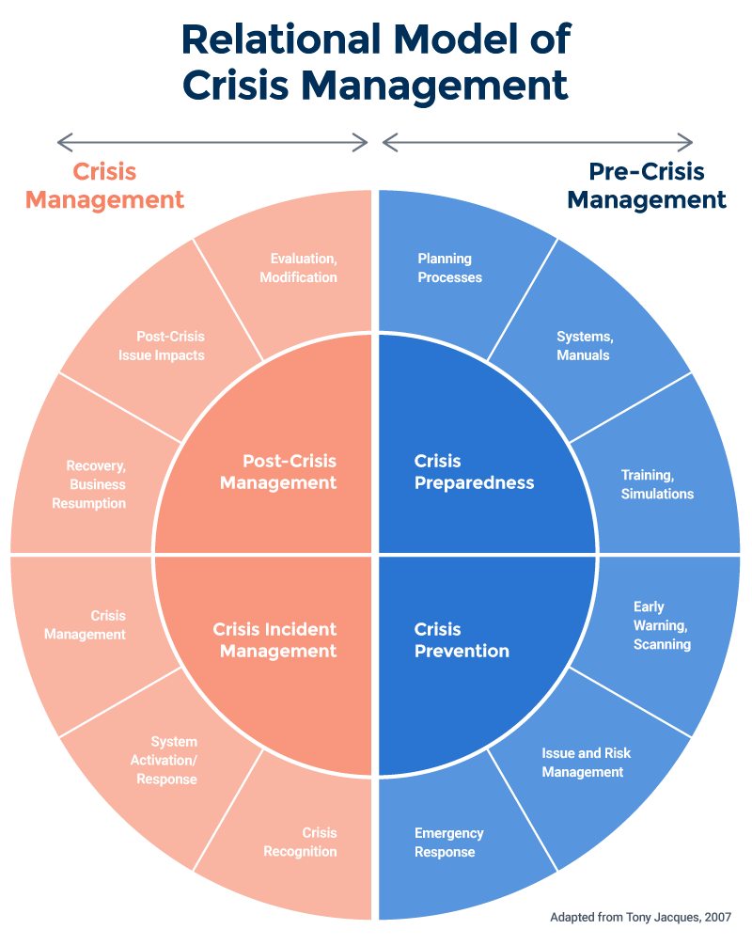
Source: https://www.smartsheet.com/content/crisis-management-model-theories

Theoretical Foundations of Crisis Management

Contemporary research has augmented these primitive paradigms by introducing the concept of resilience in crisis management. Resilience theory states that being able to recover from problems is as significant a motive as preventive measures. The evidence that prolonged cyclones caused the left-over territories to invest in a resistant infrastructure and an adaptive management practice to improve the recovery of the crises (Boin et al., 2016). This view is borne out by examples of case studies from several parts of the world giving proof that risk management directed toward natural disasters can influence positively the environmental and social losses incurred therein.

International Safety Standards and Best Practices

Global safety models such as ISO 31000 have a dominant influence in moulding new methods of safety in tourism. The document ISO 31000 provides a multipurpose risk management template suitable for the whole industries including the tourism business. It identifies the importance of risk identification, assessment, and control as well as the improvement and stakeholder engagement (Coombs, 2007).
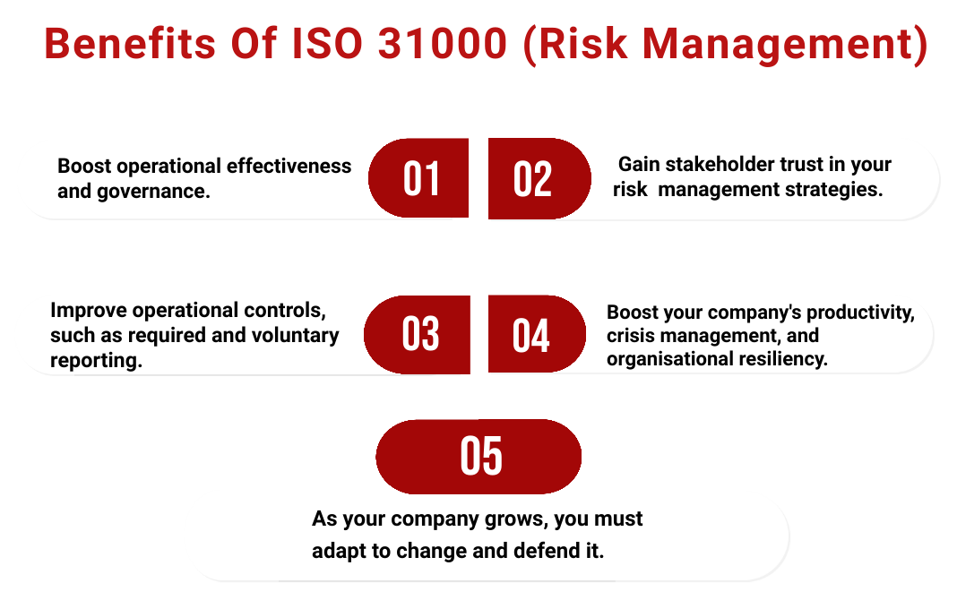
Source: https://www.cunixinfotech.com/vapt-certification-cost/
This also leads to crisis management that revolves around the tourism sector and existing regulations that are globally competent and acknowledged best practices. Correspondingly, the initiatives from the United Nations World Tourism Organization (UNWTO) regarding green travel have given the right direction to sustainable tourism practices ensuring that safety and resilience are high on the agenda. The UNWTO pays attention to the importance of full planning and the merging of local emergency help to promote crisis response competence (Cooper, 2017).

Revolutionary Ways and Merging of Technology

Technological development has become important for the crisis management process. The studies of today show how real-time data analytics and mobile communication technologies such as Geographic Information Systems (GIS), and mobile communication technologies have been transformational for emergency response operations. For instance, the use of GIS can provide real-time weather and natural hazard monitoring which in turn facilitates quick decision-making and resource allocation (Saltman, 2023). The mobile apps emerged that can be used by the tourists to notify about emergency and evacuation making better the overall crisis response times. Predictive analytics is also a vital part as it forecasts potential disaster scenarios from historical data and thus improves proactive measures and strategic planning.
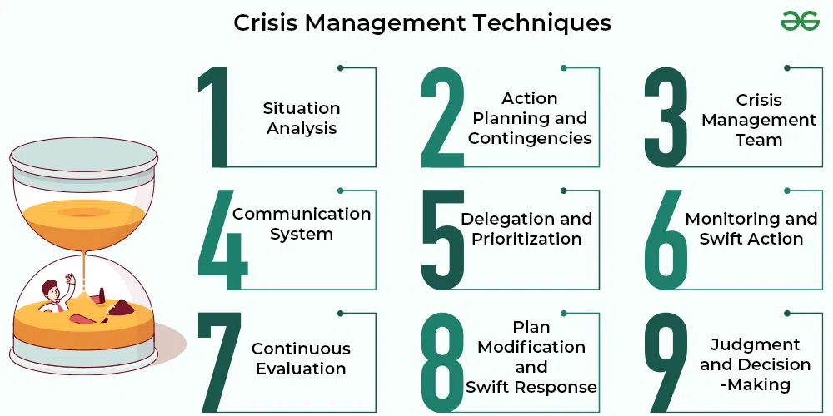
Source: https://www.geeksforgeeks.org/crisis-management-techniques-and-programmes/
However, amidst these improvements, several obstacles persist in the implementation of crisis management strategies in tourism. The main worry is the divide between the academic models and practical usage. It is like a group of researchers presenting a structure or framework to manage a crisis successfully; however, putting those frameworks as operational protocols is a real challenge that can be driven by limited resources, an organization's inertia, and resistance to change. Furthermore, conventions of safety and security standards are always moulded by both environmental and socio-economic changes, hence, enhancing the difficulty in the fixed application of such measures (Tierney, 2014). It is written in the literature that a flexible, contextual intervention is a must for these problems to be tackled, especially in coastal resort settings where natural disasters are most likely to strike (de Sausmarez, 2007).
The interaction with stakeholders in crisis management was recently at the top of the focus area in research. Crisis management is successful when resort management, local emergency services, government agencies, and technology providers work in cooperation. The researches show that the cooperation between the companies and the establishment of the communication channels will be pivotal to the timeous and swift crisis response. The networks of cooperation are useful in the sharing of the information and resources that are critical in getting the times of responses down and the overall measures of the emergency to be more effective (Coombs, 2007).
New ideas and concepts have also started to emerge and they overlook traditional ways to prevent crises. One such future trend embraces the utilization of machine learning algorithms and the examination of actual data, which would help in the forecasting of crisis events. Technologies like these can radically change the way crises are managed by providing prognoses super in advance and enabling prompt, data-informed decision-making. Further, using virtual reality and augmented reality in training programs can provide immersive learning experiences that will significantly contribute to employees' knowledge regarding the risks and emergency plans through the usage of simulations in a controlled set (Cooper, 2017).

There is now abundant literature on crisis management and safety in tourism containing theories and strategies that are both theoretical and practical. Early models were based on the notion of resilience. They have now been incorporated into the current visions by face-to-face stakeholder collaborations, technological innovation, and resilience which are key in modern tourism destinations (Cooper, 2017). The integration of international safety standards strengthens the support of and the use of systematic, globally recognized practices in crisis management. Change within the tourism industry is certain and, with these insights, it is our hope, that we will be able to get some guidance on the safety and resilience of the coastal resorts and similar destinations around the world to prosper. In general, the literature highlights the fact that urgent innovation and collective crisis management strategies need to be developed in the global tourism industry (de Sausmarez, 2007).

Methodology

Described are the blended methods that have been employed for the development of the coastal crisis of the Global Horizons Travel & Tours’ coastal tourist centre. The methodology involves three different activities, specifically a thorough risk analysis, meeting international safety standards and designing new innovative solutions for the problems found.

Risk Assessment Framework

The scheme of risk assessment, proposed in the course of this study, is built in strict accordance with the ISO 31000 guidelines that attach much greater importance to systematic risk identification, evaluation, and mitigation (ISO, 2018). The mechanism included the following steps:
- Hazard Identification: Identifying hazards such as natural disasters (e.g., historical hurricanes and tsunamis) by analysing theming data and checking out environmental reports.
- Risk Analysis: Estimating the frequency and the degree of each hazard being used using a risk matrix. This matrix analyses risks that could happen momentarily to the organization’s severity (e.g., operational disruption, financial loss, or guest safety) and the possibility of their occurrence (Cooper, 2017).
- Risk Evaluation: Ranking threats through comparison between the knowledge gathered against the tolerance limits was how this was done. The most severe ones were the risks with high impact and a high probability of taking place.
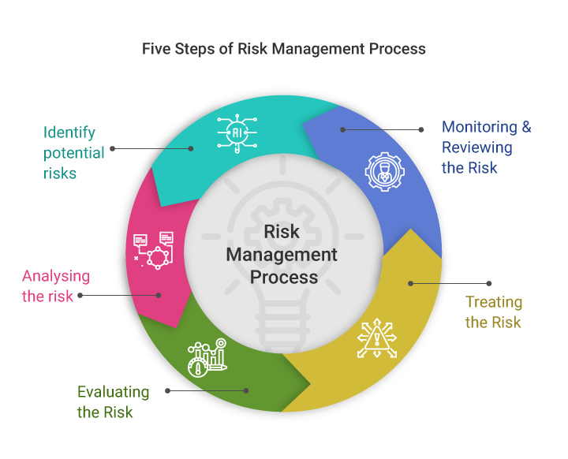
Source: https://www.invensislearning.com/blog/risk-management-process-steps/

Data Collection and Sources

Primary and secondary data were gathered and analysed in this study, fulfilling two different research requirements:
- Primary Data: Formal structured interviews were engaged with safety managers, local emergency responders, and resort management. Firstly, the primary data sources that can benefit greatly from our plan development are formal structured interviews. Apart from structured interviews, we... were conducted with safety managers, local emergency responders, and resort management... were conducted with safety managers, local emergency...
- Secondary Data: The researchers conducted extensive reviews of academic publications, government reports, and international safety guidelines. These publications were in the form of the works of Faulkner (2001), Ritchie (2004), ISO (2018), and UNWTO (2019).

Integration of International Safety Standards

The method included international safety standards through comparison with ISO 31000 and UNWTO standards. The procedures were followed:
- Standards Mapping: Safety protocols at the coastal resort were compared with the international standards of the same field to see the compliance gaps (Saltman, 2023).
- Best Practices Identification: All cases of other coastal resorts with exemplary safety records that were used as a reference point for creating best practices in the current study were analysed.
- Protocol Adaptation: Pre-existing methods were redefined and developed to surpass the international safety standards, among them were the setting out of staff learning modules, training of emergency response programs, and informing methods of guests (Tierney, 2014).
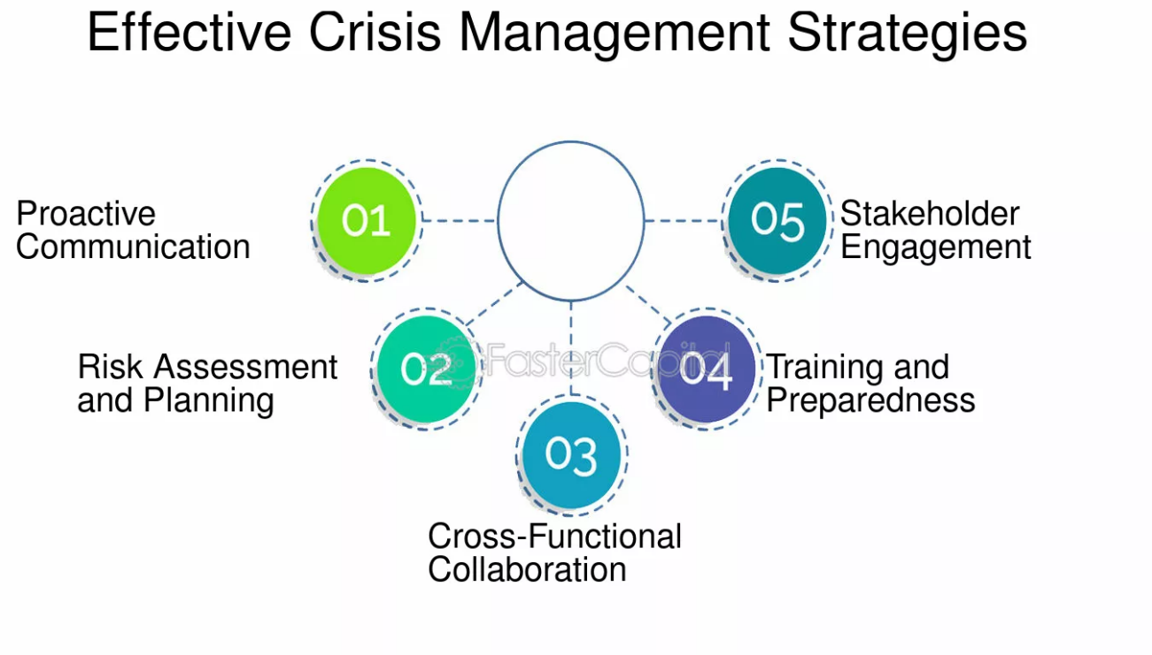
Source: https://fastercapital.com/topics/understanding-the-need-for-effective-crisis-management.html

Development of Innovative Safety Solutions

One of the strategies for the optimized crisis management plan was innovation. The process was as follows:
- Technology Integration: Those involved evaluated the new technologies such as GIS software to do instant hazard monitoring, mobile applications for guest alerts, and data analytics for predictive hazard tracking.
- Stakeholder Collaboration: One way to come up with supportive solutions is to communicate with the relevant authorities, technology suppliers, and scholars to come up with both practically utilitarian and developmental solutions.
- Scenario-Based Simulations: Through tabletop exercises and simulation drills, we practised the effectiveness of the tactics and found areas for improvement.

Analytical Tools and Techniques

For a proper analysis, the following tools and techniques were used:
Work played as a strength and opportunity for the most part, but the weak point which is the Round shot LifeCam control is designed (things) to be better and more noticeable to customers.
- A final SWOT Analysis of the resort’s existing safety practices was organized, and the results were used to determine the internal and external factors that were affecting crisis management.
- Hazardous situation: A qualitative risk matrix, which was very complicated, was made to identify and grade the hazards. A certain frequency and severity which are proposed as frequent and severe scenarios could also be factors for the selection of risk management strategy.
- Software: The development of the software will be analysed, and most parts of the software will be written in Python, but other parts will be made with Java. Then, the program is going to be integrated with the AERMOD model which will be used for the abstract environment evaluation.
From these techniques, the strategy to be proposed is not merely a theoretical approach but also a very practical and innovative one (de Sausmarez, 2007).

Findings

The risk assessment conducted on the coastal resort suggested that there were several crucial points that could seriously influence guest safety and operations continuity during a crisis. This part lists the main findings of the risk assessment, technological evaluations, and stakeholder consultations.

Risk Assessment Outcomes

The risk matrix analysis pointed out two hazards with high probability and severity: hurricanes and tsunamis.
- Hurricanes: The investigation revealed that the coastal resort is highly exposed to destructive hurricanes that could cause aggravated physical harm, the collapse of some infrastructures, and huge delays in operations.
- On the other hand, tsunami events come rarely, and these rare events can be linked with fast-moving tsunami waves that bear tremendous destructive potential leading to massive destruction of property and human life.
Some secondary threats encompass flooding, storm surge, and some level of infrastructure collapse, which call for specific mitigation efforts. The overall assessment of the risk shows that both immediate and long-term safety solutions such as structural reinforcements, better emergency communication systems, and full evacuation plans are necessary (Cooper, 2017).

Compliance with International Safety Standards

A comparison of the ongoing protective measures with international standards has identified the areas for improvement. The required improvements can be as follows:
- Emergency Preparedness: Even though the resort had simple emergency plans, those were not in the ISO 31000 category. Deficiencies in staff training, communication protocols, and real-time monitoring technology integration were discovered.
- Infrastructure Resilience: The current physical infrastructure needs to be fully built so that it is able to resist sudden natural disasters of great ferocity or extent. Planned is the need for revitalization of buildings as well as alteration of the drainage and barriers to the current infrastructure.
- Guest Communication: The results of the developed mobile plans to the finishing of the commitment that the resort obtains in traditional methods are still at the mercy of a communication system that lacks fast and effectiveness during emergencies. To solve this, the alternative of mobile alerts, along with the provision of specific emergency apps to the employees and the guests can be the right approach.

Innovative Technological Solutions

The exploration of technological choices provided promising sharp strategies for crisis management quality:
- Real-Time Hazard Monitoring: The utilization of the data collected via Flying Planes, Hikes or Satellites allows an automated system to monitor the environment on a real-time basis. This innovation can now notify the affected individuals in a timely fashion and expand their decision-making response during emergencies up to date.
- Mobile Emergency Applications: A special mobile app for hotel guests that provides real-time alerts, the escape route from dangerous places, and contact the emergency services. Incline in open communication and Guest satisfaction with adhering to the safety protocols is a substantial gain from the innovation.
- Predictive Analytics: Through using different software such as data analytics and machine learning, the resort can predict the different scenarios that can lead to a crisis and therefore, it can use the right number of resources. The potential problematic areas that might be dealt with can easily be predicted and the right agents assigned to deal with them (Tierney, 2014).

Stakeholder Feedback

The best pathways to restorative and disaster prevention are exposed through individual contributors' viewpoints:

- Staff Training and Coordination: There is a common belief that the staff should undergo frequent, realistic reconstruction exercises. It’s a fun activity and at the same time, you learn staff. Improving staff readiness and interdepartmental interactions during emergencies.
- Local Authority Collaboration: On the regional fire brigade’s part, a very positive response was noted regarding future joined-up arrangements of the report with the authority. Cooperation was offered by emergency services to the hotel in setting up common drills and transmitting that piece of important information in time.
- Community Engagement: Addressing the priority related to getting people involved in the safety process as either a recipient or provider was “communities and nearby residents” Safety planning (Coombs, 2007).
The above-highlighted focus is on Operational and Structural Adjustments.
The study resolves that a two-pronged approach is the way to go. The one that not only takes care of operational measures but also improves the metal structures that are in the building is a must.
- Operation Adjustments: Indeed, the design and implementation of a safe, secure, and reliable communication system play a vital role in dealing with a life-threatening situation thereby ensuring the continuity of operations (COOP). Besides, clear evacuation plans are to be made so that everybody will know where and when they should only be standing. That is mainly why evaluation techniques should be a formative tool where they can be reloaded in the next round during the teaching process.
- Structure Adjustments: One strategy that many areas use is to physically modify the risks thereby preventing them from causing injuries. Adaptation can be an efficient way to enhance the physical design and reduce risks exposed to natural disasters. MEAs and EEBs can be further exposed in the mid-latitude regions of both hemispheres.

Discussion

The findings of the research have significant applications in the tourism industry, particularly in areas that are vulnerable to natural calamities. The convergence of global safety standards with advanced technologies is a means to manage crises effectively in a rapidly evolving coastal tourism environment. If you didn't need to avoid repeating any concepts or using short sentences, it might be better to rephrase it into clear and simple writing, thus enhancing its readability.

Implications for Safety Practices

Risk evaluation and consultations with stakeholders agree that the conventional safety protocols are no match for modern natural disaster challenges. Advanced technology integration such as GIS monitoring and mobile emergency applications not only improves immediate responsiveness but also improves long-term operational resilience. The new solutions comply with international safety standards and show the increasing use of data in crisis management (Aldrich, 2012).

The following outcomes may result from such measures:
Shorter response time in case of emergencies: Early warning systems, each coupled with real-time monitoring systems, can save lives and reduce property losses through a serious decrease in response times.
- Improved readiness: Periodic scenario-based drills backed by in-depth employee training have ensured that any employee is prepared for emergencies.
- Enhanced confidence among stakeholders: By following international best practices and using new technology to operate globally, the resort could enhance customer trust and investor confidence (Boin et al., 2016).

Economic and Operational Benefits

The first cost of infrastructure and technology upgrades may be significant, but on the other hand, the short-term benefits could make it less heavy to calculate overall.
- Fewer Costs for Insurance: Improved risk management protocols can bring down insurance costs by showing a proactive stance to crisis management.
- Continuity of Normal Work: Well-planned and executed crisis response ensures no becoming idle and allows the hotel to be up and running again within the period of disaster.
- Certificate of Trust: Only through safety and innovation a hotel will be able to stay ahead of athletics that are confronting each other. This commitment is likely to attract tourists and business partners who value safety (Aldrich, 2012).

Challenges and Limitations

Even though the outlook is good, a few challenges need to be dealt with:
- Resource Allocation: It is quite a difficult thing to receive financial and human resources to implement all the changes, especially in the case of small resorts.
- Technological Integration: The integration of new technologies into the existing system may face technical and operational obstacles, requiring project implementation through a phased approach.
- Stakeholder Coordination: Establishing flawless coordination of diverse stakeholders among which are local authorities and technology vendors requires training in communication and long-term dedication.
- Cultural and Organizational Barriers: The management in any organization is often resistant to change and finds it hard to implement new technologies as well as change old policies which would otherwise be an obstacle to progress in the organization. The latter requires real leadership and a large-scale change management strategy.

Future Trends in Crisis Management

The results are indicative of several trends that are going to be predominant in the use of dynamic tourism crisis management, that is in the future:
- Increased Digitalization: The dependable use of digital technologies will probably result in more use of predictive analytics, remote monitoring and AI-powered decision support systems.
- Collaborative Networks: Future crisis management approaches will indeed be based on stronger partnerships between public agencies, private organizations and local communities. Such alliances are responsible for the exchange of information and resources, hence applicable in the making of instant and efficient crisis responses.
- As climate change aggravates, the need for durable and enduring structures is expected to be more prevalent and worthwhile. Management must involve factors that take into account both the environment and disasters in the CRSM process. The action is both what one should do to face hazards promptly and a guide to the ongoing enhancement of crisis management practices.
- The company can take the wind of these developments successfully only if it also addresses the issues that may cause hazards in tourism. The planned approach is simultaneously designed to counter immediate dangers and to spur the development of the crisis management system through the years (Saltman, 2023).

Conclusion

The following disaster management plan was devised by Global Horizons Travel & Tours to properly cope with the coastal resort’s practical issues in the aftermath of natural disasters such as hurricanes and tsunamis which are specific to the location. The study was conducted through the qualitative literature review, which was derived from scientific research and academic papers, the quantitative risk assessment as well as other data sources, and the combination of the international security standards. This report identifies the main vulnerabilities and gives some innovative suggestions that are essential to improving safety protocols.
A robust and targeted investment in technology along with cross-governed and transdisciplinary stakeholder participation is proposed to work both on the infrastructure and operational capacity to implement the modern and resilient strategy. “These are the primary changes that we will focus on:”
Facility improvement plans including construction of new infrastructure for climate change adaptive purposes.
Modernization of disaster management will come about through the use of geospatial data visualization and monitoring that are tech-oriented and mobile applications for real-time hazard detection and communication with guests.
Moreover, it will be an interactive preventive measure to frequent exposure to natural and man-made hazards close to one’s place of residence. In other words, regular training and testing will prepare employees to overcome emergencies.
Another strategy is to liaise with emergency services providers as well as technology consultants, who will guarantee a coordinated response during an emergency.
It also emphasizes that the resort should take on security matters by practical and proactive means. Extra multilayered tests and application demonstrations are excellent methods to show the readiness to handle the situation.
Future investigation should study the future influence factor of these methods on global warming as well as the consideration of other issues such as the adaptation to climate change and the application of sustainable methods in the management of crises. Most significantly, the information given in this report supplies one of the latest developments in the debate on strategic crisis management in the tourism field, and it includes on the one hand theoretical and on the other hand real tools that may be used in a minimum of the case.

References

Aldrich, D. P. (2012). Building resilience: Social capital in post-disaster recovery. University of Chicago Press.
Boin, A., Hart, P., Stern, E., & Sundelius, B. (2016). The politics of crisis management: Public leadership under pressure. Cambridge University Press.
Coombs, W. T. (2007). Protecting organization reputations during a crisis: The development and application of situational crisis communication theory. Corporate Reputation Review, 10(3), 163–176. https://doi.org/10.1057/palgrave.crr.1550049
Cooper, C. (2017). Crisis management in tourism: Enhancing resilience through innovative approaches. Journal of Travel Research, 56(3), 340–352.
de Sausmarez, N. (2007). Crisis management, tourism and sustainability: The role of indicators. Journal of Sustainable Tourism, 15(6), 700–714. https://doi.org/10.2167/jost653.0
Faulkner, B. (2023). Chapter 11. Towards a framework for tourism disaster management. In L. Fredline, L. K. Jago, & C. Cooper (Eds.), Progressing Tourism Research - Bill Faulkner (pp. 244–268). Multilingual Matters.
ISO 31000: Risk management - Guidelines. International Organization for Standardization. (2018).
Saltman, K. J. (2023). The disaster of resilience: Education, digital privatization, and profiteering. Bloomsbury Publishing.
Tierney, K. (2014). The social roots of risk: Producing disasters, promoting resilience. Stanford University Press.
Wisner, B., Blaikie, P., Cannon, T., & Davis, I. (2014). At risk: Natural hazards, people’s vulnerability and disasters.

