Community Participation and Development Cooperation in Tourism: A Strategic Framework for Inclusive Local Ownership
Option 2: Community Participation and Development Cooperation in Tourism
M20 - Tourism and Local Development Cooperation

Table of Contents
1. Abstract
2. Introduction
3. Literature Review
4. Methodology
5. Findings
6. Discussion
7. Conclusion
8. References
9. Appendices

Abstract
This strategic paper examines the importance of community participation and development cooperation in tourism. It focuses on the ways local communities, government agencies, NGOs and private tourism businesses can cooperate to create tourism that is socially inclusive, culturally respectful, economically useful and environmentally responsible. The central argument is that tourism development fails when residents are treated only as labour or scenery, but it becomes a stronger local development tool when residents participate as owners, decision makers, cultural interpreters and beneficiaries. The report uses a qualitative secondary research methodology and draws on development cooperation theory, community based tourism literature and examples from UNDP supported initiatives in Thailand, Türkiye and India. It finds that participatory planning improves tourism outcomes by strengthening local legitimacy, reducing conflict, preserving cultural identity, distributing benefits more fairly and improving the design of visitor experiences. However, participation must be more than consultation. It needs institutional structures, transparent information, fair representation, benefit sharing, capacity building and accountability. The paper recommends a cooperation framework based on a community tourism council, public private community partnerships, participatory planning cycles, local enterprise support, cultural safeguards, environmental monitoring and social impact indicators. The conclusion is that community participation is not a soft ethical addition to tourism planning. It is a practical governance requirement for sustainable destination development because local people carry the costs, maintain the identity and create much of the value that tourism sells.

Introduction
Tourism development is often planned through investment proposals, destination marketing strategies and infrastructure projects. These are important, but they can overlook the people who live in the destination. Local communities provide the cultural atmosphere, labour, informal knowledge, hospitality and social environment that make tourism possible. They also experience the daily impacts of tourism through changes in prices, employment, land use, public space, environmental quality and cultural representation. For this reason, community participation is central to tourism and local development cooperation. Tourism cannot be sustainable if residents are excluded from decisions that affect their livelihoods, identity and living conditions.
Community participation means that residents are involved in identifying tourism priorities, designing tourism products, managing resources, evaluating impacts and sharing benefits. It is more than being informed about decisions already made. Genuine participation gives communities influence over what type of tourism is developed, who owns enterprises, how cultural assets are interpreted, how environmental limits are managed and how revenue supports local priorities. This is particularly important in community based tourism, rural tourism, cultural heritage tourism and nature based tourism because the tourism product depends heavily on local knowledge, traditions and landscapes.
Local development cooperation in tourism refers to coordinated action between stakeholders who have different resources and responsibilities. Local communities bring lived knowledge, cultural authority and social legitimacy. Government agencies provide planning regulation, infrastructure, public finance, policy direction and legal protection. NGOs often support capacity building, inclusion, environmental management, advocacy and project facilitation. Private tourism businesses contribute investment, market access, operational expertise and employment. Development partners can provide technical assistance, evaluation systems and funding. The quality of cooperation among these actors determines whether tourism becomes a shared local development strategy or a contested commercial project.
This report focuses on Option 2 and prepares a strategic paper on community participation and development cooperation in tourism. It explains the concept of local development cooperation, discusses stakeholder roles, assesses how participatory planning improves social inclusion, cultural preservation and local ownership, and recommends cooperation frameworks for sustainable and community based tourism development. The report argues that participation is both a moral and functional requirement. It is moral because residents have a right to shape development in their own locality. It is functional because tourism projects are more resilient when they reflect local priorities and gain community support.
The strategic challenge is that participation can be difficult to implement. Communities are not homogeneous. They include different households, genders, age groups, occupations, ethnic groups, landowners, renters, formal businesses, informal vendors and marginalised residents. Some voices are louder than others, and tourism benefits can be captured by local elites. Development cooperation must therefore include mechanisms to manage power differences inside the community as well as between the community and external actors. A participatory tourism model needs not only meetings, but representation, capacity building, transparency, benefit sharing and grievance systems.
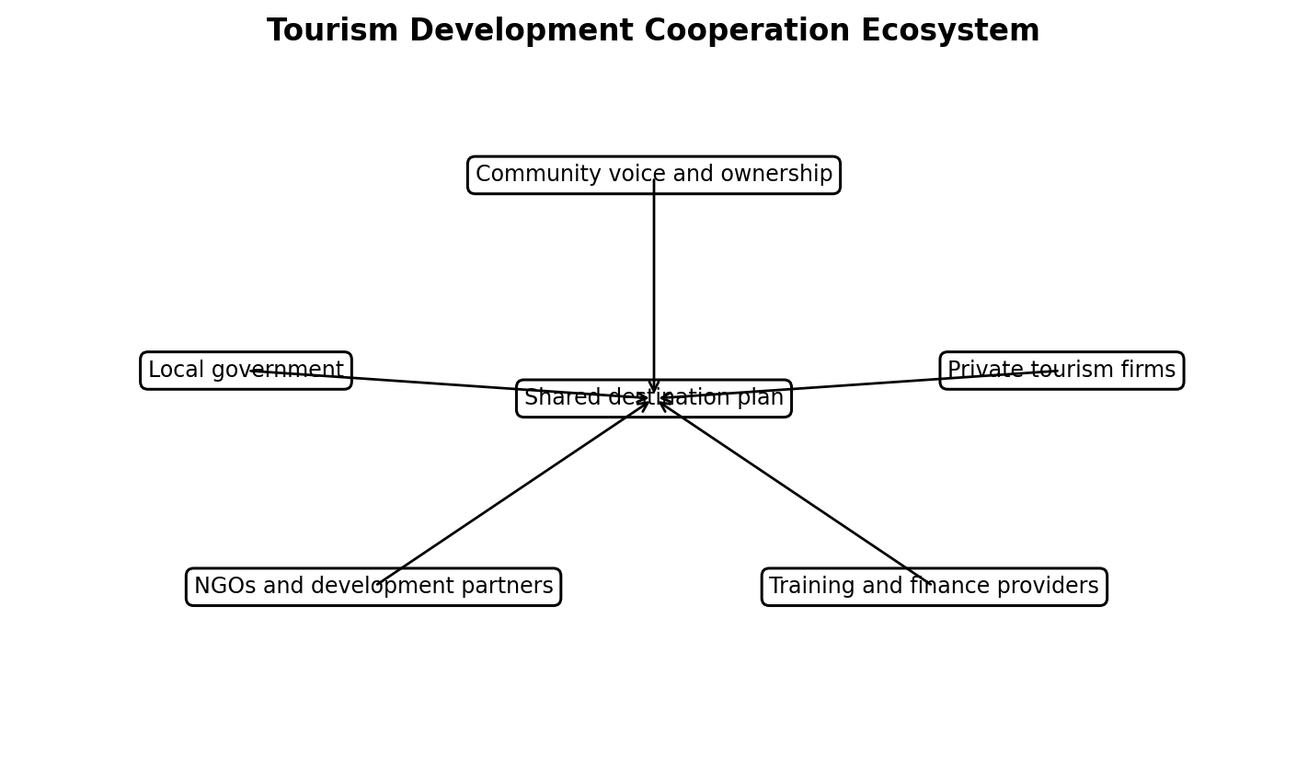
Figure 1. Tourism development cooperation ecosystem.

Literature Review
Participation has been a central theme in development studies because externally planned projects often fail when they ignore local needs, knowledge and power relations. In tourism, this problem is especially visible because the destination is a lived place. Residents cannot be separated from the tourism product. Their culture, hospitality, labour, environmental stewardship and social acceptance are part of what visitors experience. Tosun's work on community participation in tourism development showed that participation can be limited by operational, structural and cultural barriers, including centralised decision making, lack of expertise, elite domination and weak institutional support. These barriers remain relevant because many tourism projects still use participation as a symbolic consultation tool rather than as shared governance.
Community based tourism literature argues that tourism should be owned or significantly controlled by local communities and should generate collective benefits. Recent research describes community based tourism as a participatory model that can support the Sustainable Development Goals, particularly poverty reduction, decent work and sustainable communities (Jackson, 2025). However, community based tourism should not be romanticised. Community enterprises can face weak marketing, limited finance, low managerial capacity, internal conflict and dependence on external NGOs. Participation therefore needs practical support. It must be connected to market access, training, finance, governance and monitoring if it is to become economically viable.
Local development cooperation adds an institutional lens to participation. Tourism development requires cooperation because destination problems cross organisational boundaries. A waste management problem affects residents, hotels, restaurants, public health agencies, visitors and environmental groups. A cultural heritage project involves artists, elders, local authorities, guides, schools and business owners. A community homestay network requires households, booking platforms, safety standards, training providers and transport providers. Cooperation means that these actors coordinate goals, responsibilities and resources. Without cooperation, tourism becomes fragmented and conflicts increase.
Government agencies play a central role because they define planning rules, allocate infrastructure, regulate land use, issue licences, protect heritage and provide public services. They can support participation by creating community planning forums, requiring social impact assessment, protecting informal livelihoods, funding training and ensuring that tourism revenue contributes to public goods. At the same time, government can be part of the problem when planning is top down or when revenue targets override resident concerns. A development cooperation approach requires government to act as a facilitator and regulator, not only as a promoter of visitor growth.
Private tourism businesses influence whether participation becomes economically meaningful. A community may have cultural assets and willingness to participate, but without market access, fair contracts and product development support, benefits remain limited. Private firms can help by purchasing local products, partnering with community guides, supporting homestays, mentoring small enterprises, respecting cultural protocols and sharing market intelligence. Yet private firms may also dominate decision making if they control capital, marketing channels and property. Cooperation frameworks therefore need safeguards that prevent partnerships from becoming extraction under the language of inclusion.
NGOs and development organisations often act as intermediaries. They can strengthen community capacity, facilitate meetings, support marginalised groups, develop environmental standards, help with monitoring and connect local projects with funding. UNDP supported initiatives in Thailand, Türkiye and India illustrate how development partners can help communities design inclusive tourism experiences, protect nature and build local capacity (UNDP India, 2021; UNDP Thailand, 2023; UNDP Turkiye, n.d.). However, NGOs should not create permanent dependency. Their role should gradually shift from project leadership to local capacity building and exit planning.
Participatory planning improves social inclusion by making hidden groups visible. Tourism planning often privileges property owners, investors and formal businesses, while informal workers, women, young people, indigenous groups, disabled residents and renters may be excluded. Participatory tools such as community mapping, focus groups, household surveys, stakeholder committees and participatory budgeting can identify who gains and who loses. UNDP Thailand's Community Based Tourism for All project is significant because it involved persons with disabilities in the co creation process rather than treating accessibility as a late technical adjustment (UNDP Thailand, 2023). This shows that inclusion improves both social justice and product design.
Cultural preservation is another key benefit of participation. Local communities hold knowledge about rituals, food, crafts, language, sacred sites, heritage buildings and appropriate behaviour. External tourism planners may commodify culture or present it inaccurately if communities are not involved. Participation gives cultural custodians control over interpretation and helps determine what should be shared, what should be protected and how revenue should support cultural continuity. This is essential because tourism can either strengthen cultural pride and intergenerational transmission or reduce culture to a performance for visitor consumption.
Local ownership is the economic foundation of meaningful participation. If residents attend meetings but external investors own the main assets, local control remains weak. Ownership can take several forms, including household enterprises, cooperatives, community trusts, joint ventures, local supplier networks and public community partnerships. The goal is not to exclude private investment, but to ensure that residents capture a fair share of value and maintain influence over destination development. Local ownership also increases resilience because profits are more likely to be reinvested in the community and decisions are more likely to reflect resident priorities.
Table 1. Stakeholder roles in local tourism development cooperation
Stakeholder | Core role | Accountability requirement
Local communities | Define priorities, protect culture, operate enterprises and monitor impacts. | Fair representation, open records and inclusive decision making.
Government agencies | Provide regulation, infrastructure, licensing, heritage protection and public services. | Planning transparency, resident benefit tests and enforcement.
NGOs and development partners | Facilitate capacity building, inclusion, environmental management and project design. | Exit planning and transfer of skills to local institutions.
Private tourism businesses | Provide investment, market access, operations and employment. | Fair contracts, local procurement and respect for cultural protocols.
Education and finance providers | Support skills, research, training, credit and enterprise development. | Accessible programmes for small and marginalised local actors.

Methodology
This report uses a qualitative strategic analysis methodology based on secondary sources. The purpose is not to measure a specific community's attitudes through primary survey data, but to build a practical cooperation framework for participatory tourism development. The analysis combines academic concepts from community based tourism and development participation with policy examples from international organisations. Sources were selected for relevance to tourism, local development, stakeholder cooperation, social inclusion, cultural preservation and sustainable destination governance.
The method has 3 stages. First, the report defines local development cooperation in tourism and identifies the roles of core actors. Second, it assesses how participatory planning contributes to social inclusion, cultural preservation and local ownership. Third, it translates these findings into a cooperation framework that can be used by a destination authority or community tourism project. The framework is designed to be practical, so it includes governance structures, planning processes, benefit sharing mechanisms, capacity building and monitoring indicators.
The analysis is comparative rather than case specific. Examples from community based tourism initiatives are used to illustrate possible practices, but the recommendations are general enough to apply to rural, cultural, coastal and urban destinations. The limitation of this methodology is that secondary sources may not capture local conflicts in detail. To address this limitation, the report takes a critical approach and recognises risks such as elite capture, tokenistic consultation, project dependency and unequal bargaining power between communities and private firms.

Findings
The first finding is that community participation improves the legitimacy of tourism development. Residents are more likely to support tourism when they understand the proposed changes, can express concerns and can influence decisions. Legitimacy matters because tourism affects shared resources such as roads, water, beaches, forests, cultural sites and public spaces. If tourism is imposed without community consent, residents may resist through complaints, protest, non cooperation or informal conflict with visitors. Participation does not mean that every resident will agree with every project, but it creates a process in which disagreement can be heard and managed.
The second finding is that local development cooperation clarifies roles between stakeholders. Communities cannot be expected to carry all responsibility for tourism development without support. Government should provide planning protection, infrastructure, licensing clarity and public accountability. NGOs can help with facilitation, training and inclusion. Private businesses can provide market connections and investment. Education providers can support skills, interpretation and hospitality standards. Financial institutions can support small enterprise capital. When these roles are unclear, communities may be blamed for weak tourism outcomes even when they lacked resources, legal authority or market access.
The third finding is that participatory planning improves social inclusion when it deliberately reaches marginalised groups. A general public meeting may reproduce existing power structures because confident and higher status residents dominate the discussion. Inclusion requires targeted engagement with women, young people, older residents, informal vendors, disabled residents, minority groups and households living near tourism pressure points. Participation also needs accessible timing, language and venues. The UNDP Thailand example is important because it treats persons with disabilities as co creators of tourism rather than passive recipients of accessibility improvements (UNDP Thailand, 2023).
The fourth finding is that community participation protects cultural identity. Cultural tourism often depends on stories, rituals, food, crafts, architecture and ways of life. If these are interpreted by external businesses without local control, culture can be simplified, staged or commercialised in ways that residents find disrespectful. Participatory planning allows communities to set cultural protocols, decide which sites or practices are appropriate for visitors, train local interpreters and reinvest revenue in cultural preservation. This shifts cultural tourism from extraction of heritage to community controlled interpretation.
The fifth finding is that local ownership increases the economic value of participation. Residents may attend meetings, but if they do not own enterprises, land, intellectual property or tourism services, their economic benefits remain limited. Local ownership can be individual, cooperative or collective. Examples include homestay associations, guide cooperatives, craft producer groups, village tourism committees, cultural trusts and community conservation funds. Ownership encourages reinvestment and gives residents bargaining power in partnerships with tour operators, platforms and government. It also helps prevent tourism from becoming an externally owned industry that uses local culture without sharing value fairly.
The sixth finding is that capacity building is necessary for meaningful participation. Communities may have strong cultural and environmental knowledge but limited experience with accounting, digital marketing, visitor safety, online booking, language skills, customer service standards, insurance or legal contracts. Without capacity building, participation can become symbolic because communities are invited to decide on issues without the technical information needed to negotiate effectively. Capacity building should therefore include both business skills and governance skills. Communities need to understand revenue models, cost structures, risk, contracts, environmental standards and dispute resolution.
The seventh finding is that NGOs and development partners are useful when they build local capability rather than replacing local leadership. UNDP related community based tourism initiatives show that external partners can assist with co creation, accessibility, livelihood support, conservation and capacity development (UNDP India, 2021; UNDP Thailand, 2023; UNDP Turkiye, n.d.). However, projects can become dependent on external facilitation if exit strategies are weak. A strong cooperation framework should therefore specify how knowledge, networks and management responsibility will transfer to local institutions over time.
The eighth finding is that private sector cooperation is essential but must be carefully governed. Private firms have marketing power, capital and operational knowledge, so excluding them can limit viability. At the same time, unequal bargaining power can allow firms to capture most value. Community private partnerships should therefore use written agreements that define prices, revenue sharing, branding rights, cultural protocols, visitor limits, complaint processes and review dates. Fair partnership is not charity. It is a structured commercial relationship in which local communities receive fair value for assets, labour and knowledge.
The ninth finding is that participatory tourism planning must include environmental management. Community members often understand local resource pressures because they experience changes in water availability, waste, noise, wildlife, land use and congestion. Their knowledge can improve visitor management and early warning systems. Sustainable tourism is defined by the need to address current and future economic, social and environmental impacts while meeting the needs of visitors, industry, the environment and host communities (United Nations Department of Economic and Social Affairs, n.d.). Participation helps apply this definition at the local level because residents can identify practical limits.
The final finding is that cooperation needs measurement. Many participatory projects use positive language but do not track whether benefits are fairly distributed. A cooperation framework should monitor local employment, local ownership, supplier inclusion, participation quality, resident satisfaction, cultural preservation, environmental pressure and revenue reinvestment. Monitoring should be transparent and understandable to residents. If communities cannot see how tourism revenue is used or how decisions are made, trust declines. Measurement therefore supports accountability as well as planning.
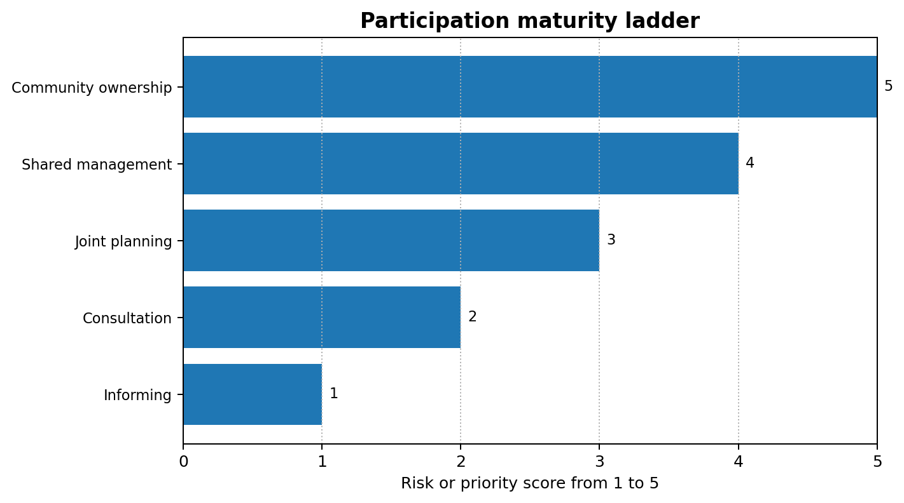
Figure 2. Participation maturity ladder from information to community ownership.

Table 2. Recommended cooperation framework for community based tourism
Framework element | Purpose | Practical action
Community tourism council | Create shared governance and resident voice. | Include women, youth, informal workers, cultural custodians and businesses.
Participatory planning cycle | Move beyond one time consultation. | Use mapping, feasibility review, pilot projects, monitoring and revision.
Benefit sharing system | Prevent value capture and build trust. | Publish revenue, rules, community fund spending and household payment criteria.
Cultural protocol | Protect dignity and identity. | Define photography, sacred sites, performance rules, fair payment and interpretation rights.
Monitoring dashboard | Make cooperation accountable. | Track local jobs, ownership, resident satisfaction, environmental pressure and complaints.

Discussion
The findings show that community participation is not a decorative part of tourism planning. It is a governance requirement because tourism depends on local people and affects local rights. A destination can build hotels, promote attractions and attract visitors, but without resident support it becomes socially fragile. Participation helps align tourism with local priorities and reduces the chance that economic growth will be experienced as dispossession. The practical question is how to move from general consultation to shared governance.
A strategic cooperation framework should begin with a community tourism council. The council should include elected community representatives, women, youth, informal workers, cultural custodians, local businesses, government agencies, NGOs and private sector partners. Its role should be to review tourism plans, monitor impacts, approve cultural protocols, identify training needs and advise on benefit sharing. Representation must be designed carefully. If only business owners and local elites participate, the council will reproduce inequality. Seats or consultation mechanisms should therefore be reserved for groups that are usually underrepresented.
The second part of the framework should be a participatory planning cycle. This cycle begins with community mapping of assets, concerns and desired futures. It then moves to product design, feasibility analysis, environmental and cultural safeguards, pilot implementation, monitoring and revision. The cycle should be repeated because tourism impacts change over time. A village may welcome initial visitors but later need visitor limits, waste systems or new cultural rules. Participatory planning should therefore be adaptive rather than a one off exercise at the start of a project.
The third part should be benefit sharing. Tourism projects need clear rules about how income is distributed between households, community funds, guides, cultural performers, conservation activities and local infrastructure. Community funds can support public goods such as paths, heritage restoration, scholarships, waste management or health facilities. However, benefit sharing must be transparent. Residents need to know how much revenue is collected, who manages it and how decisions are made. Financial opacity is one of the fastest ways to damage trust in community tourism.
The fourth part should be local enterprise support. Participation is weak if residents are asked to support tourism but cannot access markets. A cooperation framework should include training, small grants, low interest loans, shared booking systems, quality standards, cooperative branding and buyer meetings with hotels and tour operators. Digital skills are increasingly important because many visitors search and book online. Without digital access, local enterprises may depend on intermediaries who capture large commissions. Local enterprise support therefore strengthens both inclusion and competitiveness.
The fifth part should be cultural governance. Communities should decide how culture is represented, photographed, priced and protected. Cultural protocols can cover sacred sites, dress, photography, language, performance times, food authenticity, intellectual property and respectful visitor behaviour. Tourism can support cultural revival when it funds artisans, festivals and teaching. It can also harm culture when it rewards staged performances that residents feel do not represent them. Cultural governance ensures that tourism does not separate economic value from cultural dignity.
The sixth part should be environmental limits. Community based tourism is often located in fragile rural, coastal or heritage areas. Cooperation frameworks should include carrying capacity assessments, waste rules, water use standards, visitor dispersal, trail maintenance and biodiversity protection. Environmental monitoring should include local observations because residents often notice small changes before formal agencies do. If environmental costs are ignored, community support will decline and the destination's tourism assets will deteriorate.
The seventh part should be a grievance and review mechanism. Tourism creates conflict even in well planned destinations. Residents may disagree over visitor behaviour, revenue distribution, noise, land use or employment. A transparent grievance process gives people a way to raise problems before they become public conflict. Review mechanisms also allow partnerships to be renegotiated as conditions change. For example, a tour operator agreement may need revision if visitor numbers grow beyond the community's capacity or if costs increase.
Overall, community participation creates better tourism when it is institutionalised through structures, skills and rights. It is not enough to say that the community is involved. The test is whether residents have information, influence, ownership, income, cultural control and the ability to say no to harmful development. Development cooperation is therefore the bridge between participation as an ethical principle and participation as a functioning local development system.
A further strategic issue is internal community diversity. Community participation is sometimes described as if the community has one voice, but communities contain competing interests. For example, a household that owns a guesthouse may support more visitors, while a resident near a crowded trail may want stricter limits. A fair cooperation framework must therefore create space for disagreement and avoid claiming consensus too quickly.
Information quality is also critical. Participation is weak if residents are asked for opinions without understanding projected visitor numbers, land use effects, costs, revenue assumptions and environmental risks. Tourism plans should be translated into accessible language and shared before meetings. Informed participation is more demanding than consultation, but it produces decisions that are more legitimate and realistic.
Youth participation deserves special attention because young residents often decide whether tourism becomes a future livelihood or a temporary job. Training in guiding, digital marketing, languages, entrepreneurship and heritage interpretation can help young people see tourism as a professional pathway. Without youth involvement, community tourism may struggle with succession and innovation.
A further strategic issue is internal community diversity. Community participation is sometimes described as if the community has one voice, but communities contain competing interests. For example, a household that owns a guesthouse may support more visitors, while a resident near a crowded trail may want stricter limits. A fair cooperation framework must therefore create space for disagreement and avoid claiming consensus too quickly.
Information quality is also critical. Participation is weak if residents are asked for opinions without understanding projected visitor numbers, land use effects, costs, revenue assumptions and environmental risks. Tourism plans should be translated into accessible language and shared before meetings. Informed participation is more demanding than consultation, but it produces decisions that are more legitimate and realistic.
Youth participation deserves special attention because young residents often decide whether tourism becomes a future livelihood or a temporary job. Training in guiding, digital marketing, languages, entrepreneurship and heritage interpretation can help young people see tourism as a professional pathway. Without youth involvement, community tourism may struggle with succession and innovation.
A further strategic issue is internal community diversity. Community participation is sometimes described as if the community has one voice, but communities contain competing interests. For example, a household that owns a guesthouse may support more visitors, while a resident near a crowded trail may want stricter limits. A fair cooperation framework must therefore create space for disagreement and avoid claiming consensus too quickly.
Information quality is also critical. Participation is weak if residents are asked for opinions without understanding projected visitor numbers, land use effects, costs, revenue assumptions and environmental risks. Tourism plans should be translated into accessible language and shared before meetings. Informed participation is more demanding than consultation, but it produces decisions that are more legitimate and realistic.
Youth participation deserves special attention because young residents often decide whether tourism becomes a future livelihood or a temporary job. Training in guiding, digital marketing, languages, entrepreneurship and heritage interpretation can help young people see tourism as a professional pathway. Without youth involvement, community tourism may struggle with succession and innovation.
A further strategic issue is internal community diversity. Community participation is sometimes described as if the community has one voice, but communities contain competing interests. For example, a household that owns a guesthouse may support more visitors, while a resident near a crowded trail may want stricter limits. A fair cooperation framework must therefore create space for disagreement and avoid claiming consensus too quickly.
Information quality is also critical. Participation is weak if residents are asked for opinions without understanding projected visitor numbers, land use effects, costs, revenue assumptions and environmental risks. Tourism plans should be translated into accessible language and shared before meetings. Informed participation is more demanding than consultation, but it produces decisions that are more legitimate and realistic.
Youth participation deserves special attention because young residents often decide whether tourism becomes a future livelihood or a temporary job. Training in guiding, digital marketing, languages, entrepreneurship and heritage interpretation can help young people see tourism as a professional pathway. Without youth involvement, community tourism may struggle with succession and innovation.

Conclusion
Community participation is essential to tourism development because local people are not external to the destination product. They provide labour, culture, knowledge, hospitality and stewardship, and they experience the costs of tourism in daily life. Development cooperation makes participation practical by coordinating the roles of communities, governments, NGOs, private businesses, education providers and development partners. The report has shown that participatory planning improves legitimacy, social inclusion, cultural preservation, local ownership, environmental management and accountability.
The strongest form of participatory tourism is not simple consultation. It is shared governance supported by capacity building, transparent benefit sharing, local enterprise support, cultural protocols, environmental monitoring and grievance systems. Communities should be treated as decision makers and owners, not only as employees or attractions. The recommended cooperation framework gives destinations a way to convert tourism demand into inclusive local development. Tourism can support community wellbeing when it is planned with residents, managed through fair partnerships and measured against social, cultural, environmental and economic outcomes.

References
Ashley, C., Roe, D., & Goodwin, H. (2001). Pro-poor tourism strategies: Making tourism work for the poor. Overseas Development Institute.
Bramwell, B., & Lane, B. (2011). Critical research on the governance of tourism and sustainability. Journal of Sustainable Tourism, 19(4-5), 411-421.
Burgen, S. (2024, April 20). Tens of thousands protest against Canary Islands' unsustainable tourism model. The Guardian. https://www.theguardian.com/world/2024/apr/20/thousands-protest-canary-islands-unsustainable-tourism
Goodwin, H. (2011). Taking responsibility for tourism. Goodfellow Publishers.
Jackson, L. A. (2025). Community-based tourism: A catalyst for achieving the Sustainable Development Goals. Tourism and Hospitality, 6(1), 29. https://www.mdpi.com/2673-5768/6/1/29
Lacher, R. G., & Nepal, S. K. (2010). From leakages to linkages: Local-level strategies for capturing tourism revenue in Northern Thailand. Tourism Geographies, 12(1), 77-99. https://doi.org/10.1080/14616680903493654
Mitchell, J., & Ashley, C. (2010). Tourism and poverty reduction: Pathways to prosperity. Earthscan.
Organisation for Economic Co-operation and Development. (2024). OECD tourism trends and policies 2024. OECD Publishing. https://www.oecd.org/en/publications/2024/07/oecd-tourism-trends-and-policies-2024_17ff33a3.html
Quang, T. D., et al. (2023). Toward sustainable community-based tourism development. Humanities and Social Sciences Communications, 10, 676. https://pmc.ncbi.nlm.nih.gov/articles/PMC10617687/
Scheyvens, R. (1999). Ecotourism and the empowerment of local communities. Tourism Management, 20(2), 245-249.
Tosun, C. (2000). Limits to community participation in the tourism development process in developing countries. Tourism Management, 21(6), 613-633.
United Nations Department of Economic and Social Affairs. (n.d.). Sustainable tourism. https://sdgs.un.org/topics/sustainable-tourism
United Nations Development Programme India. (2021, October 23). Community-based tourism: Protecting nature, conserving traditions. https://www.undp.org/india/blog/community-based-tourism-protecting-nature-conserving-traditions
United Nations Development Programme Thailand. (2023). Community-Based Tourism for All: Co-creation Journey. https://www.undp.org/thailand/publications/community-based-tourism-all-co-creation-journey
United Nations Development Programme Turkiye. (n.d.). Capacity development for sustainable community based tourism. https://www.undp.org/turkiye/projects/capacity-development-sustainable-community-based-tourism
UN Tourism. (n.d.). Sustainable development. https://www.untourism.int/sustainable-development
World Bank. (n.d.). Tourism. https://www.worldbank.org/ext/en/topic/tourism
World Economic Forum. (2024, February 15). Turning tourism into development. https://www.weforum.org/stories/2024/02/turning-tourism-into-development/

Appendices
Appendix A provides a participation quality checklist. It asks whether the community received information early, whether marginalised groups were represented, whether residents influenced final decisions, whether cultural protocols were approved locally and whether benefit sharing rules were published.
The checklist should be repeated at the start, middle and end of a tourism project. Participation should be treated as an ongoing governance process rather than a signature collected at the approval stage.

