Leadership Styles and Their Impact on Team Performance
Selected assignment option: Option 2
Module: M25 Managerial Leadership and Emotional Intelligence
Report Type: Detailed Project Report
Submission date: 24 May 2026

Table of Contents
Section | Page
Abstract | 3
Introduction | 3
Literature Review | 4
Methodology | 9
Findings | 10
Discussion | 15
Conclusion | 19
References | 21
Appendices | 24

Abstract
This report analyzes leadership styles and their impact on team performance in modern organizations. It compares autocratic, democratic, transformational, transactional, and servant leadership, and evaluates how each style influences employee engagement, productivity, and workplace culture. The report uses a qualitative literature based methodology, supported by current workplace evidence and organizational examples. The main finding is that no single leadership style is universally effective. Team performance improves when managers understand the task context, the emotional climate, the competence of the team, and the level of risk involved. Transformational and servant leadership are generally stronger for engagement and culture because they emphasize purpose, development, trust, and empowerment. Transactional leadership remains useful for clarity, compliance, and operational reliability. Democratic leadership improves commitment when decisions benefit from employee knowledge. Autocratic leadership can be appropriate only in urgent and high risk situations where speed and coordination matter. Emotional intelligence is the adaptive capability that allows managers to select and apply the right style without becoming rigid, reactive, or manipulative. The report recommends a blended leadership approach that combines transformational purpose, servant support, democratic participation, transactional clarity, and limited ethical authority during crisis.

Introduction
Leadership style is one of the most important managerial factors affecting team performance. Employees do not experience leadership as an abstract theory. They experience it through how managers communicate, delegate, make decisions, handle mistakes, recognize effort, and respond to pressure. A leadership style therefore shapes the daily climate of the team. It influences whether employees feel trusted or controlled, whether they contribute ideas or remain silent, whether they focus only on minimum compliance or show discretionary effort. In modern organizations, this is especially important because teams are often cross functional, hybrid, culturally diverse, and dependent on knowledge sharing.
The need for effective leadership is also visible in engagement evidence. Gallup's State of the Global Workplace 2026 report found that only 20% of employees worldwide were engaged in 2025, with low engagement estimated to cost the global economy about $10 trillion in lost productivity (Gallup, 2026). This reinforces the importance of management behaviour because employees often interpret their relationship with the organization through their immediate manager. Leadership style is therefore not only a personal preference. It is a performance variable with consequences for productivity, morale, retention, innovation, and workplace culture.
The purpose of this report is to compare major leadership styles and analyze their impact on team performance. The report examines autocratic, democratic, transformational, transactional, and servant leadership. It discusses how these styles affect employee engagement, productivity, and culture. It also assesses the role of emotional intelligence in helping managers adapt leadership style to different situations. The central argument is that effective team leadership requires contingency thinking. Managers should not apply 1 style automatically. They should use emotional intelligence and evidence based judgement to match leadership behaviour with the task, people, risk, and organizational context.

Literature Review
Autocratic leadership is a style in which decision making is concentrated in the leader. The manager gives instructions, controls processes, and expects compliance. This style is often criticized because it can reduce participation, trust, and creativity. However, it is not always inappropriate. In high risk, urgent, or highly regulated contexts, clear authority can prevent confusion. For example, during a safety incident or security breach, teams require rapid direction rather than extended consultation. The problem arises when autocratic leadership becomes the normal style in knowledge based work. It can create dependence, fear, and low engagement because employees learn that their judgement is not valued.
Democratic leadership involves participation, consultation, and shared decision input. It can improve engagement because employees feel heard and are more likely to support decisions they helped shape. Democratic leadership is especially useful when managers need diverse knowledge, creativity, and commitment. It supports psychological ownership because people are not treated only as executors of instructions. However, democratic leadership also has limits. It can become slow if every issue is opened for group discussion. It can also frustrate employees if consultation is symbolic and the decision has already been made. Therefore, democratic leadership requires clarity about which decisions are open to input and which constraints are fixed.
Transformational leadership is one of the most influential leadership theories. It focuses on inspiring followers through purpose, idealized influence, intellectual stimulation, and individualized consideration (Bass, 1985; Bass & Riggio, 2006). Transformational leaders articulate a compelling vision, encourage employees to think differently, and attend to individual development. This style is strongly connected to engagement and innovation because it encourages employees to see work as meaningful. It also supports adaptability because employees are encouraged to learn rather than simply comply. The main risk is that transformational language can become unrealistic if it is not matched by resources, ethical behaviour, and operational discipline.
Transactional leadership is based on clear expectations, monitoring, rewards, and corrective action. It is sometimes presented as inferior to transformational leadership, but this is too simplistic. Teams need clarity, roles, deadlines, and performance standards. Transactional leadership supports reliability because employees understand what is expected and what consequences follow. It is effective for routine operations, compliance work, and short term targets. However, a purely transactional style can reduce intrinsic motivation if employees experience work only as exchange. It can also discourage innovation because employees focus on meeting defined metrics rather than questioning whether the metrics still make sense.
Servant leadership reverses the traditional image of leadership by emphasizing service to followers, humility, stewardship, and employee development (Greenleaf, 1977; Eva et al., 2019). Servant leaders seek to remove barriers, support growth, and build community. This style has strong relevance for modern workplaces because employees increasingly expect respect, wellbeing support, inclusion, and meaningful work. Servant leadership can improve culture by creating trust and psychological safety. Its limitation is that it can be misunderstood as unlimited accommodation. Effective servant leadership still requires boundaries, standards, and performance accountability.
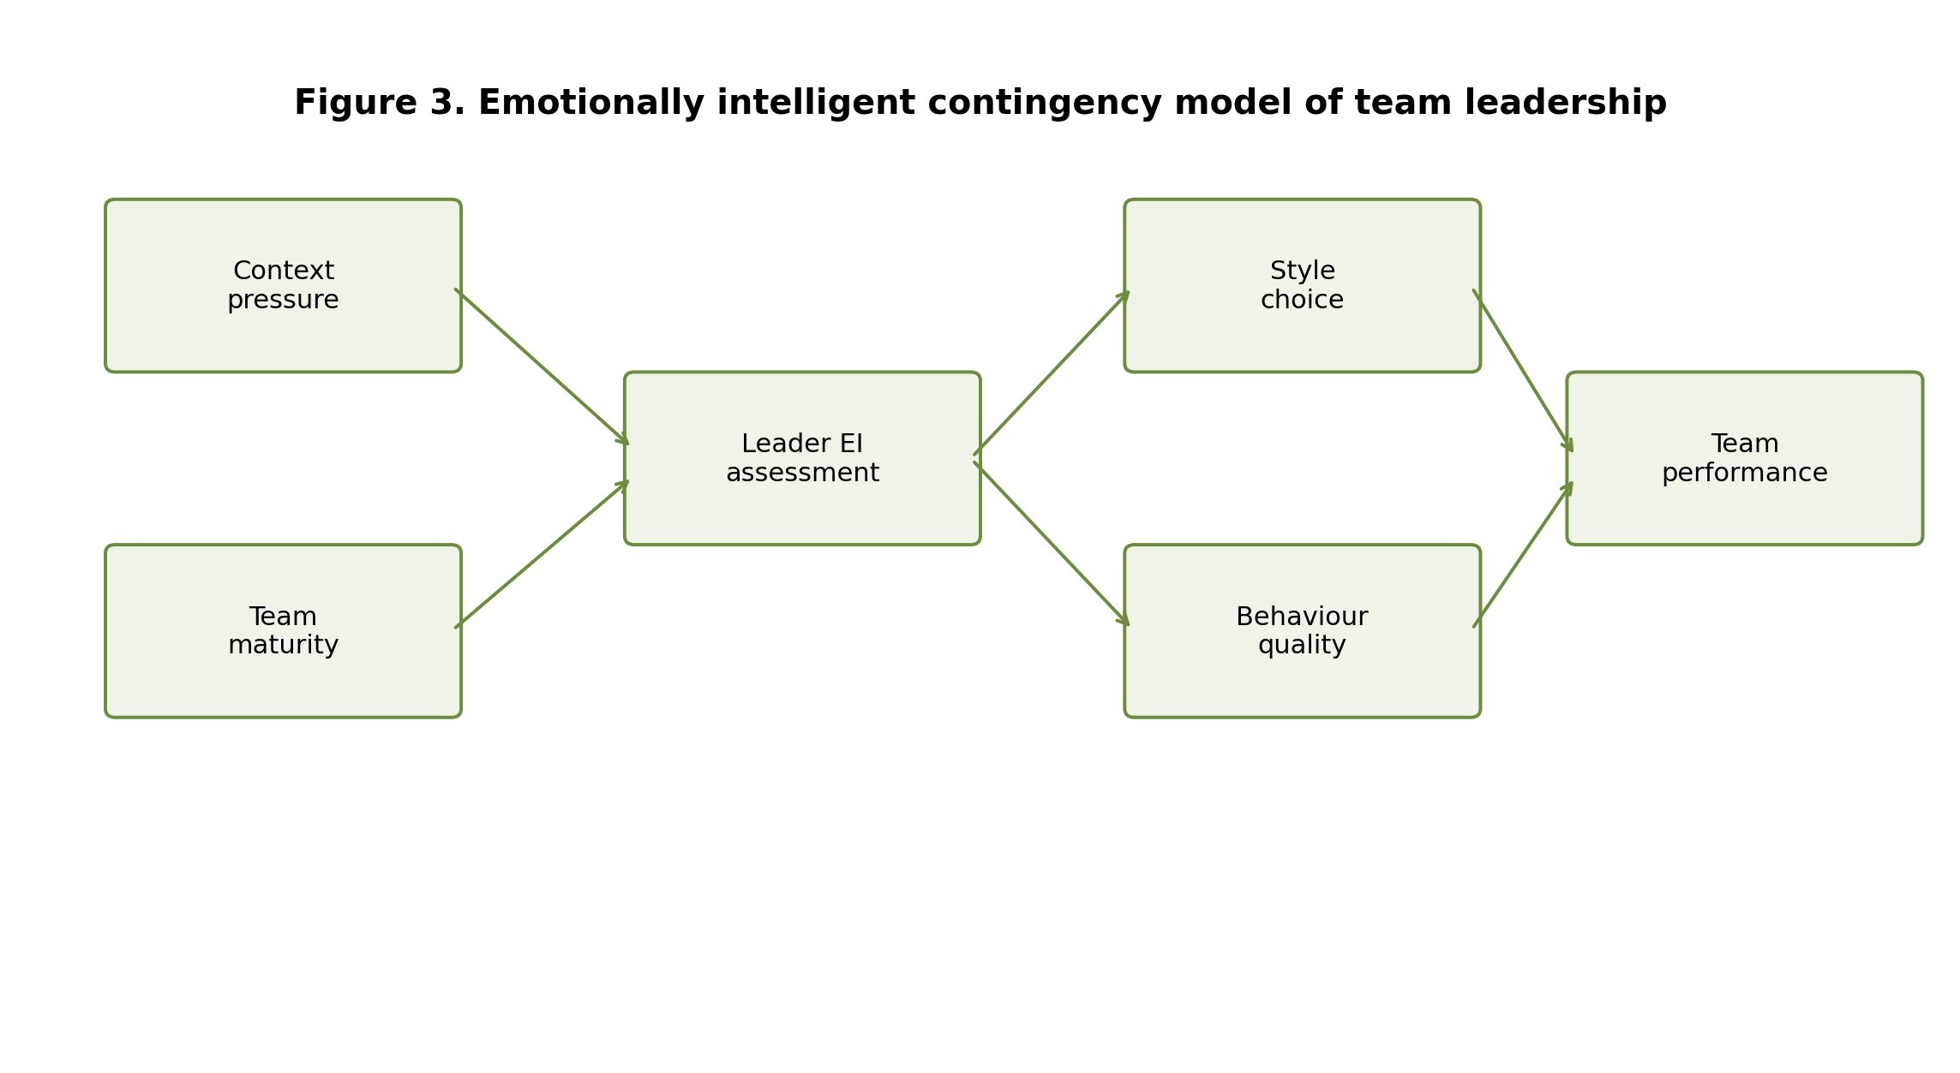
Figure 1. Emotionally intelligent contingency model of team leadership.
Emotional intelligence is central to style adaptation. A manager must read the emotional and practical needs of a situation before deciding how to lead. Mayer and Salovey (1997) define emotional intelligence as abilities related to perceiving, understanding, using, and managing emotions. Goleman's leadership model identifies self awareness, self regulation, motivation, empathy, and social skills as key emotional intelligence capabilities (Goleman, 1998). In style adaptation, these capabilities help managers decide whether a team needs direction, participation, inspiration, support, or corrective clarity. Without emotional intelligence, leaders become rigid. They either over control, over consult, over inspire, or over accommodate.
Team performance is multidimensional. It includes task productivity, quality, innovation, commitment, trust, learning, and culture. A team can hit a short term target while damaging trust and future capacity. Similarly, a team can feel positive but still underperform if roles and standards are unclear. Leadership style therefore needs to be evaluated across multiple outcomes. Transformational and servant styles tend to be stronger for engagement and culture. Transactional style tends to be stronger for short term clarity and accountability. Democratic style supports knowledge sharing and commitment. Autocratic style is most defensible during crisis, but harmful when overused.
Google's team effectiveness research is useful here because it shifts attention from individual talent to team dynamics. Google re:Work identifies psychological safety, dependability, structure and clarity, meaning, and impact as major dynamics of effective teams (Google re:Work, 2026). These dynamics are not produced by a single leadership style. Psychological safety requires servant and democratic behaviours. Structure and clarity require transactional behaviours. Meaning and impact require transformational behaviours. Dependability requires accountability. This supports the argument that effective managers need a blended and adaptive leadership approach.
The literature also warns against treating leadership style as a fixed identity. A manager might describe themselves as transformational but behave autocratically during pressure. Another manager might value servant leadership but avoid difficult feedback. This is why emotional intelligence and self awareness are necessary. Leaders need to understand not only the style they prefer but also the style their team actually experiences. Employee feedback, engagement data, turnover patterns, and meeting behaviour are important evidence. Leadership effectiveness should be judged by impact, not by a leader's self description.
A critical perspective also recognizes that leadership style is shaped by organizational systems. A manager may wish to be participative, but excessive workload, unrealistic targets, and punitive senior leadership can encourage control. A manager may wish to be transformational, but poor strategy can make vision statements sound empty. Therefore, leadership development must address both individual capability and organizational context. Leadership style is not only a personal choice. It is also enabled or constrained by culture, incentives, structure, and governance.
Leadership style theory also needs to be considered through the lens of power. Every leadership style gives and withholds power in different ways. Autocratic leadership centralizes power. Democratic leadership distributes voice. Transformational leadership uses symbolic and emotional power to shape meaning. Transactional leadership uses reward and corrective power. Servant leadership uses power to enable others. The ethical issue is not simply whether power exists, because all management involves power. The issue is whether power is used transparently, proportionately, and in the interests of sustainable performance. This is why emotional intelligence must be joined with ethical judgement.
Team maturity is another key contingency. A new or inexperienced team often needs more structure, coaching, and clarity. A highly skilled team may need autonomy, strategic direction, and removal of barriers. A team in conflict may need mediation before it can use participation productively. A team facing repeated failure may need a combination of support and stronger accountability. Leadership style therefore changes as the team develops. Managers who continue to use the same style after team conditions change can create dependency, frustration, or underperformance.

Methodology
This report uses a qualitative literature based methodology. It synthesizes leadership theory, emotional intelligence research, and practitioner evidence on employee engagement and team effectiveness. This method is appropriate because the assignment requires comparison, discussion, assessment, and recommendations rather than primary fieldwork. The report uses academic sources to define leadership styles and practitioner sources to connect the analysis to current workplace conditions.
The sources were selected using relevance and credibility criteria. Classic leadership sources were used because they define major styles and remain central to leadership theory. Current workplace reports were used to show why leadership style matters in contemporary organizations. Google re:Work was used because it offers a recognized practical model of team effectiveness. Gallup was used because it provides current engagement evidence and highlights the economic importance of management. Microsoft was used as a real world example of leadership culture based on growth mindset, empathy, and transformation. The report also draws on emotional intelligence literature to explain how managers adapt style to context.
The analysis was organized around 4 questions. First, what are the defining features of each leadership style? Second, how does each style affect engagement, productivity, and workplace culture? Third, what role does emotional intelligence play in style adaptation? Fourth, what leadership approach should organizations recommend to improve team performance? These questions were used to build the findings and recommendations. The limitation is that the report does not collect primary performance data from a specific company. It therefore provides a strategic and evidence informed argument rather than a statistical test.

Findings
The first finding is that leadership style affects engagement through the level of voice, respect, and meaning employees experience. Autocratic leadership tends to reduce engagement when employees feel that their knowledge and judgement are ignored. It can be tolerated during emergency but becomes damaging when it is used for routine decisions. Democratic leadership improves engagement because employees are invited to contribute. However, participation must be genuine. If employees are asked for input but see no evidence that input matters, trust is weakened.
Transformational leadership has a strong positive relationship with engagement because it connects work to purpose. Employees are more willing to invest energy when they understand why their work matters. Transformational leadership also supports confidence during change because it offers a narrative of direction. Servant leadership improves engagement by showing employees that the manager values their growth and wellbeing. Transactional leadership improves engagement only when employees value clarity and fairness. If it becomes narrow control through rewards and penalties, engagement becomes fragile and dependent on external incentives.
The second finding is that leadership style affects productivity differently depending on task type. Autocratic leadership can produce fast coordination when tasks are simple, urgent, and require compliance. However, it can reduce productivity in complex work because employees wait for instructions and avoid initiative. Democratic leadership can improve productivity where decisions benefit from employee knowledge. It increases the quality of solutions because front line employees often understand problems that senior managers do not see. The trade off is that consultation takes time and needs skilled facilitation.
Table 1. Comparison of leadership styles and performance implications
Leadership style | Main strength | Main risk | Best use
Autocratic | Fast decision making and clear control | Low voice, fear, and reduced creativity | Crisis, safety risk, or urgent coordination
Democratic | Participation and commitment | Slow decisions if overused | Complex decisions requiring employee knowledge
Transformational | Purpose, innovation, and change energy | Vision without execution if poorly managed | Strategic change and learning environments
Transactional | Clarity, standards, and accountability | Low intrinsic motivation if too narrow | Routine delivery and compliance
Servant | Trust, development, and inclusion | Weak accountability if misunderstood | Capability building and culture improvement
Transactional leadership is useful for operational productivity because it defines targets, deadlines, roles, and consequences. It helps teams deliver consistent outputs, especially in environments where quality and compliance matter. Transformational leadership improves productivity by raising aspiration, learning, and commitment. It is particularly useful when teams face change, innovation, or strategic renewal. Servant leadership improves productivity indirectly by reducing barriers and supporting capability. A servant manager who removes obstacles, protects focus time, and develops employees can improve output without relying on pressure.
The third finding is that leadership style has a strong impact on workplace culture. Culture is shaped by repeated behaviours. If a manager frequently uses control, blame, and unilateral decisions, the team culture becomes cautious and dependent. If a manager uses participation without clarity, the culture can become slow and ambiguous. If a manager uses inspiration without execution discipline, culture can become enthusiastic but inconsistent. If a manager uses service without accountability, culture can become comfortable but underperforming. The most effective culture requires a combination of psychological safety, clarity, purpose, and accountability.
Google's team effectiveness model supports this blended view. Psychological safety requires employees to feel safe speaking up. Dependability requires people to complete quality work on time. Structure and clarity require clear roles and plans. Meaning requires personal connection to work. Impact requires belief that work matters (Google re:Work, 2026). These 5 dynamics cannot be generated by 1 leadership style alone. Managers need democratic and servant behaviours to create voice, transactional behaviours to create clarity, and transformational behaviours to create meaning and impact.
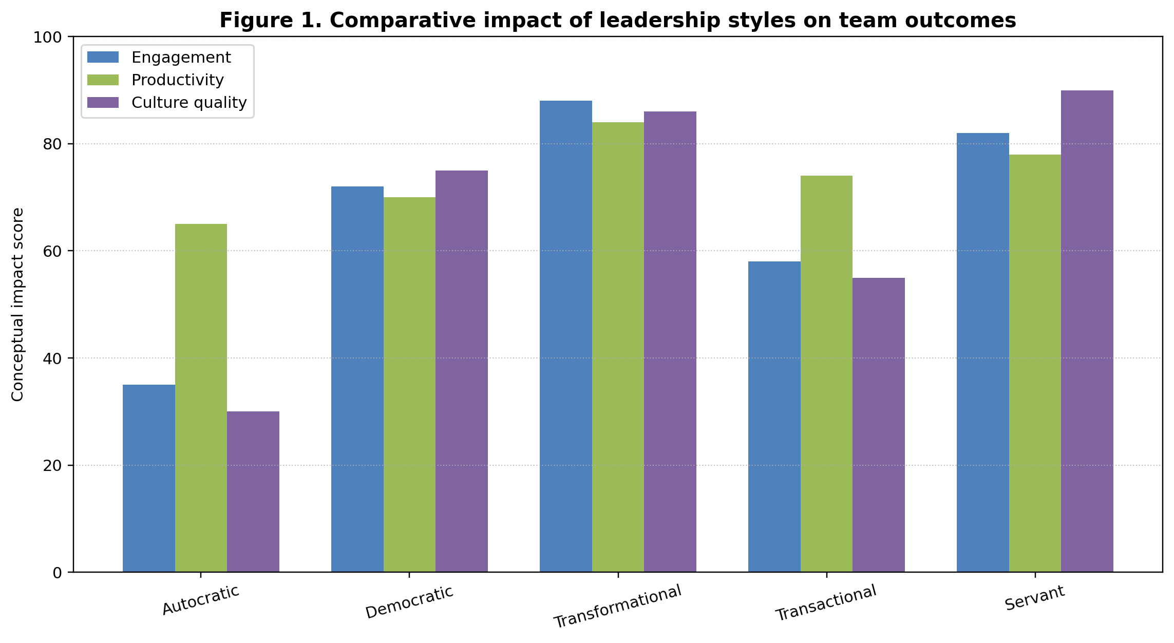
Figure 2. Comparative impact of leadership styles on team outcomes. Scores are conceptual synthesis scores based on the literature reviewed in this report.
The fourth finding is that emotional intelligence determines whether leadership style is applied appropriately. A manager with low emotional intelligence may use autocratic behaviour because they feel anxious, not because the situation requires speed. Another manager may use democratic behaviour because they fear conflict, not because participation is valuable. A transformational leader may overuse vision language to avoid operational details. A servant leader may over accommodate because they cannot tolerate employee disappointment. Emotional intelligence helps managers distinguish situational need from personal emotional habit.
Self awareness helps managers recognize their preferred style and emotional triggers. A manager who knows that they become controlling under pressure can deliberately ask for input before closing a decision. Self regulation helps managers avoid reactive over correction. Empathy helps managers understand whether employees need support, clarity, challenge, or autonomy. Social skills help managers communicate style shifts transparently. For example, a manager can say that a safety issue requires immediate direction today, but that the team will review the process together afterwards. This protects both speed and trust.
The fifth finding is that transformational and servant leadership are generally the strongest styles for long term team performance, but they still need transactional clarity. Transformational leadership gives direction and meaning. Servant leadership gives support and trust. Democratic leadership gives participation and knowledge sharing. Transactional leadership gives structure and accountability. Autocratic leadership gives emergency coordination. The recommended model is therefore not to replace one style with another. It is to build a leadership repertoire and apply each style within ethical limits.
The Microsoft example illustrates this blended approach. Microsoft publicly describes its culture as rooted in growth mindset, where potential is nurtured and people are expected to keep learning (Microsoft, n.d.). Microsoft's discussion of empathy and innovation under Satya Nadella connects empathy to collaboration, accessibility, and product improvement (Microsoft, 2019). This reflects transformational leadership through renewed purpose, servant elements through empathy, and transactional discipline through strategic execution in cloud, digital transformation, and artificial intelligence. The case shows that leadership style becomes powerful when it is linked to culture, systems, and strategic direction.
The sixth finding is that poor style fit creates performance risks. Autocratic leadership in creative teams reduces idea generation. Democratic leadership in emergency contexts delays action. Transactional leadership in innovation contexts can reduce experimentation. Transformational leadership without delivery discipline can create promise fatigue. Servant leadership without accountability can create role confusion. Therefore, managerial leadership should be evaluated through fit rather than popularity. The best question is not which style is fashionable, but which style produces ethical, sustainable performance in the specific context.
The seventh finding is that leadership style affects inclusion. Autocratic and purely transactional managers can unintentionally privilege confident employees who already understand informal rules. Democratic and servant behaviours can increase inclusion because they create space for quieter employees, new starters, and minority voices. However, participation must be structured. In unstructured discussions, dominant voices can still control decisions. Emotionally intelligent managers actively design participation through clear questions, turn taking, written input, and psychological safety. This improves both fairness and decision quality.
The eighth finding is that hybrid work makes leadership style more visible and more fragile. In office based teams, informal contact can repair misunderstandings quickly. In hybrid teams, silence can be misread, feedback can feel abrupt, and employees can feel disconnected from culture. Autocratic communication through digital channels can appear colder than intended. Democratic leadership requires more deliberate design because online meetings can privilege the most confident voices. Servant leadership requires managers to notice workload and wellbeing signals without relying on physical presence. Transformational leadership requires repeated communication because purpose can weaken when employees work in isolation.
The ninth finding is that the most effective leadership style also depends on the performance horizon. Short term productivity can sometimes be increased through transactional pressure or directive control, but this can damage long term commitment if employees feel used. Long term performance requires learning, retention, trust, and adaptability. Transformational and servant leadership are therefore stronger for sustained team capability, while transactional leadership protects operational discipline. An organization that focuses only on immediate output can mistake compliance for commitment. This becomes risky when employees face change, uncertainty, or opportunities to leave.
The tenth finding is that leadership style affects the quality of decision making. Autocratic leaders can make decisions quickly, but they risk missing information from people closest to the work. Democratic leaders gather more information, but they need methods to avoid endless debate. Transformational leaders can frame decisions around purpose, but they must avoid optimism bias. Transactional leaders can use data and standards, but they can become trapped by existing metrics. Servant leaders can include stakeholder needs, but they must avoid delaying necessary trade offs. Emotional intelligence improves decision quality by helping managers notice when emotion is distorting judgement.

Discussion
The analysis indicates that leadership style should be understood as a set of managerial behaviours rather than a fixed personality label. Team performance requires different behaviours at different times. During crisis, employees may need clear direction. During innovation, they need autonomy and psychological safety. During routine delivery, they need structure and feedback. During conflict, they need listening and fairness. During development, they need coaching and opportunity. Effective managers move between these behaviours while maintaining ethical consistency.
The most defensible recommendation is a blended leadership model. Transformational leadership should provide purpose and strategic energy. Servant leadership should provide support, trust, and development. Democratic leadership should provide employee voice and knowledge sharing. Transactional leadership should provide standards, role clarity, and accountability. Autocratic leadership should be limited to urgent, high risk, or time critical conditions, and even then it should be used with emotional restraint and later explanation. This model avoids the mistake of treating any single style as universally best.
Emotional intelligence is the integrating capability in this blended model. Without emotional intelligence, managers often confuse their comfort zone with situational fit. A leader who likes control will overuse autocracy. A leader who likes harmony will overuse consultation. A leader who enjoys inspiration will overuse vision. A leader who wants to be liked will overuse servant behaviour. Emotional intelligence enables managers to diagnose the emotional climate, manage their own reactions, and choose the style that best serves team performance and organizational ethics.
Table 2. Recommended blended leadership approach
Performance need | Recommended style blend | Managerial action
Employee engagement | Transformational plus servant | Connect work to purpose and show genuine support
Operational reliability | Transactional plus coaching | Clarify standards and provide feedback
Innovation | Transformational plus democratic | Invite challenge and encourage experimentation
Conflict repair | Servant plus democratic | Listen, mediate, and rebuild trust
Urgent risk | Limited autocratic plus ethical explanation | Direct action quickly and review afterwards
Organizations can support adaptive leadership through practical systems. Promotion criteria should assess people leadership, not only technical output. Leadership development should include style diagnosis, emotional intelligence feedback, coaching conversations, conflict management, and inclusive decision making. Performance management should reward both results and the way results are achieved. Engagement surveys should be analyzed at team level and followed by manager development plans. Senior leaders should model balanced leadership because middle managers often imitate the behaviour that is rewarded at the top.
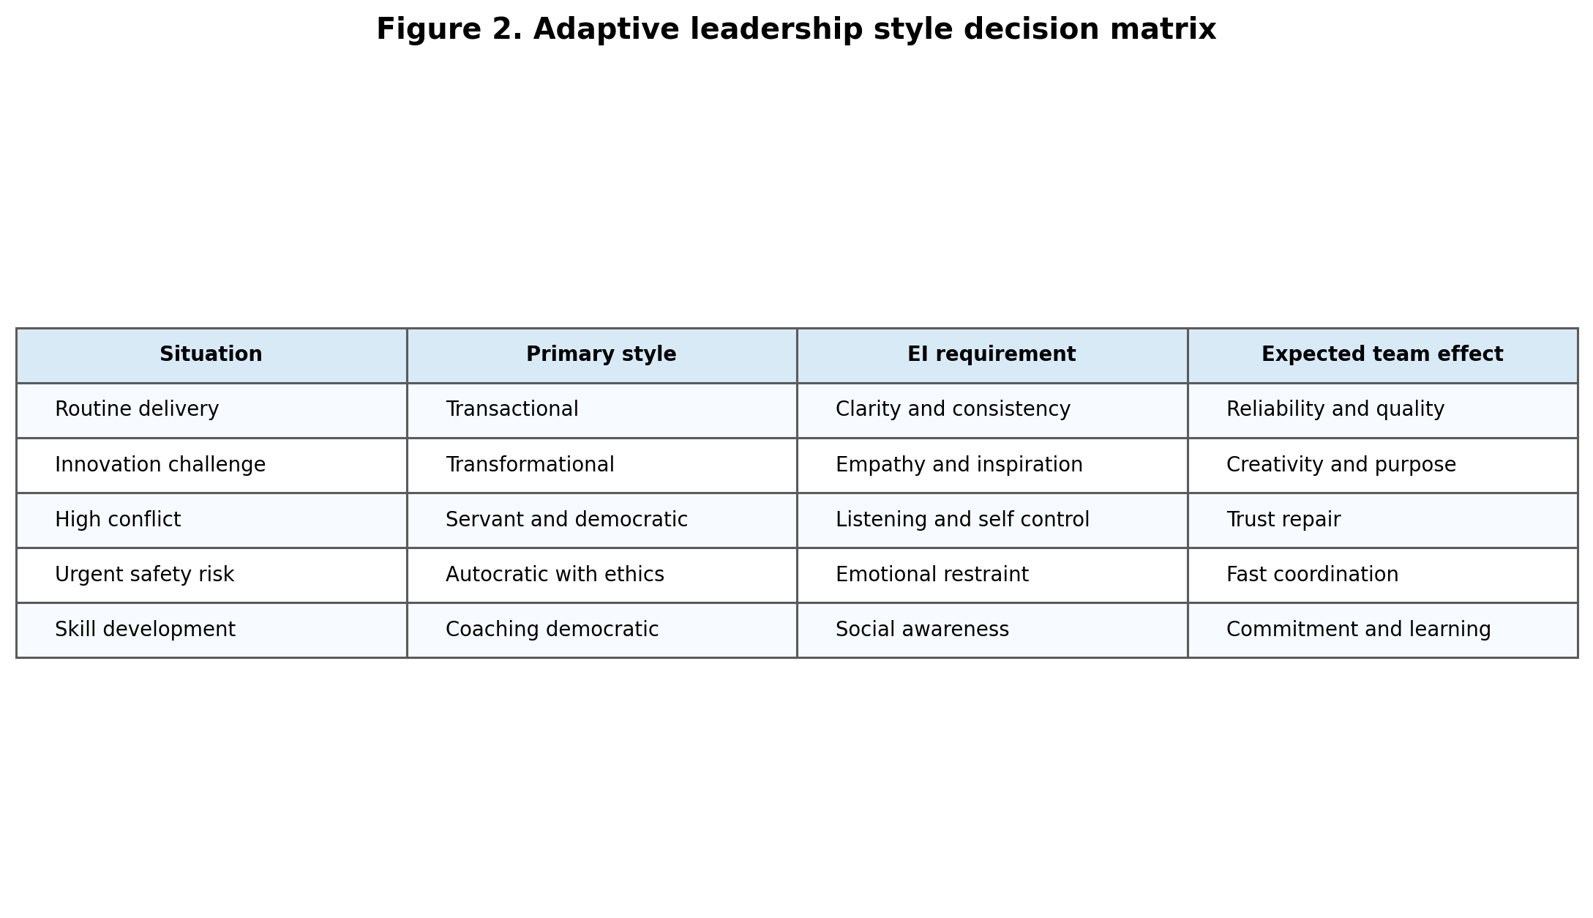
Figure 3. Adaptive leadership style decision matrix.
A specific implementation framework can use 4 stages. Stage 1 is diagnosis, where managers assess team maturity, task uncertainty, risk level, and emotional climate. Stage 2 is style selection, where managers decide whether the situation requires direction, participation, inspiration, support, or accountability. Stage 3 is communication, where managers explain expectations and decision rights. Stage 4 is review, where the team evaluates whether the leadership approach improved performance and trust. This creates a learning loop rather than a fixed style label.
The report also highlights the importance of ethical boundaries. Autocratic leadership can become bullying if it is normalized. Democratic leadership can become manipulation if consultation is fake. Transformational leadership can become charismatic pressure if vision is used to silence criticism. Transactional leadership can become unfair if rewards and penalties are biased. Servant leadership can become exploitation of the leader if support is not mutual and sustainable. Emotional intelligence should therefore be joined with ethical decision making, transparency, and accountability.
The final discussion point is that team performance cannot be reduced to employee happiness or output alone. Sustainable performance requires engaged people, reliable delivery, learning, trust, and responsible conduct. The strongest leadership approach is one that protects both human and operational outcomes. This is why the recommended model combines transformational, servant, democratic, and transactional elements. It gives teams purpose, support, voice, and structure. It also recognizes that exceptional circumstances sometimes require temporary directive authority.
For practical application, organizations should train managers to use leadership style as a diagnostic choice. Before important decisions, managers should ask 5 questions. What is the level of risk? How much expertise does the team have? How much commitment is needed for implementation? How much time is available? What is the emotional climate of the team? These questions prevent automatic leadership behaviour. They also make style choices explainable to employees, which improves trust even when the decision requires directive action.
A second practical implication is that leadership development should include evidence from the team. Managers often overestimate their own flexibility. A manager may believe they are democratic because they invite questions, while employees experience the manager as dismissive after questions are asked. Another manager may believe they are servant oriented, while employees experience lack of clarity. Team feedback helps reveal the gap between intended style and experienced style. This feedback should be used for development rather than blame, because the aim is behavioural improvement.
The final implication is that team performance should be assessed through balanced indicators. If organizations measure only output, managers may overuse pressure. If they measure only engagement, managers may avoid accountability. A balanced score should include productivity, quality, engagement, psychological safety, learning, inclusion, and ethical conduct. This encourages managers to use a balanced leadership repertoire. It also aligns leadership behaviour with sustainable performance rather than short term appearance.

Conclusion
Leadership styles have a direct impact on team performance because they shape engagement, productivity, culture, trust, and learning. Autocratic leadership can support urgent coordination but damages engagement and creativity when overused. Democratic leadership improves commitment and decision quality when participation is genuine and well structured. Transformational leadership strengthens purpose, innovation, and commitment, but must be grounded in delivery. Transactional leadership supports clarity and reliability, but becomes limiting when it is the only style. Servant leadership builds trust, inclusion, and development, but must include accountability.
The main conclusion is that effective managers need an adaptive leadership repertoire. No single style is suitable for every situation. Emotional intelligence enables managers to diagnose context, manage their own reactions, understand employee needs, and apply the right style ethically. The recommended approach is a blended model built around transformational purpose, servant support, democratic voice, transactional clarity, and limited autocratic direction during genuine crisis. This approach is most likely to improve team performance because it balances human motivation with operational discipline. Organizations should therefore develop leaders who can move beyond fixed style labels and lead with evidence, emotional intelligence, and ethical judgement.
Word count excluding references: 4114

References
Avolio, B. J., Walumbwa, F. O., & Weber, T. J. (2009). Leadership: Current theories, research, and future directions. Annual Review of Psychology, 60, 421-449. https://doi.org/10.1146/annurev.psych.60.110707.163621
Bass, B. M. (1985). Leadership and performance beyond expectations. Free Press.
Bass, B. M., & Riggio, R. E. (2006). Transformational leadership (2nd ed.). Psychology Press.
CIPD. (2025a). Evidence based HR: Make better decisions and step up your influence. https://www.cipd.org/en/knowledge/guides/evidence-based-profession/
CIPD. (2025b). Employee engagement and motivation. https://www.cipd.org/en/knowledge/factsheets/engagement-factsheet/
Edmondson, A. C. (1999). Psychological safety and learning behavior in work teams. Administrative Science Quarterly, 44(2), 350-383. https://doi.org/10.2307/2666999
Gallup. (2024). How to improve employee engagement in the workplace. https://www.gallup.com/workplace/285674/improve-employee-engagement-workplace.aspx
Gallup. (2026). State of the global workplace: 2026 report. https://www.gallup.com/workplace/349484/state-of-the-global-workplace.aspx
Goleman, D. (1998). What makes a leader? Harvard Business Review, 76(6), 93-102.
Google re:Work. (2026). Understand team effectiveness. https://rework.withgoogle.com/intl/en/guides/understand-team-effectiveness
Harms, P. D., & Crede, M. (2010). Emotional intelligence and transformational and transactional leadership: A meta analysis. Journal of Leadership & Organizational Studies, 17(1), 5-17. https://doi.org/10.1177/1548051809350894
Joseph, D. L., & Newman, D. A. (2010). Emotional intelligence: An integrative meta analysis and cascading model. Journal of Applied Psychology, 95(1), 54-78. https://doi.org/10.1037/a0017286
Mayer, J. D., & Salovey, P. (1997). What is emotional intelligence? In P. Salovey & D. Sluyter (Eds.), Emotional development and emotional intelligence: Educational implications (pp. 3-31). Basic Books.
Mayer, J. D., Salovey, P., & Caruso, D. R. (2004). Emotional intelligence: Theory, findings, and implications. Psychological Inquiry, 15(3), 197-215. https://doi.org/10.1207/s15327965pli1503_02
Miao, C., Humphrey, R. H., & Qian, S. (2018). A cross cultural meta analysis of how leader emotional intelligence influences subordinate task performance and organizational citizenship behavior. Journal of World Business, 53(4), 463-474. https://doi.org/10.1016/j.jwb.2018.01.003
Microsoft. (2019). How Microsoft is using empathy to lead innovation. https://news.microsoft.com/source/features/innovation/empathy-innovation-accessibility/
Microsoft. (n.d.). Culture. https://careers.microsoft.com/v2/global/en/culture
O'Boyle, E. H., Humphrey, R. H., Pollack, J. M., Hawver, T. H., & Story, P. A. (2011). The relation between emotional intelligence and job performance: A meta analysis. Journal of Organizational Behavior, 32(5), 788-818. https://doi.org/10.1002/job.714
Burns, J. M. (1978). Leadership. Harper & Row.
Eva, N., Robin, M., Sendjaya, S., van Dierendonck, D., & Liden, R. C. (2019). Servant leadership: A systematic review and call for future research. The Leadership Quarterly, 30(1), 111-132. https://doi.org/10.1016/j.leaqua.2018.07.004
Greenleaf, R. K. (1977). Servant leadership: A journey into the nature of legitimate power and greatness. Paulist Press.
Northouse, P. G. (2021). Leadership: Theory and practice (9th ed.). SAGE.
Yukl, G. (2013). Leadership in organizations (8th ed.). Pearson.

Appendices

Appendix A. Leadership style selection checklist
This checklist can be used before important team decisions. It encourages managers to select a leadership style based on context rather than personal habit.
Appendix Table A1. Style selection checklist
Question | Interpretation
Is there immediate safety or operational risk? | Use temporary directive authority with ethical explanation
Does the decision require employee knowledge? | Use democratic consultation
Is the team facing change or uncertainty? | Use transformational purpose setting
Does the team lack role clarity? | Use transactional clarification
Are trust and morale damaged? | Use servant and coaching behaviours

Appendix B. Team performance review indicators
Leadership style should be evaluated through both performance and human indicators. This avoids the narrow view that a team is effective only because it reaches a short term target.
Appendix Table B1. Suggested indicators
Outcome | Indicator
Engagement | Survey score, participation, voluntary contribution
Productivity | Output quality, cycle time, deadline reliability
Culture | Psychological safety, inclusion, trust
Learning | Ideas raised, experiments completed, lessons shared
Accountability | Role clarity, follow through, fair corrective action

