
Data Analytics for Business
Data-Driven Decision-Making and Business Performance: The Role of Business Analytics in Improving Managerial Decision-Making, Operational Performance and Competitive Advantage
Student Name: Rajkumar Kantibhai Donga
Student ID: HMH26006

Abstract
In this report, the role of data-driven decision-making and business analytics in enhancing managerial decision-making, operational performance and competitive advantage is analysed. It assesses four types of analytics (descriptive, diagnostic, predictive and prescriptive), and how organisations turn raw data into information and actionable insights. The research process was qualitative in nature, with the greatest emphasis being placed on the more recent academic literature analysed and published on the subject of analytical culture, performance management, marketing analytics, financial risk, organisational processes and big-data capabilities over the past 3 years.
Results show that analytics may be used to assist marketing (customer segmentation and personalisation), finance (forecasting and risk management), operations (demand and inventory management), human resources (workforce analytics), and customer relationship management (customer behaviour analysis). Nonetheless, analytics requires accurate, complete, relevant, consistent and timely data. Other risks that are identified in the report are automation bias, privacy concerns, as well as model uncertainty and algorithmic bias. Its recommendations include enhanced data management, data analytics capabilities among the employees, a unified data architecture and human controls, which can enable a viable, sustainable culture of data.

Table of Contents
1. Introduction 5
1.1 Background 5
1.2 Research Problem 5
1.3 Aim 6
1.4 Objectives 6
1.5 Report Structure 6
2. Literature Review 7
2.1 Business Data and Business Analytics 7
2.2 Four Types of Business Analytics 7
2.3 From Raw Data to Actionable Insights 8
2.4 Data Quality and Decision-Making 9
2.5 Analytics and Competitive Advantage 10
3. Methodology 10
3.1 Research Approach 10
3.2 Data Sources 11
3.3 Search Strategy 11
3.4 Inclusion and exclusion criteria 11
3.5 Limitations 12
4. Findings 12
4.1 Marketing Analytics 12
4.2 Financial Analytics 14
4.3 Operations Analytics 14
4.4 Human Resource Analytics 15
4.5 Customer Relationship Management Analytics 16
4.6 Organisational Applications and Data Quality 16
5. Discussion 17
5.1 Analytics as a Decision-Support Mechanism 17
5.2 Risks of Overdependence on Analytics 17
5.3 Analytics and Competitive Advantage 18
5.4 Human and Analytical Decision-Making 19
6. Conclusion and Recommendations 19
6.1 Conclusion 19
6.2 Recommendations 20
References 22

1. Introduction

1.1 Background
Digital transformation has increased the volume and nature of data that organisations generate nowadays. Cloud computing technologies, artificial intelligence (AI), the Internet of Things (IoT) and business intelligence systems have found applications to collect and analyse transactions of customers, financial data, operational processes and employee data (Rane, Chika and Rane, 2026). Consequently, managers are turning towards data and analytics to uncover patterns, track performance, anticipate future situations, and designate evidence-based actions to a larger extent. However, the availability of a large amount of data does not necessarily create organisational value. The relevant analytical capabilities, relied-upon technologies and skilled workers require organisations to transform raw data into valuable information and actionable insight to make managerial decisions and improve the performance of operations and competitive edge.

1.2 Research Problem
Although business data are increasingly becoming available, organisations might not be finding it easy to transform large datasets into useful and credible insights. Low data quality, information overload, analysis bias, and the lack of data-poor skills of the employees might reduce the efficiency of decision-making (Ahmed, 2026). Furthermore, excessive dependency on dashboards, automatic recommendations, and analysis models may precondition the factoring out of the organisational context and professional judgement of managers.

1.3 Aim
The aim of this report is to critically analyse how organisations use business data and analytics to improve managerial decision-making, operational performance and competitive advantage.

1.4 Objectives
The objectives of this report are:
- To address the issue of the role of descriptive, diagnostic, predictive and prescriptive analytics in the business decision-making process.
- To analyse how organisations, transform raw information into actionable and relevant information and understanding for managers.
- To evaluate the analytics that are in use in marketing, finance, operations, human resources, and customer relationship management.
- To determine what role data quality, accuracy, completeness and relevance play in making reliable decisions.
- To identify the impediments associated with excessive dependence on analytics and recommend solutions on how to establish a data-driven organisational culture.

1.5 Report Structure
This report starts with the review of the relevant literature on business analytics and data-driven decision-making. It continues by describing the method of the research, followed by the presentation of findings in the important areas of business operations. The discussion assesses the advantages, weaknesses and threats of analytics, then gives an understanding of its obstacles and the conclusion with practical recommendations on how to create impactful data-driven decision-making processes.

2. Literature Review

2.1 Business Data and Business Analytics
Business data is raw records which are generated as a by-product of organisational activities, including sales records, interactions between records and their customers, financial records and employee records. Technologies and procedures that gather, arrange, and display the data to allow business managers to make decisions are known as business intelligence (BI), but statistical and computational procedures that work towards the discovery of patterns, trends and relationships are known as business analytics. The process can be presented in the form of Data, Information, Knowledge, Insight, Decision, Action and Performance (Alshareef & Emeagwali, 2026). Analytics can help managers come up with a sense of the business situation, exploit opportunities and more effectively allocate resources. Analytical capabilities: They can help organisations respond to dynamic markets, according to dynamic capabilities. However, an appropriate level of skills and organisational processes should underpin data and technology to bring value (Emma, 2024).

2.2 Four Types of Business Analytics
There are usually four complementary approaches to business analytics, and these approaches are descriptive, diagnostic, predictive and prescriptive analytics.
Past and present data are analysed using reports, dashboards, key performance indicators (KPIs) and trend analysis of incoming past and present data. It assists managers in tracking sales, costs, productivity and other performance figures. As Sinaga-Bulgamin (2022) points out, point-of-sale systems are essential in both simplifying the business processes and in helping access transactional information.
Diagnostic analytics explores the causes of the observed results. Root-cause analysis, drill-down techniques, correlation and variance analysis enable managers to be aware of what caused a change in performance. As an example, declining sales can be analysed by product, region, or customer segment to find out some factors that can be attributed to it.
Predictive analytics is a technique to estimate the future based on past data, statistical predictions, regression and machine learning to approximate the future. Its applications are in demand forecasting, customer churn prediction, revenue estimation and evaluation of risks. Yu et al. (2024) show that a combination of data and AI/ML analytical tools can help companies increase the efficiency of manufacturing processes and access information more quickly when launching the manufacturing process.
Prescriptive analytics proposes potential actions and is an amalgamation of predictive results, joined with optimisation, simulation and scenario modelling. It can help managers to distribute resources, decide on production and evaluate the alternative options. Tiwari et al. (2024) are concerned with the approach of simulation optimisation when examining the production system, and Wissuchek & Zschech (2025) overview the subject of prescriptive analytics systems and the ways in which these are applied to make decisions within an organisation.

2.3 From Raw Data to Actionable Insights
Part of the information that organisations collect correlates with the customer relationship management (CRM) systems, enterprise resource planning (ERP) systems, point-of-sale locations, websites, social networks, IoT devices, financial systems and staff databases. Such data must be gathered, cleaned, merged and processed so as to generate insightful information. It may be presented in the form of Data collection, data cleaning, data integration, data analysis, visualisation, interpretation, action, decision, and monitoring. Data warehouses and data lakes assist organisations to store and combine information about various sources, and BI dashboards can show managers some valuable findings. Machine learning and AI are able to recognise complicated patterns and make predictions. However, Polamreddy (2025) gives an important argument in support of data integrity in enterprise point-of-sale systems, where he states that good transactional data are required to give adequate reporting and management of the business.

2.4 Data Quality and Decision-Making
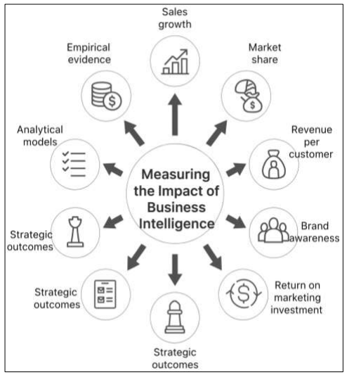
Figure 1: Impact of Business Intelligence
(Source: Rahman & Hye, 2022)
The reliability of business analytics is based on the quality of the data. Accuracy: This is required to make sure that the values are recorded correctly and represent the conditions in the real world, and completeness: This is required to make sure that all the valuable information is not left out. Relevancy means that the information ought to be relevant to the decision at hand, and timeliness ensures that the information ought to be up to date. The other important dimensions include consistency, uniqueness and validity (Polamreddy, 2025). Inaccurate forecasts and misleading reports, as well as inappropriate recommendations, can be the result of poor-quality data, which is often referred to as the logic of garbage in, garbage out. Alshareef & Emeagwali (2026) also attribute the ability to use business intelligence to organisational innovation, in addition to highlighting the role of knowledge management and data-driven decision-making.

2.5 Analytics and Competitive Advantage
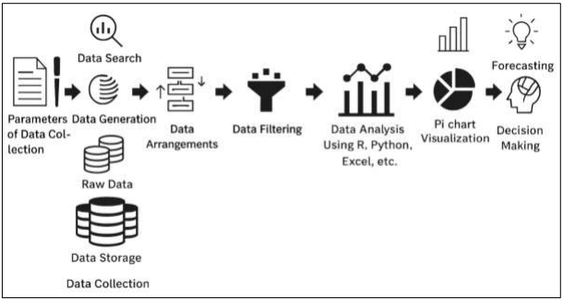
Figure 2: Data Analytics for decision making
(Source: Rahman & Hye, 2022)
Rahman & Hye (2022) refer to the implementation of evidence-based marketing decisions with the help of business intelligence, and to the possibility of using analytical information to make business plans. However, investing in analytical technology will not be a sure-footed way of gaining competitive advantage. A skilled workforce, quality proprietary information, an efficient analytic system and an evidence-based culture are also needed in organisations. Sinaga-Bulgamin (2022) explains the significance of combined and trustworthy operational data. Analytics therefore may best come in handy when there is a combination of organisational capabilities and technological resources enabling managers to observe insights and take the required actions.

3. Methodology

3.1 Research Approach
This report takes a qualitative secondary research approach in order to address the problem of how organisations utilise business data and analytics to enhance managerial decision-making, operational performance, as well as competitive advantage. The use of secondary research is suitable as vast amounts of academic research are available on decision-making based on data, business analytics, digital capabilities and organisational performance. The report synthesises the existing academic evidence so as to determine the benefits, use, problems and management implications of analytics. The authors highlight the importance of an analytical culture supporting data-driven decision-making (Szukits & Moricz, 2024), and the power of dynamic capabilities enabled by big-data quality decision-making (Altaf et al., 2026).

3.2 Data Sources
Key sources of the research are peer-reviewed journal articles, and in certain instances, academic and industry evidence is necessary to be employed. Review of Managerial Science, Journal of Management Control, Future Business Journal, Frontiers in Artificial Intelligence, IEEE Access, Journal of Business Analytics and Annals of Operations Research should be listed as the most significant sources. The selected articles contain data regarding marketing analytics, financial analytics, organisational processes, database technologies, performance management, cloud computing and business performance. Peer-reviewed research has been given priority since it provides systematic, empirical and theoretically-based evidence.

3.3 Search Strategy
Literature was located by keywords such as: data-driven decision-making, business analytics and performance, big data analytics, marketing analytics, financial analytics, data quality, predictive analytics, business intelligence, analytics capabilities and data-driven culture. More recent studies that address the issues of the relationship between analytics capabilities, managerial decisions and organisational performance were searched especially.

3.4 Inclusion and exclusion criteria
Articles that were related to business analytics, decision-making and organisational performance were targeted. Systematic Reviews and empirical studies were considered where they provide evidence. The sources that were not included were promotional websites, untrustworthy sources, and studies which were very technical without stating whether they were relevant to the managers concerned. Papers published in 2024 2026 attracted particular attention to keep up with the present time.

3.5 Limitations
The research is based on secondary evidence, and as such does not present novel survey or interview results. The self-varied nature is also applicable to organisational contexts as far as the industry is concerned, size, maturity in technologies and analyst aptitude is concerned. Moreover, some of the findings might become irrelevant over time, as quickly emerging AI and analytics technologies might alter them.

4. Findings

4.1 Marketing Analytics
Through marketing analytics, organisations can understand purchasing behaviour and trends, the success of carrying out campaigns and market trends in order to make more informed marketing decisions. Some of its applications include customer segmentation, personalised advertising, campaign analysis, customer lifetime value and predictive customer analysis. The growing role of marketing analytics in the creation of market orientation, highlighted by Irune et al. (2026), depicts how analytical potential may help organisations to react to the arising customer needs and market environment.
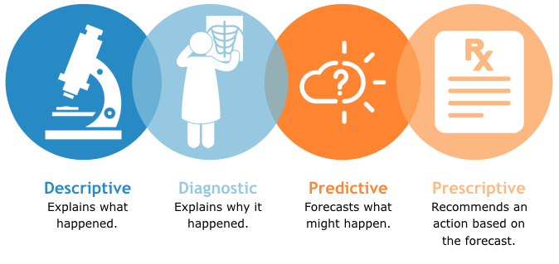
Figure 3: Types of Analytics
(Source: Roy, 2020)
As an example, by analysing customer transactions and online communication, organisations can use analysis to tap into quality customer segments and target promotional activities. It can also enable predictive models to identify the customers who would be more inclined to purchase or abandon. This will aid in targeting and allocation of resources in a better way. It is, however, in the interest of managers to remember that previous customer behaviour will not predict future preferences. Therefore, managerial judgement, market knowledge and creativity must be employed together with marketing analytics, but not replace each other.
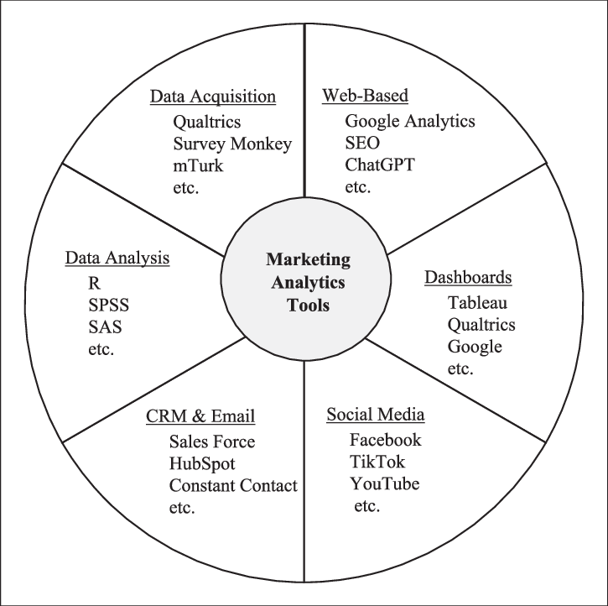
Figure 4: Applications of marketing analytics tools
(Source: Keiper et al., 2023)

4.2 Financial Analytics
Budgeting, forecasting, detection of fraud, evaluation of risk, cost analysis and investment decisions are supported by financial analytics. In Theodorakopoulos, Theodoropoulou & Bakalis (2025) unveil the growing importance of big data in relation to financial risk management, particularly the potential to identify trends and improve the risk assessment process.
The data on transactions can help financial institutions identify any suspicious transactions that may indicate fraud. Predictive models are also used to predict future cash flows and financial risks in business. Barreto et al. (2025) dwell on the part that digital technologies play in transforming management accounting by providing better access to financial data and contributing to the timely decision-making process.
Nevertheless, analytical frameworks are based on past data and assumptions that might break down in times of economic shocks or other unexpected events. At this point, managers need to combine financial analytics with professional skills and context assessment.

4.3 Operations Analytics
Demand forecasting, inventory management, supply-chain monitoring, capacity planning, quality control and predictive maintenance are some of the activities that analytics can help to make much more efficient. Feledi & Vilela (2025) name the concept of big data analytics as a more and more significant part of organisational process management, as it may enhance the visibility of the process and contribute to making evidence-based decisions.
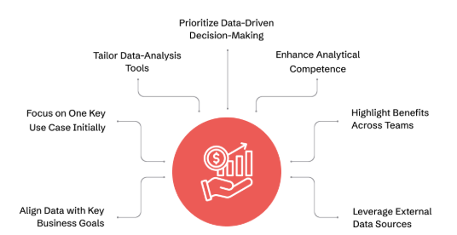
Figure 5: Business analytics applications
(Source: Srivastava, 2024)
The real time and historical data of the demand help organisations in anticipating the sales and putting a figure across the amount of inventory that is necessary. Analytics can also identify the bottlenecks within the supply chain, supplier performance and assist in making transportation choices. Makhdoom et al. (2025) also recognise the significance of big-data analytics capabilities and AI to enhance sustainable supply-chain performance.
Proper technology infrastructure is necessary for effective operations analytics. According to Dritsas & Trigka (2025), database architecture and performance are important in dealing with big data. Consequently, organisations need analytical technologies and effective workers who would subsequently be in a position to interpret insights on operations.

4.4 Human Resource Analytics
HR analytics help organisations to analyse workforce requirements, performance, workforce performance, women workforce requirements, and absence. Phan & Baird (2026) show the connection between performance-management effectiveness and the use of big data analytics, showing that analytics will be able to offer managers more solid evidence to assess performance.
Using employee turnover behaviour as an example would help organisations know which departments experienced more employee turnover and improve employee planning. Possible retention risks can also be identified using predictive analytics. Nonetheless, HR analytics raises the questions of privacy, monitoring of employees, and biases of the algorithm. Where employment-related decisions involve data analytics systems, organisations, therefore, need to ensure that there is transparency, effective data governance and human control.

4.5 Customer Relationship Management Analytics
CRM analytics is used to segment consumers, predict churn and customer lifetime value, handle complaints and enable personalised marketing. Transaction, website, application and service interaction customer information can be analysed to develop a better understanding of customer behaviour. Sheng, Amankwah-Amoah & Wang (2020) illustrate a correlation between big-data analytical intelligence and CRM performance. The analytics help businesses to identify valuable customers, forecast the likely churn and make targeted offers. However, recommendations may be mistaken because of uncoordinated or misunderstood customer information. CRM analytics thus relies heavily on data integration, responsible and quality management of data.

4.6 Organisational Applications and Data Quality
The results prove the cross-functional usage of analytics. It has the aid of marketing analytics to know more about the customers, financial analytics to avoid risks, operations analytics to be more strict in its efficiency, HR analytics to help in workforce decisions, and CRM analytics to help in the relation to the customer. El Skafi et al. (2025) observe the importance of big data and cloud computing in organisational adoption strategies, and Bhatti et al. (2025) display the connections between big-data analytic abilities and digital capabilities, innovation and MSME performance. Nonetheless, analytics is only able to yield trustworthy insights in the presence of correct, comprehensive, consistent, pertinent and timely underlying data. Bad information also results in bad predictions, bad customer identification/selection and bad financial and / personnel decisions. The issue of data quality can thus be viewed as a strategic management issue and not just an IT problem.

5. Discussion

5.1 Analytics as a Decision-Support Mechanism
The results show that analytics can enhance the managerial decision-making process by revealing patterns, trends and relationships that would not become apparent using other methods. However, analytics should not be implemented to replace managerial judgement, but should be helpful. Szukits & Móricz (2024) show that the efficiency of data-driven decision-making is affected by the analytical culture and organisational set-ups. Equally, Altaf et al. (2026) point out that dynamic capabilities are crucial in transforming big-data resources into better decision-making. Managers should hence take into consideration the organisational strategy, market conditions, interest and ethical issues of the stakeholders, as well as their analytical findings. Quantitative evidence and managerial experience in balance are necessary to make effective decisions.

5.2 Risks of Overdependence on Analytics
Overreliance on systems of analysis may result in a number of risks. Algorithmic bias is likely to occur in cases where the historical sets involved have a pre-existing inequality. If conclusions are drawn with the application of advanced analytical tools, poor data quality can give untrustworthy results. The model risk arises when the prediction models fail to represent unpredictable situations in the market. There is also a risk of automation bias, since automated recommendations will not be questioned by the managers sufficiently. Too many dashboards may cause information overload, and only those indicators that are really crucial can be noticed. Moreover, the gathering of vast amounts of customer and employee data raises privacy and cybersecurity issues. Feledi & Vilela (2025) outline that the successful application of analytics includes a broader profile than technological thinking and represents organisational and cultural levels. This fortifies the necessity to be accountable.

5.3 Analytics and Competitive Advantage
Analytics can be employed in order to attain the competitive advantage that translates into improved operational efficiencies, customer understanding, innovation and faster decision-making. But, when acquiring analytics software, there is no automatic guaranteed competitive advantage. The organisations also require skilled employees, good infrastructure, leadership and governance and a healthy sense of an analytics culture. Bhatti et al. (2025) suggest that extra digital platform and network assets are extremely crucial in disaggregating analytics, innovation, and performance. Similarly, Makhdoom et al. (2025) provide evidence of the importance of the combination of analytic capabilities and technological innovation in the framework of supply chains. Thus, the strategic importance of analytics is determined by how the organisation is able to transform data into valuable insights and then take the necessary steps to operationalise the same.

5.4 Human and Analytical Decision-Making
The evidence underpins a combined method of making decisions. Large amounts of data can be processed with the assistance of analytics, which can help to reveal trends and patterns and also enable predictions, whilst managers can be a source of context, moral judgment and strategy interpretation. Phan & Baird (2026) confirm the usefulness of using analytics in performance management, and Szukits & Moricz (2024) highlight the importance of analytical culture in organisations. Thus, when making critical decisions, it is important that organisations apply the concept of human-in-the-loop decision-making, in which analytical suggestions are checked and examined by the managers who will make the decisions.

6. Conclusion and Recommendations

6.1 Conclusion
Evidence-based decision-making has become an important feature of contemporary business administration. It is revealed that analytics can transform organisational data into information that can assist managers in decision-making, enhancing the performance and competitiveness of their operations. Marketing analytics builds on customer insights, financial analytics on risk management and forecasting, operations analytics on process efficacy, HR analytics on workforce management and customer relationship management (CRM analytics. Simultaneously, organisations need to deal with algorithmic bias, inadequate data, model uncertainty, information overload, privacy issues and automation bias. Analytics as decision-support competence ought to be embraced and not a mere final affordance to human judgement.

6.2 Recommendations
1. Strengthen Data Governance
Organisations should have certain policies that govern data ownership, data accuracy, data security, data privacy, access and accountability. Routinely, data-quality checks should be done to ensure that the data is correct, complete, consistent and pertinent.
2. Enhance the Skills of Employee Analytics
Data literacy, statistical interpretation and dashboards, business intelligence and responsible AI are the key areas in which organisations should train. Managers ought to grasp the value as well as the constraints of analytical models. This can uphold the culture of analytics in Szukits & Moraicz (2024).
3. Develop Integrated Data Infrastructure
CRM, ERP, finance, HR, marketing and operations information should be combined where necessary. Accessibility and processing can be enhanced by cloud computing and state-of-the-art database technologies (El Skafi et al., 2025; Dritsas & Trigka, 2025).
4. Maintain Human Oversight
Managers are to review automated recommendations (high-impact financial, employment and customer decisions in particular). Before implementing the recommendations, managers are advised to look into the quality of data, assumptions in the model and the entire organisation.
5. Provide Continuous Management of Data Quality
The control should be put in place with measurable controls on the accuracy, completeness, timeliness, consistency and relevance of the organisation's data. By conducting regular audits, one can detect mistakes prior to their impact on critical decisions.
6. Build a Data-Driven Culture
Top management must foster the use of evidence-based decisions, information, cross-functional sharing of information and lifelong learning. Analytics should be embedded into the organisational processes, not considered as a single IT investment. The collective development of people, processes, technology and governance can result in sustainable transformation of business performance by enhancing the organisation's ability to convert analytical capabilities into sustainable business performance improvement.

References
Ahmed, A. (2026). The Role of Management Information Systems in Organisational Decision Making. Journal of Data Analysis and Critical Management, 2(01), 1-13. https://jdacm.com/index.php/jdacm/article/download/96/65
Alshareef, H.R. & Emeagwali, O.L. (2026). Business intelligence capabilities and SME innovation: The mediating role of knowledge management capability and the moderating effect of data-driven decision making. Systems, 14(4), 339. https://www.mdpi.com/2079-8954/14/4/339
Altaf, S., Shafique, I., Qammar, A., Waqas, M. & Tariq, A. (2026). Leveraging big data-driven dynamic capabilities for enhanced decision making: a moderated-mediation approach. Journal of Business Analytics, 1-21. https://www.researchgate.net/profile/Muhammad-Waqas-19/publication/403906687_Leveraging_big_data-driven_dynamic_capabilities_for_enhanced_decision_making_a_moderated-mediation_approach/links/69e1d0e3b1056332819ce255/Leveraging-big-data-driven-dynamic-capabilities-for-enhanced-decision-making-a-moderated-mediation-approach.pdf
Barreto, A., Gomes, P., Quesado, P. & O'Sullivan, S. (2025). Advancements in management accounting and digital technologies: A systematic literature review. Accounting, Finance & Governance Review, 34. https://afgr.scholasticahq.com/article/137301.pdf
Bhatti, S.H., Ahmed, A., Ferraris, A., Hirwani Wan Hussain, W.M. & Wamba, S.F. (2025). Big data analytics capabilities and MSME innovation and performance: A double mediation model of digital platform and network capabilities. Annals of Operations Research, 350(2), 729-752. https://link.springer.com/content/pdf/10.1007/s10479-022-05002-w.pdf
Dritsas, E. & Trigka, M., (2025). Database systems in the big data era: Architectures, performance, and open challenges. IEEE Access, 13, 95068-95084. https://ieeexplore.ieee.org/iel8/6287639/6514899/11008610.pdf
El Skafi, M.A., Yunis, M.M., Zekri, A. & Daher, J.B., (2025). The confluence of big data and cloud computing in SME adoption strategies. IEEE Access, 13, 37789-37811. https://ieeexplore.ieee.org/iel8/6287639/10820123/10891810.pdf
Emma, L. (2024). Data-driven decision-making and business intelligence in modern organisations. Journal of Business Intelligence Studies. https://www.researchgate.net/profile/Lawrence-Emma/publication/386385015_Data-Driven_Decision-Making_and_Business_Intelligence_in_Modern_Organizations/links/674ff100a7fbc259f1ab0e1a/Data-Driven-Decision-Making-and-Business-Intelligence-in-Modern-Organizations.pdf
Feledi, M.E. & Vilela, J. (2025). Big Data Analytics in Organisational Process Management: A Systematic Review of Methods, Challenges, and Cultural Impacts. iSys-Journal of Information Systems, 18(1), 16-1. https://journals-sol.sbc.org.br/index.php/isys/article/download/6593/3881
Irune, G.P., Izaskun, A.A., Leire, M.A. & Maider, E.I., (2026). The role of marketing analytics in shaping market orientation: a bibliometric review of emerging trends. Future Business Journal, 12(1), 47. https://link.springer.com/content/pdf/10.1186/s43093-026-00750-8.pdf
Keiper, M.C., Nachtigal, J., Lupinek, J.M. & Stough, R.A. (2023). Marketing Analytics Curriculum Integration: An Exploration of Resource Availability for Faculty. Journal of Marketing Education, [online] 46(1), 18–31. doi:https://www.researchgate.net/publication/373549862_Marketing_Analytics_Curriculum_Integration_An_Exploration_of_Resource_Availability_for_Faculty
Makhdoom, Q., Junejo, I., Sohu, J.M., Shah, S.M.M., Alwadi, B.M., Ejaz, F. & Hossain, M.B. (2025). Impact of green supply chain management on sustainable performance: a dual mediated-moderated analysis of green technology innovation and big data analytics capability powered by artificial intelligence. F1000Research, 13, 1140. https://pmc.ncbi.nlm.nih.gov/articles/PMC12504947/
Phan, T. & Baird, K. (2026). The use of big data analytics in performance management: the antecedents and role in enhancing performance measurement system effectiveness. Journal of Management Control, 37(1), 111-139. https://link.springer.com/content/pdf/10.1007/s00187-026-00414-2.pdf
Polamreddy, V.R. (2025). Architecting Financially Compliant Enterprise Point-of-Sale Systems: Data Integrity and Revenue Recognition at Scale. International Journal of Advanced Research in Computer Science & Technology (IJARCST), 8(5), 12993-13104. https://www.ijarcst.org/index.php/ijarcst/article/download/414/402
Rahman, S.T. Hye, A. (2022). Data-Driven Business Intelligence Tools In Agribusiness: A Framework For Evidence-Based Marketing Decisions. International Journal of Business and Economics Insights, 2(1), 35-72. https://ijbei-journal.org/index.php/ijbei/article/download/38/38
Rane, N.L., Chika, O.E. & Rane, J. (2026). Business intelligence systems integrating artificial intelligence, big data analytics, machine learning, Internet of Things, and blockchain. International Journal of Applied Resilience and Sustainability, 2(2), 367-395. https://deepscipub.com/ijars/article/download/42/67
Roy (2020). Four Types of Business Analytics. [online] Caperio AI Performance Platform | Artificial Intelligence for Exceeding Expectations. Available at: https://caperio.ai/?p=4572.
Sinaga-Bulgamin, S. (2022). Research of Point-of-Sale Systems for Integrating International Business Operations. https://www.theseus.fi/bitstream/handle/10024/784068/Sinaga-Bulgamin_Sandrina.pdf?sequence=2
Srivastava, S. (2024). Unlocking the Power of Operational Analytics – Use Cases, Best Practices, and Key Implementation Strategies. [online] Appinventiv. Available at: https://appinventiv.com/business-operations-analytics/.
Szukits, Á. & Móricz, P. (2024). Towards data-driven decision making: the role of analytical culture and centralisation efforts. Review of Managerial Science, 18(10), 2849-2887. https://link.springer.com/content/pdf/10.1007/s11846-023-00694-1.pdf
Theodorakopoulos, L., Theodoropoulou, A. & Bakalis, A. (2025). Big data in financial risk management: evidence, advances, and open questions: a systematic review. Frontiers in Artificial Intelligence, 8, 1658375. https://www.frontiersin.org/journals/artificial-intelligence/articles/10.3389/frai.2025.1658375/pdf
Tiwari, P., Kim, D., Hajian, A. & Ghasemi, A. (2024). A prescriptive analytics approach for evaluating two production systems: Simulation optimisation algorithm. Decision Analytics Journal, 12, 100513. https://www.sciencedirect.com/science/article/pii/S2772662224001176
Vale de Sousa, K.P. (2025). Optimising Direct Marketing Through Data-Driven Analytics and Predictive Models (Doctoral dissertation, Dublin, National College of Ireland). https://norma.ncirl.ie/8002/1/karlapriscilavaledesousa.pdf
Wissuchek, C. & Zschech, P., (2025). Prescriptive analytics systems revised: a systematic literature review from an information systems perspective. Information Systems and E-Business Management, 23(2), 279- 353. https://link.springer.com/content/pdf/10.1007/s10257-024-00688-w.pdf
Yu, H.H., Martin, S., van der Meer, L., Yang, E., Lee, S., Xiong, W., Reddipalli, V., Burch, R., Honda, T. & David, J., (2024). Expediting manufacturing launch using integrated data with AI/ML analytic solutions. IEEE Journal of the Electron Devices Society, 13, 691-696. https://ieeexplore.ieee.org/iel8/6245494/10834603/10816252.pdf

