
Structure of Tourism Markets
Assignment 3
23.09.2026

In no more than 500 words each, explain:

Select a tourist attraction, heritage site, protected area, museum, or destination and analyse how visitors are currently managed.

Address the following:
- Visitor Management
- Briefly introduce the selected site.
- Identify the main visitor management challenges.
- Explain the potential impacts of visitors on the site, local community, and visitor experience.

Analysis of the Visitor Management of Machu Picchu, Peru.
Introduction to the Site
Machu Picchu is one of the world's most famous archaeological sites and is a UNESCO World Heritage Site in the Andes Mountains of Peru. It was built by the Incas in the 15th century and has been recognized for its historical, architectural and natural values, and is a tourist attraction. Cultural heritage and environmental values are important, and it is important to protect it with a visitor management system (VMS), and to allow the public to visit for tourism (Belsky, J. 2018).
Visitor Management
Visitor management at Machu Picchu focuses on controlling visitor numbers and reducing tourism impacts. The Peruvian Ministry of Culture uses timed tickets, designated routes, daily visitor limits, and restrictions in sensitive areas. Special guided circuits in the museum also help prevent overcrowding and protect the archaeological structures.
The site also regulates visitor traffic by allocating different hours of access to the sections of the site. This method is used to help alleviate congestion, enhance the visitor experience and to minimize pressure on sensitive sites. Other measures are monitoring visitor behavior; and restricting some activities, upgrading infrastructure around access points including the transport system between Aguas Calientes and the site (Eagles,2002).
Main Visitor Management Challenges
Even with these measures, Machu Picchu still faces challenges from overcrowding, which affects the archaeological site, pathways, ecosystems, and visitor experience. A key challenge is balancing tourism income with heritage protection, as tourism provides important jobs and supports local businesses.
The site is also in a sensitive mountain ecosystem, which poses a challenge in environmental management. As the amount of waste being produced increases, the need for continuous monitoring and improvement of waste generation, erosion due to foot traffic, and pressure on local resources (water, transportation system) also increases (Buckley, R. 2019).
Impacts on Visitors
The effects that visitors have on Machu Picchu are positive and negative. On the economic front, tourism generates jobs and boosts the economy of the local communities by offering jobs in the tourism industry, as well as at hotels, restaurants and transportation.
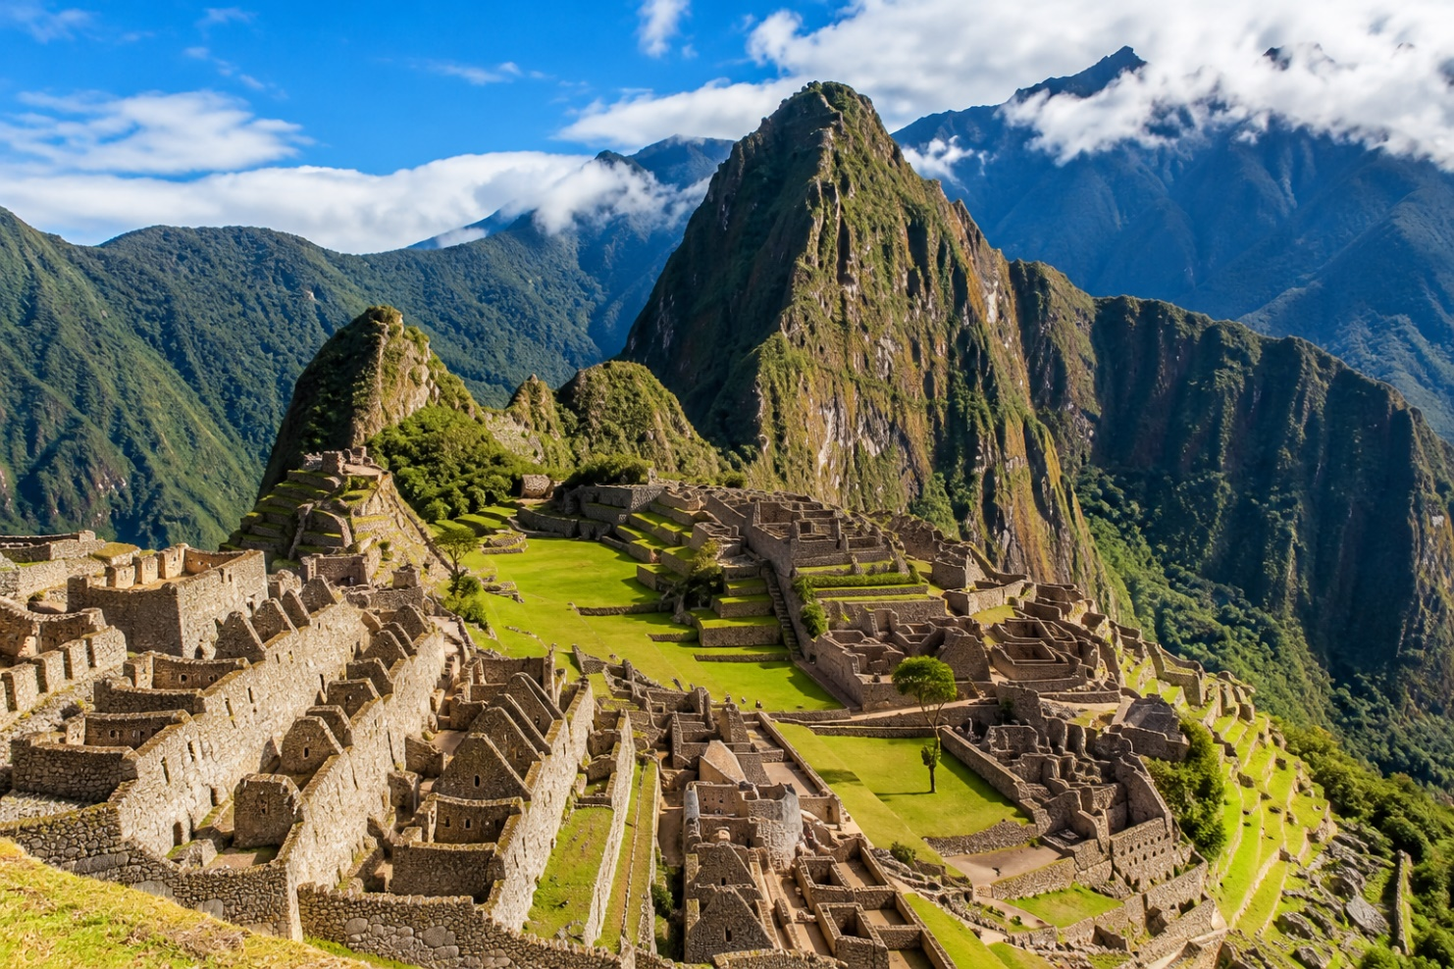
Tourism can boost the economy but may increase costs for locals and put pressure on the local economy. It can also reduce visitors’ experience through long queues, limited access, and loss of cultural meaning.
Conclusion
Machu Picchu uses limited access, timed entry and dedicated paths to protect its heritage from the impact of visitors. However, high visitor numbers remain a challenge. Visitors should help preserve this valuable site in an environmentally sustainable way.

Reference
UNESCO (2024) Historic Sanctuary of Machu Picchu. Available at: https://whc.unesco.org/en/list/274/ (Accessed: 29 September 2026).
Ministry of Culture of Peru (2024) Machu Picchu Visitor Regulations and Management Measures. Available at: https://www.gob.pe/cultura (Accessed: 29 September 2026).
World Bank (2023) Tourism and Sustainable Development in Peru. Available at: https://www.worldbank.org/en/country/peru (Accessed: 29 September 2026).
Buckley, R. (2019) Sustainable Tourism and Natural World Heritage Sites. London: Routledge.
Eagles, P.F.J., McCool, S.F. and Haynes, C.D. (2002) Sustainable Tourism in Protected Areas: Guidelines for Planning and Management. Gland, Switzerland: IUCN.
Belsky, J. (2018) ‘Tourism and heritage conservation: balancing access and protection at iconic destinations’, Journal of Sustainable Tourism, 26(6), pp. 1015–1031.

